BIM as a Whole Life Process and a Building Management Tool
Technical Case Study: The Dylan Thomas Centre, Swansea

ACBA7002 – Construction Technology and BIM
MSc Sustainable Construction – University of Wales Trinity Saint David

Nikhil
Student ID: 2511003
Module Lecturer: Gavin Traylor RIBA PP-RSAW
Submission Date: 21st January 2026 | Word Count: Approx. 4,000

Table of Contents
1. Introduction 4
2. Theme A – BIM for Existing Buildings 5
2.1 The Challenge of Data-Rich Models for Existing Buildings 5
2.2 The Scan-to-BIM Process 5
2.3 Industry Exemplars 6
2.4 Evaluation of Current FM Practices at UWTSD 6
3. Theme B – Data Investigation and Discrepancy Analysis 8
3.1 Available Data Streams 8
3.2 Coordination in Revizto 8
3.3 Discrepancy Analysis 8
3.4 Systematic Issue Documentation 9
3.5 Commentary on Accuracy, Correction, and Mitigation 9
3.6 Resolution: How Could This Be Addressed at the Dylan Thomas Centre? 9
4. Theme C – Sustainability Measures and New Technologies 12
4.1 Context and Relevance to the Dylan Thomas Centre 12
4.2 Worst-Case Thermal Performance (Approved Document L Wales) 12
4.3 Short-Term Strategy: Easy Wins (0–12 Months) 13
4.4 Medium-Term Strategy: Fabric and Systems Improvement (1–3 Years) 14
4.5 Long-Term Strategy: Smart Systems and Digital Twin (3–5+ Years) 15
4.6 Tying the Strategy to Digital Technologies 16
5. Conclusions and Recommendations 18
Reference List 20

1. Introduction

BIM has changed the way new-build projects get delivered. It gives project teams data-rich digital models that support better decisions at every stage of a building’s life (Sacks et al., 2018). UWTSD uses it for new construction. But when it comes to existing buildings, there is a real gap – buildings designed and built long before digital workflows were a consideration.
This case study uses the Dylan Thomas Centre (DTC) in Swansea to test whether BIM can work as a whole-life management tool for that kind of building. The DTC is roughly 200 years old, listed, and comes with a set of problems that make it a genuinely difficult building to manage digitally. It has complex lease arrangements with Swansea Council, poor building fabric, outdated M&E, and a history of alterations that nobody properly recorded. It is, in other words, about as difficult as existing buildings get. Which is actually the point. If BIM can add value here, the case for adopting it across the rest of the UWTSD estate is hard to argue against.
The report is organised around three themes. Theme A covers the background: how you go about creating a data-rich model for a building that was never designed digitally, what other places have done, and where UWTSD’s current Facilities Management (FM) practices stand. Theme B is the hands-on part: pulling the available data into Revizto, comparing it to the real building, spotting where the records are wrong, and – just as importantly – figuring out what can realistically be done about it. Theme C takes the corrected data and builds a practical sustainability strategy around it, structured as short, medium, and long-term measures. The aim is to show that once you have accurate data, energy performance and sustainability improvements can be planned from a position of evidence rather than assumption.

2. Theme A – BIM for Existing Buildings

2.1 The Challenge of Data-Rich Models for Existing Buildings
For new builds, the process is relatively simple. The design starts digital and gets richer as the project moves through construction and handover (Sacks et al., 2018). Existing buildings are nothing like that. There is no model. What you find instead is information in different formats – paper drawings, CAD conversions of uncertain accuracy, maintenance records in separate systems – and a physical building that has almost certainly been changed without the documentation being updated (Volk, Stengel and Schultmann, 2014).
As Volk, Stengel and Schultmann (2014) put it, you are essentially trying to reverse-engineer a useful model out of data that is incomplete, inconsistent, and in places simply wrong. For heritage buildings like the DTC, it gets harder. Revit’s parametric libraries are designed for modern construction. There are no families in there for 200-year-old rubble stone walls or hand-cut timber trusses (Khalil, Stravoravdis and Maulem, 2024).

2.2 The Scan-to-BIM Process
Laser scanning has made a real difference. A terrestrial scanner fires millions of light pulses that bounce off surfaces to produce a point cloud – a dense 3D map of every visible surface (Wang, Kim and Love, 2019). The DTC was scanned by the technical demonstrator at UWTSD to an accuracy of 1–3mm.
The catch is that a point cloud is just coloured dots with no building intelligence. The Scan-to-BIM workflow (Figure 2) converts that raw data through four stages: scanning, cleaning the point cloud, modelling geometry in Revit, and adding non-geometric information. For the DTC, that last stage is the difficult bit – nobody documented what those 200-year-old walls are made of, and intrusive testing requires Cadw consent under the Planning (Listed Buildings and Conservation Areas) Act 1990. Realistically, the DTC can reach LOD 200 to 300 for geometry in the short term. As Figure 3 illustrates, LOD 200 represents approximate size and location of elements, while LOD 300 provides geometrically accurate modelling suitable for coordination (BIMForum, 2023). The Level of Information (LOI) will trail behind until targeted surveys close the gaps (Antonopoulou and Bryan, 2017).

Figure 1: Raw point cloud of the DTC showing coloured dots with no semantic data

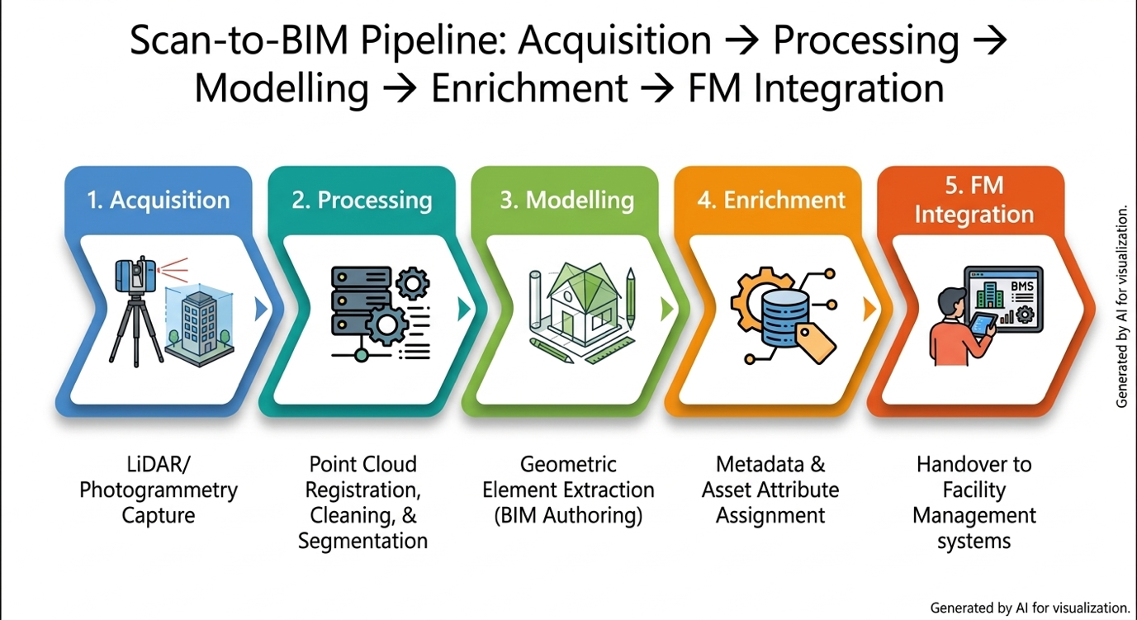
Figure 2: Scan-to-BIM pipeline: Acquisition → Processing → Modelling → Enrichment → FM Integration (Developed by author)
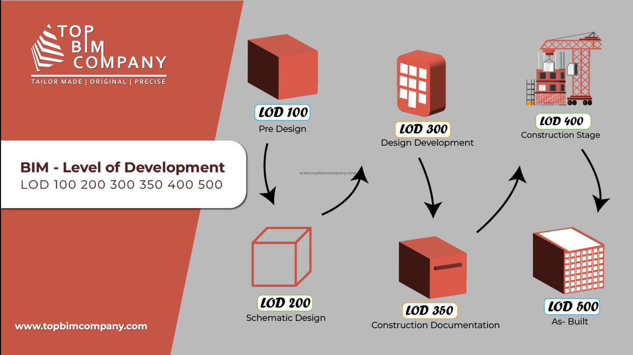
Figure 3: BIM Level of Development (LOD) progression from LOD 100 to LOD 500 (Source: TopBIMCompany, 2023)

2.3 Industry Examples
UWE Bristol used what they called a “digital recipe” approach to their Frenchay Campus. Instead of trying to model everything in one go, they began with the laser scan geometry and added data incrementally, linking it to their CAFM system and using COBie schemas whenever new projects contributed data to the campus model (Stride Treglown, 2023). That pragmatic, phased approach could transfer directly to UWTSD. Table 1 compares these three exemplars.
Muñoz Pavón et al. (2025) built a working digital twin for UPM Madrid’s campus, while Johansson et al. (2024) developed a human-centric digital twin from 3D scans at Umeå University. Antonopoulou and Bryan (2017) set out the HBIM framework for listed buildings. Beyond universities, Network Rail has adopted BIM for Grade II listed stations (BSI, 2019a) and the Pisa City Walls project demonstrated HBIM for large-scale heritage infrastructure (Croce et al., 2024). The difficulties at the DTC are not unique.
Table 1: Industry case study comparison table
Institution | Approach | Technologies | Key Outcomes | Relevance to DTC
UWE Frenchay Campus | “Digital recipe” Phased, incremental data building | Laser scanning Revit, COBie CAFM integration | Progressive model enrichment; BIM integrated with FM | Direct precedent: similar estate scale and phased approach
UPM Madrid (ETSICCP) | Complete digital twin for campus management | BIM + IoT sensors Cloud computing Custom platform | Live space booking Sensor monitoring Asset management | Shows end-state potential for DTC digital twin vision
Umeå University Sweden | Human-centric digital twin for existing buildings | 3D scanning Geospatial data FM system links | Occupant + operator focused; building operations module | Demonstrates DT for existing stock not just new builds

2.4 Evaluation of Current FM Practices at UWTSD
Two members of the UWTSD Estates team responded to a structured survey (Appendix A, Table 2): one from the Energy Team and one from Projects and Maintenance. The Energy Team uses solar PV portals, sub-metering, and AI-backed trend modelling, but entirely separately from any spatial model. The Projects respondent works in AutoCAD and SketchUp; the estates team is not set up for Revit. Quantarc, their CAFM system, links to Excel-based building databases, and not all spaces across the 300-plus estate are covered.
BIM maturity ratings averaged just 2 out of 5. The DTC compounds this: poor fabric and M&E inherited by UWTSD, a layout “chopped up” by decades of unrecorded changes, and a Swansea Council lease that has left everyone reluctant to invest – described by the Projects respondent as “a perpetual state of limbo.”
If the Energy Team’s area figures come from the inaccurate CAD plans that Theme B exposes, even clever analysis produces untrustworthy answers. Reactive maintenance costs significantly more than preventive approaches (Patacas et al., 2020), and BIM could address this by consolidating scattered data into one spatially-referenced platform. The challenges are equally real: cost and training, governance of shared ownership with Swansea Council, listed status constraints, and the risk the model goes stale (Patacas et al., 2020).
The full FM survey responses are summarised in Appendix A (Table 2).

3. Theme B – Data Investigation and Discrepancy Analysis

3.1 Available Data Streams
Five data sources were identified for the DTC. They range from highly accurate to barely trustworthy and coordinating them is the only way to work out what the FM team actually has versus what the building is.
The first and most reliable source is the 3D laser scan point cloud, captured by the technical demonstrator at UWTSD with an accuracy of 1–3mm. This is the most accurate data source available. Figure 4 shows the interior scan data.
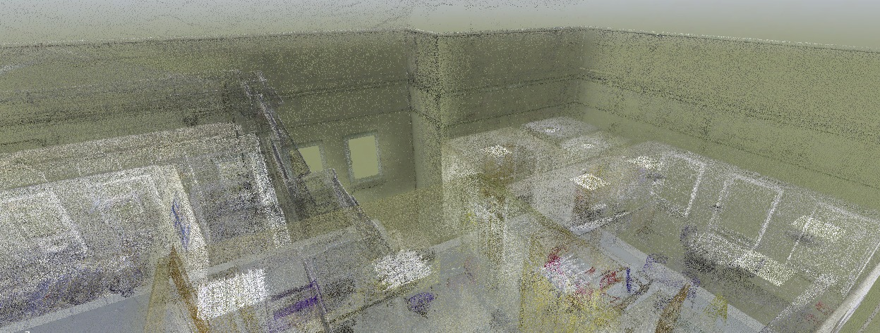
Figure 4: Raw point cloud of the DTC interior showing coloured dots with no semantic data
The remaining sources – 2D CAD drawings of uncertain age and accuracy, hard copy plans with no version control, PDFs, and photographic survey data – each capture something different, but none captures everything and none fully agrees with the others.

3.2 Coordination in Revizto
Revizto was used as the Common Data Environment (CDE). The Revit model went in as the primary 3D reference, with CAD floor plans imported as 2D overlays for direct visual comparison, and PDFs, photographs, and maintenance documents attached as linked files – consolidating data that currently sits across separate, unconnected systems.
Figure 5 shows this in action. The grey point cloud from the scan and a blue Revit-modelled element are visible together in the same view. This is two data streams coordinated on a single platform, which is the basic definition of what a CDE should do.
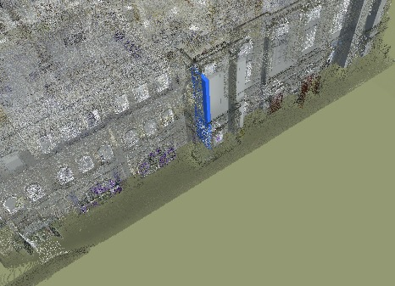
Figure 5: Revizto model showing a Revit-modelled BIM element (blue) overlaid on the laser scan point cloud of the DTC facade

3.3 Discrepancy Analysis
Once the data streams were overlaid, the discrepancies became visible. The CAD plans the FM team has been relying on do not match the building as the laser scan captured it. The problems fall into three categories.
Dimensional inaccuracies: Wall positions and room dimensions on the CAD plans differ from the scanned geometry by tens or hundreds of millimetres. If the Energy Team is using those recorded floor areas to calculate heating loads, every calculation downstream is compromised – a room recorded as 25m² that is actually 28m² gets its heating load underestimated, and that error scales across the entire building.
Missing elements: The scan reveals physical features not shown on any available drawing. Figure 6 shows the DTC’s facade as captured: arched window heads, decorative mouldings, and structural details that do not appear on the CAD floor plans. Inside, the same pattern holds for partitions, columns, and service runs added over 200 years of undocumented alterations.
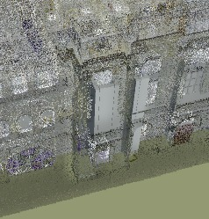
Figure 6: Point cloud of the DTC exterior facade showing architectural features not represented in existing CAD drawings
Altered layouts: Some elements shown on the CAD plans have been physically removed or altered. The FM team may be making decisions based on a spatial layout that no longer exists.
The top-down scan view in Figure 7 confirms the scale of the problem from a different angle. The actual building footprint, roof geometry, and external envelope as captured by the scanner can be compared directly against the CAD floor plan outlines, and they do not match.
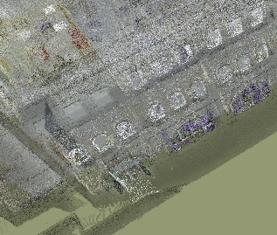
Figure 7: Top-down point cloud view of the DTC showing roof and building envelope geometry

3.4 Systematic Issue Documentation
To document these discrepancies, custom stamps were created in Revizto: Geometric Inaccuracy, Missing Element, Altered Layout, and Data Conflict. Each discrepancy was tagged directly on the 3D model at its exact location. The result is a spatially referenced issue register: you can click on any stamp and see what the problem is, where it is, and which data sources conflict. Revizto then pulls all the tagged issues into an automated report, sorted by category and location. That report is, in effect, a prioritised job list of things that need correcting before the FM team’s records can be considered reliable. Figures 8 and 9 show the resulting discrepancy map and the automated issue report respectively.
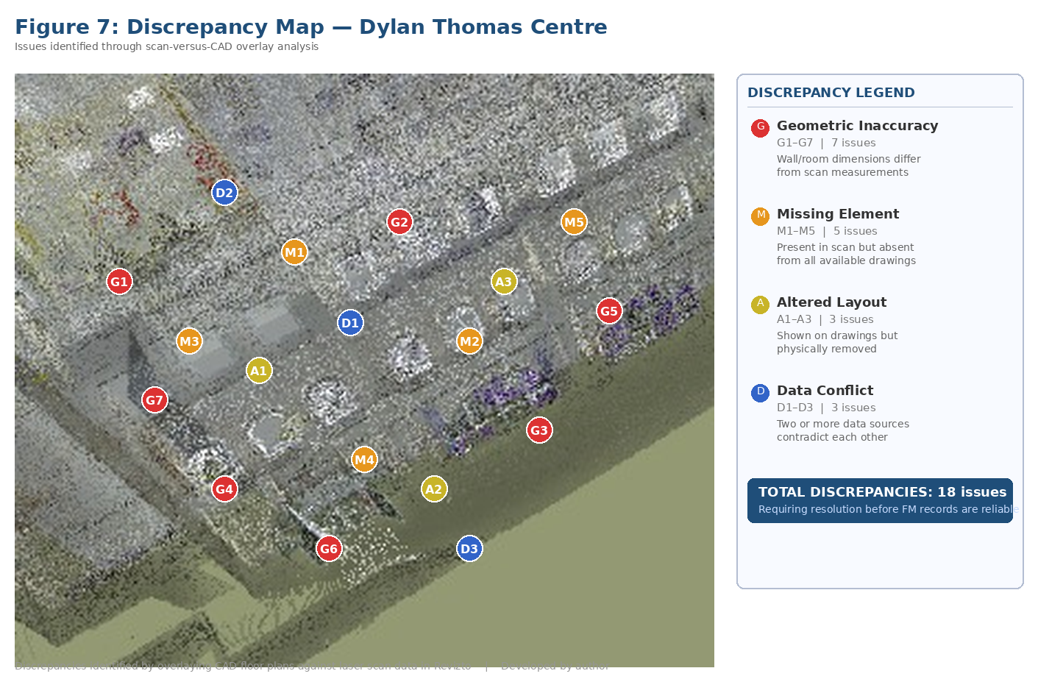
Figure 8: Discrepancy map showing categorised issues identified across the DTC model
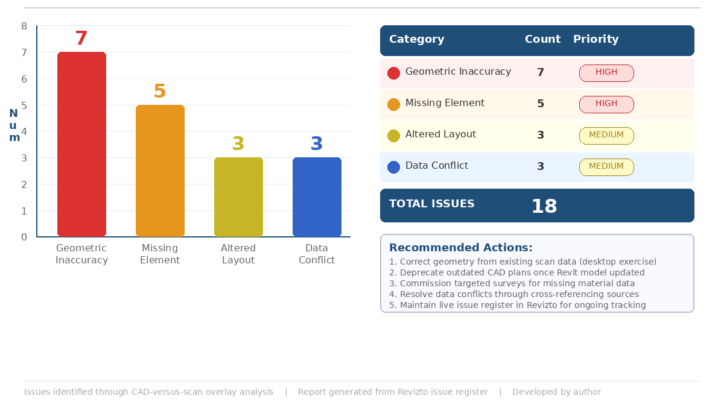
Figure 9: Discrepancy issue report summarising counts and priority by category

3.5 Commentary on Accuracy, Correction, and Mitigation
Ranking the data sources by reliability: the laser scan sits at the top (1–3mm accuracy), followed by the Revit model derived from it, then CAD drawings of unknown vintage, and hard copy plans at the bottom. Figure 10 maps this hierarchy.

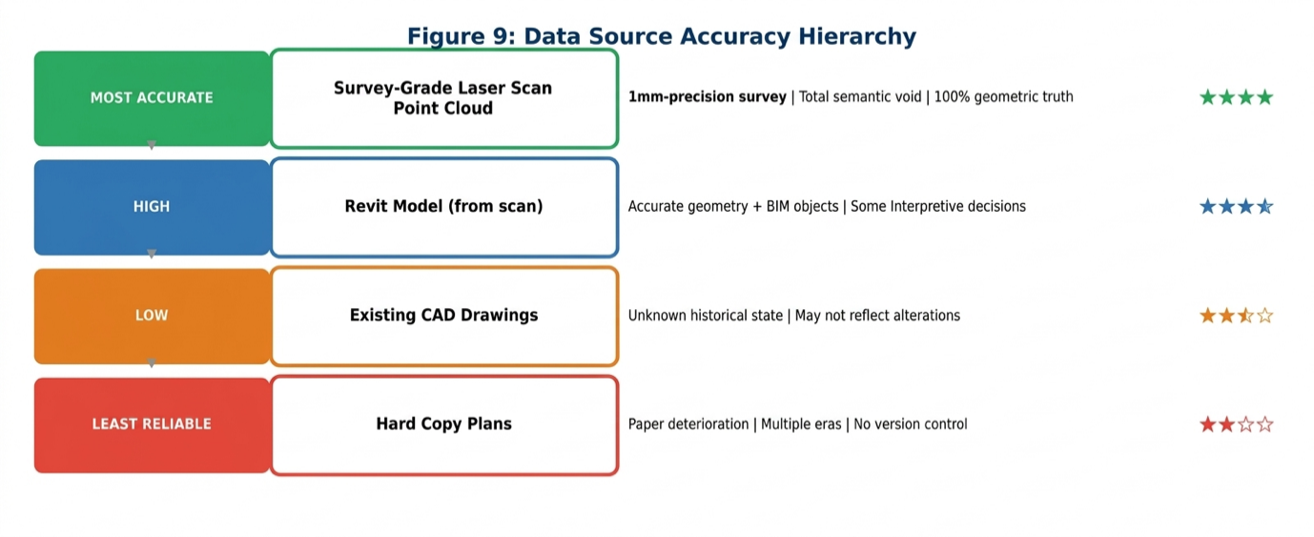
Figure 10: Data source accuracy hierarchy for the Dylan Thomas Centre

3.6 Resolution: How Could This Be Addressed at the Dylan Thomas Centre?
Identifying inaccuracies is useful, but the module lecturer’s feedback made the point clearly: it is one thing to say the data is wrong, but how could it actually be fixed at the DTC? That means being realistic about what is straightforward, what is harder, and what the specific constraints of this building allow.
What is straightforward: The geometric errors can be corrected by updating the Revit model to match the scan – the data already exists. Wall positions, room boundaries, openings, and floor areas can be remodelled to reflect scanned reality, and the outdated CAD plans formally retired. This desktop exercise is the single highest-impact, lowest-cost fix available.
What is moderately challenging: Getting non-geometric data into the model – wall composition, structural condition, material properties – means physically investigating a 200-year-old building where none of this is documented. Listed status complicates intrusive testing, requiring Cadw consent under the Planning (Listed Buildings and Conservation Areas) Act 1990. Non-intrusive methods like thermal imaging are more practical but give indicators rather than definitive answers.
What is genuinely difficult: A fully data-rich model is a long-term goal. The governance, investment, and training barriers identified in the FM evaluation (section 2.4) apply equally to digital infrastructure.
The practical path forward: Follow the UWE “digital recipe” model: start with geometry correction, use Revizto’s issue tracking to maintain a live register of what is confirmed versus what needs investigating, and enrich the model incrementally every time the FM team visits site. Figure 11 maps this phased pathway.
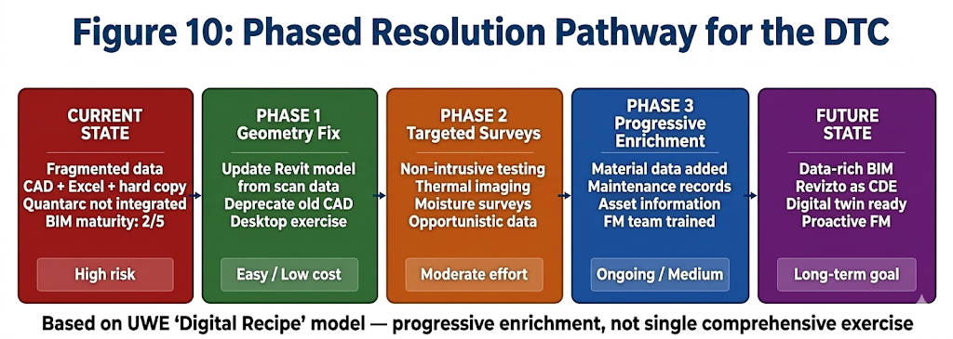
Figure 11: Phased resolution pathway from current fragmented data to data-rich BIM

4. Theme C – Sustainability Measures and New Technologies

4.1 Context and Relevance to the Dylan Thomas Centre
For the specialist area required by the brief, this section focuses on Sustainability Measures and New Technologies. Given the constraints identified in the earlier themes – listed status, shared lease, unreliable data – this section establishes a practical retrofit strategy.
In the absence of measured data, this section assumes worst-case U-values benchmarked against Approved Document L Wales targets, then forms a Short, Medium, and Long-Term strategy starting with the cheapest measures. All of it depends on the accurate data established in the earlier themes. The approach follows the fabric first principle set out in PAS 2038 (BSI, 2021): address the building envelope first, then improve the M&E systems, and only then consider renewables. The Welsh Government’s Better Homes, Better Wales, Better Buildings strategy (Welsh Government, 2020) reinforces this hierarchy at national policy level. The first assignment in this module used PAS 2035 (BSI, 2019b) for domestic retrofit; those same principles apply here but at a larger and more constrained scale, since the DTC is subject to the Planning (Listed Buildings and Conservation Areas) Act 1990 and any works affecting its character require listed building consent from Cadw.

4.2 Worst-Case Thermal Performance (Approved Document L Wales)
Since there is no intrusive survey data for the DTC, worst-case U-values have been assumed based on the building’s age and construction type and compared against the new-build targets in Approved Document L Wales (Volume 2, Welsh Government, 2022). Given the building’s solid masonry walls, original single-glazed timber windows, and what is almost certainly an uninsulated roof, Table 3 sets out these worst-case assumptions:
Building Element | Worst-Case U-value (W/m²K) | AD L Wales Target for New Build | Performance Gap
External walls (solid masonry, uninsulated) | 2.10 | 0.18 | Approx. 11.7x worse
Windows (single glazed, timber frame) | 4.80 | 1.40 | Approx. 3.4x worse
Roof (uninsulated pitched) | 2.30 | 0.13 | Approx. 17.7x worse
Ground floor (suspended timber, uninsulated) | 1.20 | 0.15 | Approx. 8x worse

The roof is the standout at nearly 18 times below modern standards. Because the BIM model has correct geometry from the scan, calculations using these U-values are based on accurate areas and volumes – not the flawed CAD data that Theme B exposed. The DTC would almost certainly sit at EPC rating F or G. With the Welsh Government’s public sector net-zero target of 2030 (Welsh Government, 2021), even modest improvements tracked through the BIM model would represent significant progress.

4.3 Short-Term Strategy: Easy Wins (0–12 Months)
The PAS 2038 retrofit optimisation matrix (Figure D1) confirms that airtightness and controls measures can proceed independently, while insulation and heating upgrades need coordination. The short-term measures cost very little, need no consent, and could start immediately:
Draught-proofing: Sealing gaps around windows, doors, pipe runs, and floor junctions is cheap, quick, and needs no heritage consent.
How BIM enables this: Using the Revizto model, each door, window, and external opening can be tagged with an issue stamp identifying it for treatment, which generates a prioritised works schedule directly from the digital model rather than from a manual walkthrough.
Heating controls optimisation: Air conditioning left running throughout holiday periods in unoccupied rooms wastes significant energy. Reviewing schedules, adjusting thermostats, and correcting timers costs next to nothing.
How BIM enables this: The BIM model makes this spatial: overlaying the Energy Team’s occupancy sensor data onto the 3D model immediately reveals which rooms are conditioned while empty, something a spreadsheet of meter readings cannot show.
LED lighting upgrade: LED lighting is a straightforward swap with quick payback. No consent needed for internal fittings.

4.4 Medium-Term Strategy: Fabric and Systems Improvement (1–3 Years)
These take more planning, more money, and sometimes listed building consent. They are also where BIM coordination pays for itself:
Secondary glazing: A glazed panel fitted inside each existing window leaves the originals untouched externally. U-values drop from around 4.8 to 1.8–2.0 W/m²K – a meaningful improvement for minimal visual impact.
Internal wall insulation (selective): In modernised rooms with no heritage-sensitive surfaces, internal insulation is feasible. The main risk is interstitial condensation: insulating internally makes the wall behind colder, causing moisture to condense on the masonry. For heritage buildings like the DTC, where lime mortar and lime plaster rely on breathability, impermeable modern materials can trap moisture and accelerate decay. A vapour control layer and room-by-room assessment of wall makeup are essential, but done properly a 50–60% cut in wall heat loss is realistic.
Roof insulation: Where the roof void is accessible, adding insulation at ceiling level offers one of the best returns available. It has no effect on external appearance. Given that the roof is the worst-performing element at nearly 18 times below modern standards, this should be near the top of the list.
M&E system renewal: Both FM survey respondents confirmed the M&E needs replacing – an opportunity to install an air-source heat pump (ASHP) at CoP 2.5–3.5. The BIM model’s accurate geometry ensures correct sizing, unlike calculations based on flawed CAD plans.
How BIM enables this: All of this can be coordinated through Revit and Revizto for clash detection, heritage impact review, and works sequencing.

Solar PV is worth assessing: the BIM model has the roof geometry, orientation, pitch, and shading data for an accurate feasibility study, though Cadw consent for panels on a listed roof remains a separate question. BIPV, which replaces roof slates with photovoltaic equivalents, may be more acceptable to heritage officers since it maintains the roofline (Attoye, Aoul and Hassan, 2017), subject to Cadw pre-application consultation. Smart TRVs offer room-by-room temperature control linked to occupancy sensors, directly addressing energy waste identified in module sessions. With a proper BIM model, each option can be tested against the building’s real geometry and constraints instead of being dismissed or approved based on guesswork (Khalil, Stravoravdis and Maulem, 2024). Figure 12 summarises the full Short, Medium, and Long-Term strategy.
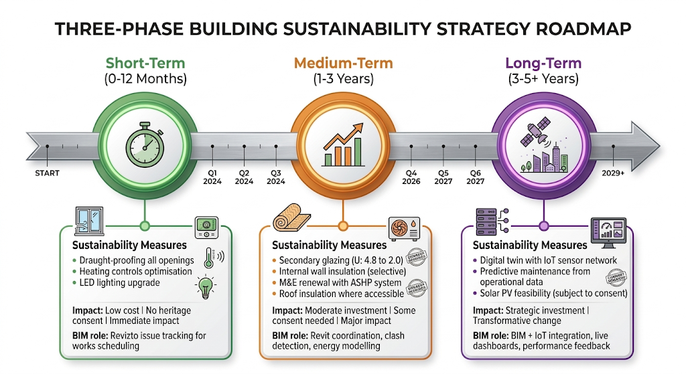
Figure 12: Short, Medium, and Long-Term sustainability strategy for the DTC

4.5 Long-Term Strategy: Smart Systems and Digital Twin (3–5+ Years)
Longer term, the focus shifts from physical fabric to intelligent management:
Digital twin integration: Connecting the BIM model to live IoT sensors for temperature, humidity, CO², occupancy, and energy creates a working digital twin. The DTC currently has occupancy sensors that do not adjust anything – a digital twin closes that gap.
Predictive maintenance: Over time, the twin spots patterns – flagging a boiler heading toward failure before it breaks, directly addressing the reactive maintenance cycle identified in the FM survey.
Performance benchmarking: Actual energy use can be compared against thermal model predictions, informing the next round of investment.
How BIM enables this: All of this needs the BIM model underneath it. Without the scan geometry, the Revizto coordination, and the analysis built on top of that, a digital twin has nothing reliable to run on (Muñoz Pavón et al., 2025).
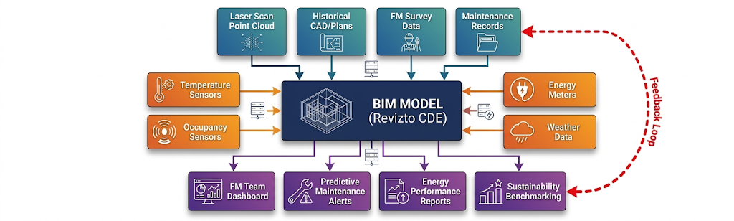
Figure 13: Digital twin architecture for the DTC

4.6 Tying the Strategy to Digital Technologies
Every measure in this strategy depends on the digital technologies covered in this case study. Without the laser scan, the Scan-to-BIM process, and Revizto, this strategy would rest on the same bad assumptions undermining current practice. Figure 14 illustrates the whole-life cycle.
Table 4 summarises how each digital technology supports each phase of the sustainability strategy:
Strategy Phase | Digital Technology | How It Supports
Short-Term (Easy Wins) | Revizto issue tracking | Tag all draught-proofing locations; create works schedule from model
Short-Term | BIM model + sensor overlay | Spatial analysis of occupancy vs. conditioning to identify waste
Medium-Term | Revit + Revizto coordination | Design retrofit interventions; clash detection; heritage impact review
Medium-Term | Energy analysis (Revit Insight/IES VE) | Size ASHP correctly using accurate geometry; model PV feasibility
Long-Term | Digital twin (BIM + IoT) | Real-time monitoring, predictive maintenance, performance benchmarking
All Phases | Laser scan / Point cloud | Foundation of all accurate geometry; the starting point for everything

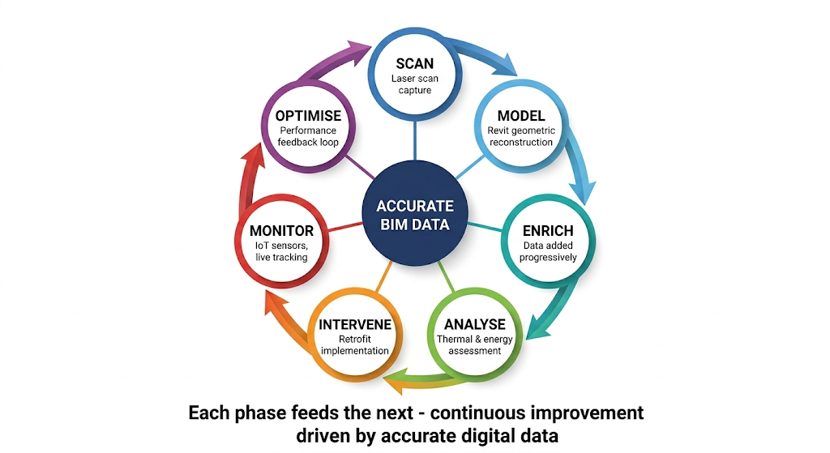
Figure 14: Whole-life BIM sustainability cycle: Scan → Model → Analyse → Intervene → Monitor → Optimise

5. Conclusions and Recommendations
The question this case study asked was whether BIM can work as a whole-life management tool for a building like the DTC. The answer is yes, but it takes time, and it only works if you are honest about the constraints.
Theme A established that creating a data-rich model for an existing building is slow, iterative, and full of gaps, with a BIM maturity score of just 2 out of 5.
Theme B proved real geometric errors in the FM team’s drawn records and proposed a phased resolution: correct the geometry first from existing scan data, then enrich gradually through the “digital recipe” approach.
Theme C demonstrated that reliable data unlocks a practical sustainability strategy: from quick wins requiring no consent, through medium-term fabric and systems improvement, to a long-term digital twin for predictive management.
Recommendations for UWTSD:
- Adopt a phased “digital recipe” approach, starting with geometry correction using existing scan data as the highest-impact, lowest-cost first step.
- Establish Revizto as the central CDE for the DTC, replacing the current fragmented approach across Quantarc, Excel, CAD, and hard copy systems.
- Implement the Short-Term easy wins immediately – draught-proofing, controls review, LED upgrade – using the BIM model to generate works schedules.
- Plan the Medium-Term M&E renewal as a strategic decarbonisation opportunity (ASHP), using BIM-accurate geometry to correctly size replacement systems.
- Commission a non-intrusive thermal survey to validate worst-case U-value assumptions and refine the fabric improvement programme.
- Invest in FM team BIM training and negotiate clarity on the DTC lease with Swansea Council to remove the barriers preventing improvement.

Reference List
Antonopoulou, S. and Bryan, P. (2017) BIM for Heritage: Developing a Historic Building Information Model. Swindon: Historic England.
Attoye, D.E., Aoul, K.A.T. and Hassan, A. (2017) ‘A review on building integrated photovoltaic façade customization potentials’, Sustainability, 9(12), p.2287.
BIMForum (2023) Level of Development (LOD) Specification Part I and Commentary. Available at: https://bimforum.org/lod (Accessed: 15 January 2026).
BSI (2019a) BS EN ISO 19650-1:2018. Organization and digitization of information about buildings and civil engineering works. London: British Standards Institution.
BSI (2019b) PAS 2035:2019 Retrofitting dwellings for improved energy efficiency. Specification and guidance. London: British Standards Institution.
BSI (2021) PAS 2038:2021 Retrofitting non-domestic buildings for improved energy efficiency. Specification. London: British Standards Institution.
Croce, V. et al. (2024) ‘A HBIM pipeline for the conservation of large-scale architectural heritage: the city Walls of Pisa’, Heritage Science, 12, p.31.
Johansson, T. et al. (2024) ‘Showcasing a digital twin for higher educational buildings’, Frontiers in Built Environment, 10, p.1347451.
Khalil, A., Stravoravdis, S. and Maulem, M. (2024) ‘HBIM for heritage conservation: Framework of challenges, gaps, and existing limitations’, Developments in the Built Environment, 19, p.100511.
Muñoz Pavón, R. et al. (2025) ‘BIM-based Digital Twin development for university campus management’, Expert Systems with Applications, 262, p.125696.
Patacas, J. et al. (2020) ‘BIM for facilities management: evaluating BIM standards in asset register creation and service life planning’, Journal of Information Technology in Construction, 25, pp.313–331.
Planning (Listed Buildings and Conservation Areas) Act 1990. London: HMSO.
Sacks, R. et al. (2018) BIM Handbook. 3rd edn. Hoboken: Wiley.
Stride Treglown (2023) Bristol Business School, UWE Bristol. Available at: https://stridetreglown.com/projects/bristol-business-school/ (Accessed: 10 January 2026).
Volk, R., Stengel, J. and Schultmann, F. (2014) ‘BIM for existing buildings – Literature review and future needs’, Automation in Construction, 38, pp.109–127.
Wang, Q., Kim, M.K. and Love, P.E.D. (2019) ‘Scan planning for existing buildings without BIM’, Automation in Construction, 103, pp.6–16.
Welsh Government (2020) Better Homes, Better Wales, Better World: Decarbonising existing homes in Wales. Cardiff: Welsh Government.
Welsh Government (2021) Net Zero Wales Carbon Budget 2 (2021–2025). Cardiff: Welsh Government.
Welsh Government (2022) Approved Document L, Volume 2: Buildings Other Than Dwellings – Conservation of Fuel and Power. Cardiff: Welsh Government.

Appendix A: FM Survey Responses
Table 2: FM survey comparison table: Energy Team vs Projects/Maintenance
Survey Question | Respondent A (Energy Team) | Respondent B (Projects/Maintenance)
Digital tools used | Energy portals, sub-metering, billing metadata, AI trend modelling | AutoCAD, SketchUp, Revit occasionally; not set up for BIM
CAFM system | University CAFM; not all spaces fully integrated | Quantarc linked to Excel-based building databases
BIM maturity (1–5) | 3 | 1
Data sources for DTC | CAFM, CAD plans, building sensors, gas/electric metering | CAFM, hard copy plans, CAD, asset tags, O&M manuals, visual surveys, BMS, sensors
Energy monitoring | HH reporting, supplier portals, AI trend modelling | Yes (unspecified method)
DTC different from estate | Sub-metering planned for expansion | Yes – age, mixed usage, Swansea Council shared management
Main challenges | Dated systems, shared ownership of space | Poor condition, M&E needs renewal, lease = reluctance to invest

