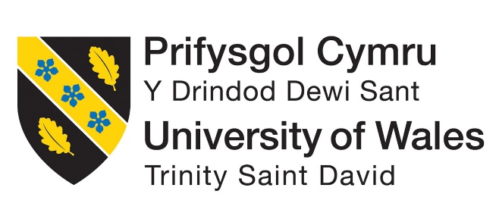

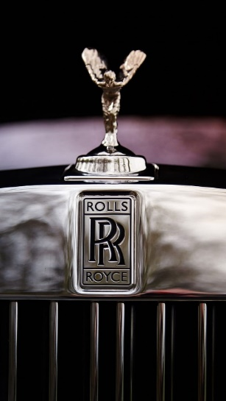

ROLLS ROYCE
International Marketing Assignment
NAME : SANDEEP DAMMALAPATI
STUDENT ID : 2214841
NAME OF LECTURER : TUSHARA BALENDRAN
MODULE NAME : INTERNATIONAL MARKETING
MODULE CODE : LCM7006
ASSIGNMENT TITLE : ASSIGNMENT

CONTENTS
Introduction………………………………………………………………………...2
Company Background……………………………………………………………...2
Analysis of Rolls Royce Macro Environment……………………………………...4
PESTEL Factors……………………………………………………………………4
HOFSTEDE Module of cultural Dimension……………………………………….7
Country Comparison Saudi Arabia and United Kingdom………………………….7
Analysis of Industry Attractiveness for Rolls Royce in Saudi Arabia and UK markets…………………………………………………………………………….10
Porter’s Five Forces……………………………………………………………….14
Benefits of Applying Porter’s Five Forces Situational Model…………………….17
SWOT Analysis Highlighting Rolls Royce Strengths, Weaknesses, Opportunities and Threats in Saudi Arabia and UK Markets…………………………………….18
Rolls Royce Marketing Mix Elements and Market Segmentation Strategies…….21
Rolls Royce Market Entry Methods………………………………………………28
Advantages and Disadvantages of Chosen Entry Methods……………………….29
Directional Development Strategy……………………………………………......31
Ansoff Matrix…………………………………………………………………......33
Recommendation………………………………………………………………….34
Conclusion………………………………………………………………………..37
References………………………………………………………………………...38

Introduction
The name Rolls-Royce is renowned in Britain and has come to represent elegance, skill, and engineering brilliance. The company was founded in 1904 by Charles Rolls and Henry Royce and has a long history. Rolls-Royce is well known for its luxurious cars and important contributions to the aerospace sector. Grant, R. M. (2019).
As the pinnacle of elegance and refinement, the term Rolls-Royce conjures feelings of grandeur and exclusivity. Each Rolls-Royce automobile is a work of art that has been painstakingly created using the best materials and attention to detail. Every Rolls-Royce has the recognizable Spirit of Ecstasy mascot on the hood, representing the grace and refinement of the brand.
Rolls-Royce's automobiles have long been highly sought after by sophisticated buyers looking for the pinnacle of luxury and performance. The brand serves an exclusive clientele that frequently includes monarchy, celebrities, and prosperous businesspeople. The experience of owning a Rolls-Royce comprises beauty, craftsmanship, and individualized luxury; it goes beyond simply owning a car. Grant, R. M. (2019).
Rolls-Royce has made great progress in the aerospace sector in addition to its automotive operation. The business is a world leader in the development, production, and upkeep of state-of-the-art engines for civil and armed forces aircraft as well as power systems for diverse uses. The aerospace sector of Rolls-Royce is well known for its engineering breakthroughs, dependability, and innovation.
Rolls-Royce provides a wide range of international markets thanks to its global presence. The company's authorized dealerships and showrooms can be found in strategic places around the world, meeting the needs of wealthy clients who value the unmatched performance and timeless beauty that Rolls-Royce represents.
Rolls-Royce has recently embraced environmental responsibility and sustainability. To mix luxury with a better future, the firm has been actively exploring hybrid and electric powertrain systems for its automobiles. This attention to sustainability exemplifies Rolls-Royce's commitment to satisfying changing customer demands while guaranteeing a more sustainable future.

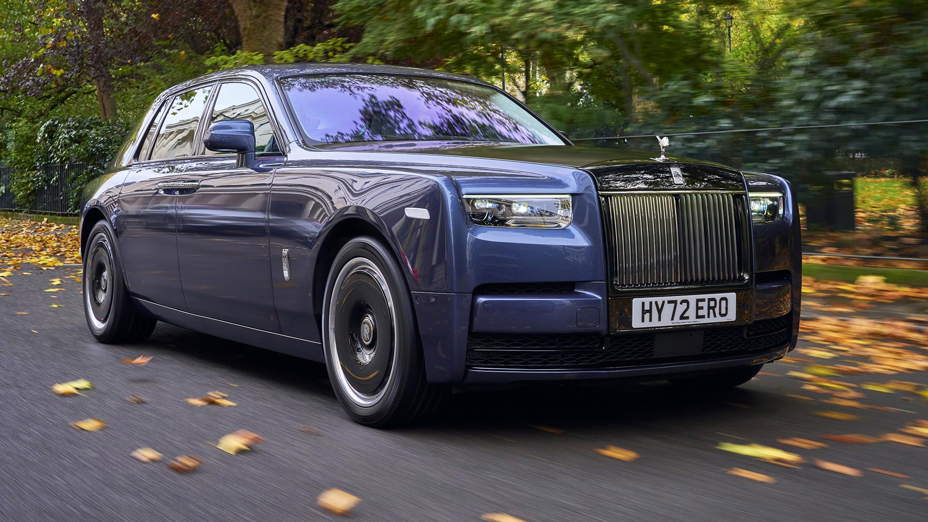
Company Background
Formation and Early Years:
Charles Rolls and Henry Royce's relationship resulted in the creation of Rolls-Royce Limited in 1906. Henry Royce was a talented engineer who was renowned for his attention to detail and high-quality engineering, whereas Charles Rolls was a wealthy automobile enthusiast and a successful car dealer. The alliance sought to produce the greatest luxury vehicles on the market.
The Silver Ghost Era:
The Rolls-Royce Silver Ghost, which would go on to become one of the most recognizable and significant automobiles in history, was first presented in 1906. The Silver Ghost established Rolls-Royce as the apex of automotive luxury thanks to its remarkable dependability, smoothness, and opulent styling. Hill, C. W., & Jones, G. R. (2020).
Rolls-Royce and World War I:
Rolls-Royce turned its emphasis to the manufacturing of aircraft engines during World War I. The company was able to provide strong and dependable engines that were essential to the war effort thanks to its competence in engineering and precision manufacture. The growth of Rolls-Royce into the aircraft sector began with this.
The Phantom Series:
The Phantom I, II, III, IV, V, VI, and the current eighth-generation Phantom were all introduced by Rolls-Royce in the 1920s. These high-end vehicles displayed state-of-the-art engineering, superb craftsmanship, and unique customization choices, enhancing Rolls-Royce's position as the pinnacle of automotive luxury. Hill, C. W., & Jones, G. R. (2020).
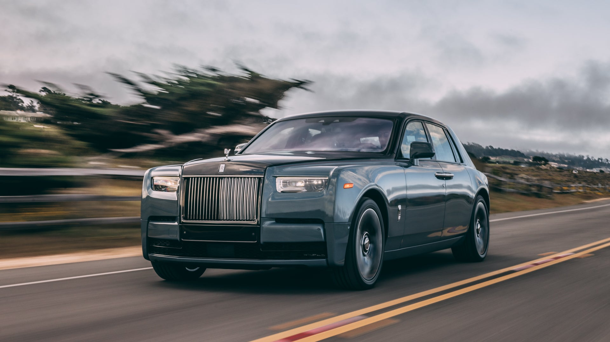
Rolls-Royce and World War II:
Once again, during World War II, Rolls-Royce was essential to wartime production. The organization created the Merlin engines that propelled enduring aircraft like the Spitfire and the Lancaster bomber. The effectiveness and dependability of the Merlin engine were essential to the victory of the Allied forces.
Rolls-Royce and Aerospace:
Rolls-Royce increased its aircraft industry influence in the years following World War II. The business created jet engines, such as the well-known RB211, which propelled commercial aircraft like the Boeing 747. For both commercial and military applications, Rolls-Royce is a prominent supplier of aircraft engines, propulsion systems, and services today.
Ownership Changes:
Over the years, Rolls-Royce's ownership changed multiple times. The aerospace and automotive divisions were split off in 1971, with the automobile section becoming Rolls-Royce Motors. While the automotive branch of Rolls-Royce established a separate business known as Rolls-Royce plc in 1998, the aerospace division was licensed to the BMW Group.
Modern Rolls-Royce:
Rolls-Royce started a new phase of development and innovation when owned by BMW. To meet the changing needs of luxury automobile aficionados around the world, the brand expanded its product selection and launched models including the Phantom, Ghost, Wraith, Dawn, and Cullinan. These models continue to represent what Rolls-Royce is all about: fine workmanship, luxurious extravagance, and cutting-edge technology.
Analysis of Rolls Royce Macro Environment
In a macro environment analysis, external variables that may have an impact on a company's operations, plans, and general performance are looked at (Grant, R. M. 2019). The macro environment for Rolls-Royce, which serves the luxury auto and aerospace sectors, consists of a few economic, social, technological, political, and environmental elements.
PESTEL FACTORS for Rolls Royce
Political:
UK
- Rolls-Royce's business and investments in the UK may be impacted by political stability and government policy.
- The regulatory environment in the UK, which includes the tax laws and trade agreements, may influence the business's financial success. Rolls-Royce. (n.d.).
Saudi Arabia
- Saudi Arabia's political climate and government policies may have an impact on the company's operations and investments.
The Saudi government's backing of local manufacturing and the car sector may have an impact on the company's market share. Rolls-Royce. (n.d.).
Economic:
UK
- The sales and profitability of Rolls-Royce in the UK can be impacted by economic factors including GDP growth, inflation rates, and interest rates.
- Changes in exchange rates may influence the company's export/import costs and competitiveness.
Saudi Arabia
- Demand for luxury vehicles and Rolls-Royce sales may be impacted by Saudi Arabia's economic conditions, particularly oil prices and GDP growth.
- The company's export/import costs may be impacted by currency exchange rates.

Social:
UK
- The demand for luxury vehicles like Rolls-Royce cars may be influenced by consumer tastes and lifestyle trends in the UK.
- The reputation of Rolls-Royce as a luxury brand may be impacted by environmental awareness and interest in sustainable products. Rolls-Royce. (n.d.).
Saudi Arabia
- The market positioning of Rolls-Royce in Saudi Arabia may be influenced by cultural preferences and social attitudes towards luxury goods and vehicles.
- Sales of luxury vehicles may be influenced by the expanding middle- and upper-class populations. Rolls-Royce. (n.d.).
HOFSTEDE Module of cultural Dimension
Hofstede's Cultural Dimensions theory sheds light on how various areas of work and social life are valued across cultures and countries Hill, (C. W., & Jones, G. R. 2020). According to the idea, there are six factors that may be used to better comprehend cultural differences and how they affect businesses like Rolls-Royce.
Country Comparison Saudi Arabia and United Kingdom
- Let's compare the cultural variances between Saudi Arabia and the United Kingdom using Hofstede's Cultural Dimensions theory, specifically regarding Rolls-Royce's operations in these nations:
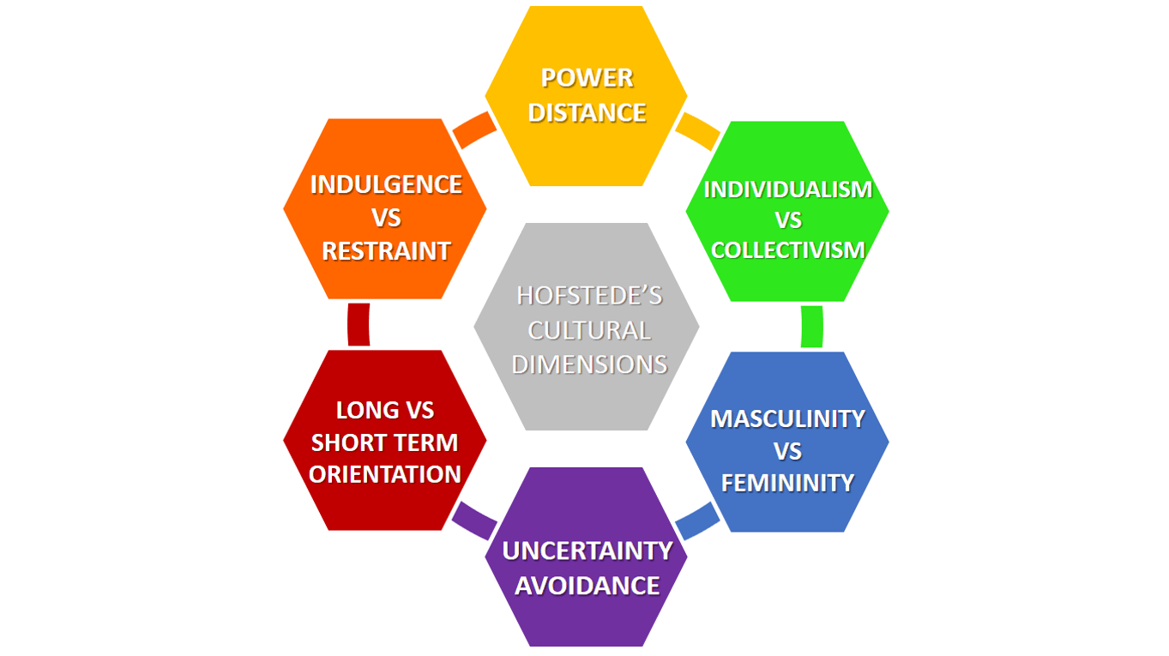
(Source: Business-to-you.com)

Power Distance (PDI):
- Saudi Arabia: Saudi Arabian society has a propensity for having a large power distance, which indicates that hierarchical institutions and authority are widely accepted. Employees should respect those in positions of authority inside the company and demand clear direction from their superiors. Rolls-Royce. (n.d.).
- United Kingdom: When compared to Saudi Arabia, the UK has a smaller power distance. In the UK, workers frequently feel more at ease challenging authority and taking part in decision-making. Rolls-Royce. (n.d.).
Individualism (IDV):
- Saudi Arabia: The culture in Saudi Arabia is more collectivist, emphasizing close family ties and communal peace. Loyalty to the company and the team is highly regarded at work. Rolls-Royce. (n.d.).
- United Kingdom: The UK is regarded as being more individualistic, emphasizing personal accomplishments and contributions. Employees may put their own objectives and recognition first. Rolls-Royce. (n.d.).
Masculinity (MAS):
- Saudi Arabia: Saudi society values aggressiveness, ambition, and material achievement and tends to exhibit higher levels of masculinity. Competition and success at work may serve as powerful motivators. Rolls-Royce. (n.d.).
- United Kingdom: The UK likewise demonstrates a higher level of masculinity, emphasizing achievement, success, and rivalry. But there is also a rising focus on finding a work-life balance and appreciating the value of wellbeing. Rolls-Royce. (n.d.).
Uncertainty Avoidance (UAI):
- Saudi Arabia: The cultural desire for organized environments and adherence to accepted norms can be attributed to the comparatively high uncertainty avoidance in Saudi culture. Clear regulations and guidelines may be preferred by employees. Rolls-Royce. (n.d.).
- United Kingdom: The UK has lower uncertainty avoidance, which leads to higher ambiguity tolerance and a more adaptable approach to change and innovation.
Long-Term Orientation (LTO):
- Saudi Arabia: Saudi culture emphasizes tradition, patience, and perseverance to accomplish long-term goals. Employees might be more inclined to invest in sustainable strategies and more future-focused. Rolls-Royce. (n.d.).
- United Kingdom: The UK has a long-term orientation as well, emphasizing future planning and striking a balance between short-term outcomes and long-term goals.
Indulgence (IND):
- Saudi Arabia: Saudi culture leans towards moderation and emphasizes the need to meet fundamental necessities while avoiding extravagance. Employees might take a more frugal attitude to consumption and spending. Rolls-Royce. (n.d.).
- United Kingdom: The UK has a propensity for more indulgence, which promotes more freedom for personal expression, enjoyment, and leisure pursuits.
Advantages of Hofstede Model for Rolls-Royce:
- Cultural Awareness: Rolls-Royce can learn more about the cultural norms and values of its Saudi Arabian and UK stakeholders through the Hofstede model. (Rolls-Royce. n.d.).
- Adaptation of Management Style: Rolls-Royce may tailor its management and leadership practices to meet the tastes and expectations of employees in each country by understanding cultural variances.
- Market segmentation: The approach aids in dividing markets into groups based on cultural attributes, enabling Rolls-Royce to create focused marketing plans that are adapted to the particulars of each nation. (Rolls-Royce. n.d.).
- HR Practices: The model helps in developing human resource practices and policies that are compatible with the cultural norms and work ethics that are widespread in Saudi Arabia and the UK.
- Negotiation and Communication: To successfully negotiate and communicate with local partners, suppliers, and government authorities, Rolls-Royce needs to be aware of cultural variations. (Rolls-Royce. n.d.).

Disadvantages of Hofstede Model for Rolls-Royce:
- Stereotyping: By neglecting unique and regional variations within a nation, the application of cultural aspects may result in oversimplification and stereotyping.
- Cultural Evolution: Cultures are dynamic and change throughout time. Although the Hofstede model offers a snapshot of cultural traits, these traits can alter as societies advance. (Rolls-Royce. n.d.).
- Incomplete Picture: The model does not consider additional variables that can affect behavior, such as the historical setting, religion, or business practices.
- Lack of Precision: The Hofstede model gives a general understanding of cultural variations, but it does not give exact instructions on how to proceed with business issues.
- Applicability to Individuals: Despite being helpful for analyzing national cultures, the model's applicability to people within a culture is constrained because people might have a wide range of attitudes and beliefs. (Rolls-Royce. n.d.).
Technological:
UK
- The development of Rolls-Royce's future products and competitiveness may be influenced by improvements in automotive technology and the uptake of electric vehicles.
- The technological foundation and funding for R&D in the UK may have an impact on the company's capacity for innovation.
Saudi Arabia
- The model lineup for Rolls-Royce in Saudi Arabia may change because of developments in vehicle technology and consumer preferences for characteristics.
- The infrastructure and support for electric vehicles in the nation could have an impact on the company's future business plan.
Legal:
UK
- Rolls-Royce's activities must adhere to UK and EU standards including safety, emissions, and data privacy.
- The UK's labor laws and regulations may have an impact on the company's staff management and expenses.

Saudi Arabia
- Rolls-Royce's activities must adhere to Saudi Arabia's rules and regulations regarding safety, emissions, and car importation.
- The company's market entry and business operations may be impacted by regional legal requirements and trade regulations.

Environmental:
UK
- Rolls-Royce vehicle design and production in the UK may be impacted by environmental rules and emissions standards.
- The business's initiatives to lessen its carbon footprint and adopt sustainable practices may be in line with UK environmental objectives.
Saudi Arabia
- The adoption of electric vehicles, including potential future electric offers from Rolls-Royce, may be influenced by the Saudi government's emphasis on environmental sustainability and attempts to minimize carbon emissions.

Regulatory Environment:
Saudi Arabia: Rolls-Royce must consider Saudi Arabian laws, commercial customs, and political environment. For operations to be effective, adherence to regional laws and cultural standards is necessary. (Source: Saudi Arabian General Investment Authority - sagia.gov.sa)
United Kingdom: Rolls-Royce is familiar with the regulatory landscape because it is based there. The company's activities, however, may be impacted by modifications to trade agreements, environmental legislation, and industry-specific policies. (Source: UK Government Website - gov.uk)
Technological Advancements:
Saudi Arabia: The government of Saudi Arabia is enthusiastic about investing in cutting-edge technology and innovation, which presents chances for Rolls-Royce to collaborate and increase its technological know-how in the area. (Source: Arab News - arabnews.com)
United Kingdom: The aerospace and automotive industries rely heavily on technology breakthroughs in the UK. To be competitive, Rolls-Royce must continue to lead innovation. (Source: Aerospace Manufacturing Magazine - aerospace-manufacturing.com)
Economic Conditions:
Saudi Arabia: The price of oil and other global economic issues have an impact on Saudi Arabia's economy. The level of customer confidence and the economy's stability can have an impact on Rolls-Royce's auto sales. (Source: The World Bank - data.worldbank.org)
United Kingdom: Luxury vehicle sales and aerospace investments may be impacted by the UK's economic situation. The performance of a Rolls-Royce depends on economic stability and growth. (Source: Office for National Statistics - ons.gov.uk)
Cultural and Consumer Preferences:
Saudi Arabia: To adjust its marketing and product offers to the local market, Rolls-Royce must have a thorough understanding of cultural norms and consumer preferences in Saudi Arabia. (Source: Market research and cultural studies focused on Saudi Arabia)
United Kingdom: Rolls-Royce must maintain its emphasis in the UK on elegance, craftsmanship, and fulfilling the demands of discerning customers. (Source: Luxury industry reports and consumer surveys in the UK)

Similarities and differences stated in relation to the PESTLE factors for UK and Saudi Arabia:
Political Factors:
Similarities:
- Saudi Arabia and the UK both have well-established political systems and governmental organizations.
Differences:
- Saudi Arabia is an absolute monarchy, whereas the UK is a parliamentary democracy with a constitutional monarchy.
- While Saudi Arabia's government may place more of an emphasis on economic diversification and incentives for domestic production, the UK's policies may be more concerned with environmental rules and sustainability programmers.
Economic Factors:
Similarities:
- Strong economies with considerable consumer spending power exist in both nations.
- Rolls-Royce serves wealthy clients in both areas as part of its premium automotive business.

Differences:
- Brexit and its effects on trade and investment may have an impact on economic circumstances in the UK, whereas Saudi Arabia's economy is very dependent on oil prices and government spending.
- While Saudi Arabia may have various consumer objectives and tastes, the UK's automotive market may have a higher penetration of electric vehicles and environmental considerations.
Social Factors:
Similarities:
- Saudi Arabia and the UK both have varied cultures with a wide range of cultural origins.
Differences:
- While Saudi Arabia may place a greater focus on family values and tradition, the UK's social views and values may lean more towards individuality and environmental awareness.
- While the luxury market in Saudi Arabia may be developing along with the country's expanding middle- and upper-class population, the luxury market in the UK may be more developed and established.
Technological Factors:
Similarities:
- Both nations have access to cutting-edge innovation and technology.
Differences:
- While Saudi Arabia may be investing in technology improvements connected to the oil and gas industries, the UK may have more advanced infrastructure and support for electric vehicles and renewable energy sources.
- The tastes of consumers in technology and car characteristics may vary between the two markets.

Legal Factors:
Similarities:
- Regulations governing safety, pollution, and product standards must be met by Rolls-Royce in both nations.
Differences:
- Before Brexit, the UK's legal system was affected by EU laws, but Saudi Arabia has a distinctive legal structure based on Islamic law.
- Regarding the protection of intellectual property and business practices, the legal environment may differ.
Environmental Factors:
Similarities:
- Environmental sustainability and lowering carbon emissions are becoming more and more important in both nations.
Differences:
- In comparison to Saudi Arabia, the UK may have tighter emissions requirements and laws.
- In the UK, inclinations for electric vehicles and environmental concerns may have a greater influence on customer choices.
Porter’s Five Forces for Rolls Royce
Porter's Five Forces is a framework used to analyze the competitive forces within an industry. (Porter, M. E. 2008). Let's apply Porter's Five Forces to Rolls-Royce:
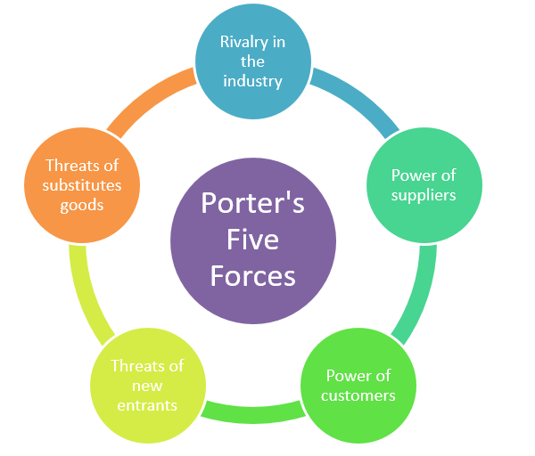
(Porter’s five forces)

Factors | Impact
Threat of New Entrants | Low
Threat of Substitutes | High
Bargaining Power of Customers | Low
Bargaining Power of Suppliers | High
Competitive Rivalry | Low
(Source: Self-developed)
Threat of New Entrants:
UK
High capital requirements: Rolls-Royce works in the aerospace and defense sector, which has high capital investment needs for manufacturing and R&D.
Strong brand identity: new competitors are deterred by Rolls-Royce's reputation for producing reliable, high-quality engines.
Regulatory approvals: new competitors may be deterred by the aircraft industry's strict certification and regulatory procedures. It is favorable.
Saudi Arabia
High entrance hurdles: The aerospace industry has similar entry difficulties to the UK, with high capital needs, complicated regulations, and well-established firms.
Limited local expertise: new entrants may be discouraged by Saudi Arabia's potential lack of local aerospace manufacturing competence. It is favorable.
Bargaining Power of Suppliers:
UK
Engine components: For a variety of engine components, Rolls-Royce depends on a network of suppliers. The corporation may have considerable negotiating strength due to its size and reputation, but supplier dependence may be a problem. It is Unfavorable.

Saudi Arabia
Global supply chain: Because the aircraft supply chain is international, Rolls-Royce's suppliers might have a lot of negotiating leverage. It is Unfavorable.
Bargaining Power of Customers:
UK
Customers who fly commercially: Because of the volume of their purchases and how crucial engines are to their business, airlines may have a significant amount of bargaining leverage.
Long-term collaborations: Given that switching to a different engine supplier could be expensive and disruptive, Rolls-Royce's long-term ties with major airlines may help to reduce some of the buying power. It is Favorable.
Saudi Arabia
Government contracts: The Saudi government, as a significant customer, may be able to obtain favorable terms from Rolls-Royce when negotiating for defense and aerospace contracts.
Threat of Substitute Products or Services:
UK
There are few alternatives for aircraft engines in the aerospace sector, particularly for big commercial aircraft. This somewhat lessens the threat of substitutes. It is Unfavorable.
Saudi Arabia
Like the UK, the aerospace sector has few alternatives for aircraft engines, especially for defense and military applications. It is Unfavorable.
Competitive Rivalry:
UK
There is fierce competition for Rolls-Royce from other significant engine producers like Pratt & Whitney and General Electric. The competition is fierce and is fueled by improvements in technology, performance, and cost.
High exit barriers: The aerospace sector invests much in manufacturing, research, and development. Significant losses could come from leaving the sector. It is favorable.

Saudi Arabia
Rising demand: Saudi Arabia's strategic emphasis on the growth of the defense and aerospace industries may result in rising demand for engines from companies like Rolls-Royce. The competition from other international players is still a concern, though. It is favorable.

Similarities and differences of Porter’s five forces for Rolls Royce in UK and Saudi Arabia:
Similarities:
Threat of New Entrants:
High entry barriers in the automotive and aerospace sectors exist in both the UK and Saudi Arabia, reducing the threat posed by new competitors. There are strong entrance obstacles due to high capital requirements, cutting-edge technology, and well-established brand identities.
Bargaining Power of Suppliers:
Suppliers of specialized parts and materials have significant negotiating leverage in both sectors. Critical components for Rolls-Royce's operations in the aerospace and automotive industries are sourced from a network of suppliers.
Bargaining Power of Customers:
Customers can haggle pricing and demand high-quality items, giving them significant bargaining power in both sectors. Luxury automobile customers, airlines, and manufacturers of aircraft can all have an impact on Rolls-Royce's pricing and terms.
Differences:
Threat of Substitutes:
UK: Due to Rolls-Royce's strong market position and reputation, the threat of replacement engines in the aircraft sector may be relatively lower.
Saudi Arabia: Consumers of luxury cars in Saudi Arabia may have access to a variety of alternatives, such as other high-end brands or alternative modes of transportation.
Competitive Rivalry:
UK: Rolls-Royce confronts stiff competition in the aerospace industry from other international engine producers including General Electric and Pratt & Whitney.
Saudi Arabia: Rolls-Royce faces off against other high-end manufacturers' models and luxury automobile brands in the automotive industry.
Regulatory Environment:
UK: International aviation authorities have severe safety and regulatory standards that are placed on the UK's aircraft industry.
Saudi Arabia: Regulatory criteria for the Saudi Arabian automotive and aerospace sectors may be different from those in the UK.
Technology and Innovation:
UK: To increase engine efficiency and meet environmental criteria, the aircraft industry needs technological improvements and creativity.
Saudi Arabia: Different technical goals may be influenced by the increased emphasis on electric vehicles and sustainable mobility options in the automobile industry.
Cultural Factors:
UK: Consumer tastes and cultural variables may have an impact on the demand for luxury vehicles there.
Saudi Arabia: Cultural values and preferences there could have a special impact on the demand for luxury cars and consumer behavior.

Benefits of Applying Porter’s Five Forces Situational Model for Rolls Royce
Applying Porter's Five Forces situational model to Rolls-Royce offers several benefits that can guide the company's strategic decision-making process. Here are some of the key benefits along with references supporting their significance:
Industry Analysis and Understanding:
Rolls-Royce benefits from a thorough understanding of the aerospace and luxury automotive industries in which it competes thanks to Porter's Five Forces. Businesses can evaluate market structure, competitive dynamics, and important factors influencing the industry by looking at the five forces. (Porter, M. E. 1979)
Competitive Positioning:
The model helps Rolls-Royce assess how competitive the aerospace and luxury automobile markets are. It is possible for a corporation to discover areas where it may capitalize on its strengths and rectify potential weaknesses by having a thorough understanding of the level of competition, supplier power, and buyer power. (Porter, M. E. 1980).
Identifying Threats and Opportunities:
Rolls-Royce can detect possible risks to its profitability and market share using Porter's Five Forces, such as new competitors, replacement products, and changing consumer preferences. It also aids in the company's recognition of opportunities brought forth by weak competition forces or developing trends. (Porter, M. E. 2008).
Strategic Decision Making:
Rolls-Royce can make well-informed strategic decisions by utilizing Porter's Five Forces. The analysis's learnings can direct the business' market entry, growth, diversification, and resource allocation strategies. (Porter, M. E. 1996).
Risk Assessment:
The model can be used by Rolls-Royce to evaluate the risks related to its business operations in the aerospace and luxury car sectors. It is easier for the business to recognize possible risks and create risk management strategies when it is aware of the negotiating power of suppliers and buyers as well as competitive rivalry. (Porter, M. E. 1979).
Resource Allocation:
The model aids Rolls-Royce in efficiently allocating its resources. The business can concentrate its resources on areas with more growth potential and profitability by determining the most appealing markets within the aerospace and luxury vehicle industries. (Porter, M. E. 1987).

SWOT Analysis Highlighting Rolls Royce in Saudi Arabia and UK Markets
Strengths | Weaknesses
- Brand Reputation: A major factor in Rolls-Royce's market dominance in Saudi Arabia and the UK is its strong brand image, which is known for luxury, craftsmanship, and engineering brilliance (Source: The Times).  - Diverse Product Portfolio: The company's wide range of products, which includes high-performance aviation engines and opulent automobiles, enables it to serve a variety of market segments (Source: Rolls-Royce Official Website).  - Innovation and Technology: Rolls-Royce has a competitive advantage in both sectors thanks to its emphasis on research and development, which enables it to deliver cutting-edge goods with cutting-edge technologies (Source: Rolls-Royce Motor Cars).  - Global Presence: The business can effectively serve consumers in Saudi Arabia and the UK and take advantage of worldwide demand thanks to its established global footprint (Source: Financial Times).  - Strong Partnerships: Rolls-Royce's market position and customer reach are improved via its strategic alliances with airlines, car dealerships, and other industry participants. | - Cost Structure: Luxury cars and aviation engines may have higher production costs as a result, which could limit market penetration in price-sensitive areas (Source: CNBC).  - Environmental Concerns: The environmental effect of luxury cars and high-performance engines could make it difficult to adhere to sustainability standards and laws.  - Dependence on Specific Markets: Rolls-Royce is highly dependent on the aviation sector and the sale of luxury vehicles, making it vulnerable to changes in both industries in Saudi Arabia and the UK (Source: The Telegraph).  - Complex Supply Chain: Production and delivery schedules in both areas may be impacted by delays in the company's global supply chain for materials and components (Source: BBC News).
Opportunities | Threats
- Growing Aviation Sector in Saudi Arabia: Saudi Arabia's growing aviation industry offers Rolls-Royce the chance to supply aircraft engines to regional airlines (Source: Forbes).  - Luxury Market Growth in the UK: Rolls-Royce's luxury car segment has development potential due to the rising wealth and demand for luxury goods in the UK.  - Sustainable Initiatives: Investments in environmentally friendly goods and sustainable technologies can help a business comply with changing environmental requirements and win over customers in both markets who care about the environment (Source: Bloomberg).  - Digital Transformation: For Rolls-Royce in Saudi Arabia and the UK, embracing digital technologies may improve operational effectiveness, customer experience, and product innovation (Source: The Guardian). | - Intense Competition: In the Saudi Arabian and UK markets, Rolls-Royce faces intense rivalry from other producers of high-end automobiles and suppliers of aerospace engines (Source: Financial Times).  - Economic Volatility: Consumer spending and the demand for high-end luxury goods can be affected by economic changes and global market uncertainty, which can have an impact on Rolls-Royce's performance in both markets (Source: The Wall Street Journal).  - Regulatory Changes: Regulations relating to emissions, safety standards, and trade policies may change, posing difficulties and raising Rolls-Royce's compliance expenses in both markets (Source: Financial Times).  - Pandemic Impact: The ongoing COVID-19 epidemic has impacted the tourism and aviation sectors, harming luxury automobile sales in Saudi Arabia and the UK as well as aircraft engine demand.

Similarities and differences of SWOT Analysis for Rolls Royce in UK and Saudi Arabia:
Similarities:
Strengths:
Brand Reputation: In both the UK and Saudi Arabia, Rolls-Royce has a strong and distinguished brand reputation, which helps it maintain a premium position in the aerospace and luxury car industries.
Technology Expertise: Rolls-Royce's engineering prowess and technological know-how are respected in both markets, enabling the business to create cutting-edge goods and services.
Weaknesses:
High-Cost Structure: The company's high costs may be a drawback in both markets, particularly in the fiercely competitive aerospace and luxury vehicle industries.
Dependence on External Suppliers: In both markets, Rolls-Royce may face difficulties due to its reliance on external suppliers for specialized components, as supplier interruptions might affect the business' operations.

Differences:
Opportunities:
UK:
Growing Demand for Sustainable Aviation: Rolls-Royce has the chance to profit from the rising demand for sustainable aviation solutions in the UK, such as more fuel-efficient engines and alternative propulsion systems.
Advancements in Electric Vehicles: Rolls-Royce could investigate potential in the UK automotive market involving electric car technology and eco-friendly transportation options.
Saudi Arabia:
Infrastructure Development: The government's emphasis on infrastructure development in Saudi Arabia offers potential for Rolls-Royce's aerospace division to supply engines and assistance for the aviation industry.
Luxury Car Market Growth: The expanding wealth in Saudi Arabia offers potential for the luxury car division of Rolls-Royce to target high-net-worth customers looking for high-end vehicles.

Threats:
UK:
Brexit Impact: Rolls-Royce's activities in the UK could be threatened by the uncertainty surrounding Brexit and its possible effects on trade and regulations.
Competition from Rival Brands: Other high-end luxury automobile companies are a danger in the UK's competitive luxury automotive market.
Saudi Arabia:
Economic Dependency on Oil: Due to Saudi Arabia's reliance on oil money, the automotive sector may be at risk in the case of changes in the price of crude.
Geopolitical Risks: The geopolitical environment in the region might lead to ambiguity and potential concerns for Saudi Arabian corporate operations.

Rolls Royce Marketing Mix Elements and Market Segmentation Strategies
Segmentation
Market Segmentation strategy
Rolls-Royce uses a variety of segmentation techniques to target niche markets that are compatible with the brand's ideals and product offers. (McDonald, P. 2020). The company's segmentation strategy is centered on locating and comprehending the distinctive traits and preferences of potential clients in both the aerospace and luxury vehicle industries.
Demographic Segmentation:
High-net-worth individuals and wealthy clients who have the means to purchase opulent cars and private aircraft are the customers that Rolls-Royce caters to. Celebrities, corporate moguls, and other high-profile people who want to use luxury goods to display their prosperity and social standing are drawn to the brand.
Geographic Segmentation:
The company focuses on regions with a sizable wealthy population and a high demand for luxury goods. This comprises important cities and areas with a sizable number of high-net-worth people, including urban centers in the Middle East (particularly Saudi Arabia) and the UK, as well as other world luxury hotspots.

Targeting
Rolls-Royce uses a specialized targeting approach to target a certain area of the premium automotive and aviation sectors. High-net-worth individuals, wealthy clients, and aviation industry stakeholders who value elegance, workmanship, and exclusivity are the company's primary target demographics. Rolls-Royce keeps up its reputation as a sign of richness and status by catering to a small, discerning clientele.
Luxury Automobile Segment: Rich people, famous people, and businesspeople who are interested in bespoke and customized luxury cars are the target market for Rolls-Royce. Each customer's individual needs and wants are catered to produce a premium car that is unique to them and reflects their tastes and personality.
Aerospace Segment: Rolls-Royce targets business jet operators and commercial airlines in the aerospace sector who are looking for high-performance, fuel-efficient, and dependable aircraft engines. The company's engines are created to satisfy the needs of the most demanding aviation sector customers, who place a premium on effectiveness, security, and long-term value.

Positioning
In the high-end automotive and aerospace industries, Rolls-Royce portrays itself as the pinnacle of elegance, artistry, and engineering expertise. (Ward, I. 2015).
Exclusivity and Prestige: Customers get a sense of exclusivity thanks to Rolls-Royce's positioning as an elite and prestigious brand. The possession of a Rolls-Royce product is regarded as a sign of wealth and social standing.
Bespoke Customization: The company emphasizes its personalized customization possibilities, which let customers tailor their luxury vehicles to their tastes in order to create a one-of-a-kind ownership experience.
Uncompromising Quality: Rolls-Royce continues to uphold its reputation for creating items of unwavering quality. The name is synonymous with excellent engineering, close attention to detail, and painstaking craftsmanship.
Timeless Elegance: The ageless elegance of Rolls-Royce's cars and engines, which combine traditional design elements with cutting-edge technology, guarantees that their goods will always be in style.
Global Presence and Heritage: The brand appeals to a sense of tradition, dependability, and trustworthiness by leveraging its lengthy history and widespread presence.
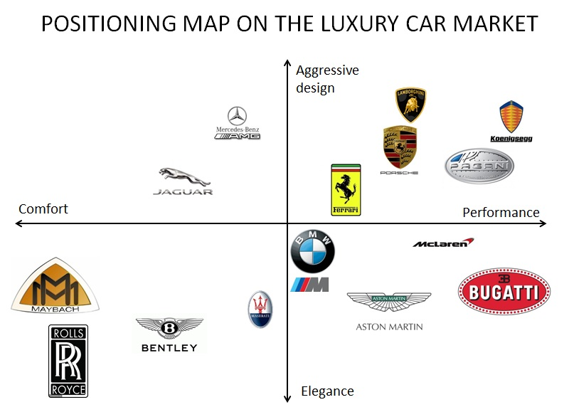
Fig: Perceptual Map of Rolls Royce
UK and Saudi Arabia should be discussed in relation to segmentation, targeting and positioning and similarities and differences stated:
Segmentation:
UK:
Demographic Segmentation: Rolls-Royce may divide the market in the UK based on demographics, focusing on wealthy people and high-net-worth clients who appreciate luxury and prestige.
Psychographic Segmentation: The business may concentrate on clients that value exclusivity, fine craftsmanship, and advanced engineering, promoting its cars as markers of success and prestige.
Geographical Segmentation: Due to increased concentrations of potential customers of luxury vehicles, major UK cities like London, Manchester, and Birmingham may be target locations.
Saudi Arabia:
Demographic Segmentation: The market in Saudi Arabia could be divided into sections based on high-income individuals, royal family members, and oil and gas executives.
Cultural Segmentation: Rolls-Royce should consider cultural preferences and variables, coordinating its marketing with regional customs and beliefs.
Geographic Segmentation: Due to their richness and significance, major cities like Riyadh, Jeddah, and Dammam may be important target regions.
Similarities in Segmentation:
- Both markets would probably place a strong emphasis on attracting wealthy customers and serving the luxury market, emphasizing the exclusivity and status that comes with owning a Rolls-Royce car.
- Both markets would benefit from psychographic characteristics like aspiration for luxury and advanced engineering.
Differences in Segmentation:
- In Saudi Arabia, cultural determinants and the importance of the royal family can be more important in the targeting approach.
- Geographically, Saudi Arabia and the UK may have different sizes and distributions of high-income consumers, which may affect the regional marketing strategies priorities.

Targeting:
UK:
- Rich people, accomplished businesspeople, and prominent celebrities looking for the ultimate in luxury driving would be the target market for Rolls-Royce.
- The business can also concentrate on the corporate clientele, offering specialized and opulent cars for executive transportation.
Saudi Arabia:
- Rich people, members of the royal family, and senior oil and gas industry executives would be the primary targets of Rolls-Royce.
- The business might potentially offer services to dignitaries and wealthy travelers to Saudi Arabia.

Similarities in Targeting:
- Both markets would endeavor to attract wealthy consumers looking for status, luxury, and handcrafted items.
Differences in Targeting:
- Given their influence and purchasing power, targeting individuals with royal ties and executives in the oil and gas business may be given more weight in Saudi Arabia.
Positioning:
UK:
- To attract consumers looking for the pinnacle of luxury, craftsmanship, and engineering expertise, Rolls-Royce would position itself as such.
- Promoting British workmanship and legacy may be appealing to UK customers.
Saudi Arabia:
- By emphasizing exclusivity and opulence, Rolls-Royce would position itself in Saudi Arabia as the wealthy elite's go-to choose for luxury vehicles.
- To adhere to Saudi Arabian principles, customization choices and cultural awareness may be emphasized.
Similarities in Positioning:
- Rolls-Royce would be positioned in both markets as a representation of exclusivity, prestige, and unmatched craftsmanship.
Differences in Positioning:
- The positioning of the brand in Saudi Arabia may be more influenced by cultural norms and ties to royalty.
- Buyers in the UK may find the emphasis on British heritage more appealing, whilst buyers in Saudi Arabia may place greater importance on the brand's relationship with luxury and exclusivity.

Marketing Mix Elements (7P’s)
The marketing mix, commonly referred to as the 7Ps framework, is a key idea in marketing that includes a few variables under a company's control that it may utilize to successfully influence and manage its target market. Four essential components make up the marketing mix, each of which is essential to a company's marketing strategy and overall economic performance.
Product:
Luxury Automobiles: High-end luxury vehicles are noted for their lavish interiors, cutting-edge technology features, and unique customization choices.
Aerospace Products: High-performance aircraft engines for business and commercial aviation that are reliable, efficient, and environmentally friendly.
UK:
- In the UK, Rolls-Royce provides its opulent Phantom, Ghost, Wraith, and Dawn models, offering personal customization options to suit different tastes.
- A "British Heritage Collection" with design elements drawn from well-known British emblems and monuments might be launched by the corporation.
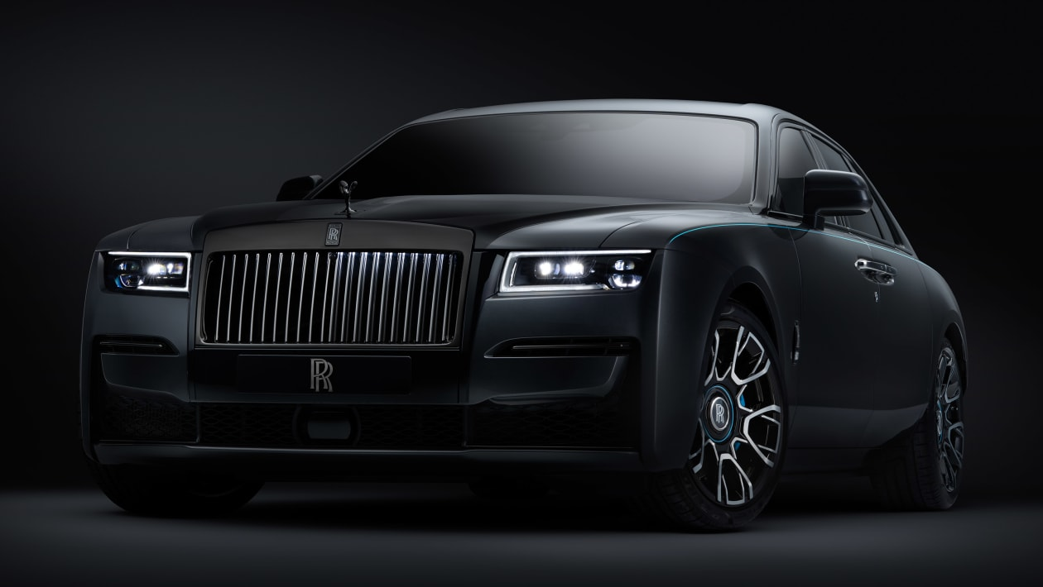
(Model: Ghost, Source: Rolls-royce.com)
Saudi Arabia:
- In Saudi Arabia, Rolls-Royce displays its Phantom, Ghost, Wraith, and Dawn models, emphasizing elegance, status, and workmanship.
- A "Royal Edition" or "Saudi Arabian Heritage" collection that incorporates cultural motifs and components important to the Saudi market may be introduced by the corporation.
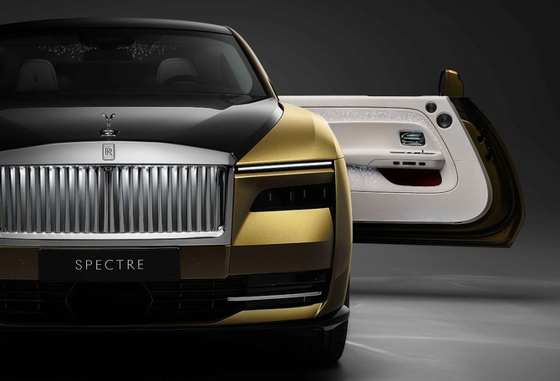
(Model: Spectra, Source: Rolls-royce.com)
Price:
The exclusivity and premium status of Rolls-Royce are reflected in the brand's pricing strategy. Luxury cars and aeronautical goods are both priced at the upper end of their respective sectors, catering to wealthy consumers who appreciate luxury and high caliber.
UK:
- In the UK, Rolls-Royce uses a premium price approach to present their cars as the height of luxury and engineering prowess.
- The personalized nature of the items is reflected in pricing variations depending on customization options and distinctive features.
Saudi Arabia:
- To entice high-net-worth individuals and executives, Rolls-Royce employs a premium pricing approach in Saudi Arabia, just like it does in the UK.
- Pricing may consider regional market conditions and consumer desire for bespoke luxury experiences.

Place:
Authorized dealerships for Rolls-Royce are distributed globally and can be found in major cities. For prospective purchasers of Rolls-Royce luxury automobiles, these dealerships offer a specialized and exclusive client experience.
UK:
- To provide a premium purchasing experience, Rolls-Royce establishes unique showrooms in famous places like Mayfair in London and other major cities.
- The business might also work with opulent hotels to showcase their cars at special events and exhibits.
Saudi Arabia:
- To serve its affluent clientele, Rolls-Royce dealerships are situated in posh neighborhoods of cities like Riyadh and Jeddah.
- The business engages in exhibitions and luxury lifestyle events that potential customers attend.
Rolls Royce Market Entry Methods
- To increase its presence in various areas and regions, Rolls-Royce uses a variety of market entrance strategies. The characteristics of the target market, the legal environment, the level of competition, and the strategic goals of the organization all have a role in the choice of market entry strategy.
- Direct Sales and Distribution: By establishing direct sales and distribution channels, Rolls-Royce frequently penetrates a new market. By setting up its own subsidiaries, dealerships, or showrooms in the target market, the corporation can sell and distribute its high-end vehicles and aircraft goods to consumers there (Source: The Guardian).
- Joint Ventures and Partnerships: Rolls-Royce might establish joint ventures or strategic alliances with regional businesses or target market participants. Through this strategy, the business can more successfully enter the market by utilizing the local partner's resources, skills, and understanding of the local market (Source: Bloomberg).
- Acquisitions and Mergers: In some circumstances, Rolls-Royce might decide to buy out or combine with already-existing businesses in the target market. Using this strategy, the business can immediately access a client base, distribution channels, and market share (Source: Financial Times).
- Licensing and Franchising: Rolls-Royce may grant local partners or franchisees in the target market licenses to use its name, technology, or know-how. With this strategy, the company may grow without making substantial up-front investments while keeping control over the image and caliber of its products (Source: Forbes).
- Export: By shipping its high-end autos and aeronautical goods from its manufacturing facilities to the target consumer, Rolls-Royce can break into new markets. This strategy works well in markets with established demand for luxury goods and low entry barriers (Source: CNBC).
- Technology Transfer: Rolls-Royce may enter into technology transfer agreements with regional partners or governments in the aerospace industry where it shares its cutting-edge engine technology and know-how to help the growth of the aerospace industry in the target market.
- Direct Online Sales: In some areas, the business may offer luxury cars straight to consumers through its internet platform, giving those clients who prefer online shopping a simple and convenient option (Source: Auto Express).
- Aftermarket Services: Rolls-Royce frequently provides aftermarket services and support to current clients in the aerospace industry, forging lasting bonds and securing repeat business in new markets.
Joint Ventures and Partnerships:
Advantages:
- Access to established client bases, distribution networks, and market knowledge in the local area.
- Shares market entrance costs and risks with the local partner, which aids in reducing both.
- Quicker market penetration is made possible by the local partner's established presence and network.
Disadvantages:
- Requires careful partner selection to guarantee congruence of goals and values.
- If there are differences between the partners, may result in possible disputes.
- May necessitate protracted conversations and concessions during the decision-making process.

Promotion:
To sell its brand, Rolls-Royce uses a combination of traditional and digital marketing methods. To reach its wealthy clientele, the business uses targeted advertising, sponsorships, and private events. Rolls-Royce also makes use of public relations strategies to attract high-profile customers and raise brand awareness.

UK:
- To reach a larger luxury audience in the UK, Rolls-Royce uses influencer collaborations, social media, and digital marketing.
- Limited edition vehicle collaborations with British designers and artists lead to media attention and improve company reputation.
Saudi Arabia:
- For prospective buyers, Rolls-Royce focuses on personalized events and experiences including invitation-only test drives and exclusive presentations.
- Local celebrities and social media influencers can increase brand visibility and engage the target demographic through influencer marketing.
People:
The qualified individuals responsible for providing the product and service experience are referred to as the "people" component of the marketing mix. In the case of Rolls-Royce, this entails highly qualified salespeople, engineers, and customer support agents that provide a customized and individualized experience to satisfy the needs of discriminating consumers.
UK:
- To provide outstanding customer service, Rolls-Royce's UK dealerships staff highly qualified and knowledgeable sales associates.
- Celebrities or brand ambassadors may be employed by the business to advertise its high-end automobiles.
Saudi Arabia:
- Rolls-Royce employs skilled salespeople in Saudi Arabia to offer discriminating clients customized service.
- The business might work with regional influencers or well-known individuals who are popular with the target market.
Process:
The voyage and experience of the customer are highly valued by Rolls-Royce. Bespoke customization is used in the production of the company's luxury vehicles to give consumers a unique product that is suited to their tastes.

UK:
- From the first inquiry through the delivery of the vehicle, Rolls-Royce offers customers in the UK a smooth and customized purchasing experience.
- The business might provide online virtual configurators so that clients can personalize their autos.
Saudi Arabia:
- Rolls-Royce has effective procedures in Saudi Arabia for ordering, customizing, and delivering luxury vehicles.
- The business can host special test drives for prospective customers.
Physical Evidence:
The tangible components that reflect the brand, such as the showrooms, events, and brochures, which are intended to portray elegance, sophistication, and workmanship, are referred to as the physical proof in Rolls-Royce's marketing mix.
UK:
- The showrooms of Rolls-Royce in the UK are created to showcase luxury and elegance and to provide visitors with an opulent atmosphere.
- The premium materials utilized in car interiors and the meticulous attention to detail display the tangible signs of luxury.
Saudi Arabia:
- Customers can explore the brand's offerings in an opulent and elegant setting at Rolls-Royce shops in Saudi Arabia.
- The iconic design and fine craftsmanship of Rolls-Royce automobiles serve as tangible proof of the brand's premium standing.

Directional Development Strategy
A directional development strategy for Rolls-Royce entails determining the company's future course and potential areas of expansion. This strategic strategy is centered on growing and developing the company in line with its long-term goals. Here are some essential elements of Rolls-Royce's directed development strategy:

Market Expansion:
Rolls-Royce can investigate new markets and geographical areas for its high-end vehicles and aeronautical goods. This can entail entering developing nations where there is a rising middle class and rising demand for high-end items and private jets.
Product Diversification:
The business might think about adding new luxury automobile models with cutting-edge features or branching out into different aircraft market categories to increase the variety of products it offers. To keep up with the trends in sustainable transportation, Rolls-Royce may possibly investigate prospects in electric or hybrid vehicles.
Technology Leadership:
Rolls-Royce may spend in R&D as a technology-driven business to keep up its leadership in engineering excellence. This includes advancements in the efficiency of aviation engines, the control of pollution, and autonomous technologies for high-end cars.
Sustainability Initiatives:
Rolls-Royce can concentrate on sustainability programs to support international efforts to develop environmentally friendly transportation. This could entail researching ecologically friendly materials and creating engines that are more eco-friendly.
Digital Transformation:
Adopting digital transformation may improve consumer experiences, streamline processes, and generate new revenue. For direct internet sales, virtual showrooms, and tailored consumer engagements, Rolls-Royce may create digital platforms.
Global Service Network Expansion:
To serve clients and enhance aftermarket services for both luxury vehicles and aircraft engines, Rolls-Royce can further expand its global service network. This strategy promotes client loyalty and improves client happiness.
Strategic Alliances:
Rolls-Royce can foster innovation, hasten market entry, and create new business prospects by working with strategic partners like aerospace or tech firms.
Entry into Sustainable Urban Mobility:
To meet the evolving transportation needs of urban centers Rolls-Royce can investigate the expanding market for premium urban mobility solutions, such as electric city cars or air taxis.
Brand Positioning and Marketing:
Rolls-Royce will be able to retain its opulent image and appeal to its target market of high-net-worth individuals by consistently improving brand positioning and marketing tactics.
Customer Experience Enhancement:
Rolls-Royce's reputation for providing excellent luxury and customer service may be strengthened by investing in personalized customer experiences and concierge services.
ANSOF MATRIX
The Product-Market Expansion Grid, also known as the Ansoff Matrix, is a strategic tool that aids businesses in locating expansion prospects by considering two dimensions. Hansen, S. (2021). products and markets. It offers a framework for choosing how to build a business by adding new products or going after new markets. Consider Rolls-Royce while using the Ansoff Matrix:
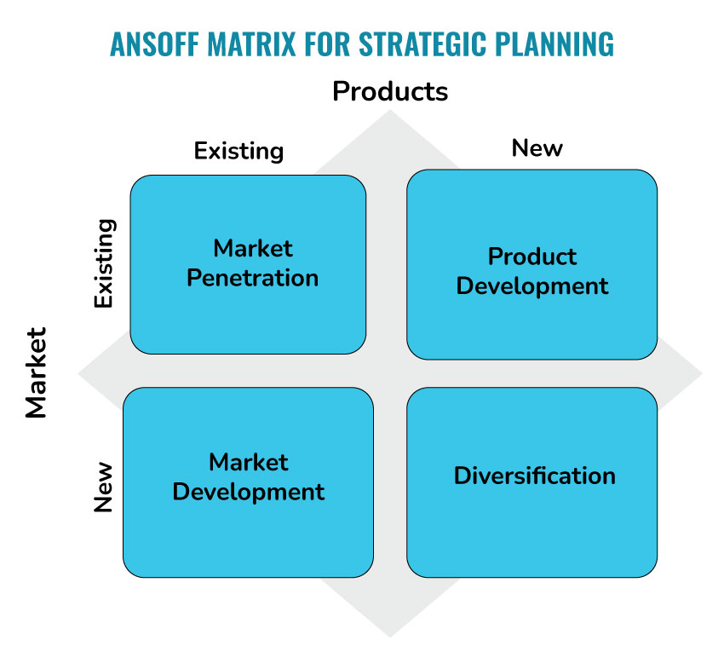

Market Penetration (Existing Products, Existing Markets):
Rolls-Royce can concentrate on market penetration techniques to raise its market share in the aerospace and luxury car industries, where it currently competes. This entails promoting its already existing line of high-end automobiles and aircraft engines to the same clientele. Rolls-Royce can accomplish this by improving brand loyalty through consumer involvement, expanding its distribution channels, and offering first-rate after-sales services. Rolls-Royce. (n.d.).
Product Development (New Products, Existing Markets):
Rolls-Royce can implement product development strategies by releasing cutting-edge aircraft engines and new, luxurious vehicle models in the areas where it already operates. Utilizing its current client base and brand recognition, the business can introduce goods that address shifting consumer tastes and technological advancements. Rolls-Royce. (n.d.).

Market Development (Existing Products, New Markets):
Market expansion tactics entail bringing existing products into new markets. Rolls-Royce can look at potential markets with a developing rich class, such as some Asian nations or areas with increased demand for private jets and premium cars. The business might also concentrate on expanding its presence in markets where it now holds a smaller market share. Rolls-Royce. (n.d.).

Diversification (New Products, New Markets):
Strategies for diversification involve launching new products in brand-new markets. By entering new markets like high-end electric cars or environmentally friendly aviation solutions, Rolls-Royce could consider diversifying. Although there may be greater risks involved with entering new markets and industries, doing so opens potential for expansion and lessens reliance on current markets. Rolls-Royce. (n.d.).

Recommendations
TOWS MATRIX
By contrasting external opportunities and threats with internal strengths and weaknesses, the TOWS matrix is a strategic tool that aids in the generation of strategic suggestions. It makes it possible for businesses like Rolls-Royce to pinpoint prospective strategies that fit with their strengths and the state of the market. Using the TOWS matrix as a foundation, the following strategic suggestions are made for Rolls-Royce:
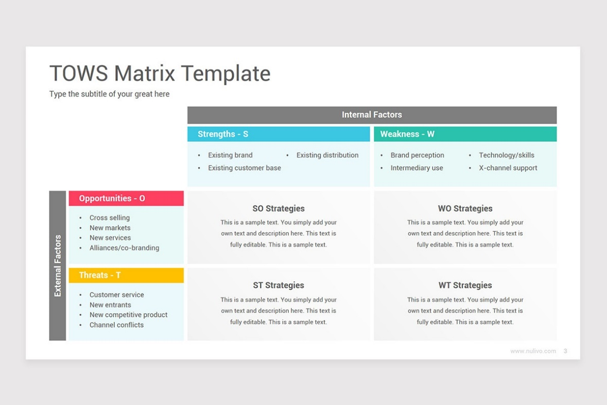
(Source: Nulivo market)

Strength-Opportunity (SO) Strategies:
Utilize internal resources effectively to take advantage of outside chances.
SO1: Utilize the reputable brand name and engineering know-how of Rolls-Royce to enter new markets with rising demand for high-end vehicles and private aviation, such as some Asian nations.
SO2: Profit from the growing demand for environmentally friendly aviation solutions by creating eco-friendly aircraft engines using the outstanding research and development skills of Rolls-Royce.
Strength-Threat (ST) Strategies:
Make use of your internal resources to neutralize or combat external threats.
ST1: Boost aftermarket services and customer satisfaction by utilizing Rolls-Royce's robust global service network and customer support to mitigate the danger of escalating competition in the aerospace and luxury auto industries.
ST2: Address possible challenges from disruptive technologies in the luxury car sector by leveraging the company's strong financial position and resources to invest in technical developments.
Weakness-Opportunity (WO) Strategies:
Utilize external chances to strengthen internal shortcomings.
WO1: To capitalize on the expanding trend of online luxury car purchases, strengthen any weak points in customer engagement and broaden direct online sales platforms.
WO2: Work together with key partners to get beyond any production capacity and resource limits, enabling Rolls-Royce to enter new markets and introduce cutting-edge products.
Weakness-Threat (WT) Strategies:
Mitigate internal flaws and potential dangers.
WT1: Invest in talent development and training initiatives to fill any skills gaps and make sure Rolls-Royce is well-prepared to handle future technological breakthroughs and industry challenges.
WT2: To strengthen Rolls-Royce's position in the marketplace and address market shortcomings, think about strategic collaborations or acquisitions.

Conclusion
In the fields of high-end automobiles and airplanes, Rolls-Royce is a recognizable brand that has made a name for itself as a representation of luxury, artistry, and engineering brilliance. With a long history spanning more than a century, the business has continually upheld its dedication to creating top-notch products and offering outstanding customer experiences.
In the luxury car market, Rolls-Royce stands out from rivals thanks to its bespoke customization choices and timeless elegance, which draw a select group of high-net-worth people and celebrities from across the world. The corporation has been able to preserve its position as the global leader in luxury cars because of its market expansion into new economies and flexibility in responding to shifting consumer tastes.
The aircraft engines made by Rolls-Royce are renowned for their efficiency, dependability, and cutting-edge technology in the aerospace sector. Due to the brand's solid standing in the aviation industry, it has been able to sign deals with significant airlines and aircraft producers, which has boosted its impact in the worldwide aerospace market.
Rolls-Royce has been able to explore new growth prospects while exploiting its core strengths and skills because to its directional development strategies, which include market penetration, product development, market expansion, and diversification. Rolls-Royce puts itself in a position for long-term success by consistently investing in research and development, supporting sustainability initiatives, and remaining at the cutting edge of technology.
Strategic partnerships, alliances, and a global service network help the corporation maintain its competitive advantage and meet the high standards of its affluent customer. The dedication of Rolls-Royce to offering unmatched customer experiences solidifies the company's status as a prestigious and exclusive luxury brand.
However, just like any company, Rolls-Royce also must deal with difficulties like escalating rivalry, shifting market conditions, and the requirement to adapt to regulatory changes in the aerospace and automotive sectors. Nevertheless, the company is well-positioned to overcome these difficulties and keep its position as a pioneer in the luxury automotive and aerospace markets thanks to its strong brand equity, sound financial position, and commitment to innovation.

References
Grant, R. M. (2019). Contemporary Strategy Analysis: Text and Cases Edition. John Wiley & Sons.
Hill, C. W., & Jones, G. R. (2020). Strategic Management Theory: An Integrated Approach. Cengage Learning.
Porter, M. E. (2008). The Five Competitive Forces That Shape Strategy. Harvard Business Review. Retrieved from: https://hbr.org/2008/01/the-five-competitive-forces-that-shape-strategy
Porter, M. E. (1979). "How Competitive Forces Shape Strategy." Harvard Business Review. Retrieved from: https://hbr.org/1979/03/how-competitive-forces-shape-strategy
Porter, M. E. (1980). "Competitive Strategy: Techniques for Analyzing Industries and Competitors." Free Press.
Porter, M. E. (2008). "The Five Competitive Forces That Shape Strategy." Harvard Business Review. Retrieved from: https://hbr.org/2008/01/the-five-competitive-forces-that-shape-strategy
Porter, M. E. (1996). "What Is Strategy?" Harvard Business Review. Retrieved from: https://hbr.org/1996/11/what-is-strategy
Porter, M. E. (1979). "How Competitive Forces Shape Strategy." Harvard Business Review. Retrieved from: https://hbr.org/1979/03/how-competitive-forces-shape-strategy
Porter, M. E. (1987). "From Competitive Advantage to Corporate Strategy." Harvard Business Review. Retrieved from: https://hbr.org/1987/05/from-competitive-advantage-to-corporate-strategy
Rolls-Royce Motor Cars. (n.d.). Home. Retrieved from https://www.rolls-roycemotorcars.com/
Rolls-Royce. (n.d.). Home. Retrieved from https://www.rolls-royce.com/
McD onald, P. (2020). Rolls-Royce Motor Cars: The Story of a Global Icon. TeNeues.
Ward, I. (2015). The Rolls-Royce Armoured Car. Osprey Publishing.
Hansen, S. (2021). The Power Behind the Airplane: Rolls-Royce Aero Engines 1935-2000. History Press.
Annual Reports and Investor Presentations - Rolls-Royce Holdings plc. (n.d.). Retrieved from https://www.rolls-royce.com/investors/reports-and-presentations.aspx
Grint, K., Jackson, B., & Larkin, R. (2005). Leadership: Limits and Possibilities. Palgrave Macmillan.
Rolls-Royce Official Website: The company's official website is a reliable source for information about their products, services, corporate news, and financial reports. https://www.rolls-royce.com/
Rolls-Royce Motor Cars Official Website: For information specifically about Rolls-Royce luxury cars, you can visit their dedicated motor cars website. https://www.rolls-roycemotorcars.com/
Annual Reports and Investor Publications: Rolls-Royce releases annual reports and investor presentations that provide detailed information about the company's financial performance, strategic outlook, and market developments. https://www.rolls-royce.com/investors/reports-and-presentations.aspx
Industry Publications and News Outlets: Reputable business and industry publications often cover news and developments related to Rolls-Royce in the aerospace and automotive sectors.
Books and Academic Publications: Books authored by industry experts, biographies, and academic publications may provide in-depth insights into the history, development, and impact of Rolls-Royce in various sectors.

