Mapping in Layers

The MapInfo map window is built up by placing a number of map layers or tables onto the screen at any given time. We can turn the necessary layers or spatial datasets on and off to give us different visualisation of the geographical data.

Objectives
- Understand Map Layers.
- Manage Layers of a Map.
- Reorder Layers.
- Add a Layer.
- View an Entire Layer.
- Use the Info Tool.
- Remove a Layer.
- Change the Appearance of a Layer.
- Set Zoom Layering.
- Create a Duplicate Map Window.
- Save a Workspace.

Start with a clean MapInfo session.

From the File menu, choose Open.
From the Files of Type drop down choose Mapinfo (*.tab).

Use the training data that contains the necessary data for this exercise.

Navigate to UK and Select UK Region, MWays and postarea while holding down the CTRL button. Click Open.

Now go to the World folder. Select OCEAN and WORLD. Click Open.

Notice that your Map window has surprisingly changed appearance for the worse as the ocean layer has covered most of the map detail. We can fix this by using Layer control.

Opened one more supporting table, however do not place in the current map window.

From the File menu, choose Open.

Make sure the Files of Type drop down reads Mapinfo (*.tab).
Navigate to the Tutorial folder UK.
From the Preferred View drop-down list, choose No View.
Select UK-CITYand click Open.
Notice that the title bar of the Map window does not change, nor do you see any of the objects in UK-CITY, even though it is opened.

You can use Layer Control to reorder, add and remove layers, and change how and when layers are displayed. Take note of the Layer Control dialog.

- Open the Map menu.
- Choose Layer Control. The Layer Control dialog displays.

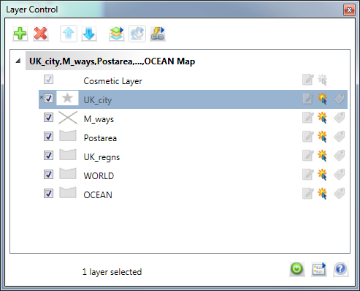

The cosmetic layer is always in a map and always the top layer it cannot be removed or reordered.
Note: If you move your cursor over a layer and pause, the .TAB file’s path information will display in an InfoTip bubble.

The Layer Control Check Boxes:

Your map should be composed of the table layers above. Because the World and Ocean layers are positioned on top of the UK layer, no regoinal outlines are displayed. We can reorder the layers so that the all layers are visible.

- Select the WORLD layer.
- Click the Down button from the Reorder group and move it to the bottom.
- Select the OCEAN layer.
- Click the Down button from the Reorder group and move it underneath the WORLD layer.
- Click OK.

Notice the State boundaries are now visible.

Although we have opened the UK-CITY table, we did not include it in the Map window. We are now going to add this table to the map.
- Click the Layer Control button.
- This button is equivalent to choosing Map > Layer Control from the menu bar.
- Click Add (the + button) from the Layers group. The Add Layer dialog displays.
- Choose UK-CITY_125 from the Add Layers list.

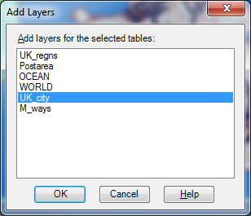

- Click Add.
- Click OK to close the Layer Control dialog box.

The map redraws showing the new layer you have added.
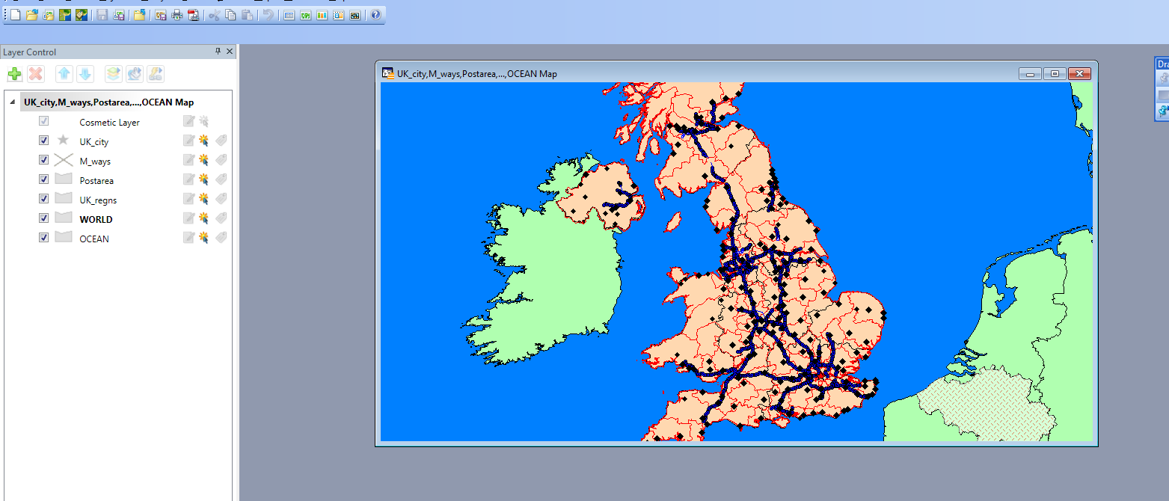

Preferred Order of Layers

You may have noticed MapInfo attempts to logically place tables (as layers) in a Map window when opening tables or using Layer Control. When opening tables using the default option or adding layers though Layer Control, MapInfo looks at the type of map objects that are in the table. When MapInfo finds a layer containing mostly text, that layer will become the topmost layer. MapInfo will then place points layers underneath text, lines underneath points, and polygons underneath lines.
If you open two tables that contain the same type of map object, for example polygons, it will make the layer of the first table opened the bottom-most polygon layer. When the second table is opened containing polygons, its map layer will be placed on top of the first polygon layer. This behaviour is true for other types of map objects

You can remove a layer by closing the table. You can also remove a layer using the Remove button in Layer Control. In this latter case, the data table itself is still open within MapInfo; it simply is no longer available in the Map window.
Remove the STATECAP layer from our map window:
- From the Map menu choose Layer Control.
- Select the STATECAP layer.
- Click Remove from the Layers group box.
- Press OK.

The layer is removed from the Map window. Once again, note that STATECAP is still open, and you could use the Layer Control dialog to add it back in without having to open the table.

You may want to change the appearance of a layer. It is possible to do this without permanently changing the table.
- From the Map menu choose Layer Control.
- Double click the STATES layer.
- The States Display Options dialog displays.

In this dialog you can override the default style settings that determine how this layer displays in a Map window.
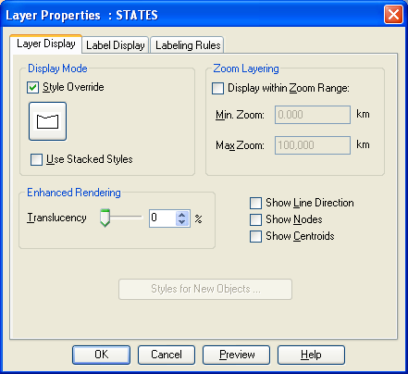

- Check the Style Override check box to override the default style of a layer.
- Click the Region Style button and the Region Style dialog displays.
- Click Foreground drop-down menu from the Fill group box.

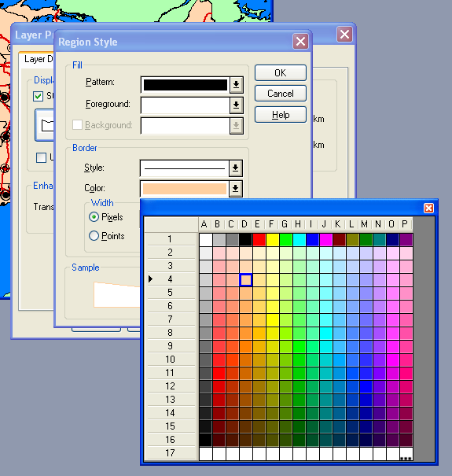

- From the colour palette, choose a new colour such as Yellow.
- Click OK to accept the colour choice.
- Click OK to accept the Display Options.
- Click OK to close the Layer Control dialog.

Many layers that you use in your map windows may only be appropriate to use at certain zoom levels. For example, if you take a street map and zoom out so that all of the streets are in the window, there is too much detail. To manage the level of detail that appears in a map you can use the zoom-layering feature. This feature allows you to specify a range of zoom levels for the layer to be displayed in.
In your map, if you zoom out too much, the CITY_125 layer will practically cover up the lower 48 states. We will set up the Map window so that the CITY_125 layer is only visible if the map is zoomed in to view 5,000 miles or less.

- Open the Map menu.
- Click on Layer Control.
- Select the City_125 layer.
- Click the Display button and the Display Options dialog box displays.
- Check Display Within Zoom Range.
- Enter 5000 for the Max Zoom.

- Click OK to close the Display Options dialog box.
- Click OK to close the Layer Control dialog box.

The cities will only be displayed if the zoom level is 5,000 miles or less.
Once you have customized a view of your map, you may want to create a clone, or copy of the map window. In this way you are able to see two views of a map at the same time, perhaps choosing to zoom in for one view (to create an inset), while letting the other view provide the bigger picture.

- From the Map Menu choose Clone View.

A duplicate map appears. This feature can be handy when you need to produce a map with several insets. To see both map windows tile the windows.

- Open the Window Menu and choose Tile Windows

Since many new settings have been included in the map layers, your work needs to be saved in a workspace.

- Open the File menu and choose Save Workspace.
- Type myWorkspace.
- Press Save.

When you save a workspace, all layer control settings that you have applied to your maps will be remembered in the workspace. Layers based on a query made by select tools will not be saved.

To view all of the objects associated with a map layer within a Map window, use the View Entire Layer command.

- From the Map menu choose View Entire Layer.

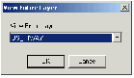

- Choose the US_HIWAY layer from the View Entire Layer drop-down menu.
- Press OK.

Use the Info Tool to view tabular data associated with objects. The information displays in the Info Tool window. If more than one object is at the same geographic location, the Info Tool window indicates how many objects are at that location, and the table in which each resides. For example, you might click on a city using the Info Tool and simultaneously get information on its State and Country. Select the appropriate item (City, State, Country, and so on) to display all information associated with the object.

- Select the Info Tool from the tool bar.
- The cursor will now appear as a large cross on the screen.
- The cross can be places over a number of layers

As you move the cursor within the map window, the Info Tool will present InfoTips the same way the Select button does.

- Click on a city in the Map Window. In the Info Tool window, a list of the map objects that were under your mouse pointer appears:

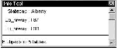
- To get further information on one of these objects, click the text (in the Info Tool window) of the object you want to see. All of the tabular data appears for that object.
- Close the Info Tool window

