Pitch — Connect & Care

The Digital Social Prescribing App to Reduce Loneliness among Older Adults in the UK

Student Name: Elisabete Nobrega
Student ID: 2336792
Module Code – BMHP5014
Module Title – Changemakers: Creativity and Value Creation
Assessment 2 – Poster Presentation & Pitch

Table of Contents
Poster 3
Pitch 4
Introduction 4
The Case for Connect & Care 4
Major Elements of the Innovation 5
Customised activity matching 5
Safe one-to-one or group communication 5
Associated care pathways 5
Digital inclusion features 5
Security and safeguarding measures 5
Value Created by the Innovation 6
Older adults 6
Communities 6
The NHS and social care 6
Implementation Plan 6
Challenges and Mitigation Strategies 7
Why Action is Needed Now 7
References 9

Poster
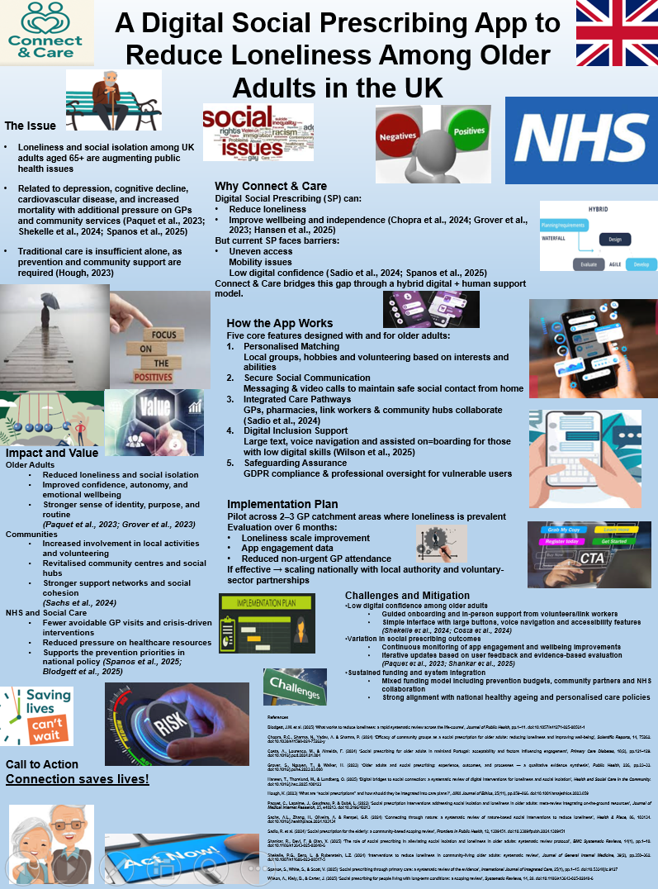

Pitch

Introduction
Social isolation and solitude indicate higher and emerging health issues in the United Kingdom, especially among people 65 years old and above (Blodgett et al., 2025). Present national data proposes that a high volume of elderly people often feel lonely, putting them at increased risk of growing various mental and physical health concerns. Current solitude throughout their life has been severely aligned with despair, augmented cognitive decline, and injurious physiological conditions like cardiovascular complications, increasingly dedicating to mortality rates among elderly individuals (Paquet et al., 2023; Shekelle et al., 2024)Such people’s health effects also convert into a broader issue within the worldwide system, or press extra tension on General Practitioners (GPs), community health providers, and mental health services (Spanos et al., 2025).
As the aging population in the UK increases, it poses challenges to the health and social care system, forcing institutions to create pre-emptive approaches in order to surpass outdated medical treatment. Such strategies should emphasise community involvement, emotional sustenance, and essential social bonds. In addition, social prescribing (SP) is known as a promising approach for identifying social metrics of health by connecting people to non-clinical services like volunteer groups, community initiatives, or even hobbies (Hough, 2023). Nonetheless, SP provision could be irrelevant, allowing restricted responsibility for elderly individuals encountering mobility issues, rural segregation, and decreased awareness (Sadio et al., 2024; Spanos et al., 2025). Thus, Connect & Care is represented as the digital SP solution that provides access to social sustenance and adequate social interference (Costa et al., 2024).

The Case for Connect & Care
Various studies show that SP could decrease solitude and augment general wellbeing for elderly people, especially when associated with constant social sustenance (Chopra et al., 2024; Paquet et al., 2023). Still, several interventions might depend vastly on personal provision, avoiding the ones with restricted mobility or availability to transportation. Parallel with that, digital health programs are indicating serious potential to identify social segregation. Based on the latest steady outlines, digital platforms could successfully enhance assumed social support and decrease solitude within specific groups of adults (Hansen et al., 2025; Grover et al., 2023). Moreover, research assessing conversational agents and entertaining technologies shows that digital companionship instruments could assist elderly individuals in sustaining independence and emotional resistance (Shekelle et al., 2024).
Connecting SP with available technology like Connect & Care provides a mixed model for captivating the positives of community sustenance and decreasing accessibility issues.

Major Elements of the Innovation
Connect & Care would provide five major features, created by and for elderly individuals:

Customised activity matching
A concise on-boarding evaluation defines interests, mobility, location, and wellbeing preferences, permitting the application to imply customised propositions.

Safe one-to-one or group communication
Safety messaging and video calling drive social involvement, especially when users are located at home.

Associated care pathways
The application would perform under collaborations with GP practices, pharmacies, NHS link workers, voluntary institutions, and community hubs to provide real-life social engagement possibilities (Sadio et al., 2024).

Digital inclusion features
Utilising large icons, simple buttons, optional voice navigation, and personal on-boarding processes guarantees utilisation from individuals with obvious injury, arthritis, nervousness regarding technology, or lower digital abilities.

Security and safeguarding measures
Criteria including encrypted personal data, GDPR acquiescence, and professional supervision permit high-risk cases to be noted and maintained properly.
Such a hybrid strategy guarantees improvement of the digital solutions, not only a substitution of human interference.

Value Created by the Innovation
The estimated positives of Connect & Care affect various stakeholders, such as:

Older adults
Decreased solitude, enhanced autonomy, powerful relationships, augmented mental wellbeing, and heightened sense of meaning (Grover et al., 2023; Paquet et al., 2023).

Communities
Better involvement in local initiatives, renewal of social hubs, and improved joint sustenance networks (Sadio et al., 2024; Sachs et al., 2024).

The NHS and social care
Avoiding deterioration in social and mental wellbeing could decrease redundant GP appointments and referrals, as well as postpone and evade expensive crisis-related interferences (Spanos et al., 2025; Wilson et al., 2025; Blodgett et al., 2025).
In general, Connect & Care directly sustains the UK prevention schedule and endorses healthy aging through a structure, community, and individual position.

Implementation Plan
The activity would launch a six-month trial period including two or three GP fields, considered high-levelled zones of social solitude among older citizens. Endorsement would be managed via initial care groups, local institutions, and voluntary partners within the sector. Elderly individuals would be included utilising assistance, such as home visitations for the ones not capable of participating in community meetings.
Dimension of efficacy throughout the period would involve the following:
- Loneliness and wellbeing scales or baseline vs. follow-up
- App involvement and engagement data
- Deviations in health care usage, such as the non-urgent GP visits
Based on the assessment, Connect & Care would be improved and measured gradually in supplementary localities via national cooperation and associated commissioning approaches.

Challenges and Mitigation Strategies
At first, an elderly individual might experience frustration and hesitation regarding digital instrument utilisation. According to Shekelle et al. (2024) and (Costa et al., 2024), enhancing technology with human-based sustenance augments approval and success. In addition, Connect & Care offers a hybrid method in order to establish digital confidence.
Diversification within SP efficacy has been indicated within the research, showing the necessity for vigorous observing, cooperation, and constant assessment (Paquet et al., 2023; Shankar et al., 2025).
Durable results and organisational buy-in should be safely preserved. In addition, a mixture-finding approach is suggested, including preclusion budgets, local authority sustenance, health collaborations, and charity consideration, guaranteeing adequacy and sustainability.

Why Action is Needed Now
Solitude during the last periods is avoidable; still, it is considered as broadly and severely damaging. With the recognition from governmental industries and serious health organisations, enhanced with fast improvements within the digital capability and social prescribing infrastructure, the UK is properly assumed to apply and measure essential interferences (Hansen et al., 2025; Spanos et al., 2025).
Moreover, Connect & Care relates closely with this momentum, providing passionate, proof-related, actual innovative support to elderly people in staying socially bound, emotionally capable, and vigorous in their societal groups.
Connect & Care is considered as more than a digital instrument; in addition, it is a preventive lifeline to bond people to people before loneliness turns into a problem.
Therefore, stakeholders of health, social care, and voluntary industries are extremely motivated to enhance the development and implementation of this application.
Connection saves lives. The time to act is now.

References
Blodgett, J.M. et al. (2025) ‘What works to reduce loneliness: a rapid systematic review across the life-course’, Journal of Public Health, pp.1–11. doi:10.1057/s41271-025-00561-1
Chopra, R.C., Sharma, N., Yadav, A. & Sharma, P. (2024) ‘Efficacy of community groups as a social prescription for older adults: reducing loneliness and improving well-being’, Scientific Reports, 14, 75262. doi:10.1038/s41598-024-75262-y
Costa, A., Lourenco, M., & Almeida, F. (2024) ‘Social prescribing for older adults in mainland Portugal: acceptability and factors influencing engagement’, Primary Care Diabetes, 18(2), pp.121–129. doi:10.1016/j.pcd.2024.01.004
Grover, S., Nguyen, T., & Walker, H. (2023) ‘Older adults and social prescribing: experience, outcomes, and processes — a qualitative evidence synthesis’, Public Health, 226, pp.23–33. doi:10.1016/j.puhe.2023.03.008
Hansen, T., Thorslund, M., & Lundberg, O. (2025) ‘Digital bridges to social connection: a systematic review of digital interventions for loneliness and social isolation’, Health and Social Care in the Community. doi:10.1016/j.hsc.2025.100123
Hough, K. (2023) ‘What are “social prescriptions” and how should they be integrated into care plans?’, AMA Journal of Ethics, 25(11), pp.859–866. doi:10.1001/amajethics.2023.859
Paquet, C., Lapalme, J., Gaudreau, P. & Dubé, L. (2023) ‘Social prescription interventions addressing social isolation and loneliness in older adults: meta-review integrating on-the-ground resources’, Journal of Medical Internet Research, 25, e40213. doi:10.2196/40213
Sachs, A.L., Zhang, H., Oliveira, A. & Rempel, G.R. (2024) ‘Connecting through nature: a systematic review of nature-based social interventions to reduce loneliness’, Health & Place, 86, 103134. doi:10.1016/j.healthplace.2024.103134
Sadio, R. et al. (2024) ‘Social prescription for the elderly: a community-based scoping review’, Frontiers in Public Health, 12, 1309451. doi:10.3389/fpubh.2024.1309451
Shankar, R., Devi, F. & Qian, X. (2025) ‘The role of social prescribing in alleviating social isolation and loneliness in older adults: systematic review protocol’, BMC Systematic Reviews, 14(1), pp.1–10. doi:10.1186/s13643-025-02848-6
Shekelle, P.G., Bero, L. & Rubenstein, L.Z. (2024) ‘Interventions to reduce loneliness in community-living older adults: systematic review’, Journal of General Internal Medicine, 39(2), pp.350–362. doi:10.1007/s11606-023-08517-5
Spanos, S., White, S., & Scott, V. (2025) ‘Social prescribing through primary care: a systematic review of the evidence’, International Journal of Integrated Care, 25(1), pp.1–15. doi:10.5334/ijic.9127
Wilson, A., Kiely, B., & Carter, J. (2025) ‘Social prescribing for people living with long-term conditions: a scoping review’, Systematic Reviews, 14, 28. doi:10.1186/s13643-025-02848-6

