
MANAGING ENTERPRISE IN THE 21ST CENTURY


De Cod: BMSW4006
Students name: ionela Dinu (2027947) and Mihaela Breazu (2027947)
Teacher name: Mushfiqur Rahman
Ionela Dinu part is from Introduction to Operations Mihaela Breazu is from Technology Plan to Conclusion
Table of Contents
INTRODUCTION 2
MAIN BODY 3
ABOUT “THE BEST” 3
MISSION AND VISION OF THE BEST 3
BUSINESS STRUCTURE 3
PRODUCT OR SERVICE DESCRIPTION 4
MARKETING ANALYSIS AND TRENDS 5
SWOT ANALYSIS 6
PESTLE ANALYSIS 9
OPERATIONS 10
TECHNOLOGY PLAN 11
MANAGEMENT AND ORGANISATION 12
SOCIAL RESPONSIBILITY AND SUSTAINABILITY 12
DEVELOPMENT, MILESTONE AND EXIT PLAN 13
FINANCIAL DATA 14
PROFIT AND LOSS ACCOUNT 15
CASH FLOW STATEMENT 16
BALANCE SHEET 17
CONCLUSION 19
REFERENCES 20
PRESENTATION SLIDES 23

INTRODUCTION
Management of enterprise would allow the gaining growth and success within a business environment as well as gain the set business goals effectively. Enterprise management not only involves the efforts imposed by the management operating within the firm but also the employees and other workers that give their best efforts towards the overall success and development of their personal and professional progress. The report here will be including a business plan which is named “The Best” showing the overall aspects to be kept in mind in order to bring the wide range of product and services in the market. The report here will be including a brief analysis about the business structure, internal and external analysis of the environment, financial budgeting of the new business plan formed as well as the usage of technology to be undertaken for gaining success within the business environment. In addition to this, the report will also be including proper management of technology and the social responsibility to be followed by the management of the firm stating its positive effect within the business environment.

MAIN BODY

ABOUT “THE BEST”
The Best is a small enterprise dealing in chocolates and various similar products wherein the firm would be located in London, UK. The wide range of products available here would include chocolate bars, blocks, biscuits, spreads, beverages, puddings, cakes, pastries and ice cream. In addition to this, it could be noted that the target market for the firm will be the young generation since they are highly interested in chocolates and other related products. Apart from this, it could be noted that the main aim of this chocolate shop would be to be best in confectionery providing the UK population with high-quality chocolates and related products and the objective of the firm will be to make an increase in the reach of consumers by 10% as well as undergo an increase in their sales by 15%.

MISSION AND VISION OF THE BEST
The mission which is being stated by the firm is that the management here involved will remain highly committed to the chocolate products being produced by them which would be of high-quality as well as good in taste and promises to make constant improvement in the overall production made.
The core vision behind coming up with a new brand and innovation in the product is that the firm will be working effectively and together towards bringing up loved products in the market that could be enjoyed by the targeted consumer base. In addition to this, the vision of the firm also includes that the firm will be valuing each individual that is associated with The Best which not only include the employees operating but also the consumers as well as various other stakeholders that have helped the company come up within business environment effectively (Popova et al., 2019). The firm would also try passionately towards ensuring that they make improvements in their product and services constantly so that they could sustain within the market effectively.

BUSINESS STRUCTURE
There are different types of business structures existing such as sole proprietorship, limited liability, partnership as well as corporation and each business structure has got its own unique way of implementing the different operations within the business in an effective manner. The business structure that would be followed here for The Best will be a partnership wherein the business partners will together work for the development and growth of the chocolate shop formed. In addition to this, it should also be noted that the partners involved here will be having an equal share of ownership and hence they would be equally liable towards any loss or the risk being faced in association with the business would be entitled towards the entire amount referred to as profits (Sgroi et al., 2021). Hence, it should also be noted that in partnership there are various advantages as well as disadvantages and these are with the application of partnership structure very less paperwork is involved wherein the partners need to meet the same requirements that the limited liability is subjected towards (Abad-Segura et al., 2019). In addition to this, special taxation arrangement is also enjoyed by the partners here while filing for the income tax return. Whereas, looking at the downside of undertaking partnership would be that the partners here would be liable towards the debts as well as the obligations being made within the business and hence, it may be possible that personal assets need to be sold by them in order to pay the business debts involved.

PRODUCT OR SERVICE DESCRIPTION
The Best will be coming up with a wide range of products in the market wherein the management here would also ensure that proper research is being implemented by them in order to know the taste, preferences and demand of the potential consumer base as this would help them in make relevant improvement in their products accordingly. The firm basically plans here to launch a new product in the market that is the chocolate bars which are healthy and tasty and includes various healthy ingredients such as nuts, cereals, fruits etc. In addition to this, the company also made sure that they use various other alternatives of sugar to add sweetness to the chocolates so that they could be able to make a healthier version that could be enjoyed by everyone especially the diet-conscious that are not willing to enjoy their chocolates involving lots of sugar. The chocolate bar that would be launched by The Best would be named Mixed Choco and will be including ingredients such as muesli, granola, orange, hazelnut and almond making it all the healthier and tastier version of normal chocolate bars. In addition to this, it should be noted that the product here made will be sugar-free and hence would be consisting very fewer calories also, there are various health benefits related to the product and these are it could be enjoyed by diabatic people and others that are having various diseases and are not able to enjoy sugar-coated products.
Other than this, the firm will also be keeping different types of chocolates in the form of spreads, biscuits etc. In addition to this, it could be noted that the products being manufactured by the firm would completely be product premium which states that the quality of the products being used in making chocolates here would be premium hence making the product all the more, tastier to be consumed by the potential consumer base.

MARKETING ANALYSIS AND TRENDS
In order to bring the product in the market effectively The Best management here will also be making sure that the right segmentation, targeting and positioning of the product is implemented by them so that it could reach the set audience effectively making them gain increased satisfaction from the consumption of the product. Segmentation basically could be referred to as undergoing identification of the niche market for the business wherein the main focus could remain towards marketing as well as undergoing better engagement of the consumers. Whereas, targeting here for The Best would be the females that are of age between 10-34. Further segmentation of the audience is classified by The Best would be on the basis of psychographic which includes the consideration of lifestyles, activities as well as hobbies that the females have (Ali and Hamad, 2021). And on the basis of the research implemented by The Best management, it could be noted that the majority of the audience that is interested in buying the products were of age 10-34 wherein most of them involved were women (Statista, 2021).
The researches made also shows that 10-18 years of age children also showed that interest in buying the products made available by The Best and this age group is very important to be attracted effectively by the firm since they are the audience segment that helps the firm in spreading word-of-mouth as well as help the firm make an increase in their sales. Apart from this, the young generation is another group segment which is from the year 20-35 will also help the firm in gaining success and sustainable position in the market since based on the studied, it could be observed that this group is highly aware and conscious about their health which in turn is making all the easier for the firm to capture this market segment effectively due to their healthier versions of chocolates being made available in the market.
On the other hand, positioning could basically be based on the current trends existing in the market and hence for The Best management to ensure that they attain sustainability in the market, it is very important to note the recent trends which are involved within the confectionery industry. Some of the recent trends that have been come up within the industry include involvement of different types of citrus fruits such as orange and other dried fruits available, involvement of desserts as a component while undergoing the manufacturing of different chocolate products, including different vegetables in chocolate products, as well as different types of nuts usage such as almond, cashew, resins etc. Apart from this, it could also be observed that floral notes, as well as white chocolates to be used in chocolate products, have increased and based on the research made, it can be seen that in 2019, the confectionary industry turnover in the UK was $4billion due to bringing new innovation in the product (Ashrafi et al., 2018). Also, to be noted that the management operating at The Best will make sure that proper segmentation, positioning as well as targeting of the product being manufactured by them is done on the basis of keeping in mind various aspects involved such as the taste and preferences of the consumers, their lifestyles, trends existing in the market, innovation brought by competitors in the market etc which would further help in the firm is undergoing constant improvement hence attain success and growth accordingly.

SWOT ANALYSIS
Following are the strength, weaknesses, opportunities and threats of The Best recognized by the management involved:
STRENGTH:
Well-organized business management: The Best management would make sure that a well-organized structure is being maintained by them as this would help them in implementation of each task to take place effectively as well as help in ensuring towards the attainment of overall success and growth.
Plan towards the creation of strong image: The firm has also formed a plan through which they would try to gain a sustainable position in the market and hence for strong image and this would mainly be done by them through the help of various social media platforms existing in the market such as Facebook, Twitter, Instagram etc. With the implementation of these social media platforms, the firm will be able to create increased awareness about the new innovation being brought up by the firm in the market and this, in turn, would attract an increased targeted consumer base easily.
Skilled employees: The Best here will be including 48 employees that are well skilled and have got the right knowledge about the products being made available by them to the targeted consumer base. In addition to this, the management operating within the firm will also be making sure that they hire the best employees that have got the capabilities to implement the tasks being assigned to them effectively along with providing them with the training needs to execute the tasks effectively (Bartik et al., 2020).
Situated in London: It could be noted that the existence of The best is in London which can be said as one of the favorable places for the firms to undertake their business helping in reaching great heights. Through the researches made, it could also be observed that having the business in London allows the firms in attaining the attention of an increased consumer base hence making it easy for them towards gaining increased sales and profits.
WEAKNESS:
Inflexible working condition: It may be possible that the working condition provided to the employees may not suit them and this can also lead towards increased employee retention as well as attainment of increased dissatisfaction from the job role to the employees.
Poor salary: This could be another weakness that the company can face while undergoing its operations wherein since the firm would be new in the market and hence would not be gaining many profits. Therefore, this situation would also lead towards the creation of dissatisfaction among the employees which can also create an impact on the overall working of the firm within the business environment.
Lack of budget: As “The Best” is new in the market, not much of the funds are invested by the partners and hence the budget here drawn by the firm is less in comparison to the budget being kept by the large companies (Bashir et al., 2017).
OPPORTUNITIES:
Increased number of outlets: With undergoing an increase in the number of outlets, The Best management could easily be able to undergo an increase in their sales as well as production which in turn would help the firm in attaining a sustainable position within the business environment. It could also be noted that making an increase in outlets would allow the firm in making increased awareness about the products being made available by them in the market hence attaining growth and future development.
Advanced technologies: Since the business environment evolving has started coming up with different technologies in the market, The Best management could also come up with new and advanced technologies in the market through their online and offline stores which in turn would help them in creating a sustainable position in the market and attract the consumers effectively. Also, it could be noted that bringing advancement in the market through the help of technologies not only will help the firm in bringing innovation and increased productivity but also will help in increasing the firm's sales, development as well as a positive brand image within business environment (Bashir et al., 2017).
Improvement in salary and working condition: This aspect has got the direct relation with the happiness and satisfaction level of the employees as the firm making improvement in the working condition and salary and therefore will be able to effectively engage employees to remain within the firm for the longer time period. In addition to this, it should also be noted that an increase in salary would act as a motivation for the employees helping them in coming up with new ideas within the firm as well as undergoing increased productivity for the overall welfare of the firm at large.
THREATS:
Imposition of restriction: With the existence of Covid-19, there are various restrictions that are being imposed by the government and this may act as a threat for The Best to undergo increased sales and development within the business environment. In addition to this, imposition of lockdown has also impacted the supply chain being undertaken by The Best which in turn has forced the firm to stop the smooth flow of operations take place.
Increased competition: For “The Best”, there are various competitors existing in the market such as Cadbury which has got well-known existence in the market already and hence formed an effective share in the market. Apart from this, it could also be noted that the confectionery market is not new and hence there include various companies that have created their sustainable existence in the market and hence to overcome them, it is very important for the firm to make sure that new innovative and creative product is being launched by them in the market so as to remain competitive and gain relevant growth (Symeonidis, 2017).

PESTLE ANALYSIS
Following is the analysis of the external environment being made by The Best management in order to ensure they attain a smooth flow of operations within the business environment:
Political: Brexit has been one of the major reasons that can create an impact on the overall working of the firm in the market. In addition to this, the UK has got a stable political condition and hence this would create a positive impact on the trade being implemented by The Best in the market. It could be noted that with the introduction of Brexit in the market, an increase in the cost of the product and hence there may be a decrease in the overall sale of the firm impact the business at large in a negative manner.
Economic: There are basically two factors that will create an impact on the operations implemented by The Best and this include the GDP rate wherein it could be noted that an increase in GDP will create a positive impact on the business implemented by the confectionery industry while on other hand, the inflation rate will be negatively impacting the business operations (Brandini, 2020).
Social: For the confectionery industry, population and per capita income are the main aspects that should be noted since having an increase in population will allow The Best to have an increase in their sales in the market whereas, decrease taking place in per capita income will create a negative impact on the sales undertaken by the firm within the business environment. Keeping in mind the social aspects related with the working of the organisation is very important since this can allow the firm in deciding upon the changes to be brought within the product and services provided by them as well allow in knowing the areas to be improved so that increased satisfaction among the consumers could be attained.
Technological: Introduction of technology within the confectionary business will allow the firms in attaining increased profits as well as undergo increased productivity. For the firms to gain success within the business environment and looking at the increasing competition in the market, it is very necessary that new technologies are being used by the confectionery industry in order to meet the demand and needs of the potential consumer base effectively. This would also lead towards the creation of a positive impact on the business.
Environmental: The Best management in order to come up within business environment effectively has made sure that the right application of eco-friendly practices is being implemented by them which does not create any harm to the environment. The firm has also made sure that the right application of the environmental protection act 1990 is implemented by them along with keeping in mind the Covid-19 restrictions necessary to be imposed by them in order to ensure that no spread of the virus could further take place. In addition to this, the researches also show that with the increase in globalization taking place, there has been an increase in the demand for the firms to make usage of eco-friendly products which is a positive sign whereas the environmental protection act formed can create a negative impact on the confectionary industry (Brandini, 2020).
Legal: There are various factors that can impact the overall working of the business and this include the changes being brought up in legislation as well as the implementation of various rules and regulations. It could be observed through the researches made that the change being brought up in employability rights act 1996, equality act 2010 and in the health and safety act 1974, the confectionery industry has been able to profits whereas, the application of the national minimum wages act 1998 will be creating an impact on the financial status of The Best and their working.
Overall, it could be said that for the firm to remain sustainable and attain a competitive advantage in the market, it is very important that external factors are well-noted so that overall success and attainment of set objectives could be gained by the firm in an effective manner.

OPERATIONS
There are different operations that would be implemented by The Best management wherein a detailed plan will also be formulated for the different tasks to be implemented wherein it includes investing, marketing, human management, delivery of the products as well as services, financing and manufacturing of the goods. It should be noted that the right application of these operations is very necessary to be implemented since the firm is new in the market and hence in order to ensure that proper attention is being gained by them of the targeted consumer base, each operation being implemented by them needs to be completed effectively and carefully.
In addition to this, it should also be noted that though implementation of different operations is necessary at the same time it is also very essential for the firm to make sure that proper controlling and monitoring of each activity take place so that no hindrance in the working could take place and hence the smooth flow of the different tasks could be undertaken by the firm (Cruz et al., 2021).

TECHNOLOGY PLAN
Since technology is one of the main aspects to be noted by the firm in order to work effectively in this rapidly changing business scenario, it is very crucial that The Best management ensure that right and effective use of technology take place and hence the firm will be making use of cloud storage with the help of which data could be stored of the firm in an effective manner and can remain safe from cyber-attacks and other misleading ways. In addition to this, belt coating would also be used at the time of manufacturing chocolates as well as at the time of manufacturing automatic pans for large capacity (Goryńska-Goldmann et al., 2021).
Apart from this, it could be noted that The Best management would also be making effective use of various modern technologies at the time of packaging and in the manufacturing of the product so that increase in productivity could take place as well as improvement in the services of the firm could take place. Also, online stores and the delivery undertaken by the firm would be done through the use of modern technology which could further add to the increased satisfaction and happiness of the consumers at large helping them in remaining loyal towards the firm. Along with this, it could be noted that The Best management will also ensure that the employees operating remain updated and well-aware about the new technology coming up in the market as this would allow them in bringing innovation and new ideas within the firm hence further working for the overall welfare and success (Halkos and Skouloudis, 2018). Employees operating will also be provided with regular training and seminars wherein they are made aware about the new technologies coming up in the market as well as are made to improve their skills effectively helping them in their personal as well as professional career.

MANAGEMENT AND ORGANISATION
The Best management would be implementing functional organisational structure in their working as with the implementation of this business structure, employees could be grouped on the basis of their skills, speciality as well as the related roles already implemented by them in the past. With the application of this structure, a proper hierarchy would be followed that include different departments along with the guidance of leaders operating within the firm. The management of the firm with the application of this organisational structure would be able to group people on the basis of their same knowledge skills and this team environment would also be able to help the firm in the attainment of the set goals in an effective manner (Hall, 2018).
At The Best, the managers operating within each department will be reporting to the directors of the firm about the progress and the implementation of various activities made by them and this information will help the director in further forming a better understanding of the situation accordingly helping in bringing changes in the overall operations of the firm accordingly. Also, it should be noted that the management operating within each department have the following tasks to be implemented effectively such as planning, organizing, staffing, controlling, leading as well as motivating the employees effectively for the attainment of success (Hall, 2018). The departments formed due to the help of functional organisational structure is very useful and effective since this would allow the firm in distinguishing its various roles and responsibilities effectively as well as have a smooth flow of operations.

SOCIAL RESPONSIBILITY AND SUSTAINABILITY
Based on the researches made, it could be observed that there has got a lot of impact of the organisational activities on the environmental degradation and hence this is one of the main factors to be noted by the firm while undergoing proper setting up of the business. It is the duty of the firm to make sure that the activities being implemented by them do not harm the environment. The Best has well implemented and has strictly ensured that they not only work for the attainment of increased profits but also make sure that they undertake such operations that do not harm the environment (Johnston et al., 2021).
It should be noted that CSR is very essential to be implemented in order to ensure that sustainability and a cleaner environment could be maintained effectively and also no pollution is made with the various activities being implemented by them. In addition to this, use of natural ingredients will be made by them such as vegetables and fruits in their manufacturing and packaging have done would also be effective that make less use of paper and plastic. Apart from this, The Best management would also ensure that they make improvements in the livelihoods of the farmers manufacturing cocoa by helping them economically. The use of biodegradable components will be made by the firm at the time of packaging of the products and this would ensure that sustainability and their contribution made towards the environment.
Also, with the various researches made, it could be observed that consumers have become very conscious about the ways firms are able to make sustainable position within the business environment and the products, raw materials as well as the usage of technologies being implemented by them and these aspects also create an impact on the overall success and increase in sales of the firm (Keers and van Fenema, 2018). And therefore, keeping these aspects in mind, it should be noted that different firms have come up in the market that is ensuring that they form a good image in the minds of consumers and at the same time ensuring that environmental sustainability is maintained by them. Apart from this, the employees operating within The Best will also be making use of effective CSR policies formed by the firm as this would help them in attracting and engaging increased potential consumer base as well as polite towards the consumers along with listening to their needs and wants further helping in the attainment of satisfaction.

DEVELOPMENT, MILESTONE AND EXIT PLAN
The Best management has got the plan formed wherein they would make sure that constant efforts are being imposed by them towards the small enterprise being formed and to gain success within the business environment. The management here will make sure that they establish themselves effectively in the market of UK and set up the right milestone to be achieved for the overall attainment of success. It should also be noted that various strategies would be implemented by The Best management for the better formation of marketing plans and for spreading the awareness about the consumers effectively. Also, an increase in the number of stores will be made by the firm which in turn would help in making an overall increase in the production of sales, increase in consumer base and development of the chocolate shop formed (Maxwell and Metz, 2021).
In addition to this, it could be noted that there are various milestones that are been set up by The Best management and this include making an increase in the sales by 15%, profitability of the firm by 10%, coming up with sustainable products and making an increase in consumer reach by 10% with the time span of a year. Apart from this, there are different exit plans that are also formed by the firm in case a huge loss is being incurred by them. Also, to avoid complete separation under such circumstances, family members here could also be made part of the firm. Other strategies that are formed by the firm in advance to ensure that they operate effectively includes The Best undergoing merging with another small enterprise that is already dealing in confectionery products and has got the same aim as well as objectives and this idea would work best for the firm to attain the exit by undergoing merging. With undergoing merging, negotiation in the terms, as well as prices, could also be made by the firm. Also, to be noted, the firm would also be operated publicly by raising up an IPO through which sustainable profits could be gained easily.
Overall, it could be said that The Best management has well made a detailed plan wherein they made different strategies that could be implemented by them in order to gain success within the business environment, as well as the exit plan in case losses, are being made by the firm within business environment (Pantazia, 2021). And having this well-structured plan would help The Best in attaining increased sustainability and growth in the market which in turn would help them in gaining a competitive edge among the already existing organisations in the UK market. It should also be noted that the formation of various techniques, strategies and operations made by The Best is on the basis of the Covid-19 situation existing in the market.

FINANCIAL DATA
It could be observed that there are different sources available in the market through which funding could be gained by The Best and this include government grants, bank loans, donations etc. Also, the finances being maintained by the firm is through the help of financial manager wherein they look at the proper budgeting in terms of the different activities being implemented along with keeping a check on the overall success and growth that the firm would be able to gain on the basis of the set target (Pell et al., 2021).
Apart from this, the investment made by The Best management will be on the basis of profits gained by them and the overall development which is possible. Formation of the financial data has got various benefits associated with it such as it would be possible for the management to form real-time analysis, effective management of the debt, management of cash flow, optimization of financial performance, elimination or reduction in risk exposure as well as improvement could be made in the supplier relationship management which in turn would help the company in growing and attaining success within the business environment. Overall, it could also be said that knowing about the financial status would allow the firm in making up best choices in terms of marketing, manufacturing and the usage of products which in turn would overall help in the attainment of increased success and development to take place.

PROFIT AND LOSS ACCOUNT
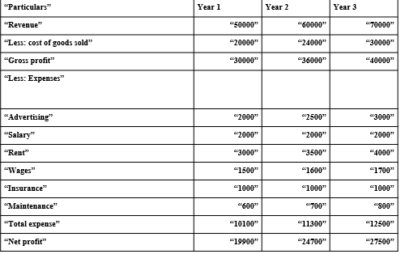
From the above information provided, it could be analysed that future predictions are already effectively done by The Best management wherein the firm has made sure that they meet the set milestone effectively. The information shows that every year 10% increase in profits of the firm will take place along with a 15% increase in the overall sales of the firm. In addition to this, the figures also show that constant increase in each factor of the firm will take place showing the overall growth and success of the firm in the market and this could easily be observed looking at the rent, wages, maintenance, total expenditure, gross profit and the expense made on advertisements (Seetharaman, 2020).
Apart from this, it should also be noted that with the formation of profit and loss account right judgement could be made by the management operating within the firm as to how much spending needs to be made by them each year and how they would be able to meet their milestones set in an effective manner.

CASH FLOW STATEMENT
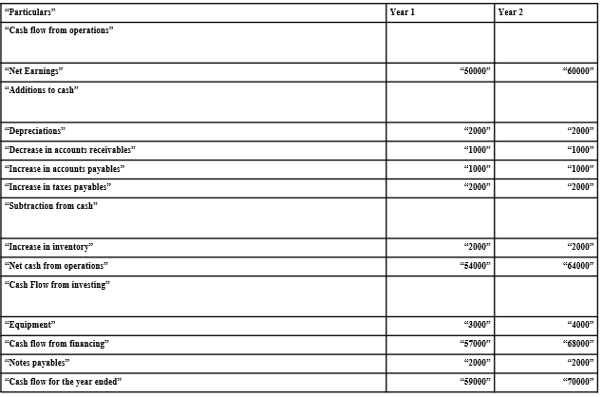
The above information presents the flow of cash that would be taking place within the business in case if the right application of technology and strategies are being implemented. It could be observed that there are a few of the factors that are fixed and does not change over the year and this include depreciation, decrease in account receivables, increase in account payables, and increase in inventory. Apart from this, it can be noted that cash flow being taking place through financing is increasing over the year which states the positive response of the firm in the market indicating towards the attainment of increased profitability and growth. Cash flows stating the inflow and outflow of the cash has also increased for the year ended (Funminiyi, 2018).
Overall, it could be said that the cash flow statement formed will help The Best management in measuring the position of cash of the business made within the accounting year further helping the business in knowing about the cash availability in the business operation effectively. Also, knowing the detailed inflow and cash flow of cash, The Best management would be able to form effective structural analysis for a long and short-term plan keeping in mind the need for working capital as well as level of cash to execute the business effectively.

BALANCE SHEET
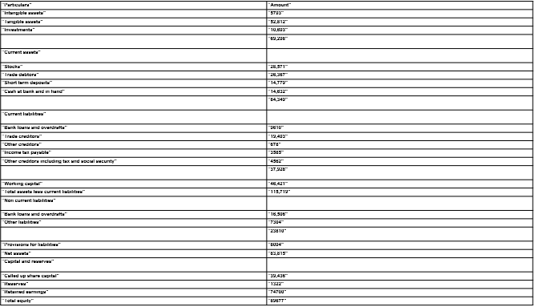
The balance sheet here presented by The Best management shows that the firm has got the tangible and intangible assets along with the investments made by them in order to gain success and growth within the business environment. In addition to this, the firm has also maintained current assets as well as current liabilities, short-term deposits and cash existing in hand and in the bank. This information gained clearly shows that the firm is effectively been able to maintain the right flow of essential aspects and have also measured the various risks associated with them (Jensen et al., 2021). Apart from this, the balance sheet also shows the bank loan, and other liabilities being maintained by the management at The Best with the help of which they would be able to make balance in the assets as well as liabilities being attained by them showing the overall success of the firm in the past years. And as it could be seen that the core purpose of the formation of the balance sheet is to provide the interested parties with an idea about the overall financial position of the firm and hence it is important that the investors came to know about the usage, analysis as well as proper reading up of the balance sheet since proper insight could be gained in terms of the reason for making an investment in the stocks available in an effective manner. Through the information gained here, the firm will also be able to compare the overall growth being made by them over the years as well as try to understand the firm’s ability in terms of undergoing the expansion of the projects as well as the ways in which unforeseen circumstances could arise and needs to be managed. Company funding sources can also be evaluated in terms of which would work best for the overall success and attainment of increased sales within the business environment (Melancon and Dalakas, 2018).

CONCLUSION
The report here undertaken has clearly able to show the business plan formulated for The Best wherein the management operating has made sure that various aspects of business are well taken care of such as the internal and external factors that could create an impact on the business operations, the management, sustainability, implementation of CSR activities, the financial status of the firm including the balance sheet, profit and loss account as well as cash flow statement. In addition to this, the information collected also showed that for the firm to gain success and a sustainable position in the market, it is very essential that implementation of the right technology is being implemented by the firm wherein the skilled employees are hired that have got the right knowledge and understanding of the business environment helping further in the attainment of success and development. Along with this, The Best management has also ensured to keep in mind the Covid-19 situation existing in the market and accordingly come up with the strategies, future plans as well as exit plans that significantly show the effective organisational presence being maintained by the firm within the business environment.

REFERENCES
Abad-Segura, E., Cortés-García, F.J. and Belmonte-Ureña, L.J. (2019). The sustainable approach to corporate social responsibility: A global analysis and future trends. Sustainability, 11(19), p.5382.
Ali, D.J. and Hamad, H.A. (2021). The role of the cash flow statement to provide accounting information for the financial decision-making process:(Case study International Islamic Bank of Kurdistan in the year 2018). QALAAI ZANIST SCIENTIFIC JOURNAL, 6(2), pp.870-887.
Ashrafi, M., Adams, M., Walker, T.R. and Magnan, G. (2018). How corporate social responsibility can be integrated into corporate sustainability: A theoretical review of their relationships. International Journal of Sustainable Development & World Ecology, 25(8), pp.672-682.
Bartik, A.W., Bertrand, M., Cullen, Z., Glaeser, E.L., Luca, M. and Stanton, C. (2020). The impact of COVID-19 on small business outcomes and expectations. Proceedings of the National Academy of Sciences, 117(30), pp.17656-17666.
Bashir, N., Papamichail, K.N. and Malik, K. (2017). Use of social media applications for supporting new product development processes in multinational corporations. Technological Forecasting and Social Change, 120, pp.176-183.
Brandini, A. (2020). Food industry dynamism and evolving business models: food delivery system as a manifestation of food industry's evolution.
Cruz, S.C.S. and Teixeira, A.A. (2021). Spatial analysis of new firm formation in creative industries before and during the world economic crisis. The Annals of Regional Science, pp.1-29.
Funminiyi, A.K. (2018). Impact of Organisational Structure on Employee Engagement: Evidence from North Central Nigeria. International Journal of Advanced Engineering, Management and Science, 4(8).
Goryńska-Goldmann, E., Gazdecki, M., Rejman, K., Łaba, S., Kobus-Cisowska, J. and Szczepański, K. (2021). Magnitude, Causes and Scope for Reducing Food Losses in the Baking and Confectionery Industry—A Multi-Method Approach. Agriculture, 11(10), p.936.
Halkos, G. and Skouloudis, A. (2018). Corporate social responsibility and innovative capacity: Intersection in a macro-level perspective. Journal of cleaner production, 182, pp.291-300.
Hall, R. (2018). Partnership accountability. In Men’s ways of being (pp. 211-237). Routledge.
Jensen, C., Fang, K., Grech, A. and Rangan, A. (2021). Trends in Sales and Industry Perspectives of Package Sizes of Carbonates and Confectionery Products. Foods, 10(5), p.1071.
Johnston, D.W., Kung, C.S. and Shields, M.A. (2021). Who is resilient in a time of crisis? The importance of financial and non‐financial resources. Health Economics, 30(12), pp.3051-3073.
Keers, B.B. and van Fenema, P.C. (2018). Managing risks in public-private partnership formation projects. International Journal of Project Management, 36(6), pp.861-875.
Maxwell, J. and Metz, K. (2021). How Technology Life Cycles Increase the Financial Position of the Firm. American Journal of Management, 21(3), pp.1-8.
Melancon, J.P. and Dalakas, V. (2018). Consumer social voice in the age of social media: Segmentation profiles and relationship marketing strategies. Business Horizons, 61(1), pp.157-167.
Pantazia, M. (2021). Towards a Criticism of Profit and Loss Account. Accounting and Management Information Systems AMIS 2021, p.208.
Pell, D., Mytton, O., Penney, T.L., Briggs, A., Cummins, S., Penn-Jones, C., Rayner, M., Rutter, H., Scarborough, P., Sharp, S.J. and Smith, R.D. (2021). Changes in soft drinks purchased by British households associated with the UK soft drinks industry levy: controlled interrupted time series analysis. BMJ, 372.
Popova, O., Koval, V., Antonova, L. and Оrel, A. (2019). Corporate social responsibility of agricultural enterprises according to their economic status. Management theory and studies for rural business and infrastructure development= Vadybos mokslas ir studijos-kaimo verslų ir jų infrastruktūros plėtrai: mokslo darbai, 2019, vol. 41, no. 2, p. 277-289.
Seetharaman, P. (2020). Business models shifts: Impact of Covid-19. International Journal of Information Management, 54, p.102173.
Sgroi, F., Donia, E. and Mineo, A.M. (2021). Company Competitiveness as a Variable Success Strategy for the Territory and the Environment. Quality-Access to Success, 22(180).
Statista (2021). Turnover of enterprises for the manufacture of cocoa, chocolate and sugar confectionery in the United Kingdom (UK) from 2008 to 2019. [online] Available at <https://www.statista.com/statistics/481625/chocolate-and-sugar-confectionary-sales-turnover-united-kingdom-uk/> [accessed on 28th October 2021]
Symeonidis, G. (2017). Does product market competition increase strike activity? Evidence from the UK. European Economic Review, 97, pp.42-56.

PRESENTATION SLIDES
Slide 1

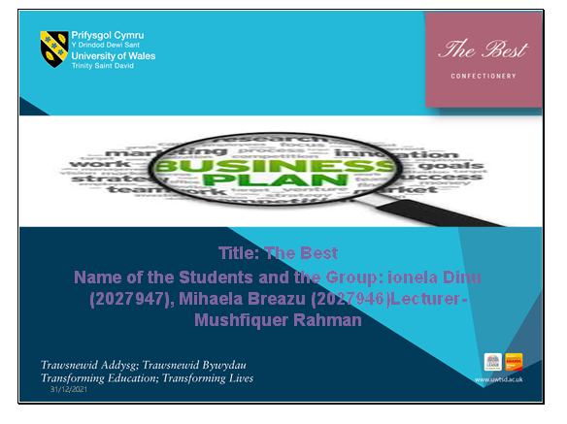

Slide 2

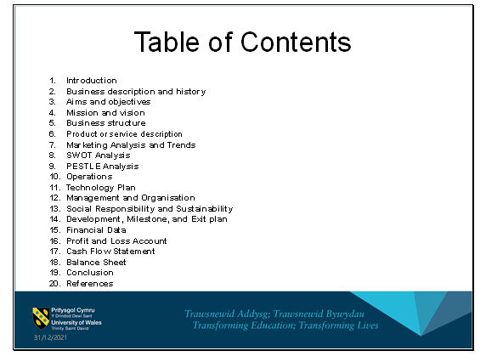

Slide 3

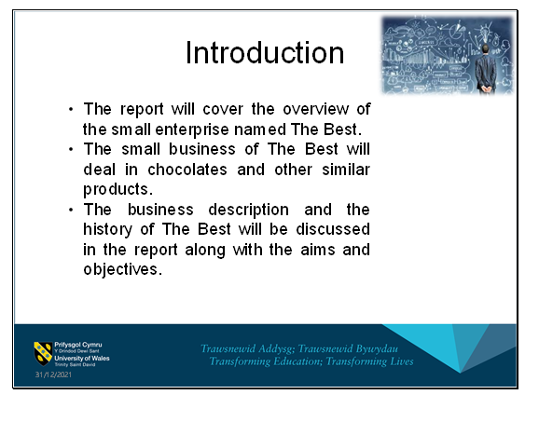

The mission and vision of The Best and the business structure will also be included in the report. The description of the new product to be launched and the market analysis for the enterprise will be discussed below along with the SWOT and PESTEL analysis. Operations, technology plan, and management and organisation will also be elaborated in the report. The sustainability and the social responsibility of the business along with its development, milestone and exit plan will be included in the report as well. An overview of the financial data including the cash flow statement, profit and loss account, and balance sheet will also be included in the report.

Slide 4

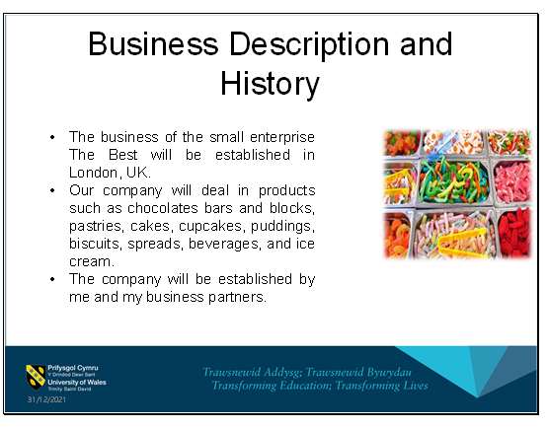

We have a business plan of increasing the range of products and services of the company along with an increase in the number of customers. The target market of the company will include the young generation. We aim at increasing the reach of the company and have setups in various regions in the UK and other parts of the world.

Slide 5

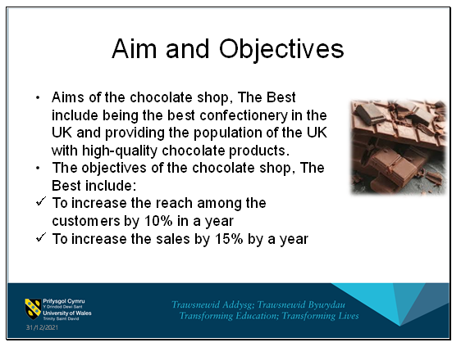
To increases the profitability by 10% by an year
To launch 4 new products within an year

Slide 6

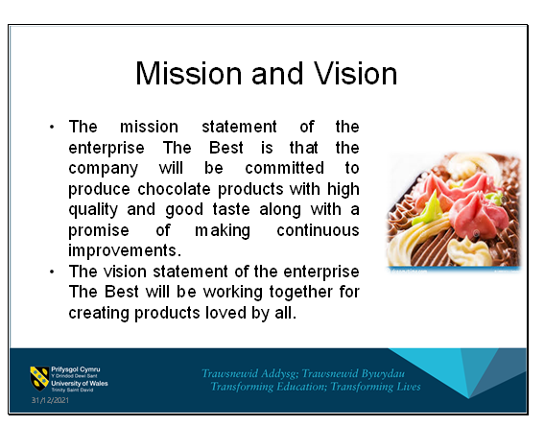
The vision of the company states that the company will value everyone associated with The Best including the consumers and the stakeholders and the company will be passionate about continuously improving the products and their services.

Slide 7

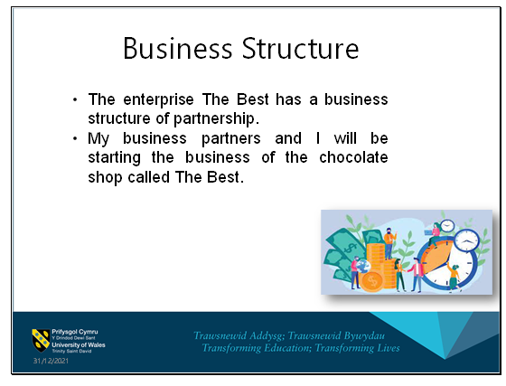
All of us having equal ownership of the company will be responsible for all the risks and losses associated with the business and will be entitled to the entire amount of profit. Our personal accounts will be under risk when legal issues are faced by the company.

Slide 8

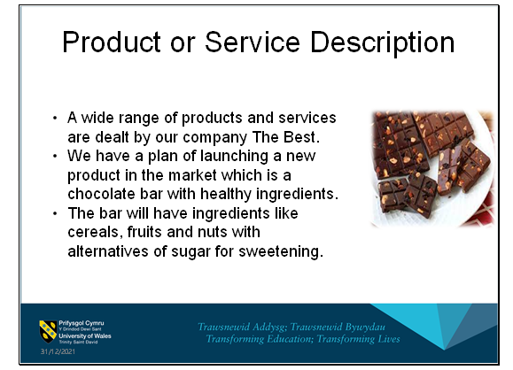
The chocolate bar will be named Mixed choco. The Mixed choco will include ingredients like granola, muesli, hazelnut, almond, and orange. The product is to be made sugar-free consisting of minimal calories. The health benefits of the products makes it more available to the individuals with diabetes and other diseases as well as the people concerned about their health.

Slide 9

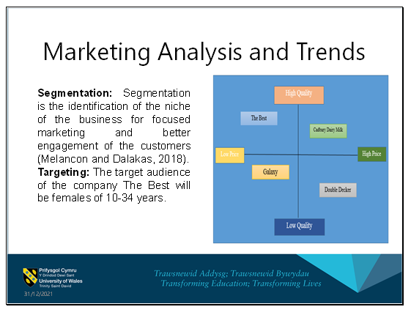
The sectioning of the audience of The Best can be based on psychographic segmentation considering the activities, lifestyle and hobbies. The segmentation of the audience can be demographic considering the gender, age and occupation. Majority of the customers of The Best will be from the age group of 10-34 years and who are mostly women.
The children of the age group of 10-18 years are also an important part of the target audience. The students will mostly be the customers of the products of The Best. The young generation of the age group of 20-35 years might also be the part of the target audience.
Positioning

Figure 1: Positioning
(Source: Created by author)
Trends
Current trends in the market for confectionery industry include:
Including various types of citrus fruits other than orange in the manufacturing of the products.
Including the dessert as a component in the manufacturing of the chocolate products.
Incorporation of vegetables in the ingredients of the chocolate products (Jensen et al., 2021).
Incorporation of various types of nuts like peanuts, almonds, and hazelnuts in the products.
Use of floral notes and white chocolate in the chocolate products.
As of 2019, the turnover of the confectionery industry of the UK is 4 billion pounds.

Slide 10

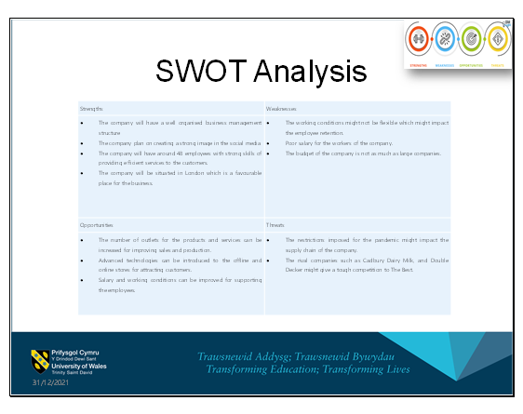
Strengths
Weaknesses
The company will have a well organised business management structure
The company plan on creating a strong image in the social media
The company will have around 48 employees with strong skills of providing efficient services to the customers.
The company will be situated in London which is a favourable place for the business.
The working conditions might not be flexible which might impact the employee retention.
Poor salary for the workers of the company.
The budget of the company is not as much as large companies.
Opportunities
Threats
The number of outlets for the products and services can be increased for improving sales and production.
Advanced technologies can be introduced to the offline and online stores for attracting customers.
Salary and working conditions can be improved for supporting the employees.
The restrictions imposed for the pandemic might impact the supply chain of the company.
The rival companies such as Cadbury Dairy Milk, and Double Decker might give a tough competition to The Best.
Table 1: SWOT analysis
(Source: Created by author)

Slide 11

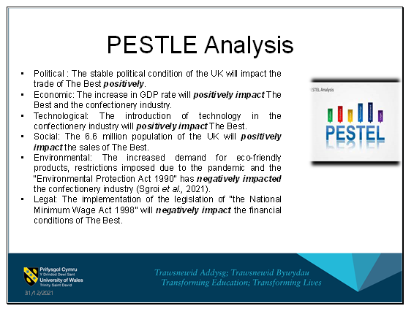
PESTLE Analysis

Elements
Macro factors
Implications
Political
Political condition
Brexit
The stable political condition of the UK will impact the trade of The Best positively.
The introduction of Brexit has increased the cost and will negatively impact The Best.
Economic
GDP rate
Inflation rate
The increase in GDP rate will positively impact The Best and the confectionery industry.
The increase in the inflation rate will negatively impact The Best.
Technological
Strong technological base
The introduction of technology in the confectionery industry will positively impact The Best.
Social
Population
Per capita income
The 6.6 million population of the UK will positively impact the sales of The Best.
The decrease in the per capita income of the UK will negatively impact the sales of The Best.
Environmental
Eco-friendly products
COVID-19
“Environmental Protection Act 1990”
The increased demand for eco-friendly products, restrictions imposed due to the pandemic and the “Environmental Protection Act 1990” has negatively impacted the confectionery industry (Sgroi et al., 2021).
Legal
Changes in legislation
Rules and regulations
Changes in “Employability Rights Act 1996”, “Equality Act 2010” and “Health and Safety Act 1974” have positively impacted the confectionery industry (Symeonidis, 2017).
The implementation of the legislation of “the National Minimum Wage Act 1998” will negatively impact the financial conditions of The Best.
Table 2: PESTEL analysis
(Source: Created by author)

Slide 12

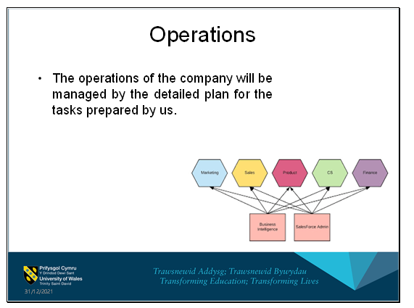
The manufacturing, investing, marketing, management of human, financing, and delivery of products and services to the customers will be the activities of the enterprise The Best.

Slide 13

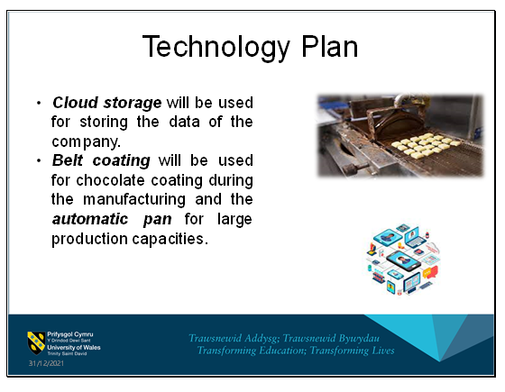
We have a plan of using modern technologies in the manufacturing and the packaging of the products. The delivery and online stores of the company will also use modern technology for providing better services to the customers.

Slide 14

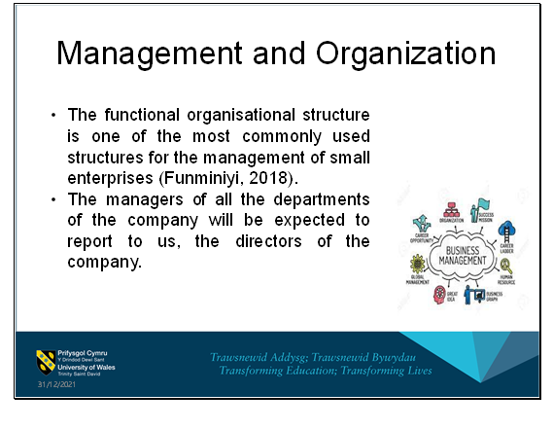
We will appoint a manager of the company for handling all the activities of the business. The management includes planning, staffing, controlling, leading, and motivating. The organisational structure of the business of The Best will be functional organisational structure.
This type of organisational structure is helpful in separating the departments based on expertise which increases the efficiency of the management of the business of The Best.

Slide 15

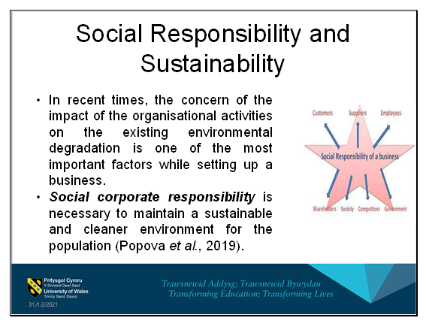
The company will strictly follow the policies of corporate social responsibility. More natural ingredients and organic fruits and vegetables will be used for the manufacturing of the products of The Best. Our company will focus on improving the livelihoods of the cocoa farmers by helping them economically. Biodegradable components will be used for the packaging of the products of the company for maintaining sustainability.

Slide 16

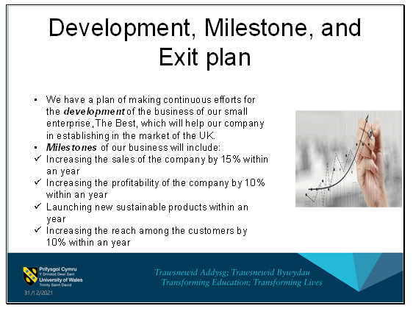
The business of our company will be improved through implementing strategies of better marketing plans for spreading awareness among the customers. The production and sales of our company will be increased through increasing the number of stores which will also increase the number of customers of the chocolate shop.
We can use several exit plans for the company in case of huge losses. We can continue the business of the company by including our family members which will prevent our complete separation from the business. Merging with another small enterprise dealing in confectioneries with similar aims and objectives can be one of the best ideas for an exit plan for our company. The terms and the prices can be negotiated through merging. Our business can also be continued publicly with an IPO and we can earn substantial profit through it.

Slide 17

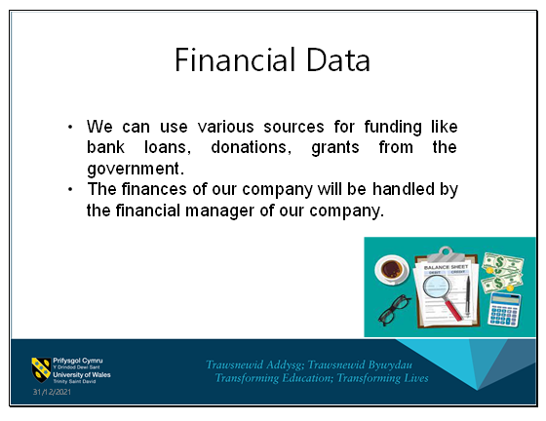
The investment will be done accordingly for gaining profits and development of our company.

Slide 18

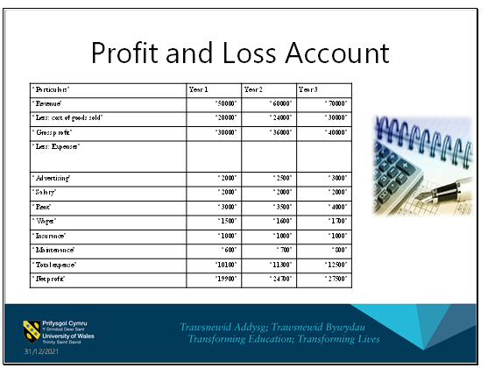
“Particulars”
Year 1
Year 2
Year 3
“Revenue”
“50000”
“60000”
“70000”
“Less: cost of goods sold”
“20000”
“24000”
“30000”
“Gross profit”
“30000”
“36000”
“40000”
“Less: Expenses”
“Advertising”
“2000”
“2500”
“3000”
“Salary”
“2000”
“2000”
“2000”
“Rent”
“3000”
“3500”
“4000”
“Wages”
“1500”
“1600”
“1700”
“Insurance”
“1000”
“1000”
“1000”
“Maintenance”
“600”
“700”
“800”
“Total expense”
“10100”
“11300”
“12500”
“Net profit”
“19900”
“24700”
“27500”
Table 3: Projection of profit and loss
(Source: Created by author)

Slide 19

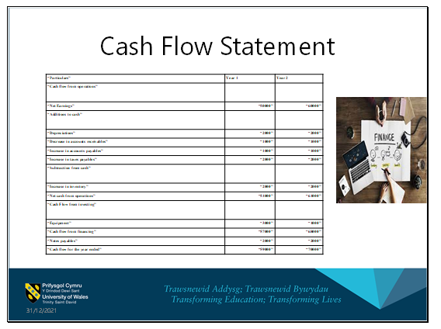
“Particulars”
Year 1
Year 2
“Cash flow from operations”
“Net Earnings”
“50000”
“60000”
“Additions to cash”
“Depreciations”
“2000”
“2000”
“Decrease in accounts receivables”
“1000”
“1000”
“Increase in accounts payables”
“1000”
“1000”
“Increase in taxes payables”
“2000”
“2000”
“Subtraction from cash”
“Increase in inventory”
“2000”
“2000”
“Net cash from operations”
“54000”
“64000”
“Cash Flow from investing”
“Equipment”
“3000”
“4000”
“Cash flow from financing”
“57000”
“68000”
“Notes payables”
“2000”
“2000”
“Cash flow for the year ended”
“59000”
“70000”
Table 4: Cash flow statement
(Source: Created by author)

Slide 20

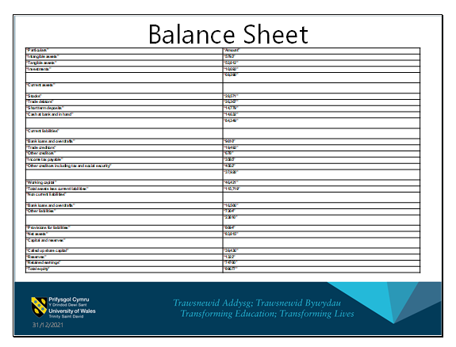
“Particulars”
“Amount”
“Intangible assets”
“5793”
“Tangible assets”
“52,812”
“Investments”
“10,693”
“69,298”
“Current assets”
“Stocks”
“28,571”
“Trade debtors”
“26,367”
“Short term deposits”
“14,779”
“Cash at bank and in hand”
“14,632”
“84,349”
“Current liabilities”
“Bank loans and overdrafts”
“9610”
“Trade creditors”
“19,493”
“Other creditors”
“678”
“Income tax payable”
“3585”
“Other creditors including tax and social security”
“4562”
“37,928”
“Working capital”
“46,421”
“Total assets less current liabilities”
“115,719”
“Non current liabilities”
“Bank loans and overdrafts”
“16,506”
“Other liabilities”
“7304”
“23810”
“Provisions for liabilities”
“8094”
“Net assets”
“83,815”
“Capital and reserves”
“Called up share capital”
“39,436”
“Reserves”
“1322”
“Retained earnings”
“74700”
“Total equity”
“89677”
Table 5: Balance sheet
(Source: Created by author)

Slide 21

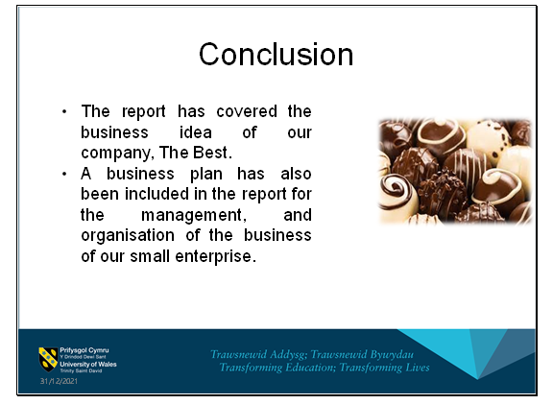
The SWOT analysis of the company and the PESTEL analysis for the confectionery industry has also been covered in the report for the assessment of conditions for its development in the UK along with the financial data of the company.

Slide 22

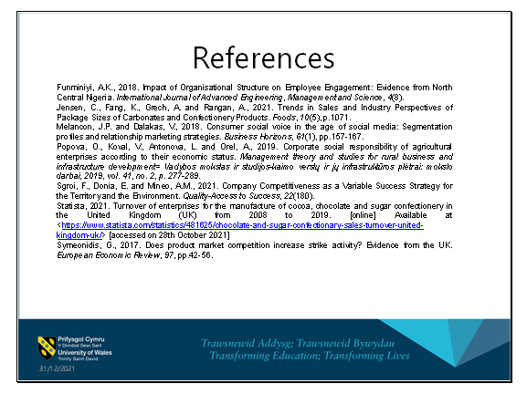

Slide 23

