Daniel Ford
P150595
Robert Jones/Chris Buxton
M6X01899
Word Count: 2392

Specialism Report
Throughout my time in university I have made a variety of different genre films. I have written, produced and directed every film I have made, some have gone horribly wrong and some have worked. The one movie that stands out for me is the documentary I made about a wrestling promotion, which developed my confidence behind the camera. This documentary led on to a mockumentary, which follows the same codes and conventions, in that mockumentaries are observational just like documentary and can take different forms.
The role of Director I have enjoyed through working on projects that I have written, the area I am specialising in is directing, especially the comedy included in mockumentary. Directing mockumentaries allow actors to play with their roles and improvise; playing with the idea of scripted and unscripted dialogue is a technique I enjoy. The visual style of a mockumentary is often handheld and can be used for close-ups, which will convey character reaction. Mockumentary was once an underground genre with series such as The Office, which has helped draw audiences to this style of filmmaking. Within most mockumentaries the comedy used is observational and also are topic themes concentrate on society such as the reality show generation.
Mockumentary can appeal to audiences that are interested in watching the mocking of social topics such are celebrity status, the class system, cultural topics and LGBTQ. The observational convention of documentary is used within the mockumentary genre to great effect and is often dialogue driven. Mockumentary is a hybrid genre and walks a fine line between fictional and factual, which plays with audiences due to the documentary style. (Mast, 2009)
Two directors that have inspired my choice in making a mockumentary were Tom George and Larry Charles, both have different backgrounds in film. Tom George is a director of This Country, a mockumentary series about two cousins who live in the Cotswolds. Kerry and Kurtan want more from their lives and look to the show in order to showcase their talents. This Country is a BBC Three funded television show, as a mockumentary series This Country has inspired the visual style of my film due to its use of handheld and close ups of character reaction. (Bradshaw, 2008)
Tom George started as a runner and worked his way up to directing and eventually directed his own short film, which led to him gaining recognition with peers in the industry. As George states:
On set we shoot a mix of one and two cameras and always let the logic of the documentary style lead the way. We want the show to have an “under cut” feel, rather than cutting to a different angle or a different take every few seconds. This fits the observational documentary style, but it’s also a performance preference for me. Watching a scene unfold without lots of camera cuts draws you into the performances. (Bradshaw, 2008)
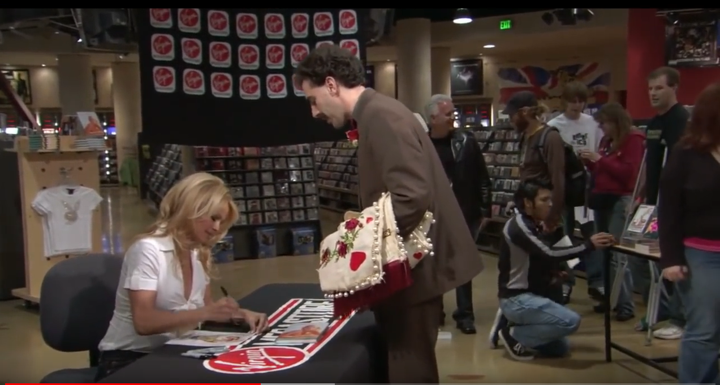
Fig 1. Screenshot from Borat (2006)
Another influence in terms of mockumentary has been Larry Charles, Charles’ style of mockumentary is improvisational comedy. Charles is best known for directing Seinfeld and Entourage which were big hits with audiences around the world. Larry Charles has a strong relationship with Sacha Baron Cohen whose films are always character driven, and with him taking the lead role. As a director Charles pushed boundaries in order to give his actors the opportunity to showcase their skills; Bruno one of Charles’ films, critiques social topics of homophobia, celebrity and fame. Charles has given Baron-Cohen the platform to demonstrate his various characters and this collaboration has produced well-known mockumentaries such as Borat (2006) and The Dictator (2012). In discussing his improvisational style Charles states,
When we're doing scenes at real locations with real people, someone may step into the scene and suddenly become the focus of the scene. And we have to, on the fly, be able to shift our plan right there at the moment and sort of seize this new direction (Bradshaw, 2018).
Larry has always directed stage scripted comedy such as Seinfeld which encourages the use of improvisation. Larry later went on to direct Borat and developed a good working relationship with Baron Cohen. This later lead to him directing two further Baron Cohen films, Bruno and The Dictator. (Weinman, 2009, P.69)
Directing comedy or directing in general has not been the route I initially wanted to undertake, however, directing my own projects that I have written has always been something I enjoy, as this gives the opportunity to visualise fully my intentions. I also take a responsible attitude to the organisation needed to facilitate the production process. When the course started I had an idea in mind of the career route I wanted to take but this has since developed. The degree has enabled me to hone my directional skills. There are many directors that have influenced my directional style including Alfred Hitchcock and James Wan, who I analysed in detail through contextual practices. Hitchcock and Wan have inspired how I direct my actors due to the hands on approach of their actors, in order to drive dialogue and build characters, although have not visually influenced the content of my work due to the difference in genre.
Comedy directors that have influenced the way I interpret the genre are Judd Apatow, Edgar Wright and Robb Reiner to name a few. Apatow’s films include The 40 Year Old Virgin and This is 40. His style of writing has inspired the way I wrote my script. Apatow writes awkward comedy to great effect, the male lead in my film has the same mannerisms and traits within the dialogue, which is then exaggerated through acting within films. Apatow discusses his approach to comedy: “It’s easy to beat up on people for their attempts at growing, but it takes great courage to be funny, to go for hard-funny, for thoughtful-funny, to go for drama” (Weiner, 2015).
Rob Reiner directed Spinal Tap a mockumentary about a rock band trying to make it into the music industry, audiences that watched the film actually believed it to be about a real band, due to the visual and documentary style. The script was strong, and the performances from the actors successful due to the realism conveyed (Muir, 2010).
Writing comedy has presented myself with a difficult challenge opposed to horror, comedy is technically easier to film due to in my case the realistic location, which was Swansea city centre, but the real test for the film will be the audience screenings. As a film lover, I have always felt drawn to the horror genre and have written horrors in the first and second years of the degree and this was a genre that I saw myself developing for my final film. However, my strengths do not lie within the horror genre at this point of my career, as I do not feel confident to play with the cinematic tropes that this genre offers. Currently I enjoy directing comedy, and this is one of the areas that I would like to develop further.
I find the roles and responsibilities of directing my own films enjoyable because it is a chance to put visualisation into the script. Watching your idea develop eventually into a film, is for me the most fulfilling part of a director’s role. The improvisational nature of mockumentaries is what inspires me to direct actors. Holding auditions for the two main roles of my major project was a very exciting opportunity to test this out. The auditioning process of the film was a stimulating experience as it was the chance to understand the casting process. It is also important that a director makes his actors feel at ease in order to get the best out of them.
Auditioning actors was my chance to sell my directorial style and try and integrate as much of my personality as possible. The casting component of the module became difficult as the four actors that auditioned for the two main roles were both excellent, however, after conversations with a trusted colleague I was able to cast the two roles successfully and was happy with the decisions made.
As part of my preparations for the auditioning process of my major project I did some research on how to deal with improvisation. The casting process was vital and finding experienced actors was important as my mockumentary had a lot of leeway for interpretation.
While holding auditions I spoke to my two actors about improvising a scene of my script, my actors responded well to the flexibility of their roles. Before beginning the shoot I read relevant sections of Directing Film Techniques and Aesthetics; this book helped inform some of my decisions including the importance of protecting my cast from tensions with crew and keeping professional practices on set (Rabiger, 2008).
My style of directing within this film was very relaxed; I have my own visual style, throughout the films I have produced, written and directed. I like to bounce ideas around with my cast and crew in order to create a fun and professional working environment and to develop engagement with the project.
The filmic aesthetics of this project was similar to Tom George’s style, which is to make use of long takes with very little cut always to other camera angles. This is a style I adopted in part due to limitations including time and a small crew, but also a directorial choice, which is often associated with mockumentaries. This style I believe, drew solid performances from my cast and also allowed for the portrayal of unscripted unpredictable events, which was the intention of my film and supported by Bradshaw (2008) although understand that sometimes long takes can lose the audience’s attention. The long takes I directed were improvised scenes due to the nature of the genre, having used a couple of long takes, it was really important that the characters were engaging. I felt my actors Scott Christie and Rebecca Donovan drove the dialogue in the script forward and they responded to my direction well.
This is further supported by Mike Leigh’s process of how he drives performances from his actors: “I’ll set up an improvisation, I’ll analyse and discuss it, we’ll do another, and I’ll refine and refine until the actions and dialogue are totally integrated. Then we shoot it” (Mike Leigh, 2014). It was important to drive performances from my actors, before the shoot I sat down with them and discussed the character profiles as it would help them get into character. The purpose of this excercise was to give a back story of each persona as well as bouncing idea with each other.
I only had one camera on the shoot, the role of Director of Photography were alternated due to a clash of personality with the original Cinematographer; on the first day we filmed in a hotel, which was set dressed to look like the main character’s bedroom, there were also some technical difficulties and personality clashes that were quickly rectified due to clear direction, balancing the creative and technical side of directing, this also became easier as the shoot went on. The second day of the shoot I think my own cinematography told the story through POV shots, which complements the mockumentary. The mix of the staged and POV shots worked well and compliments the codes and conventions of the mocumentary genre.
The equipment used was a Canon 70D and shoulder rig to stabilise the hand held shots used in the film, sound equipment such as a shotgun mic and boom pole were used. We also used different camera lenses dependent on the type of shot and scene.
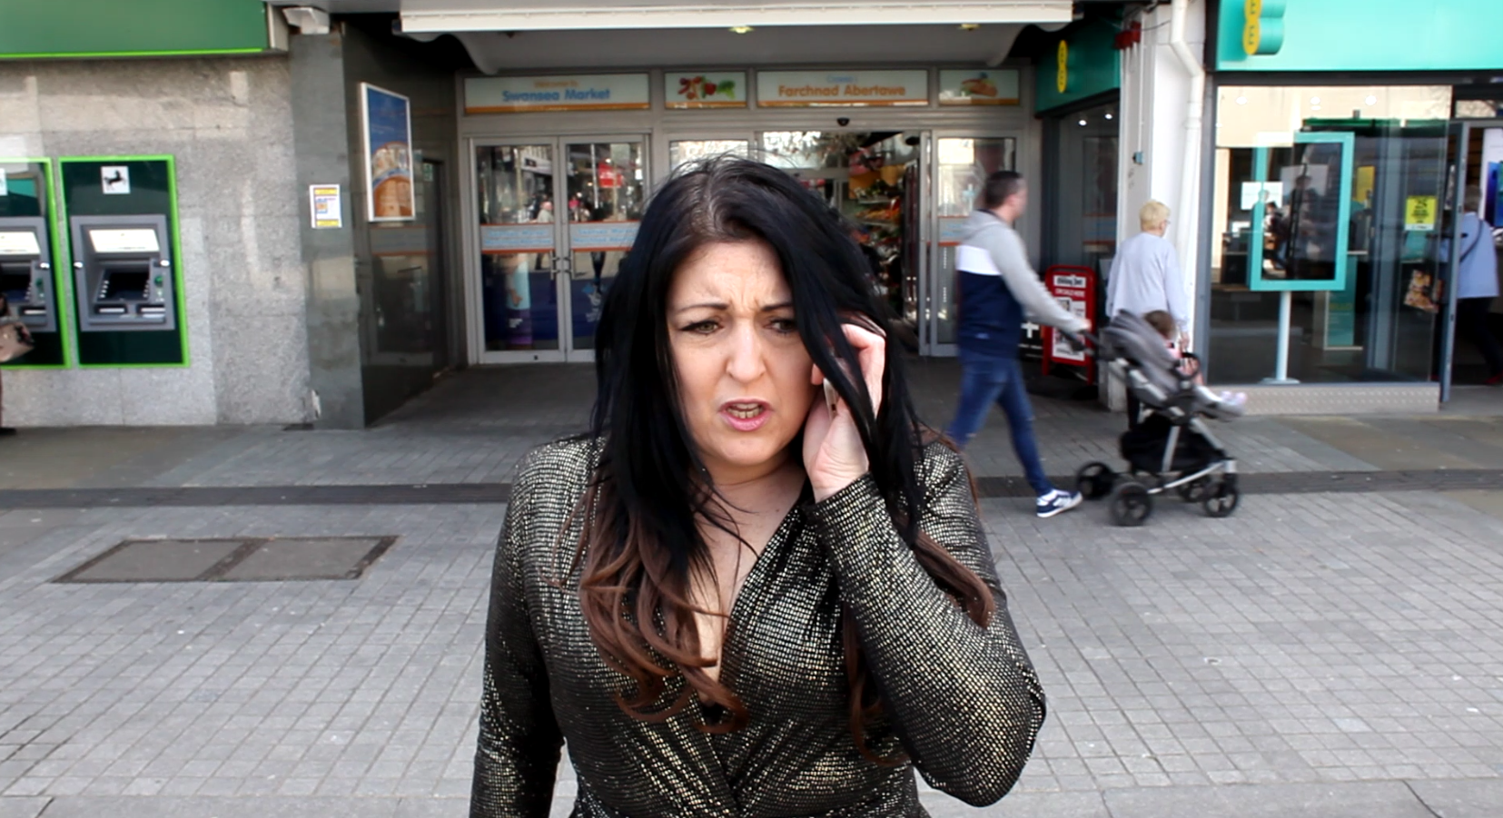
Fig.2 Screen grab of Little Big Brother (2019)
The film I think tells the story of how a population of the public inspire to be on TV and highlights how shallow and unfulfilling that kind life could be. Although this was an improvised comedy it is important to have some underlying story arc, which in Little Big Brother was Reality TV and it’s relationship in society. As a Director it is important to have an underlying message encoded in the work.
If I was to reshoot the film, I would have a two-camera set up just as Tom George does in This Country. The two-camera set up would have worked for my chosen film but due to financial limitations, booking equipment and lack of a crew, this was not something I pushed for but should have in hindsight.
Directing my own short film has challenged me in a lot of different ways, one of the most important lessons learnt through this process was building my own confidence, which is a very important attribute of a director. Working with a new group of people was refreshing at it enabled me to learn how to work in a team with people I did not know very well. The whole process engaged me fully and has ignited a passion to develop this area further. I am also writing a sequel then another script and hopefully expanding my directing experience. I have also lined up experience with Bad Wolf on leaving the course.

Bibliography

Books
Muir, J. K. (2010). This Is Spinal Tap: Music on Film Series. Limelight Additions.
Rabiger, M. (2008). Directing Film Techniques and Aesthetics . London: Focal Press.
Images
Fig 1. Charles, L. (2006) Borat [Film] Available at: https://www.youtube.com/watch?v=vqDcC-CrYOI Accessed date: 20th May 2019
Fig2. Ford, D. (2019) Little Big Brother [Film] Available at: https://www.youtube.com/watch? v=zR49JcK9x1o Accessed date: 20th of May 2019

Websites
Bradshaw, N. (2008, July 30). 'My top tip? Never sign a release form'. Retrieved from The Guardian: Available at: https://www.theguardian.com/film/2008/jul/29/larry.charles Accessed date: 10th May 2019
Collins, J. (2018). 'Write stuff, film sketches' This Country director Tom George on starting out, directing TV and more. Available at:: https://www.mandy.com/news/this-country-comedy-tv-series-interview-director-tom-george# Accessed date: 10th May 2019
Grow, K. (2014) Rob Reiner on Life Imitating Art with ‘This is Spinal Tap’ Available at: https://www.rollingstone.com/music/music-news/rob-reiner-on-life-imitating-art-with-this-is-spinal-tap-203993/ Accessed: 16th May 2019
Mike Leigh’s process and techniques. (2014). Available at: http://www.actorhub.co.uk/383/mike-leighs-process-and-techniques Accessed date: 10th May 2019
Weiner, J. (2015, July 14). Judd Apatow: The Rolling Stone Interview. Available at: https://www.rollingstone.com/movies/movie-news/judd-apatow-the-rolling-stone-interview-62034/ Accessed date: 10th May 2019
Journal
Mast, J. (2009). New directions in hybrid popular television: a reassessment of television mock-documentary. Media, Culture & Society, pp.231- 250.
Weinman, J. (2009). The Other Man Behind Bruno. Maclean's, pp.69-70.

