Elis Edwards
HND Applied Computing
Introduction to Web and Database Concepts

Contents
No table of contents entries found.

1. Introduction
CraftGem is a small independent handmade jewellery business that previously managed its operations through manual systems. This included customer information, tracking, order processing and inventory management using paper records. This approach is no longer efficient in this day and age and is unsuitable for a business that is looking to grow.
To resolve this issue a relational database system was developed using Microsoft Access. The goal of this database was to help improve operations by enabling digital data entry tracking of customers orders, inventory management and easy access to business reports. The reason Microsoft access was chosen was due to its built-in tools for form creation, queries and reports. All of which suited a company that isn’t used to being technical.
The development process followed structured design methods starting with the creation of entity relationship diagram, normalised tables and clearly defined relationships. The system includes user friendly forms with simplicity and room for customisation with easy navigation between all other forms and reports to support informed decision making. This report documents the development of the system, including screenshots.

2. Screenshots and Explanation of Development
The database includes the following tables: Customers, Orders, OrderDetails and Items. Each table contains fields with auto number primary keys and appropriate foreign keys to enforce referential integrity.
Customers- CustomerID (Primary Key), FullName, Email, PhoneNumber
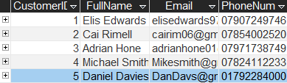
Items – ItemID (Primary Key), ItemName, Description, QuantityStock, Price
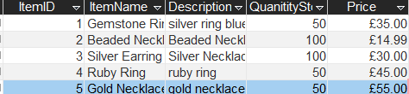
Orders – OrderID (Primary Key), CustomerID, OrderDate, Status
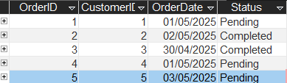
OrderDetails – OrderDetailsID (Primary Key), OrderID, ItemID, Quantity
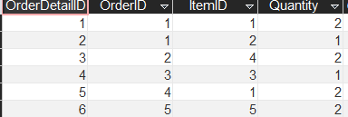
All tables were designed to conform to Third Normal Form, ensuring that data is atomic and are functionally dependent on the Primary Key. This level of normilsation ensures that the database avoids common anomalies such as data duplication and update inconsistencies.
For example, in the orders table the customerID serves as a foreign key linking to the customers table. This means that only customers from that table can be associated with orders, therefore maintaining consistency and no issues arising, This is also done through the other tables and brings me to the next talking point.
Relationships were established using the Access Relationship tools. For example, CustomerID in customers was connected to CustomerID in orders, OrderID in Orders was connected to OrderID In OrderDetails and ItemID in Items was connected to ItemID in OrderDetails.
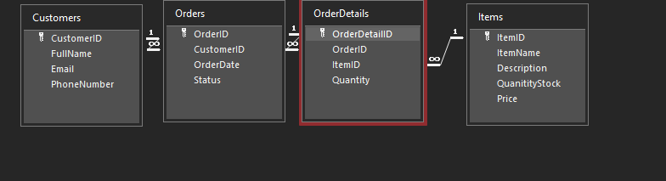
Referential integrity was enforced across all relationships. This ensures that every foreign key value must match an existing primary key. This goes back to the point of ensuring consistency throughout all the tables.
The ERD (Entity relationship Diagram) was used to visually plan the relationships between the tables. It helps identify how each table will interact and ensure that data flow was logical and efficient.
Forms were developed to allow user to input and edit all the data easily. Each form includes navigation features such as built in navigation buttons to cycle through each record, these forms show all details about the customers orders, and items. Each form can be easily accessed through the main menu as well with all of this shown below.
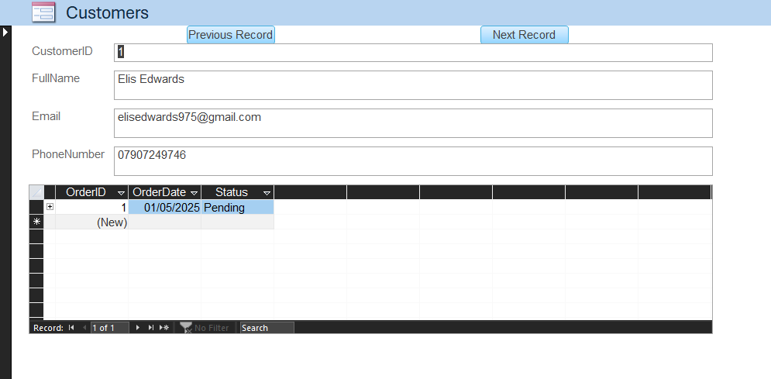
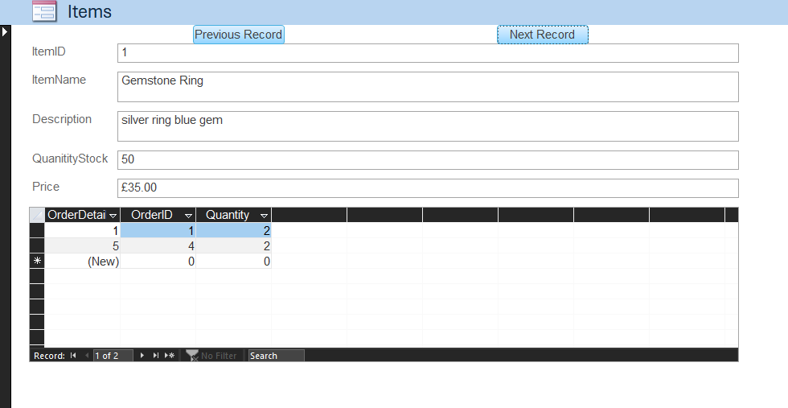
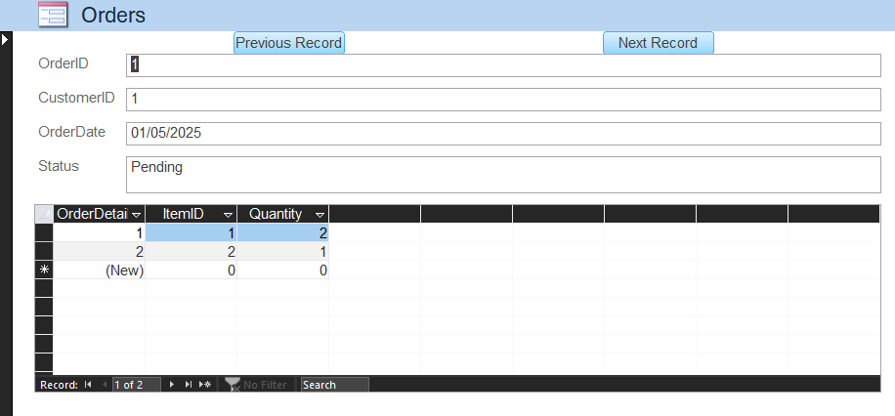
Record selecting was placed at the top to cycle through the five example customers that were placed as well as the five items and the orders placed by these customers.
Currently one query was created which was LowInventoryQuery, this was added to show an example of what queries can do with the business being able to add more as time goes on. This query was designed to identify jewellery items that are frequently being ordered and may require restocking. It is based on data from the orderdetails table specifically of item quantity.
This query acts as an inventory flag, helping staff anticipate when to restock certain items, despite no inventory table being created it was designed through how often an item is purchased to see what’s popular and might continue to be purchased.
One report was generated from this query being Low inventory report, this report formats the results of the query in a readable layout with headers item names and quantity indicators, this is the layout with no example shown as items were not purchased enough.
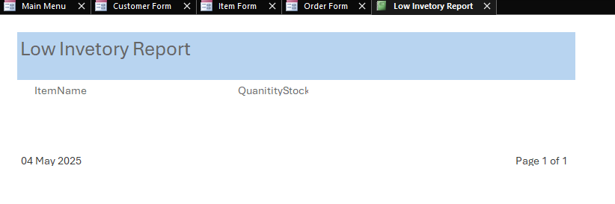
Future development could allow for more queries and reports to be made this is just an example of what the business can do and can grow its database out further.
As stated above a menu was created to cycle between all the forms and serves as the main navigation hub, this links to the customer form items form orders form and the low inventory report.
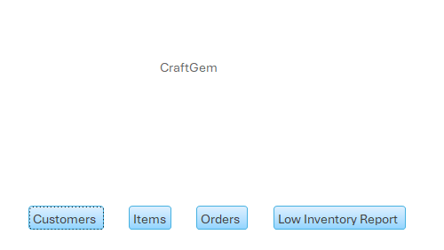
Each button is linked using embedded macros for navigation to open the relevant form. This provides easy access and is easy to use as it opens up immediately once the file is opened as done through settings.

3. Justification for Queries and Reports
The low Inventory query was selected for CraftGem’s operational context. Despite the original non digital format this company used, if there is to be growth this query will allow for estimating item demand and ensuring customers can always access what they need. An additional inventory log would require additional inputs from the business which could be later added for more use.
The same logic goes for the report of the inventory, the report translates the data into a visual printable format making it easier for the company to know where the demand is, it can be used in weekly planning meetings or shared with suppliers to ensure a constant flow of products and nothing is ever sold out when in demand.
While only one query and report were implemented, the system design leaves room for plenty of future expansion, this is just a taste of what the company could have. Businesses need to constantly evolve and taking the step to go digital is a move in the right direction for this company and its products and customers.

References
Michael Alexander, 2018, Microsoft Access 2019 Bible, Available at: https://books.google.co.uk/books/about/Access_2019_Bible.html?id=xQNuDwAAQBAJ&redir_esc=y (Accessed 01/05/2025)
Microsoft, Date Unknown, Create edit or delete a relationship, Available at: https://support.microsoft.com/en-gb/office/create-edit-or-delete-a-relationship-dfa453a7-0b6d-4c34-a128-fdebc7e686af (Accessed 02/05/2025)

