Sabah Kauser 2026079

Module - Health, Wellbeing and Sustainable Development

Assignment Title - Component 1 – Written Report
Lecturer - Chloe Harries

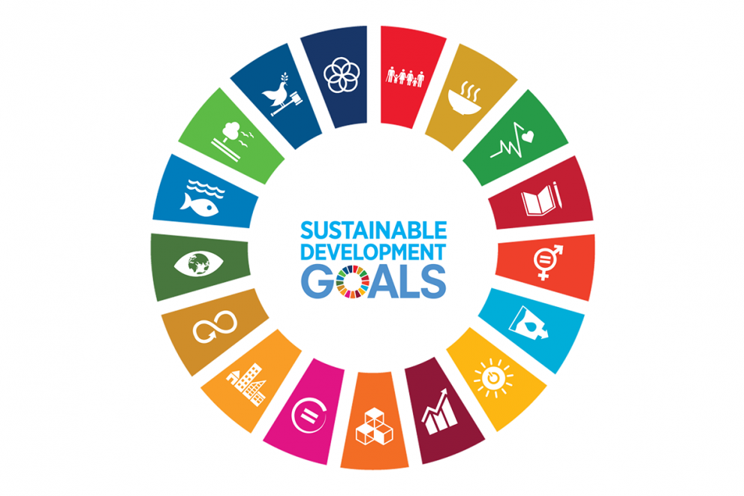(European Commission, 2022)

Contents
Introduction ……………………………………………………………………………....3
Introduction to concepts …………………………………………………………...….4
Sustainable Development ……………………………………………………………..5
Four Pillars Of Sustainability ………………………………………………...……….5 -6
Health …………………………………………………………………………………….. 6 - 7
Sustainable Development Goals ……………………………………………………..8 – 11
Goal A – Good Health and Wellbeing ……………………………………….. ……..12 - 14
Target 1 - 3.4 …………………………………………………………………………… 14 - 16
Target 2 – 3.8 ………………………………………………………………….….…….. 16 - 17
Goal B : Ensure access to affordable, reliable, sustainable, and modern energy for all ………………………………………………………………………….…………..……… 17 – 19
Target 1 – 7.1 …………………………………………………..………………………….19
Target 2 – 7.2 ………………………………………………………..…………………….20
Conclusion ………………..…………….…………………………………………………21
References ……………………………………………………………………………….. 22 - 30

Introduction

The 70th General Assembly for the United Nations agreed a comprehensive set of development goals in 2015. These objectives aim to improve both global economy, society, and environment by 2030. That 17 Sustainable Development Goals, referred to simply the SDGs, represent the primary United Nations endeavour to enhance the overall quality of life while addressing many global challenges, including gender disparities, climate change, and insufficient access to excellent education. The Millennium Development Goals (MDGs) are substituted by them.

This report is intended for the head chief of the NHS and its purpose is to assess and scrutinise the advancements made by the UK government in the implementation of two United Nations Sustainable Development Goals (SDGs): Goal 3 aims to guarantee the provision of good health and well-being for people of all ages, whereas Goal 7 focuses on ensuring that everyone has access to affordable, dependable, sustainable, and contemporary energy. These objectives are integral to the worldwide initiative aimed at tackling urgent matters of health, welfare, and sustainable progress. Goal 3 acknowledges the significance of optimal health and well-being as essential for the long-term progress of society. This report aims to analyse and assess the implementation of Goal 3 and Goal 7 in the UK. It will examine two specific strategies/programs employed by the UK government to achieve these goals, critically evaluate their effectiveness, and assess the progress made thus far. Furthermore, it will investigate the impact of these implementation efforts on health, well-being, and sustainable development in the UK. The report will also address the challenges encountered in implementing these goals and conclude with recommendations for successfully achieving them.

Introduction To Concepts
Wellbeing
Simons et al (2021) argue that well-being and quality of life are frequently used separately, despite being distinct concepts. In the fields of sociology and psychology, the concept of wellbeing has been attributed to individual choice. Similarly, in the context of healthcare, the quality of life in the UK has also been associated with individual choice. Wellbeing is the state of being comfortable, in good health, and satisfied. It encompasses an individual's psychological, affective, and physiological welfare. The significance of wellbeing lies in its direct impact on an individual's quality of life and overall satisfaction. Furthermore, it is vital for enhancing productivity, fostering connections, and advancing societal growth as a whole (Mental Health Foundation 2015).

Sustainable Development

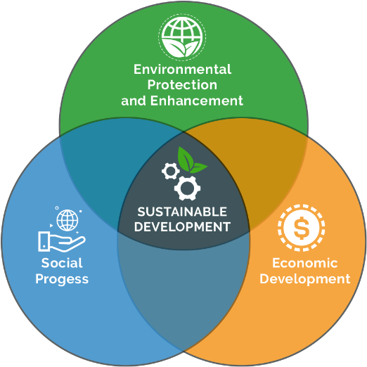 (Arena, no date)

According to the World Health Organisation (2023), it is recommended the objective of SDG aims to meet present requirements without compromising the ability of later generations to meet their personal needs. It involves achieving a harmonious equilibrium between societal progress, ecological conservation, and economic development. The significance of sustainable development lies in its ability to guarantee the enduring feasibility of resources, foster social fairness, and safeguard the environment for future progenies. Sustainable Development Commission (2019) claims that sustainable development involves a range of perspectives, but fundamentally seeks to accomplish balance between diverse and often contradictory requirements. It also recognises the societal, economic, and environmental limitations that must be taken into account.

Four Pillars of sustainability
Environmental Sustainability - This pillar primarily focuses on the conservation and safeguarding the natural environment, encompassing ecological systems, biodiversity, and natural resource. It involves implementing measures such as reducing pollution, conserving water and energy, promoting the use of renewable resources, and aiding in mitigating climate change (GOV.UK, 2023).
Economic Sustainability – According to Jänicke (2012) Economic sustainability highlights the necessity of socially and environmentally responsible economic development and growth. It includes promoting fair trade, generating employment, guaranteeing an equitable distribution of income, and supporting entrepreneurship and innovation.
Social Sustainability - UN Global Compact (2023) emphasises the advancement of justice, equity, and social well-being. It includes addressing social injustices and inequalities, supporting social cohesion and inclusivity, and guaranteeing that everyone has access to necessities like housing, healthcare, and education.
Human Sustainability – Benn et al (2006) states this pillar recognises the value of human welfare and life quality. It includes supporting gender equality and human rights, safeguarding access to clean water and sanitation, boosting health and safety, and cultivating a feeling of community and belonging.

Health
The World Health Organisation (2023) emphasises that health encompasses complete physical, emotional, and social well-being. This extends beyond the absence of illness or impairment. It encompasses various elements, including social connections, psychological well-being, and physical condition. Health is important because it allows individuals to lead fulfilling lives, pursue their goals, and contribute to society. It is also crucial for economic productivity and overall societal well-being. Every aspect of well-being must be addressed in a holistic manner in order to achieve and preserve good health (WHO, 2018).
The definition of health can be interpreted in three different ways. They are crucial to comprehending the patient's perspective on their health and self, particularly for those with chronic illnesses.
Positive: a condition of health and wellbeing.
Functionality is the capacity to carry out necessary tasks.
Negative: the lack of disease.
The biomedical model and the biopsychosocial model are the two dominant theories of health. The table below highlights their differences (Simplemed.co.uk, 2020).

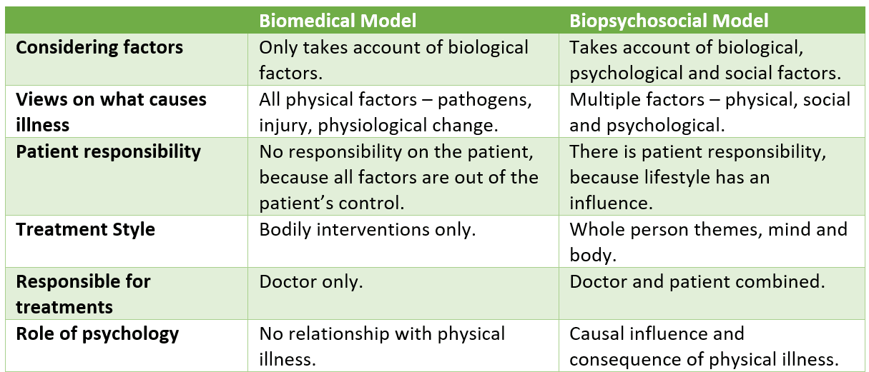
(Simplemed.co.uk, 2020)

Sustainable Development Goals
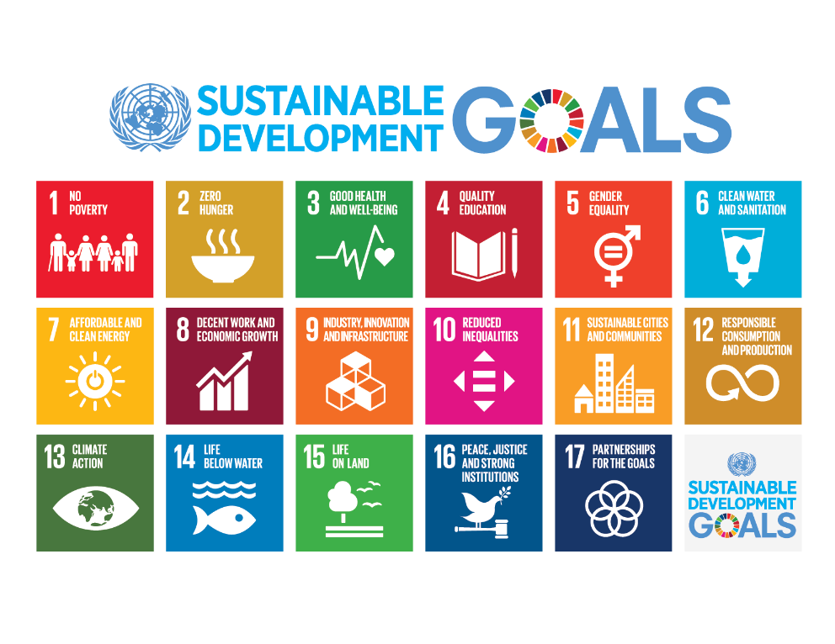 (United Nations, 2015)
The United Nations created the SDGs, a group of seventeen global objectives, in 2015. They seek to address issues like poverty, inequality, climate change, and sustainable consumerism, among other social, economic, and environmental problems that the globe faces. The SDGs are significant because they offer a framework for international action and collaboration aimed at creating a more just and sustainable society. They guide governments, organisations, and individuals in setting priorities and taking concrete steps towards a better future for all (United Nations Development Programme, 2023)
These are the 17 SDGs:
No Poverty. - An ongoing challenge for humanity is the complete elimination of poverty throughout all its manifestations. Despite a reduction of nearly 50% in the percentage of individuals residing in severe poverty from 1990 to 2015, a significant number of people still have difficulties in fulfilling their fundamental requirements (UNDP, no date).
Zero hunger - The SDGs aim to achieve full eradication of starvation including malnutrition by 2030, ensuring universal access to sufficient food, particularly for children, throughout the year. This involves promoting small-scale agriculture, supporting sustainable farming practises, and ensuring fair accessibility to marketplaces, technology, and property. International collaboration is essential to ensure investments in facilities and technologies that will enhance agricultural output (von Braun et al., 2021).
Good health and well-being – WHO (2022) emphasises the significance of health and wellbeing as essential components of sustainable development. The objectives encompassed by this initiative include reducing maternal mortality, curbing the transmission of communicable diseases, ensuring equitable availability of essential healthcare services, and promoting psychological well-being.
Quality Education – Boeren (2019) argues that recognising the need of providing widespread access to excellent quality, accessible education supports the concept that it is a highly effective and reliable initiative for sustainable development. This objective will ensure that by 2030, every male and female child will have access to cost-free education at both the primary and secondary levels. Additionally, it aims to attain widespread availability of excellent tertiary education, eradicate disparities in income and gender, and ensure equitable access to inexpensive vocational education.
Gender Equality - Seeks to enhance the power and agency of women as well as girls and attain equality between genders. Gender equality, as stated by the United Nations, represents a basic human right as well as a crucial element in establishing a peaceful, successful, and sustainable society (Iberdrola, no date).
Clean Water and Sanitation- Availability to clean water, adequate sanitation, and sufficient hygiene are the most essential prerequisites for individuals health and well-being. Failure to achieve a fourfold increase in progress will result in billions of individuals being deprived of accessibility to these vital services by 2030. This demand for water is rising as a result of urbanisation, rapid population increase and increasing water needs from the electricity, manufacturing, and agricultural areas (Tortajada, 2020).
Affordable and clean energy- The objective aim for the United Nations SDGs is to ensure universal accessibility to modern, cheap, reliable and ecological energy. This purpose recognises the significance of energy in enhancing living standards, expediting economic progress, and promoting sustainability growth. Approximately Global Goals for the year 2023.
Decent Work and Economic Growth- Promotes comprehensive and efficient employment, equitable and enduring economic expansion and satisfactory job opportunities for all. Goal 8 recognises the need of achieving high levels of economic productivity and sustained growth in order to: - generate well-compensated, high-standard employment opportunities - ensure consistent advancements in the efficient use of resources for production and consumption. The objective is to eradicate coerced labour, human trafficking, and child labour, while ensuring complete employment and satisfactory job prospects for everyone. Additionally, it aims to promote the progression of workers' rights and provide safe and protected working conditions (sdgdata.gov.uk, no date).
Industry, Innovation and Infrastructure- According to Küfeoğlu (2022) This goal proposes that all nations should industrialise in a sustainable manner since technological advancement and industrialisation are the cornerstones of growth. Innovation and infrastructure investment are key components of economic development. More than 50% of the global population currently resides in urban areas. Launching new enterprises, advancing renewable energy sources, public transit, and information and communication technology is now more imperative than ever. Long-term solutions to financial along with environmental issues, particularly energy efficiency as well as job creation, necessitate innovative transformation, Investment in technological research and innovation, as well as the promotion of sustainable industries, may all contribute to sustainable development. SDG-9 is a project that several nations are working on worldwide.
Reduced Inequalities- Inequality poses a significant challenge to the sustained social and economic progress, impeding poverty reduction efforts and eroding individuals feeling of satisfaction and self-esteem. The income development rate of the lowest forty percent of the population have exceeded overall national average within the majority of countries. However, recent evidence, albeit contradictory, suggests that COVID-19 could have interrupted the positive trend of decreasing inequality among countries. The pandemic is responsible for the most significant surge in global inequality in the past three decades. To decrease inequality, it is essential to ensure fair allocation of resources, make investments in educational institutions and skill enhancement, apply social protection measures, combat discrimination, encourage marginalised groups and promote worldwide cooperation for fair exchange and financial systems. These measures are crucial for addressing inequality inside and among nations. The source of this information is the United Nations in the year 2018.
Sustainable Cities and Communities- Seeks to provide convenient transportation options, limit urban expansion, enhance urban governance participation, safeguard cultural heritage, and tackle challenges connected with urban resilience along with climate change to promote inclusive, secure, resilient, environmentally friendly and community development (Küfeoğlu, 2022).
Responsible Consumption and Protection - According to Chan et al (2018), this objective separates economic development from unsustainable resource utilisation and emissions, while also enhancing rubbish and dangerous material handling. It advocates for the practise of fair consumption and production. This request specifically pertains to the execution about the 10-Year Guidelines of Initiatives on Sustainable Consumption alongside Production (SCP), known as responsible handling of chemicals, an effective utilisation of natural resources, the mitigation of food along with additional waste, sustainable public procurement, along with the acceptance of more resilient practises by companies.
Climate Action - There is no denying that climate change poses an imminent risk to the entire civilization. If action is not taken, the effects will be catastrophic and already evident. There is the ability to implement the necessary adjustments to protect the ecosystem via innovation, education, plus adherence to climate agreements. These improvements also present significant opportunities for updating the infrastructure, resulting in the generation of new employment opportunities and enhanced global prosperity (The Global Goals, 2023).
Life Below Water – Seeks to safeguard and ensure the sustainable utilisation of the oceans. This include the reduction of marine pollution, its impacts of ocean acidity, the stopping of excessive fishing, and the conservation of marine including coastal ecosystems. There are significant connections between Goal 14 and many other Sustainable Development Goals (SDGs), such as oceans: - maintain coastal livelihoods and economies - aid in the production of food Eliminate carbon dioxide from the environment (sdgdata.gov.uk, no date)
Life on Land - Sayer et al (2019) suggests Numerous obstacles arise from the size and complexity of the loss of tropical forests and the decline in biodiversity in comparison to the scarce resources for forestry and conservation.
Peace Justice and Strong Institutions – Martin (no date) proposes that SDG-16, harmony, Justice, and Strong Institutions, aims to strengthen corporate culture and justice in order to achieve sustainable development with social harmony. Key areas of focus for SDG-16 encompass upholding the principles of legal order, promoting the involvement of developing countries in international governing bodies, and substantially decreasing criminal activity and conflicts through the establishment of fair and robust institutions. This chapter presents the business ideas and use cases of eight companies that utilise state-of-the-art technologies to create value for SDG-16. It is crucial to highlight that a single use case might employ many new technologies and be linked to various Sustainable Development Goals.
Partnerships For The Goals - The objectives of Goal 17 are to enhance the mechanisms for achieving SDGs and to restore the international collaboration. In order to effectively execute the SDGs and turn the agenda into a tangible reality, partnerships play a crucial role as the binding force. Goal 17 calls for enhancing partnerships with all stakeholders and strengthening the mechanisms for implementation (UNICEF DATA, no date)

Goal A - Good health and well-being
United Nations SDG goal 3 aims to tackle a range of health-related issues, including reducing the mother's and child death rates, preventing the spread of transmissible diseases, ensuring access to essential medical treatment services, along with promoting mental well-being. This goal was to ensure healthy lives and well-being for people of all ages. Furthermore, it emphasises the importance of achieving universal healthcare and providing equitable access to essential pharmaceuticals and immunisations that are both safe and effective, of superior quality, and fairly priced (Nunes et al, 2016).

NHS along with the Healthy Lives, Happy People policy are two UK initiatives that support the achievement of Goal 3 (Healthy Lives, Healthy People: Our strategy for public health in England, no date). The NHS, as stated by Chang et al (2019) is the publicly financed healthcare system in the United Kingdom that offers extensive healthcare services for all inhabitants. It has a vital function in guaranteeing availability to healthcare services alongside fostering well-being. The primary objective of the Healthy Lives, Healthy People plan is to enhance public health and diminish disparities in health outcomes. The primary focus remains on effective intervention and prevention, aiming to empower individuals and communities to assume responsibility for your own health along with well-being (Health, 2010).

According to England (2023) The NHS has been successful in providing universal healthcare coverage and ensuring access to essential healthcare services for all UK residents. It has significantly contributed to improving health outcomes and reducing mortality rates. However, it faces challenges such as increasing demand, financial constraints, and workforce shortages. It is suggested by Middleton (2011) The Healthy Lives, Healthy People strategy has made progress in promoting public health and prevention, but there is a need for more targeted interventions to address health inequalities and improve overall well-being.
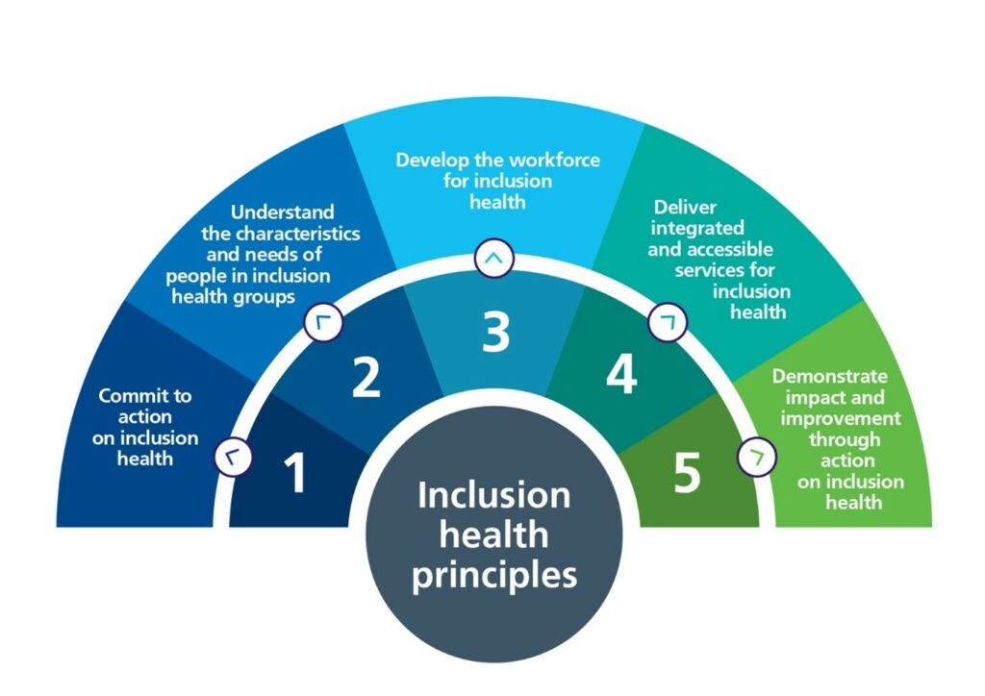 (England, 2023)

The UK government has made significant progress in implementing Goal 3. For instance, UNICEF UK (no date) states the maternal mortality ratio has decreased and child mortality rates have declined. The government has also taken steps to combat communicable diseases, such as implementing vaccination programs and promoting awareness (NHS England, 2023). However, there are still challenges in achieving universal health coverage and addressing health inequalities. The government must prioritise addressing social determinants of health and expanding access to healthcare services, particularly for underserved groups (Buzelli et al, 2022).
In the UK, the implementation of Goal 3 contributed to improved health, wellbeing, and sustainable development. Access to healthcare services and improved health outcomes contribute to individual and societal well-being. By promoting preventive measures and addressing health inequalities, the implementation of this goal can lead to a healthier and more equitable society. It also contributes to sustainable development by ensuring the long-term well-being of individuals and communities (Martin, 2023).
However, there are challenges in implementing Goal 3. According to Yovo (2022) These include financial constraints, workforce shortages, and the increasing burden of non-communicable diseases. Health inequalities and disparities also pose significant challenges. A comprehensive approach involving cooperation between the government, healthcare providers, communities, and other stakeholders is needed to address these issues.
To achieve Goal 3, Sophie (no date) states several proposals can be made. Firstly, a greater amount of investment is required in healthcare infrastructure, workforce development and research. This will help address the challenges faced by the NHS and ensure the provision of quality healthcare services. Secondly, a focus on prevention and early intervention is crucial to reduce the burden of non-communicable diseases and promote overall well-being. This can be achieved through targeted public health campaigns, education, and policy interventions. Thirdly, addressing health inequalities requires targeted interventions and policies that deal with housing, education, and other social determinants of health (www.england.nhs.uk, no date)

Targets of sustainable development Goal 3 to ensure healthy lives and Promote wellbeing for all at all ages.
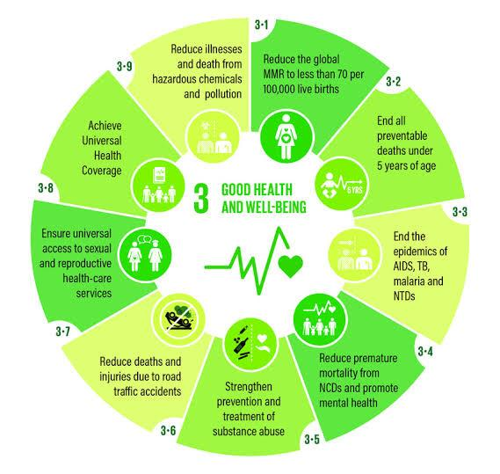(LSHTM, no date)

Target 1 - 3.4
Reduce Mortality from Non-Communicable Diseases And Promote Mental Health
By 2030, aim to decrease premature mortality caused by non-communicable illnesses by 33% through preventive measures, treatment, and the promotion of mental health alongside well-being (United Nations, 2022).

Non-communicable diseases (NCDs) causes 41 million deaths every year globally, which amounts to 74 percent of all deaths. Each year, more than 15 million individuals aged 30 to 69 die from a non-communicable disease (NCD), with minimal and middle-income countries responsible for eighty-five percent of these untimely fatalities. Cardiovascular illnesses are responsible for the highest number of non-communicable disease (NCD) deaths, over an annual count of 17.9 million. Cancer follows by 9.3 million loss of life, while respiratory diseases as well as diabetes rank two and three, with 4.1 million in addition to 1.5 million deaths respectively. These four groups of disorders are responsible for almost eighty percent of all premature the passing caused by non-communicable diseases (NCDs) (World Health Organisation, 2023).

The proliferation of poor lifestyles, increasing age among the population and also the rapid and uncontrolled urbanisation are among the causes fuelling the prevalence of various diseases. Unhealthy diets and lack of physical activity manifest in symptoms such as obesity, high blood lipids, high blood pressure, and raised blood glucose levels. These are classified as the metabolic risk factors, which have the capacity to induce cardiovascular disease, the non-communicable disease that leads to the highest number of early deaths (World Health Organisation, 2023).

As stated by Varghese (2017) the primary objective of this target is to decrease premature mortality caused by non-communicable diseases (NCDs) such as cancer, diabetes, cardiovascular disease, and chronic respiratory diseases, while also promoting mental well-being. Non-communicable diseases (NCDs) are the leading cause of death globally, with a particularly significant impact on low- and middle-income countries. Frieden et al (2020) proposes to achieve this objective, it is necessary to implement interventions and policies aimed at preventing and managing non-communicable diseases (NCDs), promoting healthy lifestyles, ensuring affordable and high-quality healthcare for all, and enhancing health systems. Furthermore, according to Minas et al (2015), given that mental diseases contribute significantly to the global disease burden, this objective also prioritises the improvement of mental well-being. It promotes the provision of assistance and therapy for individuals with mental health disorders, as well as the incorporation of mental health services within primary healthcare.

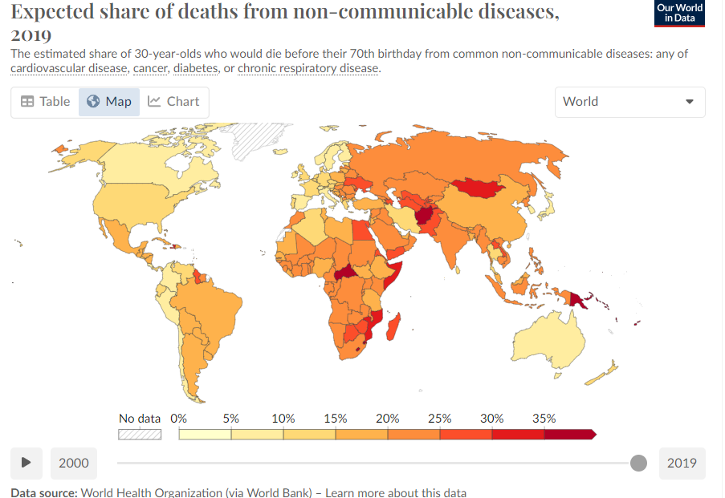
(Team and Roser, 2023).

Target 2 – 3.8
Achieve Universal Health Coverage
Attain comprehensive health coverage, encompassing security against financial risks, availability of high-quality essential health services, plus accessibility to secure, successful, quality, and cheap vital medications and immunisations for all individuals (United Nations, 2022).

Attaining universal health coverage (UHC) involves ensuring that individuals are shielded from financial hazards and have equitable access to top-notch healthcare services, being well as affordable critical medications and vaccines that are safe along with effective. The objective is to ensure that individuals are not deprived of essential medical treatment due to their financial incapacity to afford it (www.who.int, no date). In order to achieve health equity and minimise health inequalities, universal health coverage is essential. It entails offering every person and community a full range of necessary health services, such as promotive, curative, rehabilitative, and preventive care. Since essential medications and vaccines are necessary for both disease prevention and treatment, this target also highlights the significance of having access to them at an affordable, high-quality, safe, and effective level. In order to achieve UHC, health systems must be strengthened, healthcare financing must be increased, service delivery must be improved, and access barriers like those based on geography, income, or culture must be addressed (World Health Organization, 2022).

The fundamental principle of Universal Health Coverage (UHC) is to ensure that everyone has equal access to affordable, top-notch primary healthcare. Nevertheless, some individuals continue to encounter obstacles in fulfilling their essential healthcare requirements. Given its frequent disregard, it is important to recognise that mental health remains a vital aspect of Universal Health Coverage (UHC) as it directly impacts individuals' ability to live meaningful lives (The World Bank, 2022).

The two SDG 3 targets remain crucial for enhancing global health outcomes when ensuring universal access towards a healthy and satisfying life. The achievement of SDG 3, which aims to promote good health and well-being, may be realised through the concerted efforts to address non-communicable diseases, prioritise mental health, and ensure universal access to healthcare services.

Goal B: Ensure access to affordable, reliable, sustainable, and modern energy for all.
Goal 7 aims to achieve widespread availability of contemporary, reliable and affordable energy services for all. The United Nations (2022) emphasises the need to increase the share of sustainable energy in the global energy portfolio, strengthen international collaboration in the energy industry, and enhance energy efficiency. This objective recognises that the attainment of economic development environmental long-term sustainability and the elimination of poverty are contingent upon the availability of cleaner and sustainable energy.

The Clean Growth Strategy and the Renewable Energy Roadmap are two UK initiatives that support the achievement of Goal 7 (The Clean Growth Strategy Leading the way to a low carbon future, no date).

The United Kingdom government's aims for attaining sustainable and clean economic growth is outlined in the Clean Growth Strategy. One on the main objectives is to lower greenhouse gas emissions, boost energy efficiency, and support low-carbon technology. The government's plan to raise the proportion of renewable energy in the UK's energy mix is laid out in the Renewable Energy Roadmap (UK Renewable Energy Roadmap, 2011).
Energy efficiency and greenhouse gas emissions have improved thanks to the Clean Growth Strategy. It has supported low-carbon technologies and established challenging goals for the use of renewable energy (publications.parliament.uk, no date). Concerns exist, nevertheless, regarding the rate of adoption and the amount of money allocated to renewable energy. Although the share of renewable energy has increased thanks to the Renewable Energy Roadmap, more comprehensive and focused policies are still required to hasten the shift to a low-carbon energy system.
In the UK, the implementation of Goal 7 has improved sustainable development, well-being, and health. According to Pachauri et al (no date) affordably priced and dependable energy is essential for many daily activities, such as cooking, heating, and transportation. It raises living standards, boosts output, and encourages economic growth. The switch to sustainable and clean energy sources helps lessen the effects of climate change and promotes environmental sustainability (Jaiswal et al, 2022).
According to Jayachandran et al (2022) challenges in implementing Goal 7 include the high cost of renewable energy technologies, the need for infrastructure development, and the lack of awareness and capacity in renewable energy deployment. The government needs to address these challenges through targeted policies, financial incentives, and capacity-building initiatives.
To achieve Goal 7, several recommendations can be made. First and foremost, more funding is required for research and development as well as infrastructure related to renewable energy. This will hasten the adoption of renewable energy technologies and assist in lowering their cost. Second, in order to encourage people and companies to adopt energy-efficient practises and technologies, the government should offer financial incentives. This will support sustainable energy use and assist in lowering energy consumption. Thirdly, in order to hasten the global switch to clean and sustainable energy, there is a need for international cooperation and knowledge sharing (Towards achieving the Sustainable Development Goals in the UNECE region A statistical portrait of progress and challenges, no date)

Targets of sustainable development Goal 7 – Affordable and clean energy
Target 1- 7.1
Access to Energy
By the year 2030, guarantee widespread availability of inexpensive, dependable, and up-to-date energy services. Ensure equitable and affordable access to reliable and up-to-date energy services for all individuals: The primary objective for this target aims to ensure equitable access to affordable, reliable and up-to-date energy services for all individuals (Setyowati, 2021). Currently, there are 789 million individuals worldwide who lack access to electricity, along with a significant number of people depend upon traditional biomass in order to stay warm and also cooking. This reliance on biomass has detrimental impacts on both human well-being as well as the environment (ODI, no date). Expanding the availability of clean cooking options and power is crucial for achieving this objective, particularly for disadvantaged communities and individuals residing in remote and secluded regions, as mentioned by the Clean Cooking Alliance (no date). In order to reduce reliance on chemical fuels and mitigate the effects of global change, it is imperative to promote the utilisation of sustainable energy sources such as hydroelectric, solar, as well as wind power. Moreover, it is necessary to implement measures that promote sustainable energy practises and enhance the utilisation of energy in properties, transportation and industries.

Target 2 - 7.2
Increase Global Percentage of Renewable Energy
By 2030, significantly enhance the proportion of sustainable energy in the worldwide energy composition (ocm.iccrom.org, no date). The objective for this target aims to increase the percentage of renewable energy within the global energy portfolio. Renewable electricity sources, such as geothermal, wind, hydro and solar power offer environmentally friendly and sustainable alternatives to fossil fuels, that exacerbate air congestion and add to climate change. To tackle climate change, minimise greenhouse gas emissions, plus foster sustainable development, it remains crucial to augment the proportion of renewable energy sources. To achieve this objective, it is necessary to establish laws and incentives that encourage developments in renewable energy. Promoting studies and improvement in renewable energy technology is vital, alongside bolstering international collaboration to facilitate the implementation of renewable energy within underdeveloped countries. In order to facilitate the incorporation of renewable energy sources, it is important to enhance grid systems including energy structures.

The two targets of SDG 7 are crucial in addressing the challenges of energy poverty, climate change and environmental degradation, while also facilitating the transition towards a sustainable energy future. To make substantial progress towards reaching SDG 7 and creating a better sustainable with resilient world, it is crucial to ensure universal access to affordable and reliable energy services, while also increasing the share of renewable energy in the global energy portfolio.

Conclusion
The COVID-19 pandemic, initially a health issue, has rapidly transformed into a multifaceted crisis affecting both the economy and humanity. This is evident in its impact on all 17 Sustainable Development Goals (SDGs). The crisis has endangered the progress of the Sustainable Development Goals (SDGs), but it also amplifies the urgency and imperative of attaining them. Preserving recent advancements to the farthest degree is crucial. To effectively tackle the crisis, minimise the likelihood of future crises, and enhance the fulfilment of the 2030 Agenda and Sustainable Development Goals (SDGs) in the Decade of Action, it is crucial to pursue a transformational recovery from COVID-19 (United Nations, 2020).

The primary objective of SDG 7 is to guarantee universal access to contemporary, cost-effective, reliable, and environmentally friendly energy. The UK government has made progress towards meeting its aim with programmes such as the Renewable Energy Roadmap and the Clean Growth Strategy (Mulugetta et al, 2019). However, there are still unresolved matters, like the requirement for infrastructure advancement and the problem of energy poverty. In the United Kingdom, the execution of Goal 7 has enhanced sustainable development, well-being and health. In order to accomplish this objective, it is imperative to enhance funding in renewable energy, advocate for energy efficiency, and foster international collaboration. The UK can make a valuable contribution to a future that is both sustainable and secure in terms of energy by actively pursuing Goal 7 (Krozer, 2019).

Goal 3 of the SDGs is around the objective of guaranteeing sound physical and mental health and fostering overall welfare for individuals of all ages. The UK government has made strides towards reaching this target with the assistance of initiatives like as the NHS and the Healthy Lives, Healthy People policy. Nevertheless, there are still obstacles to overcome, such as disparities in health and limitations in financial resources (Orton et al, 2011). The execution of Goal 3 has yielded favourable outcomes in terms of health, well-being and sustainable development in the United Kingdom. In order to accomplish this objective, it is imperative to provide more funds towards healthcare, prioritise preventive measures, and tackle disparities in health. By striving to achieve Goal 3, the United Kingdom can make a valuable contribution to fostering a society that is both healthier, more fair and sustainable.

References
Arena. (no date). Sustainable Development. [online] Available at: https://www.arenasolutions.com/resources/glossary/sustainable-development/ (Accessed: 10 November 2023).
Benn, S., Dunphy, D. and Griffiths, A. (2006). Enabling Change for Corporate Sustainability: An Integrated Perspective. Australasian Journal of Environmental Management, 13(3), pp.156–165. doi:https://doi.org/10.1080/14486563.2006.10648683. (Accessed: 16 November 2023).
Boeren, E. (2019). Understanding Sustainable Development Goal (SDG) 4 on “quality education” from micro, meso and macro perspectives. International Review of Education, 65(2), 277–294. https://doi.org/10.1007/s11159-019-09772-7 . (Accessed: 14 November 2023).

‌Buzelli, L., Dunn, P., Scott, S., Gottlieb, L. and Alderwick, H. (2022). A framework for NHS action on social determinants of health - The Health Foundation. [online] www.health.org.uk. Available at: https://www.health.org.uk/publications/long-reads/a-framework-for-nhs-action-on-social-determinants-of-health. (Accessed: 11 November 2023).
Chan, S., Weitz, N., Persson, Å. and Trimmer, C. (2018). Stockholm Environment Institute SDG 12: Responsible Consumption and Production -A Review of Research Needs 1 1 SDG 12: Responsible Consumption and Production A review of research needs. [online] Available at: https://www.sei.org/wp-content/uploads/2018/11/review-sdg12-research-needs-final.pdf. (Accessed: 12 November 2023).

Clean Cooking Alliance (no date) Unlock the SDGs and Net-Zero with Clean Cooking SDG7 Multi-Stakeholder Energy Compact. Available at: https://cleancooking.org/wp-content/uploads/2021/10/Clean_Cooking_Energy_Compact.pdf (Accessed: 28 November 2023).
Department of Health, 2010. Healthy lives, healthy people: Our strategy for public health in England (Vol. 7985). The Stationery Office. (Accessed: 18 November 2023).
Chang, J., Peysakhovich, F., Wang, W. and Zhu, J., 2011. The UK health care system. The United Kingdom, 30, p.2019. (Accessed: 13 November 2023).
England, N. (2023). NHS England» A national framework for NHS – action on inclusion health. [online] www.england.nhs.uk. Available at: https://www.england.nhs.uk/long-read/a-national-framework-for-nhs-action-on-inclusion-health/. (Accessed: 16 November 2023).

Frieden, T.R., Cobb, L.K., Leidig, R.C., Mehta, S. and Kass, D. (2020). Reducing Premature Mortality from Cardiovascular and Other Non-Communicable Diseases by One Third: Achieving Sustainable Development Goal Indicator 3.4.1. Global Heart, 15(1), p.50. doi:https://doi.org/10.5334/gh.531. (Accessed: 19 November 2023).
‌The Global Goals (2023). Goal 7: Affordable and clean energy. [online] The Global Goals. Available at: https://www.globalgoals.org/goals/7-affordable-and-clean-energy/. (Accessed: 16 November 2023).
‌The Global Goals. (2023). Goal 13: Climate Action. [online] Available at: https://www.globalgoals.org/goals/13-climate-action/. (Accessed: 18 November 2023).
‌GOV.UK. (2023). Environmental sustainability. [online] Available at: https://www.gov.uk/government/collections/environmental-sustainability (Accessed: 21 November 2023).
Healthy Lives, Healthy People: Our strategy for public health in England. (no date). Available at: https://assets.publishing.service.gov.uk/media/5a7590feed915d506ee7fcf9/healthy_lives_healthy_people.pdf. (Accessed: 25 November 2023).

Iberdrola. (no date). Iberdrola and its firm commitment to gender equality. [online] Available at: https://www.iberdrola.com/sustainability/committed-sustainable-development-goals/sdg-5-gender-equality. (Accessed: 25 November 2023).

‌ indicators.report. (no date). 7.1 by 2030 ensure universal access to affordable, reliable, and modern energy services – Indicators and a Monitoring Framework. [online] Available at: https://indicators.report/targets/7-1/. (Accessed: 26 November 2023).
‌Jaiswal, K.K., Chowdhury, C.R., Yadav, D., Verma, R., Dutta, S., Jaiswal, K.S., SangmeshB and Karuppasamy, K.S.K. (2022). Renewable and sustainable clean energy development and impact on social, economic, and environmental health. Energy Nexus, 7, p.100118. doi:https://doi.org/10.1016/j.nexus.2022.100118. (Accessed: 25 November 2023).
Jänicke, M. (2012). ‘Green growth’: From a growing eco-industry to economic sustainability. Energy Policy, 48, pp.13–21. doi:https://doi.org/10.1016/j.enpol.2012.04.045.
(Accessed: 11 November 2023).

Jayachandran, M., Gatla, R.K., Rao, K.P., Rao, G.S., Mohammed, S., Milyani, A.H., Azhari, A.A., Kalaiarasy, C. and Geetha, S. (2022). Challenges in achieving sustainable development goal 7: Affordable and clean energy in light of nascent technologies. Sustainable Energy Technologies and Assessments, [online] 53, p.102692. doi:https://doi.org/10.1016/j.seta.2022.102692. . (Accessed: 20 November 2023).

Krozer, Y. (2019). Financing of the global shift to renewable energy and energy efficiency. Green Finance, 1(3), pp.264–278. doi:https://doi.org/10.3934/gf.2019.3.264. . (Accessed: 23 November 2023).

Küfeoğlu, S. (2022). SDG-9: Industry, Innovation and Infrastructure. Emerging Technologies, pp.349–369. doi:https://doi.org/10.1007/978-3-031-07127-0_11. (Accessed: 26 November 2023).
‌Küfeoğlu, S. (2022). SDG-11: Sustainable Cities and Communities. Emerging Technologies, pp.385–408. doi:https://doi.org/10.1007/978-3-031-07127-0_13 . (Accessed: 11 November 2023).

LSHTM. (no date). Sustainable Development Goal: Health & Wellbeing (SDG-HaW) Research Consortium. [online] Available at: https://www.lshtm.ac.uk/research/centres-projects-groups/sdg-haw. (Accessed: 24 November 2023).

Martin (no date). Peace, justice and strong institutions. [online] United Nations Sustainable Development. Available at: https://www.un.org/sustainabledevelopment/peace-justice/. (Accessed: 26 November 2023).
‌Martin (2023). Health. [online] United Nations Sustainable Development. Available at: https://www.un.org/sustainabledevelopment/health/. (Accessed: 22 November 2023).
Mental Health Foundation (2015). What is well-being, how can we measure it and how can we support people to improve it? [online] www.mentalhealth.org.uk. Available at: https://www.mentalhealth.org.uk/explore-mental-health/blogs/what-well-being-how-can-we-measure-it-and-how-can-we-support-people-improve-it. (Accessed: 17 November 2023).
Middleton, J. (2011). Healthy people, healthy lives. The English public health white paper: risks and challenges for a new public health system. Clinical Medicine, [online] 11(5), pp.430–433. doi:https://doi.org/10.7861/clinmedicine.11-5-430. . (Accessed: 16 November 2023).

Minas, H., Tsutsumi, A., Izutsu, T., Goetzke, K. and Thornicroft, G. (2015). Comprehensive SDG goal and targets for non-communicable diseases and mental health. International Journal of Mental Health Systems, 9(1). doi:https://doi.org/10.1186/s13033-015-0003-0 . (Accessed: 20 November 2023).
‌Mulugetta, Y., Hagan, E.B. and Kammen, D. (2019). Energy access for sustainable development. [online] Available at: https://iopscience.iop.org/article/10.1088/1748-9326/aaf449 (Accessed: 14 November 2023).
‌NHS England (2023). NHS England» National COVID-19 and Flu Vaccination Programmes. [online] www.england.nhs.uk. Available at: https://www.england.nhs.uk/contact-us/privacy-notice/national-flu-vaccination-programme/. (Accessed: 22 November 2023).
Nunes, A.R., Lee, K. and O’Riordan, T. (2016). The importance of an integrating framework for achieving the Sustainable Development Goals: the example of health and well-being. BMJ Global Health, [online] 1(3), p.e000068. doi:https://doi.org/10.1136/bmjgh-2016-000068 . (Accessed: 12 November 2023).
ODI (no date) FAQ 1: oil and gas, poverty and energy access, ODI: Think change. Available at: https://odi.org/en/about/our-work/climate-and-sustainability/faq-1-oil-and-gas-poverty-and-energy-access/#:~:text=How%20many%20people%20live%20in (Accessed: 28 November 2023). (Accessed: 26 November 2023).
Orton, L.C., Lloyd-Williams, F., Taylor-Robinson, D.C., Moonan, M., O’Flaherty, M. and Capewell, S. (2011). Prioritising public health: a qualitative study of decision making to reduce health inequalities. BMC Public Health, 11(1). doi:https://doi.org/10.1186/1471-2458-11-821. . (Accessed: 23 November 2023).

Pachauri, S., Brew-Hammond, A., Barnes, D., Modi, V., Prasad, G., Zerriffi, H., Kemausuor, F., Kowsari, R., Nagai, Y., Rijal, K. and Sathaye, J. (no date). Energy Access for Development Energy Access for Development Convening Lead Authors (CLA) Lead Authors (LA) Contributing Authors (CA) Touria Dafrallah (Environment and Development Action in the Third World, Senegal) Conrado Heruela (United Nations Environment Programme) Review Editor Energy Access for Development. [online] Available at: https://pure.iiasa.ac.at/id/eprint/10069/1/GEA%20Chapter%2019%20Energy%20Access%20for%20Development.pdf. (Accessed: 22 November 2023).
‌publications.parliament.uk. (no date). Clean Growth: Technologies for meeting the UK’s emissions reduction targets: Government and Ofgem Responses to the Committee’s Twentieth Report of Session 2017–19 - Science and Technology Committee - House of Commons. [online] Available at: https://publications.parliament.uk/pa/cm201919/cmselect/cmsctech/287/28702.htm. (Accessed: 23 November 2023).

‌Sayer, J., Sheil, D., Galloway, G., Riggs, R.A., Mewett, G., MacDicken, K.G., Arts, B.J.M., Boedhihartono, A.K., Langston, J. and Edwards, D.P. (2019). SDG 15 Life on Land – The Central Role of Forests in Sustainable Development. [online] library.wur.nl. Available at: https://library.wur.nl/WebQuery/wurpubs/558241. (Accessed: 21 November 2023).
‌sdgdata.gov.uk. (no date). Goal 8 - Decent jobs and economic growth - U.K. Indicators For The Sustainable Development Goals. [online] Available at: https://sdgdata.gov.uk/8/. (Accessed: 21 November 2023).
sdgdata.gov.uk. (no date). Goal 14 - Life below water - U.K. Indicators For The Sustainable Development Goals. [online] Available at: https://sdgdata.gov.uk/14/. (Accessed: 26 November 2023).

Setyowati, A.B. (2021) ‘Mitigating inequality with emissions? Exploring energy justice and financing transitions to low carbon energy in Indonesia’, Energy Research & Social Science, 71, p. 101817. Available at: https://doi.org/10.1016/j.erss.2020.101817. (Accessed: 17 November 2023).

‌Simons, G. and Baldwin, D.S. (2021). A Critical Review of the Definition of ‘Wellbeing’ for Doctors and Their Patients in a Post Covid-19 Era. International Journal of Social Psychiatry, [online] 67(8), p.002076402110322. doi:https://doi.org/10.1177/00207640211032259. (Accessed: 26 November 2023).

Simplemed.co.uk. (2020). Models of Health. [online] Available at: https://simplemed.co.uk/subjects/population-and-social-science/models-of-health#:~:text=There%20are%20two%20common%20models. (Accessed: 26 November 2023).
‌Sophie (no date). Voluntary National Review of progress towards the Sustainable Development Goals. [online] Available at: https://assets.publishing.service.gov.uk/media/5d28c296ed915d2feeac499e/UK-Voluntary-National-Review-2019.pdf. (Accessed: 24 November 2023).
‌Sustainable Development Commission (2019). What is Sustainable Development. [online] Adoption UK Charity. Available at: https://www.sd-commission.org.uk/pages/what-is-sustainable-development.html. (Accessed: 26 November 2023).
Team, O.W. in D. and Roser, M. (2023). Ensure healthy lives and promote well-being for all at all ages. Our World in Data. [online] Available at: https://ourworldindata.org/sdgs/good-health-wellbeing#sdg-indicator-3-4-1-mortality-rate-from-non-communicable-diseases. (Accessed: 26 November 2023).
The Clean Growth Strategy Leading the way to a low carbon future. (no date). Available at: https://assets.publishing.service.gov.uk/media/5ad5f11ded915d32a3a70c03/clean-growth-strategy-correction-april-2018.pdf. (Accessed: 23 November 2023).
The Global Goals (2023). Goal 7: Affordable and clean energy. [online] The Global Goals. Available at: https://www.globalgoals.org/goals/7-affordable-and-clean-energy/. (Accessed: 25 November 2023).
‌The Global Goals. (2023). Goal 13: Climate Action. [online] Available at: https://www.globalgoals.org/goals/13-climate-action/. (Accessed: 25 November 2023).
The World Bank (2022) Universal health coverage, World Bank. Available at: https://www.worldbank.org/en/topic/universalhealthcoverage. (Accessed: 26 November 2023).
‌Tortajada, C. (2020). Contributions of recycled wastewater to clean water and sanitation Sustainable Development Goals. npj Clean Water, 3(1). doi:https://doi.org/10.1038/s41545-020-0069-3 (Accessed: 19 November 2023).
Towards achieving the Sustainable Development Goals in the UNECE region A statistical portrait of progress and challenges. (no date). Available at: https://unece.org/sites/default/files/2021-07/SDG_report_for_web.pdf (Accessed: 23 November 2023).

UK Renewable Energy Roadmap. (2011). Available at: https://assets.publishing.service.gov.uk/media/5a79e9bae5274a18ba50fb84/2167-uk-renewable-energy-roadmap.pdf (Accessed: 23 November 2023).

UN Global Compact (2023). Social Sustainability | UN Global Compact. [online] unglobalcompact.org. Available at: https://unglobalcompact.org/what-is-gc/our-work/social. (Accessed: 26 November 2023).

UNDP (no date). Sustainable Development Goals | United Nations Development Programme. [online] UNDP. Available at: https://www.undp.org/sustainable-development-goals/no-poverty. (Accessed: 26 November 2023).

UNICEF UK. (no date). More women and children survive today than ever before – UN report. [online] Available at: https://www.unicef.org.uk/press-releases/more-women-and-children-survive-today-than-ever-before-un-report/ (Accessed: 23 November 2023).

United Nations (2015). Social Development for Sustainable Development | DISD. [online] United Nations. Available at: https://www.un.org/development/desa/dspd/2030agenda-sdgs.html (Accessed: 26 November 2023).

‌United Nations (2018). Goal 10: Reduce Inequality within and among Countries. [online] United Nations Sustainable Development. Available at: https://www.un.org/sustainabledevelopment/inequality/ (Accessed: 23 November 2023).
‌United Nations (2020). Decade of Action. [online] United Nations Sustainable Development. Available at: https://www.un.org/sustainabledevelopment/decade on-of-action/ (Accessed: 25 November 2023).
‌United Nations (2022). Energy - United Nations Sustainable Development. [online] United Nations Sustainable Development. Available at: https://www.un.org/sustainabledevelopment/energy/ (Accessed: 24 November 2023).
‌United Nations (2022). Goal 3: Good health and well-being. [online] The Global Goals. Available at: https://www.globalgoals.org/goals/3-good-health-and-well-being/ (Accessed: 26 November 2023).
‌United Nations Development Programme (2023). Sustainable Development Goals. [online] Sustainable Development Goals. Available at: https://www.undp.org/sustainable-development-goals (Accessed: 27 November 2023).
Varghese, C. (2017). Reducing premature mortality from non-communicable diseases, including for people with severe mental disorders. World Psychiatry, 16(1), pp.45–47. doi:https://doi.org/10.1002/wps.20376 (Accessed: 23 November 2023).
‌Von Braun, J., Chichaibelu, B.B., Torero Cullen, M., Laborde, D. and Smaller, C. (2021). Ending Hunger by 2030 – policy actions and costs. bonndoc.ulb.uni-bonn.de. [online] doi:https://doi.org/10.48565/scfss2021-kz31 (Accessed: 26 November 2023).
‌WHO (2022). Sustainable Development Goals. [online] www.who.int. Available at: https://www.who.int/europe/about-us/our-work/sustainable-development-goals (Accessed: 23 November 2023).
World Health Organization (2022). Targets of Sustainable Development Goal 3. [online] www.who.int. Available at: https://www.who.int/europe/about-us/our-work/sustainable-development-goals/targets-of-sustainable-development-goal-3 (Accessed: 24 November 2023).
‌World Health Organization (2023). Noncommunicable Diseases. [online] World Health Organization. Available at: https://www.who.int/news-room/fact-sheets/detail/noncommunicable-diseases (Accessed: 26 November 2023).
World Health Organization (2023). SDG Target 3.4 Non-communicable diseases and mental health. [online] www.who.int. Available at: https://www.who.int/data/gho/data/themes/topics/sdg-target-3_4-noncommunicable-diseases-and-mental-health (Accessed: 20 November 2023).
‌World Health Organization (2023). Sustainable Development. [online] www.who.int. Available at: https://www.who.int/health-topics/sustainable-development#tab=tab_1 (Accessed: 23 November 2023).
www.england.nhs.uk. (no date). NHS England» About the prevention programme. [online] Available at: https://www.england.nhs.uk/ourwork/prevention/about-prevention-programme/ (Accessed: 25 November 2023).

‌www.who.int. (no date). SDG Target 3.8 | Achieve universal health coverage (UHC). [online] Available at: https://www.who.int/data/gho/data/themes/theme-details/GHO/universal-health-coverage (Accessed: 26 November 2023).

WHO (2018). A VISION FOR PRIMARY HEALTH CARE IN THE 21ST CENTURY Towards universal health coverage and the sustainable development goals. [online] Available at: https://www.who.int/docs/default-source/primary-health/vision.pdf (Accessed: 23 November 2023).
‌Yovo, E. (2022). Challenges on the road to achieving the SDG 3.2 targets in resource-limited settings. The Lancet Global Health, 10(2), pp.e157–e158. doi:https://doi.org/10.1016/s2214-109x(21)00597-0 (Accessed: 25 November 2023).

