Instrumentation and control
  - Control System Design
Jenkins, Christopher
ACDA5011
January 3, 2022
Table of Contents
1. Abstract 2
2. Introduction 2
3. Simulation Setups 4
4. Results 8
5. Discussion 12
6. Conclusion 13
7. ANNEX A 14
8. References 16

Abstract
  - This assignment details the design of a closed loop control system for a Close-in Weapon System, CIWS, and the effects on the system following its tuning.
  - A CIWS is a weapon system used in a defence role usually to protect against in coming missiles aircraft or other projectiles that are deemed a threat to the facility or vehicle it is mounted to.
  - The closed loop control system was modelled and simulated using MATLAB Simulink which was also utilised to generate the diagrams and graphs found throughout the report.
  - The results showed that the end design of the system produced a stable system falling within the stated parameters found within the assignment brief [1]:
    - A time of less than 2 seconds should be achieved for the system bringing the process under control
    - The overshoot present in the final design of the system should be no greater than 5%.

Introduction
  - A control system can be defined as a number of connected components that form a system response that is required by the designer and/or end user of the system.
  - Control systems allow for the output of the system to be adjusted by varying the stimulus being inputted to the system
  - An open loop control system is a control system that does not use feedback from the output of the system to make adjustments. A simple example of an open loop can be seen in figure1 below.
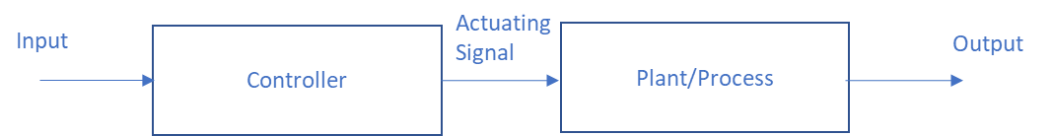
Figure 1 - Simple open loop control system.
  - The input stimulus to the controller, for example a car key fob, transmits the signal to the plant/process. In this example the plant or process is the car door to lock or unlock depending on the initial state of the system, no feedback is provided to the Key fob to indicate if the door is locked or unlocked.

  - In a closed loop system data from the output is fed back to be continually compared to the input stimuli generating an error value, this error value is fed to the controller which in turn feeds the process. An example of a simple Closed loop control system can be seen in figure 2. 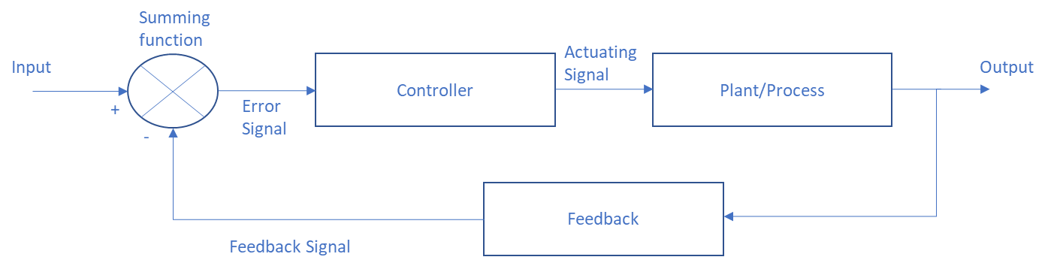
Figure 2 - Simple closed loop control system

  - In this example the input stimulus is the turning up of central heating thermostat the error signal if greater than zero opens the controller, a valve in this system. This actuating signal drives the plant/process to heat the room, as the output changes i.e. the ambient temperature increases. The output value is fed back to the summing function when the value of the feedback is the same of that of the input the error signal generated reaches zero and the controller (valve) closes.
  - The example shown in figure 2 and described in 2.7 is a typical discrete control system with only 2 states on or off. Multiple other forms of closed loop control systems exist, which include [2]
    - Three state controllers
      - 3 States: on, off and halfway on. The controller decides on the output to the process by using the error signal.
    - Proportional (P) Controllers
      - The controller decides on the output to the process by using a proportion of the error signal.
    - Proportional – Integral (PI) Controllers
      - The controller decides on the output to the process by using the moving average, integral, of the error signal. This removes the steady state error that can be large when only using the current error values.
    - Proportional – Derivative (PD) Controllers
      - The controller decides on the output to the process by using the rate at which the error changes, stability of the system is improved by overshoot being controlled with effect to the steady state error.
    - Proportional – Integral – Derivative (PID) Controllers
      - The controller decides the output to the process by taking into account of the current error, the previous errors and possible errors caused by overshoot.
  - Each of the systems have various pros and cons associated with them which should be considered when designing a control system for a specific purpose.
  - For this assignment an appropriate closed loop control system will be created using the MATLAB Simulink simulation software to control the CIWS within parameters given in the assignment brief and as detailed in section 1.3.

Simulation Setups
  - The transfer function for the system was given within the assignment brief was:
$$G\left(s\right)=\frac{1}{as^{2}+bs+c}$$
  - Additionally in the brief values for a, b and c were given as 3,3 and 2, plugging these values into the transfer function resulted in the equation now becoming:
$$G\left(s\right)=\frac{1}{3s^{2}+3s+2}$$
  - A block diagram of the control system with the transfer function in the process block can be seen in figure 3.

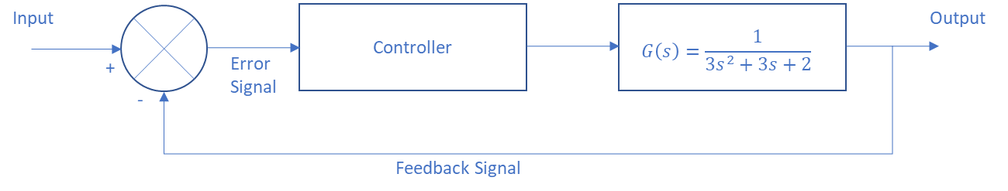
Figure 3 – CIWS control system block diagram
  - Block diagram with a step change input was created and the simulation ran in Simulink this can be seen in figure 4.
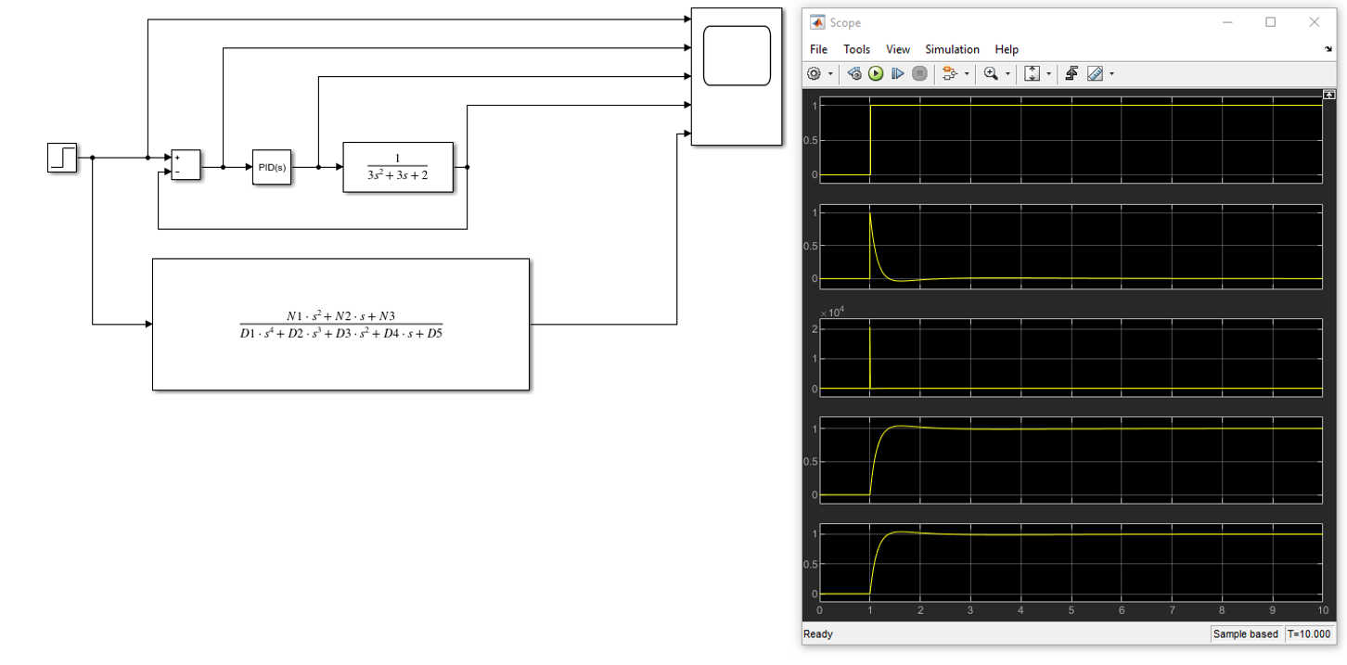
Figure 4 – Simulink block diagram
  - Within MATLAB the tuner function for the PID was used to tune the system to ensure the settling time was below 2 seconds and the overshoot was below 5%. This was accomplished by adjusting the Response time and the Transient behaviour. This is depicted in figure 5.
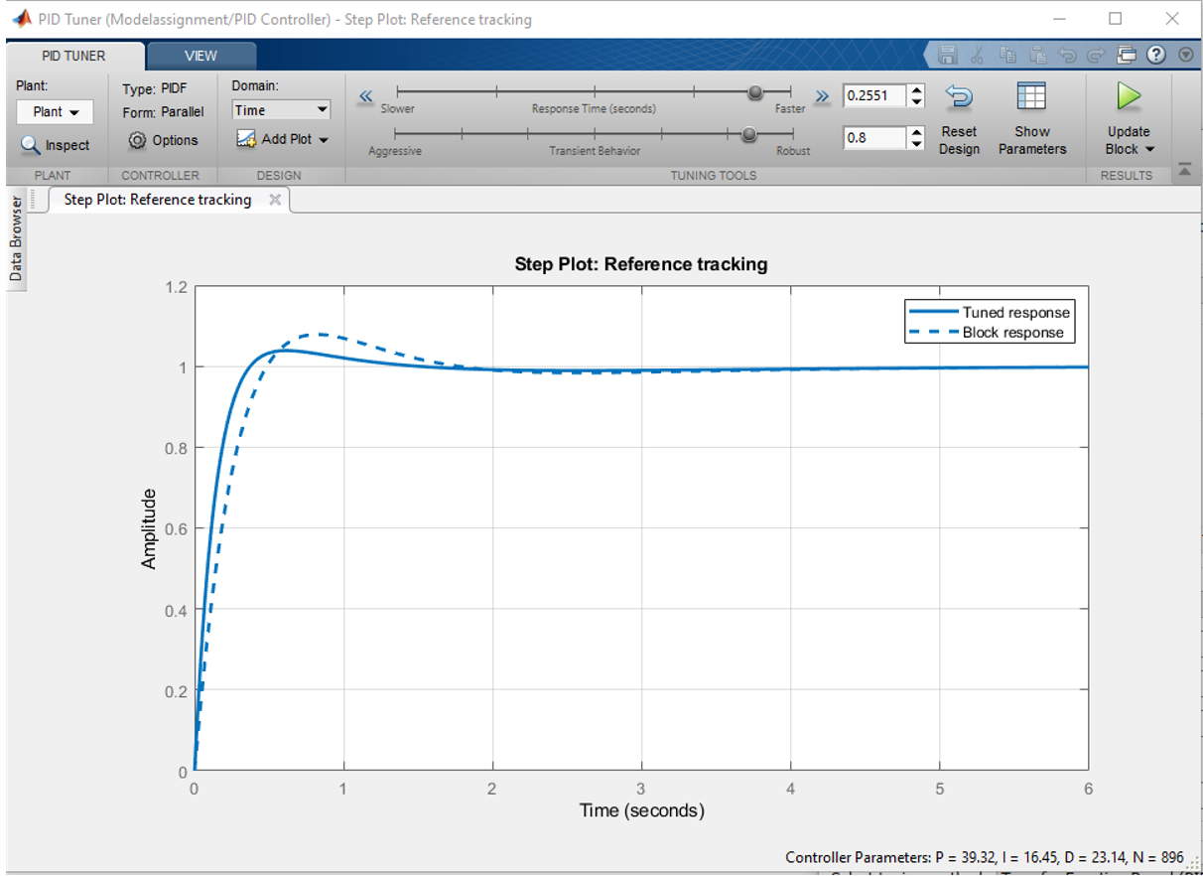
Figure 5 – PID Tuner

  - By opening the controller parameters option in the MATLAB PID tuner using the Show Parameters tab the values for Kp, Ki, Kd and N are given in greater precision than in the PID tuner. Additionally, the values attained for the setting time and the overshoot are displayed. These can be seen in Figure 6.
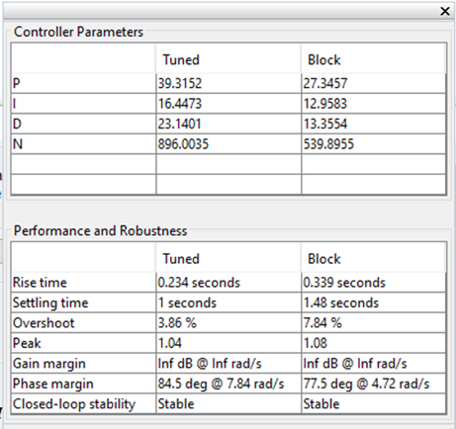
Figure 6 – PID Tuner controller parameters

  - The values gained we used to mathematically check the simulation.
  - As seen in figure 6 the value obtained for the current error, or the proportional control was: Kp = 39.3152
  - The value obtained for the addition of previous errors, or the integral control was Ki = 16.4473
  - The value obtained for the derivative control that accounts for the potential future errors resulting from overshoot was: Kd = 23.1401
  - The values can now be introduced to the transfer function of the PID:
$$\frac{K_{d}s^{2}+K_{p}s+K_{i}}{s}$$
$$\frac{23.1401s^{2}+39.3152s+16.4473}{s}$$
  - This results in the block diagram of the control system now looking like that depicted in figure 7.
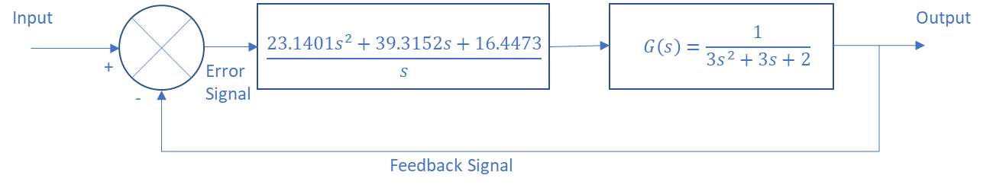
Figure 7 – CIWS control system block diagram 2.

  - By multiplying the controllers transfer function with the process function the forward path transfer function was calculated:
$$\frac{23.1401s^{2}+39.3152s+16.4473}{s}×\frac{1}{3s^{2}+3s+2}$$
$$\frac{23.1401s^{2}+39.3152s+16.4473}{3s^{3}+3s^{2}+2s}$$
  - This allows the block diagram to be further modified as seen in figure 8
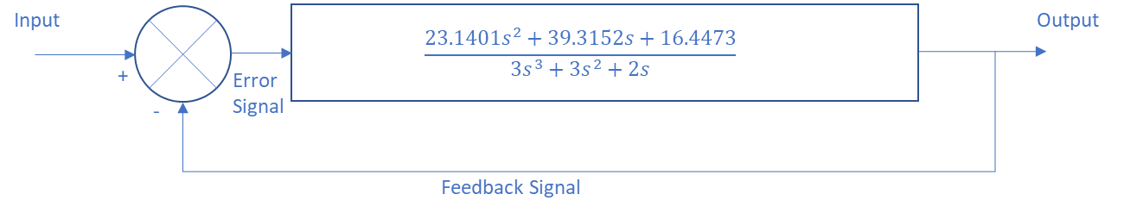
Figure 8 – CIWS control system forward path transfer function block diagram.

  - The transfer function for the whole system can now be calculated by using:
$$TF=\frac{G}{1+GH}$$
  - G represents the forward path transfer function; H is the feedback signal transfer function which for this system has a value of 1.

$$TF=\frac{\frac{23.1401s^{2}+39.3152s+16.4473}{3s^{3}+3s^{2}+2s}}{1+\left(\frac{23.1401s^{2}+39.3152s+16.4473}{3s^{3}+3s^{2}+2s}\right)×1}$$

$$TF=\frac{\frac{23.1401s^{2}+39.3152s+16.4473}{3s^{3}+3s^{2}+2s}}{\frac{3s^{3}+3s^{2}+2s}{3s^{3}+3s^{2}+2s}+\frac{23.1401s^{2}+39.3152s+16.4473}{3s^{3}+3s^{2}+2s}}$$

$$TF=\frac{\frac{23.1401s^{2}+39.3152s+16.4473}{3s^{3}+3s^{2}+2s}}{\frac{3s^{3}+3s^{2}+2s+23.1401s^{2}+39.3152s+16.4473}{3s^{3}+3s^{2}+2s}}$$

$$TF=\frac{\frac{23.1401s^{2}+39.3152s+16.4473}{3s^{3}+3s^{2}+2s}}{\frac{3s^{3}+26.1401s^{2}+41.3152s+16.4473}{4s^{3}+3s^{2}+6s}}$$

$$TF=\frac{23.1401s^{2}+39.3152s+16.4473}{3s^{3}+3s^{2}+2s}×\frac{3s^{3}+3s^{2}+2s}{3s^{3}+26.1401s^{2}+41.3152s+16.4473}$$

$$TF=\frac{\left(23.1401s^{2}+39.3152s+16.4473\right)\left(3s^{3}+3s^{2}+2s\right)}{\left(3s^{3}+3s^{2}+2s\right)\left(3s^{3}+26.1401s^{2}+41.3152s+16.4473\right)}$$
$$=\frac{{69.4203s}^{5}+69.4203s^{4}+46.2802s^{3}+117.9456s^{4}+117.9456s^{3}+78.6304s^{2}+49.3419s^{3}+49.3419s^{2}+32.8946s}{9s^{6}+78.4203s^{5}+123.9456s^{4}+49.3419s^{3}+9s^{5}+78.4203s^{4}+123.9456s^{3}+49.3419s^{2}+6s^{4}+52.2802s^{3}+82.6304s^{2}+32.8946s}$$

Which can be simplified further to:

$$TF=\frac{69.4203s^{5}+187.3659s^{4}+213.5677s^{3}+127.9723s^{2}+32.8946s}{9s^{6}+87.4203s^{5}+208.3659s^{4}+225.5677s^{3}+131.9723s^{2}+32.8946s}$$

  - The block diagram can now be modified with a single block representing the control system as shown in figure 9.
Figure 9 – Whole system transfer function block diagram

Results
  - There are a number of toolsets that were employed evaluate how the system is performing, these include:
    - Nyquist Plot of the forward transfer function
    - Bode diagram
    - Pole Zero plot of the closed loop transfer function
    - Pole Zero plot of the plant
  - The Nyquist diagram or Nyquist stability criterion is a method to calculate and display both the Phase margin and the Delay margin on one plot based on the frequency response of the transfer function [3].
    - The Phase margin is the angle between the negative real axis and the dotted line, it provides the system designer a value of phase shift that if it were present, it would make the system become unstable [4].
    - The Delay margin gives us the amount of lag that can be added to the feedback before the system becomes unstable [4].
  - Figure 10 shows the Nyquist plot of the forward transfer function for this system.
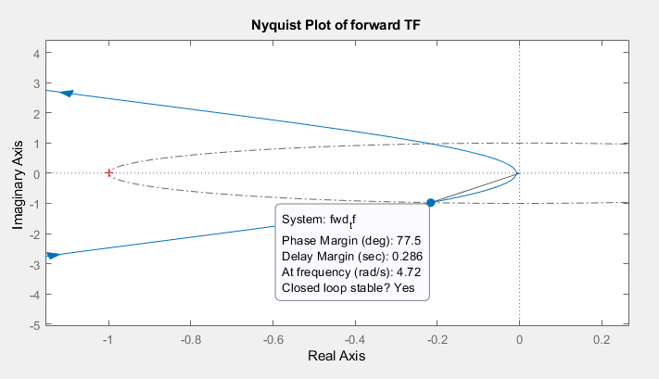
Figure 10 – Nyquist plot for the FWD TF
  - Bode plots are a graphical display of the frequency response of a system it shows the magnitude in dBs and the Phase in degrees. MATLAB automatically choses the frequencies to plot based on the parameters of the system being simulated [5].
  - Figure 11 shows the Bode plot diagram for this system.
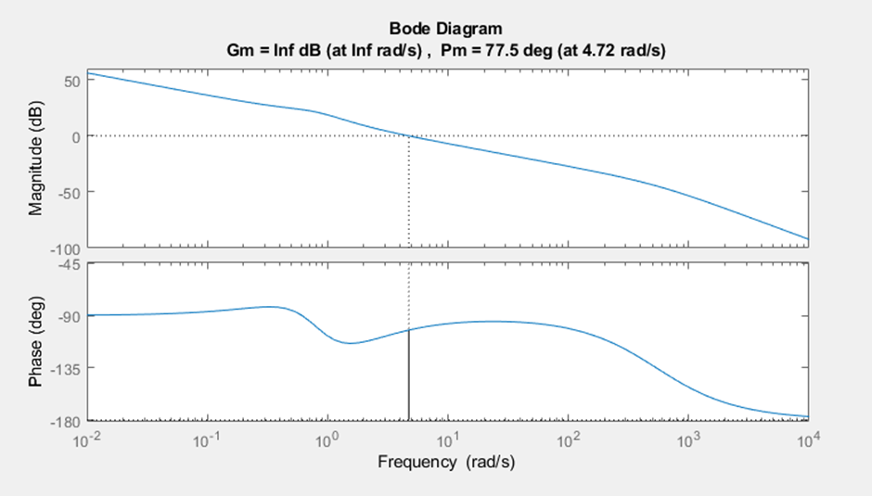
Figure 11 – Bode plot for the CIWS

  - The Pole location of the plant function was calculated using the formulae for the transfer function as detailed in section 3.2
$$G\left(s\right)=\frac{1}{3s^{2}+3s+2}$$
  - As the numerator has a value of 1 there is no value of s to calculate and only the denominator has to be calculated therefore the equation now becomes:
$$0 =3s^{2}+3s+2$$
  - Using the quadratic equation:
$$s=\frac{-b±\sqrt{b^{2}-4ac}}{2a}$$
$$s=\frac{-3±\sqrt{3^{2}-4x3x2}}{2x3} \\ s=\frac{-3±\sqrt{9-24}}{6}$$
$$s=\frac{-3±\sqrt{-15}}{6}$$
$Value 1 s=\frac{-3}{6}+\frac{\sqrt{-15}}{6}$
$$Value 1 s=-0.5+\frac{\sqrt{15}}{6}*\frac{\sqrt{-1}}{6}$$
$$Value 1 s=-0.5+\frac{3.8729833j}{6}$$
$$Value 2 s=-0.5-\frac{3.8729833j}{6}$$
  - This gives the two plots as:
$$Value 1 s=-0.5+0.6455j$$
$$Value 2 s=-0.5-0.6455j$$
  - Using MATLAB these can be plotted and checked using the command window with the prompt >> roots ([a b c]). The MATLAB generated pole zero plot can be seen in figure 12.
  - Command scripts used in MATLAB can be found in annex A.
  - The position of the poles indicate that this is stable system as they are located in the real axis negative sectors [6].
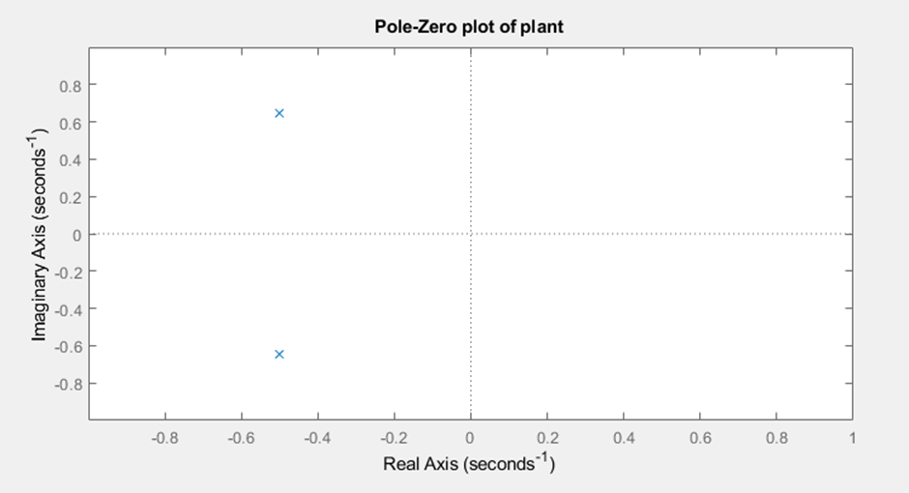
Figure 12 Plant pole zero plot generated by MATLAB
  - Individual pole plots for the controller and system were also created using MATLAB these can be seen in figure 13.
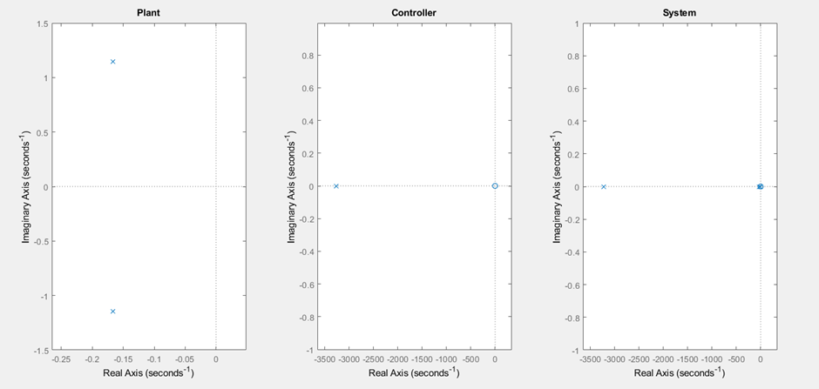
Figure 13 – Pole zero plots of the Plant, Controller and System

  - MATLAB was also used to generate the pole zero plot of the closed loop transfer function, this can be seen in figure 14.

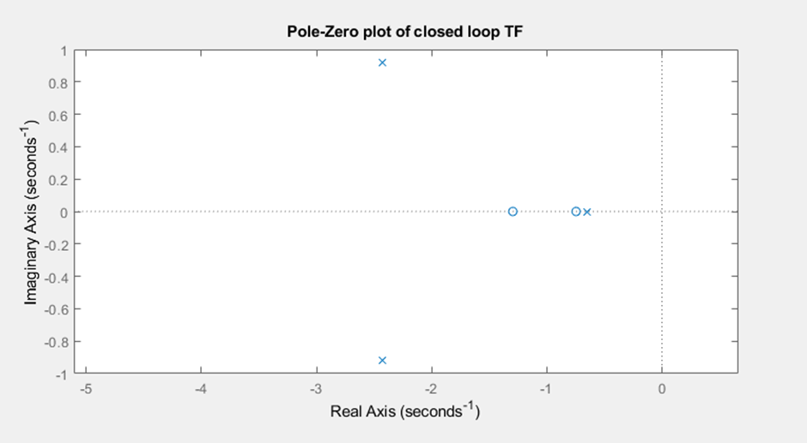
Figure 14 – Pole zero plot of the closed loop transfer function generated by MATLAB

Discussion
  - The PID controller used prior to tuning was a relatively suitable component in regard to the fact the response time was within the limits and the overshoot just beyond the limits specified in the assignment brief indicating that it required a little tuning however, tuning did provide a marked advantage in improving these limits.
  - The comparison of these before tuning values and the after tuning value can be seen in figure 6, where the Block column contain the data for the untuned PID. Tuning provided an improvement of the settling time of 0.48 seconds and a reduction of the overshoot of 3.98%.
  - These improvements result in the CIWS traversing in elevation and azimuth to a stable position at a quicker rate than it would without tuning. This is obviously advantageous to the CIWS being able to destroy incoming fast-moving targets.
  - The Nyquist plot as seen in figure 10 shows the Phase response and the frequency response which have been further confirmed in the Bode plot.
  - The Nyquist plot also shows that the critical point, found at the coordinates Real 1, Imaginary 0 is not intersected by the Nyquist curve identifying that the system is stable.
  - The bode plot can handily give the system designer a relatively quick overview of the system [7].
  - As shown in figure 11 the upper graph shows that the system gain margin that moves towards infinity in both axis, with the horizontal axis representing Frequency in Radians per Second and the vertical axis representing the gain in magnitude measured in dB’s, The graph suggests that the amplitude of the output signal can be significantly higher than the inputted signal without the system becoming unstable.
  - The lower graph found in figure 11 shows a solid vertical line, this line indicates that the Phase margin is 77.5° in an ideal system the phase margin would be between 0 and 180°. The lines placement directly correlates with the frequency at which the gain margin line intersects the 0dB value.
  - This Phase margin value means that the any change in phase shift equal to or greater than 77.5° would result in the system beginning to become unstable.
  - The Plant, Controller and System zero-pole plots along with the pole-zero plot of the closed loop transfer function indicate that the poles are located in the negative Real side of the plot which also identifies the system as being stable.
  - Additionally, the positions of the poles in the pole-zero plot of the closed loop transfer function identify them as a complex conjugate where the response component generated is in the form of a decaying sinusoidal wave form. This is where the output oscillates above and below the input level until reaching the desired level. An example of a decaying sinusoidal wave form can be seen in figure 15.
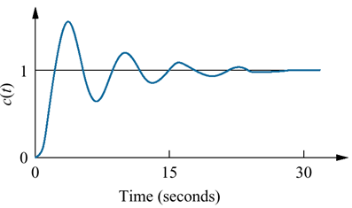
Figure 15 – Example of a decaying sinusoidal wave form [8].

Conclusion
  - In this experiment it has been determined that the use of the tuned PID controller provided a more than adequate control system for the CIWS that exceeded the design parameters as defined in the assignment brief.
  - The stability analysis performed in the form of pole plots proved the system to be stable at all points.
  - As expected the use of MATLAB and SIMULINK to construct the controller was a far easier task than the calculation of the whole system transfer function which has a much greater susceptibility of errors being introduced to the system at the design stage.

ANNEX A
% Plant transfer function values from assignment spec
a=3;
b=3;
c=2;

% Controller parameters from PID tuning block in Simulink
Kp=27.3457;
Kd=13.3554;
N=539.8955;
Ki=12.9583;

% Numerator coefficients of transfer functions
N1=Kp+(N*Kd);
N2=(Ki+(N*Kp));
N3=N*Ki;

% Denominator coefficients of closed loop transfer function
D1=a;
D2=(a*N)+b;
D3=Kp+(N*Kd)+(b*N)+c;
D4=(N*Kp)+Ki+(c*N);
D5=N*Ki;

% Denominator coefficients of forward transfer function
d1=a;
d2=(a*N)+b;
d3=(b*N)+c;
d4=c*N;
d5=0;

% create forward transfer function
fwd_tf=tf([N1 N2 N3],[d1 d2 d3 d4 d5]);

% Create Nyquist plot of forward transfer function
% This HAS to exclude the feedback as it will be a measure of
% System stability - how much gain / phase shift needed to make instable
figure;
subplot(2,2,1);
nyquist(fwd_tf);
title('Nyquist Plot of forward TF');

% Create Bode plot of forward transfer function
% - provides similar info to Nyquist plot
subplot(2,2,2);
margin(fwd_tf);
%title('Bode plot of forward TF')

% Create closed loop transfer function of whole system (inc. feedback)
system_tf=tf([N1 N2 N3],[D1 D2 D3 D4 D5]);

% Plot Pole-Zero diagram of closed loop system
subplot(2,2,3);
pzplot(system_tf);
title('Pole-Zero plot of closed loop TF');

% Create transfer function to represent only the plant
plant_tf = tf(1,[a b c]);

% Plot pole-zero diagram of plant transfer function
subplot(2,2,4);
pzplot(plant_tf);
title('Pole-Zero plot of plant');

References

[1] | S. Mosey, “Control System Design Assignment,” UWTSD, Swansea, 2021.
[2] | S. Mosey, “Controller Types Presentation,” UWTSD, Swansea, 2021.
[3] | L. WANG, “Closed loop performance and stability,” in PID Control System Design and Automatic Tuning using MATLAB/Simulink, John Wiley & Sons Ltd, 2020, pp. 237-245.
[4] | L. WANG, “Closed loop perfromance and stability,” in PID Control System design and auctomatic tuning using MATLAB/SIMULINK , Wiley Ltd, 2020, p. 38.
[5] | MathWorks, Inc., “Help Center,” MathWorks, Inc., 1994-2021. [Online]. Available: https://uk.mathworks.com/help/control/ref/lti.bode.html?s_tid=doc_ta. [Accessed 17 12 2021].
[6] | T. A. Marcel Escudier, “pole-zero plot (pole-zero configuration),” in A Dictionary of Mechanical Engineering (2 ed.) , Oxford University Press, 2019, p. 255.
[7] | R. M. M. Karl Johan Åström, “The Bode Plot,” in Feedback Systems: An Introduction for Scientists and Engineers, Chicago, Princeton University Press, 2008, pp. 250-259.
[8] | S. Mosey, “Stability presentation,” UWTSD, Swansea, 2021.

