

Research on Prediction of Rail Transit Environmental Vibration Based on Database

Student: Han Zhengyuan
Lecturer: Chris House
Student ID number: 2105611
Module code: ACFA7004
Module: Postgraduate Research Method
Programme: MSc Programme

Date:29/3/2022
Content
1. Introduction 1
1.1 Background 1
1.2 Research objectives 1
1.3 Research approaches 2
2. Literature Review 5
2.1 Current status of research on impact prediction of rail transit vibration environment 5
2.2 Current status of research based on computer algorithm of correlation prediction model 8
2.3 Basic Theory and Classification of Sensitivity Analysis Methods 9
2.4 Related Theory and Classification of Clustering Algorithms 11
3. Methods 14
3.1 Architecture of Rail Transit Environmental Vibration Prediction Database and Calculation of Source Data 14
3.2 Global sensitivity analysis of soil transfer function based on Sobol method 16
3.3 Design of transfer function optimization algorithm based on weighted k-means clustering 17
3.4 Prediction Process of Rapid Prediction of Rail Transit Environmental Vibration Based on Database 20
4. Results and discussion 22
5. Conclusion 23
6. Reference list 25

Table of Charts and Table

Table 1: Classification of prediction methods…………………………………………5
Chart 1: Research contents…………………………………………………………….2
Chart 2: The research route……………………………………………………………3
Chart 3: The relationship between data tables…………………………………….….14
Chart 4: Transfer function optimization process………………………………….….18
Chart 5: The design mentality of transfer function optimization…………………….18
Chart 6: The prediction process of environmental vibration of rail transit……….….20

Abstract

With the development of urbanization, the scale of cities and the traffic pressure continues to expand, which results in the rapid development of urban rail transit. At present, the commonly used method is the empirical formula method, which has problems such as low prediction accuracy and inability to provide more accurate reference values for some sensitive targets with high requirements in specific frequency bands. Therefore, it is necessary to find a fast and accurate method for regional environmental vibration prediction.

The purpose of this research is to establish a rail transit environmental vibration prediction method and the rail transit environmental vibration prediction database. The prediction method can find the transfer function corresponding to the closest point of the target point in the database as the target point transfer function. It is in order to realize the vibration prediction of the earth's surface. The Research Question of this study is how to optimize the rail transit environmental vibration prediction method. In theory, if the amount of data in the transfer function database is infinite, the predicted value obtained by this method will be infinitely close to true value. On the other hand, with the development of computer technology, the means of analysing large amounts of data with computer algorithms have become more and more mature. As result, computer algorithms can be introduced into the calculation of the database to make the calculation faster and more accurate.

The main contents and conclusions of this research are as follows:
(1) The rail transit environment vibration prediction database is designed using MATLAB, and the structure of three sub-databases, including the single and multi-layer soil transfer function database, the train vibration load database and the tunnel structure correction function database, is completed.
(2) The Sobol global sensitivity analysis method is introduced to analyse the global sensitivity of each parameter. Based on this, the influence of each parameter change on soil transfer function is studied.
(3) Based on the weighted k-means clustering algorithm, the transfer function optimization algorithm is designed to realize the solution of the optimal transfer function.
(4) Based on the above research results, the detailed process of the database-based rapid prediction method of rail transit environmental vibration is established by using MATLAB to write programs.

Key Words: Based on database; Prediction method; Clustering algorithm

1. Introduction
This chapter provides an introduction to the background of the research; research objectives and research approaches.

1.1 Background
With the development of urbanization, the scale of cities and the traffic pressure continues to expand, which results in the rapid development of urban rail transit. In most metropolitan Chinese cities, urban rail transit accounts for more than 50%, whereas in Tokyo, New York, and Hong Kong, the proportion is as high as 80–90% [1]. Although the development of urban rail transit has eased the urban traffic pressure, it has also brought about more severe environmental problems of rail transit. For instance, the environmental vibration and noise of rail transit have a great impact on ancient buildings, and the new underground railway system in Palermo has a dynamic impact on the remains of the catacombs built in the 4th century [2]. Nowadays, the application of big data has penetrated into different fields of world. The combination of various industries and computer artificial intelligence technology has become a general trend. In terms of environmental vibration prediction, there is relatively little research using artificial intelligence and big data. Based on the above background, this article will carry out research on the rapid prediction method of rail transit environmental vibration based on computer technology and transfer function databases.

1.2 Research objectives
The purpose of this research is to establish a rail transit environmental vibration prediction method and the rail transit environmental vibration prediction database. The prediction method can find the transfer function corresponding to the closest point of the target point in the database as the target point transfer function. It is in order to realize the vibration prediction of the earth's surface. In theory, if the amount of data in the transfer function database is infinite, the predicted value obtained by this method will be infinitely close to true value. On the other hand, with the development of computer technology, computer algorithms can be introduced into the calculation of the database to make the calculation faster and more accurate.

Therefore, the research objectives of this research are to design a database-based rapid prediction method for rail transit environmental vibration. Based on Sobol global sensitivity analysis method and weighted k-means clustering algorithm, an algorithm to find the optimal solution of the transfer function is designed. In order to realize fast and accurate regional vibration prediction based on transfer function database, train vibration load database and tunnel structure correction function database.

1.3 Research approaches
Based on the above purposes, the research contents are shown in chart 1.
Chart 1: Research contents
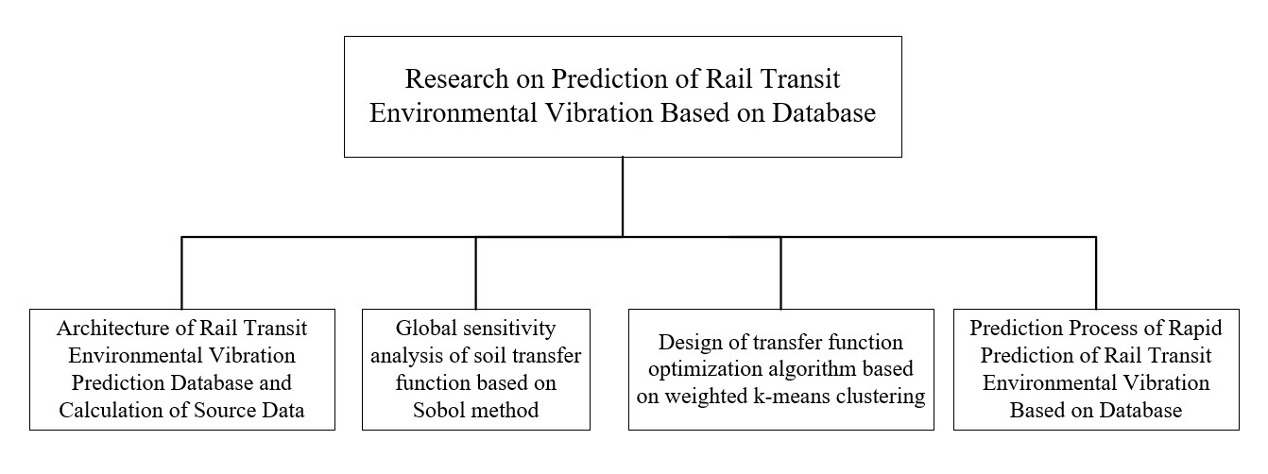
From chart 1, it can be found that the specific research contents are as follows:
- Using MATLAB to design the database, the database includes sub-libraries such as soil transfer function database, train vibration load database and tunnel structure correction function database.
- When calculating the transfer function from the vibration source in the soil to the surface response point, the parameters of the soil are analysed using the Sobol global sensitivity analysis method. In this way, the global sensitivity of each parameter can be obtained, and the influence law of each parameter change on the soil transfer function can be studied.
- Using a weighted k-means-based clustering method combined with the global sensitivity of each influencing parameter of the transfer function. Then design the soil transfer function optimization algorithm. Finally, predict the randomly generated target transfer function, the correlation coefficient and the relative error as the index to evaluate the accuracy of the optimization algorithm.
- Based on the transfer function database to solve the optimal solution of soil layer transfer function. Combine with the train vibration load database and the tunnel structure correction function library, establish rapid prediction methods of environmental vibration in rail transit. In view of the actual subway interval period of ground vibration test, and the test points around the table to predict the vibration response analysis, compare the measured results and the prediction results, verify the rationality of the database-based rapid prediction method of rail transit environmental vibration.
The combined form of each chapter is composed of technical routes, as shown in chart 2.
Chart 2: The research route
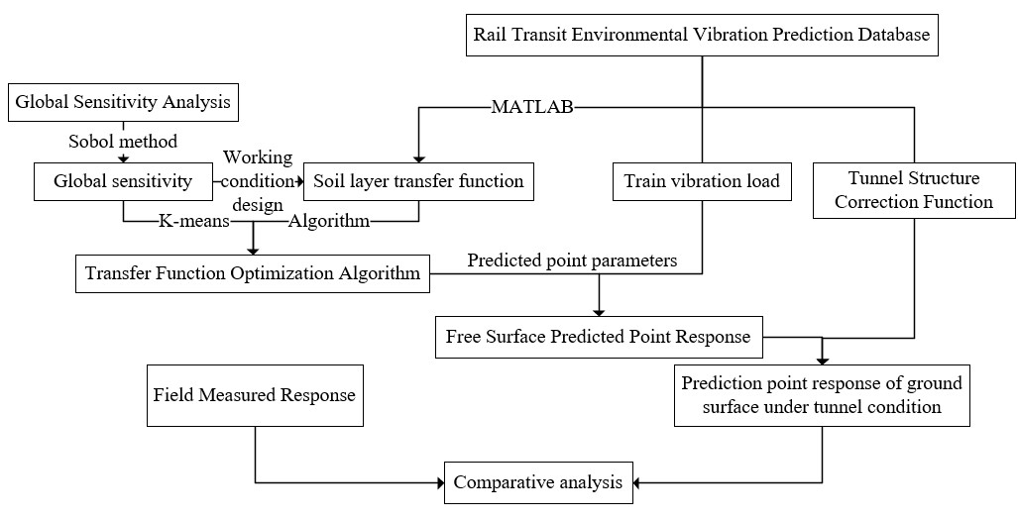
From chart 2, it can be found that the first of research route is the structure of the database and the calculation of the source data of the database; the second is the analysis of the influence of the changes of soil parameters on the transfer function; the third is the design of the soil transfer function optimization algorithm; the fourth is the rail transit environment based on the database Validation of vibration prediction methods.

This chapter surveys the relevant literature. It is divided into three sections: background of the research; research objectives and research approaches. The research objectives of this research are to design a database-based rapid prediction method for rail transit environmental vibration. The following chapter will address these issues in literature Review: Current status of research on impact prediction of rail transit vibration environment; Current status of research based on computer algorithm of correlation prediction model; Basic Theory and Classification of Sensitivity Analysis Methods and Related Theory and Classification of Clustering Algorithms.

2. Literature Review
This chapter provides some focused and critical opinions about: Current status of research on impact prediction of rail transit vibration environment; Current status of research based on computer algorithm of correlation prediction model; Basic Theory and Classification of Sensitivity Analysis Methods and Related Theory and Classification of Clustering Algorithms.

2.1 Current status of research on impact prediction of rail transit vibration environment
In recent years, many different types of rail transit environmental impact prediction methods have been developed, and some scholars have summarized and compared them [3]. In general, the methods for predicting the environmental vibration induced by subway train operation mainly include: empirical prediction method, analytical method, numerical method and field measurement method. In order to adapt to different stages of the project, the prediction methods of rail transit vibration environmental impact can also be divided into preliminary prediction, confirmed prediction, and accurate prediction, as shown in table 1.
Table 1: Classification of prediction methods
Prediction grade | Applicable stage | Method of prediction | Predict cost | Predict time | Accuracy
Preliminary prediction | Feasibility research | Empirical method | Low | Low | Low
Confirm prediction | Scheme design stage | Analytical method,  Numerical method | Medium | Medium | Medium
Precise prediction | Construction design stage | Field measurement method | High | High | High
From table 1, it can be found that due to the fact that in the development process of actual rail transit engineering projects, different construction stages have different requirements for the realization method, prediction time and accuracy of the prediction method.

The empirical prediction method is often used in the feasibility study stage, and its purpose is to establish a prediction model by combining a large amount of measured data or engineering, and summarize it into an empirical or semi-empirical prediction formula. As early as 1975, Ungar and others further realized that the vibration energy will be dissipated due to various factors, so different types of correction coefficients were introduced to predict the vibration environment response caused by the operation of subway trains at different points [4]. In 1979, Kurzweil proposed a prediction chain formula for predicting the vibration level of indoor ground considering the influence of stratum and buildings on vibration attenuation [5]. In 1988, Melke considered the transmission loss of the track, tunnel structure, stratum and sensitive buildings, and proposed an empirical prediction chain formula similar to the above to predict the noise and vibration in buildings affected by rail traffic [6].

Analytical and numerical methods are often used in the design stage, and their purpose is to further predict and determine the highly sensitive targets obtained from the preliminary prediction and judgment. At present, the widely disseminated analytical prediction model is the effective model proposed by Hussein in 2006 to predict the vibration response of underground excitation on the surface in layered soil in semi-infinite space, namely the Green function of the soil layer and the PIP (in-pipe) model. The Tube) method combines analytical models [7]. In 2018, Zou Chao et al. proposed a vibration prediction method based on an impedance model based on the propagation law of axial waves through the column and the impedance properties of the intermediate floor, and characterized and predicted the vibration transmission of the superstructure of the subway depot [8,9]. Due to the development of computer technology and the development of numerical software, numerical methods are widely used in subway vibration research. The most common method in numerical analysis is the finite element method. As early as 1979, Kurzweil applied the finite element method to research the vibration prediction of subway trains [5]. In 1985, Karabalis etc. proposed a finite element-boundary element coupling analysis method, which can analyse the vibration frequency domain and time domain [10]. In 2003, Wolf et al. used FLAC finite difference software to establish a three-dimensional numerical model to analyse the propagation and attenuation of low-frequency vibration on the ground caused by the operation of light rail trains, and studied the influence of precision instruments [11]. In 2004, Cllouteau et al. used limited the element-boundary element coupling method is used to study the environmental vibration caused by subway train operation [12]. In 2005, Degrande G et al. developed a periodic finite element-boundary element coupled model, which assumed that the soil-tunnel system had periodic characteristics along the tunnel axis [13,14]. In 2007, Gupta etc. further improved the periodic finite element-boundary element coupling model [15].

The field measurement method is often used in the accumulated prediction stage, and its purpose is to target a specific building or sensitive point based on field test data. In 2011, the Zhang et al. arranged measuring points in the tunnel by means of reverse ground hammering [16]. Through the analysis of a large number of test data, the transfer characteristics of the free stratum of the tunnel are obtained and the vibration response of Chengdu Metro Line 2 to the Chengdu Museum is predicted. In 2012, Jaquet etc. expounded the principle of using the borehole excitation method to test and calculate the transfer function, and put it into practical application on Beijing Metro Line 8 [17].

From above research, it can be found that the method for predicting the environmental impact of rail transit vibration refers to the measurement, quantitative calculation or qualitative measurement of the environmental vibration response of sensitive objects within the impact range of rail transit by various means during the design, construction and operation of the rail transit project judgement. Vibration response prediction indicators can be displacement, velocity, acceleration, etc., and the form of prediction results can be expressed in the form of peak value, vibration level or vibration frequency range and its derived mathematical description. And the prediction results should be able to guide the rail transit vibration isolation design including rail vibration reduction measures, propagation path vibration isolation and sensitive point vibration isolation to a certain extent.

In order to provide a basis for the design of rail transit lines and vibration isolation schemes, the empirical method is usually used in the feasibility study stage of rail transit construction to carry out large-scale rail transit environmental vibration prediction to confirm the sensitive areas. The empirical method is often combined with a large amount of measured data or engineering to establish a prediction model and summarize it into an empirical or semi-empirical prediction formula. Due to the few calculation parameters and the quick and convenient calculation, the empirical prediction method is widely used. However, due to many factors affecting vibration attenuation, such as differences in geological structure, track form, and tunnel structure in different regions, calculation accuracy is often poor in practical applications, and it lacks frequency domain information. For some sensitive targets with high requirements in specific frequency bands, more accurate reference values cannot be given.

Therefore, it is necessary to find a method that can quickly and accurately predict regional environmental vibration. This method needs higher accuracy than empirical prediction methods which are required to guide anti-vibration design for sensitive targets. From a theoretical point of view, the analytical method is applied to the ground environment vibration prediction caused by the vibration operation of subway trains, and more accurate prediction results can be obtained. At the same time, for a specific building or sensitive point, based on on-site test data, analysing the entire vibration propagation characteristics from the vibration source to the sensitive target will greatly improve the accuracy of subway vibration prediction results.

2.2 Current status of research based on computer algorithm of correlation prediction model
Due to the characteristics of vibration propagation, most of the vibration prediction methods inevitably involve a lot of complicated calculations. This inevitably involves computer algorithms to improve predict accuracy and predict speed. In 2014, Connolly etc. established a fast prediction model with high prediction accuracy for high-speed railway environmental vibration based on the neural network method [18]. First select some parameters that have a major impact on vibration, perform finite element calculation by adjusting different influencing parameters, use the input and output results of different models for the training and learning of the neuron network, and finally use the mature neuron network for learning. The results show that the use of neural networks in the prediction of environmental vibration can not only improve computational efficiency but also improve computational accuracy. In 2017, Jianjun Shi et al. developed a blasting vibration velocity peak prediction system based on Matlab program and VB software, using ActiveX automation technology and BP neural network algorithm [19]. The prediction system can select the main factors affecting blasting vibration as input parameters according to the actual situation of the project, so as to predict the peak value of blasting vibration velocity.

From the above research, it can be found that most of the current artificial intelligence-based vibration prediction only predicts the vibration magnitude, ignoring the frequency domain information of the vibration. Therefore, in the research process, this research will optimize the algorithm for finding the optimal solution of the transfer function, in order to achieve the purpose of improving the accuracy of the final prediction result.

2.3 Basic Theory and Classification of Sensitivity Analysis Methods
In order to scientifically set the working conditions of the soil transfer function in the database, it is necessary to analyse the parameters before calculating the soil transfer function. This research needs to calculate the effect of changes on the transfer function and the global sensitivity of each parameter. The sensitivity analysis method is a method to study the relationship between the input and output of the evaluation model, it usually includes local sensitivity analysis (LSA) and global sensitivity analysis (GSA). LSA method relies on a One-parameter-At-a-Time (OAT) methodology, by which the modeller evaluates the impact on the results of the variation of a single parameter while all other input parameters are held constant at their reference value [20]. GSA is a generic description of methods that evaluate the effect of an input parameter on the output by varying not only the parameter in question, but all other input parameters chosen for analysis as well [21].

From the above research, it can be found that the local sensitivity analysis method only analyses the influence degree of a single parameter at a certain point on the model output, and the interaction between parameters is not considered in the calculation process, and its mathematical expression is relatively simple. The global sensitivity analysis is to analyse the influence of multiple parameters on model output. The interaction between the parameters is considered in the calculation process, but the calculations are relatively complicated. Compared with local sensitivity analysis, the analysis process of global sensitivity analysis is not limited by the model, and the sensitivity of parameters in the entire definition domain can be analysed. The global sensitivity analysis method is usually used when studying nonlinear models or models with different magnitudes of influence parameter uncertainty [22].

At present, the more common global sensitivity analysis methods include screening methods, Monte Carlo methods and FAST methods. Specifically, the screening method is the simpler method in the global sensitivity analysis method. Morris method and IFFD method are all screening methods [23]. It is usually used to remove factors that have little influence on the output of the model when there are many parameters affecting the model, so as to reduce the calculation amount of subsequent processing and prepare for the subsequent adoption of other sensitivity analysis methods. The screening method can only do a qualitative analysis of the model parameters, and the obtained results cannot reflect the specific differences in the sensitivity of each parameter. The Monte Carlo method is a method of random sampling based on probability distribution [24]. The main idea of this method is to sample according to the probability distribution of the influencing parameters, and calculate the model output corresponding to the sampling point. Uncertainty and sensitivity analysis is performed based on sample point data and the output of the model. FAST (Fourier Amplitude Sensitivity Test) method, namely the Fourier amplitude sensitivity test method. is a variance-based sensitivity analysis method [25]. The main idea of this method is to represent each influencing parameter in the model by a function with common independent parameters, and convert the model into a periodic function about the independent parameters. On this basis, follow-up expectation and variance operations are performed to evaluate the global sensitivity of each parameter to the model.

Additionally, there is a global sensitivity analysis method called Sobol. The Sobol global sensitivity analysis method is a method based on variance and Monte Carlo sampling [26]. The basic idea is to calculate the total variance of the model, the biased variance of each variable, and the biased variance under the combined action of each variable. The ratio of the biased variance to the total variance of each variable is used to measure the impact of the variable on the model results, and the ratio of the biased variance to the total variance under the combined action of each variable is used to measure the interaction between variables.

Compared with other global sensitivity analysis methods, the Sobol method has the advantages of simple and clear calculation process and comprehensive sensitivity analysis results for model parameters. Sobol global sensitivity analysis method can not only analyse the sensitivity when each parameter changes individually, but also analyse the sensitivity when different parameters change simultaneously. The Sobol global sensitivity analysis method adopted in this research is a method based on variance and Monte Carlo sampling. The basic idea is to calculate the total variance of the model, the biased variance of each variable, and the biased variance under the combined action of each variable. The ratio of the biased variance to the total variance of each variable is used to measure the impact of the variable on the model results, and the ratio of the biased variance to the total variance under the combined action of each variable is used to measure the interaction between variables.

2.4 Related Theory and Classification of Clustering Algorithms
The clustering algorithm is an analysis method for large amounts of data. The function of the clustering algorithm is to gather a large amount of data into several clusters according to certain rules, so that the data in each cluster is as similar as possible, and the data in different clusters is as different as possible. At present, clustering algorithms have been widely used in the fields of data mining, data management and data prediction. A large amount of transfer function data is involved in the design of the transfer function optimization algorithm, so clustering algorithm is introduced to study it. The k-means clustering algorithm is an unsupervised clustering algorithm based on distance. The basic idea is to divide the data sample into several data clusters for a given data sample, so that the distance between the sample points in each cluster is as far as possible, is small, the sample distance between different clusters is as large as possible [27]. The k-means clustering algorithm has the following advantages [28]:
- the clustering effect is excellent and the understanding is simple;
- the algorithm can process a large amount of data and guarantee the processing of efficiency.
By contrast, the k-means clustering algorithm has the following disadvantages [29]:
- the number of clusters 𝐾 needs to be specified in advance, that is, the optimal value of 𝐾 needs to be determined in advance;
- it is not suitable for finding non-convex clusters, and the clustering results It may be a local optimum;
- When processing high-dimensional sample data, the clustering effect of sample points with abnormal eigenvalues in a certain dimension is poor.

From the above analysis of the advantages and disadvantages of the k-means clustering algorithm, it is not well confirmed whether the k-means clustering algorithm has enough favourable reasons to support me using it. The weighted k-means clustering algorithm assigns weight to each feature based on the classical k-means clustering algorithm [30]. The weight reflects the degree of influence of the corresponding features on the clustering results, so as to distinguish the importance of different features. Compared with the k-means clustering algorithm, the weighted k-means clustering algorithm performs better in clustering high-dimensional sample data.

This chapter surveys the relevant literature. It discussed various ways of many different types of rail transit environmental impact prediction methods; research based on computer algorithm of correlation prediction model; many different types of sensitivity analysis methods and classification of Sensitivity Analysis Methods and Related Theory and Classification of Clustering Algorithms. The evidence suggests it is necessary to find a method that can quickly and accurately predict regional environmental vibration; it is necessary to optimize the algorithm for finding the optimal solution of the transfer function; it is necessary to choose Sobol global sensitivity analysis method as research method and it is necessary to choose the weighted k-means clustering algorithm as research algorithm. The following chapter will address these issues in methods: Architecture of Rail Transit Environmental Vibration Prediction Database and Calculation of Source Data; Global sensitivity analysis of soil transfer function based on Sobol method; Design of transfer function optimization algorithm based on weighted k-means clustering and Prediction Process of Rapid Prediction of Rail Transit Environmental Vibration Based on Database.

3. Methods
This chapter provides some specific methods about: Architecture of Rail Transit Environmental Vibration Prediction Database and Calculation of Source Data; Global sensitivity analysis of soil transfer function based on Sobol method; Design of transfer function optimization algorithm based on weighted k-means clustering and Prediction Process of Rapid Prediction of Rail Transit Environmental Vibration Based on Database.

3.1 Architecture of Rail Transit Environmental Vibration Prediction Database and Calculation of Source Data
This research mainly studies the rapid prediction method of rail transit environmental vibration based on the database, so the construction of the rail transit environmental vibration database is particularly important. This chapter mainly introduces the architecture of the rail transit environmental vibration prediction database and the calculation of the source data in the database. The rail transit environment vibration database mainly includes three sub-databases, which are the transfer function database, the train vibration load database and the correction function database of the tunnel structure's response to vibration. The relationship between the databases in the rapid prediction method of rail transit environmental vibration is shown in chart 3:
Chart 3: The relationship between data tables
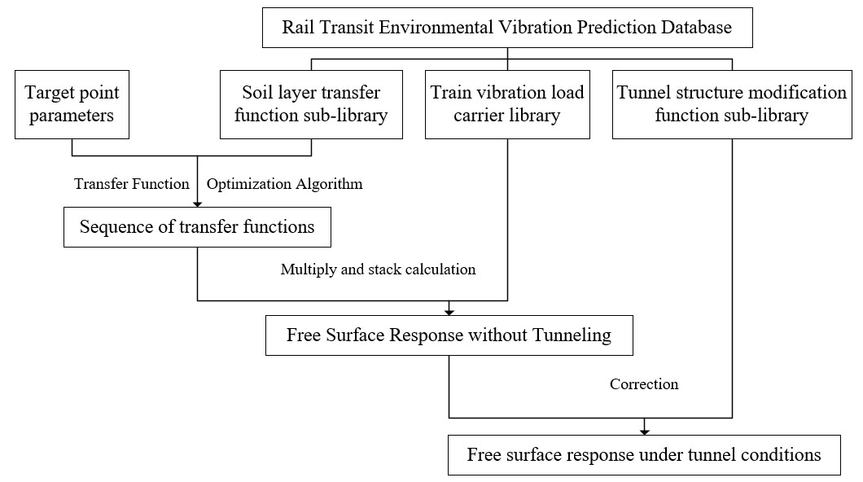
From chart 3, it can be found that the storage of each sub-database is independent of each other, and calling different sub-databases in different prediction stages can realize rapid prediction of rail transit environmental vibration.
The structure of each sub-database is:
- The calling of train vibration load data is mainly based on its corresponding speed characteristics. When building the train vibration load database, the train vibration load data is stored in Excel, and the name of the Excel file is its corresponding vehicle speed. At the same time, all the speed data are stored on the Excel table to establish the train vibration load index data table.
- In the transfer function database, the transfer function is called based on its corresponding characteristic parameters. When building the transfer function database, the transfer function data of each soil layer condition is stored in an Excel table, and the name of the Excel file is formed by the arrangement and combination of its corresponding characteristic parameters. At the same time, the eigenvalue parameters corresponding to all soil layer conditions are stored in the transfer function index data table, and the transfer function index data table is in Excel format.
- The structure of the tunnel structure correction function database is similar to that of the above two sub-databases. Since it mainly considers the tunnel buried depth and the horizontal distance of the response point when it is called, when the index data table without tunnel correction function is established, the data stored in the index data table is the tunnel buried depth and the horizontal distance of the response point corresponding to the correction function.
When the parameters of the target point are known, the transfer function database is called by the transfer function optimization algorithm to solve the target point transfer function sequence; the train vibration load sequence can be obtained by calling the train vibration load database according to the vehicle speed, and the obtained transfer function can be obtained by calling the transfer function database. The multiplication and superposition operation of the sequence and the train vibration response sequence can obtain the free surface vibration response under no tunnel condition; finally, the tunnel structure correction function is adjusted according to the structure of the horizontal distance and buried depth rail transit environment vibration prediction database and the calculation of the source data. Moreover, the addition, deletion, modification and checking of data in the database can be implemented through different codes in MATLAB. In order to realize the rapid management of a large amount of data, it is necessary to build an index data table when constructing the database. In the prediction model, the data storage path is constructed for the index data tables of different sub-databases, and the calling data is read by MATLAB code.

3.2 Global sensitivity analysis of soil transfer function based on Sobol method
At the same time, according to some sensitivity analysis methods introduced in the previous chapter, the Sobol global sensitivity analysis method is the most suitable. Therefore, this research intends to use the Sobol global sensitivity analysis method to analyse the transfer function of the soil layer. Consequently, this research mainly uses the Elastodynamic Toolbox (EDT) developed by the University of Leuven based on MATLAB for calculation [24]. When performing Sobol global sensitivity analysis, MATLAB is mainly used for programming calculations. The specific calculation process can be divided into three steps: sampling, calculation of the transfer function corresponding to the sample, and calculation of the global sensitivity. Sampling is to directly use the built-in function sobolset in MATLAB for sampling, the sampling dimension is the number of calculation parameters, and the sampling number is 1000. The sampling range is the full range of each parameter of the soil layer in the region. The calculation of the transfer function corresponding to the sample is to use the MATLAB+EDT toolbox to calculate the transfer function corresponding to the different parameter combinations obtained by sampling. To calculate the global sensitivity, use MATLAB to program to calculate the global sensitivity of each parameter. Since the value of the transfer function is in complex form, the global sensitivities of the real and imaginary parts of the transfer function are calculated separately here.

3.3 Design of transfer function optimization algorithm based on weighted k-means clustering
In the process of using the database for regional environmental vibration prediction, if the parameter combination of the target point matches the existing parameters in the transfer function database, the transfer function can be directly located in the database, so the prediction accuracy is high. However, due to the wide variation range of parameters such as soil physical parameters, soil thickness, and tunnel depth, the database cannot cover all the data.

The transfer function data in this research is high-dimensional sample data, so the weighted k-means clustering algorithm is used in the design of the transfer function optimization algorithm. Based on the transfer function database, the algorithm can realize fast and accurate prediction of the transfer function of the target point. The clustering algorithm is introduced into the multi-parameter optimization calculation, and the optimization algorithm of the transfer function is designed based on the weighted k-means clustering algorithm. The algorithm can realize the fast and accurate solution of the transfer function of the target point based on the limited data in the database.

The optimization process of the transfer function optimization algorithm can be divided into two branches according to the matching of the target point parameters and the data in the transfer function database. When the target point parameter exactly matches the corresponding parameter of a certain piece of data in the transfer function database, the transfer function is directly called the target point transfer function. When there is no transfer function matching the parameters of the target point in the transfer function database, the transfer function is optimized based on the weighted k-means clustering algorithm to find the optimal solution of the transfer function. The optimization process is shown in chart 4.
Chart 4: Transfer function optimization process
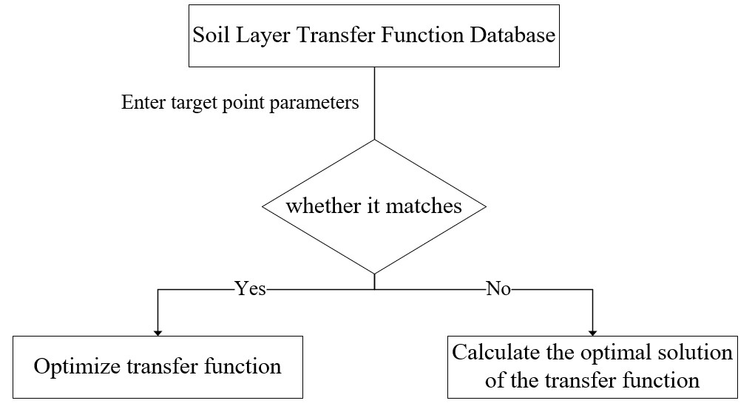
Combined with the above chart 4, when there is no transfer function matching the parameters of the target point in the transfer function database, the transfer function needs to be optimized to find the optimal solution of the transfer function. It is mainly divided into three parts: the clustering of the overall sample (the first clustering), the secondary clustering, and the construction of the transfer function of the target point. The optimization idea of the transfer function optimization algorithm based on weighted k-means clustering is shown in chart 5.
Chart 5: The design mentality of transfer function optimization
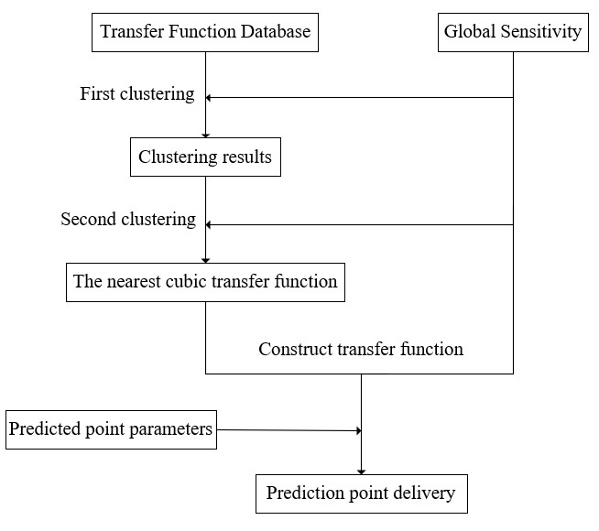
From chart 5, it can be found that the overall sample clustering is to divide the entire data set into several small data clusters and save the clustering results for subsequent algorithm calls. The purpose of secondary clustering is to avoid large errors in the prediction of the data in the data cluster corresponding to the cluster centre closest to the prediction parameter if the clustering result of the overall sample clustering is directly used. After completing the above steps, according to the results of secondary clustering, a cluster with the target point as the cluster centre can be found, and the transfer functions corresponding to the three points closest to the target point in the cluster are extracted. Based on these three transfer functions, an interpolation method based on the weight of each parameter is used to construct the transfer function of the target point.

Compared with the traditional algorithm, this algorithm considers the global sensitivity of each parameter to solve the transfer function of the target point. Under the premise of ensuring the accuracy of the transfer function, the demand for data in the transfer function database is relatively small. And when the optimal solution of the transfer function is obtained, the matching of the parameters of the target point and the transfer function database is considered, which improves the solution accuracy of the transfer function. For the case where there is no transfer function matching the parameters of the target point in the transfer function database, the optimal solution of the transfer function is solved based on weighted k-means clustering. The solution process has the following advantages:
- The clustering results of the overall sample clustering are stored, which greatly speeds up the calculation speed of the optimization algorithm;
- Secondary clustering effectively avoids the possible local optimal solution in k-means clustering;
- The weight of each influencing parameter is considered in the calculation process, and the adaptability to the high-dimensional transfer function sample data is good.

3.4 Prediction Process of Rapid Prediction of Rail Transit Environmental Vibration Based on Database
According to the previous method research in this research, the database architecture was first completed using MATLAB. Then completed Global sensitivity analysis of soil transfer function based on the Sobol method. Finally, the algorithm design of the optimal solution of the transfer function is completed, and the key problem of using the database to quickly predict the environmental vibration of rail transit is solved. Based on the above research results, this chapter mainly designs the prediction process of the database-based rapid prediction method of rail transit environmental vibration, which makes the prediction process more convenient and faster.

When using the database-based rapid prediction method of rail transit environmental vibration, it is first necessary to provide the parameters of the predicted target point, as shown in chart 6.
Chart 6: The prediction process of environmental vibration of rail transit
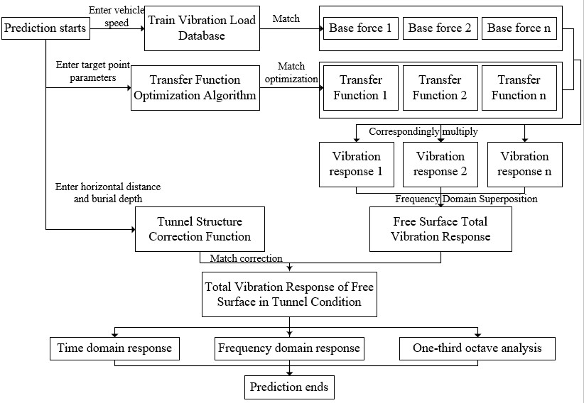
From chart 6, the prediction work is completed in four steps:
Step 1: Match the fastener reaction force sequence in the train vibration load database according to the speed of the subway train.
Step 2: According to the parameters of the target point, use the corresponding transfer function optimization algorithm to match the optimal solution sequence of the transfer function in the transfer function database.
Step 3: Multiply and add the obtained fastener reaction force sequence and transfer function sequence to obtain the frequency domain vibration response of the free surface. After conversion, the surface vibration time history, frequency spectrum, 1/3 octave and other data can be obtained.
Step 4: Considering the influence of tunnel conditions on the surface vibration response, according to the horizontal distance from the target point to the vibration source and the tunnel burial depth, match the correction function sequence in the tunnel structure correction function database, and correct the free surface vibration response. Finally, Obtain final predictions of surface vibration response for environmental vibration assessment.

This chapter surveys the relevant literature. It discussed the research intends to use rail transit environment vibration database which includes three sub-databases, which are the transfer function database, the train vibration load database and the correction function database of the tunnel structure's response to vibration; the research intends to use the Sobol global sensitivity analysis method to analyse the transfer function of the soil layer; the research intends to use the weighted k-means clustering algorithm is used in the design of the transfer function optimization algorithm and the research intends to designs the prediction process of the database-based rapid prediction method of rail transit environmental vibration, which makes the prediction process more convenient and faster. The following chapter will address these issues in results and discussion.

4. Results and discussion
This research is temporarily in the research planning stage, but there are still certain plans for future research. In order to verify the accuracy of the prediction results of the rapid prediction method of rail transit environmental vibration proposed in this study, it is planned to select the ground vibration test in the field. At the same time, the prediction method proposed in this research is used to analyse the surface vibration of the section, and the prediction results are compared with the field measured results. In order to achieve the purpose of proving whether there are laws and whether errors are controllable.

5. Conclusion
This research comprehensively adopts the Sobol global sensitivity analysis method, weighted k-means clustering algorithm, MATLAB language and other methods to carry out relevant research on the rapid prediction method of rail transit environmental vibration based on the database. A rapid regional prediction method of rail transit environmental vibration based on the rail transit environmental vibration prediction database is established, which realizes the rapid prediction of the surface vibration response. The main work and conclusions are as follows:
- Design of rail transit environment vibration database
The rail transit environment vibration prediction database is designed by using MATLAB language. The database includes three sub-databases, such as the single and multi-layer soil transfer function database, the train vibration load database and the tunnel structure correction function database.
- Research on the influence law of each parameter change on the transfer function
The Sobol global sensitivity analysis method is introduced to analyse the global sensitivity of each parameter. Based on this, the influence of each parameter change on soil transfer function is studied.
- Design of transfer function optimization algorithm
Based on the weighted k-means clustering algorithm, the transfer function optimization algorithm is designed to realize the solution of the optimal transfer function.
- Establishment of a rapid prediction method for rail transit environmental vibration
Based on the above research results, the detailed process of the database-based rapid prediction method of rail transit environmental vibration is established.

Moreover, the cross-research on database and rail transit environmental vibration prediction is still in its infancy. Based on the database, this research proposes a rapid prediction method for rail transit environmental vibration, which can realize rapid regional prediction of rail transit environmental vibration considering frequency domain information. But there are still some problems that need to be further improved:
- In this research, the transfer function optimization algorithm is used to solve the optimal solution of the transfer function under the premise of limited database source data. With the improvement of database data, the accuracy of this method will be further improved. Therefore, in future work, the database source data should be enriched according to the actual conditions of different cities and regions;
- In this research, when the transfer function optimization algorithm is carried out, the error calculation can be performed on the data of different sub-databases by establishing the accuracy evaluation index to improve the prediction accuracy.

6. Reference list
[1] Bao, Xuding. "Urban rail transit present situation and future development trends in China: Overall analysis based on national policies and strategic plans in 2016–2020." Urban Rail Transit 4, no. 1 (2018): 1-12.

[2] Breccolotti, M., A. L. Materazzi, D. Salciarini, C. Tamagnini, and F. Ubertini. "Vibrations induced by the new underground railway line in Palermo, Italy Experimental measurements and FE modeling." In Proceedings of the 8th International Conference on Structural Dynamics, Leuven, Belgium, pp. 719-726. 2011.

[3] MA, Meng, Wei-ning LIU, and Wei-feng LIU. "Research progress of prediction method and uncertainty of train-induced environmental vibration [J]." Journal of Traffic and Transportation Engineering 3 (2020): 1-16.

[4] Ungar, E. E., and E. K. Bender. "Vibrations produced in buildings by passage of subway trains; parameter estimation for preliminary design." (1975).

[5] Kurzweil, Leonard G. "Ground-borne noise and vibration from underground rail systems." Journal of Sound and Vibration 66, no. 3 (1979): 363-370.

[6] Melke, J. "Noise and vibration from underground railway lines: proposals for a prediction procedure." Journal of Sound and Vibration 120, no. 2 (1988): 391-406.

[7] Hussein, M. F. M., Shashank Gupta, H. E. M. Hunt, Geert Degrande, and J. P. Talbot. "An efficient model for calculating vibration from a railway tunnel buried in a half-space." In Proceedings of the Thriteenth International Congress on Sound and Vibration, Vienna. 2006.

[8] “ISO 27000, first steps with the standard - OSTEC blog,” OSTEC, 2020. [Online]. Available: https://ostec.blog/en/general/first-steps-iso-27000/.

[9] Zou, Chao, Yimin Wang, Peng Wang, and Jixing Guo. "Measurement of ground and nearby building vibration and noise induced by trains in a metro depot." Science of the Total Environment 536 (2015): 761-773.

[10] Karabalis, Dimitris L., and Dimitrios E. Beskos. "Dynamic response of 3-D flexible foundations by time domain BEM and FEM." International Journal of Soil Dynamics and Earthquake Engineering 4, no. 2 (1985): 91-101.

[11] Wolf, S. "Potential low frequency ground vibration (< 6.3 Hz) impacts from underground LRT operations." Journal of sound and vibration 267, no. 3 (2003): 651-661.

[12] Clouteau, Didier, Maarten Arnst, T. M. Al-Hussaini, and Geert Degrande. "Freefield vibrations due to dynamic loading on a tunnel embedded in a stratified medium." Journal of sound and vibration 283, no. 1-2 (2005): 173-199.

[13] Degrande, Geert, Mattias Schevenels, P. Chatterjee, W. Van de Velde, P. Hölscher, V. Hopman, A. Wang, and N. Dadkah. "Vibrations due to a test train at variable speeds in a deep bored tunnel embedded in London clay." Journal of Sound and Vibration 293, no. 3-5 (2006): 626-644.

[14] Degrande, Geert, Didier Clouteau, Ramzi Othman, Marteen Arnst, Hamdi Chebli, Ralf Klein, Pranesh Chatterjee, and Bram Janssens. "A numerical model for ground-borne vibrations from underground railway traffic based on a periodic finite element–boundary element formulation." Journal of Sound and Vibration 293, no. 3-5 (2006): 645-666.

[15] Gupta, Shashank, W. F. Liu, Geert Degrande, Geert Lombaert, and W. N. Liu. "Prediction of vibrations induced by underground railway traffic in Beijing." Journal of sound and vibration 310, no. 3 (2008): 608-630.

[16] Zhang, N., H. Xia, W. G. Yang, and S. Zhao. "Prediction and control of building vibration under metro excitations." In Proceedings of the 8th International Conference on Structural Dynamics (EURODYN 2011). Leuven, pp. 705-711. 2011.

[17] Jaquet, T. "Ensuring Acceptable Vibration Levels in Listed Buildings by Means of Precise Vibration Measurements and Highly-Efficient Floating Slab Track." Noise and Vibration Mitigation for Rail Transportation Systems (2015): 385-392.

[18] Connolly, D. P., Georges Kouroussis, Antonios Giannopoulos, Olivier Verlinden, P. K. Woodward, and M. C. Forde. "Assessment of railway vibrations using an efficient scoping model." Soil Dynamics and Earthquake Engineering 58 (2014): 37-47.

[19] Jianjun, Shi, Li Qingya, Zhang Qi, Wei Xing, and Wang Hui. "Forecast system for blasting vibration velocity peak based on Matlab and BP neural network." Explosion and Shock Waves (2017).

[20] Kristensen, Martin Heine, and Steffen Petersen. "Choosing the appropriate sensitivity analysis method for building energy model-based investigations." Energy and Buildings 130 (2016): 166-176.

[21] Kristensen, M. and Petersen, S., 2016. Choosing the appropriate sensitivity analysis method for building energy model-based investigations. Energy and Buildings, 130, pp.166-176.

[22] Han, Linsheng, Xiangyang Li, and Dakao Yan. "Several mathematical methods of sensitivity analysis." J. China Water Transport 004 (2008): 177-178.

[23] Homma, Toshimitsu, and Andrea Saltelli. "Importance measures in global sensitivity analysis of nonlinear models." Reliability Engineering & System Safety 52, no. 1 (1996): 1-17.

[24] Metropolis, Nicholas, and Stanislaw Ulam. "The monte carlo method." Journal of the American statistical association 44, no. 247 (1949): 335-341.

[25] McRae, Gregory J., James W. Tilden, and John H. Seinfeld. "Global sensitivity analysis—a computational implementation of the Fourier amplitude sensitivity test (FAST)." Computers & Chemical Engineering 6, no. 1 (1982): 15-25.

[26] Nossent, Jiri, Pieter Elsen, and Willy Bauwens. "Sobol’sensitivity analysis of a complex environmental model." Environmental Modelling & Software 26, no. 12 (2011): 1515-1525.

[27] Likas, Aristidis, Nikos Vlassis, and Jakob J. Verbeek. "The global k-means clustering algorithm." Pattern recognition 36, no. 2 (2003): 451-461.

[28] Ray, Susmita. "A quick review of machine learning algorithms." In 2019 International conference on machine learning, big data, cloud and parallel computing (COMITCon), pp. 35-39. IEEE, 2019.

[29] Santini, Marina. "Advantages & disadvantages of k-means and hierarchical clustering (unsupervised learning)." URL: http://santini. se/teaching/ml/2016/Lect_10/10c_Unsupervise dMethods. pdf (Accesed 17.04. 2019) (2016).

[30] Chen, Xiuguo, Wensheng Yin, Pinghui Tu, and Hengxi Zhang. "Weighted k-means algorithm based text clustering." In 2009 International Symposium on Information Engineering and Electronic Commerce, pp. 51-55. IEEE, 2009.

