Marketing Plan for Six Senses

Name: Virag Pusztai
Student ID: 2242115
Module title: Marketing Essentials BMIH4005
Lecturer’s name: Scott James
Submission date: 17.06.2023. 1:50am
Words count: 1228 (without main page and references)

Six Senses is a part of Intercontinental Hotel Group (IHG). The group itself was established in 1995 in Bangkok. They consist of 23 hotels around the world, however, there are 6 new openings in 2023-2024.
The marketing opportunity will be shown for the properties located in Maldives (Laamu, Kanuhura) through the “5 C’s”, SOSTAC, positioning map, Bowman strategy clock, PESTLE, marketing mix, SMART target, Ansoff Matrix, RACE/Communication mix, Gannt cart and seek a possible marketing opportunity.

This part of the assessment will show the situational analysis.

First, have a look at the first “company”.
 | Strengths | Weaknesses | Opportunities | Threats
 | Unique designs, destinations, sustainable, high-quality | Limited destination; one-time daily domestic flight (Maldives) | Media coverage; does not have competitors (own their island, Maldives) | Not accessible to everyone (pricey) (Bad reviews regarding domestic flights, Maldives)

This hotel group is a leading hotel in “sustainable luxury”). They follow nowadays trends, which is more a lifestyle: find the harmony between body and mind. Their exclusive products serve a significant part of market segments (concentrated targeting).
The table below demonstrates from which country, gender, and age are the target audience.
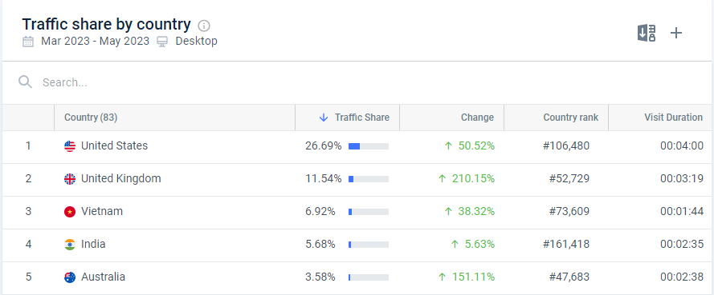

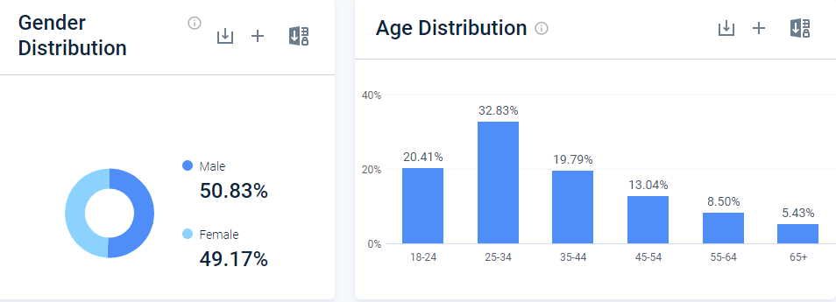

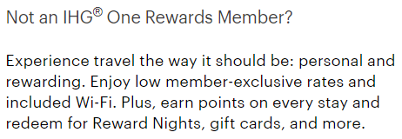

To demonstrate where Six Senses are located in the market compared to the competitors, the perceptual positioning map and Bowman Strategy clock been used.
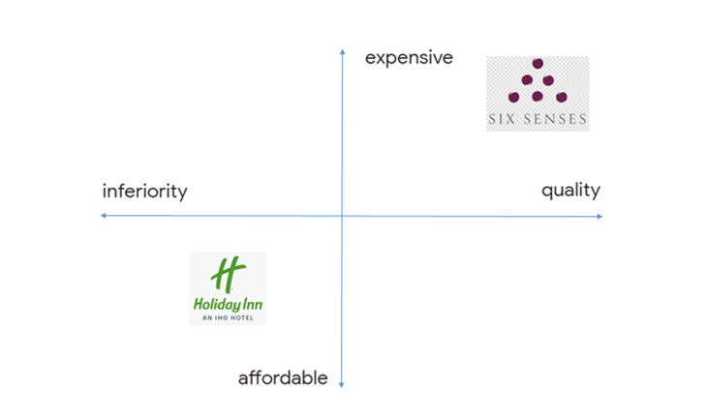
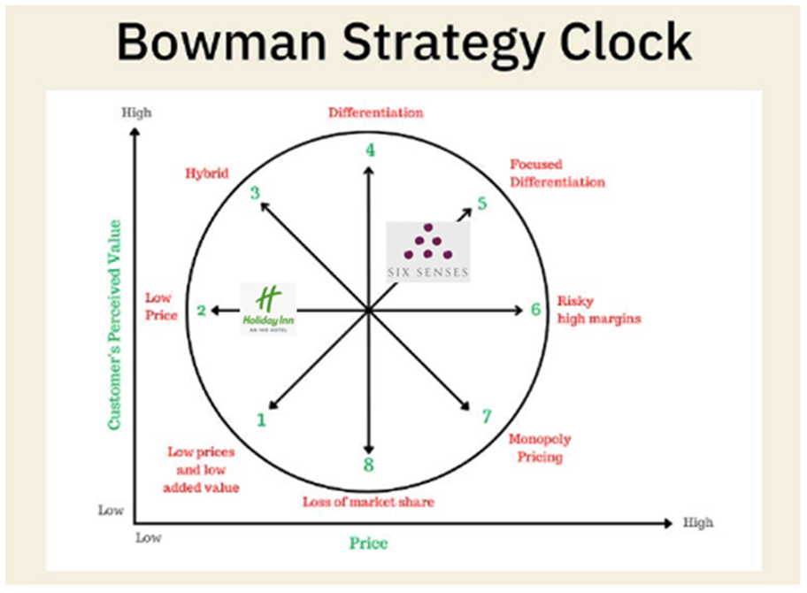

A huge part of the success of this hotel is the collaboration. At each destination, they support the local communities to help to reduce the ecological footprint. The company strives to reduce plastic waste.
The hotels located in China are part of UNESCO.
The company takes an active part in modern social media “advertising”, such as operating a Tik Tok account with attractive videos showing facilities and programs. As well as they are active on Instagram, Youtube, Facebook, and Twitter.

PESTLE
 | Politics | Economics | Social | Technological | Legal | Environmental
Six Senses Maldives | Collaborating with local suppliers | Employment rate (IHG) | Skills Academy Program by IHG | Modern advertising | Disabled rooms; halal, kosher, vegan, vegetarian, gluten-free, etc options | All properties at a unique location

Marketing mix
 | Product | Promotion | Price | Place | People | Process | Physical evidence
Six Senses Maldives | Attractive website | Different packages for different needs | Highly priced for high quality | High-speed wifi | Qualified staff | Follow processes in each department | Successful marketing (5 new openings in 2023-2024)

The goal is definitely to be a leading sustainable hotel company, with an excellent reputation.
The measure is more followers on social media, keep tracking the website, and viewers. As well as it could be measured with the growth of revenue.
It is achievable, with a focused, targeted marketing plan. For the Christmas season, it could be increased by 90k on Instagram (Kanuhura), Laamu by 165k, and Six Sensis official by 250k, since the“product” is perfectly reflecting what the company stands for.
Would be given a 6 months time frame.

The product itself is a new product-existing market. This process requires the company to do product development. There are different platforms, likewise Facebook questionnaires, and Instagram story votes. The IHG members could receive the questionnaire via email or through the applications. The most important following goal is to be a well-known company and people could associate sustainability and well-being with Six Senses.
The marketing mix requires part changes. As it is new merchandise, it needs to have a different price. As well they could have made a plan for the promotion, and how it is going to be delivered to the audience. Another important section could be the sister hotels’ upsells. Promote the new opening within the welcoming (with a promotional code). Another option could be as soon as the guests connect to the wifi a new window could appear with an attractive video, and a promotional code could be used only for these packages. . . . . . . .
An important aspect could be to personalize the package; options are already been made. This makes the guests feel they are valued.

The company needs to build awareness in the mind of the guests. Which are the ways to reach it? Advertising and good reputation. As the target is the wealthy audience, mostly the 25-36 years old adults. Based on deep research, one of the most popular advertising platforms is social media sites, however, written advertising could be successful as well using popular newspapers or catalogs, likewise sailing, golf, and horse sport.
As mentioned principal part is to interact with the individuals and make them feel part of the research. A satisfying, minimalist, straight questions sent by email, could be done in the app, be found on the website, or on social media sites. It could not take more than 5 minutes, since people are in a rush most of the time. Newsletters and notifications from the app would be great ideas as well (weekly).
Introducing the new product could be promoted by paid influencers or/and brand ambassadors. Brand ambassadors could be famous people with a background which is reflecting the company’s stands.
Loyalty members could enjoy the possibility to be the first ones to “test”, with promotion and personalized gifts (a small-sized recycled water bottle with the logo of Six Senses, the location and the name of the guest, etc…)
To build trust, most hotels hire a guest relations manager who could keep track of the guest from the moment of booking, through the stay until the moment of leaving. Every department could take part in personal selling, with training on how to upsell.
As well the brand itself could create a small shop in each hotel to sell Six Senses branded gadgets, likewise umbrellas, pens, clothing, etc…

As below it could be seen there are dissimilar options for busy and quiet months. There are time frames, likewise Thursday, Friday, Saturday, and Sunday people most likely spend time surfing the internet. However the rest of the days before work and after work (7:30am-10:30am, 5:00pm-10:00pm) is the busiest time.
Maldives is a destination that is attracting more tourists in the European winter season. Six Senses could use the low season the build reputation, and discover a way to reach wider targets.
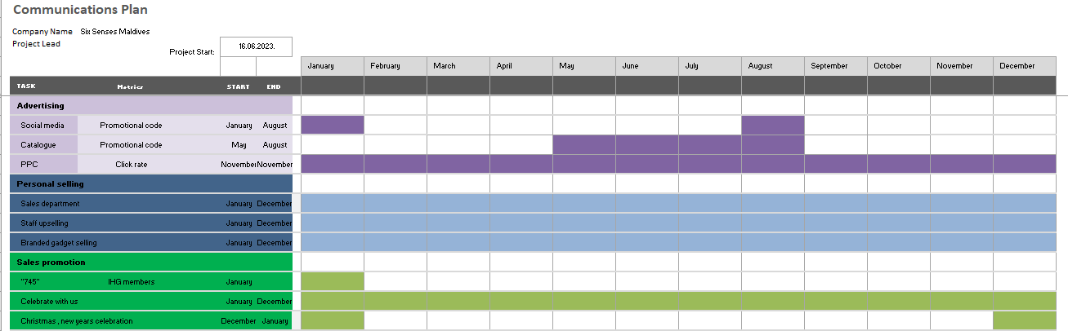

Measuring the success. One of the most visible is the growing number of followers, IHG members, and people who subscribe to the newsletter. Another, which could improve the reputation is the excellent reviews. New customers who come from other hotel brands (Mandarin Oriental etc…) could be big potential due to the fact they might have been loyal to that brand for years however the marketing, the standards, or a “mouth to mouth” review has changed their mind. All in one, the most “numerous” is the growing revenue, which allows a brand to open other branches.
The reason Six Senses properties in the Maldives have been chosen is there is a big potential to satisfy guests’ needs better. Since they will operate 2 hotels in similar locations would be a huge marketing goal to announce the Kanuhura hotel as an “adults only” property and the Laamu as family-friendly.
As this hotel group represented sustainability and quality the new product would change the segment of the market since no competitors offer the resource in the price category.
Somehow they could use marketing better and reach a wider audience using the low-season opportunities. In a few years, the company could be the leader in its category.

References:
Six Senses (2022) Corporate
Available at: https://www.sixsenses.com/en/corporate/media-center/press-releases/2021/six-senses-is-the-first-hospitality-brand-to-partner-with-the-united-states-coalition-on-sustainability-and-sustainchain
https://www.sixsenses.com/en/corporate/media-center/press-releases/2020/six-senses-joins-global-tourism-plastics-initiative-to-become-plastic-free-by-2022
Accessed: 12.06.2023

Six Senses (2023) “Luggage free”
Available at: https://www.sixsenses.com/en/trade-enewsletter/partnership-with-luggage-free
Accessed: 12.06.2023

Six Senses (2022) Main residence
Available at: https://www.sixsenses.com/en/corporate/media-center/press-releases/2017-2018-2019/six-senses-hotels-resorts-spas-to-manage-hotel-and-residences-in-bangkok
Accessed: 12.06.2023

Six Senses (2022) Corporate Fact Sheet
Available at: https://www.sixsenses.com/media/14698/six-senses-corporate-fact-sheet-0323.pdf
Accessed: 12.06.2023

Six Senses (2023) New openings
Available at: https://www.sixsenses.com/en/new-openings
Accessed: 12.06.2023

Tripadvisor (2023) Hotels
Available at: https://www.tripadvisor.co.uk/Hotels
(Accessed: 16.06.2023.)

Booking.com (2023) Find your next stay
Available at: https://www.booking.com/index.en-gb.html?aid=375647&label=msn-9bzcB7s5VBAHr*ba0LfpMg-80607971641557%3Atikwd-80608220256431%3Aloc-188%3Aneo%3Amte%3Alp164255%3Adec%3Aqsbooking.com&utm_campaign=Booking+Name&utm_medium=cpc&utm_source=bing&utm_term=9bzcB7s5VBAHr*ba0LfpMg&msclkid=b9b49a5dd83e1ee53b8dfe3e6071d534&lang=en-gb&soz=1&lang_changed=1
(Accessed: 16.06.2023.)

Expedia.com (2023) Ideas for your next travel
Available at: https://www.expedia.co.uk/
(Accessed: 11.06.2023.)

Pro Similarweb (2023) Website Analysis
Available at: https://pro.similarweb.com/#/digitalsuite/home
(Accessed: 16.06.2023.)

Facebook (2023)
Available at: https://www.facebook.com
(Accessed: 16.06.2023)

Instagram (2023)
Available at: https://www.instagram.com
(Accessed: 16.06.2023.)

Tiktok (2023)
Available at: https://www.tiktok.com
(Accessed: 16.06.2023.)

Linkedin (2023)
Available at: https://www.linkedin.com
(Accessed: 16.06.2023.)

Apple App Store (2023)
Available at: https://appstoreconnect.apple.com
(Accessed: 16.05.2023)

Twitter (2023)
Available at: https://pro.similarweb.com/#/digitalsuite/home
(Accessed: 16.06.2023.)

Power Point slides


