

Assignment Title:
Coursework: Essay (Project Plan)

Programme: BA BUSINESS MANAGEMENT
Module name: PROJECT MANAGEMENT
Module code: LCBB5005
Student name: ALEXANDRA CREANGA
Student ID: 2113195

Table of Contents
Introduction 2
Principles of Project Management 2
Management Tools and Techniques 4
Core Elements of Project Lifecycle 5
Project Management Methodology 6
Critical Evaluation of Risk Factors 7
Stakeholder Analysis 8
Conclusion 10
Recommendations 10
Reference List 11

Introduction
The essay entails the selection of the Hinkley Point C nuclear power plant in Somerset, UK. The main objective of the power plant is to produce low-carbon electricity which creates 25,000 job opportunities and lights approximately 6 million homes, thereby providing sustainable benefits and stable revenue to the overall GDP of the UK economy. The construction project operations provide 1000 apprenticeships which cover 64% of the construction value of the nuclear project. Based on this consideration, the principles of project management, tools and technique have been discussed in detail as per the core elements of the project life cycle. The methodology approached for the project management of the Hinkley Nuclear Power Plant has been interpreted for analysing the stakeholder analysis. Lastly, the risk factors have been critically evaluated for the accurate determination of delays and overruns.

Principles of Project Management
The concept of project management is crucial for integrating the team efforts for meeting client objectives and nuclear project deadlines. The focal pointers are determined by the project manager as per the organisational hierarchy for decentralising the designated duties. Nuclear power projects are complex therefore specialised skills are necessary in every operational phase as per the project management structure.
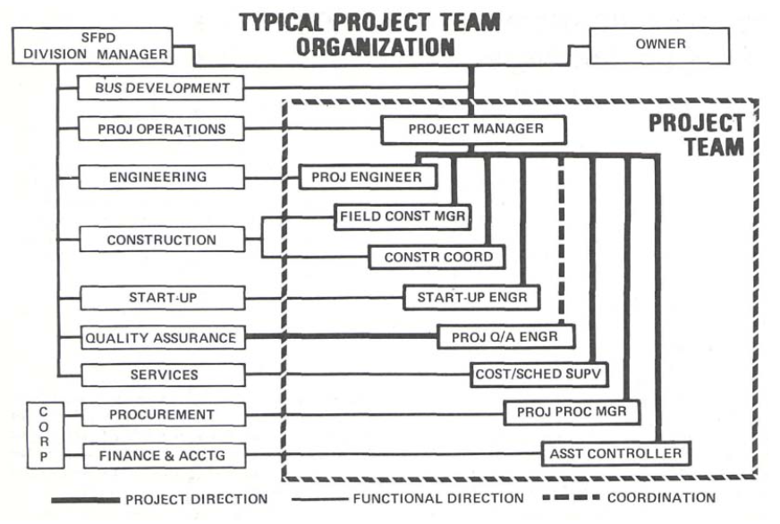
Figure 1: Designation Hierarchy in Nuclear Power Plant
(Source: Chen et al. 2019)
The project manager is responsible for coordinating the central tasks of the Hinkley Nuclear Power plant. This team includes a project procurement manager, field construction manager, project engineer, cost supervisor, construction coordinator and startup engineer (Alam et al. 2019). The project management of the nuclear power plant is dependent on monitoring the project performance such that the focal objectives are met within the stipulated deadline. The project manager of Hinkley Nuclear Power Plant here acts as an interface or the direct communication link between the corporation and the client. The project manager oversees that the objectives are met within budget and is on schedule and is acceptable to both the corporation and the client. The prerogative of modern project management helps in shaping the efforts put in by each employee as per the project life cycle (Martinsuo et al. 2019). Specific standard computer programs and techniques are incorporated for maximising total capability as per the available human resources. This type of project management technique helps in influencing consistency and reduces the possibility of error. Based on this consignment, the principles of project management in nuclear power plants are enlisted below as follows:
Project Plan
This is regarded as the first preliminary development stage of the nuclear power project which helps in defining the scope of services, functional responsibilities, cost estimation and procedures. The proposal plan for Hinkley Nuclear Power Plant provides a rough estimate of the location and equipment as per the client's request (Fernandes et al. 2020). The preliminary system flow diagram of the site facility, plant arrangement, quantity take off and site condition data are considered. The project plan also comprises three elements such as scope, cost and schedule.
Project Monitoring
An Engineer Control System helps in guiding the team members of Hinkley Nuclear Power Plant with engineering information, specification and drawing status. The system program helps in updating the construction schedules of the power plant and identifying the design constraints. The detailed engineering activities are further enhanced by the Quantity Tracking System which helps in indicating status and estimating the number of materials and equipment for the plant project (Ghorbani, 2023). The commodities are installed based on the control system and job reporting. Permanent plant equipment is identified from drawings and designed via procurement before startup, testing, installation and acceptance. Concrete-related materials such as valves, electrical equipment such as instrumentation, and mechanical equipment such as pipe hangers are ordered in bulk quantities for the nuclear power plant project.
Project Performance
Field Manhour Control is used by the project managers of Hinkley Nuclear Power Plant to track the performance of each team member (Liu et al. 2020). The software provides a performance report which contradicts the planned performance versus the real-time performance of project members. This type of report help in providing proper visibility and warns the management about the deviation in plans and allows the higher authority to take corrective action before adverse situations such as exceeding budget and manhour overruns.
Project Report
The status of the Hinkley Nuclear Power Plant is communicated to the client via financial analysis and management reports. The report provides detailed performance progress, work quality and schedule along with a production summary and progress photographs.

Management Tools and Techniques
Gantt Chart
The chart represents the timeline considered for the Hinkley Nuclear Power Plant project. Gantt Chart is regarded as an efficient tool for project managers to outline their responsibilities and get an overview of the project life cycle. The timeline showcased here starts from 12 July 2023 to 12 September 2023. The design of the Hinkley Nuclear Power Plant is created beforehand to check the procurement and get a licence as per the quality assurance metrics.

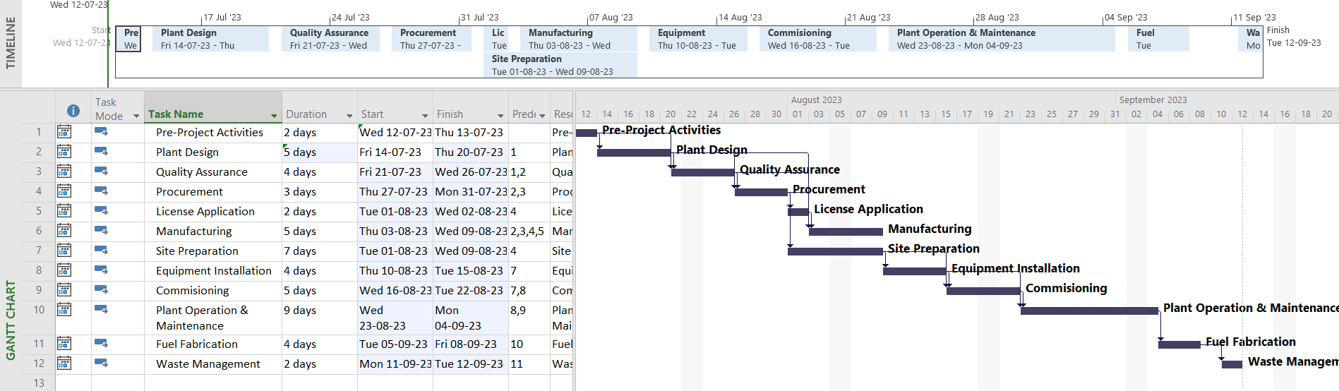
Figure 2: Gantt Chart for Hinkley Nuclear Power Plant
(Source: Self-Developed)
The time taken for preparing the site takes seven days however plant operation and maintenance takes nine days. These are assumed duration as per the predecessors of the activities considered for the Hinkley Nuclear Power Plant project. The Gantt Chart also considers fuel fabrication and waste management which is an integral aspect of the power plant for facilitating the smooth functioning of the business operations. The project managers used this chart to monitor and submit to the client for approval and get capital as per budget.
Critical Path Technique
This technique is useful for understanding the critical tasks as per the activities highlighted in the Gantt Chart. This approach helps in the acute identification of the activities which require a longer duration to finish and need special supervision. The critical activities act as the backbone of the project structure of Hinkley Nuclear Power Plant and the critical path technique showcases the interconnection between all the activities.
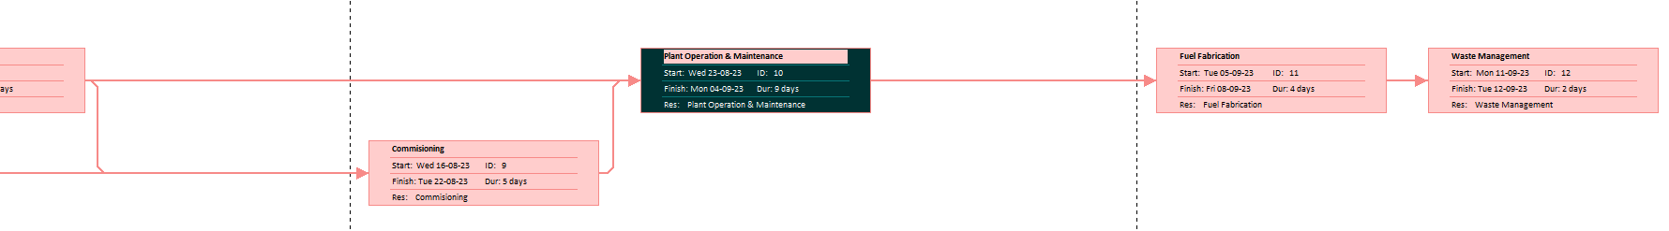
Figure 3: Critical Path Technique
(Source: Self-Developed)

Core Elements of Project Lifecycle
Project lifecycle is the kind of process in which methods used in the management and organizational works are classified in a linear manner. The project lifecycle is the essence by which an organization or management makes proper use of their objective-oriented executions. In this concern, the project lifecycle of The Hinkley Point C will be evaluated. Initiation is the element of the project life cycle that makes the proper starting of the processes and mechanical works in Hinkley Point C. The use of planning is the fundamental element and in the project lifecycle this will provide the need of making a blueprint based on the mechanical and management works in Hinkley Point C (Ghorbani, 2023). With the use of proper and better planning the project stability and dynamics will be in linear precision in Hinkley Point C. This will make the objective-based code of working to be in perfect equilibrium. This will provide the project with proper accomplishment with the stakeholders, time, and resource management. Execution is the element of the project lifecycle that makes proper essence of conduct. Monitoring provides proper control needed in the project lifecycle in Hinkley Point C. Closing is the element that proper superior success to the project work in Hinkley Point C.

Project Management Methodology
There are many kinds of project management methodology that can be used by Hinkley Point C and these are as follows:
Agile: This will provide proper ingraining of flexibility in the dynamics of the project. It also makes the project make proper improvisation in a dynamic manner in Hinkley Point C.
Waterfall: This is a software approach in which step-by-step project execution is conducted. This makes the project works in Hinkley Point C to be in linear perfection with serious phases and closure.
Critical path: This makes the project works to be in proper linearity with available resources and code of execution. This makes the project make proper use of services of phases based on the timelines and project deadlines (Htoo et al. 2023). This will make the project execution in Hinkley Point C to be in excellent success and thrive.
Scrum: This is the kind of technique in this overarching model that is used to make the stakeholders in the project to successive thrive. This makes the project have proper use of understanding of the many kinds of stakeholders involved in it (Zhang et al. 2023). Hinkley Point C needs the use of proper examination of the effectiveness of the project in a linear manner. This will provide improvisation into the project works with proper efficiency success.
Lean six sigma: This is the statistical analysis in which perfection and empirical quality of the project works are preserved. This makes the project have a proper measure of the management and business function in a precise fashion. This makes the project have proper measuring and analysis benefits. This will make the project works in Hinkley Point C to be in a success and thrive in perfection. This will make benefit the circulation of improvement and control needed in the project stability in Hinkley Point C.
Sigma: This will make a guideline of approval to the project works in Hinkley Point C.
PRINCE 2: This will make the project have proper use of classified processes and executions. This will increase the validity of the project in a linear with proper use of time, scope, quality, quantity, and cost.
PMBOK: This makes the project have proper ordination of theoretical and practical applications. This will increase the value and virtue of the project works involved in Hinkley Point C.

Critical Evaluation of Risk Factors
There are many kinds of risk factors associated with the project and these are as follows:
Scope creep: This is the kind of risk in which inefficient objectives are followed in the project works in Hinkley Point C.
Low performance: This is the risk in which the root cause of project management is having dilemmas and lack of identification in Hinkley Point C.
High cost: This is the kind of risk in which Hinkley Point C can have the project executions to be in high expense usage.
Time crunch: This is the kind of issue in the Hinkley Point C project works are in which time management is in insufficiency.
Stretched resources: This is the issue that can make procurement dilemmas in the project works of Hinkley Point C (Stanitsas and Kirytopoulos, 2023).
Operational change: This is the condition in which a project dynamics can have a linear dilemma related to the change involved in the project dynamics in Hinkley Point C.
Lack of clarity: This is the occasion in which project works in Hinkley Point C have issues related to mismanagement.

Stakeholder Analysis
The Hinkley Point C project is a complex and challenging project with several stakeholders with different interests.
Internal Stakeholder: Internal stakeholders are the people who are working inside the business organisation for providing their best to the company in the hope of achievement or development. In this project, the internal stakeholders are Hinkley Point C Company, managers and employees.
Hinkley Point C Company: The company is constructing a power plant and also they have taken all responsibility for designing the project, constructing the project, and maintaining the plant.
Project Management Team: The project management team is responsible for undertaking the day-to-day activities of the project. They are responsible for maintaining the project and completing the project within the times and budget.
Engineers: They are responsible for constructing and designing the project. They are also responsible to ensure that the project meets all the safety and environmental standards.
Employees: The employees are the main person who is responsible for making the project on time and they also need to use high-quality materials in the project (Heslinga et al. 2019). As per the power grid, the employees need to obsess closely about their activity and their work.
Shareholders: Shareholders are the person who invested their funds with the motive of high returns. The shareholder's job is to invest a lump sum amount of money in the project. As per the power grid, the company needs to inform the daily activities of the project and also they need to report on the progress activity.
External Stakeholders: External stakeholders are the people who do not work with the company but are indirectly connected with the company by some action or motive with the company examples are the Government and the local community.
Government: The government is the main stakeholder in this project, and has a vast interest in observing the project and building the project on time with the use of high-quality materials within the budget. The government is also responsible for ensuring the project is following the rules and regulations and is meeting safety and environmental standards. The main concern of the government is that the project is completed in a limited time within the budget and it also tries to meet all the safety and environmental standards (Wood et al. 2021). The government has several tools, and by using them they can manage the project and also observe the activity related to the project. This involves the project budget, uses of materials, approving the design of the project and regulation of the project in operation and construction. As per the power grid, the company needs to satisfy the government and also they need to report to the government regarding the maintenance of laws and safety rules.
Local Community: The local community is concerned about the impact of the project on the environment and in the local areas. The local community is also in agreement with the safety of the plant and if any type of accident can occur, what will be the impact on them? The local community believes that the project can generate jobs which will be beneficial for them. But the project is dangerous from their point of view of them as they believe that it will pollute the areas and many diseases can occur (de Oliveira et al. 2019). The community is looking for assurance that the project will not harm the local environment or disrupt the livelihoods of residents. They need different types of opportunities like local employment, training and development of skills. Mitigating potential environmental impact and providing some benefits such as building the transportation facility and funding the local incentives. As per the power grids, the company need to satisfy the local community that the project will not harm the environment they also assure them to deliver some of the jobs to the local peoples.
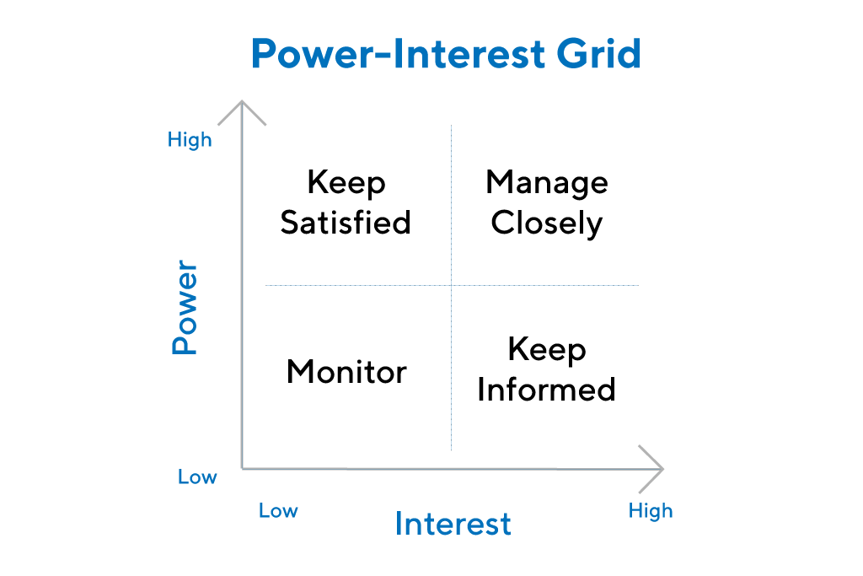
Figure: Stakeholder Analysis
(Source: Productplan.com, 2023)

Conclusion
Hinkley Point C is a nuclear power plant and it needs proper use of scientific and mechanical works with perfect precision. In this case, linear and excellent management needed to be used in every spectrum of the project. Hinkley Point C must make proper use of theoretical and practical works in their project dynamics in the nuclear power plant. The use of efficient working coordination and objective-oriented working principles are needed in Hinkley Point C.

Recommendations
There are multiple and diversified project recommendations that can be used by Hinkley Point C. One of these is ensuring all stakeholders make requirement-inclined works and executions. Proper use of a risks response team is needed to be used in this preference in the project dynamics. A linear and detailed working execution is very crucial in this context to make stability in the project management in Hinkley Point C. Hinkley Point C project works need the use of technology and leadership competences with proper success and thrive. In this consideration, the use of monitoring and tracking is being evaluated to be used with proper success and prosperity (Zeivots et al. 2023). Making a focus and concern setting is needed to be used in this reference in this project of Hinkley Point C. The proper use of communication and management is a vital need of the project success in Hinkley Point C. The time and expense of technological and digital sophistication are required to be increased in this reference of Hinkley Point C.

Reference List
Alam, F., Sarkar, R. and Chowdhury, H., 2019. Nuclear power plants in emerging economies and human resource development: A review. Energy Procedia, 160, pp.3-10.
Chen, T., Fu, M., Liu, R., Xu, X., Zhou, S. and Liu, B., 2019. How do project management competencies change within the project management career model in large Chinese construction companies? International Journal of project management, 37(3), pp.485-500.
de Oliveira, G.F. and Rabechini Jr, R., 2019. Stakeholder management influence on trust in a project: A quantitative study. International journal of project management, 37(1), pp.131-144
Fernandes, G., O'Sullivan, D., Pinto, E.B., Araújo, M. and Machado, R.J., 2020. Value of project management in university–industry R&D collaborations. International Journal of Managing Projects in Business, 13(4), pp.819-843.
Ghorbani, A., 2023. A review of successful construction project managers’ competencies and leadership profile. Journal of Rehabilitation in Civil Engineering, 11(1), pp.76-95.
Ghorbani, A., 2023. A review of successful construction project managers’ competencies and leadership profile. Journal of Rehabilitation in Civil Engineering, 11(1), pp.76-95.
Heslinga, J., Groote, P. and Vanclay, F., 2019. Strengthening governance processes to improve benefit-sharing from tourism in protected areas by using stakeholder analysis. Journal of Sustainable Tourism, 27(6), pp.773-787.
Htoo, T.T., Dodanwala, T.C. and Santoso, D.S., 2023. Project management maturity and performance of building construction projects in Myanmar. Practice Periodical on Structural Design and Construction, 28(1), p.04022070.
Liu, B., Xue, B., Meng, J., Chen, X. and Sun, T., 2020. How project management practices lead to infrastructure sustainable success: an empirical study based on goal-setting theory. Engineering, Construction and Architectural Management, 27(10), pp.2797-2833.
Martinsuo, M., Klakegg, O.J. and van Marrewijk, A., 2019. Delivering value in projects and project-based business. International journal of project management, 37(5), pp.631-635.
Stanitsas, M. and Kirytopoulos, K., 2023. Investigating the significance of sustainability indicators for promoting sustainable construction project management. International Journal of Construction Management, 23(3), pp.434-448.
Wood, D.J., Mitchell, R.K., Agle, B.R. and Bryan, L.M., 2021. Stakeholder identification and salience after 20 years: Progress, problems, and prospects. Business & Society, 60(1), pp.196-245.
Zeivots, S., Cram, A. and Wardak, D., 2023. Developing Project Management Principles by Examining Codesign Practices in Innovative Contexts. Project Management Journal, p.87569728231176924.
Zhang, L., Mohandes, S.R., Tong, Y., Cheung, C., Banihashemi, S. and Shan, M., 2023. Sustainability and Digital Transformation within the Project Management Area: A Science Mapping Approach. Buildings, 13(5), p.1355.

