Suma aktar 1707402
Molly Jack – Module Leader
Problem Solving and Decision making
Table of Contents
Introduction 3
Defining a complex problem in the workplace including its scope and impact: 4
Analyzing information on the identified problem, to help inform the decision-making process: 7
Proposing a range of alternative solutions to the problem 12
Creative Thinking Techniques undertook by Unilever: 14
Using a decision-making technique to evaluate a range of solutions to identify the most appropriate option: 16
Developing a plan for implementing the solution: 18
Communicating the plan to stakeholders: 20
Assess appropriate monitoring and review techniques to ensure successful implementation of the solution 23
Conclusion 25
Reference: 26

Introduction (unilever company)
Decision making simply defines the ability to analyze a problem and make a solution out of it. Firstly, one has to understand the main reason for the problem and then he should analyze it step by step. Secondly, he has to find out related parties to the problem and finally he can make a roadmap to solve the problem. Different elements do influence a problem and also a decision. One’s educational background, lifestyle, age, perspective etc. are very important during the time of problem-solving and decision making.
Unilever is a world-famous company that provides goods to consumers all over the world. It is famous for its varieties of brands, categories that fulfill the need of people. Though the large company, there are negative reviews about the top Management from the current employees of the company. They do not seem as satisfied as they should be working in such a large and demanding organization. It is high time Unilever took these matters in hand and tried to solve these problems because these problems have become now common among the employees. Also, they are facing less initiative in technological advancement, introducing newer marketing tools, newer product line and participative management. All of their products are more or less the same for a couple of years and they do not invest much in their research and development. They invest in their sales and marketing strategies but sometimes the product itself is a motivation for buyers to purchase. Also, employees should be the primary marketer for a company and for this these issues got focused on each and every chapter of the report. This will entirely cover the determination, problem identification, analyses, alternative finding and implementing alternatives in case of business operation of Unilever. They are facing problems in leadership, motivation, employee participation in decision making, technology usage in departments for which company is introducing training session, incentives and introducing the automated system in finance, HR, marketing and sales for better performance which will ultimately maximize the wealth of the owners.

Defining a complex problem in the workplace including its scope and impact:
I have used Unilever is one of the best-known brands in the world. These brands are present in almost 98% of households around the UK. Approximately, 2 billion people use Unilever products every day. Unilever is a global company that sells Fast Moving Consumer Goods (FMCG). Their main purpose is to make sustainable living commonplace. Unilever has almost 400 brands focused mainly on health and wellbeing. They usually produce Lipton, Knorr, Dove, Axe, Hellmann’s and Omo, alongside trusted local names such as Blue Band, Pureit, and Suave.
It is a large and world-class company still there are complaints from employees regarding the Management of the company. They have complained that they have faced insecurity of culture that has made them miserable. They also feel that they have to work many days in the week. The employers working there have found the promotions to be very political. The interns working have almost no interaction with the top Management they feel isolated from the company. Unilever now seems flattered as an organization because they feel career advancement has become limited. Turnover has recently become high in marketing and supply chain planning because of base salaries at this department are lower than the market. Some also feel that all the processes of different departments take a million years to develop a simple thing because many people have to approve. A statistic of their number of employees working in the UK is a 2500 person.
Scope: The Company follows the structure in every situation which may seem difficult to follow for some people. The employees have also complained that the merit of an employee does not have that much influence on future promotion which creates frustration among the employees. They feel that management needs to listen to some of the ideas of the workers working there. Management is very demanding sometimes and loose Management was also seen periodically. Unilever is usually focused on top-line initiatives. Employees of Unilever have faced that the goals of the company were not aligned from top to bottom level. Finance department usually runs the company which should not be the case. Some managers have also felt that Unilever should cut the travel budgets on huge meetings which are a waste of money and people would be happier with smaller local team meetings. Though the following picture is showing a good motive participative management system should be included to ensure the highest possible potential of all the resource.
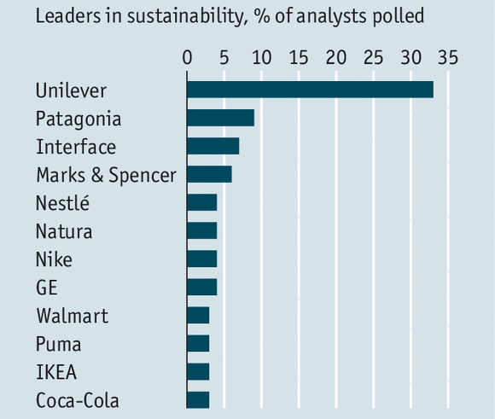
Figure: the sustainability of the business
Source: (Chow, 2011)
Impact: There have been sometimes handed off Management that has increased stress for the employees at tough times because Management was slow to respond underlying issues until it became a top priority (Chow, 2011). In the execution layer, there is no ensured alignment from top to bottom position. Employees have also faced organizational confusion. They feel the company should focus more on the long-result and development of the employees for retaining the employees and betterment of them. They have also experienced a lack of individual development plans for career growth. The employees strongly feel that Unilever should reduce the workload to have happier employees. The serious impact of Poor Management affecting the employees of Unilever is discussed below:
Fear of Management: Because of lack of communication between employees and top Management, a fear is created among the employees regarding the Management and they don’t want to continue their job. It, in turn, creates tension and unnecessary stress that ultimately affect an employee’s performance.
Poor Employee Mental/Physical Health: Management is usually a stressful place. This work stress sometimes is the result of taking on new habits such as smoking, drinking or using illicit drugs, to cope with work stress. If members of Management feel stress, it passes to the rest of the staff which leads to depression, weight gain and poor lifestyle choices hampering on the overall mental/physical health of the workforce.
Final Thoughts: Employees already working at Unilever possess innovative ideas in mind to change things around at the company to increase productivity and increase sales. But Unilever usually takes all decision at the meeting where only Top Management is present. So all the new idea remain unused which in turn reduces the confidence of the employees.

Analyzing information on the identified problem, to help inform the decision-making process:
I have Analyzing information on the identified problem involves establishing causes and effects related to the problem. Here the root causes of the problem will re-identified.
Unilever has great People to work with. The company does not focus on longer-term plans and short-term profits. People joining new Takes a while to get adjusted to the culture and all. The Management is not careful about creating a network. They are also not always clear about what is expected of staff and rarely offer feedback and reviews of performance.
The objective setting in relation to the problem:
Poor Communication: There is a huge communication gap between the employees and the top management of Unilever. Most of the time managers are unable to state what's necessary to get the job done. But they cannot express decisions clearly because they are not invited while taking the most important decisions for the company. This leaves employees with an unclear sense of purpose and employees might be performing the same task in different ways. With successful management, a manager could have organized and executed plans with confidence.
Micromanagement: Unilever lacks micromanaging. Employees here do not work as a team who share a common goal -- to get the job done. There is a lack of positive recognition and appreciation which results in a lack of trust. Employees would have worked best if managers trusted them.
Not Making Productive Use of Employees: Each employee of Unilever possess different abilities but these are not known to the top Management. Employees have almost no access to the Management they lack sense of purpose. Their unique talents go unnoticed and unused.
Lack of training: There is a lack of training for Unilever. They also don’t have strong way of giving feedback. So employees working lose their motivation and confidence. Gradually they lose trust in the Management that leads to workplace dissension among departments and high turnover rates as employees are dissatisfied with the performance of Management staff.
Lack of leadership support: There is a lack of Management and leadership support at Unilever. Though the leaders are committed and actively engaged in performance Management activates, they rarely provide support and recognition to managers and employees who exhibit the expected behaviors and actions. So even though the process at Unilever is very well designed, performance Management there is not a very successful topic.
Lack of appropriate recognition and rewards: To keep the employees engaged, motivated, and inspired about their future with the company, reward and recognition is a must (Li and Jhang, 2012). But there is no such arrangement at Unilever for the employees.
Problems can be analyzed through models too which are given here.
PESTEL analysis
The PESTLE Analysis is a tool for managers to understand the influence of the external environment on businesses(Leonard and Ambrose, 2012). In the case of Unilever, these external factors differ significantly because it is an international business.
Political Factors: The political factors affect Unilever’s performance. While trying to develop a helpful and friendly management, Unilever may face the impact of governments on firms’ remote or macro-environment.
Economic Factors: In the process of developing the current business, Unilever will have to pay more wages to the Managers because their responsibilities and work areas will expand. The economic stability will also be ensured. But they are not introducing information technology or trying to enhance their innovative activities.
Social Factors: Improvement of the management team will improve the overall health consciousness, rising environmentalist behaviors and dismantle of the gender division.

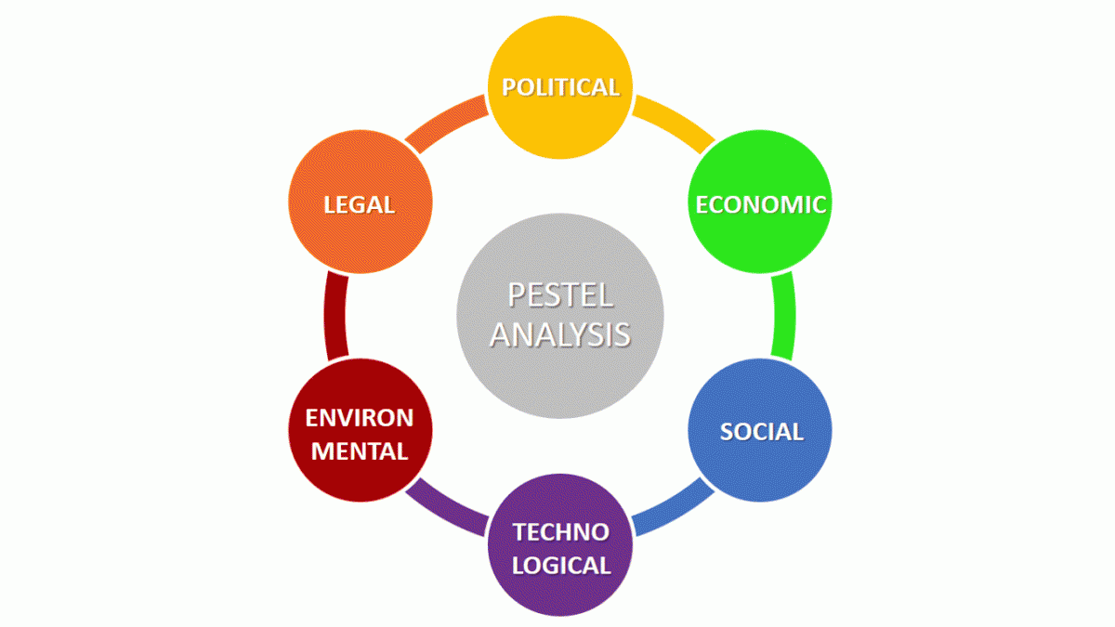

Figure: PESTEL
Source: (Seelos, 2013)
Technological Factors: The new decision to improve Unilever technologically will lead to rising business automation rising R&D investmentsandDecreasing cost of transportation based on technological efficiencies. This needs huge investment for automation in all the departments.
Environmental Factors: The new decision will have an impact on increasing business efforts on sustainability and Increasing complexity of environmental programs. It will also help to raise interest in the business environment.
Legal Factors: The new decision taken will increase the complexity of environmental regulations, Strengthen international patent laws and consumer rights laws.
Organizational analysis, such as SWOT analysis
SWOT analysis of Unilever is presented below:
Strengths: Unilever has a broad portfolio of brands and a diversified product range, which makes it positioned to tap into the changing consumer preferences across the world. Unilever has a competitive advantage over its nearest competitor which is its biggest strength.
The Weaknesses is The biggest and w
They are facing by Unilever is that it operates in such a competitive market where the other global giants like P&G and Nestle challenge its dominance at every turn. The products of Unilever can easily be replaced by substitutes which is another weakness.
Opportunities: Unilever has a greater opportunity of grabbing the market and more expanding because it is an established market in the mind of the common people. Its products are totally trusted and known to be sustainable by users.
Threats: One of the biggest threats of Unilever today is the increased awareness among the global consumers. Now Unilever must be careful in taking each and every strategic move that will affect the company. People do follow the technological change and they want home service, free delivery, offers etc. These are the initiatives for newer marketing strategies that Unilever should take care of.
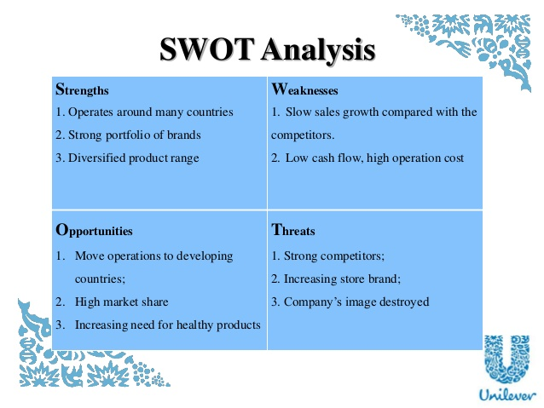
Figure: SWOT analysis
Source: (Seelos, 2013)
An established brand has a strong customer base but they also need to improve their technological expertise and introduce creativity in their sales, marketing, product mix, and production system. But they have not taken any initiative in this respect yet. In their HR department, they should train people to communicate with customers properly or read the minds of customers by selling products. They need to maintain a database as information is the key to attracting people through their choices and preferences. Organizations are trying to tag artificial intelligence with blockchain system to facilitate sales and marketing by offering relevant products to customers. For managing financial issues newer software can be used which is very much relevant at this moment.

Proposing a range of alternative solutions to the problem
Brainstorming: Brainstorming can be used as an effective way of generating many ideas on a certain issue which can be filtered and reviewed to determine which idea or approach is the most appropriate (Chow,2011). The Management of Unilever can perform with groups of between 8 and 12 people in a relaxed environment.
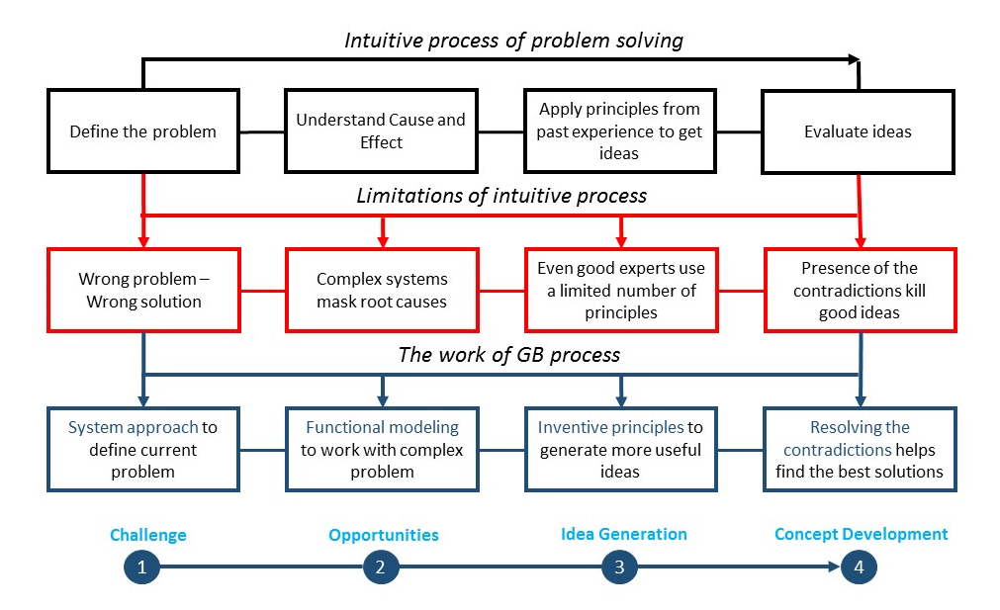
Figure: Brainstorming process
Source: (Chow, 2011)
To solve the problem at Unilever, the group of formed for brainstorming can try to solve the problem like the process to described in the picture. What they they can do to defain the They can first try to define the problem by understanding its cause and effect. They can also apply principles previously used at Unilever to get ideas of how the Management used to handle a relationship with the employees. Finally, they can evaluate the ideas generated by each member of the group.

Developing Leadership at Unilever: Unilever can try to develop the leadership theory followed there. They may try Participative or Democratic Leadership to improve the internal business environment.
increasing motivation: Motivation is really important for every employee. Due to lack of motivation, employees lose their interest and excitement from their desired job and gradually think of leaving the job. So Management of Unilever can undertake motivational work.
Developing Communication system: Building a good communication system among the employees has become a must for Unilever. Due to lack of communication, all the problem and misunderstanding are taking place.
Friendly Environment: Creating a friendly environment is really necessary for any company. So Unilever can try to arrange recreational program or family tour to strengthen the relationship. These will ultimately have a positive impact on developing the internal relation.
participative management: Unilever can arrange the employees to participate in decision making and share their unique ideas with everyone. This will encourage the creativity of the employees and also bring different ideas for Unilever.
Problems around Innovation and Creativity:
Innovation: Innovation is a must for any company to compete with others. So Unilever must focus on innovations to maintain their brand image and stay in the market. Besides this is also going to help the employees working there prove their worth.
Inability to change: Unilever is an established brand which hs structured format which is almost impossible for the company to change now so it prevents the firm from accepting any new change for the firm.
HR problems: The Human resources whether plans to accept the change or not hs the most important impact on whether the company can change its established form of running the business or not. Their employees reused to working with the long-established structure so they re not willing to bring changes in the structure of Management.

Creative Thinking Techniques undertook by Unilever:
Mind Mapping: Here the top management of Unilever can take note of every idea that comes up. They should not neglect anything. They should try to generate as many ideas as possible which will help to find the correct solution soon.
The Checklist: asking questions to help generate more ideas and problems get cleared. In the checklist, Managers of Unilever can ask six universal questions – Why, Where, When, Who, What, How, to determine the answer.
Six Thinking Hats: This theory was developed by Edward de Bono in the early 80swhichare now used by businesses all over the world (Li and Jhang, 2012). There are six hats and each hat represents a different direction of thinking.
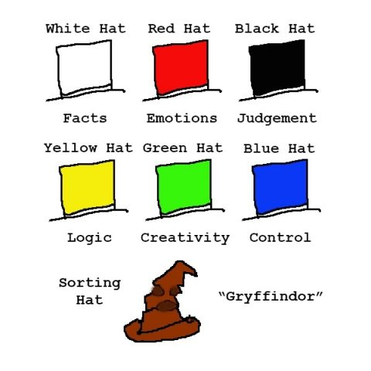
Figure: Six Thinking Hats
Source:(Leonard and Ambrose, 2012)
People in Unilever may find themselves ‘wearing’ more than one hat at once. These hats allow the managers to think and decide on topics in a rational but creative way.
Evaluating available options
To evaluate different options available from brainstorming and others, it is now necessary to evaluate the options and choose best from them. Following steps can be maintained to evaluate the available options:
Getting an expert opinion: Top management can ask for help from experts to help them decide which option will be the most promising for the betterment for Unilever. Experts have more idea in these fields and they can really help in the decision-making process.
Getting the right data: Using customer feedback from the regular customers of Unilever is a great way to get data. Besides research reports, industry trends and asking experts can also help. Having reliable data will help the top management make the best decisions for the existing business problem.
Understanding the risks: Understanding the possible and present risks of decisions will help the management of Unilever make better choices. Before making a decision they must consider the risks and the worst possible outcome for that decision. Knowing what the risks are will allow the company to prepare and which will make decision-making easier.

Using a decision-making technique to evaluate a range of solutions to identify the most appropriate option:
The importance of adequate and relevant information for effective decision-making: To make correct decisions is one of the most important tasks of a successful manager. In choosing among available alternatives managers of Unilever should consider only relevant information which includes the probable future costs and revenues that differ among the alternatives. The adequacy of information makes decision making easier for Unilever. A decision taken can prove to be either very fruitful or very damaging to the company. There is a scarcity of resources and managers must know how to make the best use of these scarce resources. Managers of Unilever face with limited machine hours, direct labor hours, raw materials in their company. Besides managers must have accurate and up-to-date information about their potential clients. So it must develop a good strategy to attract new and trustworthy customers. Relevant information is necessary for optimizing the tasks of the team. It also helps build better relationships with customers. Relevant data quantifies the purpose of Unilever that helps make better decisions. Relevant and adequate information will make information believable to the management that may prove to be beneficial to Unilever.
Unilever has come up with different alternative solutions in the previous discussion through the following brainstorming process. The company needs to evaluate each one of the alternative solutions to determine which one would be the best for the company. For the evaluation purpose, the company has applied Paired Comparison Analysis.
PairedComparisonAnalysis: In this decision-making technique, the company will compare the developed alternative solutions with each other and will score them to evaluate their significance.
Developing Leadership: Unilever can develop their leadership but they have high-class leaders who may not accept changes. So this may not be a fruitful idea.
Increasing Motivation: This will be the easiest for Unilever to follow. By engaging someone in motivation related work, both employees confidence will increase and their performance will also be affected positively.

Developing Communication system: It is the most followed in almost all businesses now. If employees can maintain good communication, it will not only affect their performance but they will also have more chance to express their ideas.
Participative management: participation is really necessary for a team to succeed in the long run(Leonard and Ambrose, 2012). Unilever as a company succeeds because its different divisions and sectors work together. But there should also be a system for ensuring participation of each employee in the decision-making process.
In this situation, it will be best for Unilever to create a participative management. This one decision is expected to solve all the problems currently faced by Unilever.

Developing a plan for implementing the solution:
Unilever can prepare a Gantt chart for deciding the schedule of meeting for different groups. Each meeting will last for certain hours and must be ensured that no employees miss the chance. It will also give the management a clear view of who is participating in the meeting at what time of the month.
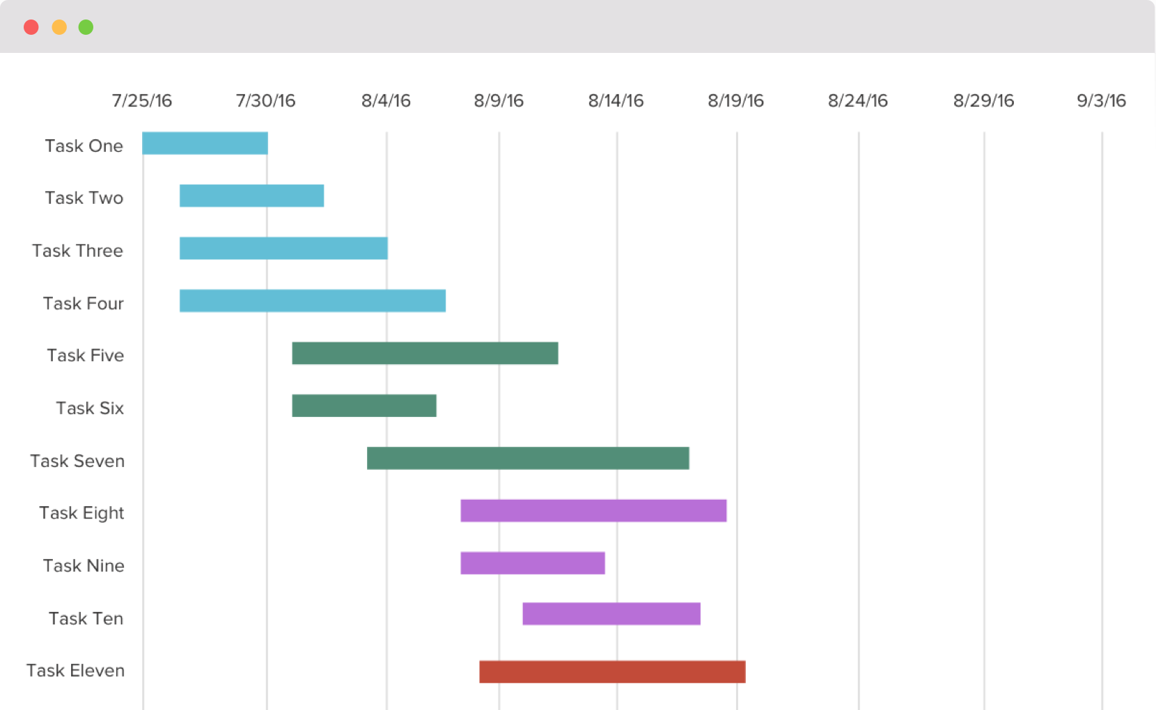

Figure: Gantt chart
Source: (Author, 2018)
Different solutions can be followed to implement the plan:
Help from Expert: Help from an expert is must in this case because new ideas can be developed and better implemented with the help of outside experts. They can be hired with a higher pay.
Employing two or three expert people to the Management Board: this can be really helpful when it is almost impossible to change the whole management so by changing two or three people, the ide can be spread throughout the group easily.
Structure development: The structure which is mentioned in Unilever can be modified by adding communication channels among employees. This will develop a relationship in the employee's and motivate them to work with more enthusiasm.

Communicating the plan to stakeholders:
Feasibility and viability of the change for stakeholders:
The stakeholders must be informed of the new change taking place at Unilever. They can help assess the feasibility and viability of the new decision. They can give their valuable ideas on whether it will prove to be successful in the near future and whether it will bring good to the company. Stakeholders include not only employees of the company but also customers, lenders, investors, public- all the parties, internal and external related with the business.
Clear communication of change and the importance of involving people to facilitate effective change:
To facilitate effective change, it is necessary to involve stakeholders. There must be a clear way of communication between all the stakeholders so that they can express their opinion on the change to happen. By involving people, they can give their valuable ideas on how the change can be introduced, how it can be made easier for people to accept and adjust, and how it can affect on the future and development of Unilever.
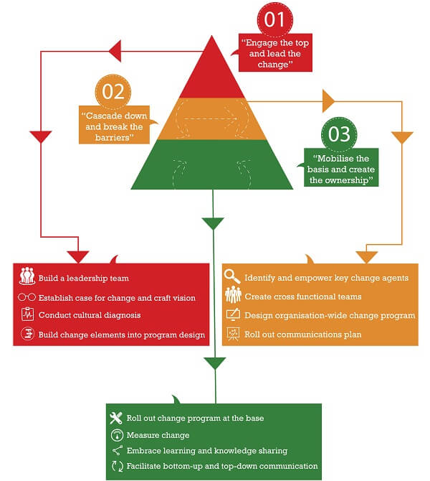

Figure: Successful Change Management
Source: (Jickand Peiperl, 2011)

Management should be always in communication with all other employees. They must know what is in the minds of the people, how they want to develop themselves and what else do they expect from the company. A successful change in the Management usually involves the employees of the company.

Assess appropriate monitoring and review techniques to ensure successful implementation of the solution
Monitoring and review techniques
Electronic communications: Unilever can use these electronic devices to control how the employees are working with the change and trying to develop the changed organization with their effort. By using companies email system, communications can be monitored and recorded.
Software: Unilever can install keystroke loggers on their machines to monitor employees’ computer usage. They can record all the letters employees’ type into their computer terminal's keyboard. The passwords and deleted information are also recorded by keystroke loggers. Employers can also monitor computer screens using remote monitoring software.
Surveillance: Employers of Unilever may physically visit workstation to monitor the tasks being performed. Video surveillance is a common method used by employers to monitor employee workstations (Li and Jhang, 2012). Strategically placed video cameras can record and archive employees’ daily computer usage. These are legal in the workplace without notice.
Proper monitoring by the top management can only ensure the successful implementation of the participative management. Employees should be monitored properly by the top management regularly to ensure the continuity of the work going on. Without the monitoring, employees may not properly concentrate on what they should do that might totally destroy the whole planning process to bring change. Solution to be developed must be communicated to the employees before they start working on that.
Monitoring should be made regular at Unilever because it will increase the quality of the work and the company. It will both improve the relationships among employee's and make works better and fruitful.
Monitoring and reviewing techniques to evaluate outcomes of problem-solving activities
Performance indicators: These indicators measure inputs, processes, outputs, outcomes, and impacts of development of Unilever. They can use these setting targets and measure progress towards them.
Formal surveys: Managers of Unilever can use this to collect standardized information from a sample of people or households. They can be useful for understanding actual conditions and changes over time.
Rapid appraisal methods: through this, managers can quickly and cheaply provide decision-makers with views and feedback from beneficiaries and stakeholders. They include interviews, focus groups, and field observation.
Participatory methods: These will allow all stakeholders of Unilever to be actively involved in decision-making. These will result in the best decision ever made for the company.

Conclusion:
I think Changing the Management can brings large change in the company. Unilever is a well-established company that has goodwill around the world. So it is just that it has a good board of Management that cares enough for the betterment of the employees and maintains good communication with them. Without developing the management, it is not possible to retain the active employees and retain them. Only good communication between employees and top Management can make the company desired one. Here Paired comparison analysis has been chosen to select the solution for solving management problem prevalent in Unilever. Through PESTEL and SWOT analysis the viability of the technique has been discussed. By taking help from an expert, developing the structure can be helpful to implement the solutions. Besides some problems are also existent is developing these solutions. The thing that can help the most in this situation is to build a strong and effective communication system in the whole organization

References that I have used
Budgen, D., Kitchenham, B. and Brereton, P. (2014). Company analysis.
Chow, G. (2011). ECONOMIC ANALYSIS AND POLICIES FOR ENVIRONMENTAL PROBLEMS. Pacific Economic Review, 16(3), pp.339-348.
Contributor, P. (2018). What is Business Analysis?. [online] PESTLE Analysis. Available at: http://pestleanalysis.com/what-is-business-analysis/ [Accessed 16 Jul. 2018].
DelPo, A. and Guerin, L. (2015). Dealing with problem employees.
Jick, T. and Peiperl, M. (2011). Managing change. Boston: McGraw-Hill/Irwin.
Leonard, N. and Ambrose, G. (2012). Idea generation.
Li, Z. and Zhang, L. (2012). A Study on Multi-Project Management Based on the Gantt Chart and Network Planning Technique. Applied Mechanics and Materials, 174-177, pp.2854-2860.
McNaull, J., Augusto, J., Mulvenna, M. and McCullagh, P. (2012). Data and Information. Journal of Data and Information Quality, 4(1), pp.1-15.
Min, M. and Petrovic-Lazarevic, S. (2012). Manager's role in implementing organizational change. [Caulfield East, Vic.]: Monash University, Dept. of Management.
Mindtools.com. (2018). Change ManagementMaking Organization Change Happen Effectively. [online] Available at: https://www.mindtools.com/pages/article/newPPM_87.htm [Accessed 15 Jul. 2018].
Seelos, C. (2013). Theorizing and Strategizing with Models: Generative Models of Business Models. SSRN Electronic Journal.
Successful change requires more than change management. (2013). Human Resource Management International Digest, 16(7).
Vaněk, M., Mikoláš, M. and Žváková, K. (2012). Evaluation Methods of Swot Analysis / Metody Vyhodnocení Swot Analýzy. GeoScience Engineering, 58(2), pp.23-31.

