Task 2: Report (2000 words) - 50% of the final mark for the module Write an appropriately structured academic report where you reflect on your learning in this module, using a recognised model of reflection (one). Discuss 3-4 topics from those covered during the term (listed below) and reflect on how useful they have been to you, taking into consideration what you already knew and any learning you undertook outside of the classroom. You will need to explain the chosen model of reflection and apply it to each topic. You will also need to analyse published literature relating to the specific topics you discuss and use the feedback you received on all in-class activities.
Topics covered:
1. Time management / Organising study
2. Academic Writing
3. Paraphrasing
4. Summarising
5. Referencing
6. Reflection
7. CV writing
8. Cover letter writing
9. Public speaking and giving presentations
10. Online Learning Experience



Academic and Employability Skills
Reflective report
Term 1

Student: Oana-Ramona Ladariu
Student number: 1906081
Lecturer: Barbara Chinyani
Due date:27.04.2021

Table of content:
- Aknowledgments……………………………………………………………………….page 3
- Introduction……………………………………………………………………………..page 3
- Methodology…………………………………………………………………………..…page 3
- Reflective report………………………………………………………………………page 3
  - Topic 1 C.V. writing(Gibbs) …………………………………………………..page 3
  - Topic 2 Public speaking and giving presentations (Kolb’s)…….. page 5
  - Topic 3 Time management(Driscoll)………………………………………..page 6
  - Topic 4 Online learning experience(Schon)……………………………..page 7
- Conclusion………………………………………………………………….…………...page 9
- Refferences………………………………………………………..…………...…...page 10
- Appendices …………………………………………………………………..…….…..page 11

Introduction
The reflective report that I have written has the purpose to show in which ways the knowledge gained during this term on the module is helping me to develop my skills, especially my employability ones. According to D. Pool&Sewell( 2007), “Employability is having a set of skills, knowledge, understanding and personal attributes that make a person more likely to choose and secure occupations in which they can be satisfied and successful.’’
As a simple way to explain this, considering that the employability is about being capable to get and keep a fulfilling job for an individual, I consider that my employability depends on knowledge, skills and attitude. As an example, I need to analyse what I know, what I am doing with my knowledge and which are the ways that I am approaching the tasks.
Methodology
During this academic year, I reflect of what I gained as knowledge from following this module. I found out about different methods which can be used to develop my skills, my abilities, to increase my knowledge and how to have and use a proper attitude. I reflect on these methods using 4 of different models of reflection such as Schon, Driscoll, Kolb and Gibbs. In order to analyse my C.V. writing skills I have used Gibbs model of reflection and this is as a first topic. To reflect on second topic which is Public speaking and giving presentations, I choosed to use Kolbs model of reflection. For the reflection of the third topic, I choosed Driscoll model of reflection to reflect on time management and on the last topic I have analysed online learning experience and I have used Schon model of reflection.
Topic 1. C.V. Writing
For me, a C.V. is one of the most requested and important documents which are ever created and helped during a career experience in order to check on my employability. To write a C.V. can be a difficult task and also a stressful one because I need to think at a description of my self-including which is my experience regarding education, work experience, any achievements, my hobbies, which are my interests, what abilities I have and also some references if they are requested. That is why is also a stressful task for me because I need to include all that in no more than 2 pages of a document with no grammar mistakes. This is where my academic skills occur during the writing of the C.V. Also it is recommended to create a Cover Letter along with a C.V. and I want to mentions as well that a Personal Statement is what stands out in a C.V. content.
In order to reflect, I have used Gibbs reflective model which contains 6 steps in the cycle of reflection as following:
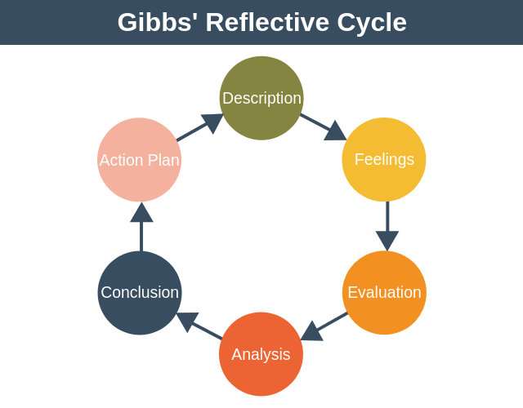
- Description
During this year I was a student and also a employer. Finding time for both makes a way to time management skills which I will write about later but the thing is that I wanted to change my job in order to have time to study as well. First step which I make is to write my CV.
- Feelings
Due to all the knowledge and abilities which I have gained I become more confident in my CV writing skills and now I can see myself as a better person ebcause I am shaped entirely different on both fields (personal and professional) due to multiple skills gained during this year of university.

- Evaluation
I evaluate my weak points and the fact the I didn`t know how to properly write a CV and also that it is recommended to have a Personal Statement was considered a weak point. The good thing about what I learned is that I have applyed the knowledge and I transformed this weak point into a stronk one and I practise and practise a lot to have the proper format.
- Analysis
After I analysed the situation that I am into and also myself in a deep way, I was able to create the most accurate version of my CV and I am proud to write one which really represents me and all my experiences.
- Conclusion
After a short waiting of applying with this CV I was called at a few interviews and succeded to change my job anf to have enough time for university and worl and also this new job is by far the best positionfor myself in a company recognised internationally.

- Action Plan

My plan is to never stop to evolve my writing skills and the way that I am presenting myself with the help of a CV. Also, I want to follow my personal development plan to check what goals I have accomplished in my professional life and which are the skills needed for improving my employability.
Topic 2. Public speaking and giving presentations
For me, public speaking represents a talent of addressing to an audience in a effective way. The ability to communicate to the audience is the key, even it is in front of people which I already know or if they are complete strangers. Giving presentations with clarity and confidence for the information is known as public speaking skills.
In order to reflect on my public speaking and giving presentations skills, I have used the Kolb’s Learning Cycle of reflection which follows concrete, reflective, abstract and active steps.
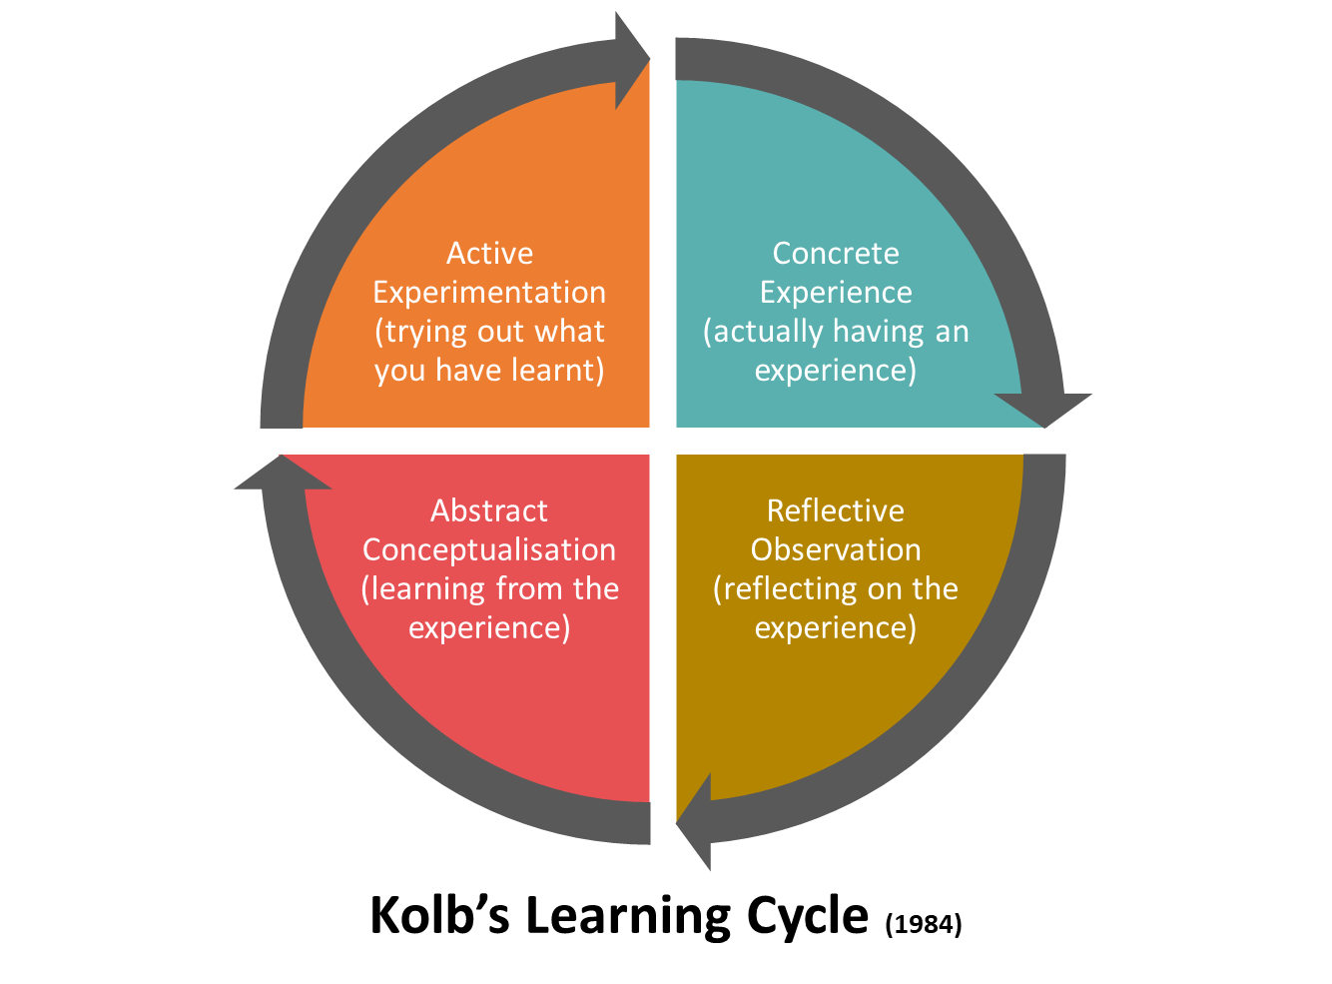
Concrete experience
During this year, in my academic experience I had to do a few presentations either by myself or with a group about different subjects during my classes and I had to also present myself during interviews in a way to find a new job so the public speaking, making and giving presentations are some skills which needed to be sharpened because I am not a natural public speaking person.

Reflective Observation
During my observation I must say that due to the fact that I am not a natural public speaking person, my presentations and public speaking weren’t my strongest skills. As a student at this university and also as a team-leader in the retail industry I gained some interesting experiences which really helped me in order to improve these skills. A few thinks such as presenting to my colleagues, to my teachers, some projects in front of the class or interacting with unknown people in the store that I work at made me more confident on myself.
Abstract Conceptualisation
I learned from these experiences the fact that if I get myself out of my comfort zone I can explore new things and I can try to develop my abilities. Also, I learned to present myself anytime and anywhere to anyone because I became prepared to do so.
Active Experimentation
An active experimentation was at this module because I had to make a in-class presentation which basically change my point of view about presentations and public speaking in general because I succeeded and I received a very good feedback on that.
Topic 3. Time Management
A crucial skill in everybody’s life is time management. Belong this text I have attached Stephen Covey’s Matrix. Basically this matrix is named The Eisenhower Method and it helped me to improve my time management skill. In order to analyse my task/activities I have used this method to see which task is urgent or less urgent and which one is important and less important. In this way, I divided my activities in 4 categories which are: non urgent and non-important, urgent but not important, not urgent but important and urgent and important. I the first category I included all my tasks which are urgent and important such as writing this reflective report.

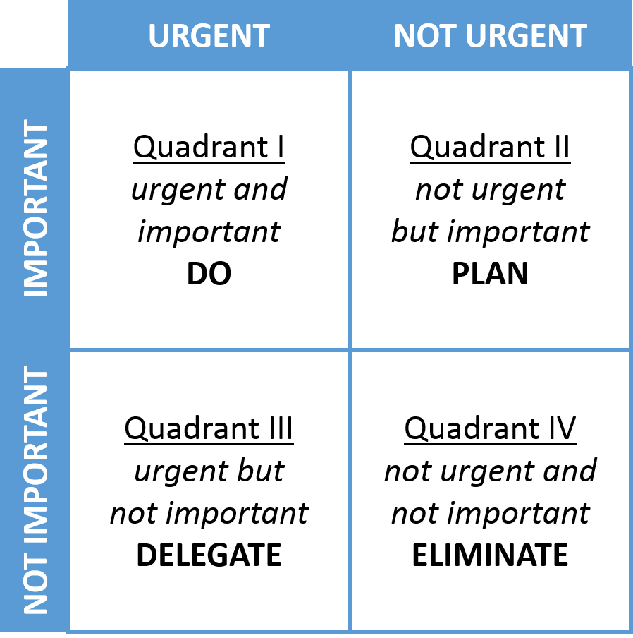

In order to write this reflective report, on this third topic I choosed time management and the Driscoll’s model of reflection to reflect on it.
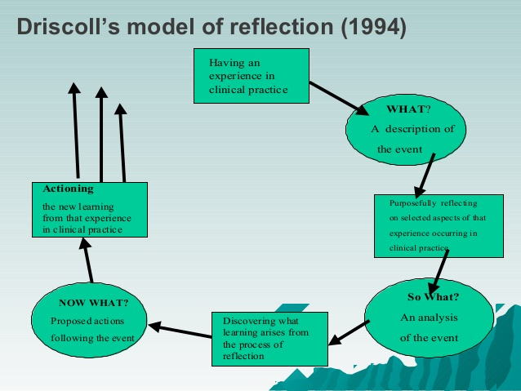
Description of the event >What<
At the beginning of this academic year, I was always late for classes, meeting or even showing at work on time. Also with all the deadlines that I have for projects, exams and the goals in both professional and personal life, I was at the edge of doing it because I wait until the last minute to do it. After I have learned about the Time Management Matrix, I understand how to plan my activities and my daily tasks in order to complete everything successfully and on time.
Analysis of the event>So what<
The first step was to analyse all the events which leads to the idea of improvement of time management. I observed the amount of time I was late with everything existed just because I was busy with focusing on all the irrelevant activities or the ones which were not important and stole my time.
Proposed actions following the event>Now what<
With the help of the Eisenhower method I managed to make for myself a matrix including the activities and starting with the ones which are important and urgent and so on with the rest of categories of activites.
After that, I made a personal development plan which helped me to get focused on my current and future goals and to make priorities in personal, professional and academic experiences. With the help of persona development plan and with the matrix of time management I can now prioritize my tasks in an effective way and I can include the planning of everything along with arriving on time for everything. Also I can manage to do everything on time as well (Cathro, O’Kane&Gilbertson, 2017).
Topic 4. Online learning experience
Reflecting on this subject, I have choosed Schon’s model of reflection.
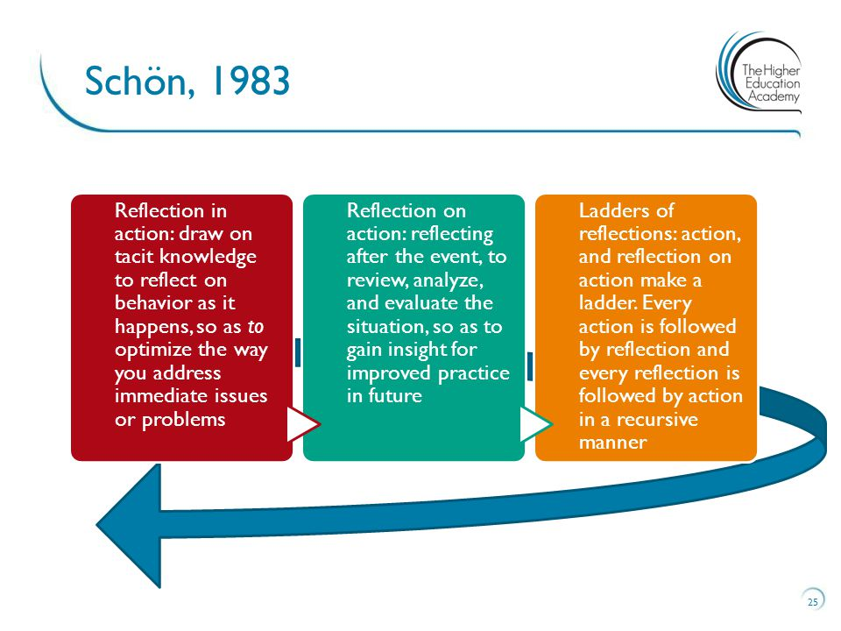
Reflection in action
Due to the pandemic situation, there have been issues in every field such as work, education, free time, etc. In the online learning experience, I can say that this year of studies which had place exclusively online on the Microsoft Teams platform and all the universities websites such as Moodle and online library and made in a good way an online learning experience.

Reflection on action
After almost finishing this university year, I analysed everything and now I can evaluate the situation.
A good online learning experience is one which can be challenging and engaging. The university invited me and all the other students to participate along with the teachers which motivates us to contribute and to capture all our interests and our attention to different modules and subject and all the information learned during classes. This brings me joy of learning and the way in which I learned this year, even if it was online, it enhance my skills, my abilities and expand my knowledge.
Ladders of reflection
By learning online I gained skills for navigating online, for using the Microsoft Teams platform along with colleagues and lecturers and the IT team. Also I learned how to access all the valuable information not only gained during my classes but in my out-of-classes time still online by accessing the Moodle, the online library, to search on Google scholar and to be active on my student email as a main way of communication between me and university in this pandemic situation. I refined critical-thinking skills, improved virtual communication and collaboration and I can work from anywhere at any time for my classes to review lectures instantly and to expand my knowledge. Also, even if me and my colleagues are different, we can learn together. (Green, Hammer & Star, 2009)


Conclusion
As a conclusion, since I almost completed successfully my first year of university and now I have more experiences during this year I am preparing an action plan for my future. I want to write in my personal development plan to learn more skills and abilities and to learn about more technological tools as now I have a bit more interest in managing my time, in technology, in the online learning experience in general and also to present myself in a proper way and to develop the public speaking. I reflected on this with different reflective cycles and now I can perform better in any field. In addition I can say that I am focusing more on shaping my attitude, knowledge and personality as well because I believe that my personal life as a huge impact on my professional life.



References
Archer, C., 2010. Significance of work experience on a graduate’s employability. Hospitality Management Review Student Journal at Sheffield Hallam University, 1.
Cathro, V., O’Kane, P. and Gilbertson, D., 2017. Assessing reflection: Understanding skill development through reflective learning journals. Education+ Training, 59(4), pp.427-442.
Cottrell, S., 2015. Skills for success: Personal development and employability. Macmillan International Higher Education.
Green, W., Hammer, S. and Star, C., 2009. Facing up to the challenge: why is it so hard to develop graduate attributes?. Higher Education Research & Development, 28(1), pp.17-29.
Harvey16, M., Baker, M., Bosanquet, A., Coulson, D., Semple, A.L. and Warren, V., 2012, November. Moving beyond the diary: Innovation in design and delivery of reflection. In 2012 Australian Collaborative Education Network National Conference (p. 109).
Hooker, J. and Whistance, J., 2016. Embedding key transferable employability skills for lifelong success through blending an innovative portfolio to complement traditional assessment. Practitioner Research in Higher Education, 10(1), pp.156-175.

