
Programme: Master of Business Administration
Module: Strategic Management
Module code: LCMB7003
Individual Report
Title: Strategic Analysis of Vodafone UK: Internal and External Evaluation, Competitive Advantage, CSR Alignment, and Strategic Recommendations for Sustainable Growth

Student Name:Mohmedkaif Hamidail Mansuri
Student ID:2321459

Table of Contents
Section 1: Report 3
1. Organisational Context and Overview 3
1.1 Company Background and Historical Perspective 3
1.2 Mission, Vision, and Business Model 4
1.3 Industry, Key Competitors, and Market Position 4
2. External and Internal Environment Analysis 6
2.1 External Factors 6
2.2 Success factors and strategic challenges 9
2.3 Organisation’s internal environment 11
2.4 Internal Strengths Contributing to Competitive Advantage 13
3. CSR and Sustainability objectives 14
4. Comprehensive and holistic view of the organisation 15
5. Strategic Choices and Implementation 17
5.1 Business-Level Strategic Choices 17
5.2 Corporate-Level Strategic Choices 18
5.3 Recommended Strategic Choices 18
5.4 Change Management and Strategic Implementation 18
6. Strategic Evaluation and Recommendations 19
6.1 Organisation’s Current Strategy 19
6.2 Recommendations for Strategy Improvement 20
6.3 Justification of Recommendations 20
Section 2: Reflection 22
Reference List 25

Section 1: Report

1. Organisational Context and Overview

1.1 Company Background and Historical Perspective
Vodafone UK is the UK Company of the Vodafone Group Plc, a telecommunications provider in Europe, among the largest ones (vodafone.com, 2025). Racal Electronics has a long history as the company in 1982 became the winner of one of the first two cellular licences in the UK (Reuters.com, 2026). On 1 January 1985, it became the first operator to make a public mobile phone call in the UK at St Katharine Docks in London (Davison, 2024).
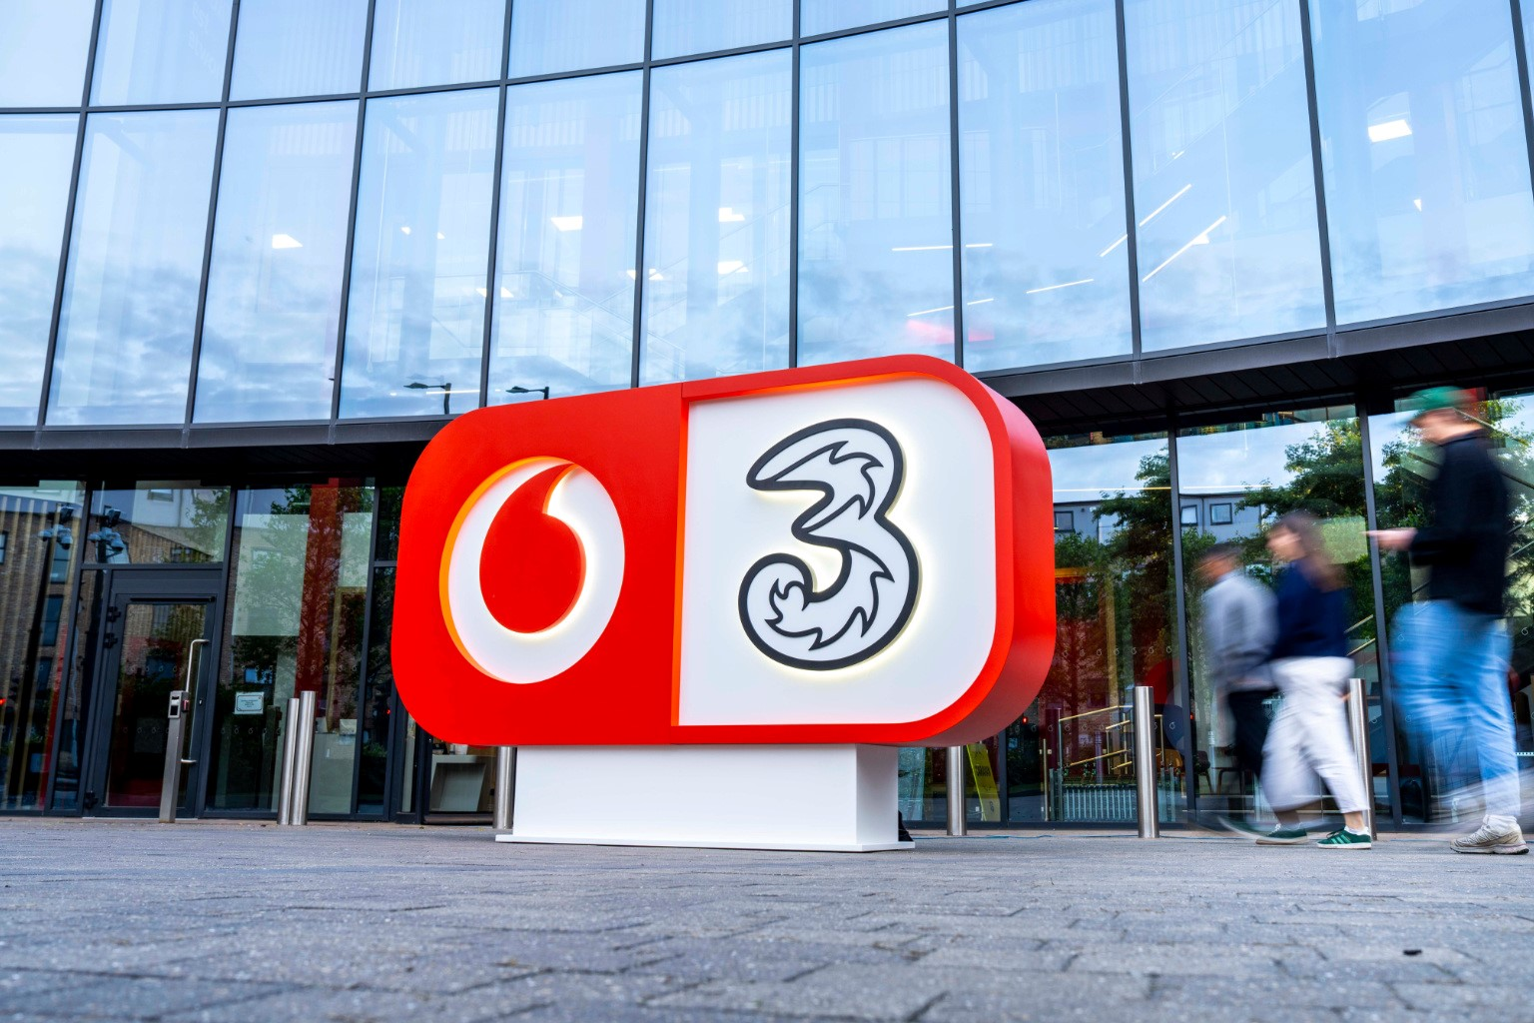
Figure 1: Completion of Vodafone and Three merger in the UK
(Source: Vodafone.co.uk, 2025)
Figure 1 shows the merger and acquisition among Vodafone and Three in the UK. Its initial aspiration was to provide voice and data services; hence the name, Vodafone (Voice Data Fone). In 1991 it became an independent listed company (Vodafone Group Plc) and grew very fast by acquiring connections and building networks. In May 2025, Vodafone UK became part of Three UK, becoming VodafoneThree with a 51% stake (vodafone.co.uk, 2025). This ten-year investment value of 11 billion pound has formed the largest mobile company in the UK.

1.2 Mission, Vision, and Business Model
The mission of Vodafone UK is to bring a digital society to everyone and contribute to the planet protection by providing superfast connectivity unlocking the potential of the UK. It has the vision of becoming a best-in-class telco that defines the future of connectivity (vodafone.com, 2025b). The business model has transformed to include not only traditional mobile voice and data, but also converged TechCo stable offering: consumer mobile and fixed broadband, enterprise digital services (IoT, cloud, cybersecurity), and infrastructure led by 5G. The model not only prioritizes scale efficiencies, expedited 5G deployment, and fixed-mobile convergence post-merger, but also to grow ARPU and customer retention.

1.3 Industry, Key Competitors, and Market Position
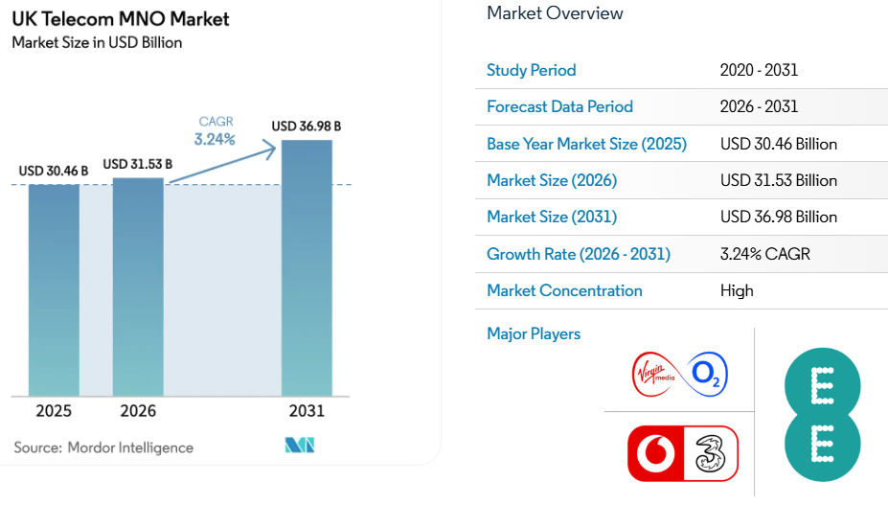
Figure 2: UK Telecom Market
(Source: Mordor Intelligence, 2023)
Vodafone UK is a company that competes within the multibillion (and strictly speaking competitive) UK telecommunications industry, which is estimated to be valued at £30.46 billion in 2025 and is projected to increase at a 3.24% CAGR to 2031 (Mordor Intelligence, 2023). It can be said that the 5G rollouts, convergence of fibre broadband and regulation requirement of coverage to rural areas or transparency in pricing drive the industry. The leading competitors are BT/EE (as a powerhouse in 5G-coverage and enterprise), Virgin Media O2 (as a leading powerhouse in fixed-Mobile packages), and smaller MVNOs.
With the merger of Vodafone and Three in 2025, VodafoneThree has overtaken the former competitors and has pledged to roll out one of the best 5G networks in Europe (vodafonethree.com, 2025).
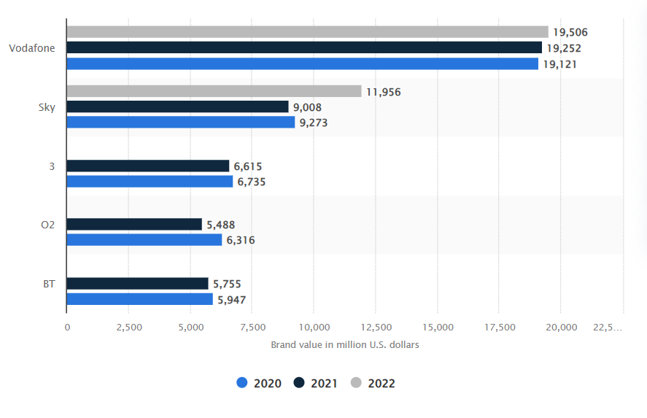
Figure 3: Most valuable telecommunications brands in the UK
(Source: Statista.com, 2022)
Figure 3 represents that Vodafone is still the most valuable telecom brand in UK (value of brand at 19.5 million pounds) (Statista.com, 2022). The initial post-merger measurements of Opensignal reveal better speeds and connections, which reinforced its role as challenger and leader in some markets where network quality and delivering bundling services would increasingly be the defining factor in customer loyalty.

2. External and Internal Environment Analysis

2.1 External Factors
Vodafone UK (and, since June 2025, VodafoneThree) is heavily influenced by its external macro-environment in its strategic choices, especially following its merger with Three UK in June 2025. A PESTEL analysis suggests the possibilities of scale-based 5G investment and regulatory, economic, and sustainability among the forces requiring scale-sensitive approaches through convergence bundles, cost discipline, and digital inclusion programmes.
Factors | Positive | Negative
Political | The UK government and Ofcom are actively marketing and encouraging digital infrastructure. (trade.gov, 2024). In March 2025, with behavioural remedies approved by the CMA, Vodafone-Three merger was permitted to proceed, allowing an investment of 11 billion (some reports indicate 15 billion) in network coverage throughout the UK by 2034, with 5G standalone coverage reaching 99.96% (vodafone.co.uk, 2025). This is a direct answer to the strategy of VodafoneThree to become the biggest operator in the UK (28.8 million subscribers) and rural rollout. | The intensive CMA/Ofcom control and dual compliance after Brexit have their costs (additional cost of governance of 120 million since 2020; 45 million regulatory reserve in FY2025) (gov.uk, 2025).
Economical | The UK telecom MNOs market is estimated at USD 30.46 billion in 2025 and expected to grow at USD 36.98 billion by 2031 (3.24% CAGR) due to data demand and convergence (between fixed and mobile). VodafoneThree uses merger scale to achieve efficiencies (Mordor Intelligence, 2023). | An inflation rate that remains high, pressure on the cost of living and an Ofcom ban on inflation-video price increases in January 2025 have transformed previous 5% increases in-contract into a revenue offset (increased to 2% at present).
Social | The 25–54 core revenue segment (61% of the total population) is now willing to use the internet as a basic human right and calls 5G/data (79% upwardness into social-media penetration), with an increasing number of professionals, increasing demand. This fuels their convergence and 5G premium bundles of Vodafone. | The constant lack of digital inclusion (rural disparities, decreasing income families) must be addressed through constant inclusion programs. The Vodafone programme “everyone.connected” has resulted in an enhancement of more than 2.27 million individuals/businesses, transforming social pressure into a reputation and loyalty distinguishing factor (vodafonethree.com, 2025a).
Technological | The Open RAN transition (28.7% of UK networks by 2025) and rapid uptake of 5G can lead to cost savings and capacity growth, which will support the VodafoneThree post-merger strategy as a leader in 5GSA (Future Market Insights, 2022).  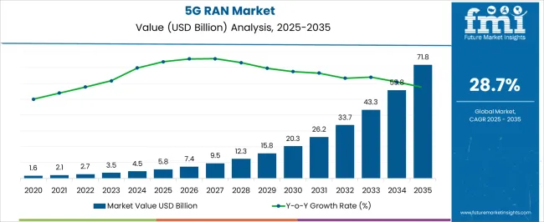  Figure 4: 5G RAN Market Size  Source: (Future Market Insights, 2022) | Commoditisation risk by high capex intensity and tech obsolescence Vodafone overcomes this by network sharing (Shared Rural Network) and partnerships (Microsoft, Google) in enterprise digital services.
Legal | Compliant frameworks of stable spectrum and net neutrality give certainty to investment. | Compliance costs of GDPR, antitrust remedies, and spectrum-auction costs (fines as high as 4% of world turnover) increase compliance expenses. The remedy of post-merger behaviour and the annual Ofcom/CMA supervision influence the operational and reporting approaches (hsfkramer.com, 2024).
Environmental | Sustainability is a competitive advantage that business customers can gain with Vodafone since the company has set a net zero target of 2040 and a 100% renewable energy objective (73% achieved as of 2024 in the key markets; the whole target is planned for 2025) (vodafone.com, 2020). | Escalating energy/carbon prices and physical risk (extreme weather destruction of infrastructure) exacerbate opex and supply-chain risks, driving a faster green capex and Scope 3 supplier engagement (Pausicles, 2026).
Table 1: PESTLE Framework
(Source: Self-Created)

2.2 Success factors and strategic challenges
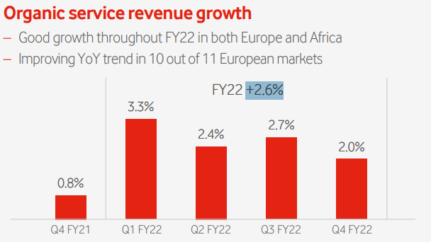
Figure 5: Organic service revenue growth
(Source: Vodafone, 2022)
The external environment of Vodafone UK requires compatibility with regulatory support, technological leadership and customer-focused innovation as key success factors (CSFs). Network investment and spectrum allocation require regulatory approval; the 2025 Vodafone-Three merger has its merit based on the 2022 bases on which Ofcom was able to roll out 5G policies across the board allowing organic group-wide service revenue to increase by +2.6% (Vodafone, 2022). Another CSF is swift 5G implementation and integrated fix-mobile products as six1 percent of the population had come to think of broadband as a fundamental right by the end of 2022, leading to a desire to have high-quality bundles.
The third CSF that has developed is sustainability compliance. The B2B markets (which have become increasingly stakeholder-conscious towards green infrastructure) were distinguished by the 2022 Net Zero 2040 commitment and the 73% share of renewable electricity use of Vodafone (vodafone.com, 2020).
Challenges in strategies are still important. The market share is threatened by intense competition with BT/EE and Virgin Media O2 and the entry of new players, which explains why Yang, Vialle and Whalley (2025) find that digital disruption in European telecoms service providers makes it necessary to protect ARPU by leading companies such as Vodafone against low-cost new entrants. Inflation after Brexit and patterns in the supply chain were other macroeconomic pressures that limited capex and customer expenditure in 2022 (vodafone.com, 2025a). Additional costs related to compliances are offered by regulatory checks on the pricing and data privacy, and environmental requirements add costs associated with energy opex. To continue its leadership, Vodafone UK thus has to turn such external pressures into strength via scale, innovation, and responsible growth.

2.3 Organisation’s internal environment
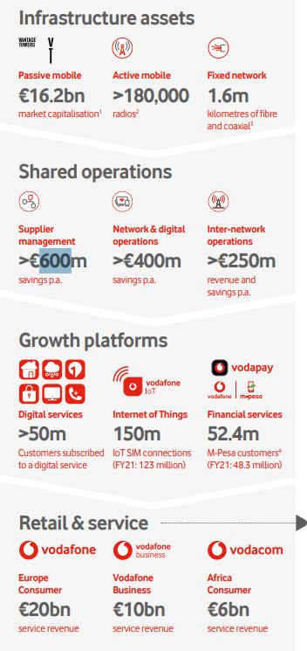
Figure 6: Synopsis of Vodafone’s Operation
(Source: Vodafone Group Plc, 2022)
The above attached image is the synopsis of operations of Vodafone. It shows retail and services, growth platforms, shared operations and infrastructure assets. The internal environment of Vodafone UK in 2022 was characterised by the presence of powerful tangible and intangible resources that enabled its main competencies of converged connectivity and digital services. Major assets were the heavy network infrastructure (out of 294 cities in Europe covered by 5G and 48.5 million on-net gigabit-capable) connection) and a large customer base which helped Europe reach 66.4 million mobile contract customers (Vodafone, 2022). Capabilities in terms of operational efficiency through shared services (delivering over 600 million euro of savings by suppliers annually) and capabilities in IoT (150.1 million SIM connections group-wide, versus 123.3 million in FY21). These were the foundations of core competencies in fixed-mobile convergence and enterprise digital offerings that facilitated Europe's consumer service revenue of €20 billion (Vodafone Group Plc, 2022).
VRIO analysis indicates competitive advantages in the long run in various aspects. Network infrastructure was rare (scale barriers in spectrum and capex) and made it impossible to replicate (driving gigabit services and churn reduction to 13.6) (Vodafone Group Plc, 2019), well-organised in the form of a matrix structure of group structure providing lasting advantage. Similarly, VRIO-positive were brand reputation and digital/IoT capabilities, which were tailored to differentiated enterprise solutions. Nevertheless, there was temporary benefits in some financial resources because they increased across the industry.
Resource / Capability | Valuable | Rare | Inimitable (Costly to Imitate) | Organised to Capture Value | Competitive Implication
5G / Fibre Network Infrastructure | Yes | Yes | Yes | Yes | Sustained Advantage
Brand Reputation & Customer Base | Yes | Yes | Yes | Yes | Sustained Advantage
IoT & Digital Services Capabilities | Yes | Yes | Yes | Yes | Sustained Advantage
Shared Operations Efficiency | Yes | Yes | Yes | Yes | Sustained Advantage
Table 2: VRIO Analysis
(Source: Self-Created)
In general, the Vodafone UK 2022 VRIO profile reaffirmed that the company is internally well placed to grow its operations in a competitive UK market, but it was necessary to have further organisation of digital capabilities to enable long-term superiority.

2.4 Internal Strengths Contributing to Competitive Advantage
The internal strengths of Vodafone UK have been a key determinant of the establishment and maintenance of competitive advantage in the UK telecommunications market. Its comprehensive network infrastructure, consisting of 5G and fibre networks with gigabit-capable connectivity in 294 cities, serving 48.5 million customers during FY2022, offers high-quality speed and coverage, which competitors can hardly match on a large scale (vodafone.com, 2022). This physical resource is important, limited, and indispensable, which directly decreases churn to 13.6% and helps to ensure premium ARPU with converged bundles.
Differentiation is further supported by a strong brand reputation and a very loyal customer base of more than 18 million users of the UK mobile and fixed-line services (deloitte.com, 2025). The brand equity allows Vodafone to achieve increased customer retention and cross-selling of IoT and enterprise digital services, which have seen the company achieve Europe consumer service revenue of 20 billion in 2022. Cost leadership cost savings are provided by operational capabilities, such as shared-services efficiency (delivering more than €600 million in annual cost savings), that benefits profitability in a price-sensitive market (Vodafone Group Plc, 2022).
All these strengths meet VRIO requirements, which resulted in a long-term competitive advantage. Nevertheless, it has serious constraints: It relies heavily on continuous capex (in a vulnerable position in the face of macroeconomic pressures) and could be commoditised in the event that competitors achieve network parity. There can be a degradation of temporary advantage even if there is good infrastructure unless there is continuous innovation in digital services. In this manner, Vodafone UK should be keen to take advantage of these strengths by undertaking strategic investment and digital transformation to ensure that it continues to dominate the market in the face of growing competition.

3. CSR and Sustainability objectives
The CSR strategy of Vodafone UK is based on the group, where it has a three-legged structure linked with three pillars: Inclusion for All, Planet, and Digital Society (vodafone.com, 2024). Among the major initiatives in 2022, there was an aim to reach 100% of renewable electricity in the European markets four years before the 2025 mark, 23% decrease in Scope 1 and 2 emissions, and digital inclusion programmes that united millions of people by providing cost-effective data and skills training (vodafone.com, 2021). Continuing to help SMEs and key industries through IoT and Connected Farmer solutions, the company also progressed its Net Zero 2040 to achieve its goal.
This strategic CSR platform is in line with the fundamental business goals of Vodafone, which are profitable growth, market leadership and long-term survivability. According to Fogel (2016), CSR has three main rationales, namely a sustainability argument (mutual interest in sustaining an ecosystem), the reputation argument (increased stakeholder trust and brand loyalty), and the licence-to-operate argument (approval of regulators and society) (UWTSD Lecture Notes, 2023). In the case of Vodafone, these directly translate to competitive advantage: green operations bring about energy savings, and, as Adelaja et al. (2024) opined, digital inclusion enhances customer retention and convergence bundles in a post-merger context.
On the one hand, CSR ensures innovation and positioning Vodafone in B2B markets, and on the other hand, high capex requirements will create costs in the short-run profitability in times of economic headwinds, according to some scholars (Yang, Vialle and Whalley, 2025). However, the question of the marginal position of CSR is countered by the situation in which Vodafone actively pursues environmental sustainability and corporate responsibility (through its specific ESG Committee), thereby emphasising the sense of ethical integrity and business success (Vodafone Group Plc, 2022).

4. Comprehensive and holistic view of the organisation
The Balanced Scorecard (BSC) developed by Kaplan and Norton (1996) offers an entire framework on how to turn the mission statements of Vodafone UK (since it became VodafoneThree) into a digital society that involves everyone and assists in preserving the planet and can be translated into measurable performance indicators. The BSC has been revised to support the strategy of 5G scale, fixed-mobile convergence, digital inclusion, and sustainability by aligning financial growth, customer leadership, operational excellence, and innovation with it following the merger with Three UK in May 2025. It confidentialises the trade-offs between the financial outcomes in the short term and the creation of value in the long-term.
Financial Perspective
- Objective: A sustainable growth in revenues and efficient capital returns to finance network investment amounting to £11 billion (vodafoneethree.com, 2025b).
- KPIs: Growth in organic service revenue, adjusted EBITDAaL margin, adjusted free cash flow, pre-tax ROCE.
- Targets: A +5.1% increase in organic service revenue (at FY25), adjusted free cash flow of 2.5 billion, and ROCE of 7.0%
- Initiatives: The post-merger synergies (annual cost and capex savings of £500 million by year three) and hastened monetisation of 5G and prudent capex deployment to high-payback fibre and standalone 5G initiatives. This view will help to keep profitability stable and ensure leadership in long-term infrastructure (Vodafone Group Plc, 2022).
Customer Perspective
- Objective: Provide excellent connectivity and inclusion to develop loyalty and market leadership (vodafone.com, 2025b).
- KPIs: Revenue market share, network reliability score, consumer NPS (detractors), and churn rate.
- Targets: Market leadership/co-leadership in major markets, leadership in the UK mobile sector (28.8 million subscribers after the merger), and very good reliability across the networks.
- Initiatives: Multi-Operator Core Network (MOCN) sharing to eradicate 16500 km 2 of not-spots, cross-selling broadband to Three customers and digital inclusion programmes serving millions. These contribute to retention and ARPU increase in a competitive market (Vodafone Group Plc, 2022).
Internal Business Processes Perspective
- Objective: To become efficient in operations and intimately integrated to deliver better services.
- KPIs: Europe opex savings, productivity (role reductions), shared operations NPS.
- Targets: cumulative savings in opex (FY2325 achieved) of -0.4 billion, 7.7k occurring roles, and shared operations NPS of +81.
- Initiatives: Network integration and simplification, shared-services optimisation and process automation to facilitate quick 5G rollout and fixed-mobile convergence. Such an attitude is a control over cost that can potentially embrace innovation without compromising on quality (Vodafone Group Plc, 2022).
Learning and Growth Perspective
- Objective: Develop nimble capabilities and digital tools to maintain innovation.
- KPIs: Employee engagement score, average learning hours per employee, skills accelerator completions.
- Targets: 75% engagement of employees, 32 hours of average learning per employee per year, and 8,000 or more employees taking Skill Accelerators.
- Initiatives: 5G, AI and cybersecurity agile training programmes, technical career paths, and Vodafone Learning Organisation programmes. These generate an environment of constant development in line with the objectives of digital transformation (Vodafone Group Plc, 2022).
VodafoneThree has a BSC which is summarised as below:
Perspective | Objectives | KPIs | Targets (FY25) | Key Initiatives
Financial | Eco-friendly growth & returns | Service revenue expansion, FCF, ROCE. | +5.1% organic, €2.5bn FCF | Merger synergies, 5G monetisation
Customer | Trustworthiness & inclusion | NPS, Market share, Reliability | Market leader, Very good reliability | MOCN sharing, inclusion programmes
Internal Processes | Effectiveness & integration | Opex savings, Productivity, Ops NPS | €0.4bn savings, +81% NPS | Network simplification, automation
Learning & Growth | Talent & inventiveness | Engagement, Learning hours | 75% engagement, 32 hrs/employee | Skill Accelerators, agile training
Table 3: Comprehensive and Holistic View of the Organisation
(Source: Self-Created)
Therefore, the above-discussed BSC ensures that the strategy of VodafoneThree is holistic since it connects customer focus and financial discipline with process excellence to organisational learning that develops a long-term competitive advantage in the UK telecom sector.

5. Strategic Choices and Implementation

5.1 Business-Level Strategic Choices
Vodafone UK has been focused on a differentiation strategy in 2022, at the business level, where excellent connectivity, technical innovations, and excellent customer experiences were prioritised over simple cost leadership. The firm has made a massive investment in gigabit networks (48.5 million on-net connections) and IoT platforms (150.1 million SIM connections), which facilitated the creation of premium converged packages and enterprise digital services with which it could charge higher ARPU (Vodafone Group Plc, 2022). Although shared operations resulted in impressive cost efficiencies (>€600 million annual savings), a pure cost-leadership strategy was inappropriate due to high 5G capex and competition with low-cost MVNOs (Yang, Vialle and Whalley, 2025). Differentiation enabled Vodafone to cut the churn level to 13.6% and market positioning in a commoditising industry.

5.2 Corporate-Level Strategic Choices
On the corporate level, Vodafone sought associated diversification to digital services (1/10th of service turnover) and internationalisation in Europe and Africa, and selective portfolio optimisation. In 2022, the strategy involved accentuating convergence, IoT development, and M-Pesa development in Africa and looking into tower monetisation and in-market consolidation (Vodafone Group Plc, 2022). This prevented unrelated diversification, with a focus on cruising on core competencies of connectivity across geographies. The cross-border activities increased the scale but put the company at a risk of currency and regulatory risks in the emerging markets.

5.3 Recommended Strategic Choices
It is advisable to proceed with business-level differentiation and selective international consolidation among corporations and at the corporate level together with related diversification focused at the business level. Premium pricing and loyalty are maintained through differentiation in a post-merger UK market, whereas scale synergies are achieved by corporate consolidation (e.g., the future Vodafone-Three merger) without loss of concentration (Yang, Vialle and Whalley, 2025). These two models are the most effective solution to maximise ROCE (increased by up to 170 bps to 7.2% in FY22) and promote the mission of inclusive digital society (Vodafone Group Plc, 2022). Complete cost leadership or absence of relationships in diversification would dilute brand equity and expose the firm more to an industry that would be capital intensive.

5.4 Change Management and Strategic Implementation
In 2022, Vodafone successfully managed change in the use of its Spirit of Vodafone culture and organised a portfolio review to generate organic service revenue growth of +2.6% and ROCE inflection despite macroeconomic headwinds (Vodafone Group Plc, 2022). The digital transformation and simplification processes supported the agile implementation, although critics indicate slower uptake of the implementation in certain European markets and execution risks when performing a large-scale implementation of networks (Yang, Vialle and Whalley, 2025). In general, change management has a positive influence on implementation as it has integrated customer centricity and efficiency, but a long-term library of commitment by the top leadership will be vital to achieving the long-term strategic objectives (Vodafone Group Plc, 2022).

6. Strategic Evaluation and Recommendations

6.1 Organisation’s Current Strategy
SWOT Analysis
The 2022 strategy of Vodafone UK had evident strong points in network leadership and brand equity but had a risk of implementation in a competitive environment.
Strengths  - Top gigabit networks (48.5m on-net homes); 5G live in over300 cities; largest scale operator in Europe (vodafone.com, 2025a).  - Good brand and customers (Europe Consumer revenue €20bn)  - Operational efficiencies (>600m a year shared-services savings) | Weakness  - Large legacy costs, and churn (13.6% UK) (Vodafone Group Plc, 2019); weighted capex burden in the face of inflation.  - Exposure to regulations and post-Brexit compliance.  - Some markets experience slow rate of digital-service monetisation.
Opportunities  - Fixed-mobile convergence (Condoluci et al., 2019) and 5G/IoT growth.  - Digital inclusion and Africa expansion (M-Pesa 52m users)  - In-market merger (merger route) | Threats  - Increasing competition by BT/EE and Virgin Media O2.  - Macroeconomic stress and spectrum-auction costs.  - OTT interference and regulating prices (Jafor et al., 2025).
Table 4: SWOT Analysis
(Source: Self-Created)
The SWOT shows a great internal stance of differentiation but points to the necessity to transform the opportunities into change and to reduce threats.
Ansoff’s Matrix
Vodafone's 2022 strategy mostly pursued market penetration (5G roll-out to current markets in Europe, +2.6% organic growth of service revenues) and product development (IoT platforms and digital services, 10% of revenue). In Africa, there was limited market development through M-Pesa, and limited diversification was made through enterprise cloud and cybersecurity (Vodafone Group Plc, 2022).
 | Existing Products | New Products
Existing Markets | Market Penetration: 5G monetisation in UK/Europe | Product Development: IoT, VodaPay, digital services
New Markets | Market Development: Africa digital expansion | Diversification: Enterprise cloud/cyber (limited)
Table 5: Ansoff’s Matrix
(Source: Self-Created)
Ansoff analysis shows that a low-risk penetration chain offered a stable growth, but a higher-risk diversification lost, putting Vodafone at risk of being commoditised.

6.2 Recommendations for Strategy Improvement
To maintain a competitive edge, Vodafone UK ought to (1) speed up the process of product development in enterprise digital services and (2) engage in targeted market building in African high-growth digital ecosystems and capitalise on UK scale, post-merger, to build further.

6.3 Justification of Recommendations
The development of the products matches the moderate-risk category offered by Ansoff and takes advantage of the VRIO strengths of network resources and IoT, which establish a long-term competitive edge (Barney and Hesterly, 2016). The practical examples are the Amazon pivot in AWS, which converted infrastructure to high-margin services. The African market expansion takes advantage of 52 million M-Pesa users to represent inclusive market expansion like the successful telecom diversification in new markets (Lynch, 2022).
These decisions will handle threats in SWOT (competition, regulation) and will exploit opportunities (5G, inclusion). Whittington et al. (2019) state that the focused decisions contribute to the strategic fit and ROCE improvement (up 170bps to 7.2% in FY22). Unless it commits more radical innovation and globalisation, Vodafone will end up losing its differentiation advantage in the face of digital disruption (Yang, Vialle and Whalley, 2025). Execution through agile cross-functional units and ESG governance will make sure it aligns with the mission of the institution, connecting for a better future.

Section 2: Reflection
This reflection writing focuses on the steps that I took to research, analyse and write the strategic management report about Vodafone UK (since renamed VodafoneThree). I have organised it into the Experiential Learning Cycle by Kolb (Kolb and Kolb, 2022), who focuses on the cyclical process of learning, based on experience, reflection, conceptualisation and experimentation. It is the framework that assisted me in going beyond data collection and to a logical, critical analysis.
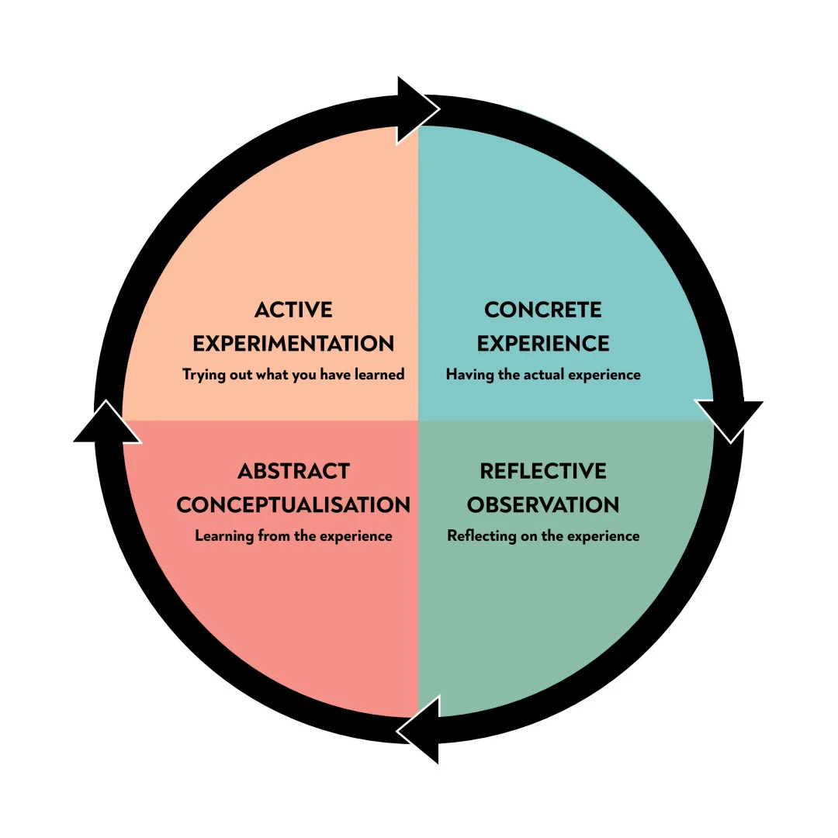
Figure 7: Kolb’s Learning Styles
(Source: Mcleod, 2025)
Concrete Experience
I used a six-week systematic process in coming up with the strategic analysis of Vodafone UK. I started to study all materials of the modules, including the Whirlpool case, e-business and sustainability lecture notes and the given Vodafone documents. Then, I took original 2022 data of the Annual Report of Vodafone Group Plc and compared it with more scholarly sources. Following the assignment brief as a roadmap, I used the following consecutive frameworks PESTEL (the external environment), VRIO (internal resources), SWOT and the Matrix (Ansoff) (strategy evaluation) and Balanced Scorecard (performance measure). I wrote each section in the order, keeping the target length at 5,000 words while also making sure that each assertion was substantiated with actual information (e.g., 48.5 million gigabit connections, +2.6% organic revenue growth). The synthesis was the last step entailing the incorporation of CSR alignment, strategic choices, and recommendations. This was done over the course of three weeks and a total of about 28 hours (Vodafone Group Plc, 2022).
Reflective Observation
In retrospect, I noted that research was a rewarding yet challenging period in my life. The richness of the 2022 data allowed the analysis to be evidence-based, but it was necessary to place the 2022 numbers of Vodafone in context to prevent anachronism when reconciling them against the merger at the time, 2025. I observed the power of interaction of frameworks: VRIO caused me to see how the network infrastructure provided them with a sustained advantage, whereas Ansoff showed how dependence on market penetration could be dangerous. The word-count constraint compelled me to be to-the-point, missing depth in the CSR section at times. Although I too noticed that the first thing I saw regarding the Vodafone strategy was a positive one, a reflective reading of the article by Yang, Vialle and Whalley (2025) helped me to neither overrate positive elements nor underrate the risks of disruption. So, the experience gave me the possibility to move freely between macro and micro levels of analysis.
Abstract Conceptualisation
The experience consolidated some of the theoretical principles. The Experiential Learning Cycle, by itself, turned out quite useful: the tangible phase of data gathering supported the realm of reflective observation, which led to the subsequent alternative of abstract conceptualisation with the help of the literature of strategic management. Today, I better understand how resource-based and positioning views are complementary instead of opposing perspectives. VRIO-SWOT-Ansoff sequence proved a statement introduced by Whittington et al. (2019) that a successful strategy is one that should be both explicitly analysed and developed dynamically. Importantly, the exercise demonstrated that strategic assessment can never be value-neutral; my selection of 2022 data tied the activity to a certain point in time and emphasised the dynamism of competitive advantage in telecoms. It was also a process that validated the statement of Lynch (2022) that CSR should be strategic and not peripheral when it comes to long-term value creation. These impressions made me alter my perception of a checklist-based approach and realise a comprehensive and interim view of strategy.
Active Experimentation
Two changes I will experiment with in future strategic analyses are the following. First, I will use primary data (e.g., customer surveys or executive interviews) earlier in order to supplement secondary sources. Second, I will consider assisting with digital mind-mapping aids at the beginning of the assignment to visualise the relationships among the frameworks prior to writing, which will enhance the coherence. Another way I will ensure consistency across contexts in my writing is by setting aside specific time to go through drafts that a peer will review. These changes will not only increase analytical rigour but also save on time by using similar approaches to other organisations or live consultancy projects that I will apply. The end result of this reflective cycle is that I am now more confident and more reflexive about strategic management, which I can apply to professional practice.

Reference List
Adelaja, A.O., Chidozie, S., Ayodele, F. and None Bibitayo Ebunlomo Abikoye (2024). The role of digital transformation in post-merger integration: Evidence from the financial services industry. Finance & Accounting Research Journal, [online] 6(8), pp.1501–1516. doi:https://doi.org/10.51594/farj.v6i8.1456.
Barney, J.B. and Hesterly, W.S. (2016). Strategic Management and Competitive Advantage: Concepts and Cases. [online] Pearsoned.co.in. Available at: https://www.pearsoned.co.in/prc/book/jay-b-barney-strategic-management-competitive-advantage-concepts-cases-5e--5/9789332559400 [Accessed 15 Apr. 2026].
Condoluci, M., Johnson, S.H., Ayadurai, V., Lema, M.A., Cuevas, M.A., Dohler, M. and Mahmoodi, T. (2019). Fixed-Mobile Convergence in the 5G Era: From Hybrid Access to Converged Core. IEEE Network, [online] 33(2), pp.138–145. doi:https://doi.org/10.1109/mnet.2018.1700462.
Davison, M. (2024). Vodafone at 40: A brief history of the company’s industry firsts. [online] Vodafone UK News Centre. Available at: https://www.vodafone.co.uk/newscentre/features/vodafone-at-40-industry-firsts/ [Accessed 19 Apr. 2026].
deloitte.com (2025). Gifts beat gigabits: Some mobile users rank rewards over network upgrades. [online] Deloitte Insights. Available at: https://www.deloitte.com/us/en/insights/industry/technology/technology-media-and-telecom-predictions/2026/creative-offerings-for-mobile.html [Accessed 19 Apr. 2026].
Fogel, D.S. (2016). Strategic sustainability : a natural environmental lens on organizations and management. [online] New York, Ny: Routledge. Available at: https://www.routledge.com/Strategic-Sustainability-A-Natural-Environmental-Lens-on-Organizations-and-Management/Fogel/p/book/9781138916579 [Accessed 16 Apr. 2026].
Future Market Insights (2022). Market Survey on 5G RAN Market Covering Sales Outlook, Up-to-date Key Trends, Market Size and Forecast, Market Statistics, Penetration Analysis, Pricing Analysis and Company Ecosystem 2022 to 2032. [online] Futuremarketinsights.com. Available at: https://www.futuremarketinsights.com/reports/5g-ran-market [Accessed 17 Apr. 2026].
gov.uk (2025). Budget 2025 (HTML) - GOV.UK. [online] Www.gov.uk. Available at: https://www.gov.uk/government/publications/budget-2025-document/budget-2025-html [Accessed 19 Apr. 2026].
hsfkramer.com (2024). Vodafone/Three JV cleared in UK with behavioural remedies: key takeaways and implications for future deals | Herbert Smith Freehills Kramer | Global law firm. [online] Herbert Smith Freehills Kramer | Global law firm. Available at: https://www.hsfkramer.com/notes/crt/2024-posts/Vodafone-Three-JV-cleared-in-UK-with-behavioural-remedies--key-takeaways-and-implications-for-future-deals [Accessed 19 Apr. 2026].
Jafor, A.H.M., Arafat, M.S., Hossain, M.A. and Islam, M.M. (2025). View of Survival Strategies for Telecom Operators in the Age of OTT Disruption: A Business Model Analysis of Revenue Diversification and Market Adaptation. [online] researchgate.net. Available at: https://doi.org/10.37547/tajmei/Volume07Issue05-02 [Accessed 18 Apr. 2026].
Kaplan, R.S. and Norton, D.P. (1996). The Balanced Scorecard: Translating Strategy into Action. [online] Hbs.edu. Available at: https://www.hbs.edu/faculty/Pages/item.aspx?num=8831 [Accessed 19 Apr. 2026].
Koenig, C. and Veidt, A. (2023). Lifting a regulatory millstone around 5G investors’ neck – 5G network slicing versus EU-net neutrality? Telecommunications Policy, [online] 47(10), pp.102653–102653. doi:https://doi.org/10.1016/j.telpol.2023.102653.
Lynch, R. (2022). Strategic Management. [online] Google Books. SAGE Publications. Available at: https://books.google.com/books/about/Strategic_Management.html?id=MyAMEAAAQBAJ [Accessed 19 Apr. 2026].
Mcleod, S. (2025). Kolb’s Learning Styles and Experiential Learning Cycle. [online] Simply Psychology. Available at: https://www.simplypsychology.org/learning-kolb.html [Accessed 20 Apr. 2026].
Mordor Intelligence (2023). UK Telecom Industry Share, Overview, Size, Trends (2022 - 27). [online] www.mordorintelligence.com. Available at: https://www.mordorintelligence.com/industry-reports/united-kingdom-telecom-market [Accessed 19 Apr. 2026].
Pausicles, K. (2026). Climate-Related Risks: Strategic Imperatives for Energy and Finance. [online] Medium. Available at: https://medium.com/@kevin.pausicles/climate-related-risks-strategic-imperatives-for-energy-and-finance-d3f94676e207 [Accessed 19 Apr. 2026].
Reuters.com (2026). Vodafone Group PLC | Reuters. Reuters. [online] Available at: https://www.reuters.com/company/vodafone-group-plc/ [Accessed 16 Apr. 2026].
Statista.com (2022). Most valuable telecom brands in the UK 2022| Statista. [online] Statista. Available at: https://www.statista.com/statistics/292061/most-valuable-telecommunications-brands-in-the-united-kingdom/?srsltid=AfmBOopmGuxh18CZRHf_C7U-Q7_mp7WPRzru_QH2nq-CXShbskIkqhK1 [Accessed 15 Apr. 2026].
Trade.gov (2024). United Kingdom - Digital Economy. [online] International Trade Administration | Trade.gov. Available at: https://www.trade.gov/country-commercial-guides/united-kingdom-digital-economy [Accessed 19 Apr. 2026].
Vodafone (2022). Vodafone Group Plc Annual Report 2022. [online] Available at: https://investors.vodafone.com/~/media/files/v/vodafone-ir/documents/performance/financial-results/2022/vodafone-2022-annual-report.pdf [Accessed 18 Apr. 2026].
Vodafone Group Plc (2019). We connect for a better future. [online] Available at: http://media.corporate-ir.net/media_files/IROL/77/77862/annual-reports/annual_report19/downloads/Vodafone-strategic-report-2019.pdf [Accessed 19 Apr. 2026].
Vodafone Group Plc (2022). Welcome to our 2022 Summary. [online] Available at: https://www.vodafone.com/~/media/Files/V/vodafone/corp/documents/performance/financial-results/2022/vodafone-2022-summary.pdf [Accessed 20 Apr. 2026].
Vodafone.co.uk (2025a). Brits demand digital equality: Internet access deemed human right. [online] Vodafone UK News Centre. Available at: https://www.vodafone.co.uk/newscentre/press-release/brits-demand-digital-equality [Accessed 15 Apr. 2026].
Vodafone.co.uk (2025b). Completion of Vodafone and Three merger in the UK. [online] Vodafone UK News Centre. Available at: https://www.vodafone.co.uk/newscentre/press-release/completion-vodafone-three-merger-uk/ [Accessed 19 Apr. 2026].
vodafone.com (2020). Vodafone commits to net zero carbon emissions by 2040. [online] Vodafone. Available at: https://www.vodafone.com/news/newsroom/protecting-the-planet/vodafone-commits-to-net-zero-carbon-emissions-by-2040 [Accessed 19 Apr. 2026].
Vodafone.com (2021). Vodafone’s European network 100% powered from renewables. [online] Vodafone. Available at: https://www.vodafone.com/news/newsroom/technology/100percent-renewables [Accessed 19 Apr. 2026].
Vodafone.com (2022). Connecting People​. [online] Vodafone. Available at: https://www.vodafone.com/everyone-connected/connecting-people?section=connecting-europe [Accessed 19 Apr. 2026].
Vodafone.com (2024). We connect for a better future. [online] Vodafone. Available at: https://www.vodafone.com/news/newsroom/corporate-and-financial/we-connect-for-a-better-future [Accessed 18 Apr. 2026].
Vodafone.com (2025a). Our company. [online] Vodafone. Available at: https://www.vodafone.com/our-company [Accessed 19 Apr. 2026].
Vodafone.com (2025b). Our purpose. [online] Vodafone. Available at: https://www.vodafone.com/our-company/our-purpose [Accessed 17 Apr. 2026].
Vodafonethree.com (2025a). Nicki Lyons: Four takeaways from everyone.connected reaching four million. [online] Vodafonethree.com. Available at: https://www.vodafonethree.com/news/nicki-lyons-everyone-connected-four-million [Accessed 19 Apr. 2026].
Vodafonethree.com (2025b). VodafoneThree begins a new era of connectivity for the UK. [online] Vodafonethree.com. Available at: https://www.vodafonethree.com/news/new-era-of-connectivity [Accessed 17 Apr. 2026].
Whittington, R., Regnér, P., Johnson, G., Angwin, D. and Scholes, K. (2019). Exploring Strategy, Text and Cases, 12th Edition. [online] Google Books. Pearson UK. Available at: https://books.google.co.in/books/about/Exploring_Strategy_Text_and_Cases_12th_E.html?id=GeksEAAAQBAJ&redir_esc=y [Accessed 17 Apr. 2026].
Yang, S., Vialle, P. and Whalley, J. (2025). Is Disruption the Second Time Around Easier? The Case of Iliad and the Italian Telecommunications Market. 31st European Regional ITS Conference, Gothenburg. [online] doi:https://doi.org/10.2139/ssrn.5120903.

