

Hands-On Guide for Students: Practical Penetration Testing of Docker Container Image Security with Examples

By Lara Costa
Supervisor: Michael Dacey

Project submitted as part of the requirements for the award of
MSc Computer Networks and Cyber Security

Abstract
The objective of this project was to create and assess interactive learning worksheets aimed at improving cybersecurity abilities in container security, emphasizing vulnerability assessment and penetration testing. Utilizing Docker and Kali Linux, the worksheets led students through practical situations featuring vulnerable images such as DVWA and OWASP Juice Shop. A systematic teaching method was used, integrating practical tasks, tests, and evaluation forms to measure educational results.

The techniques involved developing detailed guides, employing simulated settings, and evaluating participant performance via quiz scores and feedback. Key discoveries indicated a strong clarity and efficiency of the materials, with students showing enhanced confidence and understanding of container security ideas. Major challenges involved grasping intricate subjects such as vulnerabilities in custom Docker images, which led to requests for clearer explanations and additional visual resources.

The outputs consisted of useful worksheets, a customized quiz, and a review mechanism. Findings indicated that the method effectively connected theoretical understanding with practical application, validating the project's achievement in cultivating vital cybersecurity competencies. This framework emphasizes the importance of experiential learning and provides a scalable model for upcoming cybersecurity education efforts.

Declaration form and form of consent
DECLARATION
I, Lara Marina Da Costa Palma Rocha declare that I am the sole author of this Project; that all references cited have been consulted; that I have conducted all work of which this is a record, and that the finished work lies within the prescribed word limits.
This work has not previously been accepted as part of any other degree submission.
Signed : Lara Costa
Date : 02/12/2024

FORM OF CONSENT
I Lara Marina Da Costa Palma Rocha hereby consent that my Project, submitted in candidature for the M.Sc. Applied Computing degree, if successful, may be made available for inter-library loan or photocopying (subject to the law of copyright), and the title and abstract may be made available to outside organisations.

Signed : Lara Costa
Date : 02/12/2024

Content page
Contents
Abstract 2
Declaration form and form of consent 3
Content page 4
1. Chapter 1- Introduction 6
1.1 Introduction 6
1.2 Project aim and objectives 6
1.3 Report Structure 8
2. Chapter 2 – literature review 10
2.1 container security 10
2.1.1 Introduction 10
2.1.2 security threats and vulnerabilities 11
2.1.3 Mitigation methods 11
2.1.4 challenges of container security 12
2.1.4 Conclusion 14
2.3. Current teaching tools on container security 15
2.3.1 Introduction 15
2.3.2 teaching tools for container security 15
2.3.3 Reducing barriers for educators and institutions 17
2.3.4 skill development 18
2.3.5 conclusion 20
2.4 Review of pedagogical approaches in cybersecurity education 20
2.4.1 introduction 20
2.4.2 using pedagogical approaches to improve the current cybersecurity education field 21
Chapter 3: research and/or development methodology 24
3.1 Research Methodology 24
3.2 Analysis and Design 24
3.2.1 worksheets design 24
3.2.2 Survey design 25
3.2.3 Quiz design 30
3.2.4 Experimental design 35
3.2.5 Development methodology 36
Chapter 4: design and implementation 38
4.1 Design 38
4.1.1 introduction 38
4.1.2 Design decisions 38
4.2 worksheet designs 40
4.3 Implementation 61
4.3.1 Introduction 61
4.3.1 tools and techniques 61
4.3.2 Key Techniques Used 62
Chapter 5 – Analysis 63
5.1 analysis of quiz data 63
5.1.1 purpose 63
5.1.2 overall patterns 63
5.1.3 question-by-question analysis 63
5.1.4 how the results link to the literature review 66
5.2 analysis of feedback collected data 67
5.2.1 analysis of results question-by-question 67
5.2.2 how the results link to the literature review 69
Chapter 6: Results and discussions/evaluations 71
6.1 introduction 71
6.2 conclusions from data 71
6.2.1 quiz results 71
6.2.2 feedback results 71
6.2.3 objectives 71
Chapter 7: conclusions and recommendations 72
Chapter 8 – reflection 72
References 72

Chapter 1- Introduction

Introduction

With containerisation rapidly advancing, IT companies have adopted the technology into their everyday work lives due to it having high scalability, being cost-effective, and having reduced maintenance needs. A paper that discussed security challenges in cloud containers discussed the need for security improvement within the different areas, these included “more robust kernel isolation mechanisms, conduction of systematic and thorough security analysis on existing container techniques and develop comprehensive configuration checking tools.” [1]

For this project, it was determined that it would pursue the path of container security. Worksheets for pen testing will be created and assessed for students to utilize. It will establish an efficient method to teach students about the weaknesses found in containers and how to assess their security in a container-based setting. This concept emerged from the absence of cybersecurity research regarding container security; while there is extensive analysis on container security best practices, a deficit persists in practical educational resources and organized learning activities for evaluating vulnerabilities and conducting penetration tests on Docker images.

The overall aim of the project is to design a set of interactive worksheets that will guide students in how to pen test images and assess for vulnerabilities within the environment using a Kali image. The worksheets will end with a quiz to evaluate students' comprehension and a feedback form to measure the success of the activities and pinpoint areas needing improvement.

The importance of this project stems from its hands-on method of cybersecurity education. Using organized worksheets that include detailed guidelines and assessment criteria, the initiative seeks to deliver a thorough and easy-to-understand introduction to Docker security. By utilizing this method, students can gain insights into the practical challenges and methods related to container vulnerability assessment, equipping them to tackle similar issues in their future careers.

1.2 Project aim and objectives

The main aim of the project will be to develop and evaluate educational worksheets that work to increase cybersecurity skills for students and raise confidence in detecting vulnerabilities within a container environment. This goal aligns with the larger aim of equipping students with the needed skills and being able to adhere to the security needs related to containerized environments in industrial contexts.

To achieve the overall aim, this project will go through different processes that will work to establish what is needed and follow the specified objectives to ensure complete satisfaction with the results.

- Design and development of the educational worksheets.
Each worksheet will follow a structure where students will be shown how to set up the environment for the testing, for this a vulnerable image will be used to act as the victim machine within the simulation. The worksheets will be set in the form of a step-by-step guide where at the end the vulnerabilities found are stated and what mitigation methods are suitable to mitigate each one is discussed. During the design phase, the tester will test different vulnerable machines to decide on the best ones to use and put down the needed information for the test subjects to use.

The guide will include comprehensive vulnerability assessments using Kali tools, and where it is possible, it will include some attack practices for students to get more knowledge on the different types of attacks that can be carried out. The design of these worksheets will be constructed in a way that is easy for any students to follow, even if they lack any prior knowledge of containers.

- Implement realistic vulnerability scenarios
Each worksheet will state how to set up the testing environment with the dedicated vulnerable image to be used for the victim machine, the needed tools and directions will be given in a simple format where it will mimic how a pen tester would conduct their scanning in a real-world scenario. In the worksheets where attacks are included, it shows common attack methods that are used by hackers. The scenarios will showcase real security challenges that can be found in a professional setting, such as misconfigurations, outdated dependencies, and insecure images.

- Evaluate student learning through quizzes
After students complete the worksheets and test them, they will take a quiz that is designed to assess how much they were able to learn. It will test their capabilities in understanding docker security concepts, raise their skills in detecting vulnerabilities and gain insight into the possible mitigation methods that can be used.

- Gather feedback to refine educational materials
Feedback from the test subjects will be collected by having them fill out a structured form that will evaluate the clarity, relevance, engagement level, and quality of the delivery of knowledge. The results will be then analysed so that areas of improvement can be identified, this can be for the worksheet design, work delivery, scenario simulation, and overall instructional value.

1.3 Report Structure

To begin the report, the topic is first introduced by discussing the context and rationale behind choosing the project, this will be chapter 1. The first area of consideration is to be container security and what part it plays when it comes to cloud computing, the reasons for its popularity across different fields are also discussed. Other security challenges are also researched within the topic of containerisation, focusing on the educational side. The aims and objectives are presented, detailing the need for interactive worksheets, practical vulnerability assessment exercises, and structured evaluation tools.

Chapter 2 will be the literature review, which will include previous studies on container vulnerabilities and attack techniques used within real-world settings, this will be to highlight the urgency of the chosen research. The main security threats within a containerized environment will be analysed and summarised, mentioning different collected papers that highlight them. Mitigation methods will be researched and collected. There will be a Review pedagogical approaches in cybersecurity education, such as constructivist and experiential learning theories, and their applications in hands-on security training. This chapter will then be concluded by justifying the reason for the chosen project and highlighting the gaps in educational resources when it comes to container security.

Chapter 3 will feature the research and development methodology for the project, which will go down the route of the agile methodology. Different pedagogical frameworks will be researched, such as constructivism and experiential learning, that underpin the design of the worksheets. Both the quiz and feedback sheet will be analysed to ensure it meets the set objectives and that it is deemed valid and reliable, any potential adjustments are done within the initial testing phase.

Chapter 4 will be the design and implementation of the practical aspect of the project, this will start by explaining how design choices, like picking vulnerability scenarios and tools, contribute to meeting learning goals. The structure of the worksheets will be explained, this will include the environment set-up, vulnerability scanning, and mitigation discussions. The tools that were chosen will be analysed to determine the effectiveness of the learning of the test subjects. All the challenges that are encountered and addressed during the design and implementation stage are to be mentioned and argued for.

For Chapter 5, the focus will be on evaluating the effectiveness of the worksheets and student learning outcomes. It will consist of an analysis of the quiz results that are completed by the test subjects, this will work to determine the student’s understanding of docker security concepts and their ability to scan for vulnerabilities within a containerised environment. The survey feedback is then evaluated for its clarity, relevance, and engagement level in accordance with the worksheets. We will analyse quiz and feedback outcomes in comparison with the literature review, evaluating if the project achieved its goals and pointing out areas that could be enhanced.

Chapter 6 will be the results, discussion, and recommendations, this chapter will summarise the outcome of the results of both forms. It will discuss the evaluation and analysis findings, highlighting whether the worksheets successfully met their educational goals. There will be a reflection on how the established findings connect to past studies on container security education and practical learning experiences. We will talk about any restrictions faced, proposing ways to enhance in the future, like improving the situations or adding more security tools.

In Chapter 7, the work will be concluded, the chapter will consist of a summarised explanation of the project’s aims, processes, results, and contributions. It will begin by confirming the importance of hands-on cybersecurity training and the distinct benefits of the initiative. There will be an analysis of how the project fulfilled its objectives, which will reference the chosen design, implementation, and evaluation of the worksheets. It will emphasize the broader influence of the project on teaching cybersecurity and its adaptability to various educational environments. To conclude this section, there will be a discussion on possible further research opportunities, such as designing more detailed and complex worksheets for more advanced students which will cover additional container security challenges.

The last part of the report will be chapter 8, which will consist of the personal reflection of the project author. It will explain the personal learning and development that was gained through the completion of the project. It will consider the obstacles that were faced and the insights gained while creating educational material while also exploring the utilization of theoretical understanding in both container security and pedagogy in practical settings. There will be considerations on possible changes for future projects, examining ways to enhance both the development process and educational impact if the project were to be done again. There will be a reflection on the impact of this project on personal development and future career prospects in the fields of cybersecurity education and research.

Chapter 2 – literature review

2.1 container security

2.1.1 Introduction

Containerization, a type of lightweight virtualization technology, has had a major impact on the management of cloud applications, particularly in the Platform-as-a-Service (PaaS) and Infrastructure-as-a-Service (IaaS) layers. “Containerisation provides cloud application management based on lightweight virtualisation. The increasing interest in cloud container technologies shows the importance of their management and orchestration in this context.” [2] Instruments like Docker have been instrumental in promoting DevOps strategies, allowing for ongoing development and deployment processes. The study referenced, highlighted research gaps where there is a lack of empirical evaluations and tools for managing containers, particularly in clustered systems. This corresponds with the demand for educational materials since there is a lack of practical knowledge in these fields. The paper discussed the effective management of container clusters, where it focused on the deployment, scaling, availability, and networking of containers, this can refer to tools such as Kubernetes that can be used for the management of distributed, multi-container applications, concerning the project, this key tool would be good to use in future improved versions.

Container technology has allowed for more ease of use of the features that are available within virtual machines while not needing the same extensive requirements that they use up. Unlike VMs, containers are popular due to their lightweight nature, scalability, and efficiency. Cloud computing can support diverse workloads like IoT, machine learning, and microservices, necessitating robust virtualization technologies.[3] The transition from hypervisor-based to container-based virtualization has been motivated by the latter's capability to offer performance like that of physical hardware and decrease resource usage, making it the preferred option for contemporary cloud-native applications. Despite the popularity of containers, issues like dynamic resource allocation and interference between co-located containers have not been fully tackled, as pointed out in this paper written by A. Bhardwaj and C. R. Krishna. [4]

Industry giants like Microsoft, amazon, and Google have adopted this type of computing technique due to the mentioned selling feature, but as security concerns become more apparent, there is a clear need for further studies to be done about container security. Security issues are a major obstacle to the widespread use of cloud solutions, impacting trust and usability. A paper by Yara Alghofaili and others mentions four levels of security concerns, which include the application, network, host, and data layer.[5] Within the data level, the paper discusses threats such as data breaches, loss of data, problems with virtualisation, confidentiality, and integrity issues. Within the application layer, it highlights more technical problems, such as insecure API’s, authentication issues, and a higher possibility of malicious insider attacks. Within the network level, there are problems with IP reuse, BGP hijacking, and DDoS attacks. On the last layer of concern, the Host layer, there were mentioned risks that are associated with virtualization, hypervisor vulnerabilities, and side-channel attacks.

security threats and vulnerabilities

As stated in a paper by Ann Yi Wong and others, it was estimated that by 2024, 15% of applications would run in containers, and 5% in 2020.[6] Although the adoption of such technology can benefit big corporations, it also comes with high-security risks, later in the paper it was noted that 51% of docker hub images had been flagged up for having exploitable vulnerabilities, including maliciously constructed ones that were used for cryptocurrency mining. It discussed some real-world incidents where in one there was a Tesla Kubernetes breach that had attackers exploit a Kubernetes console misconfiguration and set it to run a crypto-mining malware. It also mentioned an attack on the docker hub that breached 190,000 users’ usernames and passwords. It was also said that a known nation-state threat group known as APT28 had been repeatedly targeting Kubernetes clusters. The paper discussed the use of the STRIDE framework which works to analyse six categories of threats within the container ecosystem, these included spoofing, tampering, repudiation, information disclosure, DoS, and elevation of privilege [6].

Mitigation methods

The paper previously mentioned by Yara Alghofaili tackled the mentioned security threats within the discussed layers, which included the data level, application level, network level, and host level, [5] by proposing security solutions for each one. For the data level, it proposed the use of encryption, data classification, more secure modelling, and advanced cryptographic techniques. Within the application layer, they came up with solutions like multifactor authentication, blockchain-based identification management, and advanced detection/prevention methods. Within the network level, they discussed the use of anomaly detection, firewalls, DNS protections, and hypervisor-based intrusion prevention frameworks. Within the host level, there were propositions of using security-aware VM placement algorithms, hypervisor monitoring, and also energy-efficient host-level defences. The paper recognised that these currently available solutions have limitations that still need to be worked on, for example, the inefficiency in detecting complex attack patterns, the over-reliance on specific software, and the inability to handle distributed systems.

The work discussed in this paper highlighted the gaps in existing research in different areas, one part being the need for more advanced hypervisor security, it specified the need for more context-aware solutions that would be able to detect abnormal behaviours and be able to recognise new attack patterns quickly. [5] There was also the matter of the use of authentication methods, existing solutions are known to be time-consuming and often fail to handle large-scale, heterogeneous environments. Within the network level, there was also the issue of limitations in addressing DNS-based and IP reuse vulnerabilities. With access control and identity management, there is an apparent lack of robust blockchain-based and self-sovereign identity solutions.

The paper by Ann Yi Wong discussed the STRIDE framework which listed 6 threat categories, it discussed examples of attacks and mitigation methods.[6] Within the category of spoofing, a good example to showcase an attack would be having attackers posing as legit identities, such as GitHub or docker hub accounts, and tricking users into downloading malicious images. The proposed mitigation method for this threat was to implement multi-factor authentication (MFA) and to apply methods of verifying signatures of images. With tampering, which can be classified as the modification of any data or code, there is the possible scenario of man-in-the-middle attacks where there is tampering during the CI/CD pipelines or transferring images from the docker hub to the docker host, this is done by instigating image pull requests. With this type of threat, some mitigation methods may include using secure transmission protocols, image signing, and proper vulnerability scanning. Repudiation, which is the denial of responsibility, means that attackers can modify or delete logs to erase any possible evidence of their actions, an example would be overwriting some log files within the host system. To mitigate this threat, you could implement immutable logging using blockchain or remote log forwarding. For information disclosure, also recognised as data leakage, there is a possibility of having sensitive data leaked, this type of vulnerability can be mitigated by ensuring proper configuration of the images and not using sensitive parameters like ‘—privileged’ in docker commands which could allow attackers to access host files. To do this there are ways to scan for these sensitive parameters using certain tools.

A paper by Libo Chen and others introduces a framework called “SEAF” which stands for “scalable, efficient, and application-independent” [7] This type of framework works as a layer-sensitive hierarchical structure that efficiently and effectively identifies security vulnerabilities within docker images. This system includes five detection basics to address different types of security concerns, like misconfigurations, unauthorized access, malware, software vulnerabilities, and sensitive data breaches. Within the evaluation of the framework, the paper revealed that the performance was at a superior level when compared to popular tools like Clair, it detected a broader range of vulnerabilities more efficiently. It tested 132,850 images across 11 popular applications from the docker hub, within the process it was able to detect 36,68 flaws in 26,153 images, including misconfigurations, sensitive information leaks, and malware infections.

2.1.4 challenges of container security

The paper by Ann YI Wong [6], discussed mitigation methods for the threats and vulnerabilities that were stated within the STRIDE framework, although it offers a good solution to the possible risks, it is important to recognise the limitations. In the occasions where multi-factor authentication was proposed, which would help situations where attackers would try to gain unauthorised access to accounts within the docker hub or GitHub, it would still leave the system vulnerable to social engineering or SMS-base attacks, while also increasing user friction and operational costs. When it came to ensuring image security, using techniques such as signature-based imaging which would use the docker content trust for integrity verification, and conducting regular scanning using tools like Trivy or Clair would still not ensure complete protection, tools are stated to have “65% detection accuracy” [6] which would still leave many vulnerabilities undetected. With the regular need for patching to ensure higher security, you run into compatibility issues. Unfortunately, there is no automated just-in-time patching framework that yet exists for container use. With logging and monitoring, it is recommended that you use blockchain technology to log immutability and provide remote log storage, but with the use of this type of technology there are high transaction costs that occur and there is also a chance of network failures which may lead to log data loss.

Another paper, written by Emiliano Casalicchio and Stefano Iannucci, provided a comprehensive overview of container technology's challenges, solutions, and advancements [8]. It aligns with the project focus in different ways, it discusses how there are challenges with integrating parallel programming frameworks, like MPI and CUDA with containers, which regards the managing of HPC job scheduling and ensuring there is a secure execution within a multitenant environment. This challenge suggests using tools such as Charlie Cloud and Socker to improve container functionality in HPC clusters, while also maintaining high security standards. Another obstacle that was mentioned involved implementing big data analytics, which included scaling containerized streams and batch processing systems, deploying automation, and securely managing large datasets. The suggested remedy was to utilize tools such as virtual Hadoop and stream processing platforms based on docker to allow for flexible scaling and optimal resource distribution for analytics tasks. While Containers are great for limited-resource situations, they encounter difficulties in transitioning, security, and effective resource allocation, examples such as container migration systems and lightweight orchestration frameworks show how containers can overcome these challenges.

A study was done on the topic of native container security for running applications, the paper investigated the “security and isolation features of six prominent container solutions, which were LXC, LXD, singularity, docker, kata-containers, and gVisor.” [9] A key highlight that stood out as a challenge within the paper was how all six containers require the use of Linux namespaces to isolate system resources, which included process IDs (PIDs), interprocess communication (IPC), and mount points. One unfortunate comparison is that while LXC/LXD offers robust built-in support for unprivileged containers, enhancing security, Docker is not able to activate user namespaces. When it comes to hypervisor and kernel isolation, Kata containers utilize hypervisor-based isolation to enable containers to operate within a light virtual machine, whereas gVisor achieves container isolation through a user-space kernel, guaranteeing separation at the kernel level from the host. For future work, making use of kata containers instead of docker would be a valid option since kata containers provide the highest level of isolation with hypervisor support, making them ideal for tasks with strict security needs.

When it came to the networking features, the work discussed default networking options, such as ensuring that all solutions support bridge networking by default, allowing containers to connect to virtual switches. Within the six container solutions, it was stated that Open vSwitch support is available but requires manual configuration in most solutions except LXC/LXD. Only LXC/LXD can assign physical network interfaces to containers by default, providing a unique advantage in certain use cases.[9] When it comes to bandwidth control, Singularity is the only platform that natively supports it; for other options, manual setup using cgroups or traffic control tools is necessary.

Conclusion

Containerization has completely changed modern computing by providing a constant, adaptable, and efficient alternative to traditional virtualization techniques. With the increasing use of containers by businesses for tasks such as cloud computing, IoT, and machine learning, it is important to recognize and address the security concerns that come with them. The works being discussed highlight key issues in container security, such as weaknesses in Docker images and dangers at various levels of infrastructure like the host, application, network, and data. They also emphasize the importance of comprehensive mitigation strategies, including encryption, anomaly detection, and advanced frameworks like STRIDE and SEAF.

Despite the numerous advantages they offer in terms of flexibility, resource efficiency, and performance, containers face challenges in maintaining robust security measures, smoothly integrating with high-performance computing (HPC) systems, and effectively allocating resources. Solutions such as Kata Containers and sophisticated orchestration platforms like Kubernetes present possibilities for enhancing container isolation, scalability, and administration. Nevertheless, weaknesses in current security practices, such as insufficient detection of vulnerabilities and the high costs associated with using advanced security technologies like blockchain, highlight the critical need for continual progress and innovation.

Ultimately, the results of these studies provide direction for improving container security and performance. There is a big importance of giving students hands-on experience in container security and using innovative tools to build effective, secure, and efficient systems for educational and practical purposes is emphasized by these findings. By addressing these challenges, container technology can continue to thrive as a key component of modern cloud and computing environments.

2.3. Current teaching tools on container security

2.3.1 Introduction

Talking about the current teaching tools for container security is crucial for the project as it sets the groundwork for relevance, points out educational deficiencies, and showcases the real-world implementation of the research. Within this type of study, it is important to recognise where there are gaps within the cybersecurity skill field, with the scarcity of skilled professionals in container security, there is a clear need for educational tools that bridge this gap. Due to the rise in data breaches and advanced cyber-attacks, it is essential for cybersecurity experts to have a strong grasp of the technologies supporting modern IT infrastructure, such as containers. For the project, it is important to highlight the current level of teaching tools for container security so there is a broader goal of developing a workforce that is ready to take on real-life security challenges.

There is a high importance of hands-on practical learning that includes real-world relevance. Educational resources enable learners to engage with actual container technologies such as Docker, Kubernetes, and Kata containers within a regulated, simulated setting. By doing this you can help students to gain the needed practical skills to use these tools in real-world scenarios, this will enhance employability and effectiveness in professional roles. Talking about cyber ranges and Capture the Flag (CTF) exercises highlights the significance of both soft and technical skills, such as critical thinking, problem-solving, and teamwork. This project work will consist of container-specific exercises that teach participants to secure applications, isolate resources, and mitigate threats effectively.

This project aims to bridge the gap between theoretical knowledge and application, many cybersecurity courses are theory-heavy and lack practical, hands-on components, so with this work, there is proposed use of a pedagogical approach to add more depth to how the work is delivered and ensure more user retention by adding practical elements. Educational resources created for container security serve as a link that allows learners to put abstract ideas into practice in practical situations.

2.3.2 teaching tools for container security

Within the field of cyber security, the subject of container security has been noted by many professions due to many businesses implementing container technology within their organisation. There is a clear need for answers that address modern cybersecurity challenges, particularly as containers are widely used in education, training, and operational environments. When it comes to the realm of cybersecurity education, there seems to be a gap that needs to be filled when it comes to container security, a paper was found that discussed an interesting approach to this need with the use of a platform called “PocketCTF” [10], the paper unveiled an innovative platform created to streamline and improve the implementation of interactive cybersecurity challenges. Using containerization tools such as Docker and LXC, PocketCTF reduces resource usage and offers educators a versatile and portable option for building virtual labs. It uses a gamified approach where challenges are set for students to enjoy learning rather than overload them with theory. For the improvement of the project, this tool can be used in the future to help deliver content to the test subjects in a more enjoyable manner. The platform's utilization of lightweight technologies such as Docker and LXC reduces resource requirements, allowing institutions with limited infrastructure to access it easily—an important consideration when discussing inclusivity and scalability in educational tools.

Another paper that was found on container-based infrastructures proposed a system where there would be an automated system that would deploy web-based services, it would work by having a self-service portal that would enable educators to deploy web-based teaching tools and applications dynamically, reducing the reliance on centralized, rigid systems. The platform would be called Cook.up [11] and it would promote quick deployment, scalability, and accessibility by automating the provisioning of these tools with predefined "recipes." These characteristics are especially useful for teachers who want to incorporate unique and specialized teaching situations without the need for a lot of administrative help or technical know-how. Since the project aims to also improve cybersecurity education with the use of practical container-based activities, the concepts behind Cook.UP offers valuable ideas that can be incorporated onto the work to improve it. The project's objective of simulating real-world penetration testing scenarios is supported by using containerized environments for deploying and managing educational tools. Cook.UP's user-focused design, adaptability, and security features serve as a basis for creating a personalized learning environment for container security that is dynamic and interactive. The project aims to develop a platform that streamlines deployment, enhances the student learning experience, and fills important skills gaps in the cybersecurity industry, drawing inspiration from this paper.

There was a study that highlighted the advancements in integrating containerisation technology into online education, the paper focused on using containers to advance the way that educators present the work so that students can have the content delivered more interactively. It details the development of a tool called “Cornell Container Runner Service (CCRS)” [12] which would work to enhance the interactivity of online learning environments. It uses container technology to enable students to execute commands, edit code, and complete practical exercises directly within web-based materials. This type of approach takes the needed steps to address the gap in traditional online education by providing an engaging and experimental learning experience that fosters practical skills in computing and programming. By putting a strong focus on interaction, replicability, and simplicity in implementation, CCRS offers a strong framework for incorporating hands-on activities into online educational materials. This is in line with the objectives of the project, aiming to create an interactive learning platform for students to practice penetration testing on containers, identify vulnerabilities, and solidify their understanding with quizzes and interactive tasks. Utilizing the principles and innovations of CCRS, this project aims to connect theoretical knowledge with practical application, equipping students for real-world cybersecurity challenges.

For future improvement of the project, the CCRS [12] tool could be used to add more complexity to the worksheets by implementing their features so that students can run security-related commands or scripts directly in an embedded environment. It would also be a good idea for students to have the option to utilize an editor or terminal interface (like CCRS) for simulating container penetration testing and recording vulnerabilities in future works. This functionality would allow for live testing and strengthening theoretical ideas through hands-on practice. With this type of container-based training environment, you can provide pre-configured, portable environments where educators can easily deploy exercises for students without needing too much time to set them up. For the project at hand, this could be used for packaging a container with all the needed tools for teaching container security and deploying it through a web interface inspired by CCRS.

2.3.3 Reducing barriers for educators and institutions

When it comes to cybersecurity education, a lot of establishments of teaching have limited resources when it comes to building a complex lab with all the needed tools to provide the appropriate security training. The paper that suggested the use of “PocketCTF” [10] platform highlighted how these fields often suffer without sufficient technical expertise and infrastructure capabilities and how there is a big-time constraint that does not allow students to complete all the needed activities. The suggested platform of the paper aims to solve these issues by using lightweight containerization tools like LXC and Docker, simplifying deployment and minimizing resource consumption. For the project at hand, the use of this tool will become useful in the proposed improvements for the future; by including this tool we can promote the democratization of cybersecurity education, making it possible for smaller institutions and educators with limited resources to create practical and successful lab activities.

The paper that studied the use of the “Cook.up” [11] platform was able to offer a valuable approach to reducing obstacles for educators by providing a dynamic, container-based infrastructure that would deploy and manage teaching tools and resources for students. This would simplify access and deployments of teaching content for educators to set out. With today’s level of cybersecurity education, there exists lots of barriers and teachers constantly face technical challenges when it comes to setting up tools for teaching, with the Cook.UP solution it would allow educators to deploy pre-configured applications with little to no effort. These applications are configured to include popular teaching tools that help educators to focus on content creation rather than infrastructure setup. With a lot of traditional tools and methods, they tend to use one-size-fits-all type solutions, which lack the flexibility needed for educators to customise tools for the needed specific scenarios that would occur in the real world.

Institutions face challenges in maintaining and managing a variety of software while also ensuring security and compliance with data protection regulations. The Cook.UP[11] solution uses a containerized method to reduce overhead by isolating applications, minimizing conflicts and maintenance work. Using tools such as Rancher enables automation, ensuring efficient resource management and scalability, and reducing the burden on IT staff. By utilizing private catalogue repositories, it guarantees that applications comply with institutional security and regulations.

For the paper that suggested the CCRS [12] solution, it discussed ways in which it can reduce barriers within the cybersecurity education field in several ways, the solution itself is constructed in a way that allows for simplified deployment and maintenance, CCRS leverages containerization to package computing environments, applications, and configurations into portable and reproducible units. This eliminates the complexity of installing and maintaining software on individual machines, allowing educators to focus on teaching rather than managing infrastructure. It also provides an API that is easy to use and that enables educators to integrate interactive exercises into their class activities without needing a lot of technical expertise. Since this type of tool also uses container technology, it means there is reduced use of consumption, which makes it more feasible for institutions to run multiple concurrent environments even on limited hardware. Since the design is cloud-friendly, it means that you can host sessions in a cloud infrastructure and can scale it, provide on-demand resources, and ensure that the tool can adapt to varying class sizes and workloads without needing to use a lot of hardware resources. This tool allows teachers to incorporate interactive "edit-and-run" sessions, code compilation, and live execution into digital resources. This allows for more student involvement and enhances educational results through a focus on hands-on learning.

2.3.4 skill development

When it comes to designing and delivering teaching tools and the different mechanisms that come with them, it is important to establish what skills you are hoping your test subjects develop upon the completion of the activities that are set out. The global shortage of skilled cybersecurity professionals leaves a gap in the field where businesses and governments become vulnerable to increasingly sophisticated cyberattacks. This is why it was decided that the project would go down the route of improving cybersecurity education regarding container security, the project will aim to provide an environment and some exercises that will offer practical and hands-on activities that prepare the learners for real-world cybersecurity challenges.

The paper that featured the PocketCTF [10] platform included resources for activities like identifying intrusions, configuring SIEM systems, and analysing logs, to help students get ready for actual positions in cybersecurity operations. This is very similar to what was aimed with the project at hand, the worksheets designed work to simulate real-world container pen testing. The focus was on scenario-based learning, simulating real-world cybersecurity tasks, which enhances problem-solving, critical thinking, and technical troubleshooting skills.

With the Cook.UP [11] study, it allows for a significant contribution when it comes to skill development, it enables educators and students to engage with complex technology platforms in a practical manner that can simulate real-world settings. Educators can utilize COOK.UP on their own, enabling them to manage resources like blogs, wikis, and learning management systems without relying heavily on IT teams. Educators acquire a basic knowledge of container-based technologies such as Docker and Rancher and their practical applications, even without prior technical experience. Teachers can improve their teaching methods by experimenting with new approaches such as blended learning, working together to create content, and engaging in interactive activities using adaptable tools and platforms. Developing the ability to select, apply, and supervise educational materials allows educators to tailor solutions for their classroom needs, fostering confidence in utilising and handling technology. It helps improve the skill development of students by providing hands-on exposure to modern tools, it does this by providing advanced, industry-relevant tools hosted on COOK.UP, such as content management systems, data visualization tools, or collaborative platforms. Students are then able to gain familiarity with these tools and enhance their digital literacy which will better prepare them for professional environments. They can learn using practical applications from activities hosted on COOK.UP, such as using wikis for research or conducting surveys with LimeSurvey, allows students to apply theoretical knowledge in a practical context, reinforcing learning. With this platform, the students are also given access to tools that support collaborative projects and assist students in developing teamwork, communication, and coordination skills.

The skills that are gained using the CCRS [12] tool and the environments created in the project at hand can be comparable, but it does stand to say that they are designed to cater to different aspects of technical and cybersecurity education. With the CCRS there is a focus on hands-on engagement with practical computational exercises that involve high-performance computing and coding tasks to gain knowledge of container-based computational workflows. The project is more centred around developing cybersecurity skills with a specific focus on container security, it aims to simulate real-world scenarios that teach students how to identify vulnerabilities and test container systems for any security flaws, the way it is designed does not require advanced technical knowledge. So, there is a clear difference in the level of complexity between the two. The CCRS allows students to gain foundational computing skills where they can write, compile, and debug code in different programming languages. They can make use of command-line tools to better understand job workflows within high-performance computing environments. It provides methods to conduct interactive problem-solving by allowing students to experiment with in-line commands and troubleshoot containers in real time. While doing so, the students can familiarise themselves with container basics and learn how to set up the needed environments to ensure container isolation and work within them. By working with containerised applications, they also gain skills that help them understand how they are used to streamline the deployment of software. Since the project is based more on understanding container-based security, there is more emphasis on container-specific risks, such as privilege escalation, misconfigurations, and possible data leaks. It uses frameworks like STRIDE to categorise and mitigate vulnerabilities. Using tools like docker, it creates testing environments that replicate real-world security challenges, it does this by demonstrating to students how to conduct pen testing and document vulnerabilities that are found on different containerised applications. You use tools to analyse log files, test system defences, and evaluate the impact of cyber-attacks. By detecting the vulnerabilities, you can develop the appropriate mitigation strategies that put in place the needed defences for the containers.

Both tools work to emphasise hands-on practical learning, they contain the means for students to learn basic container management, experiment within the container environments, and familiarise themselves with container orchestration tools and security best practices. while CCRS builds foundational and computational skills, the project addresses specialized, industry-relevant container security training. Both approaches provide valuable, complementary skillsets, with CCRS offering a broader foundation and the project delivering targeted expertise in penetration testing.

2.3.5 conclusion

This section highlights the importance of using creative teaching tools and methods to fill the gaps in container security education. The tools mentioned (PocketCTF, Cook.UP, and CCRS) offer distinct benefits in breaking down obstacles, promoting skill growth, and improving teaching approaches for educators and students alike.

With the help of container-based technologies such as Docker and Kubernetes, these tools make it possible to have interactive, scalable, and practical learning experiences that connect theoretical knowledge with real-world applications. They stress the significance of tactile experiences, gamified elements, and automation in presenting intricate cybersecurity ideas in a way that is easy to understand and interesting. Additionally, incorporating them into educational environments assists institutions in addressing issues regarding limited infrastructure, time restrictions, and technical skills, making advanced cybersecurity training more accessible.

2.4 Review of pedagogical approaches in cybersecurity education

2.4.1 introduction

A pedagogical approach refers to the method and philosophy of teaching used to facilitate learning. It encompasses the strategies, techniques, and practices that educators employ to ensure students acquire knowledge, develop skills, and achieve learning objectives. The choice of pedagogical approach depends on factors such as the subject matter, the learners' needs, and the desired outcomes.

The pedagogical method utilized in the project aims to encourage hands-on learning, analytical thinking, and hands-on skill enhancement in the field of container security. The project helps learners understand complex cybersecurity concepts and get ready for real-world challenges through a combination of theory, practical experience, and reflection. Some key concepts which are introduced using this approach include experimental learning, this is described as allowing students to engage in active learning by having them experiment with docker-base containers to simulate penetration testing, this moves beyond passive learning methods where classes are theory-heavy and allows for more active learning. The designed worksheets replicate real-world scenarios, allowing learners to explore and mitigate vulnerabilities in containerized environments. By completing the set activities, the learners document the vulnerabilities found and can design a mitigation plan to combat them, this can prepare them for what will be expected of them within the cybersecurity profession by having real-world scenarios simulated.

With constructive learning, students can acquire knowledge through active problem-solving, identifying weaknesses in containers, and addressing challenges with practical tasks. Constructing the container environments, assessing them, and completing the post-exercise quiz enhances the learning by having students participate in engaging aspects of content delivery where they have hands-on experience.

The project showcases aspects of scaffolding where it has students follow the worksheets in a step-by-step manner that helps them to navigate the complexities of penetration testing and container security. Tasks are structured to become more intricate, allowing students to establish basic understanding before moving on to more challenging situations.

There are aspects of problem-based learning in the project where students are given security challenges that are open-ended and require them to recognize and fix vulnerabilities within containers. This method improves their ability to think critically and solve problems by involving them in genuine, challenging activities.

The work shows elements of competency-based learning where there is a focus placed on developing industry-relevant skills, such as vulnerability detection, documentation, and mitigation methods. The practical activities align with key competencies required in the cybersecurity field, ensuring that learners gain skills that are immediately applicable in professional contexts.

By introducing a quiz at the end of the exercises, it shows a gamified element where that works to foster a sense of achievement and reinforces the retention of key concepts. This method boosts motivation and participation through the inclusion of a challenge-and-reward system.

2.4.2 using pedagogical approaches to improve the current cybersecurity education field

The article "A Comprehensive Framework for Integrating Hands-On Learning in IoT Cybersecurity Education" [13] outlines a pedagogical strategy that incorporates competency-based learning methods for teaching cybersecurity in the context of IoT. This research closely matches the goals of this project by highlighting the importance of hands-on, real-life training to connect theoretical knowledge with practical skills. The paper explains how to prepare students for complex real-world challenges by providing a structured learning path that includes early, medium, and advanced stages, focusing on developing both technical and soft skills. Using methodologies such as challenge-based learning, project-based learning, and incorporating industry feedback into curriculum design provides useful knowledge that can be applied to teaching container security in this project. Using the methods and structures outlined in this research, the goal of this project is to create a pedagogical method that prioritizes hands-on learning, critical thinking, and practical skills.

Although the paper is more focused on IoT cybersecurity, there are key relevant points that can add value to the project. The use of containerized environments in enterprise IT has been growing, bringing with it the difficulties of ensuring the security of these technologies. Like how IoT cybersecurity focuses on protecting sensitive data and intricate infrastructures, container security specifically tackles risks such as container escape, privilege escalation, and misconfiguration. A lack of knowledge exists in the field of container security. The project is focused on filling the gap by creating a hands-on learning approach that matches industry needs, just like the paper's focus on IoT.

Both the project and the paper adopt a multi-stage learning framework. The project replicates the structured learning stages that are evident in the IoT paper, it adopts early stages of foundational knowledge that provides instructions on fundamental container technology, containerization tools like Docker and Kubernetes, and basic cybersecurity principles. The paper also highlights the combination of technical and soft skills, making sure students are equipped for actual cybersecurity challenges by emphasizing abilities such as problem-solving, collaboration, and communication. Both use pedagogical approaches which include project-based learning (PBL), challenge-based learning (CBL), and self-paced learning to engage students in hands-on, experiential activities. They simulate real-world scenarios, but the paper concentrates more on IoT challenges whereas the project is entirely focused on container environments. Both pieces of work are designed in a manner that goes from easy to more complex tasks, which progressively builds technical expertise and practical experience for students. There’s also real-world relevance in both studies, this is evident where students must tackle realistic problems, whether that may be IoT network vulnerabilities or container-based vulnerabilities.

There was another study that discussed the limited use of structured pedagogical frameworks in cybersecurity training [14], with most programs relying on customer-driven or content-focused principles. This contrasts with our project's foundation in adult learning theories such as andragogy and experiential learning. For instance, where the paper observed sporadic use of gamification and practical exercises, our project integrates these methods consistently, guided by Kolb’s experiential learning model. Moreover, while the paper highlighted reliance on basic feedback to measure training success, our approach employs comprehensive evaluation mechanisms in the form of a feedback sheet. By addressing these gaps, our project seeks to advance the pedagogical rigour of cybersecurity training programs, aligning learning methods with the needs of adult learners and organizational contexts.

Another notable paper also discussed a pedagogical approach to advancing cybersecurity education [15], it critically examined existing frameworks, evaluating educational approaches, and suggesting customized learning paths. The study combines widely acknowledged cybersecurity frameworks (NICE, ECSF, and ACM/IEEE CSEC 2017) to establish educational goals and match instructional approaches with the requirements of the industry. It focuses on competency-driven learning and establishes precise responsibilities and routes, harmonizing teaching methods with professional standards. It emphasizes competency-based education and defines clear roles and pathways, aligning pedagogy with professional and industry standards. It includes diverse teaching models where it examines a variety of pedagogical methods, including problem-based learning, hands-on learning, flipped classrooms, project-based learning, and case-based learning. By doing this they can enhance student engagement, knowledge retention, and practical application skills. This teaching model can adapt to diverse learning contexts and promote the use of advanced technologies, like virtual labs and gamified environments.

Chapter 3: research and/or development methodology

3.1 Research Methodology

The proposed project will go down the route of a pedagogical research methodology with adopted constructivist learning theory, the project emphasises hands-on activities where learners build their knowledge by first completing the designed worksheets that will have them simulate pen testing activities within a container environment. After completing the worksheets, they will take a quiz to determine how much they were able to learn, the last form will consist of the needed feedback from them that will analyse how they felt about the whole learning process.

In the research section of the project, the work follows an investigative methodology where different papers are researched and analysed, it will follow topics such as container security, teaching tools for container security, and a review of pedagogical approaches in cybersecurity. This will aim to highlight the gaps in existing resources and tools for container security education.

When it comes to the testing phase, the worksheets were designed and handed out, it was done following the experimental methodology. The overall purpose was to test the hypothesis that by using a pedagogical framework combined with practical tools, we would be able to ensure good learning outcomes for container security. Both qualitative data and quantitative can be collected from the scores from the quiz and the feedback sheet.

When designing the survey, the aim was to gather feedback on user experience and the perceived efficacy of the educational framework. To do this, the survey methodology was followed. To first implement it, the design had to showcase clarity, and accessibility, and determine the engagement level of the content. After the test subjects had completed the worksheets, they were sent the feedback form. The results were utilized to gradually enhance the framework by concentrating on simplifying intricate ideas and improving interactivity.

3.2 Analysis and Design

3.2.1 worksheets design

Certain analysis and design activities were required to create a structured and secure penetration testing framework in the worksheets. First, we had to ensure there was a set objective for the analysis, for the project to go successfully, the primary objective was set, it was to assess and uncover weaknesses in a Docker environment, specially designed applications, and existing tools. This required grasping the essential components of Docker container security, well-known vulnerabilities (such as XSS, and SQL injection), and tools needed for successful penetration testing. The worksheets were designed in a manner where an environment would be set, with step-by-step guidelines for the test subjects to follow, during the pen testing part all the tools would be downloaded and ready to use, the students would then perform the needed scans and attacks to uncover the vulnerabilities of each docker image.

Creating penetration testing environments, such as WebGoat and custom vulnerable images, was like preparing a hands-on test to assess system weaknesses. Every tool utilized which included Nikto, Nmap, and SQL Map, acted as an exploratory query aimed at obtaining valuable information. Nikto and SQL Map are tools that produce organized reports on flaws like outdated software or absent headers, fitting into the investigative approach.

The use of tools for this project is determined within the design phase. It will use Docker to pull the needed images to create the pen testing environment for the students to set up. Nmap, Nikto, and custom scripts were integrated into the workflow for multi-layered security assessments.

For the data collection for the worksheets, the students will perform automated scans from tools like Nikto and SQLMap to be able to uncover vulnerabilities within the images. Details provided information on absent headers, exposure of internal IP addresses, or configurations that could be exploited. The static analysis examined file structures and configurations (such as analyzing Dockerfiles), while dynamic testing mimicked real-world attacks like SQL injection. Discoveries made using tools were compared with security guidelines to suggest practical solutions.

The overall design methodology used in this section aligned with the Yourdon structured analysis principles, it showcased modularization by having the pen testing divided into four categories, which are reconnaissance, scanning, exploitation, and mitigation. It is designed to be process-focused by having sequential steps for students to follow which ensures comprehensive coverage. In the last worksheet, a technique called RAD (rapid application development) was used to conduct a rapid set-up and testing environment of a custom vulnerable image.

The organized activities were vital in establishing a solid educational structure by offering a clear path for conducting penetration testing and educating students on systematic security analysis. Every stage, from incorporating tools to confirming vulnerabilities, enhanced the grasp of essential cybersecurity concepts, which makes it perfect for both educational and professional environments.

3.2.2 Survey design

Introduction

Collecting and examining feedback from participants can greatly improve the effectiveness of any educational or training program. In this part, we explain the organized steps taken to create, distribute, gather, and examine a feedback survey to assess the effectiveness of the vulnerability testing tools training program. The survey's goal is to evaluate how participants view the training material, how it is delivered, and what they have learned, offering useful feedback for potential enhancements. By applying proven methods from pedagogical research and survey design, we guarantee the questionnaire is accurate, trustworthy, and customized for the specific audience. This portion states the goals, approach, and reasoning for every part of the survey, from crafting questions to analysing statistics. Two main research papers were used to help showcase how other pieces of work can use surveys to help gather the needed information, one paper exhibited similarities to the project at hand where it identified gaps in CPS cybersecurity and highlighted the need for more robust solutions against advanced cyber threats [16] and another Focused on identifying the gaps in existing cybersecurity mechanisms for CPSs, particularly the lack of message authentication, encryption, and mechanisms to detect advanced attacks like replay or DoS attacks [17]. Both papers offer thorough overviews of the subject, which can be referenced to explain why certain elements are incorporated into the feedback form, such as emphasizing dataset quality, performance measures, or issues in outdated systems.

Analysis & Design Activities Undertaken for Questionnaire Development

Understanding objectives
The main objective of the feedback survey was to assess how effective the vulnerability testing training sessions were, focusing on participants' grasp of concepts, clarity of materials, and overall learning results. This involved evaluating the training goals and aligning them with achievable results.
Smart
Specific: Evaluate the efficiency of the vulnerability testing tools training program (DVWA, OWASP Juice Shop, WebGoat, and Docker images) and pinpoint areas that need enhancement.
Measurables: Evaluate participants' opinions on training material, presentation, and learning by using the means of a quiz and feedback sheet.
Achievable: By focusing on the selected test subject, the survey guarantees appropriate feedback.
Relevant: The evaluation form emphasizes important training elements such as clarity of content, effectiveness of hands-on activities, and comprehension of skills.
Timebound: Immediately after training, feedback is gathered to guarantee recent memory retrieval.

Target group
The target group is a selection of adults who have basic cyber security skills.

Questions analysis
Question | Why was the question asked? | How the answer was delivered | Why the outcome | Recommendations
- How would you rate the clarity of the training material on vulnerability testing? | To assess the effectiveness of the material in clarifying intricate technical subjects. | A numerical rating from participants provides an objective measure of clarity. | A low score signifies badly organized or excessively technical content, whereas high scores indicate it aligns with participants' comprehension levels. | If clarity scores are low, edit the content to use easier language or add more visual aids. Employ illustrations that connect with the listeners.
- Did the training material cover the topics you expected? | To ensure the material aligns with participant expectations and training objectives. | Responses (Yes/No/Partially) provide a direct measure of content satisfaction. | Responses indicating "partially" or "no" suggest discrepancies in expectations or deficiencies in the material. | Collect initial training goals and adjust the curriculum to better meet the needs of the participants.
- Which vulnerability testing techniques were the most challenging for you to understand? | To pinpoint areas of discomfort in the technical material. | Multiple-choice responses help pinpoint areas needing clarification or additional resources. | Highlighting challenging areas allows focused improvements on specific topics. | Offer extra materials or more instances for difficult techniques.
- Did you find the demonstration examples helpful? | To assess the real-world significance and efficiency of hands-on showcases. | Ratings on a spectrum (e.g., Highly beneficial to Unhelpful) gauge the effectiveness of the presentation. | Low scores indicate that the samples could be too basic or not related to the content. | Incorporate actual scenarios and hands-on guides to improve the impact of presentations.
- How would you rate the quality of explanations provided by the instructor/training material? | To determine the effectiveness of the instructor or material in explaining concepts. | Numerical ratings offer a general idea of how satisfied customers are with the delivery service. | A poor rating indicates the necessity for instruction that is either more engaging or clearer. | Simplify and clarify explanations during revision.
- Did the hands-on exercises help solidify your understanding? | To measure how well practical activities enhance understanding of theoretical ideas. | Responses on the Likert scale show how much hands-on components are valued. | Low scores suggest a lack of practice or confusion regarding the instructions. | If hands-on activities are deemed ineffective, then enhance both the quantity and intricacy of them.
- Were there any parts of the training that felt too rushed or too slow? | To spot any pacing problems during the training process. | Open-ended answers provide clarity on sections requiring modifications. | Reports of pacing problems suggest the need to reorganize certain parts. | Utilize feedback from participants to adjust the pace of delivering content throughout sessions.
- Did you encounter technical issues with the training environment? | To recognize technical obstacles that could impede the learning experience. | Responding with only yes or no, then providing more details when asked, exposes the difficulties with technical aspects. | Regular problems emphasize the necessity for improved environments or assistance. | Ensure thorough testing of environments before training and offer immediate technical assistance.
- How confident do you feel in your ability to test for vulnerabilities? | To evaluate the participants' confidence in themselves following the training. | Numerical ratings offer a straightforward assessment of certainty. | Limited levels of confidence indicate a requirement for further training or more straightforward explanations. | Include extra practice sessions and follow-up support after the training to increase confidence.
- Did you gain a better understanding of mitigation techniques for common vulnerabilities? | To assess how well the training covers mitigation strategies. | Likert-scale answers assess the degree of agreement. | Neutral or negative feedback indicates the necessity for additional emphasis on mitigation strategies. | Allocate particular portions of the training to practical measures for reducing impacts.
- What is one key takeaway or skill you learned from this training? | To pinpoint the most influential aspect of the training. | Open-ended answers offer valuable qualitative information. | Participants often emphasize common themes as the most valuable aspects. | Highlight important points in upcoming sessions and delve deeper into widely discussed subjects.
- How can we improve future vulnerability testing training? | to collect recommendations for enhancement from the participants themselves. | Open-ended feedback enables a variety of responses. | Trends in feedback assist in determining which changes to focus on first. | Integrate recommendations that are in line with overarching training objectives.
- Would you like more advanced training in specific areas? | To assess the need for specific training subjects. | Determining interest in advanced topics is done through yes/no answers, followed by questions for more details. | Positive reactions suggest aspects that should be further investigated. | Create sophisticated modules focusing on popular subjects, like detailed SQL injection.
- Any other comments or suggestions? | To gather extra input that is not addressed by specific questions. | Open-ended answers offer more extensive understandings. | Surprising responses point out overlooked areas in organized queries. | Continue to improve the questionnaire as needed to fill in any gaps identified in this portion.

Content structuring
The questions were designed in a manner that focused on three critical aspects. First is the training content, which would showcase the evaluation of the clarity of the work, the comprehensiveness, and how students dealt with complex topics like SQL injection and directory traversal attacks. The second would be to evaluate how the training was delivered, this would consider the quality of explanations, hands-on exercises, and the overall pacing of the worksheets.

Validity of the survey
The feedback sheet ensured content validity by having the questions closely tied to the training goals, guaranteeing relevance. It can show face validity by having precise questions, that are uncomplicated and designed to obtain practical feedback. It constructs validity by involving important assessment points, such as clarity, quality of delivery, and learning results.

Reliability of the survey
To ensure reliability, uniform Likert scales and predefined options for subjective questions were used to ensure consistency. An identical survey was given to every participant to reduce differences caused by interpreting the questions.

Intended analysis
For the project, it was decided that it would use the correlation analysis method, which will aid in determining connections among various variables gathered from responses on the feedback sheet. By measuring these connections, we can discover patterns or associations that provide insights into the efficiency and areas of enhancement in the training program. To understand the relationship between the variables, we will investigate the interconnectedness of participants' views on the clarity, delivery, and results of training. A thorough investigation will be conducted to determine if increased clarity in training materials is associated with increased confidence in utilizing techniques. There will be an aim to evaluate the impact of certain factors within the study, it will evaluate if practical activities (Q6) have a substantial impact on the confidence levels of the participants (Q9). It will also help determine whether technical problems impact perceived training quality. The collected results will help in improving the training design by pinpointing the correlations that prioritise any changes within the questions.

3.2.3 Quiz design

Introduction

The purpose of the quiz is to assess how well participants comprehend and use important concepts taught in the vulnerability testing and penetration testing training. It includes specific multiple-choice questions that evaluate the understanding of tools, methods, and security concepts taught in the sessions. The quiz is a valuable tool for assessing the effectiveness of the training program and determining if further clarification or emphasis is necessary by matching the questions with the training objectives. The outcomes will give an understanding of how participants have learned and will be used to improve future training to tackle problem areas.

Analysis & Design Activities Undertaken for quiz Development

SMART objectives
Specific: To evaluate participants' comprehension of vulnerability testing, penetration tools, and security concepts covered in the training.
Measurable: Assess understanding with a series of 20 specific multiple-choice questions.
Achievable: The questions are created according to the training material.
Relevant: focuses on crucial skills and knowledge domains related to vulnerability testing and penetration testing methods.
Time-bound: The quiz should be done at the conclusion of the training session to receive prompt feedback.

Target group
The target group will be the chosen test subjects who have basic knowledge of cyber security.
Questions analysis
Question | Why asked? | How the answer was obtained | Why the outcome? | Recommendations
- What is the purpose of DVWA in penetration testing? | To evaluate how well participants grasp the purpose of DVWA as a safe space for identifying vulnerabilities. | Multi-choice | A majority of incorrect answers may suggest a lack of clarity in explaining DVWA's purpose. | Highlight the real-world uses of DVWA in the training and incorporate additional hands-on demonstrations.
- Which command is used in DVWA to test for SQL injection? | To determine if the participants can recognize basic SQL injection methods. | Multi-choice | Wrong responses could indicate that additional practical exercises involving SQL injection scenarios are necessary. | Offer additional detailed showcases and practice sessions focusing on SQL injection methods.
- What type of message indicates a successful SQL injection test in DVWA? | To evaluate the identification of system reactions that show weaknesses. | Multi-choice | Participants' difficulty could suggest they haven't received enough training in interpreting system feedback. | Integrate instances of typical system reactions in SQL injection assessments into the educational program.
- In command injection testing, what is the purpose of the whoami command? | To make sure that the participants comprehend the usage of fundamental commands in penetration testing. | Multi-choice | Wrong answers could indicate a lack of practice using command-line tools. | Create a reference document with common commands and their functions.
- Which tool would you use to conduct a directory traversal attack in OWASP Juice Shop? | To assess knowledge of tools and their specific uses. | Multi-choice | Inaccurate answers may suggest a requirement for better alignment between the tool and the technique being used. | Incorporate a separate area or quick reference guide linking tools with different types of attacks.
- What is the main purpose of using Nikto in vulnerability assessments? | To evaluate the understanding of Nikto's function in detecting vulnerabilities on websites. | Multi-choice | If numerous participants provide wrong answers, it indicates the necessity to better showcase Nikto's abilities. | Demonstrate Nikto scans live during the training session.
- What is the significance of the X-Frame-Options header? | To confirm that participants grasp how particular headers help decrease vulnerabilities such as clickjacking. | Multi-choice | Wrong answers may indicate a lack of emphasis on using headers effectively. | Provide instances or real-life scenarios illustrating how the absence of headers resulted in security breaches.
- Which header is essential for preventing MIME-type sniffing vulnerabilities? | To assess comprehension of security headers and their individual functions. | Multi-choice | Incorrect answers could suggest the importance of highlighting the responsibilities of headers. | Enhance understanding by showcasing real-life examples of attacks that were thwarted by headers.
- Why is setting the HttpOnly flag on cookies important? | To evaluate the understanding of security measures involving cookies. | Multi-choice | If participants are having difficulty, it shows a necessity for more clear presentations of cookie vulnerabilities. | Provide real-life instances of cookie hijacking with and without the HttpOnly setting.
- What is the main purpose of using Hydra in penetration testing? | To evaluate the comprehension of Hydra's involvement in brute-force assaults. | Multi-choice | Wrong responses could suggest not enough focus on Hydra's practical applications. | Offer practical activities using Hydra in different situations.
- In SQL injection attacks, what does the injection OR 1=1 achieve? | To assess comprehension of fundamental SQL injection principles. | Multi-choice | Failure to understand this could indicate the necessity for more thorough explanations of SQL injection concept. | Highlight the process of SQL injection by using visual tools.
- What command can be used to detect open ports on a target system? | To assess the knowledge and experience with tools such as nmap for conducting port scans. | Multi-choice | Wrong answers could suggest that there's a necessity to strengthen understanding of the real-world applications of nmap. | Incorporate supervised activities utilizing nmap.
- What does the Nikto scan indicate if it finds a cookie without the HttpOnly flag? | To assess understanding of Nikto's capability in detecting vulnerabilities such as XSS threats. | Multi-choice | Failing to understand this could indicate a lack of proper training in interpreting scan outcomes. | Explore tangible instances of vulnerabilities identified by Nikto in practice
- What is the potential risk of missing the X-Content-Type-Options header? | To evaluate the understanding of MIME-type sniffing vulnerabilities. | Multi-choice | Wrong responses may suggest a failure to focus on header-related attacks. | Incorporate real-life cases demonstrating the impact of missing headers on security vulnerabilities.
- What does an outdated Apache version imply in terms of security? | To assess comprehension of the dangers linked to obsolete software. | Multi-choice | Emphasizing the importance of patching and updates to address misunderstandings. | Highlight the significance of regularly updating software
- How can the ETags header potentially leak information to attackers? | To assess understanding of how HTTP headers, such as ETags, could inadvertently reveal confidential information. | Multi-choice | If a large number of participants provide incorrect answers, it indicates that there should be a more extensive discussion of the risks of HTTP headers in the training session. | Offer real-life examples or hands-on presentations of how ETags can be used in attacks to leak information.
- What vulnerability does the X-Frame-Options header protect against? | To evaluate the understanding of protections specifically designed for headers to prevent clickjacking. | Multi-choice | Not understanding this could suggest a lack of focus on teaching about clickjacking in the training session. | Utilize visual aids or simulations to demonstrate the dangers of clickjacking and the importance of this header for protection.
- What is one of the primary uses of Docker in a penetration testing setup? | To verify comprehension of Docker's function in establishing isolated, regulated environments for vulnerability testing. | Multi-choice | Wrong answers could indicate a lack of clear explanation of Docker's benefits in the training. | Provide detailed guidance and hands-on exercises for configuring and utilizing Docker in penetration testing.
- What should be checked if an internal IP address is disclosed on a web application? | To assess how well participants can recognize possible risks linked to exposed internal IPs and the required actions to address them. | Multi-choice | Incorrect answers might indicate the requirement to improve the inclusion of defensive tactics in the training. | Provide concrete instances of how sharing internal IP led to effective breaches and explore ways to prevent such occurrences.
- What is the recommended method to prevent clickjacking on a web server? | To confirm comprehension of practical steps to prevent clickjacking attacks. | Multi-choice | If participants answer wrongly, it could suggest the importance of emphasizing the practical use of headers in the training. | Offer setup instances for popular web servers such as Apache or Nginx to effectively avoid clickjacking.

Validity of the quiz
The quiz for the project was designed in a way that aligned with the training content that was delivered. The questions are directly aligned with the desired training outcomes.

Reliability of the quiz
We ensured the reliability of the quiz by using clear and unambiguous questions that remained consistent for all test subjects. Reliability is enhanced by structuring questions around well-documented tools and concepts.

Is the quiz generalisable?
The quiz is created to have broad applicability because it concentrates on fundamental ideas, resources, and strategies commonly employed in cybersecurity and penetration testing. The quiz can be applied broadly as it centres on key cybersecurity principles, uses tools and techniques that are relevant worldwide, and matches industry standards on a global scale. Its flexibility allows for utilization in varied fields, regions, and expertise levels, making it a versatile and beneficial instrument for evaluating knowledge in penetration testing and vulnerability analysis.

Analysis of results
For the analysis of the quiz results, we will use the method of quantitative analysis where there will be a calculation of the percentage of correct responses per question and will evaluate what topics were challenging for the test subjects.

3.2.4 Experimental design

Experimental hypothesis

Utilizing penetration testing tools such as DVWA, WebGoat, and vulnerable Docker images effectively showcases typical security weaknesses and helps enhance comprehension of how to address them.

Hardware used
Due to the use of container technology, the only hardware that is needed is a computer that can connect to the internet.

Software used

Software: | Its use:
Docker | to create isolated environments for vulnerable applications (as seen in worksheets 3 and 4)​(Worksheet 3)​(Worksheet 4).
Kali Linux | For penetration testing with tools such as Nmap, SQLMap, Nikto, and curl.
Vulnerable docker images | WebGoat, DVWA, and custom Docker images will be used for test subjects to perform pen testing on.

Experiment validity

The experiment is valid because it incorporates established tools and techniques like Nikto scans and SQLMap tests in a controlled environment. These tools follow common procedures to detect weaknesses such as the absence of headers or SQL injections. Utilizing reputable testing frameworks such as WebGoat and DVWA guarantees accuracy when simulating vulnerabilities.

Experiment reliability

The experiment's reliability lies in its ability to be replicated using the instructions given in the worksheets. Some instances are step-by-step guides for configuring Docker images, performing scans using Nikto, and conducting tests with SQLMap. Using well-known environments such as DVWA guarantees uniform outcomes in various tests​.

Experiment generalizability

The findings apply to similar web applications or environments. For instance, missing HTTP headers like X-Content-Type-Options and X-Frame-Options are common vulnerabilities across many web applications. Outdated software, like Apache, is a widespread issue, and mitigation strategies provided can be applied to other systems. Tools like Nmap and Nikto are universally applicable for scanning and identifying vulnerabilities in networked systems​.

Conducting the experiment

The worksheets were designed and constructed in a way that first provides a step-by-step guide on how to set up the environment. The first step is to ensure that docker is downloaded and all the vulnerable images dedicated to that worksheet are up and running. All tools must be downloaded through the image, such as SQLMap, nikto, and nmap.

The next part is the testing, this section showcases how to conduct reconnaissance using tools like Nmap to identify open ports. Some attacks will be executed in some worksheets, such as SQL injections or directory traversal. There will be a validation of vulnerabilities through logging or tool reports.

The last section will document the found vulnerabilities and propose mitigation methods for them.

3.2.5 Development methodology

Chosen methodology

The project's development phase follows the Agile approach, along with incorporating principles from constructivist learning theory. Agile's incremental method supports the requirement for regular testing, integration of feedback, and adjustment to improve the educational structure. Agile methodology was chosen due to its flexibility, allowing iterative refinement of worksheets, quizzes, and feedback mechanisms. It also emphasizes collaboration between educators and students which allows for adaptability, which is crucial for developing an evolving pedagogical tool.

There are three main advantages to the project, first, it showcases iterative refinement by using the agile methodology to enable frequent testing of worksheets, quizzes, and feedback forms, ensuring alignment with learning outcomes. It is designed in a way that is feedback-driven, so there will be proposed improvements in the project that are derived from the collected results. The design is user-centric focused, which prioritises the learners' experience and knowledge-building process.

For the disadvantages, Agile projects may encounter scope creep from ongoing adjustments. This is alleviated by keeping a concentrated backlog and prioritizing essential outputs in each sprint.

Software, tools, and materials

The selected tools and technologies for this project are based on their applicability to container security training and their capacity to replicate actual penetration testing situations.

There are three main software that are used for this project, docker, kali Linux, and python. For docker, it was used to create the simulated environments and pull the needed images, these included DVWA, OWASP juice shop, and web Goat. Dockers contained and replicable environments guarantee a secure practical experience. Kali Linux was used as the attack machine where it would run penetration testing tools like Nmap and SQL Map, allowing learners to interact with real-world scenarios. Python was used for scripting and automating penetration testing tasks, Python is perfect because of its simplicity and wide range of libraries. It was also used to create a custom vulnerable image for further pen testing.

These tools simulate authentic penetration testing scenarios, following constructivist learning principles of hands-on experience. They also correspond with the experimental approach by facilitating controlled testing conditions.

Chapter 4: design and implementation

Design

4.1.1 introduction

In creating the educational framework for container security using the pedagogical route, design choices were influenced by educational goals, technical limitations, and the desired results for students. These choices were framed within the goals and criteria set at the beginning of the project.

4.1.2 Design decisions

Choice of learning activities
It was decided the worksheets would be designed in a manner that would simulate real-world penetration testing within a containerised environment, it would use docker images such as DVWA, OWASP juice shop, and web goat.

These tools were used because they illustrate common weaknesses students may face, corresponding with the project's aim of experiential, practical learning. The worksheets enable students to engage with simulated weaknesses in a safe setting, promoting hands-on learning.

Certain tools were decided against due to their complexities, like Kubernetes security scanners. This was decision was made so that it would not overwhelm cyber security beginners. These may be included in a future advanced module.

Quiz design for assessment

It was decided that the quiz would be designed with multi-choice questions to evaluate comprehension of fundamental concepts and practical application of students. This was chosen due to the quiz being able to provide a quick and scalable way to assess knowledge while reinforcing learning. Open-ended assessments were avoided as they require more manual grading, limiting scalability in larger cohorts.

Feedback mechanism

The feedback mechanism used would be using a form template, it would be structured with both qualitative and quantitative metrics. This facilitates gathering user views on clarity, involvement, and content presentation. Open-ended questions enable learners to propose enhancements, guaranteeing ongoing refinement of the framework.

Technology stack

Tools such as docker, python, and kali Linux were chosen for the framework. Docker guarantees secure and consistent environments, whereas Python offers adaptability for scripting and automating tasks related to penetration testing. Kali Linux provides a comprehensive set of tools for practical learning in the industry.

Focus on beginner-level content

The content highlights essential weaknesses and techniques such as SQL injection, command injection, and directory traversal which are easier to understand rather than more advanced attacks. A basic understanding is essential for students to gain confidence before engaging with more complex subjects. Complex attacks, such as zero-day exploitation, were omitted to ensure clarity and accessibility.

Processes used and their contributions

The project's success relies on fulfilling criteria that tackle the educational objectives, technical limitations, and learning results for container security training. These needs were collected through a mix of research, consultation, and iterative development.

First, to fill the pedagogical requirements the design consisted of hands-on learning exercises that would allow learners to engage with real-world-like scenarios to develop practical skills in identifying and mitigating container security vulnerabilities. There would be use of the constructive approach where activities would align with the constructivist learning theory, encouraging active participation and knowledge construction through experience. We would use a system for assessing student understanding and real-world use of concepts via quizzes and worksheets. By incorporating a structured feedback system, we would be able to gauge learner satisfaction and identify areas for improvement.

Technical requirements
For the containerised environments, it would need docker to provide isolated, safe, and repeatable environments for penetration testing. Vulnerable images would be used, such as DVWA, OWASP juice shop, web goat, and a custom image. The design was constructed in a way that allows for platform independence, so the framework can operate on multiple operating systems to maximise accessibility.

Assessment and feedback requirements

The quiz would be designed using a multi-question format that would aim to assess both theoretical and practical understanding. The feedback form would have a designed mechanism that would collect learner opinions on content clarity, engagement, and delivery. The metrics for the evaluation would include both qualitative and quantitative metrics that would analyse learner outcomes and framework effectiveness.

Resource requirements

Hardware | Software
standard laptop with 8GB RAM and an internet connection | Docker for containerized environments
 | Kali Linux provides industry-standard tools for penetration testing
 | Python for scripting and task automation.
 | Tools like Nmap, Nikto, and SQLMap for testing and exploring vulnerabilities.

Research and analytical requirements

The literature review will explore current pedagogical methods and resources for cybersecurity education to uncover shortcomings and enhance the framework. There will be data gathered from the quiz and feedback sheet that will evaluate the effectiveness of the educational content. That data will then be used to refine the framework and improve clarity, interactivity, and learner engagement.

worksheet designs
Worksheet 1
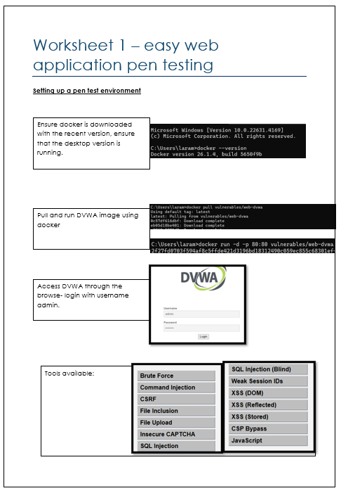
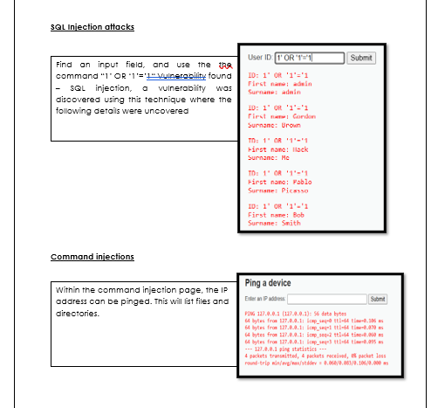

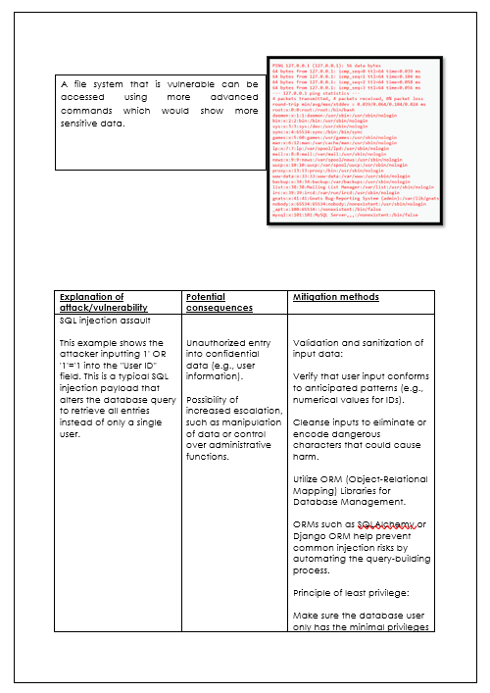

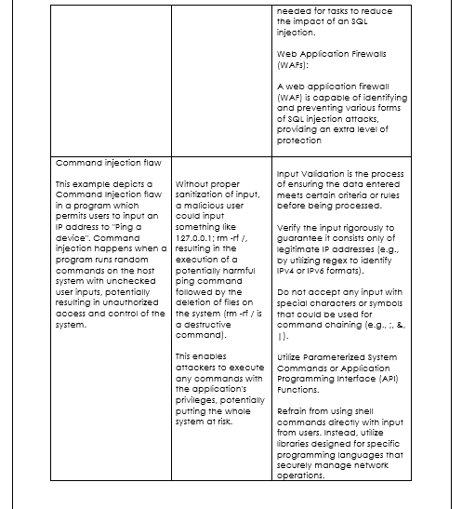

Worksheet 2

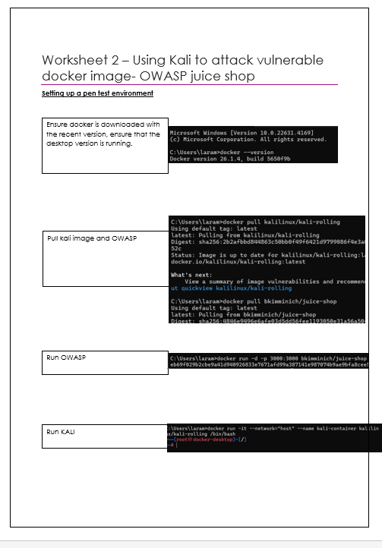

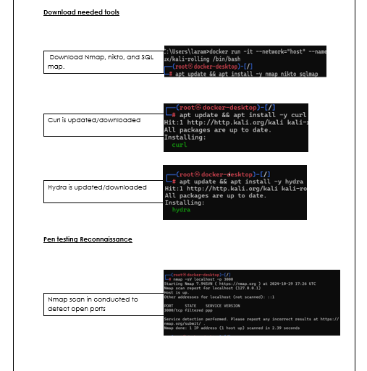
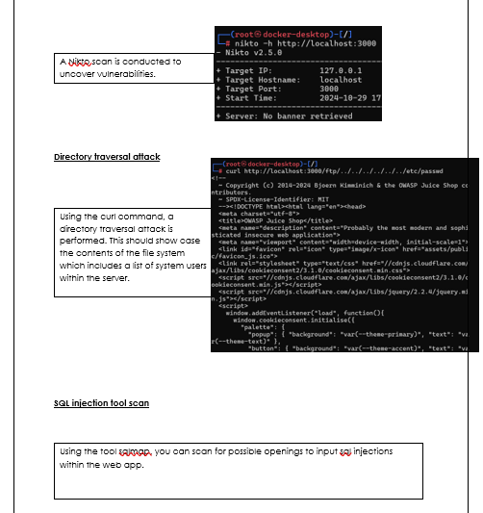
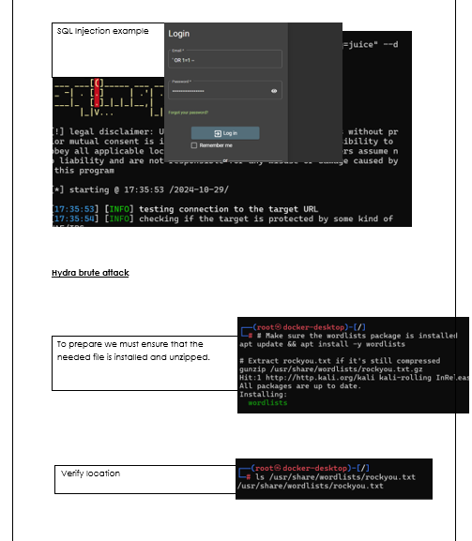
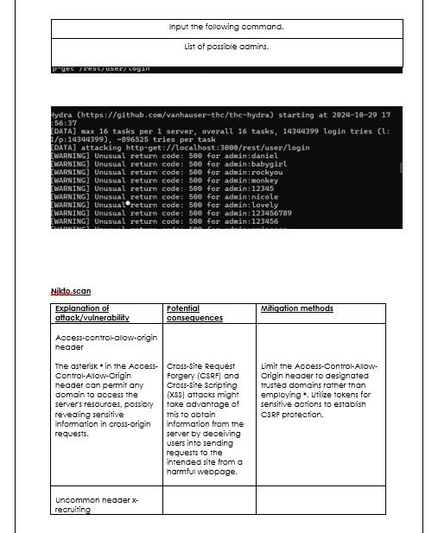
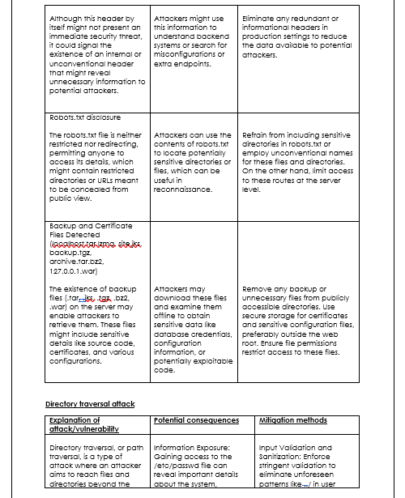
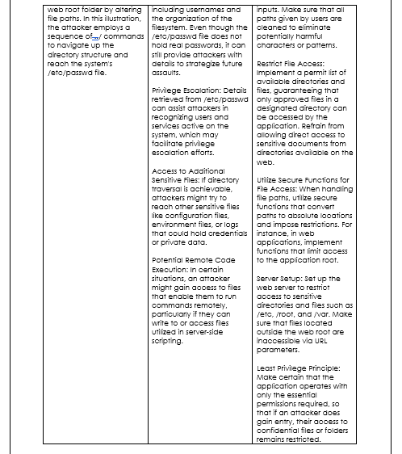
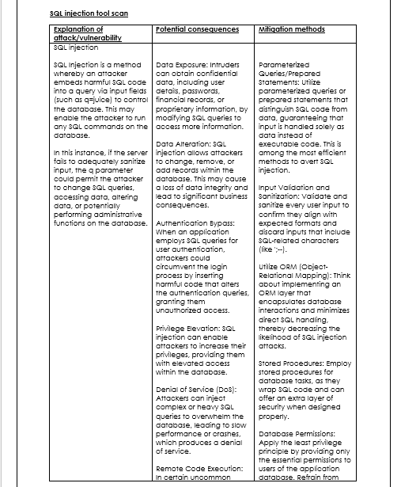
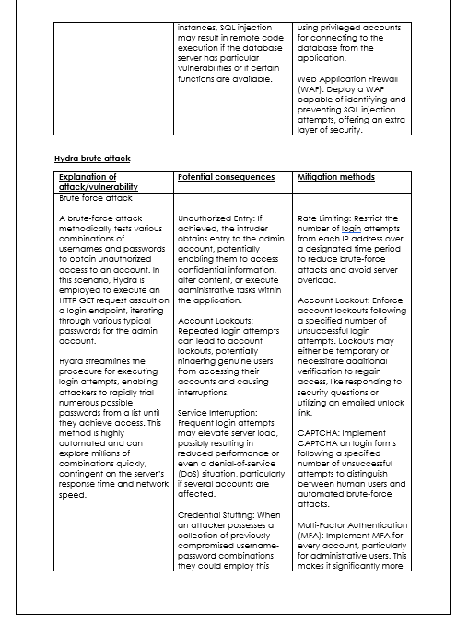
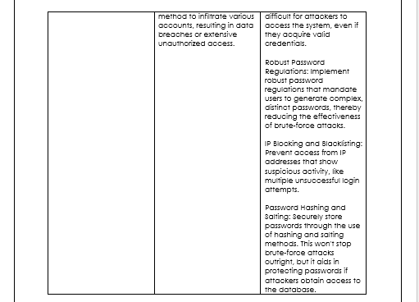

Worksheet 3
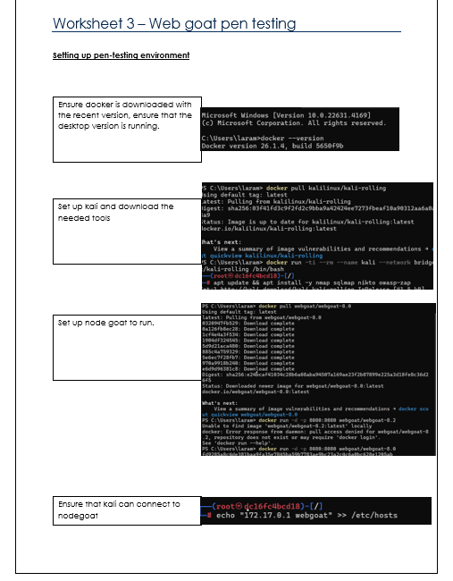
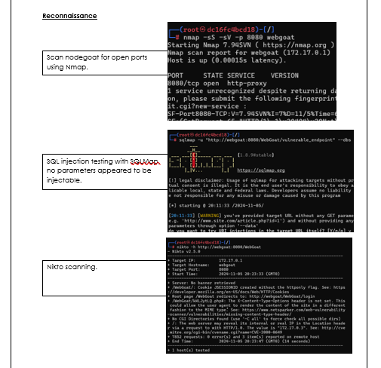
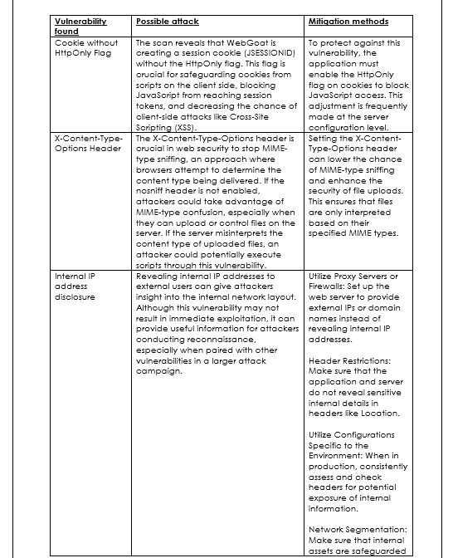


Worksheet 4
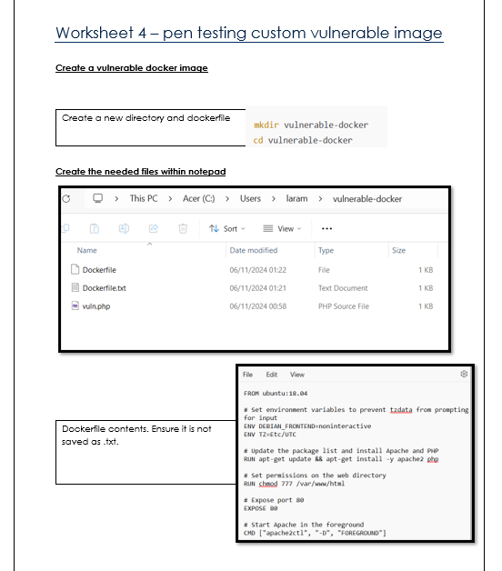
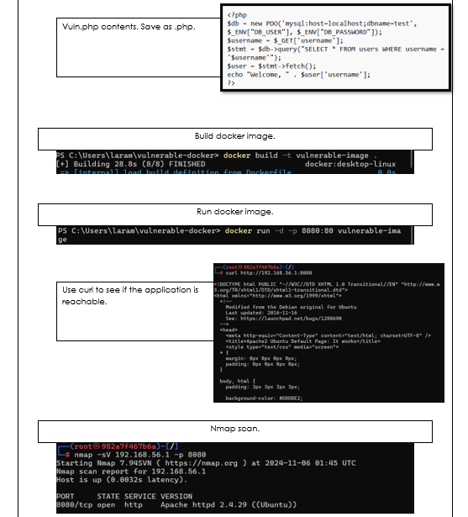
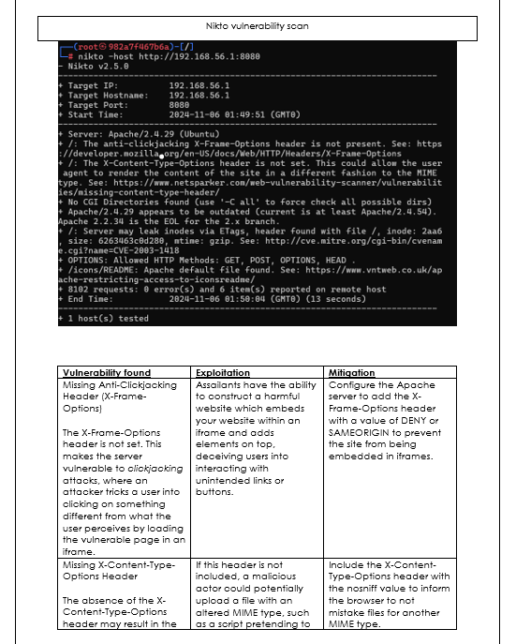

Implementation

Introduction

The execution stage of this project aimed at creating a detailed, engaging structure for instructing container security through a constructivist educational method. The deliverables consisted of worksheets that simulate penetration testing tasks, a quiz to evaluate knowledge gain, and a feedback system to collect learner perspectives. This part outlines the tools, methods, and difficulties faced throughout the execution phase.

4.3.1 tools and techniques

Containerised environment
The tool used for this task was docker, it worked to create isolated, controlled environments for learners to practice vulnerability testing. Tools like DVWA, OWASP Juice Shop, and WebGoat were hosted as Docker containers. Pre-configured docker images were developed to mimic vulnerabilities, facilitating straightforward setup and uniformity across learners' systems.

Worksheet development

Scenarios were carefully designed to gradually build learner skills, starting from basic tasks to more advanced challenges. It would use the format of a step-by-step format, for this we would use Microsoft Word. The instructions included visual guides, examples, and tips to reduce cognitive load and increase learner engagement.

Quiz design

For the quiz, the tool used would be Google Forms, which would allow for the creation of an interactive and easily accessible assessment system. The implementation would be set with multi-choice questions that would target theoretical and practical aspects which were developed based on the worksheet activity.

Feedback mechanism

Google Forms was used to design and deliver the feedback sheet, excel was used for the analysis of the results. The purpose was to gather quantitative and qualitative feedback that would assess the clarity, engagement, and effectiveness of the learning framework.

4.3.2 Key Techniques Used

A scenario simulation was showcased where docker containers were utilized to simulate realistic penetration testing scenarios, offering students hands-on experience while ensuring a managed environment.

There was the implementation of an incremental learning design where worksheets were arranged to guarantee that essential skills were perfected before students approached difficult problems.

The project included feedback-driven iteration where the feedback system enabled continuous improvement of the worksheets and assessment materials, ensuring alignment with learner needs.

Chapter 5 – Analysis

5.1 analysis of quiz data

5.1.1 purpose

The purpose of the quiz was to evaluate participants' comprehension of different penetration testing concepts and tools. In doing so it should aid in identifying areas of strength and weaknesses in the learning

5.1.2 overall patterns

There was a higher accuracy in the quiz results for simpler more commonly known concepts, such as “What is the purpose of DVWA in penetration testing?” However, there were mixed results on questions involving technical specifics, such as ETags or the HttpOnly flag, indicating potential gaps in comprehension for less intuitive or advanced topics.

5.1.3 question-by-question analysis

Questions | Correct responses | Analysis | Recommendations
1. What is the purpose of DVWA in penetration testing? | 10/10 | Every participant responded accurately, demonstrating a solid comprehension of the function of DVWA in penetration testing. This is consistent with the introductory material given during training, which thoroughly addressed DVWA as a primary tool. | Stay centered on this core idea, but think about cutting back the time allocated to it to prioritize other subjects.
2. Which command is used in DVWA to test for SQL injection? | 8/10 | The wrong answers indicate a possible deficiency in comprehending SQL injection commands. This could result from a lack of focus during the practical exercise or misunderstandings regarding terminology. | Strengthen the showcase of SQL injection attacks in DVWA and make sure test subjects actively use the commands themselves.
3. What type of message indicates a successful SQL injection test in DVWA? | 7/10 | The findings indicate that participants found it difficult to determine the result of a successful SQL injection. This might suggest a lack of focus on analyzing results throughout training. | Provide clear examples of expected outputs during exercises.
4. In command injection testing, what is the purpose of the whoami command? | 8/10 | Although most participants grasped this idea, the mistakes indicate that the practical application of commands might not have been thoroughly internalized by everyone. | Reiterate the purpose and expected output of common commands through repeated practical examples.
5. Which tool would you use to conduct a directory traversal attack in OWASP Juice Shop? | 7/10 | The individuals who provided wrong answers might not have completely understood the link between certain tools and attacks. | Showcase hands-on examples of directory traversal attacks utilizing OWASP Juice Shop and associated tools.
6. What is the main purpose of using Nikto in vulnerability assessments? | 9/10 | Most participants showed a solid comprehension of Nikto's objectives, indicating the training effectively addressed web vulnerability scanners. | Continue to use Nikto as an example but reinforce its use case through additional scenarios.
7. What is the significance of the X-Frame-Options header? | 8/10 | Incorrect answers emphasize a misunderstanding of certain security headers, likely stemming from the technical complexity of the subject. | Take extra time to clarify HTTP headers and their importance by using simple examples or analogies.
8. Which header is essential for preventing MIME-type sniffing vulnerabilities? | 6/10 | This was among the least effective questions, showing a notable deficiency in grasping MIME-type sniffing and the function of the X-Content-Type-Options header. | Dedicate a specific module to HTTP headers, emphasizing practical examples and step-by-step explanations.
9. Why is setting the HttpOnly flag on cookies important? | 7/11 | Mistakes indicate a lack of clarity regarding the role of the HttpOnly flag in improving cookie security. | Utilize hands-on examples to illustrate how HttpOnly restricts JavaScript from accessing cookies, potentially through mock attacks.
10. What is the main purpose of using Hydra in penetration testing? | 9/10 | Most participants were familiar with Hydra’s purpose, reflecting adequate training on brute-force attack tools. | Maintain current teaching methods.
11. In SQL injection attacks, what does the injection OR 1=1 achieve? | 10/10 | Correct responses suggest a strong understanding of this fundamental SQL injection technique. | Maintain current teaching methods.
12. What command can be used to detect open ports on a target system? | 8/10 | Mistakes might indicate a lack of comprehension or memory regarding port scanning tools such as nmap. | Strengthen the practical application of nmap and offer quick-reference materials throughout the training.
13. What does the Nikto scan indicate if it finds a cookie without the HttpOnly flag? | 6/10 | This was yet another poorly answered question, reflecting a limited grasp of security matters related to cookies. | Concentrate on the practical consequences of cookie weaknesses and incorporate additional instances of Nikto’s discoveries.
14. What is the potential risk of missing the X-Content-Type-Options header? | 7/10 | Like in Question 8, the findings indicate an unclear understanding of HTTP headers and their function in reducing vulnerabilities. | Clarify the meaning of HTTP headers and show their real-world effects through practical exercises.
15. What does an outdated Apache version imply in terms of security? | 8/10 | Mistakes may arise due to a lack of focus on the dangers linked to using outdated software versions. | Emphasize the significance of updates and patches by utilizing case studies or instances of actual attacks.
16. How can the ETags header potentially leak information to attackers? | 8/10 | Mistakes indicate that not all participants fully comprehended the technical aspects of ETags. | Explain the idea of ETags with diagrams or animations that illustrate how they can reveal server information.
17. What vulnerability does the X-Frame-Options header protect against? | 8/10 | Mistakes suggest a limited grasp of the header's role, possibly because of its technical details. | Continue covering this topic but integrate more relatable examples to improve comprehension.
18. What is one of the primary uses of Docker in a penetration testing setup? | 8/10 | Mistakes indicate that the flexibility of Docker might not have been clearly conveyed. | Incorporate additional specific use cases for Docker in penetration testing settings throughout the training.
19. What should be checked if an internal IP address is disclosed on a web application? | 7/10 | Mistakes indicate uncertainty about the correct steps for revealing IP addresses. | Highlight the practical consequences of revealing internal IP.
20. What is the recommended method to prevent clickjacking on a web server? | 9/10 | The majority of participants grasped this idea, indicating adequate training on clickjacking prevention. | Maintain current teaching methods.

5.1.4 how the results link to the literature review

The quiz outcomes closely match the literature review, confirming the significance of experiential, practical instruction in container security training. Elevated scores on fundamental questions demonstrate the efficacy of experiential methods highlighted in the review, including tools like PocketCTF and Cook.UP. In contrast, reduced scores on advanced subjects point to deficiencies in delivering complex ideas, as discussed in the literature regarding the challenges of container security education. In summary, the findings validate that the project's approach tackles significant knowledge deficiencies while emphasizing opportunities for enhancing the delivery of advanced material.

5.2 analysis of feedback collected data

5.2.1 analysis of results question-by-question
Questions | Results | Analysis | Reason for outcome | Recommendations
1. How would you rate the clarity of the training material on vulnerability testing? | Scores mainly fell between 4 and 5, showing a high level of satisfaction. | The training materials were clear and appreciated, demonstrating that the worksheets and their explanations successfully communicated the subject matter. | Clear instructions and structured content likely contributed to this result. | Maintain the current teaching methods.
2. Did the training material cover the topics you expected? | All results were yes. | This indicates that the content fulfilled students' expectations and thoroughly addressed the expected subjects. | The training probably matched the participants' expectations and previous knowledge effectively. | Maintain the current teaching methods.
3. Which vulnerability testing techniques were the most challenging for you to understand? | Responses varied, with "Command Injection" and "Custom Image Creation" being common challenges. | These subjects are complex and might demand extra time or clarification. | The complexity of these tasks likely posed difficulties for participants. | Add easier tutorials or break down these concepts further in future training sessions.
4. Did you find the demonstration examples helpful in understanding vulnerabilities? | Most participants found them "Extremely helpful." | The practical examples were impactful, showcasing the benefit of hands-on demonstrations for acquiring technical skills. | Practical, real-world examples tend to facilitate understanding and retention of complex concepts. | Maintain the current teaching methods.
5. How would you rate the quality of the explanations provided by the instructor/training material? | Majority of 5. | High scores indicate the explanations were thorough and easy to follow. | Appropriate explanations and guides were given. | Maintain the current teaching methods.
6. Did the hands-on exercises help solidify your understanding of the concepts? | Most participants “strongly agreed” | The practical activities successfully supported the theoretical components of the training. | Engaging in hands-on practice enhances both retention and comprehension. | Maintain the current teaching methods.
7. Were there any parts of the training that felt too rushed or too slow? | The most chosen answer was “Just right” | This indicates that the content delivery was balanced and appropriate for the audience. | The pacing was adjusted accordingly based on the participant’s technical level. | Maintain the current teaching methods.
8. Did you encounter any technical issues with the training environment? | There were a few reports of minor issues. | Although the training environment was mostly well-established, there were minor technical issues that arose. | Minor issues with tools or setup could arise due to varying participant technical levels. | Provide pre-training troubleshooting guides and technical support during sessions.
9. How confident do you feel in your ability to test for vulnerabilities using the techniques demonstrated? | Most scores ranged from 4 to 5 | Participants believed they acquired hands-on skills and confidence in utilizing the techniques. | Hands-on exercises and clear instructions helped build confidence. | Maintain the current teaching methods.
10. Did you gain a better understanding of mitigation techniques for common vulnerabilities? | Results were either “strongly agree” or “agree” | This shows the training effectively covered mitigation strategies. | The training likely included clear examples and steps for mitigation. | Maintain the current teaching methods.
11. What is one key takeaway or skill you learned from this training? | Responses included "Pen testing," "Cybersecurity skills," and "Docker image creation." | Participants gained practical, actionable skills from the training. | The focus on hands-on activities ensured participants retained useful skills. | Maintain the current teaching methods.
12. How can we improve future vulnerability testing training? | Suggestions included "Simplify the content," "Add more examples," and "Include advanced techniques." | While participants were generally satisfied, some suggested refinements for clarity and depth. | This feedback highlights areas for improvement in accessibility and content depth. | Incorporate these suggestions into future training, ensuring content remains accessible yet comprehensive.
13. Would you like more advanced training in specific areas? | Most responded "No," with a few indicating interest in advanced topics. | While the current training met most participants’ needs, some expressed a desire for more advanced material. | The participants' varying skill levels may explain the mixed responses. | Offer optional advanced modules for those seeking deeper knowledge.

5.2.2 how the results link to the literature review

The findings from the survey closely correspond with the literature review's focus on experiential learning and the implementation of practical, real-life situations to improve cybersecurity education. Research on container security, including contributions from Ann Yi Wong and others, underscores the necessity of tackling intricate security issues by actively utilizing tools such as Docker, Kubernetes, and STRIDE frameworks. The feedback indicates that the training successfully connected theoretical understanding with practical usage, as participants expressed strong confidence in assessing vulnerabilities and valued the clarity of the resources. Furthermore, the literature emphasizes the significance of employing teaching methods such as experiential and problem-based learning to develop critical skills, aligning with participants' input regarding the efficacy of worksheets and activities in replicating real-world situations. The small technical issues mentioned in the survey also reflect challenges found in the literature, like the necessity for easier deployment and troubleshooting in educational settings, which further reinforces the project's design and methodology.

Chapter 6: Results and discussions/evaluations

6.1 introduction

The assessment procedure was carried out to gauge the efficiency of the teaching framework, comprising worksheets, quizzes, and feedback forms, in instructing container security concepts. The findings are evaluated by the project's goals, purpose, and the outcomes from the literature review.

6.2 conclusions from data

6.2.1 quiz results

Participants excelled in basic concepts such as SQL injection and security headers, demonstrating successful learning from the worksheets. Nonetheless, certain individuals faced difficulties with sophisticated subjects such as custom Docker images, suggesting a demand for clearer explanations.

6.2.2 feedback results

The training resources received excellent scores for clarity and comprehensiveness (average 4.8/5). Practical exercises were commended for reinforcing comprehension. Challenges involved directory traversal and custom Docker image weaknesses, consistent with quiz outcomes. Recommendations involved making instructions easier to follow and incorporating visual supports.

6.2.3 objectives

The set-out objectives were fully met within the project. The worksheets offered practical, real-life situations that enhanced participants' comprehension of container security. The assessment procedure, incorporating quizzes and organized feedback, provided practical insights for upcoming improvements. Small modifications, like improving advanced scenarios and adding more visuals, would better optimize the materials.

Chapter 7: conclusions and recommendations

This project successfully created a hands-on learning framework to teach container security through worksheets, quizzes, and feedback. Participants gained practical skills in identifying and mitigating vulnerabilities, with positive feedback highlighting the clarity and usefulness of the materials. While foundational concepts were well understood, advanced topics proved more challenging, suggesting areas for improvement. Future updates can include simpler instructions, more visuals, and optional advanced content. Overall, the project effectively addressed a key gap in container security education and provided a valuable tool for teaching cybersecurity skills.

Chapter 8 – reflection

This initiative offered important perspectives on container security as well as educational design. Creating the worksheets and assessments was a difficult but fulfilling task, demanding a balance between technical complexity and ease of understanding for novices. Responses and quiz outcomes underscored the success of experiential, hands-on learning, while also stressing the necessity for more explicit instructions and better assistance on challenging subjects. For me, this project strengthened my abilities in cybersecurity and teaching, emphasizing the significance of continuous enhancement and user-focused design. Going ahead, I am driven to utilize these insights to develop more holistic and captivating educational resources.

References

[1]
Y. Yang, W. Shen, B. Ruan, W. Liu, and K. Ren, “Security Challenges in the Container Cloud,” Dec. 2021, (accessed: 2/11/2024)
[2]
C. Pahl, A. Brogi, J. Soldani, and P. Jamshidi, “Cloud Container Technologies: A State-of-the-Art Review,” IEEE Transactions on Cloud Computing, vol. 7, no. 3, pp. 677–692, May 2017,( accessed: 16/11/2024)
[3]
I. Ahmad, M. G. AlFailakawi, Asayel AlMutawa, and L. Alsalman, “Container scheduling techniques: A Survey and assessment,” Journal of King Saud University - Computer and Information Sciences, vol. 34, no. 7, pp. 3934–3947, Mar. 2021,( accessed: 16/11/2024)
[4]
A. Bhardwaj and C. R. Krishna, “Virtualization in Cloud Computing: Moving from Hypervisor to Containerization—A Survey,” Arabian Journal for Science and Engineering, vol. 46, no. 9, pp. 8585–8601, Apr. 2021, (accessed: 16/11/2024)
[5]
Yara Alghofaili, Albatul Albattah, Noura Alrajeh, M. A. Rassam, and A. Saleh, “Secure Cloud Infrastructure: A Survey on Issues, Current Solutions, and Open Challenges,” Applied Sciences, vol. 11, no. 19, pp. 9005–9005, Sep. 2021, accessed: 18/11/2024
[6]
A. Y. Wong, C. E. Getahun, M. Ochoa, and J. Zhou, “Threat Modeling and Security Analysis of Containers: A Survey,” arXiv.org, 2021. https://arxiv.org/abs/2111.11475 (accessed Nov. 18, 2024).
[7]
L. Chen et al., “SEAF: A Scalable, Efficient, and Application-independent Framework for container security detection,” Journal of Information Security and Applications, vol. 71, pp. 103351–103351, Oct. 2022, (accessed Nov. 20, 2024).
[8]
Emiliano Casalicchio and S. Iannucci, “The state‐of‐the‐art in container technologies: Application, orchestration and security,” Concurrency and Computation Practice and Experience, vol. 32, no. 17, Jan. 2020, (accessed Nov. 24, 2024).
[9]
Olivier Flauzac, Fabien Mauhourat, and Florent Nolot, “A review of native container security for running applications,” Procedia Computer Science, vol. 175, pp. 157–164, Jan. 2020, (accessed Nov. 24, 2024).
[10]
S. Karagiannis, Christoforos Ntantogian, Emmanouil Magkos, L. L. Ribeiro, and L. Campos, “PocketCTF: A Fully Featured Approach for Hosting Portable Attack and Defense Cybersecurity Exercises,” Information, vol. 12, no. 8, pp. 318–318, Aug. 2021, (accessed Nov. 25, 2024).
[11]
A. Watters, Teaching Machines. MIT Press, 2023. (Accessed: Nov. 25, 2024.)

[12]
S. Mehringer and B. Barker, “Using Containers to Create More Interactive Online Training and Education Materials,” Practice and Experience in Advanced Research Computing, pp. 246–251, Jul. 2020, (accessed Nov. 26, 2024).
[13]
J. Sánchez, Adrià Mallorquí, A. Briones, Agustín Zaballos, and G. Corral, “An Integral Pedagogical Strategy for Teaching and Learning IoT Cybersecurity,” Sensors, vol. 20, no. 14, pp. 3970–3970, Jul. 2020, (accessed Nov. 27, 2024).
[14]
J. Lakka-Kolari, “Pedagogical aspects in cyber security trainings offered by private companies,” Jyx.jyu.fi, 2021, (accessed Nov. 27, 2024).
[15]
M. Mukherjee, N. T. Le, Y.-W. Chow, and W. Susilo, “Strategic Approaches to Cybersecurity Learning: A Study of Educational Models and Outcomes,” Information, vol. 15, no. 2, p. 117, Feb. 2024, (accessed Nov. 27, 2024).
[16]
K. Shaukat, S. Luo, Vijay Varadharajan, I. A. Hameed, and M. Xu, “A Survey on Machine Learning Techniques for Cyber Security in the Last Decade,” IEEE Access, vol. 8, pp. 222310–222354, Jan. 2020, (accessed Nov. 27, 2024).
[17]
J. Zhang, L. Pan, Q.-L. Han, C. Chen, S. Wen, and Y. Xiang, “Deep Learning Based Attack Detection for Cyber-Physical System Cybersecurity: A Survey,” IEEE/CAA Journal of Automatica Sinica, vol. 9, no. 3, pp. 377–391, Sep. 2021, doi: https://doi.org/10.1109/jas.2021.1004261.
‌

‌

‌

‌

‌

‌

