

International Market Entry Strategy and Marketing Mix of Pizza Hut: A Comparative Analysis of the United States and India

Programme: Master of Business Administration
Module: International Marketing: Principles and Practices
Module Code: LCMB7026

Lecturer: Tushara Balendran

Student Name: Ikhtear Mahbub
Student ID: 2527585

Submission Date: 13th August, 2026
AI Acknowledgement
I declare that I have not used any AI tools in preparing, writing, analysing and completing this assessment. I conducted all my own research, evaluation and written work.

Student Name: Ikhtear Mahbub
Student ID: 2527585
Date: 13/08/2026

Table of Contents
1. Introduction 1
2. Section 1: International Market Entry Strategy and Marketing Mix 1
2.1 Comparative PESTLE and Cultural Analysis 1
2.2 Comparative STP Analysis 6
2.3 Comparative International Marketing Mix 9
2.4 Pizza Hut’s Market-Entry Strategy in India 15
2.5 Balanced Ethical Evaluation of Pizza Hut’s Marketing Mix in India 17
2.6 Recommendations for the United States and India 19
3. Section 2: Reflective Essay Using Gibbs’ Cycle 22
4. Conclusion 25
5. References 26

1. Introduction
The Pizza Hut was chosen for a comparative study of international marketing strategy in the USA (home market) and India (host market) with respect to the market entry, cultural adaptation and the marketing-mix decisions. The company was founded in Wichita, Kansas in 1958 by Dan and Frank Carney, and has grown to an international restaurant chain, known as Yum! Brands (Bashir and Ansari 2025). Its mission to “make people happy” is indicative of its focus on 'easy services' and satisfying customers and pleasurable meal experiences across markets (Pizza Hut India, 2026). The U.S. is the home market since the Pizza Hut was established there, while India is a challenging market with its cultural diversity and price sensitivity. Pizza Hut first came to India in June 1996 with its first outlet in Bangalore. The report appraises PESTLE, Hofstede's six dimensions, STP, 7Ps, Entry strategy in India, Ethical and Unethical practices, country specific recommendations and Gibbs' reflective cycle.

2. Section 1: International Market Entry Strategy and Marketing Mix

2.1 Comparative PESTLE and Cultural Analysis
Definition and application of PESTLE
PESTLE is a framework looking at the political, economic, sociological, technological, legal and environmental influences that can cause opportunities or threats to an organisation (CIPD, 2025). It is appropriate for the comparison because Pizza Hut's dilemma is that it attempts to maintain its global consistency while facing significantly different market environments in its "home" market (the United States) versus its "host" market (India) in which it operates (Yum! Brands, 2024).
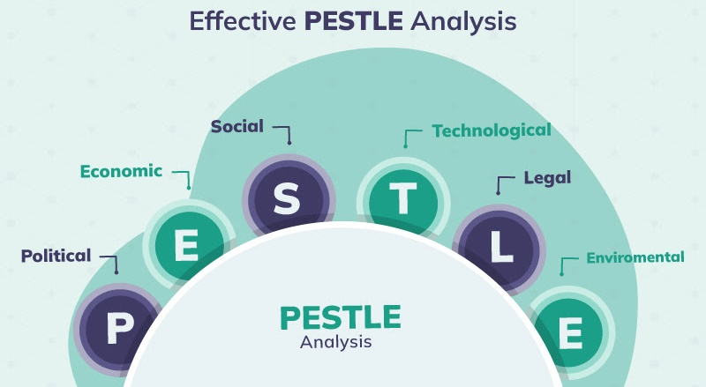
Figure 1: PESTLE Analysis
Source: (Crowjack, 2026)
Political factors
Established institutions of the franchise (in the United States) are favourable to the Pizza Hut's franchised model, while the federal, state and local requirements are unfavourable due to the increased compliance responsibilities. Local partners' knowledge of the market make it an ideal environment for the growth of franchises in India, but the state-level licensing, taxation and food-service requirements make it an unfavourable environment because of the coordination demands. With this, Pizza Hut needs to have more robust governance of the franchise in India (Yum! Brands, 2024). The emphasis on good franchise governance is further underscored by Pizza Hut's broader business strategy, which is heavily reliant on its franchise operations.
Economic Factors
The economy in the USA is favourable due to purchasing power, and, in India, the economy is favourable due to economic growth. Consumer-price inflation in 2024 was 2.9% in the United States and 5.0% in India, making inflation more unfavourable for Indian consumers (World Bank, 2025). According to Restaurant Business (2025), sales for Pizza Hut in the United States were estimated to be around $5.55 billion in 2024. A reduction in purchasing power, price sensitivity and increasing input costs are unfavourable in India. The weak demand and cost pressures were responsible for same-store sales declines at Sapphire Foods Pizza Hut in the quarter that ended on June 2024 (Reuters, 2024). India thus needs to have smaller portions, entry level pricing and affordable bundles.
Social Factors
There are favorable social conditions in the USA, as there is convenience for takeout and delivery; 47% of adults take out or order takeout weekly, and 37% order takeout weekly, especially younger consumers (National Restaurant Association, 2025). India has a favourable due to the presence of young age group in urban areas and a sense of community dining, however it is not great when it comes to religious dietary requirements and vegetarian demand. This disadvantage is mitigated by Pizza Hut's paneer, tandoori and vegetable products, which are produced locally. People's growing awareness of health is unfavourable for indulgence positioning.
Cultural Factors Using Hofstede’s Model
Culture is favourable to Pizza Hut in both countries. India's Power Distance is higher (77 vs 40) which supports clearer service roles. With 60 compared to India's 24, the US is more individualistic, preferring to order customised items and portions, while Indian collectivism prefers family bundles and group feeding. The scores on the achievement and quality messages are similar to Masculinity, 62 and 56. The scores for Uncertainty Avoidance are 46 and 40 which indicates a preference for experimentation; the scores for Long-Term Orientation are 50 and 51. The highest difference is in the score of Indulgence with 68 in the United States and 26 in India. High indulgence in both countries is good for fun-based communication while low indulgence in both countries is good for relying on personal gratification; Affordability and shared consumption are better suited (The Culture Factor Group, 2025).
However, national averages may conceal regional, religious and generational differences. Therefore, it would be not favorable to make a decision based on country scores as fixed predictors (Komisarof and Akaliyski, 2025). Hofstede must not decide on localisation, but rather alert to it.
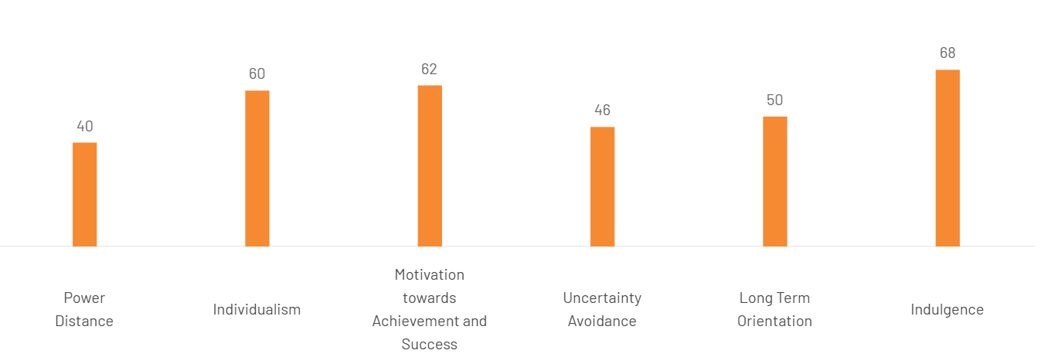
Figure 2: Hofstede Cultural-Dimension Scores for the USA
Source: (The Culture Factor Group, 2025).

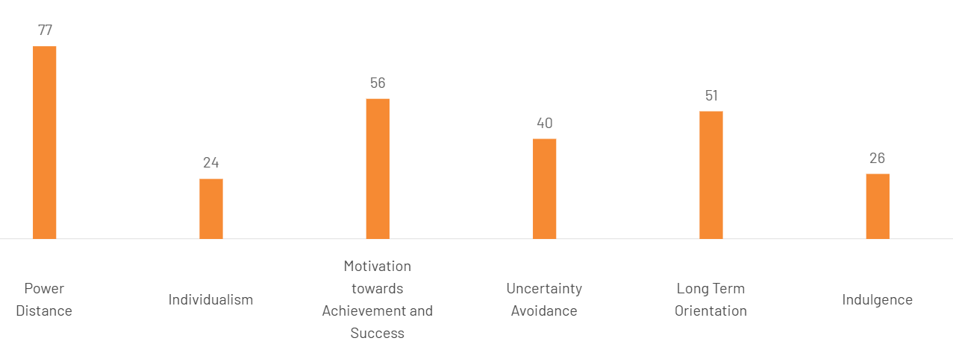
Figure 3: Hofstede Cultural-Dimension Scores for the India
Source: (The Culture Factor Group, 2025).
Technological factors
Technology is favourable in both markets. 55% of Yum! system sales in 2024 were digital, aiding in quicker service and customer satisfaction (Yum!). Brands, 2024). The penetration of the internet and mobile in India is favourable for app ordering, digital payments and aggregator delivery (TRAI, 2024). But third-party dependence is not good as it might reduce margins, control of services and ownership of customer data. The direct digital channels need to be improved.
Legal Factors
Legal conditions are favourable in that menu-labelling, food-safety and data-protection conditions can reinforce trust, but unfavourable in that there are more costs in compliance. In the United States, chains are subject to calorie labelling, while in India, food-labelling and data-protection regulations. In the United States, calorie labelling applies to chains and, in India, food labelling and data-protection regulations. It's possible to promote credibility through transparent compliance.
Environmental Factors
Unfavourable environmental pressure is caused by packaging waste, food waste and emissions, which lead to regulatory risks. But it's a good thing when Pizza Hut gets better on sustainability. The amendments to the Plastic Waste Management policy in India add more to the responsibility for packaging, and Yum! states that it has implemented sourcing and emissions reduction programs (Government of India, 2024). Measurable waste and emissions targets are important.
PESTLE and Cultural Similarities and Differences
In general, United States is more favourable to the standardization process due to purchasing power, franchising, and ease of use of digital. India is favourable due to growth, youth and group consumption, but bad due to price sensitivity, dietary complexity, and regulatory variation which need to be adapted. Pizza Hut should create a standardised base for its brand, food safety protocols and digital customer interactions while introducing menu, price, promotion and franchise execution localisation when it provides enough value for the customers.

2.2 Comparative STP Analysis
Segmentation in the United States and India
Pizza Hut is using more than one segmentation variable, since neither of the markets is homogeneous. Demographically, it targets families, working adults, Gen Z and Millennials mainly consumers who often rely on takeaway and delivery. Takeout was utilized by 47% of adults in the USA weekly in 2025 and 37% ordered takeout weekly, with younger consumers especially likely to do so (National Restaurant Association, 2025). India's main group is students, young professionals, high value conscious consumers and middle income family. The fact that younger consumers and value propositions are being identified as key strategic drivers of the Pizza Hut India proposition points to the fact that age and disposable income are two factors that are important in determining Pizza Hut's strategy (ETRetail, 2024).
Geographically, the US network is comprised of metropolitan, suburban and regional markets, delivered, takeout and selected dine-in. There's a need for more selective expansion, as if the income, infrastructure and competition varies between metro cities and smaller cities, then India needs selective expansion. Tier-II and tier-III markets account for approximately half of Pizza Hut's operations in India, presenting high growth potential areas, but growth needs to be carefully monitored for profitability of outlets and local demand (ETHospitalityWorld, 2023). It also appears to have a widely spread presence in India with its current store locator (Pizza Hut India, 2026).
VALS is a psychographic model that can be adopted as an interpretive model as well as one that can be used by companies. New tastes could appeal to the experiential crowd, and its social appeal and internet marketing might appeal to those who are looking to achieve. Savvy, cost-sensitive customers will react more favorably to packages, discounts and quality service. These typologies should not be considered as a national taxonomy, however, since there is an interaction between lifestyle and income and context (Kotler, Keller and Chernev, 2022).
Behaviourally Pizza Hut segments on the basis of ordering channel, frequency, purchase occasion, desired benefit and loyalty. The revised "US Hut Rewards" aims to incentivise repeat online purchases via points and personalised value and member access. Vegetarian and non-vegetarian menus, personal pizzas, party size and occasion (pizzas per meal and group size) are ways of segmenting, and are applicable in India (Pizza Hut India, 2026).
Targeting strategies
Targeting differentiated is the most compelling interpretation in both countries. Pizza Hut's approach in the U.S. is to appeal to younger delivery customers, families and customers who are looking for value and repeat business via digital ordering, carryout, bundles and loyalty. It's aimed at the urban young, middle-class family, vegetarian customers and consumers in emerging cities in India. These groups can be engaged via restaurants, direct online and delivery calls. However, there is a risk that high promotion levels can attract deal-switchers and could ultimately drive down the margins for the franchise; so, Pizza Hut should focus on profitable events, repeat purchase, and CLCV (customer lifetime value) instead of volume (National Restaurant Association, 2025; ETRetail, 2024).
Positioning strategies
The most common positioning that Pizza Hut employs is benefit-based and value-based positioning. Its purposeful image in the United States is pizza familiar, convenient, choice and accessible offers. This is where Hut Rewards also plays a role in reinforcing value and ease, but has some competitors with similar delivery and discounting focus (Pizza Hut, 2024). In countries where Pizza Hut has presence, the brand offers foreign dishes to the local palate which include Paneer Makhni Masala, Tandoori Paneer and Schezwan vegetable pizzas, as well as pizza take-out and sharing deals, which encourage family and social dining (Pizza Hut India, 2026).

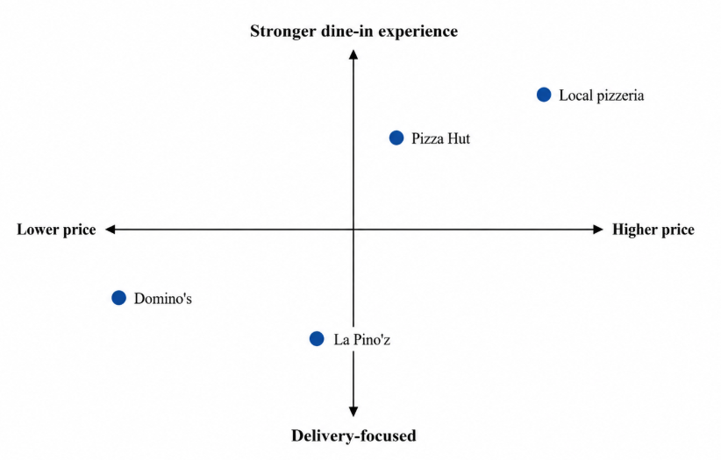
Figure 4: Perceptual positioning of selected pizza brands in India
Source: (Pizza Hut India, 2026; Domino’s India, 2026; La Pino’z Pizza, 2026).
In Figure 4, Pizza Hut is placed higher in the dine-in spectrum than Domino's is and higher in the price range than La Pino'z, which is placed towards the lower end of the price spectrum. It is an interpretation of the ordering channels and the official menus provided by the store formats (Pizza Hut India, 2026; Domino’s India, 2026; La Pino’z Pizza, 2026). The point “local pizzeria” is a generic category and doesn't represent an actual average of all pizzerias in the country.
STP similarities and differences
The markets include both families, and younger digital consumers and value seekers, both of which facilitate differentiated targeting. But there is a need for more adaptability in India with regard to vegetarianism, group eating, regional differences and difference in purchasing power. Pizza Hut can stick to its consistent guarantee of convenient and enjoyable pizza, but its Indian positioning needs to make it relevant, social and affordable while still delivering on the same level of service and making Pizza Hut a profitable franchise to own.

2.3 Comparative International Marketing Mix
Marketing Mix Definition and 7Ps Framework
Marketing mix is the amalgamation of product, price, place and promotion to create customer value. For services, they would add people, process and physical evidence because they impact the customer experience (Wirtz and Lovelock, 2022). It fits Pizza Hut particularly well, as it offers a mix of food, digital access, delivery and restaurant service.
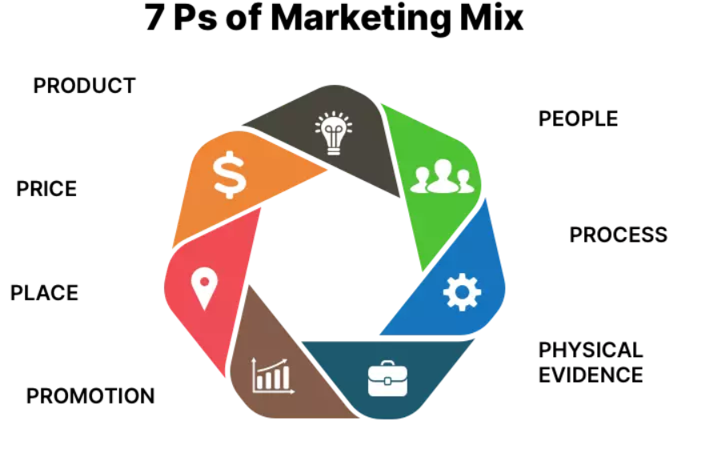
Figure 5: 7Ps of Marketing Mix
Source: (Eightception, 2020)
Product
Pizza Hut is unifying their brand and the very same pizza offering, while adjusting the product line. US product width includes pizza, pasta, wings, sides, dessert, drinks and pizza bite (aka pizza packages), and depth includes size, toppings and crusts, including Pan, Thin ’N Crispy and Chicago Tavern-Style (Pizza Hut, 2024). There are similar options, but more localised and vegetarian options, like sharing products, paneer, tandoori and Momo Mia, in India (Devyani International Limited, 2025). Localisation enhances cultural relevance and brings up new sourcing, training and food-waste challenges. Thus, the products are kept on the menu only if there is enough demand and sufficient margins for them.
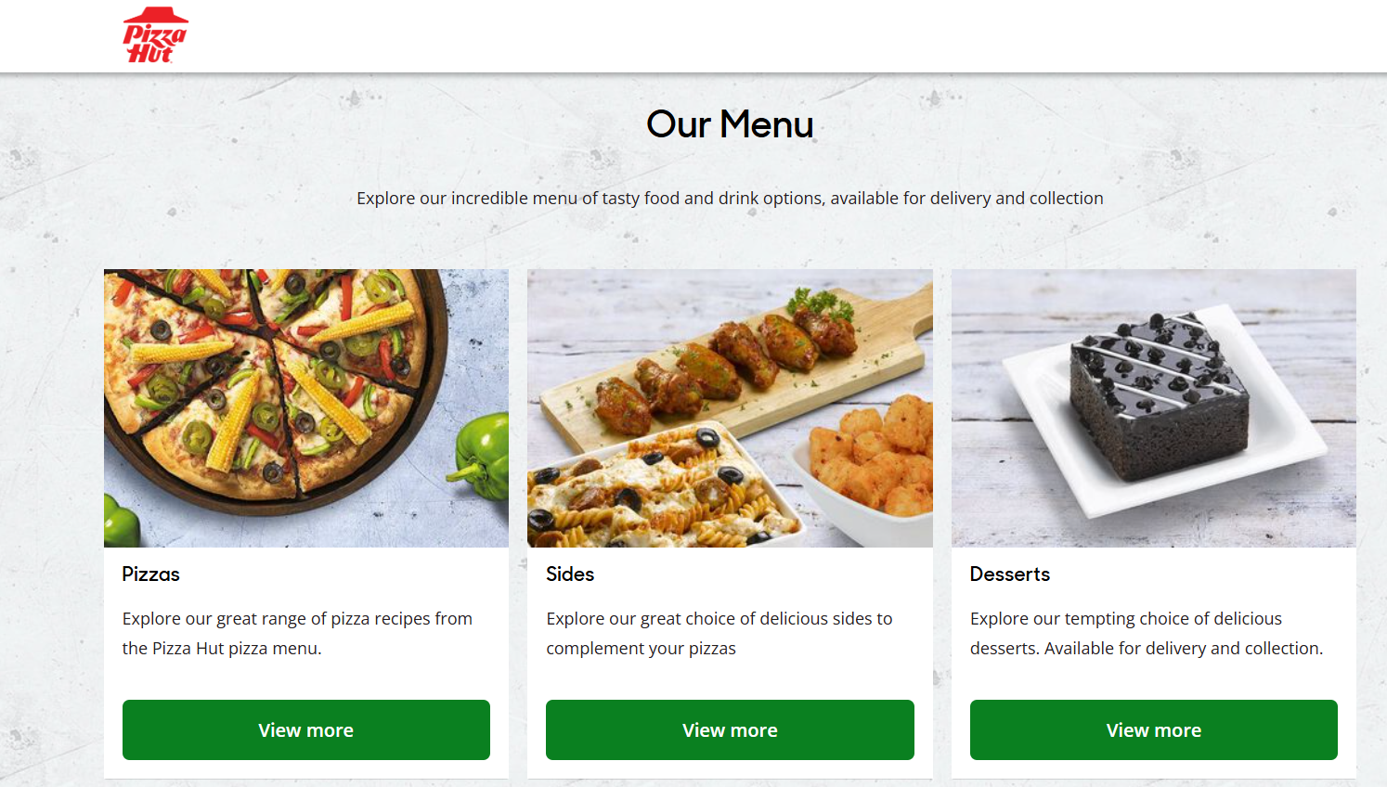
Figure 6: Pizza Hut India Product Range and Menu Categories
Source: (Pizza Hut India, 2026)
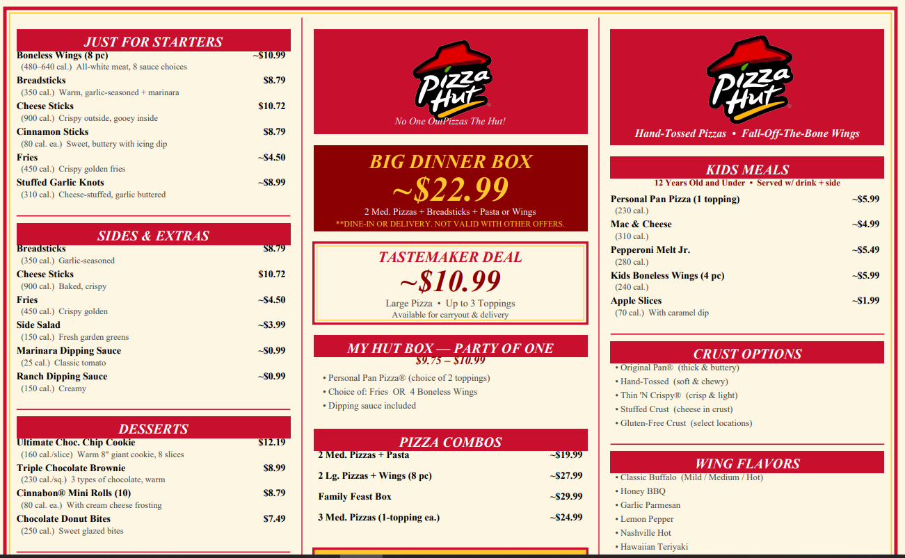
Figure 7: Pizza Hut USA Product Range and Menu Offerings
Source: (Pizza Hut USA, 2026)
Price
Pizza Hut uses bundle, promotional, competitive, value-based, segmented and loyalty based pricing. Price variations according to crust, channel and location are examples of segmented pricing, while US bundles and digital deals and Hut Rewards help to promote repeat direct sales. India is more dependent on low-cost bundles, low-priced products, festival deals, and sharing deals. However, Pizza Hut India's contribution margin decreased from 7.2% to 2.7% for FY2024-25, indicating that due to promotions, the company's sales volume could have negatively impacted its profitability (Devyani International Limited, 2025). Discounts must therefore be targeted, temporary and tied to customer retention and not be offered on a continuous basis.
Place
The USA focuses on delivery, carryout, websites, mobile apps and off-premise formats while India is more focused on digital delivery and dine-in and family-oriented occasions. As of March 2025, Devyani was running 630 Pizza Hut stores, with a plan to expand outside of metros in the future (Devyani International Limited, 2025). Direct channels provide margins, control of customer information; third-party aggregators provide market reach, but add commissions, and they make it hard to deal with service recovery.
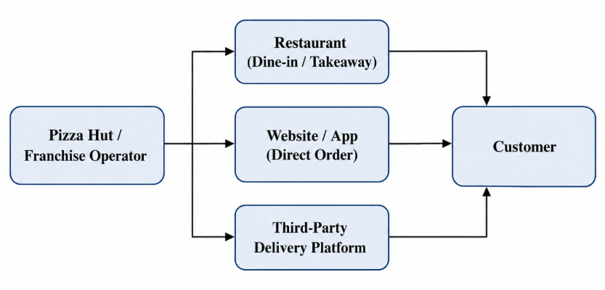
Figure 8: Pizza Hut distribution channels
Source: (Devyani International Limited, 2025; Yum! Brands, 2025).
Promotion
Integrated Marketing Communication (IMC) is a marketing strategy that aligns the role of advertising, sales promotion, public relations, digital media, direct marketing, loyalty communication and in-store activities to send a coherent message about the brand (Kotler, Keller and Chernev, 2022). US communications focus on innovation, convenience, personalisation, Hut Rewards and new-product promotions. Indian campaigns focus on festivals, local food, family events, involvement and value. While localisation is good, over repeated messages of discounting, perceptions of quality may suffer. Communication should therefore be both affordable and tasteful, experience and service reliability.

People
Pizza Hut's service quality is vital for its employees, delivery drivers, and managers of the franchise, as their competence and consistency directly impact the experience for customers. There are over 350,000 Pizza Hut employees worldwide in over 16,000 restaurants, though a specific number of employees at Pizza Hut in the United States is not published (Pizza Hut, 2026); in the United States, Pizza Hut is operated by over 100 franchise organisations. As of March 2025, Devyani International Limited employed 14,802 as of its most recent reports, but this is for the various restaurant brands and not just Pizza Hut (Devyani International Limited, 2025). Thus, it is not possible to give precise figures for the number of Pizza Hut employees in both countries. The use of standardised recruitment and training, complaint handling, audits and incentives is critical to ensure service quality is consistent across franchise outlets (Wirtz and Lovelock, 2022).
Process
The journey of the customer involves searching, choosing, ordering, paying, preparing, collecting or delivering, complaining, refunding and resolving. Refunds are taken on a case-by-case basis and customers can reach out to the restaurant, send an online message or use live chat with Pizza Hut if they wish to have their money back (Pizza Hut, 2025). Feedback is gathered through brand portals, surveys and social media, and analyzed using an integrated complaint-management system in India (Devyani International Limited, 2025). However, with the division of responsibility among the franchisees and delivery partners, there could be a loss in transparency. Common complaint record and standard of resolution would enhance accountability.
Physical Evidence
The physical signs of Pizza Hut are its logo, restaurant design, menus, packaging, uniforms, cleanliness, signage and digital interfaces. Countries use the same red and black branding and have the same global visual identity. There are, however, different emphasis points on the convenience of ordering, delivery and nutritional information on the US outlets and websites compared to the Indian physical evidence, which focuses on family-dining options, localised menus, value offers and culturally relevant products. This balance helps build brand awareness, while at the same time adjusting the customer experience to align with the market expectations (Pizza Hut, 2026).
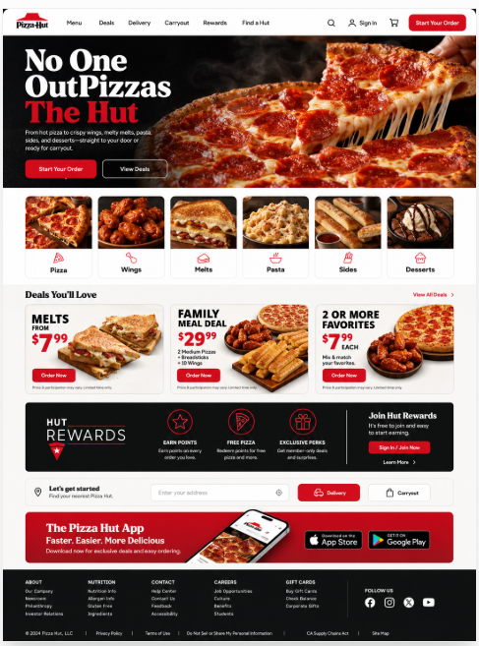
Figure 9: Pizza Hut USA Website Homepage
Source: (Pizza Hut USA, 2026).
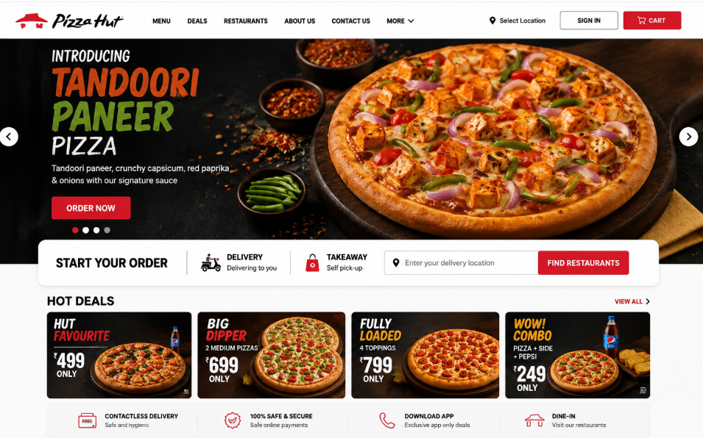
Figure 10: Pizza Hut India Website Homepage
Source: (Pizza Hut India, 2026).
Marketing-Mix Similarities and Differences
Pizza Hut simplifies its name, logo, pizza at its heart, food-safety expectations, digital ordering, and localizes its menus, vegetarian options, pricing, promotions, restaurant designs and dining moments. This balance is a good one to have, but it is important to consider the contribution margin, number of repeat purchases, satisfaction of customers and consistency with the franchise as measures of adaptation, not just sales or outlet numbers.

2.4 Pizza Hut’s Market-Entry Strategy in India
Background of Entry
Pizza Hut first came to India in 1996 with its first restaurant in Bangalore, India being the first Indian Pizza chain to open up (Restaurant India, 2021). The initial idea was not to have it all about deliveries; it was restaurant-led, and with a lot of local operating expertise it helped to introduce an international dining experience. Devyani International's association with Pizza Hut started in 1997 when they opened an outlet in Jaipur, and was expanded with full-service Pizza Hut outlets as well as smaller delivery restaurants (Devyani International, 2021).
Entry Method or Methods
Pizza Hut's main approach to entry and expansion in India has been through the technologies it has used, and the agreement it has had with local operators for the Pizza Hut and Domino's trademarks. Devyani International and Sapphire Foods invest in their restaurants, employees and operations under Yum approved agreements and Pizza Hut's brand, format, systems, and IP. Devyani's disclosure illustrates that each outlet has a contract defining the menu structure, the pricing, certain marketing aspects, how the outlets will be supplied and the quality standards (Devyani International, 2021). The model can thus be said to be a ‘controlled franchising' as opposed to ‘uncontrolled licensing'.
Justification for the Entry Method
Franchising was appropriate since it was found that India was large and small in size, has a diverse culture and administration. Local franchisees bring their own knowledge about site selection, recruitment, knowledge of local regulations, relationships with local suppliers and market knowledge, along with a reduction in direct capital exposure and sharing of operating risks by Yum. The model has also enabled pizza hut to scale fast: Pizza Hut has achieved 500th Indian restaurant in 2021 and Devyani alone has 630 Pizza hut outlets by March 2025 (Restaurant India, 2021; Devyani International, 2025). Consistency is protected at the same time as trademarks are under central control, the systems are approved and are under control, and the approved suppliers are under control.
Advantages and Disadvantages
The benefits are that it expands quicker, requires less investment from the franchisor and provides the ability to leverage local capability in the embedded area. Franchisees are allowed to customize promotions and restaurant designs, and utilize a proven operating system. But it leaves agency and coordination issues as the model may cause the customer experience to vary between operators and territories. In 2025, Devyani International and Sapphire Foods simply stopped advertising in common areas and reportedly saw a decline in transactions when they disagreed on shared advertising in common areas, highlighting the negative impact of split decisions on one brand (ETHospitalityWorld, 2025). Other restrictions may apply to franchisees flexibility including continuing fees and advertising contributions and approval from Yum (Devyani International, 2021). Growth can turn into a negative value when governance, quality of services or the economics of the outlet are low.
Overall Evaluation
To distribute the necessary local knowledge, the pace of expansion and sharing the risk was an appropriate balance for Franchising. It is still acceptable but Pizza Hut needs to improve the level of governance, service audits, data sharing and territorial co-ordination for joint campaigns. Going forward, same-store sales, contribution margin and customer consistency should be focused on, not store numbers. The advertising disagreement illustrates how critical it will be that the franchisees are united on a national level by a consistent strategy and by common performance indicators as well as quicker dispute resolution.

2.5 Balanced Ethical Evaluation of Pizza Hut’s Marketing Mix in India
Virtue ethics considers marketing based on its ethical attributes as revealed by organisational decision making, not just the law. The marketing mix of Pizza Hut India can be evaluated on the basis of its integrity, fairness, trust, respect and empathy and transparency. Integrity, fairness, trust, respect and transparency are suitable bases for the Pizza Hut India's marketing mix evaluation (Murphy, 1999).

Table 1: Virtue Ethics and Marketing
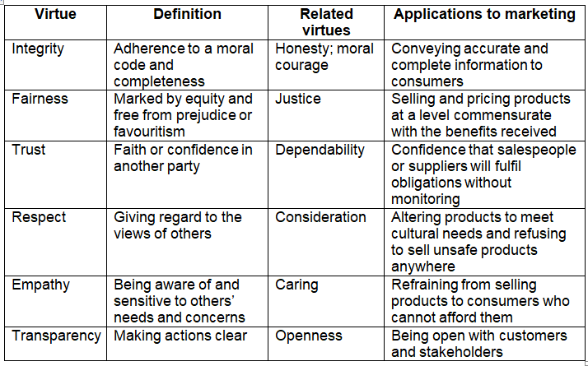
Source: Adapted from Murphy (1999, p. 113).
The first one of the ethical marketing is related to the product element. Respect and empathy is shown in Pizza Hut's vegetarian menu and locally adapted paneer, tandoori and vegetable based products and their way of catering to religious, dietary and cultural preferences of Indians. This localization can foster the international brand's connection with the local stakeholders (Poulis, 2024). But this practice is still considered ethical as long as the vegetarian ingredients, methods of preparation and potential risks of cross-contamination are accurately communicated.
The second ethical instance is about the price and the product information. Clear prices and promotional conditions, ingredient details, allergen information and nutritional labelling promote integrity, fairness and transparency, allowing consumers to make informed choices. Advantages of menu labelling include the ability to enhance awareness of calorie content and diet quality, but the impact of menu labelling on improving these outcomes is diminished when health information is not as prominent as promotional information (Jia et al., 2023).
The first unethical marketing concern is related to promotion. But, digital campaigns and indulgent offers targeted at children and young people might not align with empathy and integrity, as food marketing can affect preferences, requests for food, and food consumption habits (Boyland et al., 2022). Pizza Hut should thus refrain from targeting the young at risk and high calorie foods.
The second issue has to do with physical evidence and process. Increased deliveries generate a significant volume of waste packaging that is used once and discarded. Without measurable reductions in emissions of plastics, food waste and packaging, respectively, a green claim would be misleading (Du Rietz and Kremel, 2024).
Overall, the Pizza Hut India is good at being culturally adaptable and providing information for consumers. In general, Pizza Hut India shows ethical qualities in cultural adaptation and providing information to consumers. However, it is still not ethically sound to promote to youth and there is a need to significantly improve the disclosure and delivery-packaging waste.

2.6 Recommendations for the United States and India
Recommendations for the United States
STP Recommendation: Pizza Hut needs to take a different approach to behavioural targeting to its health-conscious Gen Z and millennial shoppers. Loyalty, intuitive technology and speed are seen as repeat-purchase factors for 67% of Generation Z and 64% of millennials, respectively (National Restaurant Association, 2025). There should, therefore, be a part of the Pizza Hut offering re-packaged with a focus on “convenient enjoyment with informed choice.” Some of the ways this positioning can be achieved may include personal sized pizzas, toppings with more vegetables, and lighter side dishes and more noticeable nutritional information.
Marketing-Mix Recommendation: The Hut Rewards programme needs to be segmented based on the frequency of ordering, the preferred channel and basket composition. It should incentivize customers to buy directly and make more nutritious food choices, not just be about discounts. This behavioral personalisation can help build the value of the customer, improve customer satisfaction, and lessen reliance on third parties for delivery services (Kotler, Keller and Chernev, 2022). Physical evidence should be enhanced, as well, through the use of recyclable and tamper-evident packaging on Pizza Hut. Over half of Americans in off-premises (including 60% of Generation Z and millennials) are willing to pay more for packaging that ensures the quality of the food product is maintained (National Restaurant Association, 2025).
Ethical Improvement: Nutritional information should be prominently displayed, just like promotional prices. As food marketing can affect younger consumers' preferences and their food intake (Boyland et al., 2022), Pizza Hut should not promote high-calorie food aggressively aimed at youth. It should also set measurable packaging reduction targets and have a consistent level of employee and service quality at their franchise outlets.
Recommendations for India
STP Recommendation: Pizza Hut should target customers looking for a great value, which is young working professionals, health-conscious consumers, and carefully chosen tier-two cities not just simply stores. By March 2025 Devyani had a total of 630 Pizza-Hut outlets, though its contribution margin dropped from 7.2% to 2.7%, indicating a need for better unit economics to enable expansion and discounting. (Devyani International Limited, 2025)
Positioning and Brand-Extension Recommendation: Pizza Hut needs to firmly establish itself as “affordable international family dining with local relevance”. Limited Edition products with flavours known in the region could be encouraged through regional segmentation. Health-focused brand extensions might feature smaller servings, whole-grain crust choices, and more prominent vegetarian and allergenic details and calorie counts.
Marketing-Mix Recommendation: Not relying on too much permanent discounting should be replaced by region-specific bundles. The digital loyalty programme should be consolidated to incentivize repeat orders, family events and collections. Franchisees are also expected to adhere to the standard practices in terms of delivery, hygiene, handling complaints and service recovery.
Ethical Improvement: Pizza Hut India should limit mass appeal of youth-friendly promotion of indulgent bundles and enhance the nutritional disclosure, and also implement measurable requirements on packaging reduction in all Pizza Hut outlets of the chain (Jia et al., 2023; Du Rietz and Kremel, 2024).
Priorities and Implementation
The first focus should be India's franchise consistency and profitability followed by repositioning based on India's loyalty. Marketing teams in country, digital marketing and franchise operation teams should run 12-month pilot programs. Some key performance indicators are same-store sales, contribution margin, repeat-purchaser rate, direct-digital sales, complaints related to delivery, healthier-product sales and packaging reduction.

3. Section 2: Reflective Essay Using Gibbs’ Cycle
Gibbs’ Reflective Cycle
Gibbs' reflective cycle contains six stages: Description, feelings, evaluation, analysis, conclusion and action planning. I chose it because it takes people from remembrance of experience to challenge assumptions, review decision making and see how it could be better. It can therefore be used as a framework to reflect on an international marketing project (Bassot, 2023).
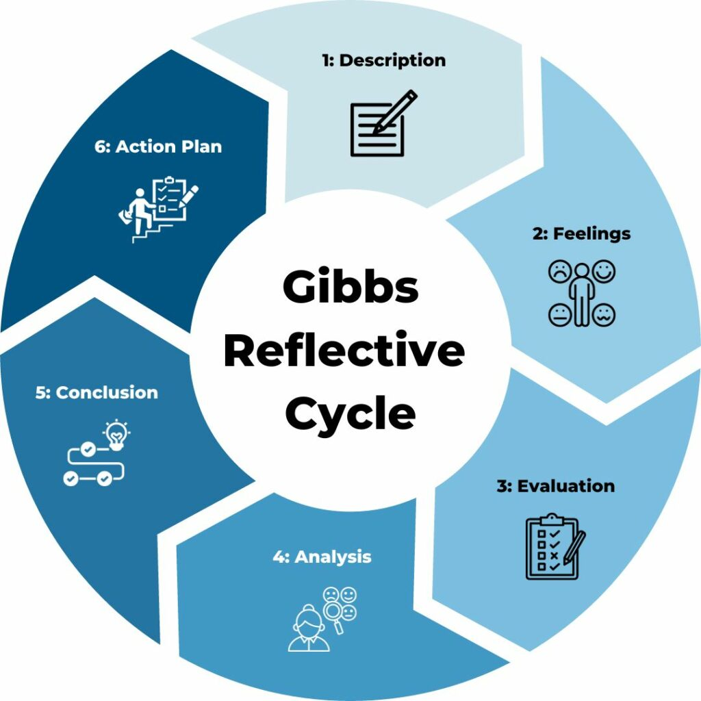
Figure 11: Gibbs’ Reflective Cycle (Channell, 2023)
Description
I conducted a research on Pizza Hut international marketing in the home market (USA) and host market (India). The countries were chosen due to the contrasting market context and to test international standardisation and adaptation to the local context. I used PESTLE, Hofstede, STP, extended 7Ps, market entry theory and virtue ethics. Books, journal articles, corporate reports and official websites and publications were used for evidence. The findings were then given as recommendations to Pizza Hut for each country.
Feelings
At first I was feeling confident as Pizza Hut is a known brand globally and information seemed to be widespread. What made me lose my faith was the conflicting numbers from stores, the cultural interpretations and different accounts of the first entry of Pizza Hut into India. The comparisons were also not something I could do with any surety without being forced to simplify one of the two countries compared. This was disheartening but I should be more judicious in my next claim and should take time to reflect on the authority, purpose and supporting evidence of the claim I want to use.
Evaluation
There are a number of things that went well. For the operational and financial data, corporate reports were used in addition to journal articles for evaluating the aspects of localisation, ethics and consumer behaviour. The direct USA–India comparison also helped to avoid the report being two disjointed country descriptions. But company sources often gave positive accounts and, sometimes, comparable figures were not available for both markets. In my initial notes, I had them listed by source instead of by argument which made some very similar arguments and slowed the synthesis. I also took too much time to gather wide-ranging PESTLE information and then narrow down to the ones that were strategically significant. Future research on how to integrate in the strongest way into the broader evidence base must not only consider a wide range of databases, but should also prioritize ones with the most extensive coverage and retrieval capabilities (Gusenbauer and Haddaway, 2020).
Analysis
Credibility is based on two factors authority of the source and suitability. Outlet numbers, sales mix and strategic initiatives sufficed for corporate reports, but were less apt at assessing shortcomings in ethics. Analysis of regulation, health and sustainability were stronger in journal articles and government publications. To this end, I triangulated key claims rather than assuming they were equally credible in my assessment of sources. This enhanced my ability to identify evidence-based arguments, from unsupported arguments, and examine the assumptions found in seemingly convincing arguments (Cottrell, 2023).
A comparison of the United States and India also had to be carefully made. National statistics were sometimes drawn from different definitions and measures and Hofstede's scores could only be national averages. PESTLE was helpful in providing a wide range of information but promoted description instead of making an obvious link to the decisions of the Pizza Hut. Likewise, the 7Ps structure the evidence, but did not automatically provide an explanation for the variations in strategies. I added a question around the focus on evidence to determine what it evidenced, why there was a difference between the markets, the strategic implication, and whether or not Pizza Hut's answer was effective.
I also learned the value of the decision making process of research being recorded. Detailed search strategies are hard to follow and reproduce due to poor reporting of them. It would have been great to be able to document my searching criteria and the rationale behind selecting items and including specific publication years.
Conclusion
I have come to understand that it's not enough to simply mechanically apply frameworks to international marketing analysis. The most valuable information were found when cultural, economic and regulatory evidence was linked to STP, marketing mix, market entry strategy. I could have created an evidence matrix sooner, and could have pre-emptively listed similar indicators before writing and have been clearer to distinguish between factual evidence and my own interpretations of it. My other weakness is to summarize complicated evidence without sacrificing the necessary depth. However, I was able to build up my skills in evaluating sources, in making cross country comparisons, and in synthesis and qualified judgement.

Action Plan
In future assignments I will start with a question based plan which will be directly related to the learning outcomes and marking criteria. I will use at least two academic databases to search and create a source matrix indicating each source's credibility, relevance, country focus, and contribution to the argument. I will note down search terms and dates and prioritise information that is directly comparable and identify gaps in information prior to drafting. Also, I will utilize reference-management software more systematically and make sure that each and every major claim is supported by an appropriate source. Once I have finished every section, I will evaluate whether or not there are comparison, explanation, limitation, alternative interpretation, and a justified judgement in that section. These activities should help to enhance the efficiency of my research, analytical depth, transparency and the overall quality of my academic output.

4. Conclusion
This report is a comparative study of Pizza Hut's international marketing in the United States and India. PESTLE and Hofstede analysis revealed that Indian customers need to be adapted more as they have low purchasing power, cultural diversity, vegetarianism and family consumption. The results found with STP suggested differentiated targeting, and localisation was found with the 7Ps with products, pricing, promotion and service delivery. The process of franchising helped India expand but needs a greater coordination. The company is somewhat culpable from an ethical standpoint. The USA should focus on convenience and loyalty to a healthier product while India should focus on the consistency of the franchise and the benefits of nutrition as well as profitability. Critical comparison and assessment of sources was reinforced through reflection.

5. References
Bashir, M. and Ansari, Z.A. (2025) ‘Maestro Pizza: Disrupting the pizza business model in Saudi Arabia’, Emerging Economies Cases Journal, 7(1), pp. 41–46.
Bassot, B. (2023) The Reflective Practice Guide: An Interdisciplinary Approach to Critical Reflection. 2nd edn. Abingdon: Routledge.
Boyland, E., McGale, L., Maden, M., Hounsome, J., Boland, A., Angus, K. and Jones, A. (2022) ‘Association of food and nonalcoholic beverage marketing with children and adolescents’ eating behaviours and health: A systematic review and meta-analysis’, JAMA Pediatrics, 176(7), article e221037.
Channell, M. (2023). Gibbs Reflective Cycle – a practical guide. [online] TSW Training. Available at: https://www.tsw.co.uk/insights/gibbs-reflective-cycle/ (Accessed: 1 August 2026).
Chartered Institute of Personnel and Development (CIPD) (2025) ‘PESTLE analysis’. Available at: https://www.cipd.org/en/knowledge/factsheets/pestle-analysis-factsheet/ (Accessed: 1 August 2026).
Cottrell, S. (2023) Critical Thinking Skills: Effective Analysis, Argument and Reflection. 4th edn. London: Bloomsbury Academic.
Crowjack (2026). A Simple and Elaborative Guide for Conducting PESTLE Analysis. [online] Crowjack. Available at: https://crowjack.com/guide/pestle-guide (Accessed: 1 August 2026).
Devyani International Limited (2021) Draft Red Herring Prospectus. New Delhi: Devyani International Limited. Available at: https://www.sebi.gov.in/filings/public-issues/may-2021/devyani-international-limited_50136.html (Accessed: 1 August 2026).
Devyani International Limited (2024) Annual Report 2023–24: Resilient Today, Refreshed Tomorrow. Available at: https://dil-rjcorp.com/wp-content/uploads/2024/06/annual-report-2023-24.pdf (Accessed: 1 August 2026).
Devyani International Limited (2025) Annual Report 2024–25. Available at: https://dil-rjcorp.com/wp-content/uploads/2025/07/annual-report-2024-25.pdf (Accessed: 1 August 2026).
Domino’s India (2026) Domino’s India: Menu and ordering platform. Available at: https://www.dominos.co.in/ (Accessed: 1 August 2026).
Du Rietz, S. and Kremel, A. (2024) ‘Consumer behavior as a challenge and opportunity for circular food packaging: A systematic literature review’, Circular Economy and Sustainability, 4(1), pp. 413–438.
Economic Times Hospitality World (ETHospitalityWorld) (2023) ‘Pizza Hut to continue aggressive expansion spree, to focus on emerging smaller markets: Merrill Pereyra’, 17 July. Available at: https://hospitality.economictimes.indiatimes.com/news/restaurants/pizza-hut-to-continue-aggressive-expansion-spree-to-focus-on-emerging-smaller-markets-merrill-pereyra/101814788 (Accessed: 1 August 2026).
Economic Times Hospitality World (ETHospitalityWorld) (2025) ‘Franchisee ad row hurting sales: Sapphire CEO’, 10 May. Available at: https://hospitality.economictimes.indiatimes.com/news/restaurants/franchisee-ad-row-hurting-sales-sapphire-ceo/121049694 (Accessed: 1 August 2026).
Economic Times Retail (ETRetail) (2024) ‘Pizza Hut targeting young demographic in India; focus on value offerings’, 30 March. Available at: https://retail.economictimes.indiatimes.com/news/food-entertainment/food-services/pizza-hut-targeting-young-demographic-in-india-focus-on-value-offerings/108588914 (Accessed: 1 August 2026).
Eightception (2020). 7Ps of the Marketing Mix - Comprehensive Marketing Strategy Framework. [online] Eightception. Available at: https://eightception.com/7ps-of-the-marketing-mix/ (Accessed: 1 August 2026).
Government of India (2023) The Digital Personal Data Protection Act, 2023. New Delhi: Ministry of Law and Justice. Available at: https://www.meity.gov.in/static/uploads/2024/06/2bf1f0e9f04e6fb4f8fef35e82c42aa5.pdf (Accessed: 1 August 2026).
Government of India (2024) Plastic Waste Management (Amendment) Rules, 2024. New Delhi: Ministry of Environment, Forest and Climate Change. Available at: https://moef.gov.in/storage/tender/GSR201%28E%29-%5B14032024%5D-Plastic-Waste-Mangement-Rules-2024.pdf (Accessed: 1 August 2026).
Gusenbauer, M. and Haddaway, N.R. (2020) ‘Which academic search systems are suitable for systematic reviews or meta-analyses? Evaluating retrieval qualities of Google Scholar, PubMed and 26 other resources’, Research Synthesis Methods, 11(2), pp. 181–217.
Jia, J., Van Horn, L., Linder, J.A., Ackermann, R.T., Kandula, N.R. and O’Brien, M.J. (2023) ‘Menu calorie label use and diet quality: A cross-sectional study’, American Journal of Preventive Medicine, 65(6), pp. 1069–1077.
Komisarof, A. and Akaliyski, P. (2025) ‘New developments in Hofstede’s Individualism–Collectivism: A guide for scholars, educators, trainers, and other practitioners’, International Journal of Intercultural Relations, 107, article 102200. Available at: https://doi.org/10.1016/j.ijintrel.2025.102200 (Accessed: 1 August 2026).
Kotler, P., Keller, K.L. and Chernev, A. (2022) Marketing Management. 16th edn. Harlow: Pearson.
La Pino’z Pizza (2026) La Pino’z Pizza: Menu and ordering platform. Available at: https://lapinozpizza.in/ (Accessed: 1 August 2026).
Murphy, P.E. (1999) ‘Character and virtue ethics in international marketing: An agenda for managers, researchers and educators’, Journal of Business Ethics, 18(1), pp. 107–124.
National Restaurant Association (2025) Off-Premises Restaurant Trends 2025. Washington, DC: National Restaurant Association. Available at: https://restaurant.org/research-and-media/research/research-reports/off-premises-restaurant-trends-2025/ (Accessed: 3 August 2026).
Pizza Hut (2024) ‘Pizza Hut unveils new Chicago Tavern-Style Pizza and toppings transformation with biggest toppings menu overhaul in over a decade’, 18 June. Available at: https://blog.pizzahut.com/pizza-hut-unveils-new-chicago-tavern-style-pizza-and-toppings-transformation-with-biggest-toppings-menu-overhaul-in-over-a-decade/ (Accessed: 10 August 2026).
Pizza Hut (2026) ‘Pizza Hut Menu’. Pizza Hut USA. Available at: https://www.pizzahut.com/c/content/menu (Accessed: 10 August 2026).
Pizza Hut (2026) Pizza Hut US: Delivery, deals and Hut Rewards. Available at: https://www.pizzahut.com/ (Accessed: 1 August 2026).
Pizza Hut India (2026) ‘About Pizza Hut’. Available at: https://m.pizzahut.co.in/aboutus (Accessed: 1 August 2026).
Pizza Hut India (2026) ‘Our Menu’. Pizza Hut India. Available at: https://www.pizzahut.co.in/menu (Accessed: 10 August 2026).
Pizza Hut India (2026) ‘Pizza Hut India: Official website’. Available at: https://www.pizzahut.co.in/ (Accessed: 10 August 2026).
Poulis, K. (2024) ‘Standardization and adaptation as a coconstituted process: The pursuit of relational fit in international markets’, Journal of International Marketing, 32(2), pp. 12–32.
Restaurant Business (2025) ‘Pizza Hut’, Technomic Top 500 Chain Restaurant Report 2025. Available at: https://www.restaurantbusinessonline.com/top-500-chains-2025/pizza-hut (Accessed: 10 August 2026).
Restaurant India (2021) ‘Pizza Hut opens 500th store in India, plans aggressive expansion in next five years’, 29 July. Available at: https://www.restaurantindia.in/news/pizza-hut-opens-500th-store-in-india-plans-aggressive-expansion-in-next-5-years.n19912 (Accessed: 1 August 2026).
Reuters (2024) ‘Pizza Hut India operator posts biggest profit drop yet on slow demand, piling costs’, 10 May. Available at: https://www.reuters.com/business/retail-consumer/pizza-hut-india-operator-sapphire-misses-q4-profit-view-slow-demand-2024-05-10/ (Accessed: 1 August 2026).
Telecom Regulatory Authority of India (TRAI) (2024) The Indian Telecom Services Yearly Performance Indicators 2023–2024. New Delhi: TRAI. Available at: https://www.trai.gov.in/sites/default/files/2024-09/Report_14082024.pdf (Accessed: 1 August 2026).
The Culture Factor Group (2025) ‘Country comparison tool’. Available at: https://www.theculturefactor.com/country-comparison-tool (Accessed: 1 August 2026).
Wirtz, J. and Lovelock, C. (2022) Services Marketing: People, Technology, Strategy. 9th edn. Hackensack, NJ: World Scientific. Available at: https://doi.org/10.1142/y0024 (Accessed: 1 August 2026).
World Bank (2025) ‘Data for India and the United States’. Available at: https://data.worldbank.org/?locations=IN-US (Accessed: 1 August 2026).
Yum! Brands (2024) Annual Report 2024. Louisville, KY: Yum! Brands, Inc. Available at: https://investors.yum.com/financial-information/financial-reports/ (Accessed: 1 August 2026).
Yum! Brands (2025) ‘Introducing Byte by Yum!: An AI-driven restaurant technology platform powering customer and team member experiences worldwide’, 6 February. Available at: https://investors.yum.com/news-events/financial-releases/news-details/2025/Introducing-Byte-by-Yum-an-AI-Driven-Restaurant-Technology-Platform-Powering-Customer-and-Team-Member-Experiences-Worldwide/default.aspx (Accessed: 1 August 2026).

