Database Management Systems

  - Name: Sarann Strange

Student Number: 1701763

University of wales Trinity saint David

Stream: B.Sc. Software engineering

Module number: ACCA5014

Table of Contents
1 Table of Contents 1
2 Table of figures 2
3 Introduction 3
4 Performance tuning 4
4.1 Queries 4
4.2 Secondary indexes 5
4.2.1 Account 5
4.2.2 Account subscription 5
4.2.3 Rental 5
5 Distributed database solution 6
5.1 Fully replicated fragmented relation 7
5.2 Bike 8
5.3 Account 10
5.4 Station 12
5.5 Rental 14
5.6 RentalBike 16
5.7 AccountSubscription 19
6 Conclusion 21
7 References 22

Table of figures
Figure 1 Original Tariff rate table 7
Figure 2 Original City table 7
Figure 3 Original Bike table not fragmented 8
Figure 4 Bike table fragment 1 8
Figure 5 Bike table fragment 2 8
Figure 6 Bike table fragment 3 9
Figure 7 Bike table fragment 4 9
Figure 8 Bike table fragment 5 9
Figure 9 Account table not fragmented 10
Figure 10 The vertical Account table fragment 1 10
Figure 11 The vertical Account table fragment 2 10
Figure 12 Account table fragment 2.1 11
Figure 13 Account table fragment 2.2 11
Figure 14 Account table fragment 2.3 11
Figure 15 Account table fragment 2.4 11
Figure 16 Account table fragment 2.5 11
Figure 17 Station table not fragmented 12
Figure 18 Station table fragment 1 12
Figure 19 Station table fragment 2 12
Figure 20 Station table fragment 3 13
Figure 21 Station table fragment 4 13
Figure 22 Station table fragment 5 13
Figure 23 Rental table not fragmented 14
Figure 24 Rental table fragment 1 14
Figure 25 Rental table fragment 2 15
Figure 26 Rental table fragment 3 15
Figure 27 Rental table fragment 4 15
Figure 28 Rental table fragment 5 15
Figure 29 RentalBike table not fragmented 16
Figure 30 The vertical RentalBike table fragment 1 16
Figure 31 The vertical RentalBike table fragment 2 17
Figure 32 ReturnStation table fragment 2.1 17
Figure 33 ReturnStation table fragment 2.2 17
Figure 34 ReturnStation table fragment 2.3 17
Figure 35 ReturnStation table fragment 2.4 17
Figure 36 ReturnStation table fragment 2.5 18
Figure 37 Joined AccoutnSubscription Table and CityCode table before fragmentation 19
Figure 38 AccountSubscription table fragment 1 19
Figure 39 AccountSubscription table fragment 2 19
Figure 40 AccountSubscription table fragment 3 20
Figure 41 AccountSubscription table fragment 4 20
Figure 42 AccountSubscription table fragment 5 20

Introduction
The report discusses the operations involved in data manipulation, what indexes are, and the ones chosen for cycles to share to improve the efficiency of the database.
The distributed database solution is a method of fragmentation of data into separate tables that are stored on different systems at different locations, these are used to improve a database and examples of this for cycles to share can be found within this report. The different fragmentation methods are analysed and used on the cycles to share database to improve its functionality and to meet the requirements set by the cycles to share company. Finally, examples of the methods on how to reconstruct the fragments to view the original tables and the data are evaluated within the report.

Performance tuning

Queries
There are four operations used for data manipulation they include create/insert which is used to input new data into a database table, read/select which is used to select data held within database table, update which is used to alter data that is already present within the database and delete which is used to permanently delete data from the database tables.
Each time a query is read it searches through the entire tables that are called within the query to carry out its operation, this takes time to carry out if the database contains large quantities of data, and to accelerate the queries indexes are implemented [1]. Indexes provide order to allow queries to search specific areas of the database, enhancing the performance of the database as queries can run faster and perform faster lookups [2][3][4].
An index is a copy of the columns that have been selected from a chosen table, there are many types of indexes three examples include non-clustered, clustered this is when data is sorted in either ascending or descending order and cluster is when a number of database and tables are joined to create an index they are related by linking primary and foreign keys[5] [6].
When creating indexes, it is imperative to avoid columns that are likely to be updated frequently, as the efficiency will be reduced, and overheads are likely to occur as the order of an index must be recalibrated for the updating of data[7] [8][5].
‘if the workload contains many insert/update/deletes then some indexes can have a negative impact on performance because they need to be maintained.’ [7] PP17
Gerhard Weikum, Arnd Christian Konig, Achim Kraiss et al.

Columns within the bike and rental bike tables will alter frequently as bikes are returned and rented, within the bike table the status column of the bike will continually alter between vacant, occupied or in-repair, while in the rental bike table the comments and the rental dates of bikes have the potential of being updated and altered requiring constant recalibration if they were indexed causing an overhead.

Tables that do not hold many records of data should not be secondary indexed as they are not large enough to benefit from the speed improvement, there would be additional writes and storage to hold the index, therefor it would not be benefiting the speed of the queries to outweigh the cost for storing or creating the index [8].
There are only 5 columns within the tariff rate table if it is updated it will only hold a limited amount of data, the city table also holds a limited number of columns although it will not be updated regularly due to it limited data it would be inefficient to index either of the tables.

Secondary indexes
The station table could have been indexed as the columns have the potential to be queried frequently and are not updated regularly, the other tables were indexed as they will potentially be queried at a higher rate and hold more data than the station table, there for it was more valuable to index those tables instead.

Account
The account tables Surname, FirstName and DateOfBirth have been indexed, users of the account may request information from their account and may not know their unique AccountId but will know their own personal information that would be used in a query that uses the surname, FirstName and DateOfBirth of the user to find the accountId that can be used in further queries to find more data that is requested.
CREATE INDEX AccountIndex ON Account (Surname ASC, FirstName ASC, DateOfBirth ASC)

Account subscription
The AccountSubscription table’s AccountNo and SubscriptionType have been indexed as many records and large quantities of data will be stored within this table. The company would not delete the gathered data but keep it for their records for as long as they are able, therefore the table will contain a large quantity of data.
The account subscription table would rarely be edited when an existing account user wish to alter their account subscription, a new account subscription is created and stored in the table for that account. Having the AccountNo and SubscriptionType indexed improves the queries that want to identify the most popular subscription types and if account users are still active or changing to another account type, this information can provide valuable insight of the subscriptions that are most popular and the number of currently active account subscriptions, due to the large quantity of data that will be held within this table it is vital that it can be accessed quickly.
CREATE INDEX AccountSubscriptionIndex ON AccountSubscription (AccountNo ASC, SubscriptionType ASC)

Rental
The Rental table’s AccountNo and RentalNo are indexed as the rental table will be queried frequently. An example of such a query can be seen within the database under the transaction section, the index for the rental table will be useful within this scenario as shown in figure 1 the AccountNo is being queried in the if condition, other queries such as this may be used on the rental table there for having it indexed improves the performance of the database.
CREATE INDEX RentalIndex ON Rental (AccountNo ASC, RentalNo ASC)

Distributed database solution
When a small business expands such as cycles to share they may require more branches that are situated in different locations to function and carryout tasks, these branches require data specific to their role within the company [9], therefore the original database structure that previously met the needs of the business requires alterations such as a distributed database management system [10].
A distributed database management system is a system that has split or copied the data held within a database across multiple sites [11] [12] [13]. The DDBMS can either be replicated were the database is copied across all sites which requires constant updating if the data is altered within one site or it can be fragmented across the different locations.
When the database is fragmented the specific data is split across the different sites that require access to it, making the system more efficient as the sites are not holding unnecessary data or trying to access data from sites that are far away which causes an overhead [14].
There are various methods of fragmenting; horizontal fragmentation is dividing the tables by the tuples or rows allowing for individual segments of data that have specific values to be separated and distributed as they are needed [15][16][17].
Vertical fragmentation is separating entire columns of data that are known as site or set, each of the sites must have at least one column the same as another for instance the primary key, this is required to reform the table to make it whole again [17] the mixed fragment is used when the vertical and the horizontal fragmentation is not enough, the mixed fragment consists of both a vertical fragment and a horizontal fragment. The derived fragment is used when two or more tables are required at the same site, but they have been fragmented at different locations, the derived fragmentation must follow the constraints of the original tables.

Fully replicated fragmented relation
For the City table and the tariff rate table it would be more costly to fragment these tables as they do not hold a large amount of data and are rarely updated or altered there for the City table as seen in figure 2 and the tariff rate table as seen in figure 1 will be replicated across all databases.

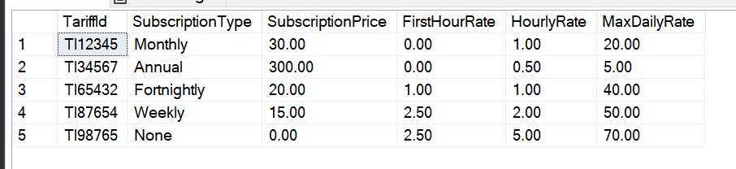
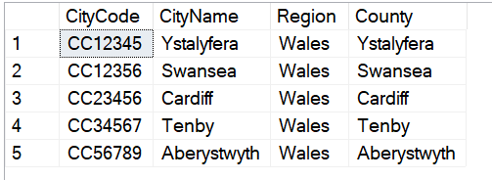
Figure 1 Original Tariff rate table
Figure 2 Original City table

Bike
The bike table would be horizontally fragmented as the different stations require access to the bikes within their own stations while not requiring the bike information from other stations. Figure 3 is the table before it is fragmented.
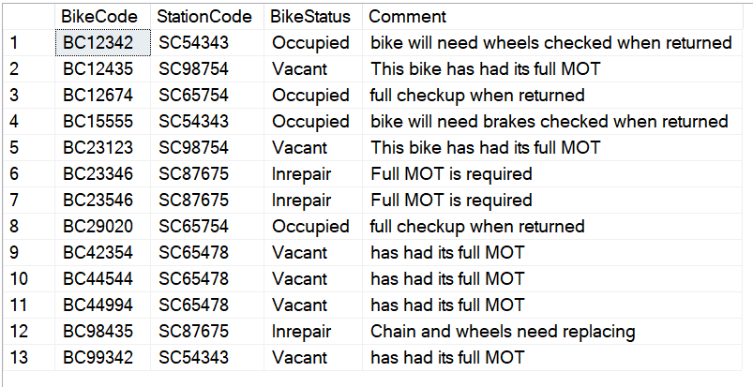
Figure 3 Original Bike table not fragmented

The images below represent the bike table after it is fragmented horizontally using the different station codes.

Bike₁: σ_{StationCode = 'SC98754'} (Bike)
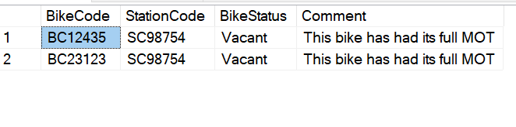
Figure 4 Bike table fragment 1

Bike₂: σ_{StationCode = 'SC65478'} (Bike)
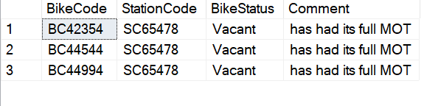
Figure 5 Bike table fragment 2

Bike₃: σ_{StationCode = 'SC65754'} (Bike)
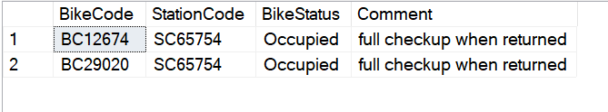
Figure 6 Bike table fragment 3

Bike₄: σ_{StationCode = 'SC54343'} (Bike)
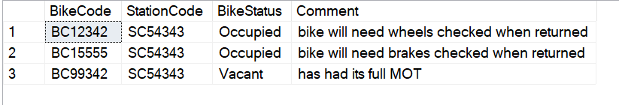
Figure 7 Bike table fragment 4

Bike₅: σ_{StationCode = 'SC87675'} (Bike)
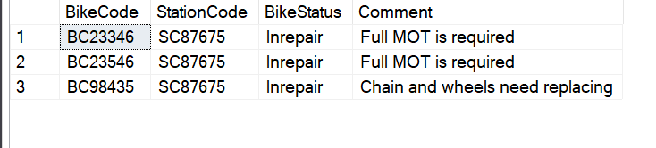
Figure 8 Bike table fragment 5

The fragments that have been configured using the StationCode are complete as all the columns are present within Bike1, Bike2, Bike3, Bike4, Bike5 as seen in figure 4, 5, 6, 7, 8.
To reconstruct the fragments back to the original table within figure 3 all the individual fragments must be brought together as a UNION e.g. UNION: BikeTable = Bike1 ∪ Bike2 ∪ Bike3 ∪ Bike4 ∪ Bike5.

Account
Cycles to Share has requested that their finance department who process and handle all payments of accounts be situated at the head office in Swansea while the other information is fragmented for HR therefore the Account table were all the columns that hold the financial data must be fragmented vertically to accommodate this request while all other data will first be vertically fragmented to HR and then horizontally fragmented to the different city stations. Figure 9 displays the Account table prior to it being fragmented.
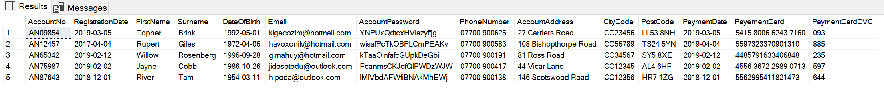
Figure 9 Account table not fragmented

The images below represent the account table after it is fragmented vertically to separate the financial data from the other personal data.

Account₁: Π AccountNo, PaymentDate, PaymentCard, PaymentCard (Account)
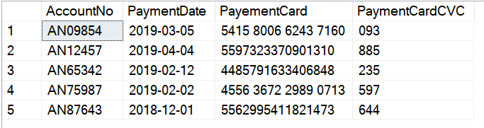
Figure 10 The vertical Account table fragment 1

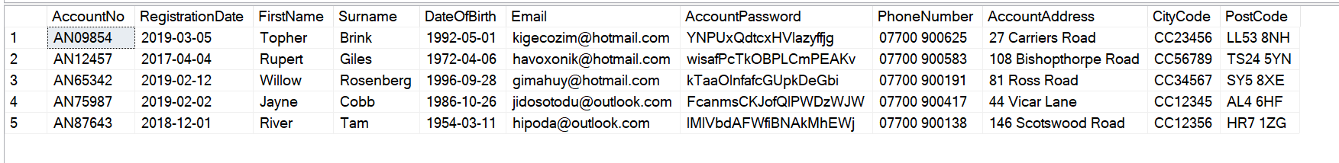
Account₂: Π AccountNo, RegistrationDate, FirstName, Surname, DateOfBirth, Email, AccountPassword, PhoneNumber, AccountAddress, CityCode, PostCode (Account)
Figure 11 The vertical Account table fragment 2

Acc2 should be horizontally fragmented as the different stations require access to the accounts within their own cities while not requiring the bike information from other stations.
Account_{2.1}: σ_{CityCode = 'CC23456'} (Account2)
Figure 12 Account table fragment 2.1

Account_{2.2}: σ_{CityCode = ‘CC56789’} (Account2)
Figure 13 Account table fragment 2.2

Account_{2.3}: σ_{CityCode = ‘CC34567’} (Account2)
Figure 14 Account table fragment 2.3

Account_{2.4}: σ_{CityCode = ‘CC12345’} (Account2)
Figure 15 Account table fragment 2.4

Account_{2.5}: σ_{CityCode = ‘CC12356’} (Account2)
Figure 16 Account table fragment 2.5

The vertical fragments that have been configured within figure 10 and 11 are complete as all the columns are present.
To reconstruct the fragments back to the original table within figure 9 all the individual fragments must be brought together as a Union and Join.
Original Account table = Account1 ⋈ (Account2.1 ∪ Account2.2 ∪ Account2.3 ∪ Account2.4 ∪ Account2.5).

Station
The station table would be horizontally fragmented using the different city codes as the different cities will have many stations within them. The cities only require the station codes of the stations within the city boundaries as those cities will likely query the information of stations to identify information such as the number of sales made within a city or the popular times of year that individuals choose to rent bikes, this information can be used by the business to increase productivity and improve marketing or establish if an additional shop within that city’s boundaries would be beneficial.
The stations would be fragmented between the different city codes as it allows for an easier expansion if new stations are added to the database as the single city fragment would require updating rather than the full database.
Figure 17 displays the Station table prior to it being fragmented.
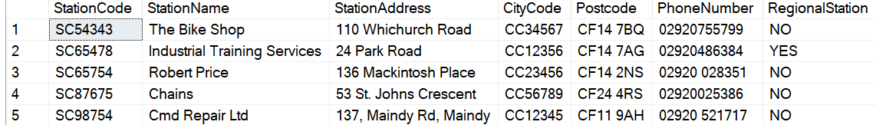
Figure 17 Station table not fragmented

The images below represent the station table after it is fragmented horizontally using the different city codes.

Station₁: σ_{CityCode = 'CC23456'} (Station)
Figure 18 Station table fragment 1

Station₂: σ_{CityCode = 'CC56789'} (Station)
Figure 19 Station table fragment 2

Station₃: σ_{CityCode = 'CC34567'} (Station)
Figure 20 Station table fragment 3

Station₄: σ_{CityCode = 'CC12345'} (Station)
Figure 21 Station table fragment 4

Station₅: σ_{CityCode = 'CC12356'} (Station)
Figure 22 Station table fragment 5

The fragments that have been configured using the CityCode are complete as all the columns are present within Station1, Station2, Station3, Station4, Station5 as seen in figure 18, 19, 20, 21, 22.
To reconstruct the fragments back to the original table within figure 17 all the individual fragments must be brought together as a UNION e.g. UNION: StationTable = Station1 ∪ Station2 ∪ Station3 ∪ Station4 ∪ Station5.

Rental
Individual stations do not require the information on the rentals from other stations, therefore the rental table will be fragmented horizontally by the PickUpStation as the pickup stations require the data of the accounts that are coming to collect the bike from their station as well as the booking date and time as the account users come to collect their bikes from the stations, the receptionist will use the information to allocate the correct bike using the rental number to the correct user. Figure 23 displays the Rental table prior to it being fragmented.
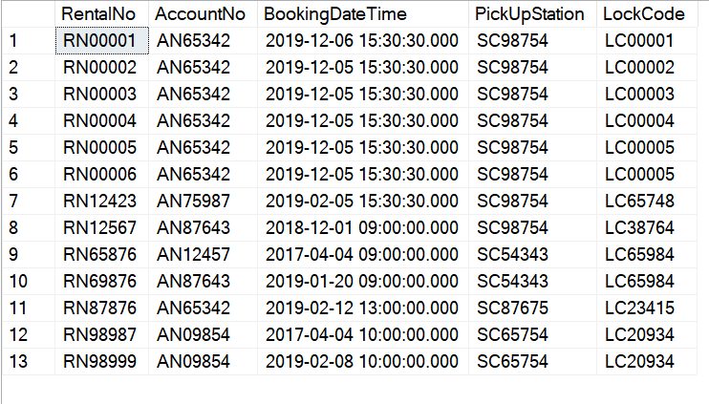
Figure 23 Rental table not fragmented

The images below represent the Rental table after it is fragmented horizontally using the different PickUpStation codes.

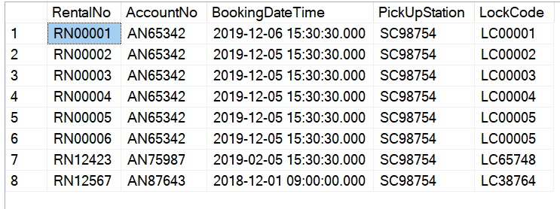
Rental₁: σ_{PickupStation = ‘SC98754’} (Rental)
Figure 24 Rental table fragment 1

Rental₂: σ_{PickupStation = ‘SC54343’} (Rental)
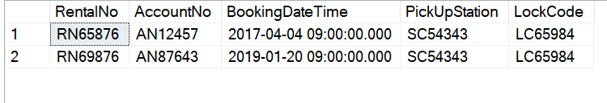
Figure 25 Rental table fragment 2

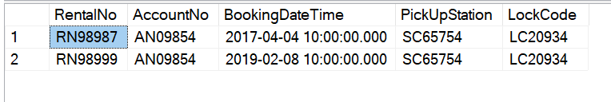
Rental₃: σ_{PickupStation = ‘SC65754’} (Rental)
Figure 26 Rental table fragment 3

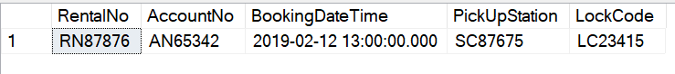
Rental₄: σ_{PickupStation = ‘SC87675’} (Rental)
Figure 27 Rental table fragment 4

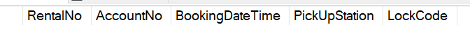
Rental₄: σ_{PickupStation = ‘SC87675’} (Rental)
Figure 28 Rental table fragment 5

The fragments that have been configured using the StationCode are complete as all the columns are present within Rental1, Rental2, Rental3, Rental4, Rental5 as seen in figure 24, 25, 26, 27, 28.
To reconstruct the fragments back to the original table within figure 23 all the individual fragments must be brought together as a UNION e.g. UNION: RentalTable = Rental1 ∪ Rental2 ∪ Rental3 ∪ Rental4 ∪ Rental5.

RentalBike
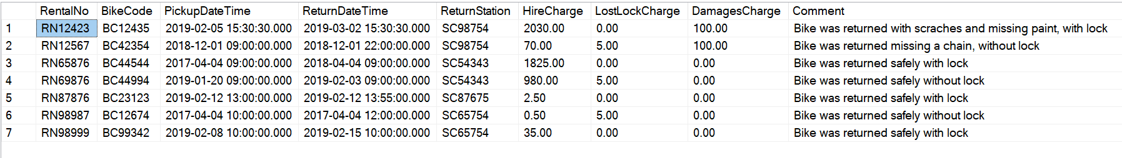
As stated within the Account 5.3 section all finances will be carried out at the main branch in Swansea therefore the financial information within the RentalBike table must be vertically fragmented to Swansea while all other data must be vertically fragmented to the administrative/customer support and then that data must be horizontally fragmented to all of the individual branches as each branch only requires the administrative/customer support information for their individual branch. The image within figure 29 represent the rental bike table prior to its fragmentation.
Figure 29 RentalBike table not fragmented

The images within figure 30 and 31 represent the RentalBike table after it is fragmented horizontally using the different PickUpStation codes. Both the RentalNo and the BikeNo must be included within both fragments as it is a composite key and both codes combined make a unique key for the rental bike table.

RentalBike₁: Π RentalNo, BikeCode, HireCharge, LostLockCharge, DamagesCharge (RentalBike)
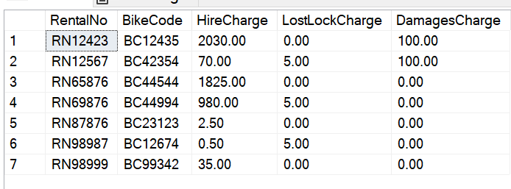
Figure 30 The vertical RentalBike table fragment 1

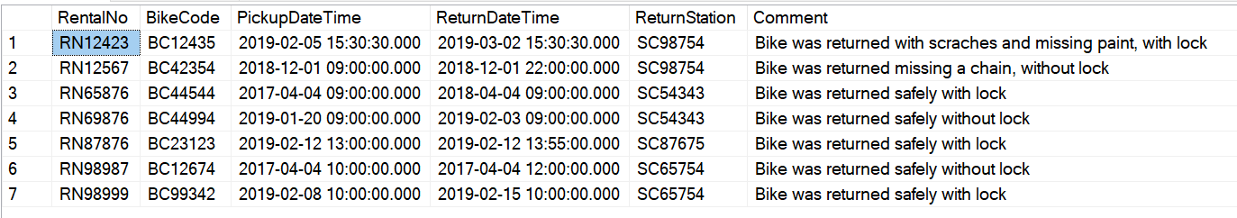
RentalBike₂: Π RentalNo, BikeCode, HireCharge, LostLockCharge, DamagesCharge (RentalBike)
Figure 31 The vertical RentalBike table fragment 2

RentalBike _{2.1}: σ_{ReturnStation = ‘SC98754} (RentalBike2)
Figure 32 ReturnStation table fragment 2.1

RentalBike _{2.2}: σ_{ReturnStation = ‘SC54343} (RentalBike2)
Figure 33 ReturnStation table fragment 2.2

RentalBike _{2.3}: σ_{ReturnStation = ‘SC87675’} (RentalBike2)
Figure 34 ReturnStation table fragment 2.3

RentalBike _{2.4}: σ_{ReturnStation = ‘SC65754’} (RentalBike2)
Figure 35 ReturnStation table fragment 2.4

RentalBike _{2.5}: σ_{ReturnStation = ‘SC65478’} (RentalBike2)
Figure 36 ReturnStation table fragment 2.5

The vertical fragments that have been configured within figure 30 and 31 are complete as all the columns are present.
To reconstruct the fragments back to the original table within figure 29 all the individual fragments must be brought together as a Union and a Join.
Original RentalBike table = RentalBike1 ⋈ (RentalBike2.1 ∪ RentalBike2.2 ∪ RentalBike2.3 ∪ RentalBike2.4 ∪ RentalBike2.5).

AccountSubscription
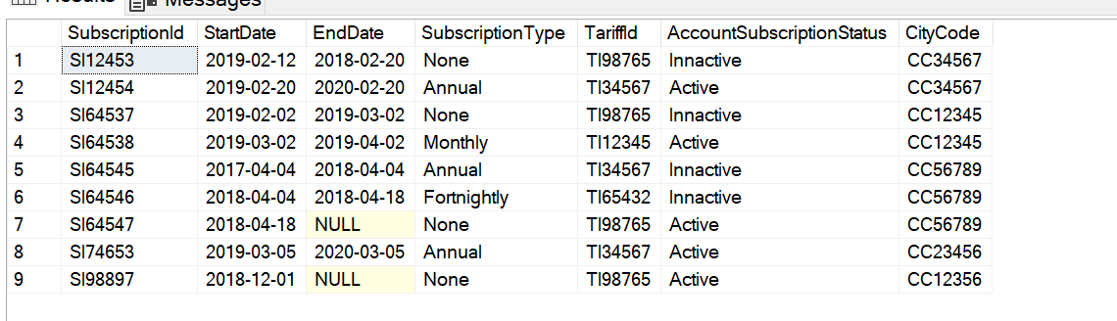
The AccountSubscription table needs to be fragmented horizontally across the different cities locations to accompany the account tables original fragments, as stated within the account section only specific city’s require accounts that reside within them and will not require access to all accounts, to do this the CityCode is needed from the account table. To gain access to the CityCode the AccountSubscription must be joined to the Account table. The AccountSubscription and the Account are joined using an inner join on their respective AccountNo fields and are then horizontally fragmented this is known as derived fragmentation were one table derives its fragmentation from another.
Figure 37 Joined AccoutnSubscription Table and CityCode table before fragmentation

The images below represent the AccountSubscription table after it has been joined and then fragmented horazontaly using the CityCodes.

AccountSubscription₁ = AccountSubscription ⊳CityCodeNo AccountSubscription_{2.1} (AccountSubscription_{2.1} is a horizontal fragment CityCode=CC23456)
Figure 38 AccountSubscription table fragment 1

AccountSubscription₂ = AccountSubscription ⊳CityCodeNo AccountSubscription_{2.2} (AccountSubscription_{2.2} is a horizontal fragment CityCode=CC56789)
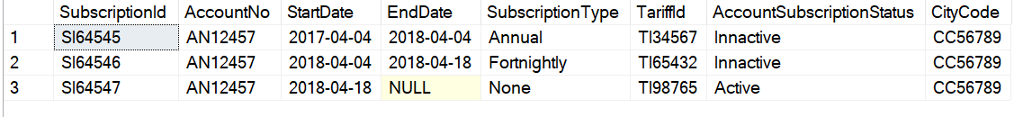
Figure 39 AccountSubscription table fragment 2

AccountSubscription₃ = AccountSubscription ⊳CityCodeNo AccountSubscription_{2.3} (AccountSubscription_{2.3} is a horizontal fragment CityCode=CC34567)
Figure 40 AccountSubscription table fragment 3

AccountSubscription₄ = AccountSubscription ⊳CityCodeNo AccountSubscription_{2.4} (AccountSubscription_{2.4} is a horizontal fragment CityCode=CC12345)
Figure 41 AccountSubscription table fragment 4

AccountSubscription₅ = AccountSubscription ⊳CityCodeNo AccountSubscription_{2.5} (AccountSubscription_{2.5} is a horizontal fragment CityCode=CC12356)
Figure 42 AccountSubscription table fragment 5

The horazontal fragments that have been configured within figures 38, 39, 40, 41, 42 are complete as all the rows are present.

To reconstruct the fragments back to the original table within figure 37 all the individual fragments must be brought together as a Union.
UNION: AccountSubscription = AccountSubscription1 ∪ AccountSubscription2 ∪ AccountSubscription3 ∪ AccountSubscription4 ∪ AccountSubscription5.

Conclusion
The report successfully identified secondary indexes and implemented forms of performance tuning for the account table, account subscription table, rental table and a restriction on users renting more than 6 bikes at any given time was implemented and tested.
Each of the tables were analysed and a distributed database solution was designed and implemented according to the various methods of fragmenting e.g. horizontal, vertical, derived, mixed and none. Both the city and tariff table were none fragmented, the bike, station and rental tables were all horizontally fragmented, the account and the rentalbike tables were both mix while the account subscription table is a derived fragmentation that uses an inner join with the Account table.

References

[1] D. Colley and C. Stanier, “Identifying New Directions in Database Performance Tuning,” Procedia Comput. Sci., vol. 121, pp. 260–265, 2017.
[2] D. Shasha and P. Bonnet, Database Tuning : Principles, Experiments, and Troubleshooting Techniques. Elsevier, 2002.
[3] G. Weikum, A. Moenkeberg, C. Hasse, and P. Zabback, “Self-tuning Database Technology and Information Services: from Wishful Thinking to Viable Engineering.”
[4] A. N. K. Chen, “Robust optimization for performance tuning of modern database systems,” 2004.
[5] J. L. Harrington, “Database Structure and Performance Tuning,” in Relational Database Design, Elsevier, 2009.
[6] S. Agrawal, S. Chaudhuri, and V. Narasayya, “Automated Selection of Materialized Views and Indexes for SQL Databases.”
[7] D. B. Lomet, A. El Abbadi, S. Chaudhuri, D. Kossmann, and A. K. Rundensteiner, Elke, Gerhard Weikum, Arnd Christian Konig, “Data Engineering Special Issue on Self-Tuning Databases and Application Tuning,” Massachusetts Avenue Washington, D.C, 1999.
[8] S. Chaudhuri and V. Narasayya, Self-Tuning Database Systems: A Decade of Progress. .
[9] Gene Pang, “Title Scalable Transactions for Scalable Distributed Database Systems,” 2015.
[10] U. Tosun, “Distributed Database Design: A Case Study,” Procedia Comput. Sci., vol. 37, pp. 447–450, 2014.
[11] P. Liu and X. Hao, “EFFICIENT DAMAGE ASSESSMENT AND REPAIR IN RESILIENT DISTRIBUTED DATABASE SYSTEMS,” 2002.
[12] P. Beynon-Davies, “Distributed Database Systems,” in Database Systems, London: Macmillan Education UK, 1996, pp. 107–115.
[13] Geeksforgeeks, “Distributed Database System - GeeksforGeeks,” 2019. [Online]. Available: https://www.geeksforgeeks.org/distributed-database-system/. [Accessed: 25-Mar-2019].
[14] M. T. Özsu and P. Valduriez, Principles of distributed database systems, 2nd ed. Prentice Hall, 1999.
[15] C. I. Ezeife and K. Barker, “A comprehensive approach to horizontal class fragmentation in a Distributed Object Based System,” Distrib. Parallel Databases, vol. 3, no. 3, pp. 247–272, Jul. 1995.
[16] S. Ceri, S. Navathe, and G. Wiederhold, “Distribution Design of Logical Database Schemas,” IEEE Trans. Softw. Eng., vol. SE-9, no. 4, pp. 487–504, Jul. 1983.
[17] M. Tamer¨ozsu, T. Tamer¨ozsu, and P. Valduriez, “Distributed and Parallel Database Systems,” 1996.

marking criteria and Student FEEDBACK

This section details the extent to which the assessment criteria are demonstrated by you, which in turn determines your mark. The marks available for each category of skill are shown. Lecturers will use the space provided to comment on the achievement of the task(s), including those areas in which you have performed well and areas that would benefit from development/improvement.

Common Assessment Criteria Applied (Assignment 1) | Marks available | Marks  awarded
1. Engagement with Literature Skills

A wide-range of appropriate, reference sources have been consulted. (Grade mark: 100.00%) | 5 | 5
2. Knowledge and Understanding Skills

A very good range of queries to create sample data for the database has been provided with additional, appropriate queries to test the constraints added to the tables. A fair attempt at the transaction with some sample data to test it, but unfortunately your logic is not quite correct. The table you need to check is the RentalBike table as this is the table that stores the bikes taken out on each rental. As such, your transaction does not work. (Grade mark: 80.00%) | 20 | 16
3. Cognitive and Intellectual Skills

Excellent analysis to determine secondary indexes to create and the chosen indexes are very good and appropriate. The case study has been very well analysed for the distributed design strategy with a very good solution proposed and clear justifications for your solution. You have also clearly shown how the global relations can be reconstructed. See your report for some additional comments. (Grade mark: 86.67%) | 30 | 26
4. Practical Application Skills

An excellent attempt. Just a few minor things to note. RegionalStation in the station table is just a field to indicate if this is the region's main station office and would probably work best as a BIT field and some cards have a CVC number with 4 characters. (Grade mark: 90.00%) | 40 | 36
5. Transferable Skills for Life and Professional Practice

The report is well-written and presented. (Grade mark: 80.00%) | 5 | 4

Assignment Mark (Assessment marks are subject to ratification at the Exam Board. These comments and marks are to give feedback on module work and are for guidance only until they are confirmed. ) | Late Submission Penalties (tick if appropriate) |  | 87%
 | Up to 1 week late (40% Max) |  | 87%
 | Over 1 week late (0%) |  | 87%

