
password
Applied Computing

Wales Institute of Science and Art (WISA)

Networks and Cybersecurity Essentials (ACCA4024)

Lab 7: Tools to check on Threats and Vulnerabilities



n.kaliyamurthy@uwtsd.ac.uk 1

Objectives
Using Packet Capturing tools and network monitoring tools.
Tasks
1. Use Nmap to scan 2.
Required Resources
- PC with Ubuntu 16.0.4 LTS installed in a VirtualBox or VMware virtual machine. (Alternatively, Any Linux Platform)
- Internet Connection to refer the outcomes o References: https://nmap.org/

Task 1
- Login as User Cisco.
- Go to Terminal and Type the following commands and examine o To do that we are using Nmap.
▪ Network Mapper, or Nmap, is an open source utility used for network discovery and security auditing. Administrators also use Nmap for monitoring hosts or managing service upgrade schedules. ▪ Nmap determines
        - what hosts are available on a network,
        - what services are running,
        - what operating systems are running, • What packet filters or firewalls are running?
o So, basically if you could get all the above details using Nmap, you could get few information which could be used later in performing attacks or mitigating attacks.

- Commands to execute o Step 1:
▪ nmap localhost
(This is a scan performed to get information about the services that are bound to the localhost)
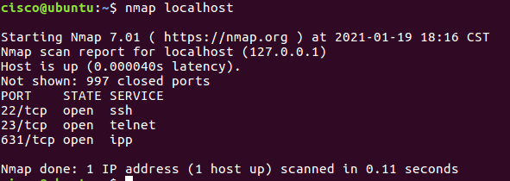

o Step 2:
▪ Replace the above command with your IP Address and other hosts (if connected/ else ignore) in your network to check the outcomes.
Type the command you used to find out your host IP Address
“ipconfig /all”
Type the command you used to scan after finding your host IP Address
Nmap 192.168.0.1
Record the outcomes of the above command here
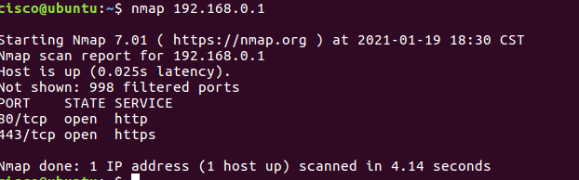

o Step 3: Analyse the outputs/outcomes from Step 1 and 2 and record your reflections. (Hint: Analyse what is the difference between local host and ip address of the host, If ports displayed are different, Why is it different? etc (not limited to the hints))
The first noticeable difference is that the IP addresses of the host and local host are different. This is because the local host is displaying the address of the loopback adapter in the pc. Meanwhile 192.168.0.1 is the laptops IP address. There is also a considerable difference in latency which shows that the localhost is much faster.
Another difference between local host and host is that local host displays 997 closed ports meanwhile the host displays that 998 filtered ports. I believe this is be due to the hosts firewall blocking the packets which display this information causing it to display as filtered instead of closed.

- Step 4: Why is the nmap scan only scans the first 1000 ports? What will be the command to scan all the ports?
nm
The command would be “Nmap -p- 192.168.0.1”

- Step 5: Scan the UDP Ports
    - nmap –sU localhost
(This is a scan performed to get information about the UDP ports and to execute this command you need root privileges. So, try)
    - sudo nmap –sU localhost
Record the outcomes of the above command here (Hint: what UDP ports could you find open through your scan)

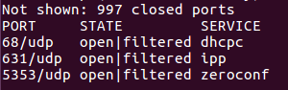
The ports shown are different to the first time scanned as they are UDP ports. The port state has now also changed from open to filtered.
- Step 6: From the above outcomes select any ports which is open
▪ sudo nmap –p137 localhost
(Change the port number 137 to any port which you found as open in the previous step (5).)
Record the outcomes of the above command here (Hint: Is the port open or closed? Why? Also, record the use of –p command)
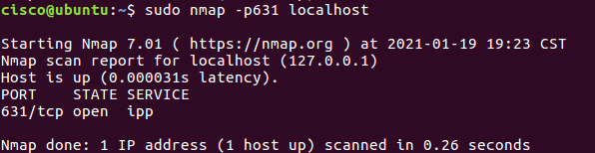
When I checked the nmap of the port 631 it showed as open in both results. This is because the command is specifying the same port meaning the result would be the same.

- Step 7: Try other port related commands and record its purpose.
    - sudo nmap –pportnumber host_ip
    - sudo nmap –pportnumber_startrange-portnumber_endrange host_ip
    - sudo nmap –pportnumber,portnumber host_ip
    - not limited to the above (Do a google search, refine your search and find out other port related commands, Hint:nmap.org)
Record the outcomes of the above commands here
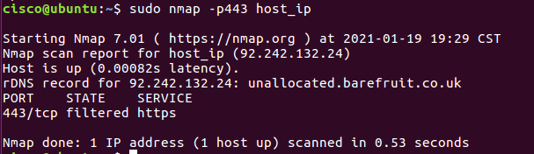
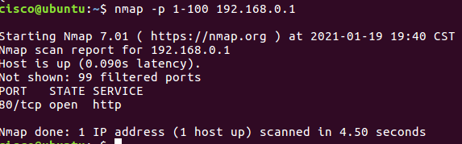
This command shows the range of ports that you ask for so if you ask for ports 1-100 it will display those ports for the user.
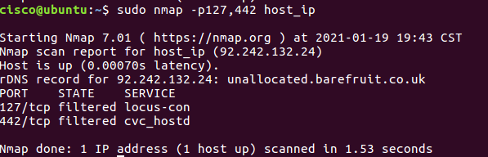

This shows the user the ports which have been input in this case port 127 and 442

- Step 8: Detecting the version is a very important part of information gathering. Try to find out the version. ▪ nmap –sV localhost
Record the outcomes of the above commands here
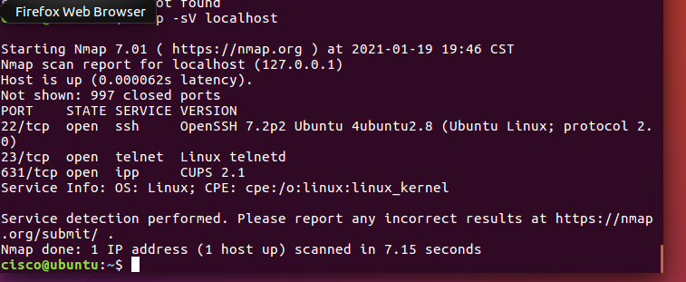

- Step 9: Try other commands to detect other versions and record its purpose.
      - Command to identify the Operating System version:
lsb_release -a
Record the outcomes of the above commands here

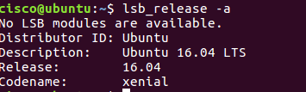
It shows the operating system version under description and also release.

      - Command to identify the Service Version
Record the outcomes of the above commands here
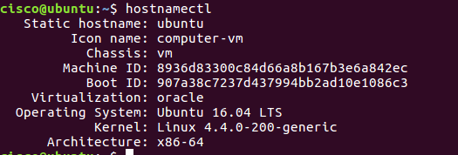

Learnings from tutorials so far:
Part 1 (Packet Tracer, Host Machines)
  - Build a home Network
  - Understand and configure IP Address
  - Use Ping/ Trace route Utility to check the connection status
  - Use ipconfig /all command to determine the MAC address of a Windows computer on an Ethernet network.
  - Analyze a MAC address to determine the manufacturer.
  - Analyze the Wired and Wireless Network connection.
  - Analyze Address Resolution Protocol (ARP).
  - Connect to a Wireless Router and configure the basic settings in a wireless router and add security features.
  - Use nslookup command to understand the url to ip conversion.
  - Configure basic connectivity settings in Intermediate devices (Switch/ Router).
  - Work with SBA Packet Tracer Files/ environment
  - Configure ftp, web, email, dns, ntp and aaa Servers Part 2
  - Set up a virtual lab environment
  - Troubleshooting the virtual lab environment
  - Working with virtual machines
  - Authentication, Authorization and Accounting
  - Threats and Vulnerabilities – Using NMAP

