Virtual Learning Environment-The impact of Moodle on students

Name- Lucian Pavlov
Student id- 1921482

Table of Contents
INTRODUCTION 2
Secondary research 2
Primary Research 3
CONCLUSION 12
REFERENCES 13

INTRODUCTION
Virtual learning environment (VLE) is a web-based platform that helps within educational institutions. Through this, teachers provide resources, activities and interactions to their students which in turn help them for different stages of assessment. The present study assists to develop a good understanding about VLE by conducting primary and secondary study. The aim of the study is to determine the learning experience at University of Wales Trinity Saint London Campus and this in turn improves the overall performance.

Secondary research
Alves, Miranda and Morais (2017) explain their views that VLE is offered to both students and teachers such that students allow them to benefit from self- paced learning and offer opportunity to learn new skills without any issues. That is why it is used by mostly students which in turn improve the overall performance. Hence, it is a learning experience which is enhanced through utilizing computers as well as the Internet from both outside and inside from an educational organization. Therefore, it is examined by Bogusevschi, Muntean and Muntean (2020) that VLE exhausts students and minimizes the social differences between students that raise the learning experience. Actually there are any issues generated within the classroom, but VLE enables students to bring new and full selves to the virtual classroom.
There are many benefits of using any software such that it increases inclusivity, accessibility and maintains the community relationship as well. Hence, it is clearly reflected that with the help of an effective virtual learning environment, students present their immediate feedback and provide comfort to the students which in turn improves the results in a positive manner. Boulton, Kent and Williams (2018) supported by stating that with the help of Moodle, a student enhances their technical skills and maintains community and relationship building which in turn provide a broader view that helps to examine the result. Also many findings from the secondary study clearly reflected that it enhances the learning by offering instant feedback which in turn helps to take responsibility for their own and also motivated them to correct the same as well.
Carlotta Olivetti and et.al., (2020) explain in their own way that online learning sources assist to share expertise which in turn help people to get more access to education which is not readily available in different locations. So, it is explained that it provides a new opportunity to meet their defined aim and generate better opportunities as well. Also, due to this pandemic, every student analyzes the importance of online learning because due to lockdown, most of the students start learning through online mode which in turn develop strong interpersonal skills and meet the defined aim. Chui and et.al., (2020) develop their views that new models of learning are always springing up in the market and that is why, it encourages people to start using the online which in turn generate the best outcomes and develop a good understanding among all as well. Hence, it is clearly reflected that there is a both positive and negative impact of using online sessions such that most of the students have to improve their interpersonal skills and time management skills which in turn improve the results in a positive manner. Otherwise it will affect the overall results in an adverse manner that sometimes it causes social isolation as well.

Primary Research
To conduct the primary research, 20 students are selected from University of Wales Trinity Saint David London Campus and this in turn helps to analyze the results. With the help of this study, scholars develop an understanding which assists to meet the defined aim and analyze the impact of VLE on student’s learning experience at University.
Theme 1: Majority of the respondents are familiar with the Moodle

 | Respondents
Extremely Familiar | 2
Very Familiar | 4
Somewhat familiar | 11
Not so familiar | 1
Not at all familiar | 2

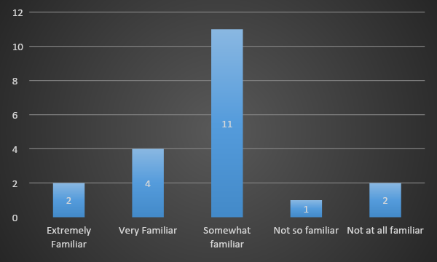
Interpretation: In accordance with the graphs and responses from respondents, it is interpreted that majority of the respondents are somewhat familiar with Moodle. Such that due to COVID-19, all the Universities prefer to offer online sessions to their students and this in turn let them understand about the Moodle. Hence, with the help of VLE, students get a new platform that assists to enhance their learning experience and raise their learning skills as well. As out of 20, 11 stated that they are somewhat familiar, while 4 of them are very familiar, but only 2 of them stated that they are extremely familiar and not at all familiar.
Theme 2: Learning through Moodle is more useful
 | Respondents
Extremely useful | 11
Very useful | 5
Somewhat useful | 1
Not so useful | 2
Not at all useful | 1

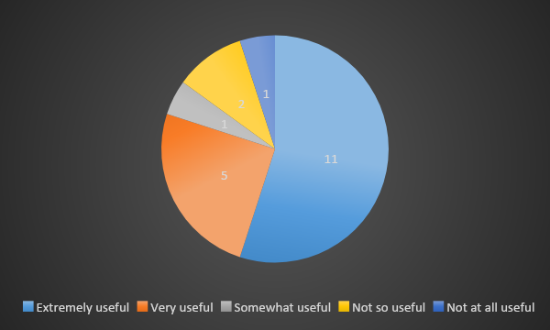
Interpretation: Majority of the respondents completely agree with the statement such that out of 20, 11 stated that they are extremely useful, while 5 of them stated that Moodle is very useful and only 1 of them stated that it is not at all useful. Hence, it is clearly reflected that with the help of Moodle, student’s learning is improved. Khlaisang and Songkram (2019) supported that with the help of Moodle, teachers deliver a powerful set of learner- centric tools along with a collaborative learning environment due to its flexibility and scalability. Hence, this provides a strong learning environment to students in this pandemic time which did not affect their overall performance.

Theme 3: Yes, Moodle is available anytime, everywhere
 | Respondents
Yes | 18
No | 2

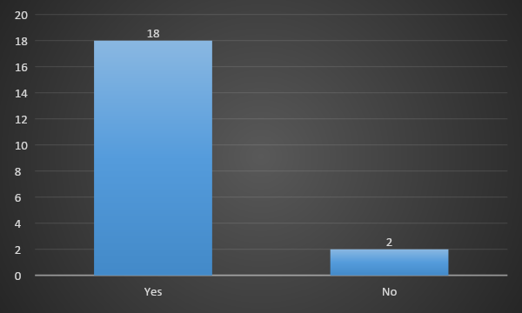
Interpretation: Through the above table, it is interpreted that Moodle is a learning platform that is especially designed for educators, administrators and learners with a single robust and this in turn provides a secured learning environment as well. Such that out of 20 students, 18 agree that Moodle can be used somewhere and anytime, while 2 of them did not agree. Hence, it is analyzed that this platform assists educators and students to learn from everywhere and at any time and it is also considered as a personalized learning environment that assists to meet the defined aim and get the best learning experience as well.

Theme 4: Respondents can easily upload documents in Moodle
 | Respondents
Strongly agree | 9
Agree | 5
Neither agree nor disagree | 1
Disagree | 3
Strongly disagree | 2

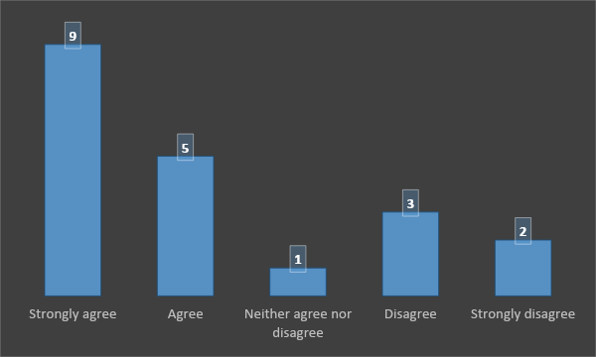
Interpretation: Through the table, it is analyzed that the majority of the respondents highly agree with the statement that students can upload their documents through this and it is far easier to use as compared to other software. Out of 20, 9 are highly agreed, while 5 of them agree and 3 disagree with the statement that they cannot upload the documents. Hence, Melissa Ng Lee Yen (2020) also shared their views and stated Moodle is a great learning platform that engages content with a variety of resources and activity types in order to learn new things in a single platform. Such that they upload their homework and contact tutor in order to exactly determine their performance level easily.

Theme 5: Majority of the respondent’s do not know that audio files are uploaded in Moodle
 | Respondents
No | 2
I don't know | 11
Yes | 7

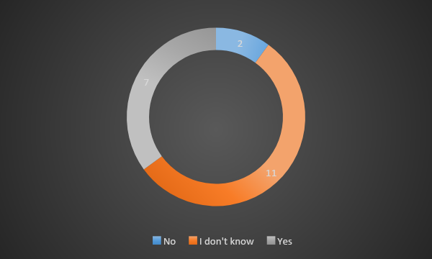
Interpretation: There are many benefits which a student gets from Moodle, but some of the students are not well-know, how to use this software. Out of 20 respondents 11 did not know about how to upload the audio in Moodle and only 7 stated yes. On the other side, 2 of them stated no and this reflected that students are not well aware of the things and that is why, students are easily able to access course material through their online account. So, it is examined to provide a better experience to their students in order to learn new things.

Theme 6: Yes, PPT usually attach on Moodle
 | Respondents
Always | 4
Usually | 9
Sometimes | 2
Rarely | 3
Never | 2

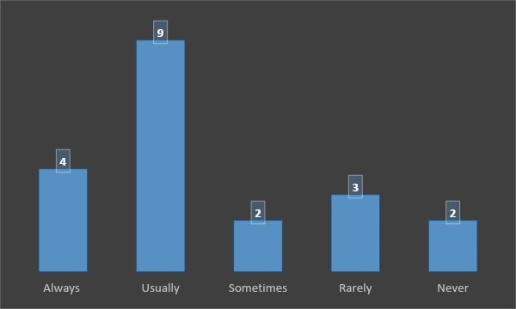
Interpretation: Yes, Power Point is also attached on Moodle because it is an online learning software where students easily access course material and this in turn helps to analyze the performance. Also, most of the respondents are usually (9) agree with the statement, while 4 of them are stated that they may easily attach PPT and 2 of them stated sometimes and 3 are stated rarely. Hence, it is clearly reflected that with the selected software, students generate different opportunities and offer great learning experience to the educator and students easily.

Theme 7: Yes, things are very easily edited in Moodle
 | Respondents
Very Easy | 8
Easy | 5
Neither easy nor difficult | 2
Difficult | 3
Very difficult | 2

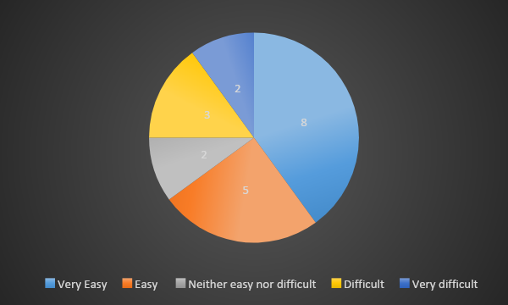
Interpretation: As per the above table, it is interpreted that the majority of the students are stated that they can easily edit things in Moodle and save the same. But once the work of students was uploaded they did not edit the same. Therefore, 8 of them stated that they very easily edit it, while 2 of them neither say easy nor say difficult and 2 stated that it is very difficult to edit the things Phungsuk, Viriya Ejakul and Ratanaolarn (2017) share their views and stated that it is offer learning experience and students sometimes did not edit the things easily in Moodle because it is protected by some important keys which is not shared by anyone.

Theme 8: Students are disagree with the statement that students can hide course
 | Respondents
Strongly agree | 2
Agree | 5
Neither agree nor disagree | 3
Disagree | 8
Strongly disagree | 2

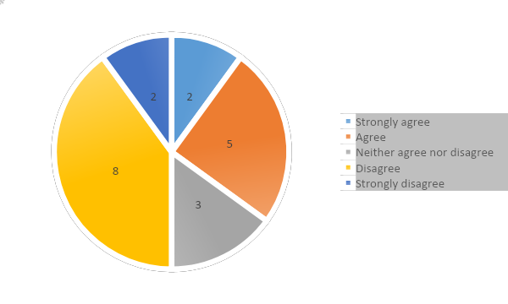
Interpretation: As per the above table, it is interpreted that students cannot hide sections of a course from others and reveal one at a time because it is not easy for them. Hence, out of 20, 8 completely disagree and 2 of them strongly agree and only 3 stated that they neither disagree nor agree with the same. Ryan and Poole (2019) explain in their study that students have a right to attend the classes and collect information which is uploaded by any professional. Hence, neither of them can hide any section but educators and professionals have the same right.

Theme 9: Online learning helped greatly lately
 | Respondents
Strongly agree | 11
Agree | 7
Neither agree nor disagree | 1
Disagree | 1
Strongly disagree | 0
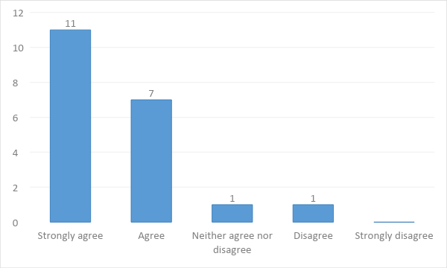

Interpretation: Yes, online learning helps the students to raise their learning experience. Such that out of 20, 11 are highly agree and 7 of them are agree, but 1 of them are disagree. Hence, it is examined that online learning is flexible and any student can anytime attend the class from anywhere which is not possible in other classes. Therefore, Yang and et.al., (2018) supported that it is one of those methods which is a cost effective method and many students take some time from busy schedules in order to meet their defined aim which in turn is accessible by everyone at any time.

Theme 10: Moodle is very likely recommended to someone else.
 | Respondents
Very likely | 7
Likely | 5
Neither Likely nor unlikely | 3
Unlikely | 2
Very Unlikely | 3

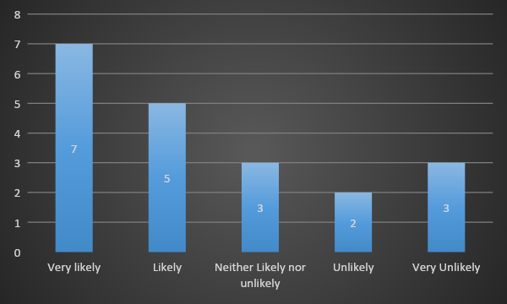
Interpretation: Through the above table, it is interpreted that the majority of the students recommended others in order to use this platform for learning purposes. It is so because it helps others to meet the defined aim and improve student’s interpersonal skills as well. Moreover, 7 out of 20 are very likely to recommend others to use this learning software, while 5 of them stated likely and 3 of them stated neither likely nor unlikely. Hence, it is clearly reflected that the online classes will assist to meet the defined aim and further enhance their abilities as well.

CONCLUSION
By summing up above it has been concluded that Virtual Learning environments provide a great access to their students which in turn offer a strong learning environment. Such that study has concluded online study is more convenient and cheaper than traditional education. As secondary study clearly reflected that this provides a great opportunity to students during this pandemic time where each and every state is locked down. On the other side, primary research has also concluded that with the help of an effective online learning environment, students may learn new things and as per their flexibility they easily manage the work and attend the classes which in turn improve the overall performance as well.

REFERENCES
Books and Journals
Alves, P., Miranda, L. and Morais, C., 2017. The Influence of Virtual Learning Environments in Students' Performance. Universal Journal of Educational Research. 5(3). pp.517-527.
Bogusevschi, D., Muntean, C. and Muntean, G.M., 2020. Teaching and Learning Physics using 3D Virtual Learning Environment: A Case Study of Combined Virtual Reality and Virtual Laboratory in Secondary School. Journal of Computers in Mathematics and Science Teaching. 39(1). pp.5-18.
Boulton, C.A., Kent, C. and Williams, H.T., 2018. Virtual learning environment engagement and learning outcomes at a ‘bricks-and-mortar’university. Computers & Education. 126. pp.129-142.
Carlotta Olivetti, E. and et.al., 2020. Engagement Evaluation in a Virtual Learning Environment via Facial Expression Recognition and Self-Reports: A Preliminary Approach. Applied Sciences. 10(1). p.314.
Chui, K.T. and et.al., 2020. Predicting at-risk university students in a virtual learning environment via a machine learning algorithm. Computers in Human Behavior. 107. p.105584.
Khlaisang, J. and Songkram, N., 2019. Designing a virtual learning environment system for teaching twenty-first century skills to higher education students in ASEAN. Technology, Knowledge and Learning. 24(1). pp.41-63.
Melissa Ng Lee Yen, A., 2020. The influence of self-regulation processes on metacognition in a virtual learning environment. Educational Studies. 46(1). pp.1-17.
Phungsuk, R., Viriyavejakul, C. and Ratanaolarn, T., 2017. Development of a problem-based learning model via a virtual learning environment. Kasetsart Journal of Social Sciences. 38(3). pp.297-306.
Ryan, E. and Poole, C., 2019. Impact of Virtual Learning Environment on Students’ Satisfaction, Engagement, Recall, and Retention. Journal of medical imaging and radiation sciences. 50(3). pp.408-415.
Yang, D. and et.al., 2018. An emotion recognition model based on facial recognition in virtual learning environment. Procedia Computer Science, 125. pp.2-10.
Online
Benefits of online Learning. 2020. [Online]. Available through: < https://www.ccaurora.edu/programs-classes/online-learning/benefits-online-education>.

