

Managing Change
  - Airbnb trips
Caoimhe McNulty | Managing Change within Tourism Organizations | 21/11/2017

Table of Contents
Introduction 2
Recognising the Need/Opportunity for Change 3
The Change Process 3
The planned approach 3
Lewin’s three step model 4
Bullock and batten’s phases of change 4
Kotter’s eight step model 5
Organisational change 6
Management vs Leadership 6
Resistance 7
Stakeholders 8
Conclusion 8
Appendix 10
Appendix 1 10
Appendix 2 11
Appendix 3 12
Appendix 4 13
Appendix 5 14
Appendix 6 14
Appendix 7 15
Appendix 8 15
Bibliography 16

Introduction
Airbnb is a home sharing platform where hosts rent out any spare space in their homes or apartments to guests who are visiting their town/city. It can range from renting their sofa as a place to sleep to a spare bedroom to even a whole property. It is totally down to the host as to how much of their property they wish to rent out and for how long. First founded in 2008, the service has been around for 9 years and has grown to become one of the biggest accommodation providers in the world competing with world class hotels that have been around for centuries like the Hilton. In 2015 it was even named the world’s largest hotelier after 15 million stays had been booked through the site since 2008 (Midgley, 2015).
However, in November 2016 Airbnb launched its newest product ‘Trips’. This addition regenerates the product offering a lot more to the user. There are three new components added to the site, Experiences, Places and Home. So now not only can you book an accommodation rental, you can book experiences, which includes city tours peer reviews and recommendations and meeting with locals. This is a way to get the Airbnb guests immersed in the local community. The new development also introduces Places. Places gives users a new series of guidebooks put together by the local hosts giving the guests recommendations on what they would do and places they would go, as appose to any traditional tourist hotspots. Places also debuted audio walks, which is the partnership between Airbnb and Detour. This will allow the guests to listen to the audio logs while they travel, learning about different parts of the city they are exploring as they travel through it. Places also has a MeetUps function which allows Airbnb users to meet up with each other easily. Another function called Near By allows users to see a map of the local area, tap on any attraction and be giving community curated information advice and tips. The most recent development under places is the introduction to restaurant reservations. You can now make restaurant reservations through the Airbnb site and app. Because Homes are already Airbnb’s main feature, there wasn’t too much developments to this feature however what changes was made was impressive. The guests now have the ability to book a car rental and order groceries from the Home section of the app.
With all of the above changes Airbnb not only want to be an accommodation provider, reservation and recommendation platform but they want to become the super brand of travel, with hints that they will add further functions to book flights and other services in the near future, having all the elements that a traveller/tourist needs in the convenience of one app.
Having made such a significant change to their business platform, the aim of this report is to investigate the change management processes by Airbnb and how these changes where implemented and evaluate each of the change models.

Recognising the Need/Opportunity for Change
Some organisations are good at understanding the importance of change therefore are good at detecting the need for change which allows them time to investigate the problem/opportunity and decide the best way to approach the situation. Others aren’t so lucky, they may not recognise the need for change until its too late and have no choice but to react quickly to an unexpected set of circumstances. And worse again others may never identify the need for change in their organisation and that could potentially be critical for the organisation’s long-term survival.
There are a number of factors that can trigger change within an organisation. See appendix 1 to see a diagram of triggers for change as seen in Rollinson’s Organisational Behaviour and Analysis (2008). Although Airbnb is still one of the predominant competitors in providing accommodation, their current business model had them stuck in a status quo. The co-founders of the service recognised that just like a traditional tourism organisation, to stay in the game they must remain competitive. In a bid to determine if there was capacity for change, Lewin’s forcefield analysis best illustrates the weighting of pros and cons for making a change in the services current state (See Appendix 2). Lewin introduced the Planned Change theories and the Forcefield analysis which examines the driving and resisting forces of any change situation. The idea is that that the driving forces must outweigh the resisting forces if any change is to happen (Cameron and Green, 2015). The middle of the diagram represents the status quo or the organisations current state and at either side are forces pushing towards the status quo, indicating how the organisation would end up in the status quo position. The driving forces are the factors FOR making a change within the organisation and the resistance forces are reasons NOT to make any changes at the current time. And because there are more driving forces indicated in the figure in Appendix 2, means that there was scope for the organisation to go ahead and make any changes they seen fit to make.

The Change Process
As mentioned before, tourism organisations change is unavoidable, organisations must be adaptable to the ever changing environments if they wish to last and succeed. The organisation’s co-founders seen further potential for the service to grow so they established a Planned Organisational change which developed into ‘Airbnb Trips’. To get a better understanding of organisational change Nadler and Tushman (1986) developed a typology chart, see appendix 3. From here the change that Airbnb put into effect is described as a RE-CREATION, a reactive/strategic change that normally involves the whole organisations strategy being re-thought.

the planned approach
ACAS (Advisory, Conciliation and Arbitration Service) believe that a planned organizational change can arise from a sense that the organization can do better. Which is exactly what the co-founders of Airbnb believed. Using the Systems Model of Change (Appendix 4) the change made by the organization was a strategy change, where goals and how to achieve them are defined. Before now Airbnb wanted to be a leading accommodation provider however their new goal is to become a one-stop shop for all tourism products making them a leading tourism provider competing with leading tour operators like TUI or Thomas Cook.

Lewin’s three step model
As mentioned before it was Kurt Lewin who initially introduced Planned Change theories. His concept of Planned Change however doesn’t necessarily mean that someone sits and writes a detailed plan of action in advance but more so an organisations acknowledgement of an area within that may require a change and then undertake a process to evaluate the situation and then carry out any change if deemed necessary (Burns, 2014). There are 4 main principles to Lewin’s planned change theory but one of the most established is his Three-Step-Model. See Appendix 5 for a diagram of this model. In reference to Airbnb’s change the first step ‘Unfreeze’ meant defining the current state of the organisation and ensuring that there were more driving forces for change i.e. the forcefield analysis. The second step is ‘Move’. This is the disruption of the current business model to move away from the status quo with the new business ideas, with the help and participation of existing hosts and other stakeholders. Then the final step is ‘Re-Freeze’, which is stabilizing the new model by setting new policies, regulations and standards to ensure that the change is sustainable and lasts, e.g. with the new Trips development, Airbnb have introduced new management model for experiences that means that each new experience has to qualify and be approved in order for it to be made available to the public (Fortune, 2017).

Bullock and batten’s phases of change
Bullock and Batten’s phases of planned change take the same principles as project management.
Exploration – this is the first stage where the opportunity or need for change is identified and attaining the resources needed to make the change happen e.g. Airbnb were slowly getting forced out of certain cities (New York) due to authorities cracking down on short term renting laws and only meant that the organisation could lay down to the ‘defeat’ or to better it’s product and become an overall tourism product rather than just an accommodation platform. Gathering resources to help deliever this new product - Detour (Audio Tours) and Resy (Restaurant Reservations).
Planning – key decision makers come together to make a change plan. At Airbnb they recognised that integration would have huge potential for economic growth. But most importantly it was the recognition that a vertical integration process was best suited for the business appose to a horizontal process, which they had already conquered in a sense -they allow hosts to rent out as little or as much spare space they have available but by introducing trips broadens what they are offering their guests, giving them choice and the opportunity not to just visit a town/city but become part of the community.
Action – actions are carried out according to the plan with mechanisms in place to re-plan if things don’t work out. And this is exactly what Airbnb did, over a two year period they tried and tested the new features before finally revealing the plan to the public.
Integration – the integration process is when the plan is put in place and is aligned with other areas of the organisation. Airbnb did this by finalising their app, including all the new features, especially in the ‘Experience’ section where each of the experiences, before being listed, are tried and tested to determine if they are within the organisations principles of being part of the community.

Kotter’s eight step model
Kotter’s eight step model highlights some of the power issues associated with making change happen and he emphasizes on the importance of a ‘felt need’ for change in the organisation. Again, he emphasizes the need to communicate the vision and continue the communication throughout the process. Kotter’s Eight Step Model is as follows;
- Establish a sense of urgency – Discussing the competitive realities and looking at future scenarios. Airbnb would have looked at their current state and affairs and increasing the need for change. Airbnb has faced a lot of controversy and has had problems with authorities all over the world so how could they overcome these problems
- Form a powerful guiding coalition – The organisation’s co-founders make up part of the team who work well together in making business choices.
- Create a vision – Building a vision to guide the change together with strategies. This is where the powerful coalition come together and come up with an action plan. Airbnb co-founders decide the direction they want the future of the organisation through diversification and restructuring its business model – to become an app that offers the opportunity to plan and book an entire trip.
- Communicate the vision – The new strategies now need to be communicated and Airbnb did this in the most extravagant way by introducing it at an ‘Airbnb Open’, an open conference.
- Empower others to act on the vision – Allows people to experiment. At this point, its where Airbnb empower their hosts to become part of the new development in adding an experience to what they are already offering their guests.
- Plan or create short-term wins. These short-term wins for Airbnb were measured by the success of the first year of the trips, e.g. initially the experiences were only offered in 12 cities throughout the world and if they proved to be successful then the experiences would reach out to other cities, which turned out to be the case.
- Consolidate improvements and produce still more change – Energize the process of change with new products, resources, change agents. The open conference was to introduce the features Homes, Experiences and Places. However it did not stop there, they hinted that sometime in the future we could see them add flights and services to their product.
- Institutionalize new approaches – Ensure that everyone understands that the new developments lead to corporate success. In just 10 months experiences grew 12 times and the evidence shows that its growing faster than homes business was at the same time. (Fortune, 2017)
- e.g. making partnership with other parts of the industry as mentioned before with Detour etc.

organisational change
Due to the nature of the change implemented by Airbnb it is obligatory to mention organisational change. This originally focused on how change affected the work force and theories were developed to help staff adjust to any changes being made. But then over time this moved away from group based and planned change to a system wide change. Regardless what organsiational change is defined as, Airbnb introducing trips is an organisational change. The structure of the organisation has change by widening its product with new stakeholders getting involved, this also meant that the operations and size of the workforce grew to cope with the demand for these new products. As for models of organisational change, the introduction of trips to the Airbnb platform is a punctuated equilibrium. This where a series a smaller ‘insignificant’ changes happen over sometime but then there is a huge change happens suddenly before going back how it was smaller changes over time – much like Lewin’s three step model. Appendix 6 shows a graph representing an Punctuated Equilibrium.

Management vs Leadership
‘Regardless of the difficulty in identifying what managers do or how they should do it, there has been a long-held belief that the major factor which distinguishes successful organisations from their less successful counterparts is the presence of dynamic and effective leadership’ (Northouse, 2013). The table below was adapted by Nahavandi (2013), where he identifies the distinction between managers and leaders:
MANAGERS | LEADERS
Focus on the present | Focus on the future
Maintain status quo and stability | Create change
Implement policies and procedures | Create a culture based on shared values
Remain aloof to maintain objectivity | Establish an emotional link with followers
Use the power of their position | Use personal power
Vroom and Jago (1998) argues otherwise, they say that managers can and do possess both managerial and leadership skills in which they can switch between the two depending on the situation.
However, based on Nahvandi’s management vs leadership processes. The qualities that he associated with leaders best describe how the co-founders of Airbnb think, particularly CEO Brian Chesky. He is the epitome of a visionary leader using Bennis’ three basic ingredients of leadership:
- A guiding vision – he sets direction and aspires for transformation
- Passion – because it’s his organisation he’s got an undoubtable desire for it to succeed in everyway
- Integrity – although he always wished-for Airbnb to succeed he never expected it to have the success that it has and because of this he comes across very humble and has great integrity about him.
When it comes to leadership styles Chesky portrays charismatic leadership which is described as a leader who sets goals, direction, reinforcement and support. Avolio et al.(2009) say that leaders who possess this leadership style are linked with a number of key organisational outcomes like motivation, job satisfaction, morale and performance.

Resistance
Resistance can be defined as ‘An unwillingness or inability to accept or to discuss changes that are perceived to be damaging or threatening to an individual.’ (Buchanan and Huczynski, 2003). When it comes to trying to understand why people resist Burke (2008) asks ‘People resist the imposition change/ bad change, or do they resist uncertainty rather than change?’
Kotter and Schlesinger (1979) distinguished four main reasons why people resist change
- Parochial self-interest – this is when people resist the new change because they think this change might cause them to lose something. Most commonly associated with stakeholders.
- Misunderstanding and lack of trust – where there is miscommunication meaning communication is key
- Different assessments – the stakeholders might review the change purposed in a completely different manor from what was intended.
- Low tolerance for change – these people may think that the new change will require them to use or develop new skills that they will not be able to deliver on.
Resistance to change also has four different levels Organisational, Functional, Group and Individual. For the stakeholders of Airbnb , if any resistance happened during the introduction of Trips it probably would have been on an organisational level.
Although there is always a chance of resistance, because of the sharing economy environment that Airbnb is apart of, the force of resistance may not feel as strong as it might do in a regular organisation.

stakeholders
Stakeholders were just touched on above, however the importance to keep stakeholders in the know is vital. Kotter and Cohen (1995) say that to minimize the problems of change is genuine participation of all staff concerned as early as possible and most importantly to secure effective change they said to ‘communicate the vision and strategy to induce understanding and commitment’. It is known though that some stakeholders will have more importance in terms of the change that’s occurring than others. So, a stakeholder map and power of interest grid was created to show Airbnb’s stakeholder and their order of importance with reference to this change (Appendix 7 and 8). ‘Just because all stakeholders are represented does not mean that all stakeholders have an equal voice’ (Worley et al, 2011). The power of interest grid places each of the stakeholder in a grid to show their importance in terms of this change and also how much power/ influence they have over the organisation. Which sequentially suggesting the higher priority stakeholders in this change case.

Conclusion
“Change management is the discipline guides how we prepare, equip and support individuals to successfully adopt change in order to drive organisational success and outcomes” (Prosci, 2017). In a sense it is the workforce that have to make all the changes within an organisation, as the change usually means them having to change how they do their jobs or even change their job roles in order to successfully implement the new strategies. If the employees are reluctant to embrace and learn a new way of working, then the strategy will fail. But if the employees embrace and accept any changes required by the strategy, it will deliver the results expected.
For tourism organisations change is unavoidable, organisations must be adaptable to the ever changing environments if they wish to last and succeed. Change managers play a key role in this transformation process along with the key change management theories. In this report only a select few of these processes were used as examples but all aspects of the change management process have been looked at (within relevance). Concluding then, the change strategy carried out by Airbnb when introducing their new development ‘Trips’ was most appropriate for the type/style of change that was being carried out. Perhaps if the chosen case study was a regular organisation and not part of the sharing economy then the exemplar change processes would be deemed appropriate or other methods of attacking change would arise. But most of all, a more detailed analysis could be given as the sharing economy is so recent, there are little to no publications on their business profiles.

Appendix

Appendix 1
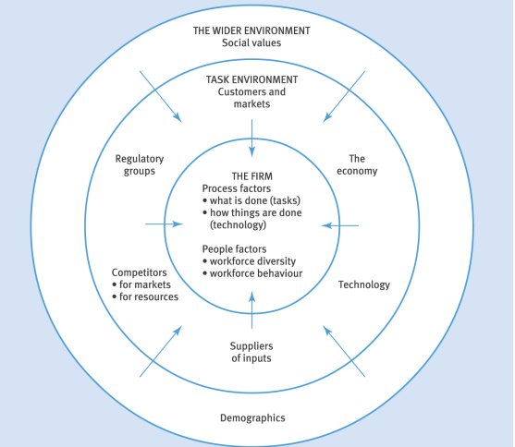
Appendix 1: Triggers to Change in Organisations
(Rollinson, 2008, pg633)

Appendix 2
Appendix 2 Lewin's Forcefield Analysis
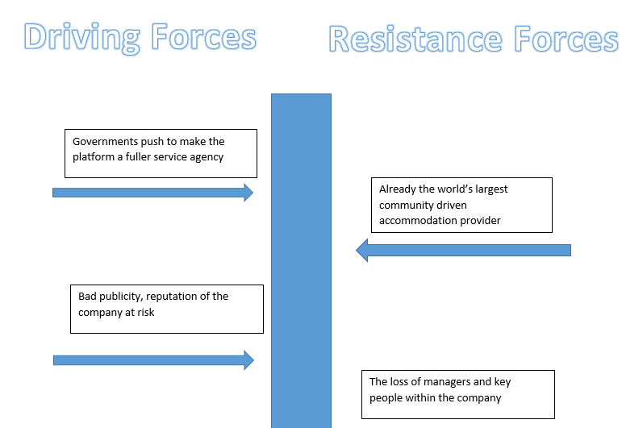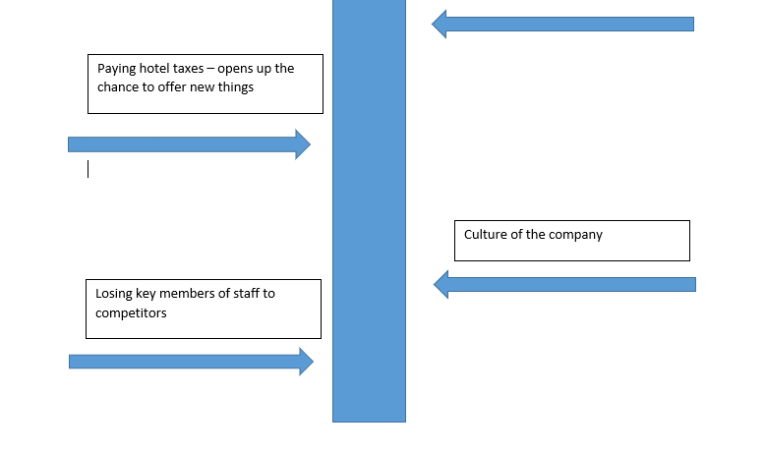

Appendix 3

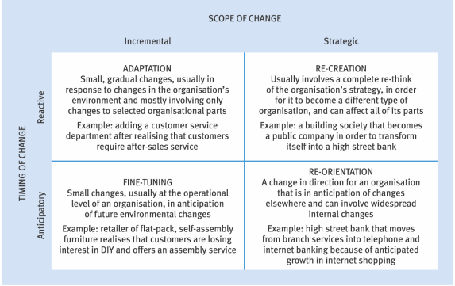
Appendix 3 Scope of Change
(Rollinson, 2008, pg632)

Appendix 4

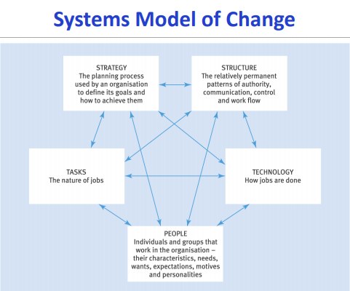
Appendix 4 Systems Model of Change
(Rollinson, 2008, pg643)

Appendix 5

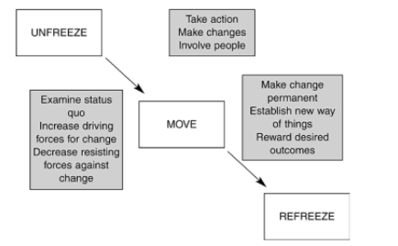
Appendix 5 Lewin's Three Step Model
(Cameron and Green, 2015, pg107)

Appendix 6

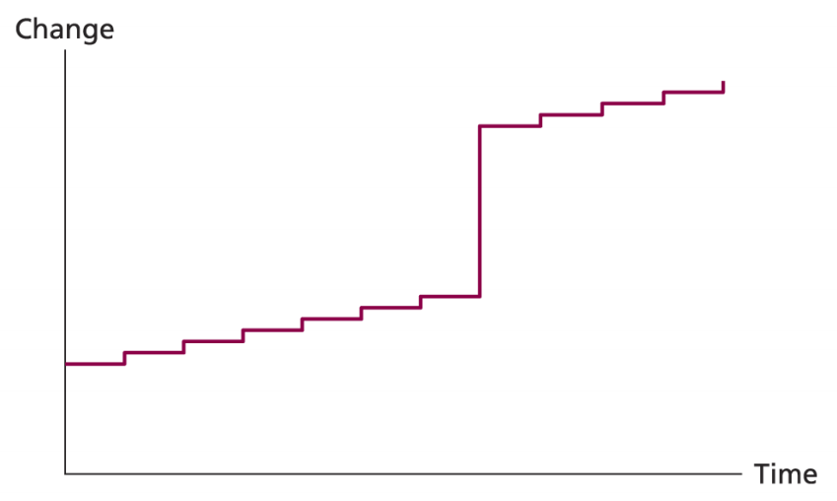
Appendix 6 Punctuated Equilibrium
(Burns, 2009, pg239)

Appendix 7
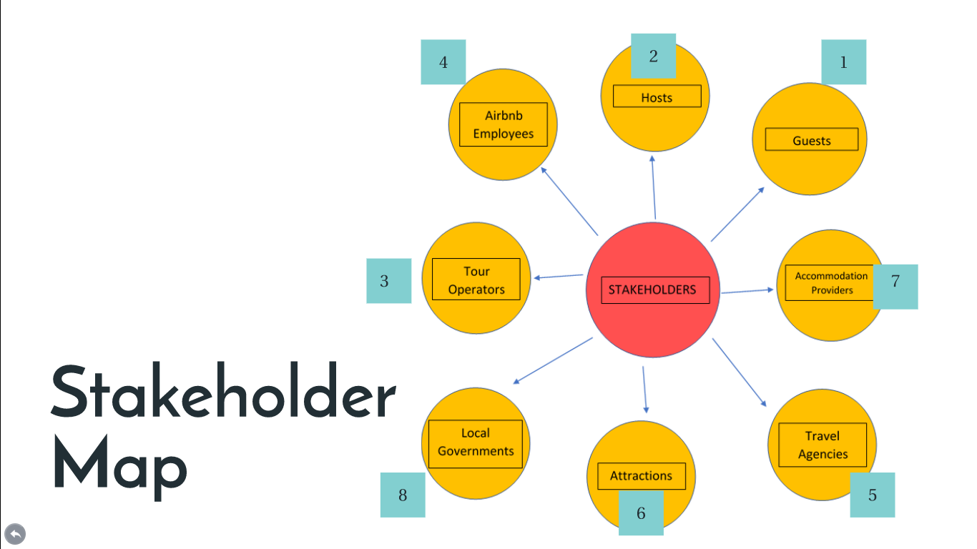
Appendix 7 Stakeholder Map for Airbnb before change – Ranked in Importance 1 being highest

Appendix 8
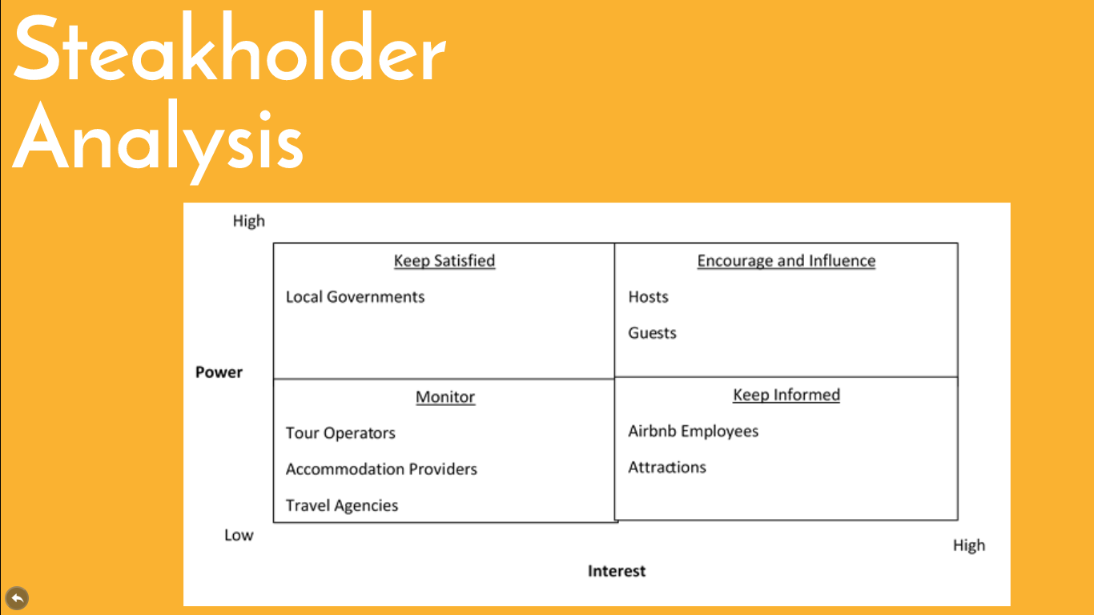
Appendix 8 Stakeholder Analysis

Bibliography
Burns, B. (2009) Managing Change, 5th edn., Essex: Pearson.
Burns, B. (2014) Managing Change, 6th edn., UK: Pearson.
Business Balls (2017) Organizational Change, Training and Learning, Available at: https://www.businessballs.com/change-management/organizational-change-training-and-learning-105/(Accessed: 03/01/2018).
Cameron, E and Green, M. (2015) Making sense of change management , 4th edn., London: Kogan Page.
Carnall, C and Todnem, R. (2014) Managing change in organizations, 6th edn., UK: Pearson.
Carroll, R. (2016) 'Whole trip' service makes Airbnb bigger than ever, but many want tougher rules, Available at: https://www.theguardian.com/technology/2016/nov/17/airbnb-launch-new-trips-service-los-angeles-protests (Accessed: 22/12/2017).
Gallagher, L. (2017) Airbnb CEO: Here's How 'Experiences' Are Doing So Far, Available at: http://fortune.com/2017/10/23/airbnb-ceo-experiences-new-york/ (Accessed: 22/12/2017).
Hartmans, A. (2016) Airbnb, worth $30billion, takes a first step toward becoming a full-service travel company, Available at: http://uk.businessinsider.com/airbnb-trips-launch-2016-11?r=US&IR=T (Accessed: 22/12/2017).
Hayes, J. (2010) The theory and practice of change management, 3rd edn., UK: Palgrave.
Kokalitcheva, K. (2016) Airbnb Wants to Go Beyond Home-Sharing With Debut of 'Experiences', Available at: http://fortune.com/2016/11/17/airbnb-experiences-trips/ (Accessed: 22/12/2017).
Mahmoud, A. (2016) The Impact of AirBnb on Hotel and Hospitality Industry, Available at: https://www.hospitalitynet.org/opinion/4074708.html (Accessed: 22/12/2017).

Midgley, D. (2015) The unstoppable rise of Airbnb, Available at: https://www.express.co.uk/life-style/life/578584/Airbnb-accommodation-rental-website (Accessed: 21/11/2017).

Peltier, D. (2017) Tourism Board Engagement With Airbnb Is Not One-Size Fits All, Available at: https://skift.com/2017/12/29/many-tourism-boards-remain-trepid-on-airbnb-but-know-its-a-force-to-be-reckoned-with/ (Accessed: 03/01/2018).
Prosci (2017) Change management process, Available at: https://www.prosci.com/change-management/thought-leadership-library/change-management-process (Accessed: 03/01/2018).
Prosci (2017) What Is Change Management?, Available at: https://www.prosci.com/change-management/what-is-change-management (Accessed: 03/01/2018).
Rollinson, R. (2008) Organisational behaviour and analysis, 4th edn., Essex: Pearson.
Williams, C. (2014) Airbnb aims to reshape the travel industry, Available at: http://www.telegraph.co.uk/finance/newsbysector/retailandconsumer/leisure/11110784/Airbnb-aims-to-reshape-travel-industry.html (Accessed: 22/12/2017).

