Exploring the impact of an eating disorder on an individual: A thematical analysis of a diary extract
Abstract
Eating disorders are on the rise, especially in adolescents. It is believed that around 1.25 million people in the UK suffer from some sort of eating disorder (BEAT, 2022). This mental illness is two times likely to affect women than men as 1 in 5 females aged 16-24 have an eating disorder (MentalHealthReearch,2022). A thematic analysis of a diary extract was used to explore the impact of an eating disorder on an individual. A total of 31 codes were derived from the extract producing four themes which were: personal development, personal achievements, resentment of self and others and self-destruction. The analysis suggested that individuals with this illness tend to have obsessive and determined behaviour, which resulted in secretive behaviour as they knew it was wrong but felt pleasure from their addiction. They also feel a sense of control over their life by calculating their calorie intake and regurgitating as they have the power to decide what enters their body or not.
Introduction
Eating disorders are mental problems regarding the consumption of food. These individuals have a difficult relationship with food and often suffer with severe anxiety about gaining weight or becoming fat despite being underweight (DSM-5, n.d.). This mental illness affects their social, psychological and physical health. This is associated with negative thoughts and feelings towards their appearance and image which enables the individual to perceive their image differently to how everyone else sees them. Anorexia nervosa, bulimia nervosa, binge eating disorder, and avoidant restrictive food intake disorder are among the several forms of eating disorders (Guarda, 2023). Behaviours linked to eating disorders include obsessive exercise, binge eating, vomiting, abusing laxatives, and restricting or avoiding particular foods. These tendencies can develop into obsessions that resemble addictions (Guarda, 2023). An eating disorder is believed to be influenced by both nature and nurture, as Dr. Bulik has stated on multiple occasions, "environment pulls the trigger, genes load the gun” (Baker, 2014).
Eating disorders generally develop during adolescence and early adulthood, affecting as much as 5% of the population. Research suggests that America has the highest percentage of eating disorders worldwide, with the United Kingdom coming second highest (MPower, 2023). The National Eating Disorders Association (NEDA) suggests that 20 million out of a total of 30 million people in the United States are women who suffer from an eating disorder (Whiteman, 2016). Research states that women are more self-conscious and dissatisfied about their bodies than men are. In continuation, social pressures are thought to be a major factor in the negative opinions people have about their physical appearance (Whiteman, 2016). Bulimia nervosa and anorexia nervosa are more common in women, but they can affect people of any age (Guarda, 2023).
Psychologists came together to attempt to investigate why women had higher tendencies of suffering with eating disorders. MRI was used to track each participant's brain activity during the experiment in order to evaluate how the brain reacts to physical appearance. The psychologists gathered 32 participants, 16 men and 16 women, who had no history of any forms of eating disorders to complete the study. Each participant had to put on a virtual reality headset that, when they looked down, showed a first-person video of a “thin” or “obese” body that appeared like it belonged to them. Researchers found that when participants observed their "obese" bodies, there was a direct correlation between activity in the anterior cingulate cortex, a part of the brain linked to processing subjective emotions like anger and fear, and activity in the parietal lobe, a region of the brain related to body perception. Researchers discovered that this type of brain activity was more common in women than in males, indicating that women are more prone to experience body dissatisfaction because of "owning" a fat body.
Individuals who suffer with eating disorders tend to have obsessive behaviour over their consumption of food and weighing themselves constantly to see their progress. Research suggests that individuals who suffer with eating disorders, particularly anorexia nervosa, tend to have the same characteristics as those who have obsessive compulsive disorder. Therefore, a study used a dimensionally oriented strategy to fully understand the causes of comorbidity between these two disorders. Self-report assessments measuring eating pathology, perfectionism, neuroticism, and obsessive-compulsive symptoms were completed by participants from a representative group sample. Most of the relationships between obsessive-compulsive and eating disorder symptoms were found to be completely controlled by neuroticism and perfectionism, according to hierarchical multiple regression analysis. The findings indicate an important role for common personality features in the coexistence of obsessive-compulsive disorder and eating disorders marked by binge eating and restricted food intake (Pollack & Forbush, 2013).
Similarly, individuals with eating disorders feel a sense of achievement and control. The individuals make themselves regurgitate to control the consumption of calories and follow strict diet routines, which allows them to have control of their lives which then leads to feelings of achievement. A study was conducted to determine which application of control is most significantly related to eating pathology and obsessive-compulsive disorder by comparing six common measures of control. The study included 175 females completing self-reports that measured eating disorder pathology, OCD and control. The results demonstrated that the significant predictors of eating pathology were feelings of failure and the fear of losing self-control (Frohreich et al., 2016).
The aim of the study was to examine the life of an individual with an eating disorder. This gave the researcher a more in-depth understanding of what it is like to suffer from an eating disorder. As it was written as a diary extract, they expressed their true feelings and thoughts, which you are unable to get from qualitive research.
Methodology
Design
The researcher carried out a thematic analysis from an existing diary extract of an individual with an eating disorder, which was a non-experimental and qualitative approach.
Participants
The diary extract that was used was written by Amanda Green, a therapeutic counsellor, who suffered severely with mental health problems such as an eating disorder and depression throughout her thirties. The book that includes Amanda’s diary extract, was published on the 19th of December 2013. The data was analyzed by a level 5 applied psychology student.
Materials
The diary extract ‘my alien self: my journey back to me', written by Amanda Green, who suffered with an eating disorder was used. The researcher used coloured highlighter pens to analyze and underline the keywords in the extract that was three pages long. View appendix 1 for the diary extract.
Procedure
View appendix 3.
Ethical considerations
The researcher did not require ethical consent as the article was in the public domain. There were eight either positive or negative articles to choose from, therefore the researcher chose to analyze a negative extract.
Results / discussion
Familiarisation phase
The initial thoughts about the extract were negative as it was rather a depressing and graphic piece of writing. It was a challenging read as she went into detail about the usage of laxatives and the consequences, she put her body through, which made the researcher sympathetic towards the suffering individual.
Table 1
Themes and quoted keywords from the diary extract.
Theme | Quote keyword | Page / line number
Personal development | ‘I’d go home instead, as part of my new routine’. | Page 2; line 30
Personal achievements | ‘The decrease in pounds of my bodyweight pleased me’. | Page 1; line 16
Resentment of self and others | ‘I didn’t see the skinny frame or my strained face, just the bulge in my tummy’. | Page 1; line 5 and 6
Self-destruction | ‘My body started to give up and my periods stopped by the summertime’. | Page 2; line 76 and 77

Personal development
Amanda showed determination when it came to making changes to her appearance. When she said, ‘I had to do something about it...It had to be flat, end of’, this shows she had an ideal image that she was determined to achieve. Similarly, she would do research into finding new techniques to lose weight. When it states, ‘I read somewhere that laxatives were good’, it suggests that she was willing to try anything to change her appearance. Amanda’s determination can be linked to previous research, when it talks about these individuals having obsessive behaviour, as she was clearly obsessed with her diet and was determined to succeed. However, Amanada had an unhealthy routine that included ‘dieting for days on end, bingeing, throwing up and exercising for hours a day’. This demonstrated her obsession with her diet but also showed personal development as she was achieving her goal of lowering her calorie intake. Furthermore, Amanda did eventually come to her senses and began to stop her eating restrictions. When she states, ‘It was 1990, the start of a new decade’, this suggests that Amanda wanted to stop her bad habits and have a fresh start and to sort herself out.
Personal achievements
Amanda followed a strict diet, which she referred to as her ‘project’. She had clear goals for what she intended to achieve, which was to limit her calorie intake and to be thinner. She felt pleased with her progress, for example when she said, ‘I loved to see the bones on my chest and ribs poking through my skin’. This shows that she was proud and that she had achieved a mission in her project. Likewise, Amanda felt in control of her body when she overcame her ‘grumbling belly and hunger’. By preventing herself from eating, she felt that she had power over her life, which is a common characteristic of someone suffering from this illness, as mentioned in further research. Amanda obsessed over her achievements, when she says, 'I weighed myself a few times a day and the decrease in pounds of my bodyweight pleased me’. This suggests that her ‘project’ had taken over her life and that everything revolved around her diet. She felt pleasure when she succeeded, which encouraged her to eat less as she could see her ‘project’ was successful.
Resentment of self and others
This theme suggests the possible reasons for Amanda developing an eating disorder. Amanda was dissatisfied with her body image, when she said, ‘I didn’t see the skinny frame or my strained face, just the bulge in my tummy’. This suggests that she was not happy with her appearance and felt the need to do something about it to be happy. This was supported by the future research as it states that women are more likely to be dissatisfied with their body than men. Amanda had negative feelings towards her appearance which made her insecure. For example, when she said, ‘a skinny, pretty girl called Marcia was thinner than me’, this suggests that she is constantly comparing herself to others, which destroyed her self-esteem. By constantly comparing herself to others, Amanda’s jealousy took over. In Amanda’s diary she states, ‘she got most of the attention’, this suggests that Amanda resented herself and wanted to look like other people to get attention. These emotions could be a result of Amanda having no female role model, as she states that, ‘it was dad who had to explain about periods...imagine that?’, this suggests that she was not comfortable with opening about personal issues to her dad who was clearly trying to be supportive. This is emphasized when she said, ‘imagine that’, as she could not image herself in a worse position.
Self-destruction
Amanda showed that she was obsessed with her diet, when she states, ‘revising the calorie counts of every type of food or drink that I might have consumed at some point’. This suggests that she prioritized her diet over everything as it was her number one priority that she did not miss a single calorie. The prioritization can be linked to obsessive behaviour, which was mentioned previously. In continuation, when Amanda states that, ‘usually I would meet my friends for lunch...but I’d go home instead as part of my new routine’. This shows that her obsession was slowly turning into an addiction as her diet ruled her life and she would not let anything interrupt her schedule, which also affected her social life. Her addiction was altering her personality as she became more secretive, when she says, ‘this six stone person was fantastic at covering her body, keeping the puking a secret and dodging all possibilities of getting caught’. This shows that she knew what she was doing was wrong but was addicted to her routine so decided to keep it a secret rather than stop. Amanda knew her actions were wrong, she may have been secretive to protect her family and friends from finding out, as she knew it was wrong but gained pleasure from her addiction.
Implications, limitations and future research
The results suggest that people with this illness are vulnerable and seek help but are afraid to speak out due to the fear of judgement and the feeling of failure. This would be useful when trying to treat people with this illness as it identifies feelings and characteristics of someone who is suffering from an eating disorder. However, the extract only looks at one participant which may limit the variety of data, as their feelings may differ from others. The researcher was unable to ask the participant any questions to get further understanding. Future research could examine more diary extracts from individuals with eating disorders but from different backgrounds and different ages/gender to get a more in depth understanding and variety of answers.
In conclusion, by thematically analyzing the diary extract, the researcher was able to explore and discover the true feelings and thoughts of someone suffering from an eating disorder. Obsessive, secretive and determined behaviour were all characteristics that the researcher highlighted from the extract. Similarly, the researcher was able to use further research in the introduction to support the points made in the discussion, which made the evidence empirical. The characteristics outlined may be useful to mental health professionals to identify those who may be suffering from an eating disorder.
Reference list
Baker, J. (March 11,2014). Eating disorders: nature vs nurture.
https://uncexchanges.org/2014/03/11/eating-disorders-nature-and-nurture/
BEAT. (2022). How Many People Have an eating disorder in the UK? Beat.
https://www.beateatingdisorders.org.uk/get-information-and-support/about-eating-disorders/how-many-people-eating-disorder-uk/
‌DSM-5. (n.d.). DSM-5 diagnostic criteria for eating disorders anorexia nervosa diagnostic criteria.
https://www.breathetherapies.co.uk/wp-content/uploads/2019/06/DSM-5-Diagnositic-Criteria-.pdf
Froreich, F. V., Vartanian, L. R., Grisham, J. R., & Touyz, S. W. (2016). Dimensions of control and their
relation to disordered eating behaviours and obsessive-compulsive symptoms. Journal of Eating
Disorders. https://doi.org/10.1186/s40337-016-0104-4
‌Guarda, A. (2023, February). What Are Eating Disorders? Psychiatry.org; American Psychiatric
Association. https://www.psychiatry.org/patients-families/eating-disorders/what-are-eating-disorders
‌Goodreads. (2023). Goodreads’ author: Amanda Green. https://www.goodreads.com/author/show/6525174.Amanda_Green
MentalHealthResearch. (2022, September 7). Eating Disorders. https://www.mqmentalhealth.org/conditions/eating-disorders/?gad_source=1&gclid=Cj0KCQiAtOmsBhCnARIsAGPa5yYz2kEFtqx8aE6jFcjHk67jQm9EfwjvuCwAjGjLMPyT2f6BzndNSUwaAnZREALw_wcB
MPower, P. (2023, January 26). Eating Disorder Statistics & Prevalence. MPower Wellness. https://mpowerwellness.com/eating-disorder-statistics/
Pollack, L. O., & Forbush, K. T. (2013). Why do eating disorders and obsessive–compulsive disorder co-
occur? https://doi.org/10.1016/j.eatbeh.2013.01.004
‌Whiteman, H. (2016, October 16). Why are women more vulnerable to eating disorders? Brain study
sheds light. Www.medicalnewstoday.com. https://www.medicalnewstoday.com/articles/313466
‌

Appendices
Appendix 1 – Transcript before analysis
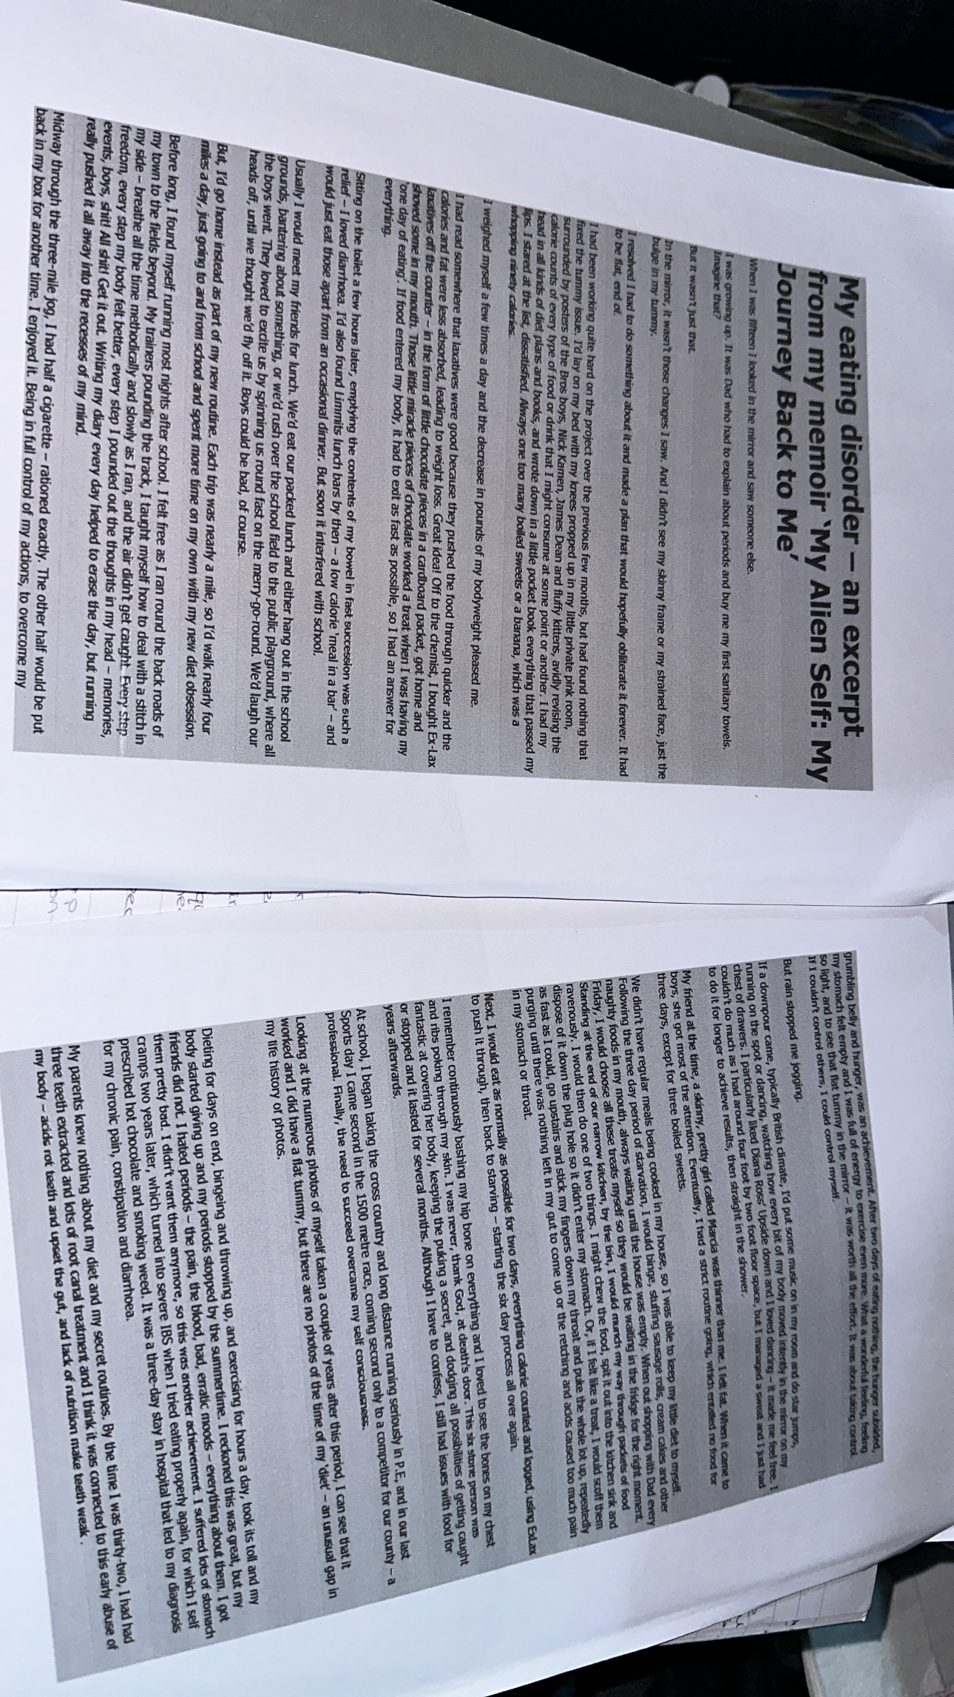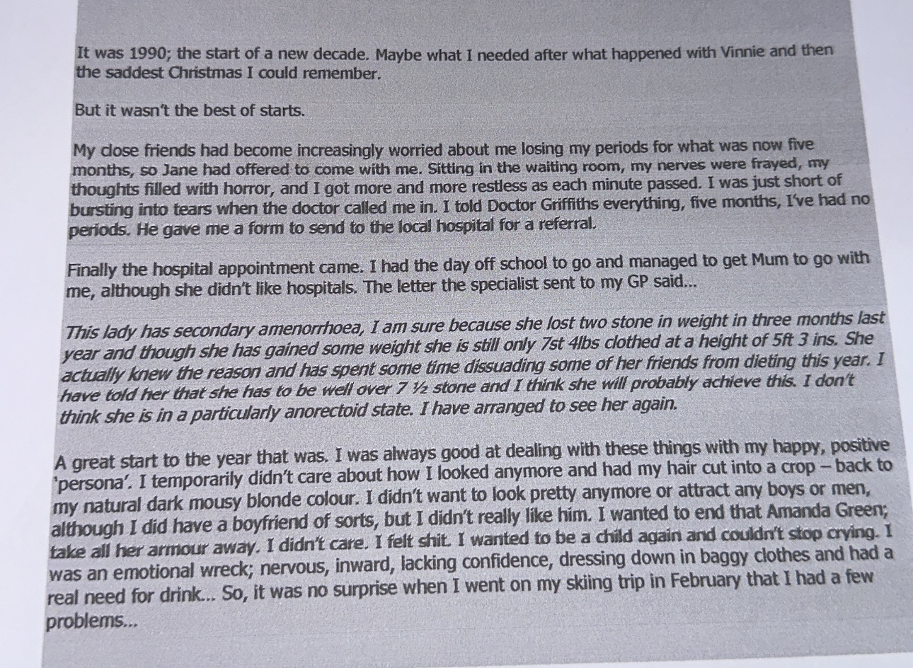
Appendix 2- Transcript after analysis
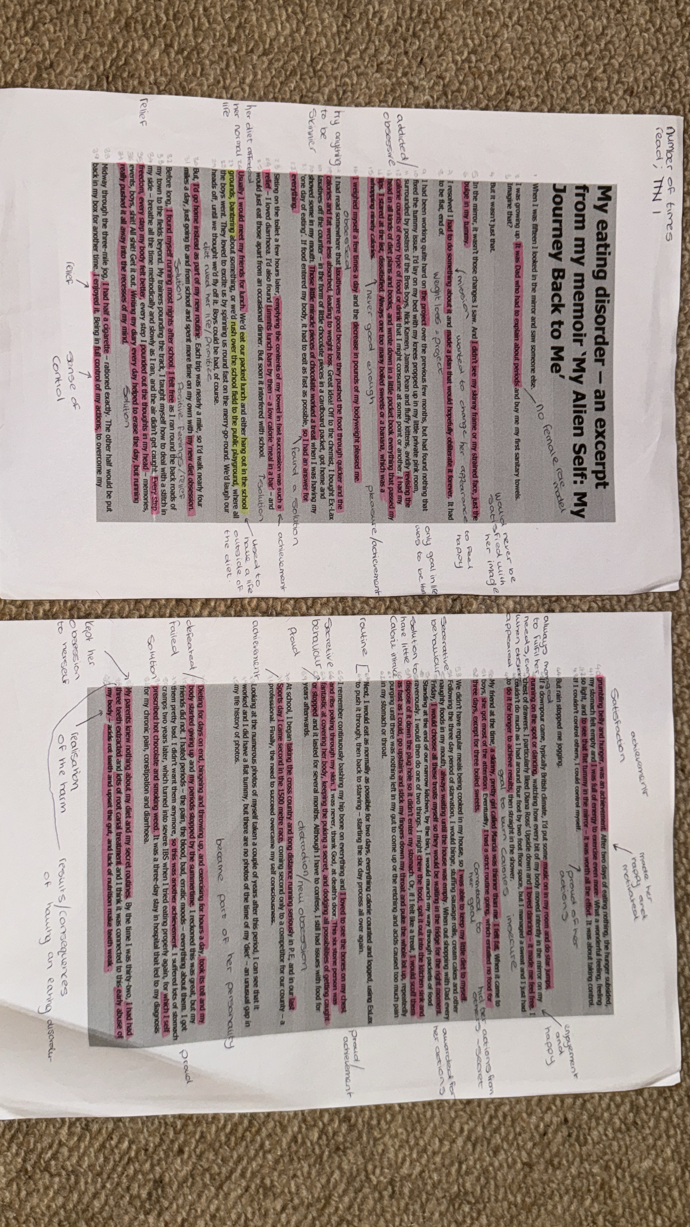
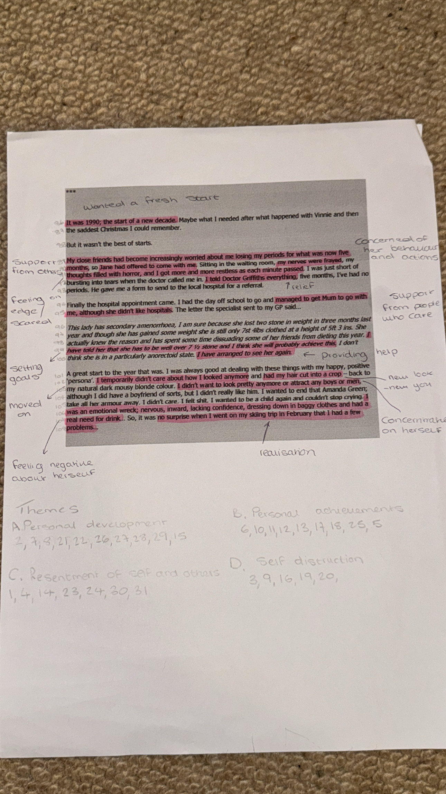
Appendix 3- Procedure
The researcher read the extract thoroughly, approximately six times. A tally chart at the top of the page kept note of this. The first read was to become familiar with the extract, then the second read the researcher began to take notes and highlight keywords in pink. The outside part of the extract was used to add comments and initial thoughts from the writing. The third read consisted of noting potential codes. The researcher kept reading through the extract to ensure all keywords had been highlighted. In appendix 2 you will find the analyzed extract. By the sixth read, the researcher had a total of 31 codes, which can be found in appendix 3. The codes were examined to see if they fitted together or had similarities to fit into themes. The researcher developed four themes: personal development, personal achievements, resentment of self and others and self-destruction. Each code was assigned a number, and the themes were lettered A, B, C or D so that it was easier to know which code had been put into a theme already. For example, happiness (10) had been put into theme personal achievements (B), view appendix 5 for organization of codes into themes.

Appendix 4- Codes
- Dissatisfaction with her body.
- Determination to succeed.
- Obsessed with her diet.
- Never felt good enough.
- Obsessed with progress.
- Achievement from her diet.
- Open to new techniques.
- Finding solutions.
- Diet affected her life.
- Happiness.
- Feeling herself again.
- Enjoyment.
- Sense of control.
- Insecurity.
- Commitment.
- Secretive behaviour.
- Awarded for her actions.
- Achievement in sport.
- New obsession.
- Consequences.
- Routine.
- Support from others.
- Apprehensive.
- Distress.
- Relief.
- Goal setting.
- Moving forward.
- Concentrating on herself.
- Realization.
- No female role model.
- Jealousy.
Appendix 5 – Organization of codes into themes


