IMAGE RECOGNITION FOR WASTE SORTING AND RECYCLING USING SECONDARY QUANTITATIVE DATASET ANALYSIS

Name: Patel Manankumar Kamleshbhai
Student id: 2515077
Module: Master Project

Table of Contents
Chapter 1: Introduction 6
1.1 Background of the Study 6
1.2 Research Context 6
1.3 Problem Statement 7
1.4 Research Aim 8
1.5 Research Objectives 8
1.6 Research Questions 8
1.7 Research Significance 8
1.8 Scope of the Research 9
1.9 Overview of Research Methodology 10
1.10 Dissertation Structure 11
Chapter 2: Literature Review 12
2.1 Introduction 12
2.2 Waste Management and Waste Classification 12
2.2.1 Global Waste Management Challenges 12
2.2.2 Waste Segregation Process 12
2.2.3 Traditional Waste Classification Methods 13
2.3 Artificial Intelligence in Waste Management 14
2.3.1 Artificial Intelligence in Environmental Sustainability 14
2.3.2 Computer Vision for Waste Recognition 15
2.3.3 Benefits and Challenges of AI-based Waste Classification 15
2.4 Deep Learning for Image Classification 16
2.4.1 Evolution of Deep Learning 16
2.4.2 Convolutional Neural Networks (CNNs) 17
2.4.3 Transfer Learning 18
2.4.4 Evaluation Metrics 18
2.5 Review of Deep Learning Models for Waste Classification 19
2.5.1 Custom CNN 19
2.5.2 MobileNetV2 19
2.5.3 ResNet50 20
2.5.4 VGG16 21
2.6 MobileNetV2 Optimisation Techniques 21
2.6.1 Fine-Tuning 21
2.6.2 Data Augmentation 22
2.6.3 Hyperparameter Optimisation 22
2.6.4 Regularisation Techniques 22
2.6.5 Learning Rate Scheduling 23
2.7 Existing Research on Robust Waste Classification 23
2.8 Research Gap 24
2.9 Conceptual Framework 25
2.10 Chapter Summary 27
Chapter 3: Research Methodology 28
3.1 Introduction 28
3.2 Research Philosophy 29
3.3 Research Approach 29
3.4 Research Strategy 29
3.5 Research Design 30
3.6 Research Method 30
3.7 Dataset Description 31
3.8 Software and Hardware Environment 32
3.9 Data Preprocessing 32
3.10 Deep Learning Models 33
3.11 Model Selection Process 34
3.12 Robustness Improvement Strategy 35
3.13 Research Workflow 36
3.14 Ethical Considerations 36
3.15 Reliability and Validity 37
3.16 Chapter Summary 37
CHAPTER 4: DATA ANALYSIS 38
4.1 Introduction 38
4.2 Dataset Characteristics and Class Distribution 38
4.3 Image Preprocessing and Augmentation Analysis 40
4.4 Generative Augmentation Analysis 41
4.5 Experimental Model Configuration 41
4.6 Custom CNN Training Analysis 42
4.7 MobileNetV2 Training Analysis 44
4.8 ResNet50 Training Analysis 45
4.9 VGG16 Training Analysis 47
4.10 Comparative Metric Analysis 48
4.11 Data Analysis Summary 52
CHAPTER 5: FINDINGS AND RESULTS 53
5.1 Introduction 53
5.2 Principal Experimental Finding 53
5.3 Finding Concerning the Custom CNN 54
5.4 Finding Concerning MobileNetV2 54
5.5 Finding Concerning ResNet50 55
5.6 Finding Concerning VGG16 56
5.7 Relationship Between the Findings and Waste-Sorting Application 56
5.8 Achievement of the Research Aim and Objectives 57
5.9 Methodological Limitations Affecting Interpretation 58
5.10 Overall Findings 59
CHAPTER 6: CONCLUSION 60
6.1 Introduction 60
6.2 Summary of the Experimental Work 60
6.3 Main Conclusion from the Results 61
6.4 Implications for Automated Waste Sorting 61
6.5 Contribution of the Comparative Approach 62
6.6 Limitations 62
6.7 Recommendations for Future Work 63
6.8 Final Conclusion 64
References 65

Chapter 1: Introduction

1.1 Background of the Study
Waste generation has emerged as one of the most significant environmental concerns in the world today due to the growing population, urbanisation and the rising consumer demand. The growing volume of domestic, industrial and commercial wastes have placed tremendous burdens on the waste disposal systems and natural habitats. The increase in landfills, pollution of the environment, the emission of greenhouse gases and threats to the ecosystem and health are some of the factors contributing to poor waste management (Ahmed et al., 2023). Waste management has consequently become a significant endeavor in working towards a sustainable environment and reducing the negative impacts of waste.
Effective waste segregation is an important aspect of enhancing the effectiveness of recycling and recovery of resources. There are usually two categories of household waste, organic waste and recyclable waste. Biodegradable waste, which comprises food and garden waste, is organic waste, and the recyclable waste includes paper, cardboard, plastic, metal and glass (Alsubaei, Al-Wesabi and Hilal, 2022). When it is properly segregated it can be properly treated and the amount of waste disposed of to landfill is reduced.
Nevertheless, sorting of waste manually is still a labour-intensive process that is time-consuming and is subject to human error. Being similar wastes, pollution and employee fatigue tend to cause incorrect identification, reduce the effectiveness of the recycling process, and increased operation expenses. As a result, the need to create automated waste classification systems has been growing, utilizing artificial intelligence and image recognition technologies (Altikat, Gulbe and Altikat, 2022). These smart systems can enhance the accuracy of classification and decrease the use of manual labour and offer a more efficient, reliable and sustainable waste management system in the modern world.

1.2 Research Context
Artificial Intelligence (AI) is an important technology to address environmental concerns since it makes waste management more efficient and automatizes the process. World governments, industries and researchers are shifting towards the utilization of AI-based solutions to allow sustainable development by guaranteeing that resources are managed more efficiently, there is less pollution and increased recycling initiatives. With AI, it is possible to make more accurate and efficient decisions in environmental applications due to the ability to work with large amounts of data (Baker, Szabo-Muller and Handmann, 2026).
One of the most significant areas of AI is Computer Vision as it enables computers to name and process digital images. Together with image recognition solutions, Computer Vision enables automated machines to recognize and label waste products using visual features like shape, colour, texture and size (Bashkirova et al., 2022). Deep Learning has also enabled more image recognition as it enables neural networks to automatically learn image complex features using large datasets. These models can effectively sort organic and recyclable waste with minimal human intervention in waste management. This has increased popularity of image-based waste classification because it offers more reliable and more scalable waste sorting in comparison to traditional manual sorting.

1.3 Problem Statement
Despite the ever-evolving waste management practice, manual sorting of waste remains to be the most popular trend in most of the homes, recycling centres and waste processing plants. This is a time-consuming, labour-intensive and highly subjective method, and difficult in achieving consistency in the classification of a large quantity of waste. With the ever-growing waste production, manual sorting is not enough to sustain the ever-increasing demand of effective and sustainable waste disposal.
Human errors in the classification of waste also reduce the effectiveness of the recycling processes (Bernat, 2023). The misclassification occurs easily with similar shape, colour or feel of the waste items, worker fatigue, lack of knowledge and inaccurate decision-making. Such misplaced sorting implies that recyclable items will now directly enter the trash bins with organic trash and biodegradable products will be combined with the recycling streams, reducing the quality and value of resources obtained.
A deficiency of high recycling efficacy has a tremendous environmental impact. The larger the amount of land is thrown away in landfills, the larger amount of land, water and air pollution, greenhouse emissions and unneeded consumption of natural resources. At that, these issues imply the need to develop more specific and smarter waste classification systems that can streamline the recycling process and reduce its environmental impact.
Although automated waste classification systems found on deep learning have demonstrated the beneficial side, most of the current models have demonstrated reduced functionality with real-life images (Bobulski and Kubanek, 2021). Some of the variants that can significantly affect the accuracy of classification are the image blur, lack of light, cluttered background, noise, partial occlusion and alternative viewing angles. Therefore, there is the need to attain a better image recognition model that can be used to guarantee high performance under various real-life conditions and can also help in effective and efficient automated waste sorting.

1.4 Research Aim
This research aims to compare the selected deep learning models that will be used in the upcoming application of waste sorting and recycling and to evaluate the performance of the image recognition models in the classification of waste into two different categories (organic waste and recyclable waste) from the dataset of waste classification made available on Kaggle.

1.5 Research Objectives
- To explore the possibilities of using image recognition to enhance waste sorting and recycling.
- To use secondary quantitative data for image classification: Kaggle Waste Classification Data.
- To train and test selected image recognition models using a 50:50 data split method, with 50% of the data for training and the remaining 50% of the data for testing/evaluation of samples.
- The accuracy, precision, recall and F1-score values of the Custom CNN, MobileNetV2, ResNet50 and VGG16 were tested to determine their accuracy.
- To propose the optimum model for future research on automatic waste sorting and recycling as dissertations.

1.6 Research Questions
- What can be done with image recognition in waste sorting and recycling?
- What is the quality of the Kaggle Waste Classification dataset for creating a waste image classification model?
- What is the accuracy of MobileNetV2 in recognising organic waste and recyclable waste in images?
- Talk about the accuracy, precision and recall values for all the classifiers (Custom CNN, ResNet50 and VGG16), as well as the performance of MobileNetV2 over all of them?

1.7 Research Significance
The study is significant, and it can be used in the development of sustainable waste management because of the use of artificial intelligence and image recognition technologies. The proposed system can decrease wrong waste division, enhance the recycling rates and decrease the amount of waste that is thrown into landfill by enhancing the precision and strength of automated waste classification (Carrera et al., 2023). These improvements help sustainability of the environment by conserving resources, reducing pollution and more effective waste management practices.
The study also helps in development of smart waste management systems. A smart image recognition system which can reliably categorise waste in various real-world scenarios can help facilitate quicker and more effective sorting mechanisms and decrease the use of human labour.
To municipal authorities, the results can be used to justify the adoption of smart waste management policies that can improve the delivery of services to the people and streamline the waste collection and recycling processes. The other benefit of the research to the recycling industry is that it demonstrates that it is possible to improve the performance of automated waste classification (Che et al., 2024). Scholarl-wise, the research adds to the existing literature in the field of Artificial Intelligence, Computer Vision and Deep Learning engaging in exploring methods to enhance model robustness. Moreover, the provided methodology can provide an outstanding foundation to the future smart city applications, where the smart waste management systems can be a constituent part and parcel of a sustainable urban infrastructure.

1.8 Scope of the Research
This paper focuses on developing an image recognition deep-learn model, and optimisation to identify binary wastes. The study is confined to the classification of two kinds of waste, i.e. Organic and Recyclable waste, with the assistance of publicly available Kaggle Waste Classification Dataset. The paper analyzes the method of the MobileNetV2 architecture application and optimisation to yield a higher classification rate and resistance to different image environments (Cheema, Hannan and Pires, 2022). The Google Colab platform with TensorFlow and Keras is used to implement model development, training, testing and performance evaluation.
The scope of this research does not include hardware implementation, Internet of Things (IoT) gadgets or robotic waste sorting systems. It also does not include multi-class waste classification that includes other types of waste like hazardous, electronic or medical waste. Moreover, the research does not consider real-time implementation in real recycling plants or intelligent waste containers. Instead, it concentrates on testing and optimising the software-based image classification model using second quantitative data in a controlled experimental study.

1.9 Overview of Research Methodology
The current study uses a secondary quantitative research design to test and enhance the performance of an image recognition model to classify waste using an automated system. The source of the secondary data is a publicly available Waste Classification Dataset, which was downloaded on Kaggle. The dataset contains pictures that are classified into Organic and Recyclable waste, which is an adequate foundation on which binary image classification can be done (Chen, 2021). The image is first processed using image processing techniques like resizing and pixel normalisation before training the model to ensure that the image is consistent in all ways and the learning process is improved.
The research employs transfer learning where the pre-trained MobileNetV2 model is used as the general classification framework. Once the model has been identified, the fine-tuning techniques are applied to tune the network and optimize it to perform better in different image conditions. The standard classification measures such as Accuracy, Precision, Recall and F1-score, along with a Confusion Matrix to determine the quality of prediction are used to evaluate model performance. Chapter 3 gives detailed implementation procedures and research methods.

1.10 Dissertation Structure

Chapter 2: Literature Review

2.1 Introduction
This chapter reviews the literature related to automated waste classification, artificial intelligence and deep learning to establish the theoretical foundation for the research. A review of the literature aids in determining the existing methods, research progress and the existing drawbacks in the field of waste classification based on images (Chen, 2022). In the chapter, the author talks about waste management practices, the use of Artificial Intelligence and Computer Vision, deep learning techniques, transfer learning models and optimisation techniques employed to enhance the performance of classification. It also critically appraises the existing literature on the robust waste classification in real-world applications and the gap in research that the dissertation fills the basis of the research methodology discussed in the next chapter.

2.2 Waste Management and Waste Classification

2.2.1 Global Waste Management Challenges
The production of waste in the world has grown by large due to the high rate of urbanisation, industrialization, population growth and shifting consumption habits. The ever-increasing municipal solid waste has also exerted a lot of pressure on waste management systems and especially in developing nations whereby infrastructure and recycling facilities are still wanting. Unmanaged waste disposal is a contributing factor to many environmental issues, such as land, water and air pollution, greenhouse gas emissions and natural resource depletion (Chen et al., 2022). Wastes are deposited in large quantities in landfills and cause soil contamination as well as risks to the ecosystem and human health. Sustainable waste management has thus emerged as a worldwide concern and is concerned with waste minimisation, reuse, recycling and recovering resources to ensure that any environmental effects are minimised whilst ensuring effective use of accessible resources.

2.2.2 Waste Segregation Process
Waste segregation can be defined as the process of sorting waste into various groups before it is treated or discarded. In the management of household waste, there are usually two types of waste, organic and recyclable. Examples of biodegradable materials that can be composted or treated biologically to form organic waste are food waste, fruit peels and garden waste. Recyclable waste is materials such as paper, cardboard, plastic, glass and metal that can be reused to create other products (Chen et al., 2022). A good segregation enhances recycling, contamination between waste streams, and waste that goes to landfill is minimized. Proper waste separation also contributes towards conservation of resources and leads to the practice of waste management that is sustainable to the environment.
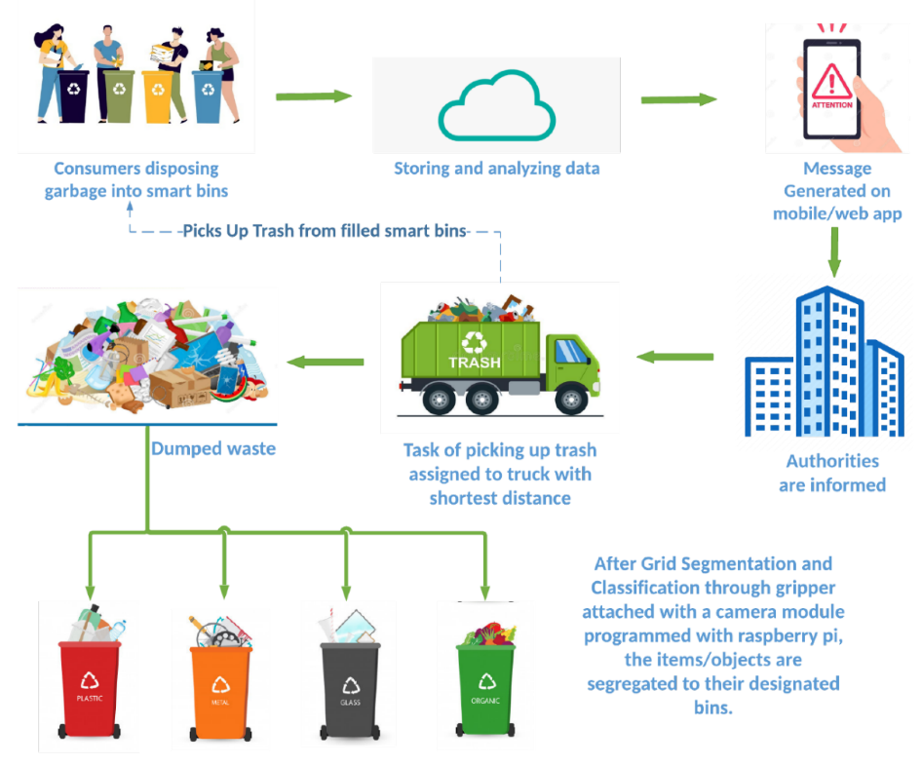
Figure 1: Smart Waste Management and Classification Systems
(Source: encyclopedia.pub, 2026)

2.2.3 Traditional Waste Classification Methods
Conventional methods of waste sorting are mainly based on manual sorting, where workers can visually sort and separate waste based on the predetermined categories. This method is popular, but it is labour-intensive, time-consuming and very reliant on human judgement. Employee exhaustion, lack of consistency in decision making and similarities in waste materials are some of the factors which lead to errors in classifications thus lowering the efficiency of recycling. Certain waste management systems have introduced rule-based systems, which categorize waste based on predetermined features like colour, shape or type of material (Choi, Lim and Yoo, 2023). These systems are, however, inflexible and cannot perform optimally when waste objects do not look the same or when the environment changes. Therefore, the traditional classification techniques cannot always reach the accuracy, efficiency and scalability of modern automated waste management systems.

2.3 Artificial Intelligence in Waste Management

2.3.1 Artificial Intelligence in Environmental Sustainability
Artificial Intelligence (AI) is now a significant technology in overcoming environmental issues by allowing smart decision-making, automation of processes and management of resources based on data. Artificial intelligence (AI) is becoming more used in different aspects of the environment, such as pollution monitoring, energy management, climate predictions and waste management. These applications enhance efficiency in operations and decrease environmental impacts and long-term sustainability goals (Du et al., 2022). In the context of waste management, AI can be used to analyze a large amount of waste data automatically, enabling organisations to optimize waste collection, sorting and recycling processes. Smart AI-enabled waste management systems can detect the types of waste, forecast waste creation trends and optimize resource use by automating decisions. With the ongoing investments in sustainable technologies by governments and industries, AI is now an important part of contemporary environmental management strategies.
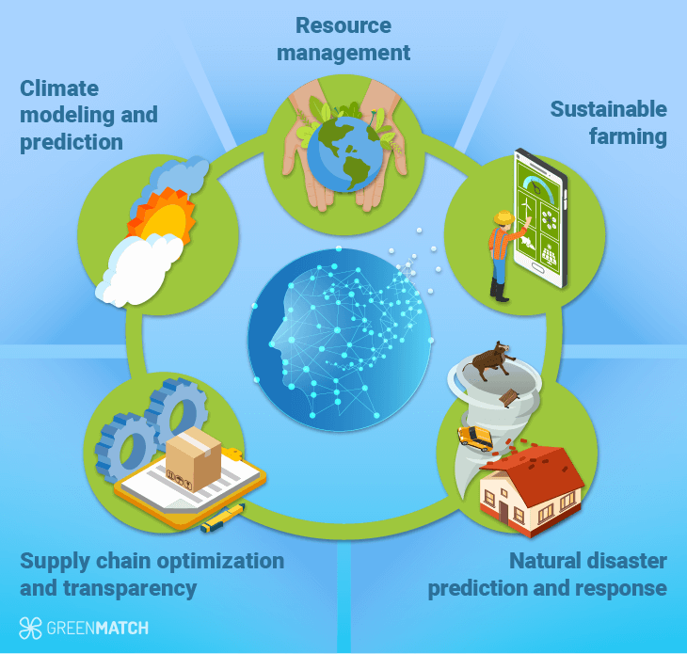
Figure 2: The Power of AI to Reach Environmental Sustainability
(Source: greenmatch.co.uk, 2026)

2.3.2 Computer Vision for Waste Recognition
Computer Vision is a specialised field of Artificial Intelligence that enables computers to acquire, process and interpret visual information from digital images. Computer Vision aids in automated recognition of waste in waste management by recognizing visual attributes like shape, colour, texture and size. Image recognition can be used to allow the system to identify the various types of waste by learning patterns of labeled sets of images. Moreover, object detection algorithms can find and recognize single waste items in an image and then classify them (Erkinay Ozdemir et al., 2021). Each object detected is then classified according to learned features to an object in the corresponding waste category by image classification models. Computer Vision and deep learning have greatly enhanced the rate, uniformity and precision of automated waste sorting in comparison to conventional manual inspection approaches.
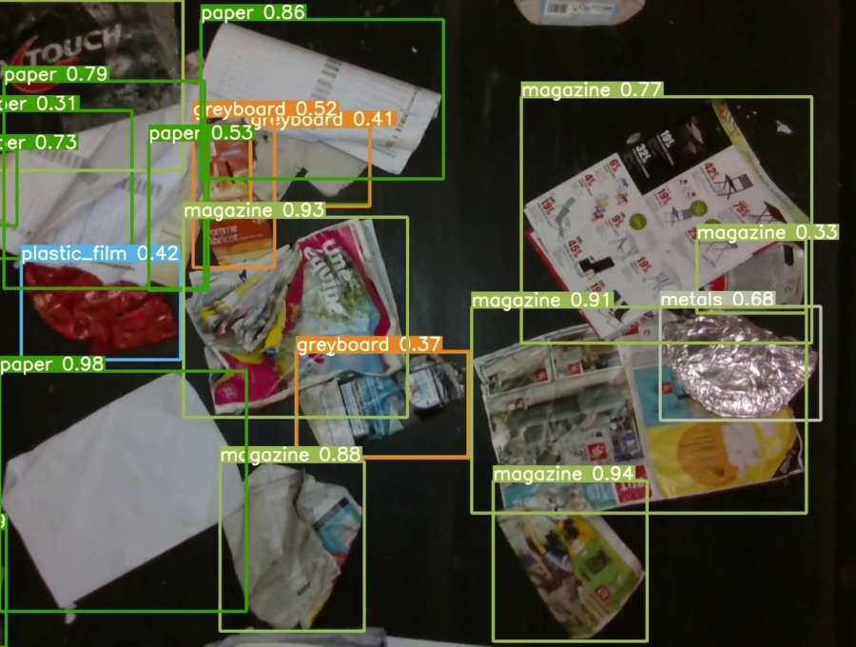
Figure 3: Computer Vision for Waste Recognition
(Source: recycleye.com, 2026)

2.3.3 Benefits and Challenges of AI-based Waste Classification
The use of AI to classify waste has a number of benefits over traditional waste sorting techniques. Automated classification systems enhance the accuracy of the sorting process, lessens manual labour, speeds up the processing process and minimises the operational expenses. They also offer a reliable classification performance and enhance efficiency in recycling through minimizing human error. All these advantages make AI a viable solution to the current waste management and sustainable recycling (Fang et al., 2023). Nevertheless, the existing AI-based systems still have several issues. The accuracy of classification can be affected as images can be blurry, have poor lighting, contain clutter on the background, have image noise, or partial objects. The quality and diversity of training data is also important for model performance and makes it harder to generalise about real-world conditions.

2.4 Deep Learning for Image Classification

2.4.1 Evolution of Deep Learning
Image classification has been developed into the current stage of Deep Learning models that can automatically learn complex visual patterns, as opposed to classical methods of Machine Learning. Algorithms of Machine Learning are typically based on manually designed features that are extracted on images followed by classification. Despite the satisfactory performance of these approaches in specific applications, the performance tends to be low when processing large and complex image datasets (Farjana et al., 2023). Deep Learning can overcome this shortcoming by learning hierarchical feature representations directly on raw image data using many neural network layers, with no supervision. Convolutional Neural Networks (CNNs) are the most popular type of Deep Learning architecture used in image classification. CNNs are effective at capturing spatial features and visual representations that allow them to recognize objects with a high level of accuracy in a wide variety of applications such as medical diagnosis, autonomous driving and automated waste classification.
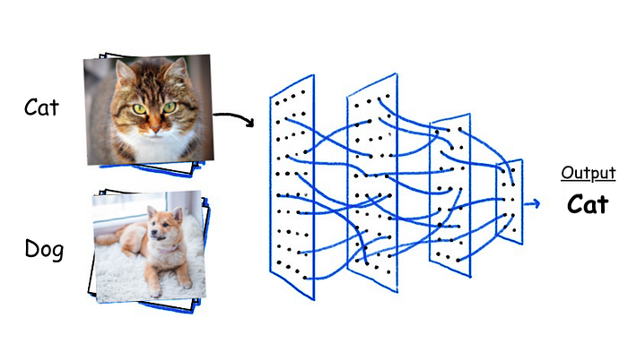
Figure 4: Deep Learning for Image Classification
(Source: medium.com, 2026)

2.4.2 Convolutional Neural Networks (CNNs)
Convolutional Neural Networks (CNNs) are specific Deep Learning models that are used to process image data to extract meaningful visual features using multiple processing layers. The hierarchical structure allows them to automatically identify simple and complex features in images and is incredibly useful when it comes to classification tasks (Hasan et al., 2022).
The first significant part of a CNN is the convolution layer. It uses various filters that can be learnt on the input image to detect local visual characteristics such as edges, textures, colours and shapes. These features are increasingly combined to portray more complex objects as the network gets deeper.
After the convolution, the pooling layer downsizes the spatial feature maps without distorting the most significant information (Jin et al., 2023). This operation simplifies computational problems, minimizes memory use and enhances the object recognition capability of the model with minimal changes in position or orientation.
The features that are extracted are then fed into fully connected layers in which data of all the preceding layers are combined to give the final classification. These layers determine the probability that an image belongs to a particular class (Koskinopoulou et al., 2021). The activation functions add non-linearity to the network and enable CNNs to acquire complicated relations between image features. ReLU and Sigmoid functions help the model to find complex visual patterns and provide correct classification outcomes.

2.4.3 Transfer Learning
Transfer learning is a technique of Deep Learning that enhances the performance of models by utilizing the knowledge gained through models that have been trained on massive image collections in the past. Pre-trained models are instead adapted to a new but similar classification problem as opposed to training a neural network completely. This method can greatly save on computation time, lessen the need to use large, labelled data and tends to generate more accurate classification (Koyanaka and Kobayashi, 2023).
Several established pre-trained models, such as MobileNetV2, ResNet50 and VGG16 have been used extensively in addressing image recognition tasks since they have already been trained on rich visual representations of millions of images (Ku et al., 2021). This acquired knowledge can be carried over to waste classification tasks with further training and fine-tuning. Transfer learning is therefore an effective and trusted method of training high-performing image classification systems and lowering the complexities of training and increasing the generalisation.

2.4.4 Evaluation Metrics
Image classification models are usually evaluated based on a variety of quantitative evaluation metrics that help to give a full picture of the quality of the predictions. Accuracy determines the fraction of correctly classified images in all predictions and gives a general idea of the performance of models (Kumar et al., 2021). Precision is a measure of the percentage of correctly predicted positive samples and is a measure of the reliability of the model to detect a particular class. Recall is the measure of how well the model can correctly recognize all the actual positive samples, which shows its sensitivity to the relevant samples. F1-score is a single balanced measure that is the result of Precision and Recall and is especially convenient when comparing the performance of the classes in various conditions.

2.5 Review of Deep Learning Models for Waste Classification

2.5.1 Custom CNN
A Custom Convolutional Neural Network (CNN) refers to a deep learning network that is created to tackle a specific image-classification issue. Custom CNN is created in contrast to pre-trained architectures, where the number of convolutional layers, pooling layers, fully connected layers and activation functions are chosen based on the properties of the dataset. This adaptability enables the model to be customized to suit classification tasks, such as waste recognition (Lakhouit, 2025). A significant strength of Custom CNN is its comparatively simple architecture that can be trained using comparatively smaller quantities of computational resources than larger pre-trained models. It also allows researchers to adjust network parameters to the needs of an experiment. Nonetheless, Custom CNN models typically have higher data and training cost demands to be competitive.
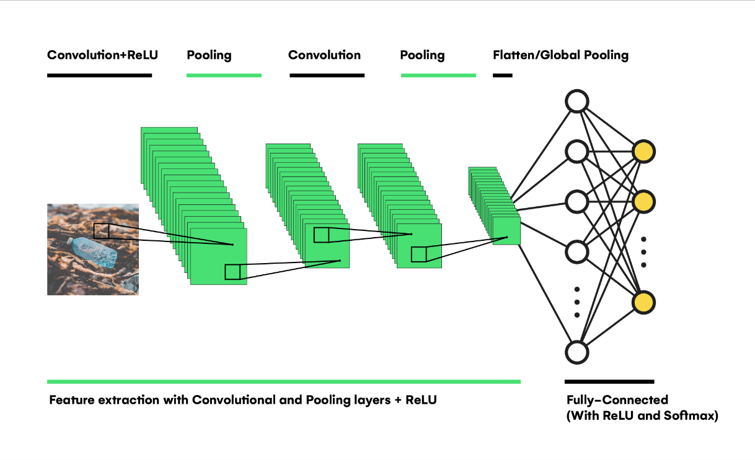
Figure 5: Advanced waste classification
(Source: towardsdatascience.com, 2026)

2.5.2 MobileNetV2
MobileNetV2 is a minimal convolutional neural network that is capable of attaining high classification accuracy with low computational complexity. MobileNetV2 has an effective architecture, unlike conventional deep neural networks, and it can be used in resource-restricted settings without severely affecting predictive performance (Liang and Gu, 2021). Its design allows it to be trained and inferred faster and with fewer parameters of the model, making it a popular choice in image recognition applications.
Inverted Residual Block is one of the main architectural units of MobileNetV2. This structure does not require feature reduction prior to processing, instead, it initially expands the feature representations and then compresses them upon feature extraction. Such a design enhances the flow of information across the network along with minimizing the number of computations and maintaining valuable visual characteristics (Lin et al., 2022).
The other notable feature is that it uses Depthwise Separable Convolution where spatial filtering is split into channel-wise computing. This method saves a lot of computations than traditional convolution operations and offers competitive classification results (Lu and Chen, 2022). Past research has already been used by MobileNetV2 to analyze medical images, detect diseases in agriculture, recognize traffic signs and classify waste. It has been one of the most appropriate transfer learning models in automated waste recognition systems due to its balance between its computational efficiency and classification accuracy.

2.5.3 ResNet50
ResNet50 is a deep convolutional neural network with fifty layers which was designed to address the issue of degradation that was experienced in very deep neural networks. Conventional architecture tends to have diminished training performance as network depth increases because of the challenges of learning more complex feature representations. ResNet50 is a solution to this problem because it uses Residual Learning, allowing the network to learn only the difference between the input and output features, not to learn feature mappings (Lu, Yang and Gao, 2022). This strategy enhances optimisation and enables more profound networks to be more convergent.
There is also the use of Skip Connections in the architecture which simply transfers information in the previous layer to the further layer. These ties alleviate the vanishing gradient issue and enhance the flow of information across the network, facilitating more effective feature learning (Lubongo and Alexandridis, 2022). Due to the capacity to learn highly discriminative visual representations, ResNet50 has been shown to perform well in a range of image classification tasks. Nevertheless, the model has many parameters and is computationally intensive and time-consuming to train. In the absence of suitable fine-tuning, ResNet50 might still underperform on specialised datasets, especially when the training data at hand are small or very dissimilar to the original pre-training data.

2.5.4 VGG16
One of the best-known deep convolutional neural networks used in image classification is VGG16 and has been applied widely in case of transfer learning. It has an architecture of sixteen learnable layers that use a series of small 3 × 3 convolution filters with pooling layers to extractively arrive at more complex image features (Majchrowska et al., 2022). This plain and universal network structure makes VGG16 easy to comprehend and apply and gives good feature extraction.
Among the significant benefits of VGG16 is that it can learn rich hierarchical image representations, which makes it very useful in conducting multiple computer vision tasks, such as object recognition, medical image analysis and waste classification. Pre-trained ImageNet weights also allow using transfer learning, which reduces training time, and enhances the classification performance on new datasets (Malik et al., 2022).
Despite these benefits, VGG16 is limited in several ways. The number of trainable parameters in the model is extremely high, which implies high memory usage and makes the model computationally expensive. Therefore, the training and inference times are higher than other lightweight frameworks like MobileNetV2 (Mao et al., 2022). It has been reported in previous work that VGG16 is capable of competitive classification when used on waste recognition, but it is not as efficient as more computationally efficient deep learning models because of its high computational needs and real-time usage.

2.6 MobileNetV2 Optimisation Techniques

2.6.1 Fine-Tuning
Fine-tuning is a type of optimisation that enhances the performance of a pre-trained deep learning model by adjusting the model to a particular application. First, most of the convolutional layers are frozen to ensure the model keeps the overall visual features that it has been trained on large-scale datasets like ImageNet. The target dataset is only used to train the newly added classification layers. Once initial performance has stabilized, more profound layers are gradually unfrozen and retrained with a smaller learning rate (Mao et al., 2021). This allows the model to acquire specifics of the task without forgetting the previously obtained knowledge, resulting in enhanced classification and enhanced generalisation.

2.6.2 Data Augmentation
Data augmentation is a common method to enhance stability and the capacity to generalise training images of a deep learning model by artificially increasing its diversity. Rather than gathering more data, different image transformations are used on the available samples, and their class labels are maintained. Typical augmentation methods are random rotation to mimic various object orientations, zoom to mimic varying distances, brightness modification to mimic various lighting conditions, and horizontal flipping to add variation to images where needed (Mishra et al., 2024). Noise is added to imitate camera flaws, and blur is added to indicate out-of-focus or motion-impacted images that are often found in real-world situations. These changes make MobileNetV2 able to learn more realistic visual representations, which minimizes overfitting and enhances classification accuracy with respect to unseen real-world waste images.

2.6.3 Hyperparameter Optimisation
Hyperparameter optimisation refers to the process of choosing the right training parameters to maximize the performance of the model. The learning rate dictates the size of weight changes in optimisation and has a direct impact on converting a model. An excessively large learning rate can make convergence impossible, and an excessively small learning rate can cause the training to take longer. The training epoch determines the number of times the model is trained on the entire dataset, which should be carefully chosen to prevent underfitting or overfitting (Mohamed and Cheong, 2023). The batch size defines the amount of training samples to be processed at a time and affects the computational efficiency and stability of learning. Also, the Adam optimiser is often used due to its ability to integrate adaptive learning and effective gradient optimisation, which leads to a quicker convergence and higher classification rates.

2.6.4 Regularisation Techniques
Overfitting is minimised and better generalisation to unseen data is achieved using regularisation techniques. In training, dropout stochastically kills chosen neurons, so that a network is not over-reliant on specific network connections and can learn features more robustly. The Batch Normalisation method normalises the distribution of features across network layers, which makes convergence faster and makes the network more stable to train (Mohammed et al., 2023). Early Stopping is a constant validation performance observing training and automatically halts the learning process when no improvement is seen. Combined, these methods can improve model reliability and minimize the possibility of degraded performance due to overtraining.

2.6.5 Learning Rate Scheduling
The learning rate scheduling is a dynamic mechanism of changing the learning rate of models in training to enhance optimisation efficiency. A popular method is ReduceLROnPlateau, which reduces the learning rate automatically whenever the validation performance has ceased to increase after a set number of training epochs (Nafiz et al., 2023). Adaptive learning with this strategy allows the optimiser to take bigger steps in the initial part of the training and smaller steps that are more accurate as the model nears convergence. Therefore, learning rate scheduling enhances training stability, convergence and helps in achieving better overall classification.

2.7 Existing Research on Robust Waste Classification
Recent research has shown that deep learning has really enhanced the accuracy of automated waste classification systems. Nevertheless, most available studies have tested classification models on clean and well-organized datasets of controlled laboratory conditions. Image blur due to motion effects, camera focus, environmental effects, and complicated backgrounds impact image quality, which is usually challenging in real-world waste management settings, thus hindering classification performance (Nnamoko, Barrowclough and Procter, 2022). This has led scientists to explore ways in which the strength of waste classification models can be enhanced in real-life situations.
A few studies have been conducted to determine the effect of blurring and noisy images on image recognition. The appearance of image blur due to camera movement or focus impairment lowers the visibility of significant visual features, and it becomes harder to identify similar waste categories by convolutional neural networks (Pluskal et al., 2021). Likewise, image noise caused by a poor-quality sensor or the environmental interference can alter the image details and decrease classification accuracy. To overcome such problems, scholars have included image enhancement algorithms, and data augmentation approaches that expose the models to blurred and noisy images throughout the training process. These methods tend to increase the strength of models, but the performance is usually worse than when high-quality images are used.
The classification of partially obstructed waste objects and low-light images have been studied by other researchers. Waste products are often piled up or even concealed by other substances such that the entire item is not in view. Moreover, the waste collection conditions outdoors do not always have adequate lighting, shadows or reflections which influence the quality of the image (Prova, 2024). Deep learning models that are trained on augmented data sets that include changes in illumination and object visibility have shown enhanced performance over adaptability, but numerous studies have found that prediction accuracy significantly declines as image degradation increases.
Background clutter is also a significant issue that has been found to be a challenge in automated waste classification. Images of waste in the real world usually have several objects, distracting backdrop and dissimilar environmental factors that add complexity to the classification. Although recent convolutional neural networks can learn discriminative visual features, the variation of background still affects the prediction performance (Sayem et al., 2025). Moreover, several published studies have used quite small or strictly controlled data sets, which restricts the capacity of the developed models to be effectively generalised to real-life waste management situations.
An overview of existing studies has shown that models of transfer learning, such as MobileNetV2, ResNet50 and VGG16, have been outperforming the traditional convolutional neural networks to perform the waste classification tasks due to their ability to extract features better. However, most works are concerned with the high classification accuracy with standard benchmark datasets instead of robustness in realistic environmental conditions. As a result, not much focus has been directed at enhancing the performance of models when handling blurred, noisy or partially covered images of waste (Shreyas Madhav et al., 2022). This weakness underscores the necessity of conducting additional studies on optimisation methods to make deep learning models more resilient and stable to realistic waste classification tasks.

2.8 Research Gap
An analysis of the literature available shows that there has been an improvement in the use of deep learning in automated waste classification. Many papers have compared the convolutional neural network architecture, such as the Custom CNN, MobileNetV2, ResNet50 and VGG16, on publicly available waste image datasets. Most of these works are mainly concerned with the evaluation of the classification performance of various deep learning models in terms of such evaluation metrics as accuracy, precision, recall and F1-score (Sirawattananon, Muangnak and Pukdee, 2021). Their results indicate that transfer learning models tend to have a high degree of classification accuracy compared to traditional convolutional neural networks when they are trained on clean and well-structured datasets.
Although these advances have been made, there are several research shortcomings. Most of the existing research does test the performance of models based on high-quality images that are obtained under controlled conditions, and which are not a full reflection of the real-life waste management setting. Therefore, there has been a lack of focus on the evaluation of model quality in the processing of blurred images, noisy images, variable lighting conditions, cluttered backgrounds or partially hidden waste objects (Sliusar et al., 2022). Moreover, even though MobileNetV2 has often been listed among the most suitable models to classify waste, few studies have explored the possibility of improving the performance of the chosen model.
The dissertation fills these research gaps by going beyond the traditional model comparison. Once the MobileNetV2 classification model has been identified as the most suitable one, the research focuses on optimising the performance of the model by using the advanced methods of fine-tuning and enhancement (Sterkens et al., 2021).

2.9 Conceptual Framework
The theoretical framework of this study starts with the Kaggle Waste Classification Dataset which undergoes image preprocessing methods such as resizing and normalisation. The trained MobileNetV2 model is then trained on the processed images via transfer learning. After that, a fine-tuning and optimisation method is used to enhance the robustness of the model. Lastly, the optimised model is tested with traditional performance indicators to determine its accuracy and efficiency in classification in the real-life waste image setting (Taneepanichskul, Purkiss and Miodownik, 2022).
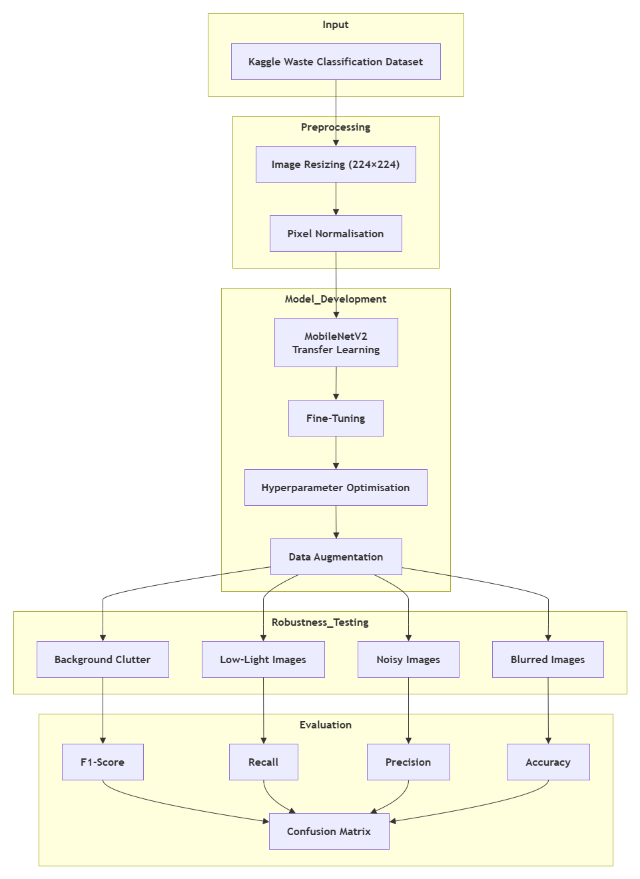
Figure 6: Conceptual Framework
(Source: Draw.io)

2.10 Chapter Summary
The chapter has critically examined the available literature as far as waste management, automated waste classification and the use of Artificial Intelligence in environmental sustainability is concerned. It talked about the applications of Computer Vision, Convolutional Neural Networks and transfer learning in enhancing image-based waste classification (Wang et al., 2021). This chapter also discussed the properties of MobileNetV2 and the optimisation methods that improve the performance and the robustness of the model. Moreover, weaknesses of previous literature were also discovered, which results in the research gap that this dissertation is focused on. The following chapter outlines the research methodology, such as research design, the dataset, model development procedure and methods of evaluation that will be used to accomplish the research objectives.

Chapter 3: Research Methodology

3.1 Introduction
The chapter describes the research methodology that is used to develop and test an automated waste classification system using deep learning. It outlines the philosophy of the research, the research strategy, research approach and the entire research design used to attain the study objectives. The secondary and quantitative research method is also applied, the selection of a Kaggle Waste Classification Dataset, image processing and a deep learning model are also described in the chapter (Wu et al., 2023). Furthermore, it explains the selection and optimisation methodology of the MobileNetV2 model, the measurement scales, which are applied to measure the performance of the model, and ethical considerations, reliability and validity measures that ensure the research is trustworthy.
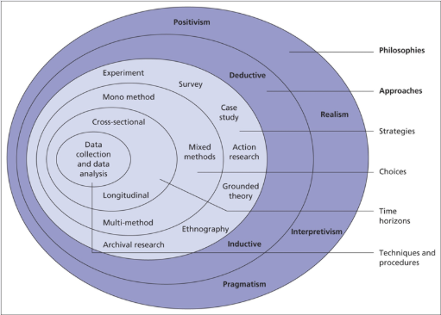
Figure 7: Research Onion
(Source: getitdoneex.com, 2026)

3.2 Research Philosophy
The research philosophy that is used in this study is positivist research philosophy that is concerned with objective observation, measurable evidence and scientific analysis to come up with reliable knowledge. Quantitative research tends to be based on positivism due to its focus on the objective data and statistical analysis as opposed to the subjective interpretation (Yudin et al., 2024). This philosophy is appropriate to the research since it constructs and evaluates a deep learning model on the MobileNetV2 to recognize waste automatically in real-time with objective metrics of performance (Zhang et al., 2021). Model effectiveness is measured using accuracy, Precision, Recall, F1-score, and the Confusion Matrix that can provide empirical and scientifically verifiable evidence of performance improvements (Zhang et al., 2022).

3.3 Research Approach
The research is a deductive research method, which draws on the earlier research and the existing theories to develop and test the suggested waste classification model. The research is based on the proven knowledge in the field of artificial intelligence and deep learning and transfer learning and then applies these ideas to real-life experiments. Instead of creating a new theory, the study investigates the possibility of enhancing the chosen MobileNetV2 model with the help of optimisation methods like fine-tuning, data augmentation, and hyperparameter optimization (Zhang et al., 2021). The effectiveness of these techniques is measured based on objective quantitative measures that give tangible evidence to justify the proposed improvements and determine the performance of the model in terms of classification and strength.

3.4 Research Strategy
The research strategy in this study can be defined as an experimental research design since it aims to investigate the usefulness of deep learning models in automated waste classification. The use of experimental research is suitable since it allows us to systematically develop, test and evaluate artificial intelligence models in controlled settings (Zhou et al., 2022). The method can allow the quantitative measurement of the impact of different model architectures and optimisation strategies using quantitative performance measures.
A comparative study of four deep learning models i.e., Custom CNN, MobileNetV2, ResNet50 and VGG16 is the first step of the study. All the models are trained and tested on the same dataset, with the same preprocessing steps and metrics to make the results comparable. A comparative analysis is used to select the model that shows the best classification performance to investigate further (Ahmed et al., 2023).
Once the models have been chosen, the study will seek to optimise the MobileNetV2 model because it improves the accuracy of the model and its ability to withstand classification. Fine-tuning, data augmentation and hyperparameter adjustment are optimisation methods to improve the capacity of the model to classify waste images in realistic settings, such as blurred and noisy images (Alsubaei, Al-Wesabi and Hilal, 2022). The entire research is conducted through software development within Google Colab platform through Python and libraries TensorFlow and Keras. The approach not only supports systematic analysis of the performance of the models, but it also ensures that the developed solution can be replicated into automated waste classification and is reliable and applicable.

3.5 Research Design
The study has a systematic experimental design to design and test an automated waste classification system. It starts with the gathering of Kaggle Waste Classification Dataset and then the image is preprocessed by resizing and normalisation of pixels. It has four deep learning models i.e. Custom CNN, MobileNetV2, ResNet50 and VGG16 that are constructed and trained under the same conditions of the experiment. MobileNetV2 is chosen as the most successful model based on comparative performance to be optimised further with the help of fine-tuning, data augmentation and changing the hyperparameters (Altikat, Gulbe and Altikat, 2022). Finally, the optimised model is tested on the strength of the model, and its quantitative performance evaluation is conducted to determine whether it will be useful in automated waste classification in the real world.

3.6 Research Method
The research will be based on a secondary approach to quantitative research to design and test an automated waste classification model based on deep learning. The study relies on secondary sources that are offered on the publicly accessible Kaggle Waste Classification Dataset that comprises labelled pictures of Organic and Recyclable waste. An existing data means that one does not have to collect primary data, instead, there is adequate high-quality data to train the model and evaluate it (Baker, Szabo-Muller and Handmann, 2026). Quantitative research method can be deemed suitable since the research aims at measuring and quantifying the performance of deep learning models based on objective numerical data as opposed to subjective opinions and observations. The selected MobileNetV2 model performance is quantified by quantifiable performance indicators, which can be statistically compared before and after the optimisation.
The evaluation is done numerically based on the standard classification measures, such as Accuracy, Precision, Recall, F1-score and the Confusion Matrix. These numerical indicators give objective results on the model’s performance and allow them to assess the proposed optimisation methods with high reliability (Bernat, 2023). So, the secondary type of quantitative research method is perfectly suitable to the objectives of this artificial intelligence experimental study.

3.7 Dataset Description
The dataset adopted in this study is the Waste Classification Dataset which is freely accessible on Kaggle platform and developed by Techsash. The dataset has been selected because it is specially designed to classify waste based on images and has been generalized in other deep learning studies. It offers an appropriate standard to assess image recognition models in the same conditions of the experiments and contributes to the creation of automated classification systems of waste (Che et al., 2024). The information set will be two categories of waste Organic and Recyclable. The biodegradable substances that are considered as organic waste are food waste, fruit and vegetable residues, and garden waste, which are naturally decayed. Recyclables consist of paper, cardboard, plastic, glass and metal among others which can be recycled to be incorporated in the manufacturing of other products.
The whole dataset will be comprised of 25,077 images, of which 22,564 are the training images and 2,513 are the testing images. The preliminary data is divided into around 85 percent training and 15 percent testing split to ensure that there is sufficient data used to learn the model and has another independent data to test the model. Training also resizes and processes images to ensure they are of the same input size as the deep learning models (Chen, 2021).
Techsash dataset has been chosen based on its publicly available nature, it’s well-labeled and large enough to conduct transfer learning experiments. Its balanced binary classification framework, image quality and its popularity in waste classification studies predispose it as a suitable dataset to compare deep learning models and then optimise the chosen MobileNetV2 model to be more accurate and robust in classification (Chen, 2022).

3.8 Software and Hardware Environment
The development and testing of the proposed automated waste classification system were done with the assistance of a combination of the most recent software frameworks and cloud computing technologies. Python was chosen as the main programming language due to its wide range of support for machine learning and deep learning applications. It was applied in Google Colab, a cloud-based development platform, that is inherently enabled to support GUIs, enabling it to train models effectively without any special local hardware (Chen et al., 2022).
A few Python libraries have been used during research. The main deep learning framework used to create, train and test the neural networks models was TensorFlow. Keras, which is a part of TensorFlow, made it easier to develop models, with its high-level application programming interface. NumPy was used to perform numerical calculations and manipulation of arrays and Matplotlib was used to visualise the training performance, such as the accuracy and loss curves (Chen et al., 2022). To compute evaluation measures, Scikit-learn was used to compute evaluation measures like Accuracy, Precision, Recall, F1-score and the Confusion Matrix. Besides, the Waste Classification Dataset was downloaded on KaggleHub to be handled on the platform to enable easy and reproducible access to the dataset.
Hardware-wise, Google Colab GPU runtime was used to perform experiments, and it offers accelerated computation to perform deep learning tasks (Jin et al., 2023). The use of CUDA-compatible hardware in the Colab environment allowed not only to reduce the time of training models, but also to improve the computing efficiency.

3.9 Data Preprocessing
The Waste Classification Dataset was pre-processed to be ready to create deep learning models and ensure that all pictures were in a similar format. Efficient preprocessing will result in a more accurate model convergence, quicker learning and reduce the risk of errors in the classification outcomes caused by discrepancies in the data (Koskinopoulou et al., 2021).
The information was directly copied off the Kaggle site through the KaggleHub library of Google Colab. This process aided in downloading the dataset automatically and enabled the possibility of making the process of research repeatable. To verify that all the pictures were correctly organized in both the training and testing folders as was necessary, the dataset structure was verified after downloading. The images were then further sorted into two class folders Organic (O) and Recyclable (R). This hierarchy enabled the deep learning system to automatically give the right labels in the form of class labels in loading the dataset.
The images were all resized to 224 × 224 pixels before the training, which is the standard input size of the MobileNetV2 architecture, and other transfer learning models utilized in this paper. Resizing made sure that all images were the same dimension and lowered the complexity of computations at model training (Ku et al., 2021).
To achieve pixel normalisation, the pixel intensity values of the original range (0-255) were then scaled (normalized) to 0-1. This change enhanced numerical stability, model convergence faster and increased the efficiency of gradient optimisation in the training process (Lakhouit, 2025).
Automatic encoding of labels through dataset directory structure was performed with Organic and Recyclable images having binary class labels that could be applied in binary classification. The training and the testing process were performed with ImageDataGenerator utility in Tensorflow Keras, which loaded image batches, preprocessed them, and efficiently handled them. The utility also simplified the process of managing the memory and loaded images in batch instead of loading the whole dataset at once (Lin et al., 2022).
Lastly, the datasets were verified by ensuring that the number of images was within the same range and that the sample images of the two categories were observed using the naked eye as well as the distribution of the classes was accurate. Such validation steps allowed making sure that the dataset was loaded and preprocessed properly and then starting the model development and performance evaluation (Malik et al., 2022).

3.10 Deep Learning Models
Custom CNN
A Custom Convolutional Neural Network (CNN) was used as a baseline model of the research. The architecture was composed of convolutional, pooling and fully connected layers that are specifically used in classifying binary images. The model was selected to be employed as a benchmark when the performance of the transfer learning models needs to be compared. Its results enabled the effectiveness of more advanced architectures to be objectively evaluated under identical experimental conditions (Mao et al., 2022).
MobileNetV2
MobileNetV2 was selected because it has a small architecture and has good image recognition classification performance. The model employs depthwise separable convolution, inverted residual block to reduce the number of computations and yet with a high feature extraction ability (Mao et al., 2021). MobileNetV2 is an efficient pre-trained transfer learning model, which offers the benefit of learning on a small dataset, and consumes less computational resources as compared to deeper networks. This was because of its very good performance in the relative analysis which made it be used in this study as the final model in optimisation and strengthening.
ResNet50
ResNet50 was included in the comparison study since it is effective in large scale image classification. It has fifty layers, it is founded on residual learning and skip connections to deal with the problem of degradation common to deep neural networks (Prova, 2024). The model has been selected since a more elaborate transfer learning framework can potentially improve the results of the waste classification. The comparison of the ResNet50 and the rest of the models assisted the research to establish the influence of the depth of the network and the residual learning on the classification accuracy.
VGG16
VGG16 was chosen as a model in comparison as it is a well-established convolutional neural network which has shown good results in various image classification tasks (Sayem et al., 2025). The architecture uses a cascade of small convolution filters along with pooling layers to extract hierarchical features of the image in a cascade manner. Being a transfer learning model, which is pre-trained, VGG16 provides trustworthy features extraction and is a useful benchmark in assessing classification performance. The presence of VGG16 in the comparative study allowed the study to compare its performance to Custom CNN, MobileNetV2 and ResNet50 in the context of the same preprocessing steps and evaluation parameters and then choose the most appropriate model to further optimise it.

3.11 Model Selection Process
The process of model selection was to determine the deep learning architecture that would be most appropriate to perform automated waste classification, and then further optimisation would be performed. The same Waste Classification Dataset was used to train four models i.e., Custom CNN, MobileNetV2, ResNet50 and VGG16. All models have been trained under identical experimental conditions i.e.: the same preprocessing operations, training and test images, input image size and test methodology (Shreyas Madhav et al., 2022). The advantage of this repeated experimental structure was that variations in performance within the model architecture and not because of the difference in the data preparation and training processes were observed.
The performance of each model was measured by using standard quantitative measures of classification. The overall percentage of images of waste correctly classified was measured using accuracy. Precision was used to measure the reliability of positive prediction by determining the number of correct samples out of the predicted samples (Sliusar et al., 2022). The capability of the model to correctly identify all the relevant waste images in each category was calculated by using Recall as contrasted to F1-score providing a balanced measure of Precision and Recall.
MobileNetV2 was the best performing network in all the evaluation metrics after comparative analysis. As a result, it was chosen as the last model to be used in this study and then optimised to enhance its robustness and classification of real-world images.

3.12 Robustness Improvement Strategy
The plan for robustness improvement was created to enhance the level at which the selected MobileNetV2 model can maintain a high classification accuracy in the challenging real-world scenario. Though most deep learning models can be trained on high-quality images, in garbage management, images of various quality and other distracting variables like light and background can be present (Sterkens et al., 2021). The proposed plan, therefore, tries to improve the ability of the model to be able to categorize waste irrespective of such differences.
The optimised model is tested on images that are blurred, noised, in low-light, rotation, and background cluttered. The blurred images recreate the effect of the photographs with moving camera or bad focus whereas the noisy images are the effect of bad quality imaging devices or conditions. The low-light shots would recreate the situation when garbage is taken in case of poor light conditions, and it is more difficult to identify objects. Rotated images are waste objects taken from varying angles of view and this is since waste may take a random position when disposing it. Background clutters are distractors and complex images that are characteristic of real-life waste collection environments, and it is more difficult to categorize objects (Wang et al., 2021).
To enhance resilience to such issues, data augmentation algorithms are used in the training of the models. Random rotation, altering brightness, zooming and flipping images are some of the transformations that increase variability of training data without gathering new data (Wu et al., 2023). The more visual variations that the model is subjected to by such augmented images enables it to learn more representative and discriminative features. Subsequently, the proposed robustness enhancement scheme enhances the ability of the model to generalise beyond the controlled laboratory environment and makes the model more applicable to automated waste classification tasks in the real-world.

3.13 Research Workflow
The development and evaluation of the automated waste classification model is carried out in a uniform manner to carry out the research. It begins with the Kaggle Waste Classification Dataset that is a repository of labelled pictures of Organic and Recyclable waste (Yudin et al., 2024). The dataset is then subjected to image preprocessing that entails resizing, normalisation and preparation of the dataset. On the same conditions of the experiment, 4 deep learning models are produced after preprocessing, they are named Custom CNN, MobileNetV2, ResNet50 and VGG16 and are trained. Comparison of their performance is done by using standard evaluation measures to determine the best performing model. MobileNetV2 is subsequently selected to optimise with the fine-tuning and improvement procedures. The optimised model is then put to the test on robustness testing using some of the tough image conditions and finally a final performance testing is undertaken to find out the efficiency of the automated waste classification.

3.14 Ethical Considerations
This study conforms to the right ethical standards during the study. The research is based on the secondary source of data on the publicly available Kaggle Waste Classification Dataset, which also implies that no primary data was to be collected. Because the dataset comprises of labelled waste images, it is not the one that uses human actors and does not gather, process or disclose any personal or sensitive data (Zhang et al., 2021). The research is also scholarly in that it does not misrepresent experimental findings, methods, and results are presented in a candid way. In addition to this, the Kaggle dataset, as well as all the materials used, are given due credit and cited to comply with the copyright requirements and accepted guidelines of scholarly research.

3.15 Reliability and Validity
The research has a reliable and valid experimental methodology due to its consistency. All the deep learning models are trained and tested on the same Waste Classification Dataset, so comparisons of the performance are not biased. All models have the same preprocessing image steps, such as resizing and pixel normalisation, to ensure uniformity (Zhang et al., 2022). In addition, the same evaluation measures are used in all models, i.e. Accuracy, Precision, Recall, F1-score and the Confusion Matrix. Both the reproducibility and consistency of the experimental results are due to the availability of datasets and thoroughly documented procedures, which are openly available.

3.16 Chapter Summary
The proposed automated waste classification system has allowed this chapter to present the research methodology that will be adopted in the development and testing of the proposed system. It covered the positivist research philosophy, deductive research approach and experimental research strategy which informed the study. The use of the Kaggle Waste Classification Dataset and image preprocessing steps and the application of four deep learning models to compare them with each other were also described in the chapter (Zhang et al., 2021). Following a comparison of the models, MobileNetV2 was selected as the best model, and an optimisation strategy was proposed to improve the resilience of the model to the real-life image conditions. Additionally, the chapter explained the evaluation measures, ethical, reliability and validity measures that were employed in the research. The second chapter demonstrates the software implementation, experimental results, comparative analysis and optimisation results of proposed MobileNetV2 model.

CHAPTER 4: DATA ANALYSIS

4.1 Introduction
The analysis of the image set and the experimental results from the realisation of the waste-sorting image recognition system are discussed in this chapter. The analysis is based on the binary classification of waste into two classes: Organic and Recyclable, and evaluates the performance of four different CNN approaches using the proposed experimental setup. The models tested were a Custom CNN, MobileNetV2, ResNet50 and VGG16. The analysis includes a description of the dataset, data preparation of the images, data augmentation, training, validation and loss function, confusion matrices, and classification metrics.
The aim of the analysis is not just to report their numerical accuracy but also to analyse how the models behave and how clearly distinguishable the two categories of waste are from each other for these different architectures (Malik et al., 2022). The three measures of accuracy, precision, recall and F1-score are all used together; a waste-sorting system cannot be evaluated only on the basis of accuracy. First of all, it is worth mentioning that the sorting effect of misclassification of recyclable materials as organic waste versus sorting of organic waste as recyclable waste differs. Errors are hence analysed per class as well as overall.
Training images and evaluation images were used in total of 22,576 and 2,513, respectively. All images were resized to 224 × 224 and then passed through the pipeline of augmentations applied. Both models were trained on the same dataset, which was also supplied as a test set, and then tested following training. Thus, the results of the evaluation are a direct comparison between the implemented models and should not be taken as a result of a completely independent test set.

4.2 Dataset Characteristics and Class Distribution
The dataset is divided into 2 classes reflecting the fundamental decision that must be taken when implementing waste sorting as suggested in this application. The first class was for Organic waste, which is comprised of biodegradable/compostable waste such as food waste, kitchen waste, etc. The second class was Recyclable, which comprised materials like plastic, aluminium, paper, cardboard and glass. This binary organisation is another relatively simple classification problem and is applicable to automated waste segregation (Sayem et al., 2025).
Python returned 22,576 images when asked for the number of images in the training directory, which means there are 22,576 images for each of the two classes. The evaluation directory comprised 2,513 images from the same two classes. The images were evaluated for 1,401 Organic and 1,112 Recyclable images. Thus, the data used for the evaluation was not ideal, with the Organic images being the larger class.
Differences in the frequencies of the classes are crucial for interpretation, as the model may perform well on both, but not necessarily. Failing to provide a balanced performance in the classification makes it possible to obtain an apparently reasonable accuracy with a model which is biased towards the majority class, Organic. The next analysis is based on precision, recall and F1 score, in addition to accuracy.
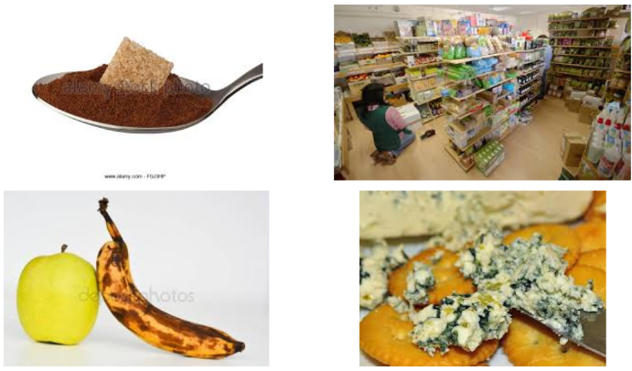
Figure 4.1: Representative Waste Dataset Images – Organic and Recyclable Categories
(Created Using python)
The representative images show the visual diversity in the classification problem. Organic waste can vary significantly in colour, shape, texture and degree of decomposition, as can the materials recycled, which include transparent, reflective and coloured shards and shapes. This variation gives rise to intra-class variation, which has to be accommodated by the classifier. At the same time, some of the objects may belong to the other class as well and have visual characteristics of the other class, so that the separation between these two classes is not as clearly defined as in an object recognition problem.
The size of the dataset provides sufficient image instances for comparison experiments using deep learning (Nnamoko, Barrowclough and Procter, 2022). The relatively large size of the training set is especially important for the Custom CNN, since the network needs to extract the features from the images directly out of the training set. The transfer-learning models, on the other hand, begin with ImageNet pre-trained representations that might be more suited for low-level and mid-level feature extraction.

4.3 Image Preprocessing and Augmentation Analysis
The resolution of all images was changed to 224x224 pixels. This is the dimension used for this input since it matches the dimension of the architectures used for experimentation, namely MobileNetV2, ResNet50 and VGG16. The standardisation of image dimensions also guarantees a uniform dimension of the tensor fed into the Custom CNN and a common input resolution for the four models, enabling them to be compared with each other.
Albumentations were used for transformations in the implemented training pipeline. To add some illumination variation, random brightness and contrast modification was added. Changes in hue, saturation and value were applied to the colour characteristics (Ahmed et al., 2023). Affine transformations were used to add changes of scale, translations, rotations and shear. The pictures were also mirrored horizontally. Images were also mirrored with respect to the x-axis. The rest of the transformations were Gaussian blur, motion blur, median blur, Gaussian noise, ISO noise and coarse dropout.
These transformations can be used in an operational setting for recognising waste in images taken in operational environments, where illumination, orientation, sharpness, camera position, and background conditions can vary. An image recognition system trained solely on visually similar images can be too dependent on the characteristics of the training set. Augmentation is thus an attempt to expand the scope of visual conditions in which the learner is exposed while training.
The augmentation configuration was fairly high. The image size range were allowed to vary from 90% to 110%, the image size was allowed to be translated up to 10% and the image size were allowed to be rotated up to 25° of the image size. The brightness and contrast may be adjusted by 20%. Probabilistic blurring and noise were applied to the images, and coarse dropout was used to select parts of the images. The aim was to expand the training distribution without changing the nature of the training class.
The code also has implementations of MixUp and CutMix. However, they were defined but were not included in the train_dataset processing pipeline (Abdu and Noor, 2022). Thus, the model results reported are not due to MixUp or CutMix training. This is significant from a methodological point of view, since there are different types of control, which are not equivalent.

4.4 Generative Augmentation Analysis
For the experimental implementation, a generative AI component was integrated with the aid of Stable Diffusion. The model was loaded using the pipeline called runwayml/stable-diffusion-v1-5, and some prompts for Organic and Recyclable waste were generated. Five synthetic Organic images and five synthetic Recyclable images were created.
The images produced are used as examples of the two target categories to demonstrate the use of generative AI to produce a larger sample of target images. The food waste for the Organic prompt was in the form of banana peels, vegetable waste, fruit waste and compost, while the Recyclable prompt included plastic bottles, aluminium cans, paper and cardboard, and glass bottles. The items created in this manner were then conceptually connected with the categories of classification.
The order of implementation, however, was important. The training set was instantiated prior to the generation of images with Stable Diffusion (Sujon et al., 2025). As such, the reported training runs did not include the 10 images that were created after the image was generated into the train_dataset object. Therefore, it is not suitable to report the performance as proof that the Stable Diffusion augmentation worked to improve classification performance.
The generative part could better be understood as an exploratory extension to showcase the capability of synthetic data generation. The inclusion of it implies that this project considered more advanced augmentation than just transformations of images, and even though the results of the model are stated, it can be assumed that the actual training pipeline is at fault.

4.5 Experimental Model Configuration
Four architectures were evaluated to conduct a comparative evaluation of a purpose-built CNN and existing transfer-learning networks. The Custom CNN had 4 convolutional blocks with the number of filters being 32, 64, 128 and 256 respectively. After the convolutional layers, it was followed by the use of batch normalisation and max pooling. This extracted representation was then passed through a dense network with 512 and 128 neurons, dropout regularisation to avoid overfitting, and a single sigmoid output node to perform binary classification.
The architecture used for the transfer learning was a lightweight architecture named MobileNetV2. It is based on a frozen base CNN followed by GEP, Batch Normalisation, Dense layers and Dropout (Naseer et al., 2022). A deep residual ResNet50 was used for a similar transfer-learning approach. Also using features pre-trained on ImageNet, VGG16 had the convolutional base frozen and a custom classification head attached.
All four models were trained using the Adam optimiser, a learning rate (LR) of 0.0001 and binary cross-entropy loss. Each of the models was trained for 5 epochs. Early stopping, learning-rate reduction, and model checkpointing were used. The training environment thus maintained the structure of optimisation, and the different architecture changes altered the result of training.

4.6 Custom CNN Training Analysis
The accuracy of the Custom CNN improved with every iteration, as the training continued. The accuracy of the training was enhanced from 0.7473 to 0.8234 from epoch 1 to epoch 5. Training loss at the same time dropped from 0.6560 to 0.4080. From this pattern, it is evident that the network is learning more and more discriminative representations from the augmented training data.
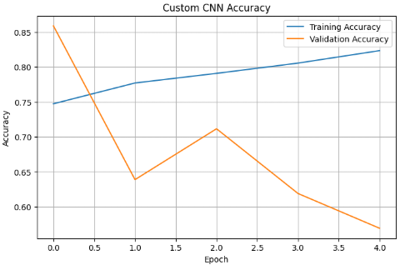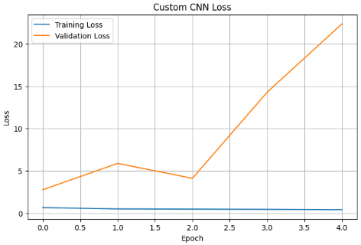
Figure 4.2: Custom CNN Training and Validation Accuracy
(Created using Python)
Validation behaviour was completely unique. Validation accuracy began at 0.8587, decreased to 0.6387 in Epoch 2, increased to 0.7115 in Epoch 3 and then declined to 0.6188 and 0.5690 in Epochs 4 and 5. The loss on the validation data jumped from 2.7706 at Epoch 1 to 22.3724 at Epoch 5. This difference between the behaviour of the training and validation sets is a good sign of overfitting or distributional mismatch (Alem and Kumar, 2022).
This led to the model achieving poorer performance on the test data, while simultaneously having a greater ability to fit the training data. This behaviour is especially crucial as it illustrates the need not just to train for accuracy to determine the best model. The results indicated that the final model could achieve an accuracy of 82.34% in training and was not so high in the evaluation accuracy.
The evaluation produced an accuracy of 85.87%, precision of 88.66%, recall of 78.06% and F1-score of 83.02%. The precision of the class-level report was 0.84, and the recall was 0.92 for the Organic class and 0.89 and 0.78 for the Recyclable class. In this way, the Custom CNN was more successful in recognising Organic images and failed to recognise more Recyclable images.
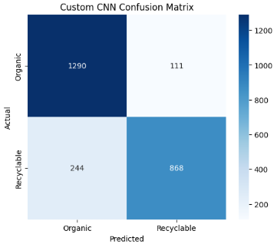
Figure 4.3: Custom CNN Confusion Matrix
(Created Using Python)
The confusion matrix had 1,290 Organic images correctly classified and 868 Recyclable images correctly classified. 111 Organic images were classified as Recyclable, and 244 Recyclable images were classified as Organic. The lower Recyclable recall is due to the fact that there was a higher number of "Recyclable-to-Organic" errors. This would imply that a substantial number (and possibly a large number) of recyclables would be classified as organic waste, when in reality they are not.

4.7 MobileNetV2 Training Analysis
The lowest overall classification performance was obtained with MobileNetV2. The accuracy of the training set rose steadily from 80.80% (Epoch 1) to 88.16% (Epoch 5), and the loss decreased from 0.4295 to 0.2854. This is because it is crucial to effectively optimise the training data.
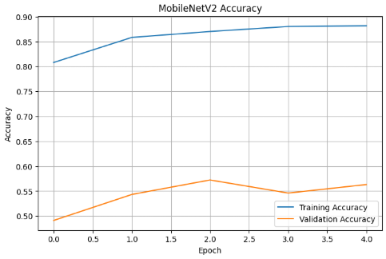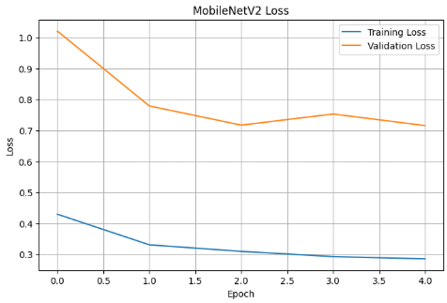
Figure 4.4: MobileNetV2 Training and Validation Accuracy
(Created using Python)
However, quite a few points were still missing in the accuracy of the evaluation. The validation accuracy was 49.10% during the first epoch, achieving 57.22% during the third epoch, which was the highest, and finally dropping to 56.31% in Epoch 5. The loss has decreased from 1.0210 to 0.7158, but the loss has been much higher than the training loss. The training-validation gap is the lack of generalisation of the developed configuration (Alotaibi et al., 2022).
Further evidence of class imbalance in model behaviour is provided in the classification report. The precision for Organic was 0.76, and the recall was 0.32. The precision and recall values for the recyclable class were 0.50 and 0.87, respectively. The overall F1-score was just 0.6381.
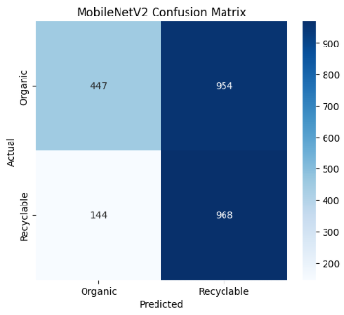
Figure 4.5: MobileNetV2 Confusion Matrix
(Created Using Python)
The confusion matrix shows that there were 968 Organic images correctly classified and 447 Recyclable images correctly classified. However, 954 of the images were misclassified as Recyclable, and 144 of the images were misclassified as Organic. This means that it has a high score for predicting the Recyclable class (Altun et al., 2023). The high Recall for Recyclable is therefore not compensated by the very low Recall for Organic, unless it is for the sake of argument. The high Recall for Recyclable is therefore not even compensated for by the extremely low Recall for Organic (for the sake of argument).
MobileNetV2 initially caught my eye because of its low resource usage and support for deployment on resource-constrained devices. The effects of the lightweight architecture, however, are not enough for the dataset and the training procedure in this study to provide a good classification.

4.8 ResNet50 Training Analysis
When compared to the other architectures, ResNet50 showed moderate performance. For the best part, the accuracy of the training increased to 78.07% during Epoch 5 from 71.12% during Epoch 1, with the loss reduced from 0.5875 to 0.4671.
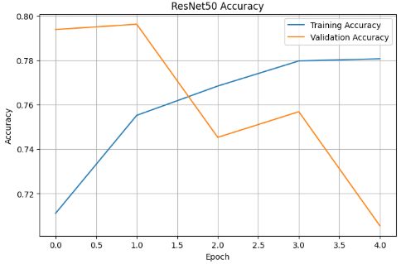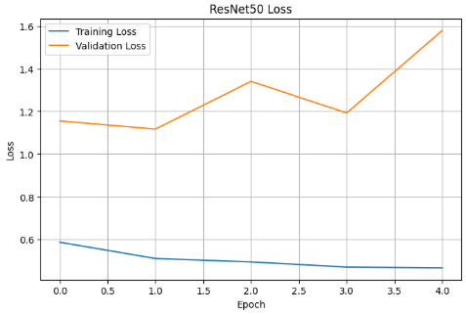
Figure 4.6: ResNet50 Training and Validation Accuracy
(Created Using Python)
For the 2nd epoch, validation accuracy reached 79.63%, then it decreased to 70.55% at the 5th epoch. The validation loss also increased from 1.1552 to 1.5787 when the epoch number increased from 1 to 5. This difference between the training and evaluation performance thus became clearer in the later epochs (Itam, Martin and Horsfall, 2024).
The accuracy of the final evaluation was 79.63%, and the precision, recall and F1-scores were all around 76.98%. The results of the precision and recall were mostly comparable between the classes: For organic, precision was about 0.82 and recall was also about 0.82, and for recyclable, precision was also about 0.77 and recall was also about 0.77.
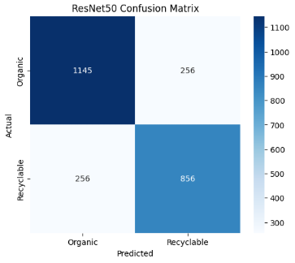
Figure 4.7: ResNet50 Confusion Matrix
(Created Using Python)
The confusion matrix has 1145 Organic images that are correctly classified and 856 Recyclable images that are correctly classified. There were 256 errors of both types. ResNet50 did not exhibit as discernible a class bias in the symmetrical error pattern, unlike MobileNetV2. The overall discriminative ability was not as good as that of the Custom CNN and VGG16, though.

4.9 VGG16 Training Analysis
VGG16 had the best overall performance. The accuracy of the trained model went from 81.14% in Epoch 1 to 88.99% in Epoch 5, and the loss of the trained model went from 0.4132 to 0.2747.
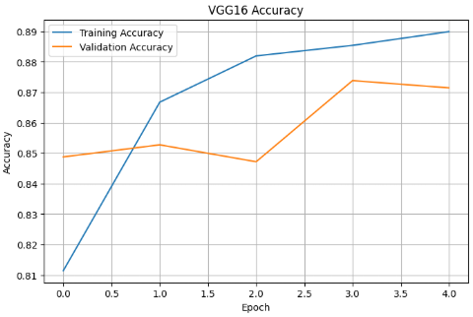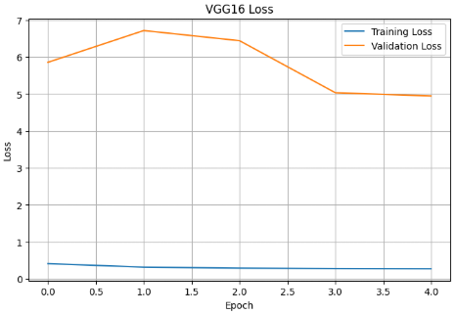
Figure 4.8: VGG16 Training and Validation Accuracy
(Created Using Python)
VGG16 had relatively stable and good validation set results as compared to the other models. In Epoch 1, the accuracy increased from 84.88% to 87.39% in Epoch 4 and decreased to 87.15% in Epoch 5. The validation loss went down from 5.8573 at epoch 1 to 4.9463 at epoch 5; however, the absolute value of the validation loss is still high compared to the training loss (Chatterjee et al., 2022).
The final accuracy was 87.15%, precision was 92.28%, recall was 77.43%, and F1-score was 84.21%. The precision is high, indicating that the predictions made for the corresponding class are relatively trustworthy; recall is a bit lower.
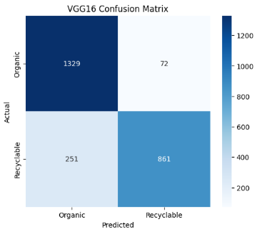
Figure 4.9: VGG16 Confusion Matrix
(Created Using Python)
In this confusion matrix, 1329 Organic images were correctly classified, and 861 Recyclable images were correctly classified. Of the 72 images classified as Recyclable were of the 72 Organic, 251 were classified as Recyclable (Chen et al., 2024). The model thus showed particularly strong performance in the Organic classification, with the main error being the classification of recyclable material as Organic.

4.10 Comparative Metric Analysis
The results indicate that there are considerable performance differences between the four architectures. The accuracy of VGG16 was the highest with 87.15%, the Custom CNN 85.87%, the ResNet50 79.63%, and the MobileNetV2 56.31%. The results indicate that the classification model's architectural design has a significant effect on the discrimination of the organic and recyclable waste categories. Although the overall accuracy of classification was evaluated using the same experimental data but different test procedures, VGG16 performed best with the same data, and MobileNetV2 performed poorly despite its relatively high training accuracy.
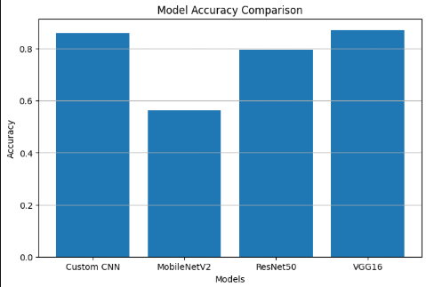
Figure 4.10: Model Accuracy Comparison
(Created Using Python)
VGG16 also performed the best in terms of precision with 92.28%. The custom CNN model, ResNet50 model and MobileNetV2 model obtained 88.66%, 76.98% and 50.36% accuracy, respectively. As for the precision results, it can be seen that the VGG16 network model is better than the other network models in terms of reducing false positive classification. In the waste sorting application, this is important as a high precision value means that the predictions in the target recyclable category were relatively accurate (Kumsetty et al., 2023). The high accuracy of the Custom CNN also demonstrated that the network's deeper convolutional layers were able to capture important visual features from the waste images. MobileNetV2 achieved a higher recall but lower precision, showing that the model is not as reliable as the more accurate model, but is making similar predictions.
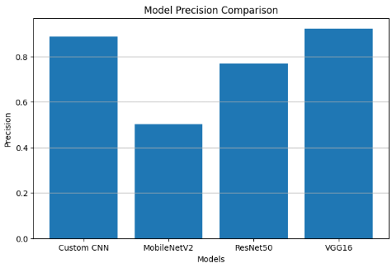
Figure 4.11: Model Precision Comparison
(Created Using Python)
Recall yielded a different ranking. MobileNetV2 achieved the highest recall at 87.05%, followed by Custom CNN at 78.06%, VGG16 at 77.43% and ResNet50 at 76.98%. This difference shows why using one measure may lead to incorrect conclusions. MobileNetV2 exhibited the best recall and the lowest accuracy and precision (Xu et al., 2022). Part of its high recall was due to its tendency to classify images as Recyclable. The recall scores are therefore not to be considered as evidence for the best architecture, namely "MobileNetV2". Rather, it demonstrates that this model performed well in the correct identification of a relatively large proportion of the relevant positive instances, but it also classified a large number of instances as false positives.
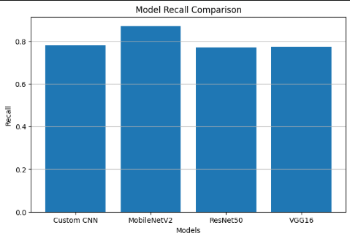
Figure 4.12: Model Recall Comparison
(Created Using Python)
F1-Score is a combination of precision and recall. VGG16 achieved the highest F1-score at 84.21%, followed by Custom CNN at 83.02%, ResNet50 at 76.98% and MobileNetV2 at 63.81%. However, the difference between VGG16 and Custom CNN is not very large, but this difference is noteworthy since both models exhibited reasonably good classification performance. However, VGG16 had an advantage when it comes to accuracy and, more specifically, results. ResNet50, however, obtained equal Precision, Recall and F1-Score (~76.98%) for both classes, resulting in a fairly balanced classification behaviour. This is compared to MobileNetV2, which had the least balanced precision and recall, and hence the overall F1 score was significantly lower.
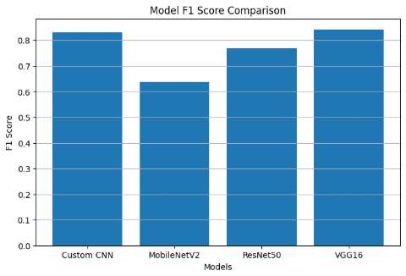
Figure 4.13: Model F1-Score Comparison
(Created Using Python)
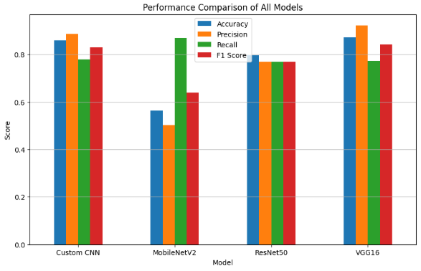
Figure 4.14: Combined Performance Comparison of All Models
(Created Using Python)
When compared to all the networks overall, VGG16 gave the best accuracy, precision and F1 score. The performance of the Custom CNN was competitive, and the performance of ResNet50 was moderate. MobileNetV2 showed good accuracy when trained, but not as much when tested, indicating a lack of generalisation power. The results show that merely training accuracy is not sufficient for model selection. Rather, the use of evaluation metrics gives a more sound basis for comparison since they are based on results on unseen evaluation data. Based on the experimental setting used, the overall classification accuracy was best for the VGG16 network, making the VGG16 architecture the best network to work with for waste classification.

4.11 Data Analysis Summary
The analysis shows that all four architectures are different in how they react to the same binary classification problem for waste types. The Custom CNN achieved good results, with the gap between training and evaluation behaviour increasing. The training accuracy was good, but the MobileNetV2 model had a high bias towards the Recyclable category. Balanced classification performance was found for ResNet50, which was comparatively low. VGG16 outperforms the other three models in terms of the generalisation metric reported for the four models.
The results also illustrate that high-level augmentation and transfer learning are not necessarily a recipe for better performance. Both the architecture and learned representations, as well as the distribution of training and evaluation examples, impact the results of classification. The results also show that an assessment of class-level performance is required to decide on the classification model in addition to the overall accuracy. The outcomes of the analyses mentioned above should therefore be interpreted in light of the purpose of the research and the practical interpretation of the differences of the observed models.

CHAPTER 5: FINDINGS AND RESULTS

5.1 Introduction
This Chapter presents interpretations of the main findings that were obtained from the experimental evaluation. This chapter focuses on the meaning of the data for the purpose of the study, and the training behaviour and numerical performance will be explored in Chapter 5. The primary aim was to investigate image recognition for waste sorting and recycling through the comparison of different deep-learning architectures with the aim of waste classification of Organic and Recyclable waste.
The results demonstrate that a CNN can be successfully used to solve the classification problem presented in this work, albeit with different performances based on the CNN architecture. VGG16 had the overall best result, with the worst overall result in MobileNetV2, and the highest recall score, according to Linhore et al. (2024). ResNet50 was in the middle, and the Custom CNN provided a competitive solution. The differences suggest that the selection of architecture is an important aspect in designing reliable waste-classification systems, especially if the consistency of classification with respect to several performance measures is needed.

5.2 Principal Experimental Finding
The main outcome is that the overall evaluation performance of VGG16 is the highest. It achieved a higher accuracy rate than the Custom CNN (85.87%), ResNet50 (79.63%) and MobileNetV2 (56.31%). The performance difference between VGG16 and the Custom CNN is relatively small (1.28 percentage points), indicating the Custom CNN is also able to learn meaningful representations for this binary classification task.
The pre-trained feature representations of VGG16 yielded a better result and were therefore more appropriate for discriminating the visual patterns in the waste data set (Poudel and Poudyal, 2022). The results showed that the model had a precision of 92.28%, suggesting that the number of false positive predictions was relatively low based on the metric used. It further had the best F1 score (84.21%), meaning that it had the best balance between precision and recall among the other models tested.
Table 5.1: Final Comparative Performance of the Four Classification Models
Model | Accuracy | Precision | Recall | F1-score
VGG16 | 87.15% | 92.28% | 77.43% | 84.21%
Custom CNN | 85.87% | 88.66% | 78.06% | 83.02%
ResNet50 | 79.63% | 76.98% | 76.98% | 76.98%
MobileNetV2 | 56.31% | 50.36% | 87.05% | 63.81%
The results therefore confirm that DNNs are good frameworks for waste classification. They also show that a set of criteria besides computational efficiency and model popularity should be taken into account when choosing an architecture.

5.3 Finding Concerning the Custom CNN
The second-best accuracy and competitive F1-score were achieved by the Custom CNN model. This is an important achievement since an ImageNet pre-trained feature extractor was not employed in training this model. Instead, it takes the convolutional representation from the waste dataset. This accuracy of 85.87% is proof that a CNN designed for a specific purpose can provide effective binary classification, with sufficient training data and augmentation.
The confusion matrix indicates that the Custom CNN is able to classify all 1290 Organic images and 868 Recyclable images. The main drawback was the categorisation of Recyclable images as Organic, as there were 244 such errors reported (Gurcan and Soylu, 2025). This indicates that the model represented organic waste, but not recyclables sufficiently.
The generalisation problem in the model is indicated by the training curves. The training accuracy was steadily increasing, and the validation accuracy was sharply decreasing after the first epoch. The loss on the validation set rose significantly, to 22.3724 in the fifth epoch. These indicate that the generalisation may be further improved by further optimisation of the Custom CNN, including using more effective regularisation, a better validation design, and systematic hyperparameter tuning.

5.4 Finding Concerning MobileNetV2
The slowest was MobileNetV2. Although the training accuracy is 88.16%, the accuracy and F1 score of the model are 56.31% and 63.81%, respectively. The gap between training and evaluation performance is quite large, suggesting that the model is learned much better in the training distribution as compared to the evaluation distribution.
The confusion matrix is of great value. The model predicted 968 images as Recyclable from 968 images that were classified as Recyclable, while 954 images were classified as Organic, but the model classified these images as Recyclable. Consequently, only 32% of the people who remembered the product were able to correctly identify it as Organic. The recall for Recyclable was 87%, but this is not a general indication of performance, as the precision for Recyclable images was 50%.
It demonstrates a significant distinction between one-class sensitivity and balanced classification. MobileNetV2 had successfully classified a considerable amount of the examples as recyclable, but had made some mistakes and classified some of the examples as Recyclable class. The problem with this behaviour is that it could result in a lot of Organic items being fed into the recycling stream.
The result also applies to the main purpose of exploring MobileNetV2 as a lightweight architecture. From experience, it appears that lightweight design does not necessarily require compromises with reliability of classification and deployment with computational efficiency. Unfortunately, with the current training setup, MobileNetV2 failed to achieve the desired overall performance and was not selected as the preferred model.

5.5 Finding Concerning ResNet50
The intermediate results were achieved for ResNet50 with 79.63% accuracy, 76.98% precision, recall and F1-score. It had a 256x256 confusion matrix with errors in both directions in both classes. This is a balanced error pattern, showing that the model did not have the severe class prediction bias like the one exhibited by MobileNetV2.
The model was less discriminative than VGG16 and Custom CNN, however. The validation accuracy decreased (Epoch 2), and the validation loss increased (Gracia and Winarsih, 2025). After using the frozen ResNet50 feature representation and the classification head used in the experiment, the model did not appear to be best suited for the data in the waste dataset for 5 epochs.
Just because it's not suitable for waste classification doesn't mean ResNet50 isn't suitable for waste classification in general. Rather, it shows that the performance of the architecture relies on the implementation configuration, such as the amount of transfer learning, fine-tuning approach, optimisation parameters, and the nature of the dataset. While this is not the optimal performance of the ResNet50 algorithm, it is due to the experimental design.

5.6 Finding Concerning VGG16
Overall, VGG16 was the best model in the principal aggregate measures. The model achieved 87.15% accuracy, 92.28% precision and 84.21% F1-score. It held steady in its validation accuracy, ending up at 87.39% at Epoch 4 and 87.15% at the final epoch.
As can be seen in the confusion matrix, the performance for Organic is good (1329 correctly classified images). 72 Organic images were predicted as Recyclable. However, the prediction of images as Recyclable included 251 Organic images, and the major drawback of this model was the identification of images as Recyclable. (Rachburee and Punlumjeak, 2022).
This is reflected in the class-level indicators. The organic recall was 95%, while the Recyclable recall was 77%. Hence, the overall accuracy of 87.15% must not be taken to represent the level of accuracy in both categories. The model has a huge edge in identifying Organic examples and all the Recyclable examples.
VGG16 however is the best model in the experiment implemented, owing to its high accuracy, high precision and highest F1-score. Given the outcome, Capsules may be designed to resist the choice of the classification architecture (VGG16) that was employed in this study.

5.7 Relationship Between the Findings and Waste-Sorting Application
The results are practically applicable since the accurate separation between waste categories is key to automated waste sorting. Misclassification may decrease the efficiency of recycling and can lead to contamination of waste streams. Therefore, the model's accuracy in the classification task should not be limited to the training accuracy; it should be accurate in predicting both classification targets.
The results of VGG16 showed that transfer learning is useful technique to obtain the visual representation of waste classification. The model has an Organic recall rate of 0.9, which allows it to find most of the examples in the Organic category, and also a high Recyclable (meaning that many examples in the Recyclable category are recalled when the model is asked to recall them). However, 23% of Recyclable examples were not identified in the reported recall value. This restriction should be interpreted as the system being a classification prototype and not a stand-alone industrial sorting system.
The results also show that the confusion matrix is useful mainly for the evaluation of the application. The confusion matrices show the type of mistakes (false positives and false negatives) made and the mean of the errors showed the direction of the error, namely whether the system is more likely to classify Organic as Recyclable or Recyclable as Organic, as shown in the tables in Patria et al. (2026). When considering deployment, it is important to remember this directional information because the ramifications of the error may vary.

5.8 Achievement of the Research Aim and Objectives
The experimental work is very relevant to the objective of the study of recognising images for waste sorting and recycling. A large image database, consisting of Organic and Recyclable classes, was implemented, trained and tested for a binary image-classification system. Four CNN architectures are compared against each other directly in the same experimental setting, providing a direct comparison of their suitability for automatic waste classification.
The comparison objective was met directly, as the general data preparation and metric framework to train and evaluate the Custom CNN, MobileNetV2, ResNet50 and VGG16 were the same. The accuracy, precision, recall, F1-score and confusion matrices (Gulzar, 2023) was used as complementary evidence for the model comparison. As the models showed diverse classification behaviours, the use of this multi-metric approach was highlighted. VGG16 was the most accurate with accuracy of 87.15%, the most precise with the F1 score of 84.21% while the least accurate and least precise were recorded by the MobileNetV2 network with the result being 81.53% and 87.05% respectively.
Conventional augmentation operations, such as brightness and contrast adjustment, colour changes, affine transformations, flipping, blur, noise and coarse dropout were also implemented to address the objective of investigating data augmentation. Within the experimental workflow, MixUp and CutMix functions were also added. Both organic and recyclable waste categories were observed to use an exploratory approach for creating synthetic images using the generative AI part of the system with Stable Diffusion. Nevertheless, the pictures produced were "instantiated" after the "training set" was produced and thus should not be presented as part of the claimed performance. Their contribution is more correctly viewed as an exploratory part of a proof-of-concept exercise to show the possibilities of generative augmentation.
To achieve the goal of model selection, the final comparative analysis was used. The VGG16 model achieved the highest accuracy, the highest precision, the highest F1 score and the others were outperformed in the other metrics, while the Custom CNN model was the second best with the highest overall accuracy. MobileNetV2 achieved a significant difference between its training and evaluation performance, while the ResNet50 exhibited moderate and relatively balanced performance (Haynes, Johnston and Elyan, 2024). The results show that the experimental comparison was implemented in order to achieve the research goals and not just by addressing them theoretically.

5.9 Methodological Limitations Affecting Interpretation
One of the major methodological weaknesses is to train the model using test_dataset and validation_data it. This means that one set of 2,513 images are used to train the monitoring, and used later in the assessment process. Consequently, the reported results should not be understood to reflect a completely independent estimate of results on the test set, but rather as results on the evaluation set. This is significant as the results of the evaluation can give a more generous appraisal of the generalisation than a fully isolated test set.
The second one is that the number of epochs for training is insufficient (5 epochs). This was sufficient to show that there were differences in the architecture, but not so sufficient as proof of the best performance of each architecture. For a few examples, the models continued training at the end of the epochs, as is visible in the training history of the models. This means that longer training, using suitable monitoring of the validation set, might yield better performance or rankings of the architectures.
A third factor is the frozen version of the transfer-learning bases. The base layers of MobileNetV2, ResNet50 and VGG16 were used for the evaluation. While it reduces computational expense and allows using the pre-trained representations, it reduces the adaptability of the feature extractors to specific visual characteristics of the waste images. It may be possible to further optimise selected upper layers to adapt better to the target classification problem.
Another restriction is the differences in training and evaluation results. The MobileNetV2 model achieved 88.16% accuracy during training and 56.31% during evaluation, which demonstrated a significant gap between the two (Santos and Papa, 2022). The difference between the training and evaluation actions of the Custom CNN was also minimal. The differences reflect differences in the effect of the dataset and augmentation pipeline on the architectures, and that good training performance was not always associated with good performance on test images.
The augmentation pipeline needs sensitive interpretation, as well. The experiment fails to carefully ablate each of the augmentation techniques in order to isolate the contribution of the individual techniques. Hence, it is not possible to draw any conclusions about the impact of a certain transformation on the performance of a model. Again, the images created using Stable Diffusion were not included in the already instantiated training set that was employed to obtain the reported results of the model. These therefore are not to be read as being indicators of an improvement in measurable performance but rather as an exploratory demonstration.
The restrictions do not impact the comparative results. Rather, they give ranges of interpretation of the results. Under the conditions mentioned, the most optimal outcome that can be concluded from the experiment is that the VGG16 model performed best. The results shouldn't, however, be taken to mean that VGG16 would always outperform the other architectures for all datasets, training methods or deployment settings.

5.10 Overall Findings
Overall, the experiment shows that using deep learning for image classification is a useful tool to differentiate Organic and Recyclable waste. VGG16 performed best overall, followed closely by Custom CNN; ResNet50 had moderate classification ability with some class bias; and MobileNetV2 had some significant class bias.
What is most significant, however, is not only the high accuracy of 87.15% that was obtained by one of the models, but that the choice of the model actually had an impact on the classification behaviour. These findings corroborate the importance of using multiple metrics and analysing at the class level when designing a machine-learning system for waste management.

CHAPTER 6: CONCLUSION

6.1 Introduction
This study aimed to investigate the potential for implementing deep-learning-based image recognition for waste sorting and recycling, with a special focus on binary classification of Organic and Recyclable waste. The research was inspired by the necessity of better and automated methods of waste segregation and the availability of computer vision for such waste classification, which is generally reliant upon manual waste sorting processes.
The experimental work was completed, and a comparative framework for deep learning based on a large scale of images with four convolutional architectures was implemented. A Custom CNN and three Transfer-Learning models (MobileNetV2, ResNet50 and VGG16) were trained in conjunction with each other. Models were evaluated using accuracy, precision, recall, F1 score and a confusion matrix to analyse the models from multiple perspectives and, finally, choose the best model based on the experimental results obtained by comparing them.

6.2 Summary of the Experimental Work
The training set consisted of 22,576 images and the evaluation set comprised 2,513 images, all of which were Organic and Recyclable waste images. Images were resized to 224 × 224 pixels, and the training pipeline involved a number of image augmentation operations aimed at adding visual variation. They comprised brightness-contrast adjustment, colour transformation, affine transformation, horizontal flip, blur, noise and coarse dropout.
Another approach was to experiment with a generative AI element using the Stable Diffusion model. Ten synthetic images were generated, consisting of five Organic and five Recyclable examples. This demonstrated the potential for being part of a larger methodological approach. However, the model performance reported is not necessarily correlated to the images generated since these images were generated after the instantiation of the training images.
The Custom CNN was made up of four convolutional blocks and fully connected classification blocks. The convolutional bases were pre-trained on ImageNet and used for all three models, with the exception of the classification layer, which varied between each model. The four models were trained for 5 epochs using the Adam optimiser, binary cross-entropy loss and early stopping, learning-rate reduction and checkpointing.

6.3 Main Conclusion from the Results
The main result is that the VGG16 model is the most powerful model using the experimental setup used. It achieved 87.15% accuracy, 92.28% precision, 77.43% recall and 84.21% F1-score. It achieves better overall accuracy and F1-score than the Custom CNN, ResNet50 and MobileNetV2.
The accuracy of the Custom CNN is 85.87%, and the value of F1 is 83.02%, indicating that by designing a CNN that is trained on a classification problem, one can achieve performance equivalent to that of pre-trained CNN representations trained on ImageNet. It performed marginally worse than VGG16, indicating that there is sufficient visual data to be used to train meaningful class representations in a custom network.
ResNet50 achieved 79.63% accuracy and an F1-score of 76.98%. The errors in the two classes were almost comparable to its overall classification accuracy, which was lower than that of VGG16 and Custom CNN.
The accuracy with MobileNetV2 was the lowest (56.31%). The least precise model with the lowest precision of 50.36% and the lowest F1 score of 63.81% was the one with the highest recall of 87.05% among all four models. The confusion matrix verified that it was strongly predicting Recyclable, and that it had very low Organic recall. Therefore, such a system with high recall was not enough for achieving effective waste classification.

6.4 Implications for Automated Waste Sorting
The results show that image recognition can be used as a complementary technology for waste sorting. Overall accuracy of approximately 87% in the model allows for classification of a fair portion of the images of Organic and Recyclable waste, showing that computer vision holds promise for automated or semi-automated waste classification.
The conclusion, however, that this developed model is suitable for unrestricted autonomous industrial use is not justified by the results. To be precise, the VGG16 model has an accuracy of 97% on the test set, as evidenced by the confusion matrix, with 323 images misclassified out of 2,513 images. 251 Recyclable images were determined to be Organic. Such errors can lead to the wrong items being recyclable.
The correct conclusion is that the study offers a proof-of-concept for a viable classification approach instead of an actual industrial sorting system. However, larger data sets, a wider range of environmental parameters and independent testing and implementation into physical sorting devices would be required for the real world.

6.5 Contribution of the Comparative Approach
The direct comparison of the four different CNN configurations is one of the main findings of this study. No attempt was made to decide which architecture would be best suited; this was tested in an empirical way in a common framework. This showed that model selection can significantly impact the classification results.
The results also illustrate the need to take into account several metrics. For the purpose of recall only, MobileNetV2 seems to be the best model. However, its low precision, low F1-score and low overall accuracy indicate otherwise. On the basis of comparing all the models, the VGG16 model was chosen for the present work as it has the best overall balance.
Also notable is the fact that not all classification problems are solved best by a lightweight architecture, as seen in the comparison. MobileNetV2 is appealing to deploy but underperforms, as there is a trade-off between classification and lightweight architecture.

6.6 Limitations
The major constraint is the evaluation approach. The dataset for evaluation was given as validation_data to the training process and was finally evaluated. Thus, the reported values should not be considered as an unbiased independent test estimate. The data should be divided into independent sets of training, validation and unseen data sets for future experiments.
The second is that the training takes 5 epochs; it's a bit too many epochs. The brief training time was sufficient to demonstrate the evidence for comparison, but not to indicate the capacities of each of the architectures. It may be different with other epochs, early stopping parameters, and hyperparameter tuning.
One concern is that the base layers might not thaw when transfer learning is performed. Seeking a closer match of the visual properties for waste, the selected layers of VGG16, ResNet50, or MobileNetV2 could be fine-tuned. Finally, systematic tuning of the learning rate, dropout, classifier size and the strength of augmentation could be applied to further enhance the generalisation.
The generative AI component needs to be further explored. Although the examples generated by Stable Diffusion were synthetic, they did not need to be shown during the training process; hence, they are not mentioned in the results of the training. The experiments described should be repeated, training the model on the set after the generation of the synthetic images and controlled comparison of the models trained with the synthetic images with those not trained with them.

6.7 Recommendations for Future Work
Future studies should first be set up with a strict training, validation and testing three-way structure. The validation set should be kept as a separate set for model selection and hyperparameter optimisation, and the final test set should be kept entirely separate for final evaluation. This would give a more reliable estimate of the generalisation performance.
Besides, more investigations are required to investigate fine-tuning, beyond frozen transfer-learning bases. The best current performance is obtained with VGG16, which can be optimised step-wise by unfreezing some of the higher convolutional layers. Controlled experiments could be done for ResNet50 and MobileNetV2 as well.
Further, more varied real-world conditions should also be considered in the dataset. Acquired images should provide a more representative basis for deployment based on various lighting, backgrounds, camera positions, the direction of the object, and occlusion. Then more categories of waste could be added to take a step further towards binary waste to multi-class waste recognition.
The other potential research direction is the Stable Diffusion part. To compare the baseline training set to training sets with a larger number of synthetic images, a controlled ablation experiment might be conducted. This would be useful to see whether the generalisation was being affected by the generative augmentation or just the dataset being augmented.
Finally, there is the possibility of examining deployment efficiency in future development. The computation load for VGG16 is undoubtedly higher than a lightweight model but is the best model in this experiment. Model compression, quantisation or knowledge distillation may thus be considered to see if it's possible to get VGG16-level performance with a more deployment-efficient model.

6.8 Final Conclusion
The study concludes that image recognition based on deep learning is a good approach to automatically classify waste streams into Organic and Recyclable streams. Results from the experimental comparison showed that there were significant differences among the four architectures that were evaluated, with VGG16 having the highest overall accuracy (87.15%) and the highest F1-score (84.21%).
After all, a relatively standard CNN can be competitive with an accuracy of 85.87% and an F1 score of 83.02% with enough data and augmentation; the Custom CNN was also very competitive. ResNet50 performed moderately, with moderate class errors for both the balanced class errors and the single high recall metric, Recyclable. In the case of MobileNetV2, the weakness of relying on a single high recall metric was highlighted, as the high Recyclable recall rate was accompanied by high Organic misclassifications.
The study will therefore be the groundwork for the application of convolutional image recognition in the field of waste sorting, while keeping in mind the existing methodological and deployment limits. The selected model, VGG16, is the most popular model tested so far but should be further tested with a different set of test data, fine-tuned, and/or additional real-world data and/or controlled synthesis augmentation, before being implemented in real waste management systems.
Overall, the work provides a technically sound proof of concept for an image-based waste classification system and shows that a careful comparison of the architectures of deep learning systems is crucial for use in a recycling-related application. The results help inform future efforts in the direction of more resilient and scalable automated waste sorting systems that are also deployment-friendly.

References
Abdu, H. and Noor, M.H.M., 2022. A survey on waste detection and classification using deep learning. Ieee Access, 10, pp.128151-128165.
Ahmed, M.I.B., Alotaibi, R.B., Al-Qahtani, R.A., Al-Qahtani, R.S., Al-Hetela, S.S., Al-Matar, K.A., Al-Saqer, N.K., Rahman, A., Saraireh, L., Youldash, M. and Krishnasamy, G., 2023. Deep learning approach to recyclable products classification: Towards sustainable waste management. Sustainability, 15(14), p.11138.
Ahmed, M.I.B., Alotaibi, R.B., Al-Qahtani, R.A., Al-Qahtani, R.S., Al-Hetela, S.S., Al-Matar, K.A., Al-Saqer, N.K., Rahman, A., Saraireh, L., Youldash, M. and Krishnasamy, G., 2023. Deep learning approach to recyclable products classification: Towards sustainable waste management. Sustainability, 15(14), p.11138.
Alem, A. and Kumar, S., 2022. Deep learning models performance evaluations for remote sensed image classification. Ieee Access, 10, pp.111784-111793.
Alotaibi, G., Awawdeh, M., Farook, F.F., Aljohani, M., Aldhafiri, R.M. and Aldhoayan, M., 2022. Artificial intelligence (AI) diagnostic tools: utilizing a convolutional neural network (CNN) to assess periodontal bone level radiographically—a retrospective study. BMC Oral Health, 22(1), p.399.
Alsubaei, F.S., Al-Wesabi, F.N. and Hilal, A.M., 2022. Deep learning-based small object detection and classification model for garbage waste management in smart cities and IoT environment. Applied Sciences, 12(5), p.2281.
Altikat, A.A.A.G.S., Gulbe, A. and Altikat, S., 2022. Intelligent solid waste classification using deep convolutional neural networks. International Journal of Environmental Science and Technology, 19(3), pp.1285-1292.
Altun, M., Gürüler, H., Özkaraca, O., Khan, F., Khan, J. and Lee, Y., 2023. Monkeypox detection using CNN with transfer learning. Sensors, 23(4), p.1783.
Baker, N.A., Szabo-Müller, P. and Handmann, U., 2026. Transfer learning-based method for automated ewaste recycling in smart cities. arXiv preprint arXiv:2606.23286.
Bashkirova, D., Abdelfattah, M., Zhu, Z., Akl, J., Alladkani, F., Hu, P., Ablavsky, V., Calli, B., Bargal, S.A. and Saenko, K., 2022. Zerowaste dataset: Towards deformable object segmentation in cluttered scenes. In Proceedings of the IEEE/CVF conference on computer vision and pattern recognition (pp. 21147-21157).
Bernat, K., 2023. Post-consumer plastic waste management: from collection and sortation to mechanical recycling. Energies, 16(8), p.3504.
Bobulski, J. and Kubanek, M., 2021. Deep learning for plastic waste classification system. Applied Computational Intelligence and Soft Computing, 2021(1), p.6626948.
Carrera, B., Mata, J.B., Pinol, V.L. and Kim, K., 2023. Environmental sustainability: A machine learning approach for cost analysis in plastic recycling classification. Resources, Conservation and Recycling, 197, p.107095.
Chatterjee, S., Hazra, D., Byun, Y.C. and Kim, Y.W., 2022. Enhancement of image classification using transfer learning and GAN-based synthetic data augmentation. Mathematics, 10(9), p.1541.
Che, C., Zheng, H., Huang, Z., Jiang, W. and Liu, B., 2024. Intelligent robotic control system based on computer vision technology. arXiv preprint arXiv:2404.01116.
Cheema, S.M., Hannan, A. and Pires, I.M., 2022. Smart waste management and classification systems using cutting edge approach. Sustainability, 14(16), p.10226.
Chen, C., Liang, R., Song, M., Zhang, Z., Tao, J., Yan, B., Cheng, Z. and Chen, G., 2024. Noise-assisted data enhancement promoting image classification of municipal solid waste. Resources, Conservation and Recycling, 209, p.107790.
Chen, H., 2021. Optimization of an intelligent sorting and recycling system for solid waste based on image recognition technology. Advances in Mathematical Physics, 2021(1), p.4094684.
Chen, X., 2022. Machine learning approach for a circular economy with waste recycling in smart cities. Energy Reports, 8, pp.3127-3140.
Chen, X., Huang, H., Liu, Y., Li, J. and Liu, M., 2022. Robot for automatic waste sorting on construction sites. Automation in Construction, 141, p.104387.
Chen, Z., Yang, J., Chen, L. and Jiao, H., 2022. Garbage classification system based on improved ShuffleNet v2. Resources, Conservation and Recycling, 178, p.106090.
Choi, J., Lim, B. and Yoo, Y., 2023. Advancing plastic waste classification and recycling efficiency: Integrating image sensors and deep learning algorithms. Applied Sciences, 13(18), p.10224.
Du, W., Zheng, J., Li, W., Liu, Z., Wang, H. and Han, X., 2022. Efficient recognition and automatic sorting technology of waste textiles based on online near infrared spectroscopy and convolutional neural network. Resources, Conservation and Recycling, 180, p.106157.
encyclopedia.pub, 2026. Smart Waste Management and Classification Systems. Available at: https://encyclopedia.pub/entry/26822 [Accessed on: 1307.2026]
Erkinay Ozdemir, M., Ali, Z., Subeshan, B. and Asmatulu, E., 2021. Applying machine learning approach in recycling. Journal of Material Cycles and Waste Management, 23(3), pp.855-871.
Fang, B., Yu, J., Chen, Z., Osman, A.I., Farghali, M., Ihara, I., Hamza, E.H., Rooney, D.W. and Yap, P.S., 2023. Artificial intelligence for waste management in smart cities: a review. Environmental Chemistry Letters, 21(4), pp.1959-1989.
Farjana, M., Fahad, A.B., Alam, S.E. and Islam, M.M., 2023. An IoT-and cloud-based e-waste management system for resource reclamation with a data-driven decision-making process. IoT, 4(3), pp.202-220.
getitdoneex.com, 2026. Research Onion. Available at: https://getitdoneex.com/the-research-onion-explained-layers-methodology-and-application/ [Accessed on: 1307.2026]
Gracia, E.S. and Winarsih, N.A.S., 2025. Comparison of VGG16, MobileNetV2, InceptionV3, ResNet50, and custom CNN architectures for furniture image classification. Infotekmesin, 16(1), pp.24-30.
greenmatch.co.uk, 2026. The Power of AI to Reach Environmental Sustainability. Available at: https://www.greenmatch.co.uk/green-intelligence-ai [Accessed on: 1307.2026]
Gulzar, Y., 2023. Fruit image classification model based on MobileNetV2 with deep transfer learning technique. Sustainability, 15(3), p.1906.
Gurcan, F. and Soylu, A., 2025. Automated waste classification for smart recycling: A multi-class CNN approach with transfer learning and pre-trained models. Environmental Technology & Innovation, p.104673.
Hasan, M.K., Khan, M.A., Issa, G.F., Atta, A., Akram, A.S. and Hassan, M., 2022, February. Smart waste management and classification system for smart cities using deep learning. In 2022 International Conference on Business Analytics for Technology and Security (ICBATS) (pp. 1-7). IEEE.
Haynes, S.C., Johnston, P. and Elyan, E., 2024. Generalisation challenges in deep learning models for medical imagery: insights from external validation of COVID-19 classifiers. Multimedia Tools and Applications, 83(31), pp.76753-76772.
Itam, D.H., Martin, E.C. and Horsfall, I.T., 2024. Enhanced convolutional neural network methodology for solid waste classification utilizing data augmentation techniques. Waste Management Bulletin, 2(4), pp.184-193.
Jin, S., Yang, Z., Królczykg, G., Liu, X., Gardoni, P. and Li, Z., 2023. Garbage detection and classification using a new deep learning-based machine vision system as a tool for sustainable waste recycling. Waste Management, 162, pp.123-130.
Koskinopoulou, M., Raptopoulos, F., Papadopoulos, G., Mavrakis, N. and Maniadakis, M., 2021. Robotic waste sorting technology: Toward a vision-based categorization system for the industrial robotic separation of recyclable waste. IEEE Robotics & Automation Magazine, 28(2), pp.50-60.
Koyanaka, S. and Kobayashi, K., 2023. Sensor-based sorting of waste digital devices by CNN-based image recognition using composite images created from mass and 2D/3D appearances. Journal of Material Cycles and Waste Management, 25(2), pp.851-862.
Ku, Y., Yang, J., Fang, H., Xiao, W. and Zhuang, J., 2021. Deep learning of grasping detection for a robot used in sorting construction and demolition waste. Journal of Material Cycles and Waste Management, 23(1), pp.84-95.
Kumar, N.M., Mohammed, M.A., Abdulkareem, K.H., Damasevicius, R., Mostafa, S.A., Maashi, M.S. and Chopra, S.S., 2021. Artificial intelligence-based solution for sorting COVID related medical waste streams and supporting data-driven decisions for smart circular economy practice. Process Safety and Environmental Protection, 152, pp.482-494.
Kumsetty, N.V., Nekkare, A.B., Sowmya Kamath, S. and Anand Kumar, M., 2023. An approach for waste classification using data augmentation and transfer learning models. In Machine Vision and Augmented Intelligence: Select Proceedings of MAI 2022 (pp. 357-368). Singapore: Springer Nature Singapore.
Lakhouit, A., 2025. Revolutionizing urban solid waste management with AI and IoT: A review of smart solutions for waste collection, sorting, and recycling. Results in Engineering, 25, p.104018.
Liang, S. and Gu, Y., 2021. A deep convolutional neural network to simultaneously localize and recognize waste types in images. Waste Management, 126, pp.247-257.
Lilhore, U.K., Simaiya, S., Dalal, S. and Damaševičius, R., 2024. A smart waste classification model using hybrid CNN-LSTM with transfer learning for sustainable environment. Multimedia Tools and Applications, 83(10), pp.29505-29529.
Lin, K., Zhou, T., Gao, X., Li, Z., Duan, H., Wu, H., Lu, G. and Zhao, Y., 2022. Deep convolutional neural networks for construction and demolition waste classification: VGGNet structures, cyclical learning rate, and knowledge transfer. Journal of Environmental Management, 318, p.115501.
Lu, W., Chen, J. and Xue, F., 2022. Using computer vision to recognize composition of construction waste mixtures: A semantic segmentation approach. Resources, Conservation and Recycling, 178, p.106022.
Lu, Y., Yang, B., Gao, Y. and Xu, Z., 2022. An automatic sorting system for electronic components detached from waste printed circuit boards. Waste Management, 137, pp.1-8.
Lubongo, C. and Alexandridis, P., 2022. Assessment of performance and challenges in use of commercial automated sorting technology for plastic waste. Recycling, 7(2), p.11.
Majchrowska, S., Mikołajczyk, A., Ferlin, M., Klawikowska, Z., Plantykow, M.A., Kwasigroch, A. and Majek, K., 2022. Deep learning-based waste detection in natural and urban environments. Waste Management, 138, pp.274-284.
Malik, M., Sharma, S., Uddin, M., Chen, C.L., Wu, C.M., Soni, P. and Chaudhary, S., 2022. Waste classification for sustainable development using image recognition with deep learning neural network models. Sustainability, 14(12), p.7222.
Malik, M., Sharma, S., Uddin, M., Chen, C.L., Wu, C.M., Soni, P. and Chaudhary, S., 2022. Waste classification for sustainable development using image recognition with deep learning neural network models. Sustainability, 14(12), p.7222.
Mao, W.L., Chen, W.C., Fathurrahman, H.I.K. and Lin, Y.H., 2022. Deep learning networks for real-time regional domestic waste detection. Journal of Cleaner Production, 344, p.131096.
Mao, W.L., Chen, W.C., Wang, C.T. and Lin, Y.H., 2021. Recycling waste classification using optimized convolutional neural network. Resources, Conservation and Recycling, 164, p.105132.
medium.com, 2026. Deep Learning for Image Classification. Available at: https://medium.com/data-science/10-papers-you-should-read-to-understand-image-classification-in-the-deep-learning-era-4b9d792f45a7 [Accessed on: 1307.2026]
Mishra, S., Yaduvanshi, R., Rajpoot, P., Verma, S., Pandey, A.K. and Pandey, D., 2024. An integrated deep-learning model for smart waste classification. Environmental Monitoring and Assessment, 196(3), p.279.
Mohamed, A.U. and Cheong, A.C.H., 2023, July. Automated color sorting for material handling system. In SECOND INTERNATIONAL VIRTUAL CONFERENCE ON INTELLIGENT ROBOTICS, MECHATRONICS AND AUTOMATION SYSTEMS (IRMAS2022): Theme: Innovation towards Automated Future (Vol. 2788, No. 1, p. 030007). AIP Publishing LLC.
Mohammed, M.A., Abdulhasan, M.J., Kumar, N.M., Abdulkareem, K.H., Mostafa, S.A., Maashi, M.S., Khalid, L.S., Abdulaali, H.S. and Chopra, S.S., 2023. Automated waste-sorting and recycling classification using artificial neural network and features fusion: A digital-enabled circular economy vision for smart cities. Multimedia tools and applications, 82(25), pp.39617-39632.
Nafiz, M.S., Das, S.S., Morol, M.K., Al Juabir, A. and Nandi, D., 2023, January. Convowaste: An automatic waste segregation machine using deep learning. In 2023 3rd International conference on robotics, electrical and signal processing techniques (ICREST) (pp. 181-186). IEEE.
Naseer, I., Akram, S., Masood, T., Jaffar, A., Khan, M.A. and Mosavi, A., 2022. Performance analysis of state-of-the-art cnn architectures for luna16. Sensors, 22(12), p.4426.
Nnamoko, N., Barrowclough, J. and Procter, J., 2022. Solid waste image classification using deep convolutional neural network. Infrastructures, 7(4), p.47.
Nnamoko, N., Barrowclough, J. and Procter, J., 2022. Solid waste image classification using deep convolutional neural network. Infrastructures, 7(4), p.47.
Patria, I.G.N.A.E., Sudipa, I.G.I., Fittryani, Y.P., Iswara, I.B.A.I. and Aristamy, I.G.A.A.M., 2026. A Comparative Study of MobileNetV2 and ResNet50 for Multi-Class AI-Generated and Real Image Classification. Sinkron: jurnal dan penelitian teknik informatika, 10(1), pp.536-549.
Pluskal, J., Šomplák, R., Nevrlý, V., Smejkalová, V. and Pavlas, M., 2021. Strategic decisions leading to sustainable waste management: Separation, sorting and recycling possibilities. Journal of Cleaner Production, 278, p.123359.
Poudel, S. and Poudyal, P., 2022, December. Classification of waste materials using CNN based on transfer learning. In Proceedings of the 14th annual meeting of the forum for information retrieval evaluation (pp. 29-33).
Prova, N.N.I., 2024, August. Garbage intelligence: Utilizing vision transformer for smart waste sorting. In 2024 Second International Conference on Intelligent Cyber Physical Systems and Internet of Things (ICoICI) (pp. 1213-1219). IEEE.
Rachburee, N. and Punlumjeak, W., 2022. Lotus species classification using transfer learning based on VGG16, ResNet152V2, and MobileNetV2. Int J Artif Intell ISSN, 2252(8938), p.1345.
recycleye.com, 2026. Computer Vision for Waste Recognition. Available at: https://recycleye.com/ai-and-waste-recognition-why-it-works-so-well/ [Accessed on: 1307.2026]
Santos, C.F.G.D. and Papa, J.P., 2022. Avoiding overfitting: A survey on regularization methods for convolutional neural networks. ACM Computing Surveys (Csur), 54(10s), pp.1-25.
Sayem, F.R., Islam, M.S.B., Naznine, M., Nashbat, M., Hasan-Zia, M., Kunju, A.K.A., Khandakar, A., Ashraf, A., Majid, M.E., Kashem, S.B.A. and Chowdhury, M.E., 2025. Enhancing waste sorting and recycling efficiency: robust deep learning-based approach for classification and detection. Neural Computing and Applications, 37(6), pp.4567-4583.
Sayem, F.R., Islam, M.S.B., Naznine, M., Nashbat, M., Hasan-Zia, M., Kunju, A.K.A., Khandakar, A., Ashraf, A., Majid, M.E., Kashem, S.B.A. and Chowdhury, M.E., 2025. Enhancing waste sorting and recycling efficiency: robust deep learning-based approach for classification and detection. Neural Computing and Applications, 37(6), pp.4567-4583.
Shetty, S., Kallianpur, S., Fernandes, R., Rodrigues, A.P. and Padmanabha, V., 2025. ECO-HYBRID: sustainable waste classification using transfer learning with hybrid and enhanced CNN models. Sustainability, 17(19), p.8761.
Shreyas Madhav, A.V., Rajaraman, R., Harini, S. and Kiliroor, C.C., 2022. Application of artificial intelligence to enhance collection of E-waste: A potential solution for household WEEE collection and segregation in India. Waste Management & Research, 40(7), pp.1047-1053.
Sirawattananon, C., Muangnak, N. and Pukdee, W., 2021, May. Designing of IoT-based smart waste sorting system with image-based deep learning applications. In 2021 18th international conference on electrical engineering/electronics, computer, telecommunications and information technology (ECTI-CON) (pp. 383-387). IEEE.
Sliusar, N., Filkin, T., Huber-Humer, M. and Ritzkowski, M., 2022. Drone technology in municipal solid waste management and landfilling: A comprehensive review. Waste Management, 139, pp.1-16.
Sterkens, W., Diaz-Romero, D., Goedemé, T., Dewulf, W. and Peeters, J.R., 2021. Detection and recognition of batteries on X-Ray images of waste electrical and electronic equipment using deep learning. Resources, Conservation and Recycling, 168, p.105246.
Sujon, K.M., Hassan, R., Choi, K. and Samad, M.A., 2025. Accuracy, precision, recall, f1-score, or MCC? empirical evidence from advanced statistics, ML, and XAI for evaluating business predictive models. Journal of Big Data, 12(1), p.268.
Taneepanichskul, N., Purkiss, D. and Miodownik, M., 2022. A review of sorting and separating technologies suitable for compostable and biodegradable plastic packaging. Frontiers in Sustainability, 3, p.901885.
towardsdatascience.com, 2026. Advanced waste classification. Available at: https://towardsdatascience.com/advanced-waste-classification-with-machine-learning-6445bff1304f/ [Accessed on: 1307.2026]
Wang, C., Qin, J., Qu, C., Ran, X., Liu, C. and Chen, B., 2021. A smart municipal waste management system based on deep-learning and Internet of Things. Waste Management, 135, pp.20-29.
Wu, T.W., Zhang, H., Peng, W., Lü, F. and He, P.J., 2023. Applications of convolutional neural networks for intelligent waste identification and recycling: A review. Resources, Conservation and Recycling, 190, p.106813.
Xu, X., Zhao, B., Tong, X., Xie, H., Feng, Y., Wang, C., Xiao, C., Ke, X. and Du, J., 2022. A data augmentation strategy combining a modified pix2pix model and the copy-paste operator for solid waste detection with remote sensing images. IEEE Journal of Selected Topics in Applied Earth Observations and Remote Sensing, 15, pp.8484-8491.
Yudin, D., Zakharenko, N., Smetanin, A., Filonov, R., Kichik, M., Kuznetsov, V., Larichev, D., Gudov, E., Budennyy, S. and Panov, A., 2024. Hierarchical waste detection with weakly supervised segmentation in images from recycling plants. Engineering Applications of Artificial Intelligence, 128, p.107542.
Zhang, Q., Yang, Q., Zhang, X., Bao, Q., Su, J. and Liu, X., 2021. Waste image classification based on transfer learning and convolutional neural network. Waste Management, 135, pp.150-157.
Zhang, Q., Yang, Q., Zhang, X., Wei, W., Bao, Q., Su, J. and Liu, X., 2022. A multi-label waste detection model based on transfer learning. Resources, Conservation and Recycling, 181, p.106235.
Zhang, Q., Zhang, X., Mu, X., Wang, Z., Tian, R., Wang, X. and Liu, X., 2021. Recyclable waste image recognition based on deep learning. Resources, Conservation and Recycling, 171, p.105636.
Zhou, H., Yu, X., Alhaskawi, A., Dong, Y., Wang, Z., Jin, Q., Hu, X., Liu, Z., Kota, V.G., Abdulla, M.H.A.H. and Ezzi, S.H.A., 2022. A deep learning approach for medical waste classification. Scientific reports, 12(1), p.2159.

