Developing Innovation and Creativity for Business Advantage

Runa Begum 1710220
University of Wales St Davies
25th June 2021

Executive Summery
This report is to analyse how innovation and creativity can change a small business for better by using different types of models and theories. This report will explain about small business and talk about innovation and creativity. Also talk about the models that can be used to come up with the innovation that will help the business. the models include, the external/internal factor, the Innovation process, the Innovation Matrix, Open and Closed Innovation, The 4P’s of Innovation and Kurt Lewin’s Force Field Analysis. Also, will be providing a recommendation.

Content page
Executive Summary……………………………………………………………………………………………2
Introduction……………………………………………………………………………………………………….4
Main Finding………………………………………………………………………………………………….5/10
Conclusion………………………………………………………………………………………………………….11
Recommendation……………………………………………………………………………………………….12
Reference……………………………………………………………………………………………………………13

INTRODUCTION
In this report the researcher will investigate a local business which is called Jays News and is in Mealfa shopping centre in Llanedeyrn, Cardiff. The business provides food and non-food products to the local community and services including post office, cash machine and a pay point. It is a family run business and has been in the area for more than thirty years. The business has innovation opportunities, and an idea is being proposed to Jay’s News. The innovation idea is to have online shopping and delivery service, through mobile app, it will help customer to shop especially the elderly generation who have difficulty going out due to COVID-19. According to Small Business (2020) having a mobile app will help the customers and business because of COVID-19 business has lost customers, where they shop at biggers stores.
Innovation according to Greenwald (2014), is the successful process of new ideas that can be turned in to a good or service, which creates value for which the customers will pay. Also, according to Hudson (2014), innovation is the creation of development and the implementation of a new product, process or service, where the improvements are made on efficiency, effectiveness or to the competitive advantages.
Creativity is turning new and inspired ideas into reality. creativity is to find hidden patterns to make or the process of making something new and useful or valuable. Also, according to Christensen (2016), creativity is stepping out of the box by going beyond the usual limit of exploring ideas or using different ways of solving issues.
The difference between creativity and innovation is the focus. Creativity is about bringing out the potential of the mind to conceive new ideas, and innovation is about introducing newly created ideas and developing the into reality suggested by Business Insider (2013).

Main Findings
SWOT Analysis
SWOT according to Parsons (2018), is a framework used to evaluate the organisations competitive position and to develop strategic planning and assess the internal and external factors and current and future potential. According to Scott (2020), SWOT means Strengths, Weakness, Opportunities and Threats and is an internal factor which identifies the core of SWOT that lead to fact-based analysis, fresh perspectives and new ideas. Using SWOT analysis benefits organisations according to Silva (2015), because helps to understand the business better, it is low cost to address weakness, recognise threats and look for opportunities and help take advantage of the strengths and can be applied to any business or situation. However, according to CIPD (2020), when using SWOT there are limitations include, does not prioritise issues, does not provide solutions or alternative decisions and can produce information that are not useful.

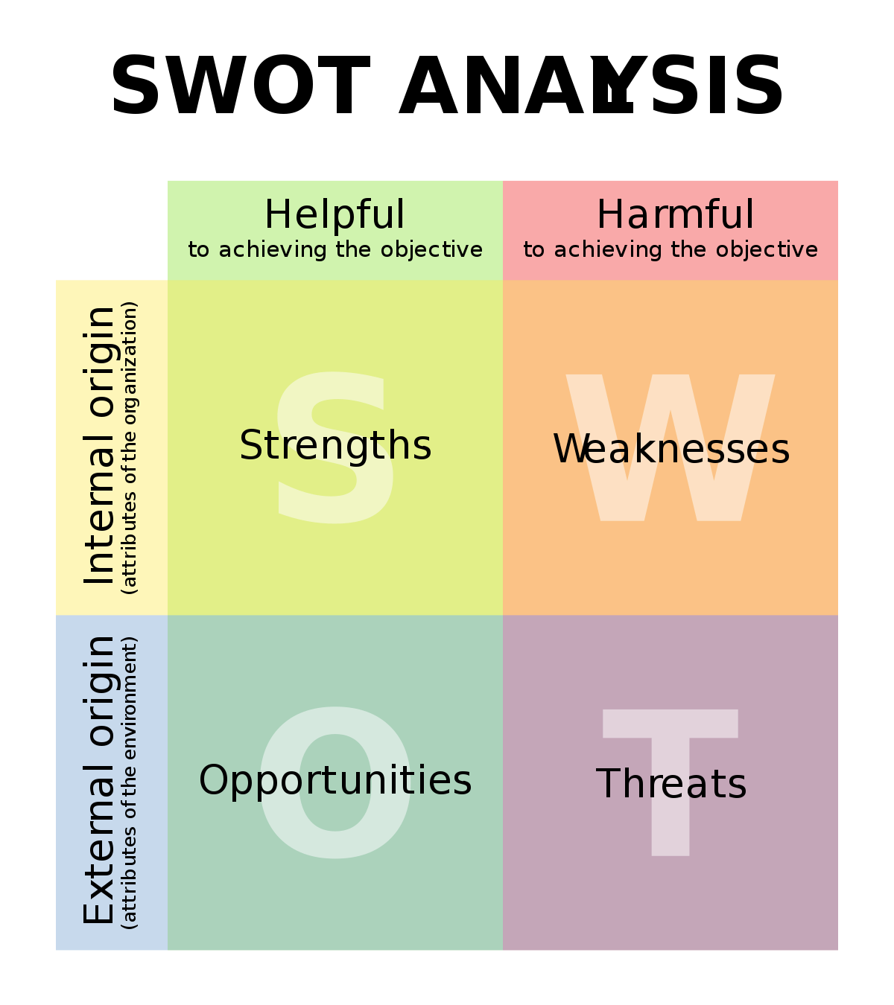

Swot of Jays corner
Strengths- provides food and non food products, provides services like cash machine, postal service and pay point,
Weakness- the location, not in busy area but in a residential area,
Threats – business has lost 50% of its income because had to reduce the opening hours due to Covid-19 and social distancing. therefore, BBC (2020) suggest small business fear it will be difficult to go back to normal after the lockdown. Also, BBC (2020) suggest when small business adapt to new rules, customers might not stay local due to covid-19 restrictions.
Opportunities – are to move to online shopping and delivery services by introducing mobile app, social media and having a web page.
Types of Innovation
Greenwald (2014), Innovation is mainly understood to be known as an introducing something new and useful, which is epitome, combination or fusion of knowledge that is original, important and valued to new products, processes or services. Without innovation there is no growth and innovation are a lifeline of any business. Cassidy (2018), for a business to produce new procedures to an existing product and services innovation is needed where they can add change in the organisation for better productivity, profit and to boost growth.
Innovation Matrix
There are different types of innovation that create and secure value. According to Davila (2013), there are four types including, Technology Innovation, Business Model Innovation, Incremental Innovation and Radical Innovation.
Technology innovation is a new or improved product or process therefor, according to Thierer (2019), technology is very important for a business where it brings creativity to develop important technology change skills share of innovation, which include of product, service contribution, process technology and enabling technology. BCG (2020), the business model innovation enhances the advantage and value creation by changes both to an organisation’s value proposition to customers and it operating model drive innovation in three areas including value proposition, value networks and target customers. At the value proposition level changes can be made to the choice of target sector by offering product or services and revenue model. Then the focus is how to drive profitability, competitive advantage and value creation on decisions on how to deliver the value proposition. Incremental innovation is needed for improvements made to a business’s existing products or services with innovative ideas for the successful growth of the business. Incremental innovation is less risky and easy to apply but produces low financial results. Pratt (2020), Radical innovation involves creating and replacing it with something completely new in the business. Radical innovation is on the furthest end of innovation and can be hard to achieve.

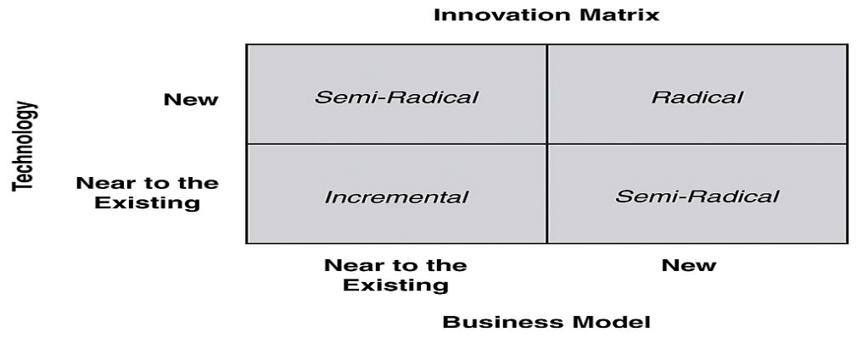

According to Davila et al, (2012), innovation matrix is divided into types of innovation to which the change of the innovation will cause to the organisations current business model and technology. The innovation matrix has four types of innovation factors, incremental, radical for an innovation it would be semi-radical or from radical to semi-radical. Knowledge, progress and reuse are competitive advantage that helps an organisation to keep its position in the market. Using innovation model has helped to identify the technology innovation being incremental.

Open and close innovation
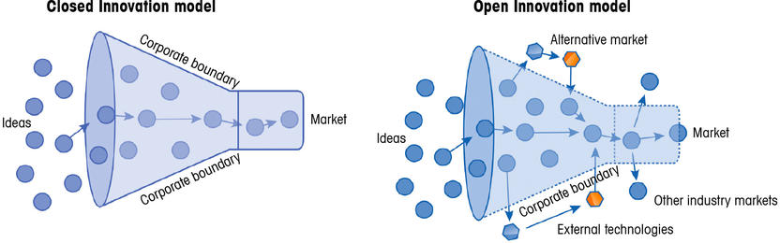
Open Innovation
Open innovation according to ICC (2021), involves strategic and managed exchanged of information from external sources and sharing their resources and knowledge into the organisations own innovative process. Lego is a very good example of open innovation according to Morikawa (2016) by engaging the users to create more value through its site called Create and Share and the Lego idea site. Create and Share site lets the Lego community members to share their Lego pictures and designs, while the idea site aims for a new product release. As a result, the community has provided Lego with thousands of new ideas therefore, Lego has a constant flow of free ideas that people are already wating to buy. This open innovation approach has been one of the core factors for Lego’s success and has saved their brand and put the at the top of the market. the benefit of innovation helps to communicate with wider customer, it will cost less and can be restricted to internal information to develop new ideas. Novoseltseva (2017), the advantage of open innovation helps innovate old products and services while having a competitive edge, helps reduce costs while creating new products or services. On the other hand, there are disadvantage that comes with risks of competition of similar products or services.
Closed innovation
Closed innovation is where the knowledge and information are used from internal sources and resources and innovations are developed by the organisations and the idea for innovation, development and marketing comes from within the organisation itself. According to Morikawa (2016) Apple is a very good example of closed innovation. Apple is very closed and secretive of its R&D before releasing any information on the new product is officially on the market. However, despite the closedness of the Apple, they use open innovation to their own term when they think open innovation is suitable. Isomaki (2018), the benefit of closed innovation is the organisation will bring the newfound innovation to the market first, have full control over the innovation process and the intellectual property, less dependent on external knowledge and no risk of leakage of confidential information. However, disadvantages come with a risk of having limited market share and high level of investments to supply the R&D department. Vapulus (2019), considering the open and close innovation model the innovation opportunity was identified using the open innovation by using the knowledge and information of external sources of organisations. The open innovation idea of how other business are using technology to innovate their business will help on implementing a similar method. Therefore, having knowledge and information from other company will provide with a prospect of how effective the mobile app and how successful it has been.

Innovation Process
Innovation process according to Lead Innovation (2020), is to translate new or existing knowledge into marketable solutions for organisation to achieve marketable answers. Organisations that have successful innovation process seems to have a competitive advantage from others and have designed a path of an idea from generation through development growth into the market. the innovation has four step processes according to Tidd (2018), including recognising the opportunity, finding the resources, developing the ideas and capturing the value. Theses four steps are very important and needs awareness of the innovation is to be managed successfully.

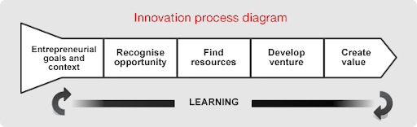
To apply this model to proposed innovation using the four phases according to Tidd (2018), first it would require recognising the idea, which was done by applying a SWOT analysis of the business (Small Business 2018 and Mindtools 2020). Then finding different resources from different organisation to achieve the goal. Evans (2017), then is to develop venture needed by people to adopt to new skills, information and support also contribute to change because the business is small. Then lastly is to create value for customer and the business. Providing the online shopping and delivery services by having a website or a mobile app will help the business in the long-term and to be profitable and sustainable. Joseph (2018), the benefit of this model includes, more productivity, reduce costs, improves recognition and value by providing guide and vision in the innovation process. Soulsby (2017), the disadvantages include, it can be very costly and time consuming, innovation not working, wasting resources and end in financial risks.

The 4P’s Innovation
The 4P’s concept was developed by Joe Tidd and John Bessant in 2005 and they are product, process, position and paradigm. This model shows how innovation focus on four concepts in four directions of change.

Diagram of 4Ps innovation
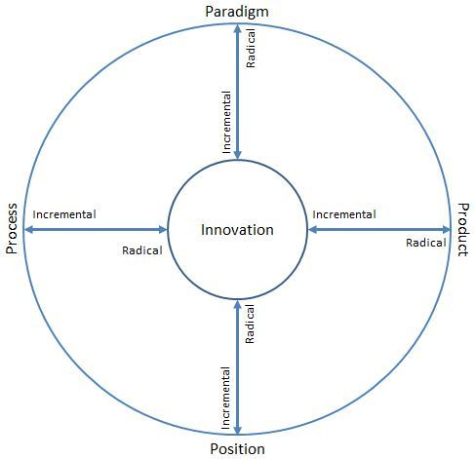

Product innovation according to David (2016), conveys the changes in things which an organisation offers to the market as a product or service. The proposed organisation proving food and non-food products, they started on delivery services and on frozen food products. Process innovation is way things are created and delivered by the organisation. By displayed special offers on some product each week and having a smiling face for the customers. Also changing the layout of the business for the customers to have easier access. Position innovation is about who the business offers service or product to and about the businesses story. The business provides traditional service to the local community. Paradigm innovation is in the change in the underlying models which shows what the business does and shows how the company does it. The businesses traditional service is changing to online shipping will be incremental change. Agola and Hunter (2016), the benefit of 4P’s is the four aspect of innovation it shows the four categories and makes aware of the innovation and change influence one another. The limitation of the model is that it lacks on guidance for further steps that must be taken.

Lewin’s Force Field Analysis
Kurt Lewin’s model according to Mindtools (2021), is used mainly in decision making when an organisation is planning and implementing change management. This analysis shows factors that forces for change and forces against change in business by marking how strong the forces is strong being five and weak being one.

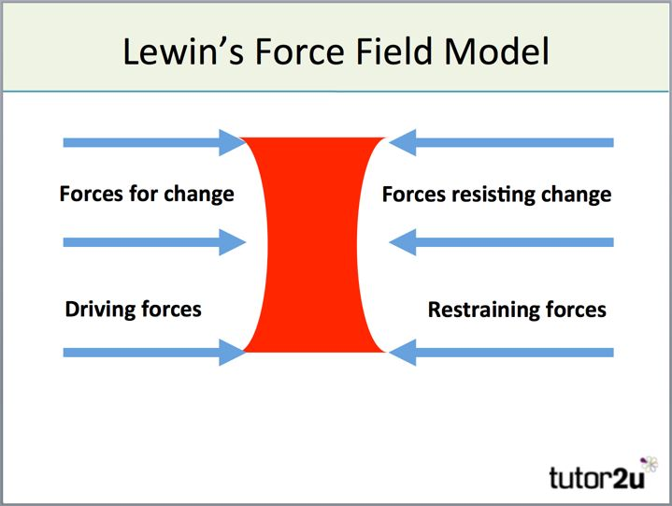
There are risks involved in innovation according to NI Business (2020), include operation cost, not attracting enough customer, finance and time invested on innovation, because change is sensitive process it requires time, finance, resources and investing in people from the business. Armstrong (2006), business and leaders need to understand challenges and risks are part of innovation therefore, they need to evaluate and manage risks, also by accept the risk that come with change only then they will survive in the market. Davis (2018), organisation needs to accept and face the rapid changes happening around them to survive and stay ahead. In organisation leaders are role models and people follow their actions, attitudes however, leaders are self-aware of their movements. Organisations change depends on the leaders and managers to lead needs to guide the employees in the changing process by supporting and implementing the change through effective communication.

Conclusion
The difference between creativity and innovation according to Business Insider (2013) is the focus. Creativity is about bringing out the potential of the mind to conceive new ideas, and innovation is about introducing newly created ideas and developing the into reality. Applying a creative idea to improve product or service therefore, invention or innovation are two different words, where innovation happens when a person improves on product that already exits and invention happens when a new product is created with an original idea. Tools Hero (2020), Innovation helps turn ideas in to value depending on the person or product. To identify an innovation for an organisation it is important to use a SWOT to analyse internal/external factor. According to Davila, (2013), there are four types of innovation including, technology innovation, business model innovation, incremental innovation and radical innovation, these innovations create and capture value. Open and closed innovation help to identify how the knowledge is sourced for the innovation idea. According to Tidd (2018), there are other models including the 4P’s, the innovation process, innovation matrix and Lewin’s force field analysis help the process of innovation to guide the innovation in action and method

Recommendation
Recommendation is to implement the idea of having online shopping and delivery service through a mobile app where the customers can easily access the product and services of the business. The report can be a guidance to act while planning to implement the idea. Pratap (2018), In the 21st century it is very important to adapt to change to stay in market and innovation is very important to stay ahead of the market.

Reference
Cassidy, F. (2018), ‘What is business Innovation’, [Online] Available at: https://www.raconteur.net/business, [Accessed 20th April 2021].
Evans, S., Valdimirova, D., & Yang, M. (2017), Creating and Capturing Value Through Sustainability, Journal Research – Technology Management, Vol. 60, Issue 3, Pages 30-39.
Novoseltseva, E. (2017), ‘Open innovation: benefits, case studies and books | Apiumhub’, [Online] Available at: https://www.apiumhub.com, [Accessed 17th May 2021].
Lead Innovation Management (2020), ‘Defining the Innovation Process’, [Online] Available at: https://www.lead-innovation.com/en/innovation-process, [Accessed 5th April 2021].
Soulsby, T. (2017), ‘advantages and disadvantages of innovation’, [Online] Available at: https://www.getrevising.co.uk, [Accessed 29th April 2021].
Vapulus (2019), ‘Open Innovation Vs Closed Innovation’, [Online] Available at: https://www.vapulus.com, [Accessed 29th April 2021].
Davila, T., Epstein, M. J. & Sheldon, R., D. (2013), Making innovation Work How to Manage it, measure it and profit from it, Updated Edition, New Jersey: Pearson Education.
Armstrong , M. (2006), Human Resource, Management Practice, Tenth Edition, London: Kogan Page.
NI Business, (2020), ‘ Use innovation to start or grow your business’, [Online] Available at: https://nibusinessinfo.co.uk, [Accessed 18th June 2021].
Pratap, A. (2018), ‘Role of Leadership in Change Management’, [Online] Available at: https://www.notematic.com, [Accessed 20th June 2021].
Tidd, J. and Bessant (2018), Managing Innovation: Integrating Technology Market and Organisational Change , Sixth Edition, Wiley.
Small Business (2018), ‘Impact of COVID-19 on small business – Where is it worst’, [Online] Available at: https://www.smallbusinesstrends.com, [Accessed 1st of May].
Tools Hero (2020), ‘What is innovation Definition Management, Models and Tips’, [Online] Available at: https://www.toolshero.com, [Accessed 19th of June 2021].
Isomaki, A. (2020), ‘Open innovation – What it is and how to do it’, [Online] Available at: https://www.viima.com, [Accessed 15th May 2021].
Mindtools (2021), ‘Force Field Analysis – Decision – Making Skills from Mindtools’, [Online] Available at: https://www.mindtools.com, [Accessed 15th June 2021].
Agola, N. O., and Hunter. A. (2016), inclusive innovation for Sustainable Development: Theory and Practice. Springer.
Davis, T. (2018), ‘How to Manage the Risk of Innovation’, [Online] Available at: https://www.thrivethinking.com, [Accessed 18th June 2021].
David, (2016), ‘Innovation Space 4P’s | Innovation Management – Group 4’, [Online] Available at: https://wwww.pla55106group4.wordpress.com, [Accessed 20th April 2021].
Joseph, C. (2018), ‘Advantage & Disadvantages of innovation Technology’, [Online] Available at: https://www.smallbusiness.chorn.com, [Accessed 15th April 2021].
Morikawa, M. (2016), ’16 Examples of Open Innovation – What Can We Learn from Them’, [Online] Available at: https://www.viima.com, [Accessed 12th April].
BCG (2020), ‘Business Model Innovation Deliver Competitive Advantages’, [Online] Available at: https://www.bcg.com>innovation-strategy-delivery, [Accessed 3rd April 2021].
Pratt, (2020), ‘what is radical innovation? – Definition from Whatls.com’, [Online] Available at: https://www.searchcio.techtarget.com>radicalinnovation, [Accessed 4th April].
Thierer, A. (2019), ‘Technology Innovation and Economic Growth’, [Online] Available at: https://www.mercatus.org, [Accessed 2nd April 2021].
BBC (2020), ‘Coronavirus: Small firms ‘on knife-edge’ amid crisis – BBC News’, [Online] Available: https://www.bbc.co.uk>news, [Accessed: 13th June 2020].
BBC (2020), ‘Small business – BBC News’, [Online] Available: https://www.bbc.co.uk>news>topic>smallbusinesses, [Accessed: 13th June 2020].
CIPD (2020), ‘SWOT Analysis | Factsheet | CIPD’, [Online] Available: https://www.cipd.co.uk>strategy>-swot-analysis-factsheet, [Accessed: 12th June 2020].
Silva, N. (2015). ‘Benefits of a SWOT Analysis and How to Fine Tune it…’, [Online] Available: https://www.business2community.com>marketing>benefit, [Accessed: 12th June 2020].
Scott, G. (2020), Strength, Weakness, Opportunity and Threat Analysis (SWOT)’, [Online] Available: https://www.investopedia.com>fundamentalanalysis, [Accessed: 12th June 2020].
Parsons, N. (2018), ‘What is a Swot analysis and how to do it Right’, [Online] Available: https://www.liveplan.com>blog>what-is-a-swot-analysis-and..., [Accessed: 12th June 2020].
Business Insider (2013), ‘Difference Between Creativity and Innovation – Business Insider’, [Online] Available: https://www.businessinsider.com>difference-between-creativityandinnovation, [Accessed: 10th June 2020].
Christensen, T. (2016), ‘What does creativity mean, really? – Creative Something’, [Online] Available: https://www.creativesomething.net>post>what-does-creativity-mean, [Accessed: 10th June 2020].
Greenwald, M. (2014), ‘What is Exactly Innovation? – Forbes’, [Online] Available: https://wwwforbes.com>michellegreenwald, [Accessed: 10th June 2020].
Hudson, K. (2014), ‘What is the best definition of innovation? | Dr Ken Hudson’, [Online] Available: https://www.drkenhudson.com>best-way-define-innovation, [Accessed: 10th June 2020].

