Nathan Davies (2003791)
Technology & Environment 1 (M4X01974)

Welsh National Police Memorial Reflective Report

Introduction
This report’s purpose is to reflect on the Design Processes and Concepts that our group endeavoured throughout the project. The brief stated that we needed to produce designs for a Welsh National Police Memorial for Cathays Park in Cardiff; the materials were required to be locally sourced from Wales and it needed to have longevity in terms of being maintained as little as possible. It was mandatory that Welsh slate was used in the proposal of the headstone due to the necessity of an occupying a plaque. These requirements were very specific and therefore limiting on our concept ideas; for example, the memorial was restricted to a six-foot squared area which compared to its surroundings, is a very minor measurement. Consequently, our initial ideas as a group were overcomplicated and unrealistic for the space we were provided with. However, we soon realised that it was essential to simplify and perfect our ideas through the philosophy, ‘less is more’.
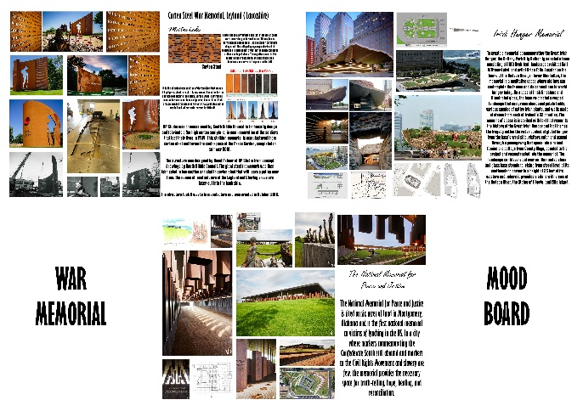
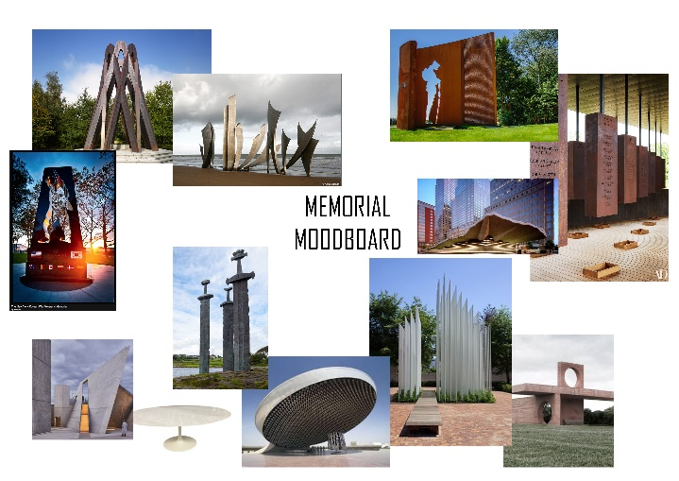
Firstly, we agreed to have a Teams meeting once a week to discuss idea developments; we would take notes on the conversation and log the minutes to record our progress. From there, we each made a mood board of existing Police Memorials that were appealing to us and shared them with the group through our Miro page. Furthermore, we agreed upon one memorial and created a precedent study around it. We analysed the materials used, the way in which it was constructed, the site analysis and how we could incorporate some of its features into our designs.

Memorial Mood board (Abbie Messer, 2021) War Memorial Mood Board (Nathan Davies, 2021)

We allocated each member of the group a role in the project; however, this was difficult for us as one of our group members has not been present for the meetings. Eventually, we agreed upon continuing the project with the three group members. Consequently, we approved the idea of increasing the number of meetings per week to two as we now had more of a responsibility in the project.

Materials
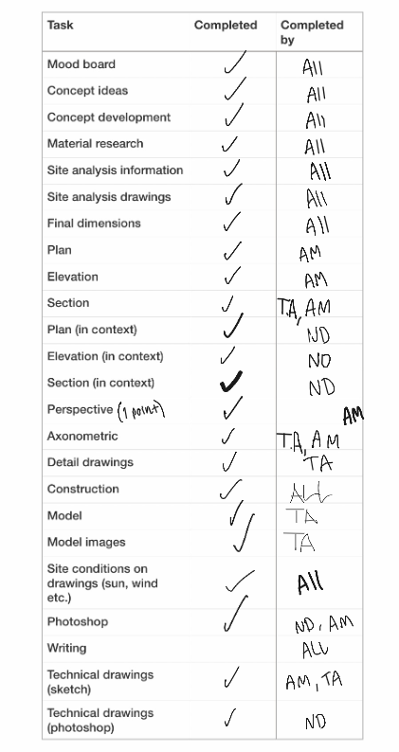
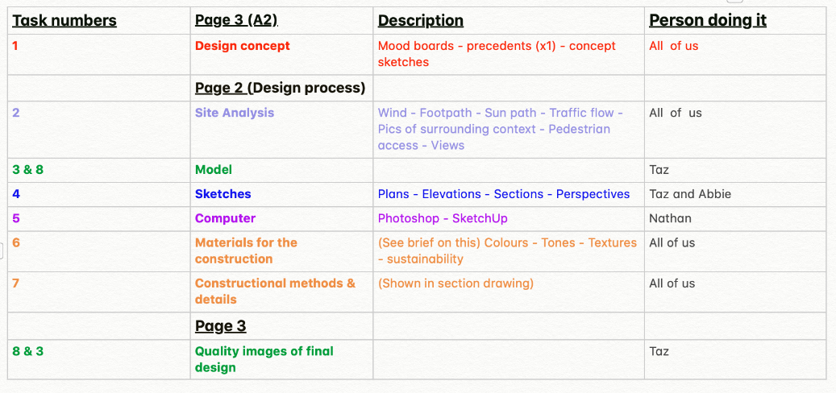
To begin, we organised ourselves by implementing a task list in Miro where we can update our progress through the project. This list displays multiple columns displaying who is responsible for certain tasks and a tick box if a task has been completed. This allows the group to be punctual and get live updates from the other members of the group in between meetings. In retrospect, this list made the whole project easy to follow and the design process was therefore presented in chronological order.
Task List (Tarenah Adibmehr, 2021)
For the design concept, we analysed and reviewed alternative materials that we could possibly create the memorial from. Every member of the group made a mood board of relevant materials that are locally sourced from Wales. This included the positives and negatives of the material, and how it would interact with the technologies and the climate of the site. For instance, we dicussed that
Task List 2 (Team 3, 2021) corten steel has the potential to stain the concrete plynth
during wet conditions; as a solution, we adapted the material choice of the plynth to slate to match the slate headstone. We also learned that corten steel changes colour over time which we agreed isn’t a major negative factor. Corten steel is able to be cut into thin but strong panels that can easily be customly modified. Our research shows that the negative spaces within this material is visually appealing and can create creative shadows with the correct positioning. Our research also suggests that corten steel is a sustainable choice as it’s 100% recycleable with no maintenance required. Steel is notoriously produced in Port Talbot, Wales which implies that corten steel is a locally sourced material. Slate is similarly still produced in Penrhyn Quarry in Wales; in addition, the material is resistant against weather elements and is a close-grained material, which offers a great foundation for carving, making it ideal for smaller memorials.
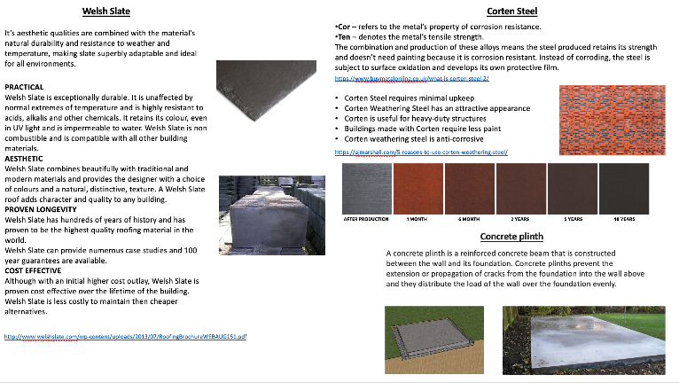
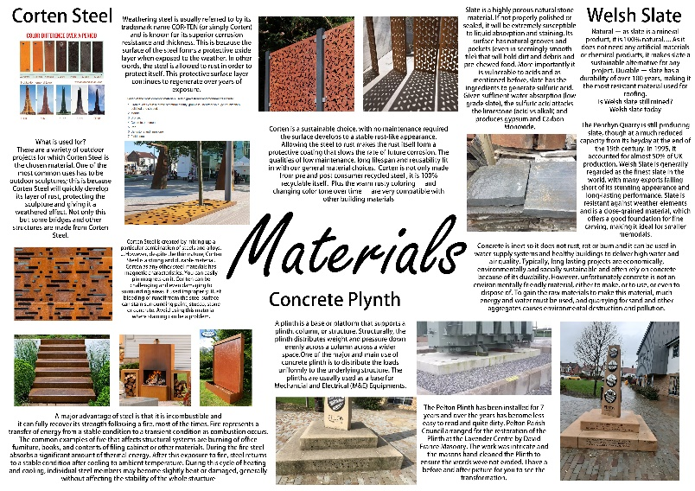
Materiality Research (Tarenah Adibmehr, 2021)
Materials Mood Board (Nathan Davies, 2021)

Design Concepts and Dimensions
Due to the restrictions of the 6 foot squared area that we were given, formulating concept ideas as a group was difficult as space was limited. For example, we wanted to include doorways made from corten steel that people can walk through; however, some people are taller than 6 foot and therefore they wouldn’t be able to maneoure around the memorial.
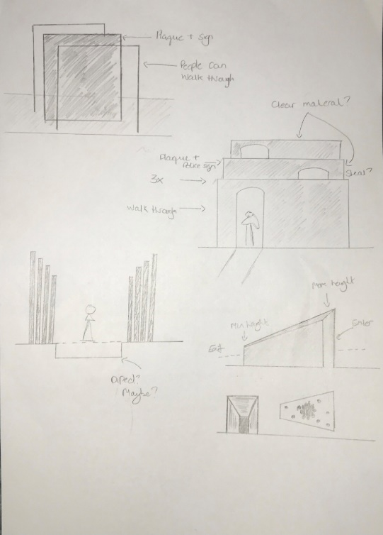
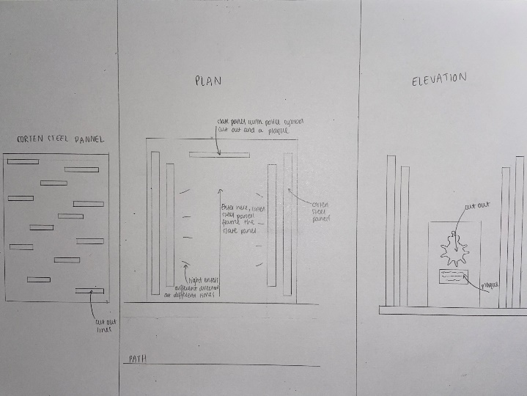
We settled for the idea of 4 corten steel panels either side of the memorial that decreased in size the closer they got to the headstone. This gave the memorial a different view depending on where someone is standing in relation. It would also allow light to travel through the holes that we designed in the corten steel panels, onto the slate floor of the memorial.

Concept Sketches (Abbie Messer, 2021)
Plan, Section and Elevation Sketch (Abbie Messer, 2021)

From here, we wanted the police logo cut out of the slate headstone to allow the sunlight to highlight a shadow of the badge on the floor of the memorial. The plaque would be situated above the logo due to easy readability and convenience for people. In order to determine this, we conferred every dimension of the memorial and updated them live on Miro whilst on a Teams Meetings.
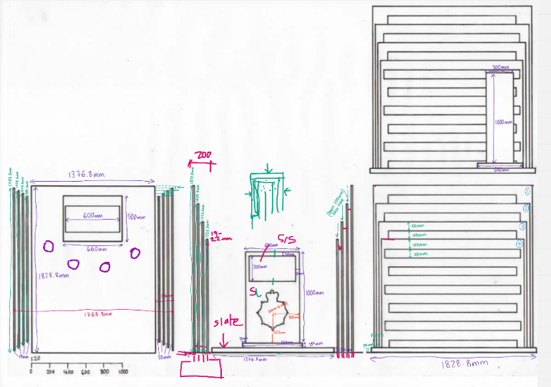
We used milimetres for our measurements to be as accurate as possible when calculating the gaps and the small dimensions.

Dimensions (Team 3, 2021)

Technology and Site Analysis
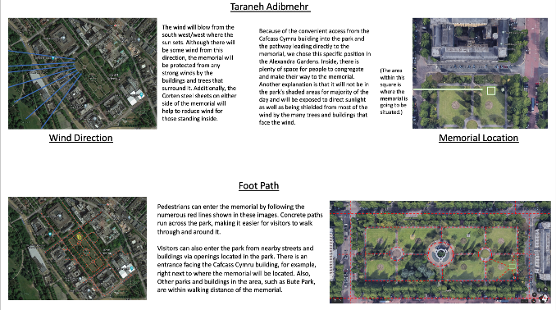
The way in which the Corten Steel panels were installed was deliberated between our group and our lecturer, Ian Standen. We consulted with an expert because we needed to ensure that the measurements for the foundation complied with the load of the memorial. In order to comprehend the impact of the area, we created a site analysis map to demonstrate the effect on the structure. Furthermore, we approved for the position for the memorial to be located in the North quadrant of Cathays Park. The site factors that we considered before making this decision was the sun path, wind direction, precipitation, surrounding buildings, foot paths and traffic flow.
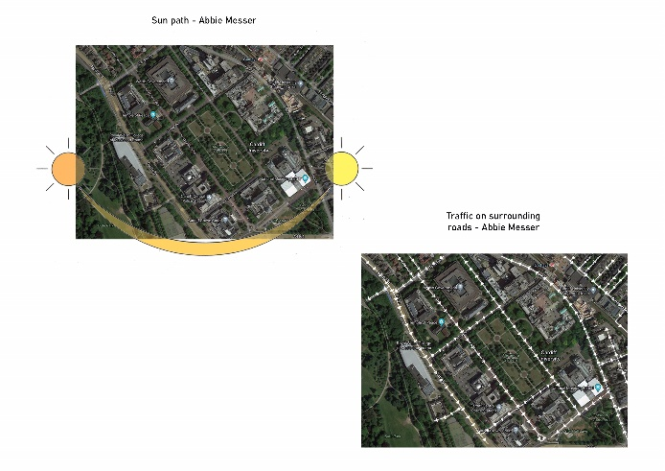
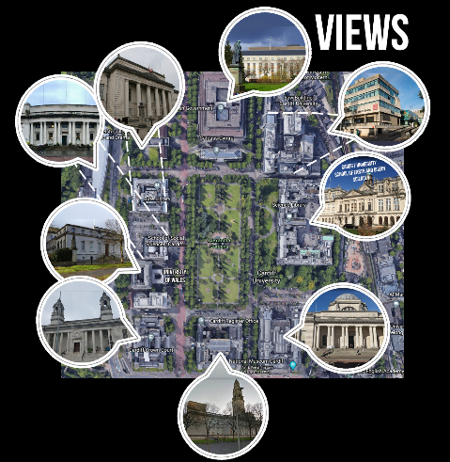
Wind Direction and Foot Path (Tarenah Adibmehr, 2021)

Views (Nathan Davies, 2021)
Sun Path and Traffic Flow (Abbie Messer, 2021)

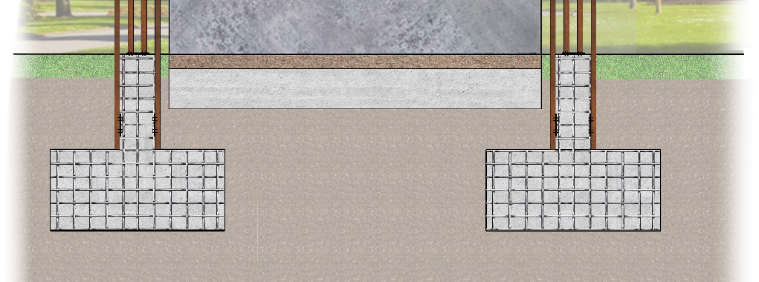
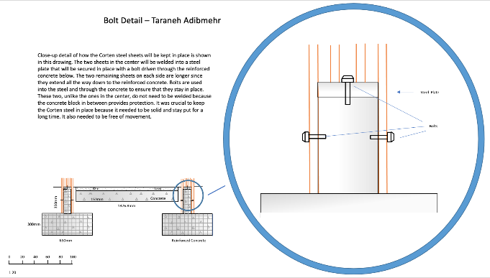
The technical drawings were very important for understanding how the memorial will be built. We distributed every group member one technical drawing to ensure everyone participated and understand its construction. We approved that the two centre corten steel panels should be welded into a metal plate that is bolted into the reinforced concrete. The remaining panels are extended in length into the ground and are again bolted, but do not need to be welded as they are supported by the reinforced concrete.
Bolt Detail (Tarenah Adibmehr, 2021)
Foundation Drawing (Nathan Davies, 2021)
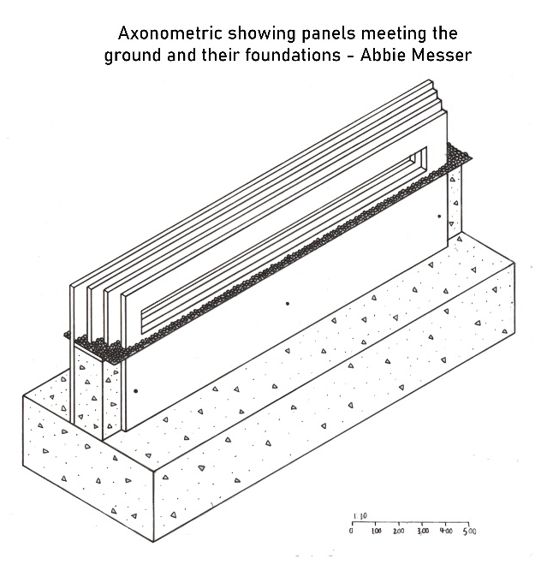

Final Drawings and Model
We allocated each drawing based on our individual strengths. For example, my main weakness is drawing on paper and Abbie’s forte is sketching; therefore, Abbie drew the final axonometric and one-point perspective that made the design come to life. My expertise lies in photoshop which led me to design the elevations, sections and plans in context and in scale. One of Tarenah’s strengths was making models and drawing details. Eventually, we all contributed to the final design pages which allows the client to see the whole process from the beginning concepts, to the final knockout images.
Axonometric (Abbie Messer, 2021)
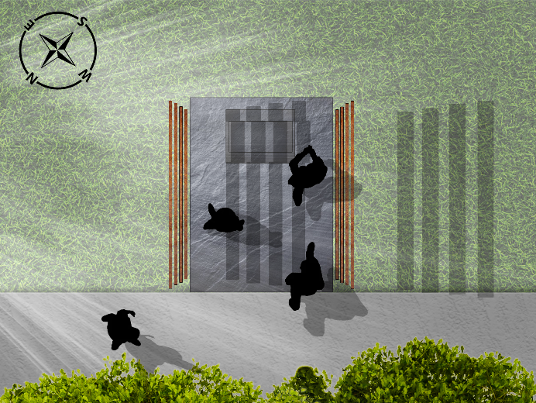
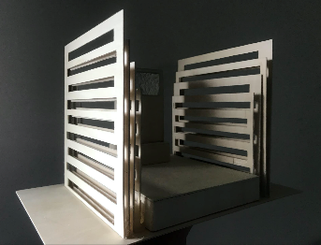
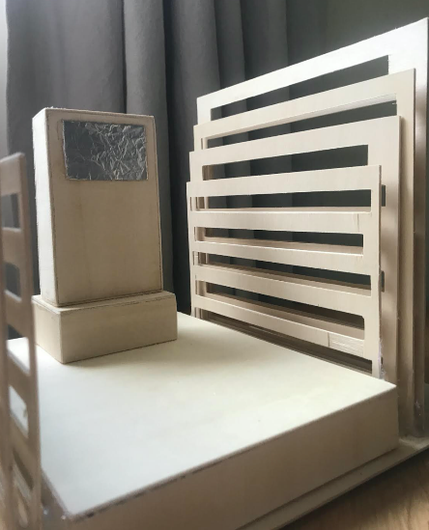

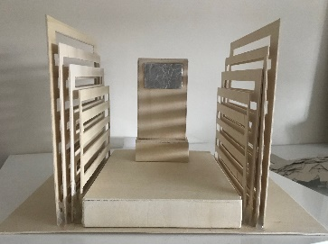

Model 1:10 (Tarenah Adibmehr, 2021)
Plan In Context (Nathan Davies, 2021)

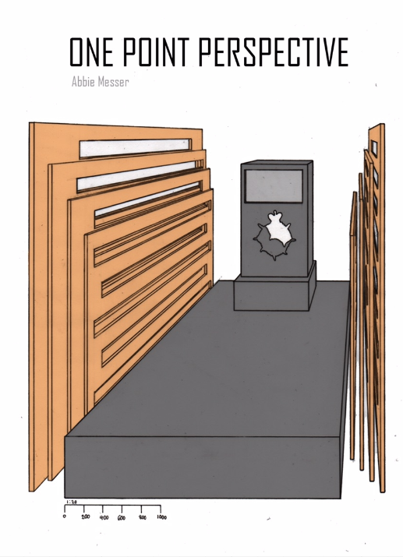
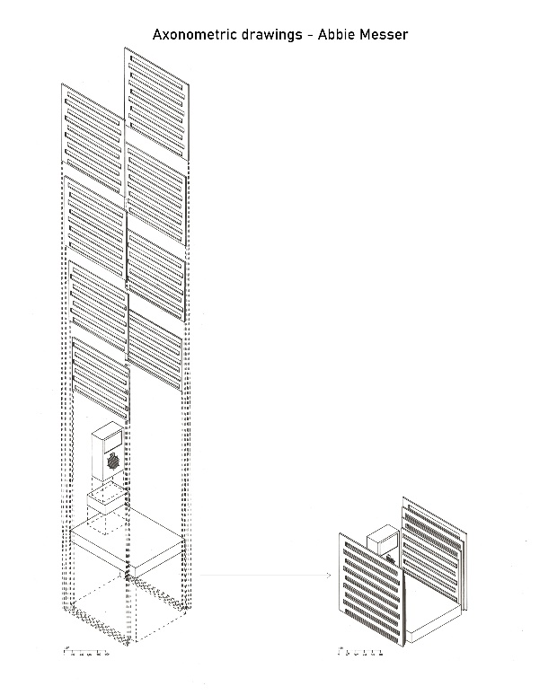

One Point Perspective (Abbie Messer, 2021)
Axonometric 2 (Abbie Messer, 2021)

References

Nathan, D. (2021) ‘War Memorial Mood Board’
Abbie, M. (2021) ‘Memorial Mood Board’
Tarenah, A. (2021) ‘Task List’
Team, 3. (2021) ‘Task List 2’
Nathan, D. (2021) ‘Materials Mood Board’
Tarenah, A. (2021) ‘Materiality Research’
Abbie, M. (2021) ‘Concept Sketches’
Abbie, M. (2021) ‘Plan, Section and Elevation Sketch’
Team, 3. (2021) ‘Dimensions’
Nathan, D. (2021) ‘Views’
Abbie, M. (2021) ‘Sun Path and Traffic Flow’
Tarenah, A. (2021) ‘Wind Direction and Foot Path’
Nathan, D. (2021) ‘Foundation Drawing’
Abbie, M. (2021) ‘Axonometric’
Tarenah, A. (2021) ‘Bolt Detail’
Nathan, D. (2021) ‘Plan In Context’
Tarenah, A. (2021) ‘Model 1:10’
Abbie, M. (2021) ‘Axonometric 2’
Abbie, M. (2021) ‘One Point Perspective’

Works Cited

Memorial Mood Board (Abbie Messer, 2021)
War Memorial Mood Board (Nathan Davies, 2021)
Task List (Tarenah Adibmehr, 2021)
Task List 2 (Team 3, 2021)
Materials Mood Board (Nathan Davies, 2021)
Materiality Research (Tarenah Adibmehr, 2021)
Concept Sketches (Abbie Messer, 2021)
Plan, Section and Elevation Sketch (Abbie Messer, 2021)
Dimensions (Team 3, 2021)
Views (Nathan Davies, 2021)
Sun Path and Traffic Flow (Abbie Messer, 2021)
Wind Direction and Foot Path (Tarenah Adibmehr, 2021)
Foundation Drawing (Nathan Davies, 2021)
Axonometric (Abbie Messer, 2021)
Bolt Detail (Tarenah Adibmehr, 2021)
Plan In Context (Nathan Davies, 2021)
Model 1:10 (Tarenah Adibmehr, 2021)
Axonometric 2 (Abbie Messer, 2021)
One Point Perspective (Abbie Messer, 2021)

