University of Wales Trinity Saint David (UWTSD)
STUDENT NAME: ABDA PARVEEN
STUDENT NUMBER: 2530580
MODULE CODE: LCHS4003: HEALTH AND SOCIAL CARE
LECTURER NAME: DR HELEN PARSONS
SUBMISSION DATE: 22 JUNE 2026

TASK 1 POSTER: PHARMACY SERVICES IN THE UK

What Are Pharmacy Services?  Pharmacy services include provision of medicines, clinical advice and public health support. They are often the first point of contact for health help in the UK (RPS, 2021)  Who uses them?  - People with short or long term conditions  - Patients who are on more than one medication, especially older patients  - Pregnant women, carers and NHS staff  Who provides them?  - GPhC-registered pharmacists and pharmacy technicians  - Dispensing assistants and medicines management teams  Where?  - ~11,600 community pharmacies across England  - GP surgeries, hospitals and online services  Why it matters:  89% of the population lives within a 20 min walk of a pharmacy. Pharmacies take the strain on GPs and A&E as they treat minor illnesses (NHS England, 2023a; Nuffield Trust, 2022). | Brief History  (Holloway, 2019; DHSC, 2022; NHS England, 2024)
  Pre-1800s | Apothecaries and herbalists provided remedies with no formal regulation.
  1815 | Apothecaries Act: first legal framework for dispensing in the UK.
  1868 | Pharmacy Act created the Pharmaceutical Society; dangerous substances controlled.
  1948 | NHS established. Community pharmacies contracted to dispense NHS prescriptions.
  1986 | OTC deregulation: medicines like ibuprofen available without prescription.
  2005 | New pharmacy contract introduced Medicines Use Reviews and advanced services.
  2019-22 | 5-year Community Pharmacy Contractual Framework (CPCF) agreed.
  2023-26 | Pharmacy First expanded (2024): pharmacists treat 7 conditions without GP referral (NHS England, 2024).

Current Function of Pharmacy Services

Core Services  - Dispense NHS and private prescriptions  - Minor illness consultations (Pharmacy First)  - Vaccinations: flu, COVID-19, shingles  - Weight management and quitting smoking  - New Medicine Service and medicines reviews  - Emergency contraception and sexual health  - Independent prescribing by qualified pharmacists | Funded and Managed By  - NHS via the Community Pharmacy Contractual Framework  - GPhC regulates all pharmacists and pharmacies  - NHS England and Integrated Care Boards (ICBs) commission services  - Part of Integrated Care Systems since the Health and Care Act 2022 (NHS England, 2023b)  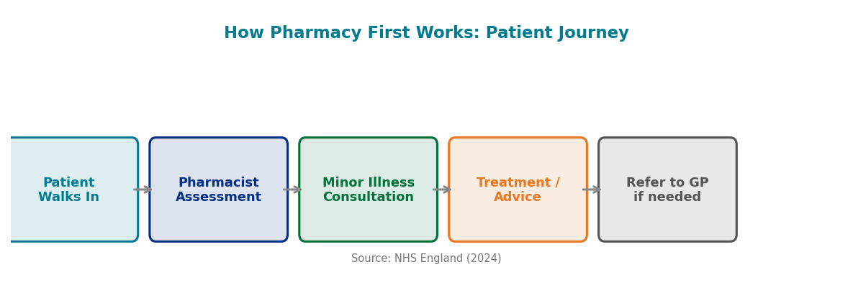 | 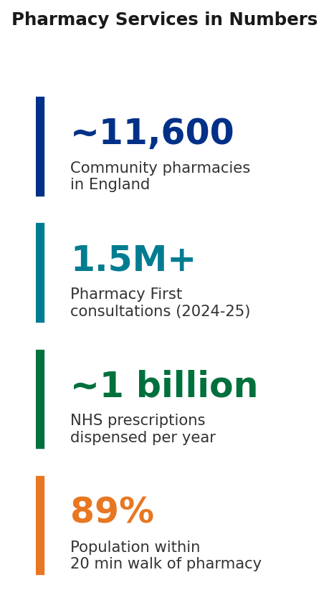

Challenges Facing Pharmacy Services

Challenge 1: Workforce Shortages  There are not enough pharmacists and technicians to meet growing demand. There has been a significant increase in vacancies since 2020 (King's Fund, 2023).  Causes:  - Poor long-term workforce planning  - High turnover in community pharmacies and burnout among their staff.  - More attractive roles available in hospitals and GP settings  Impact:  - Pharmacies reducing opening hours or closing  - Longer waits for prescriptions and consultations  - Mental health of pharmacy staff deteriorating  Evidence:  - 1 in 4 contractors struggled to recruit pharmacists (GPhC, 2023)  - 15% vacancy rate — nearly double the NHS average (NHS Digital, 2023)  - Increased workload for Pharmacy First without corresponding staffing (Lim et al., 2022)  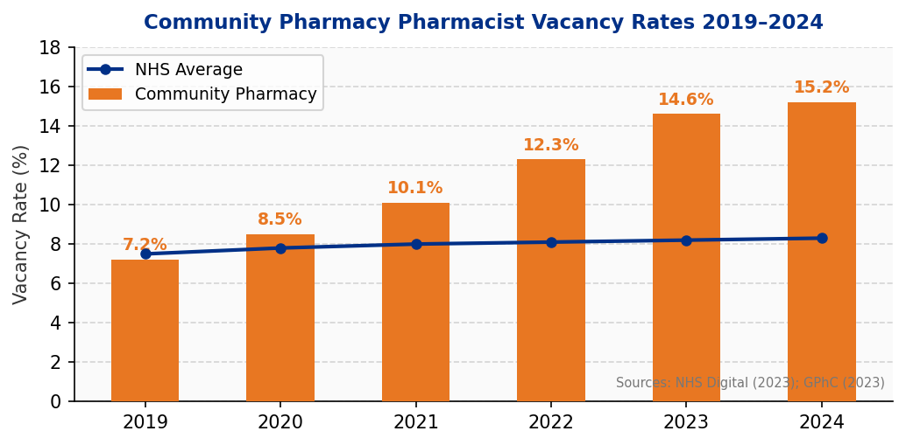 | Challenge 2: Medicine Supply Shortages  Medicine shortages have been ongoing and, at the end of 2023, more than 100 active alerts were reported at the same time (DHSC, 2023).  Causes:  - Post-Brexit importation and customs changes  - COVID-19 related disruption of global supply chains  - Fewer manufacturers producing key medicines worldwide  - Government price controls that lower the supplier's profit margins.  Impact:  - Patients unable to access prescribed medicines  - Forced switches to alternative formulations  - Non-adherence due to unavailability, risking patient safety  - Over 70% of pharmacies affected at any given time (Nuffield Trust, 2023)  Evidence:  - 100+ simultaneous supply alerts including HRT and antibiotics (DHSC, 2023)  - The solution is not for individual pharmacies to take action but for national procurement reform (King's Fund, 2024)  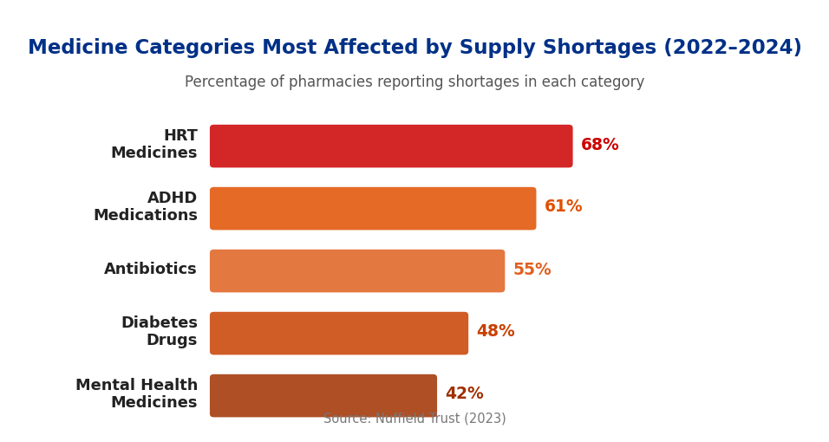

Community Mental Health Services in the UK
Introduction
Community mental health services play a crucial role in the UK's social care system, providing support to individuals who are suffering from mental health issues while still being able to live in their communities. They foster recovery, independence and social inclusion, instead of long-term institutionalisation. This essay explores the origins of these services, their current operation, and their importance to service users' quality of life.
Origins and Historical Development
The origins of mental health care in the UK are in institutional care. In the 1800s and early 1900s, individuals were frequently admitted to large asylums, the goal of which was containment not cure. This legacy of stigma and criticism for overcrowding and isolation transformed mental health stigma even after the closing of these institutions (Bhugra et al., 2017).
A major change took place in the 1950s and 1960s. The Royal Commission on Mental Illness and Mental Deficiency (1954-1957) recommended a shift away from compulsory institutional care that influenced the Mental Health Act 1959, which promoted voluntary community treatment. This was in response to an increased understanding that recovery could be improved with interventions in the community, including supported accommodation and vocational rehabilitation, rather than isolation (Killaspy et al., 2022). The Hospital Plan 1962 then speeded up the process of closing psychiatric hospitals and moving to community care.
The NHS and Community Care Act 1990 made it statutory for both local authorities and health services to provide support in the community. This was further strengthened by the NHS Long Term Plan (2019) by increasing the provision in the community and decreasing the need for inpatient care. Service delivery today was also influenced by the Five Year Forward View for Mental Health (2016).
How Community Mental Health Services Function Today
Services are today provided by Community Mental Health Teams (CMHTs) that bring together psychiatrists, psychologists, nurses, social workers and occupational therapists to provide care in a person-centred way. This is an example of partnership working, which involves partnership among professionals in order to address complex needs in a holistic way. There are GP referral, self-referral or crisis teams and supports provided include CBT, medication management and early intervention for psychosis.
Services are commissioned by Integrated Care Boards and regulated by the CQC. The NHS Long Term Plan (2019) pledged to provide help to 370,000 more adults every year, but there are real pressures. Stigma and fear of judgement are significant challenges to accessing support (Broglia, Millings and Barkham 2021), and users of services with complex emotional needs are likely to report inconsistencies in the care they receive and struggle to access services (Trevillion et al. 2022).
Significance in Enhancing Quality of Life
Community mental health services have a dramatic impact on the lives of people who use services. Spending time in their own community helps them to maintain their independence, dignity and self-confidence, as well as relationships, employment and daily living habits (Patel et al., 2018).
Another strength is early intervention which avoids deterioration as well as reducing the risk of hospital admission (Mind, 2022). The quality of supported accommodation is also crucial to recovery, and poor housing or weak support systems can have a significant impact on the effectiveness of community-based care in practice (Almeda et al., 2022).
These benefits are also not always equally shared. There are structural inequalities, with black, Asian and minority ethnic communities still being disproportionately detained under the Mental Health Act 1983 (CQC, 2023). King's Fund (2023) reports that deprived areas are more likely to experience workforce shortages, which results in the areas with the greatest need having less access. Targeted policy changes are needed to address these inequalities.
Conclusion
Today, the community mental health services are very different from the previous institutional services, and they are person centred, based on multidisciplinary teams. However, there is a gap between ambition and delivery, and benefits are not equally available because of inconsistent quality, stigma and inequality. Services need sustained investment, stable housing and partnership working if they are to maximise their potential for the people who use them.
Reference List

Almeda, N., García-Alonso, C.R., Killaspy, H., Gutiérrez-Colosía, M.R. and Salvador-Carulla, L., 2022. The critical factor: The role of quality in the performance of supported accommodation services for complex mental illness in England. PLoS One, 17(3), p.e0265319.
Bhugra, D., Tasman, A., Pathare, S., Priebe, S., Smith, S., Torous, J., Arbuckle, M.R., Langford, A., Alarcón, R.D., Chiu, H.F.K. and First, M.B., 2017. The WPA-lancet psychiatry commission on the future of psychiatry. The Lancet Psychiatry, 4(10), pp.775-818.
Broglia, E., Millings, A. and Barkham, M., 2021. Student mental health profiles and barriers to help seeking: When and why students seek help for a mental health concern. Counselling and psychotherapy research, 21(4), pp.816-826.
Care Quality Commission (CQC) (2023) Mental Health Act: the rise in detentions and inequalities. Newcastle: CQC. Available at: https://www.cqc.org.uk/publications/major-report/mental-health-act-rise-detentions-inequalities (Accessed: 15 May 2026).
Department of Health and Social Care (DHSC) (2022) Community Pharmacy Contractual Framework 2019/20-2023/24. London: DHSC.
Department of Health and Social Care (DHSC) (2023) Medicine supply notifications. London: DHSC. Available at: https://www.gov.uk/drug-device-alerts (Accessed: 15 May 2026).
General Pharmaceutical Council (GPhC) (2023) Annual report and accounts 2022-2023. London: GPhC.
Holloway, S. (2019) A history of the pharmaceutical industry. London: Routledge.
Killaspy, H., Harvey, C., Brasier, C., Brophy, L., Ennals, P., Fletcher, J. and Hamilton, B., 2022. Community‐based social interventions for people with severe mental illness: a systematic review and narrative synthesis of recent evidence. World Psychiatry, 21(1), pp.96-123.
King's Fund (2023) Mental health 360: workforce. London: King's Fund. Available at: https://www.kingsfund.org.uk/insight-and-analysis/data-and-charts/mental-health-360-workforce (Accessed: 15 May 2026).
King's Fund (2023) The NHS workforce in numbers. London: King's Fund.
King's Fund (2024) Medicines supply: what is going wrong and how can it be fixed? London: King's Fund.
Lim, R., Ng, W. and Tordoff, J. (2022) 'Pharmacy workforce planning: a global overview', Research in Social and Administrative Pharmacy, 18(3), pp. 2180-2187.
Mind (2022) Mental health in the pandemic: findings from Mind's research. London: Mind. Available at: https://www.mind.org.uk/news-campaigns/news/mental-health-pandemic-findings (Accessed: 15 May 2026).
NHS Digital (2023) NHS vacancy statistics England. Leeds: NHS Digital.
NHS England (2023a) Pharmacy First. London: NHS England. Available at: https://www.england.nhs.uk/primary-care/pharmacy/pharmacy-first/ (Accessed: 15 May 2026).
NHS England (2023b) Integrated Care Systems explained. London: NHS England.
NHS England (2024) Pharmacy First: two million consultations milestone. London: NHS England.
Nuffield Trust (2022) Community pharmacy: understanding its role in primary care. London: Nuffield Trust.
Nuffield Trust (2023) Medicine supply shortages: impact on community pharmacy. London: Nuffield Trust.
Patel, V., Saxena, S., Lund, C., Thornicroft, G., Baingana, F., Bolton, P., Chisholm, D., Collins, P.Y., Cooper, J.L., Eaton, J. and Herrman, H., 2018. The Lancet Commission on global mental health and sustainable development. The lancet, 392(10157), pp.1553-1598.
Royal Pharmaceutical Society (RPS) (2021) Professional standards for the pharmacy team. London: RPS.
Trevillion, K., Stuart, R., Ocloo, J., Broeckelmann, E., Jeffreys, S., Jeynes, T., Allen, D., Russell, J., Billings, J., Crawford, M.J. and Dale, O., 2022. Service user perspectives of community mental health services for people with complex emotional needs: a co-produced qualitative interview study. BMC psychiatry, 22(1), p.55.

