ASSESSMENT 1 HUMAN RESOURCE MANAGEMENT

Executive Summary
This report summarises a labour market analysis in the UK and considers two periods as Brexit deal and the Covid-19 pandemic period. This report includes information regarding issues in Brexit deal inclusion and shows issues in covid-19 pandemic employment activity in this country. This also includes various countries' employment information to make a comparison in this research. This report provides information regarding pre and posts Covid pandemic conditions in various organisations and the employment activity of those organisations. The main focusing part of this research is to analyse present labour market statistics in this country as per comparison with a list of previous years. This report also includes information regarding strategies of HRM to continue the development process in employment activity. In addition, this report focuses on delivering information regarding post-Covid HRM strategies to develop employment activity in the organisations in this country.

Table of Contents
Introduction 4
1.0 The current state of the labour market in the UK 4
1.1 Current posture of labour market 4
1.2 Employment in UK 5
1.3 Vacancies and job in UK 7
2.0 The emerging changes in Human Resourcing Strategies in the post-Covid, post-Brexit external environment 9
2.1 Emerging new strategies of HRM after the pandemic 9
2.2 Post-Brexit impact on job vacancies in Uk 11
2.3 External issues affecting the labour market after post-Brexit 13
3.0 PESTLE analysis 14
4.0 Theories and tools 16
Conclusion 16
References 18

Introduction
Human resource management is an effective parameter for any organisation as this management engages in completing employee engagement to complete every activity in the business process. Employment includes a list of facilities such as the continuation of productivity, enhancing sales and maintaining work-life balance in the organisation. Work-life balance can get effective support through having the fulfilment of employee number requirements as every department can segment overall activities into its total available employees in the organisation. Therefore, the workload in employees can be equally distributed to reduce their workloads and develop their work-life balance and satisfaction in the organisation. This report includes information regarding the current position of the labour market in the UK and the effect of HR strategies that contribute to overcoming issues of Covid-19 and the external environment in the period of post Brexit in the UK. This report is to deliver the impact of the recruitment process and HRM strategies to develop labour market conditions in the UK.

1.0 The current state of the labour market in the UK

1.1 Current posture of labour market
The labour market in the UK got affected due to internal and external environmental issues in this country. According to Bell and Blanchflower (2020), this research included information regarding a comparison between the pre and post covid-19 pandemic in the labour market of the UK and the US. This included an 11.2% unemployment rate present between 1982 and 1987 and 7.5% between 2008 and 2013 in the UK. Whereas other data included that 9.3% and 9.6% unemployment rate was present in 2009 and 2010 respectively in the US. Continuous development was present in the employment rate in the UK as the unemployment rate of the UK in 2018 was less than 4%. The covid-19 pandemic creates a range of issues in the business process, employment part and revenue-earning activity in the organisation. This pandemic signed several unemployment activities due to providing restrictions in the continuous business processes and organisations decided to reduce their employment numbers. EU-LFS data extraction process considers completing employment analysis in Germany, Spain, Italy and the UK (Fana et al. 2020). This research also included information on non-essential activities of the UK and Poland and this showed that 25% and 15% of non-essential activities are present in Poland and the UK respectively. EU-LFS data shows the employment distribution rate as per gender, age and sector categories and includes that the essential employment of women is 55.8%, the teleworkable rate is 52.4%, and the most essential rate is 45.7%, mostly non-essential is 18.8% and closed employment rate is 54.63% in the UK.

1.2 Employment in UK
This also includes data for young workers and includes 18.5%, 18.4%, 29.1%, 20.6% and 38.8% in essential, teleworkable, mostly essential, mostly non-essential and closed employment rates respectively in the UK (Fana et al. 2020). According to Watermeyer et al. (2021), this research conducted a survey of the total population of 1148 in the survey and the result derived employment status in England, Wales and Scotland among those participants. The survey collected employment status in terms of part-time and full-time and part-time employment included a 21% rate and full-time part included a 79% employment rate among the participant. Therefore, this shows that several full-time employment present in every workings sector in the UK and people get the opportunity to develop their careers in reputed organisations. The PAYG system includes pension policy in the European country to continue with digitalisation in the post-retirement benefit process (Börsch-Supan et al. 2021). According to Berry and McDaniel (2022), this research included that the UK experience good growth in the employment process as this country captures a record level of employment in various organisations. Data shows that two-thirds of total employment growth was captured after 2008 in the UK. This research also included that youth people faced issues of employment in low payment and unemployment due to having less scope in the UK.
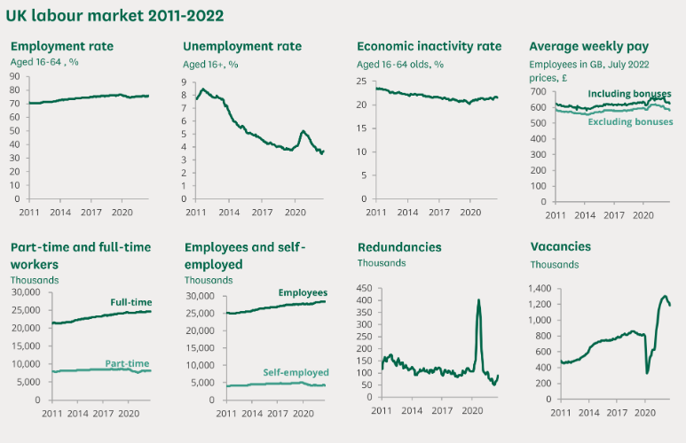
Figure 1: Labour market statistics between 2011 to 2022 in the UK
(Source: Commons library.parliament.uk, 2023)
The initial stage after leaving the European Union faced a slow growth rate in employment and at present, the employment rate continuously grows. Data from CIPD shows the labour market outlook (LMO) report and included that the organisational share faced difficulties in filling vacancies inclement from 56% in 2017 and this rate in 2019 was 61%. Another data from the LMO report 2019 included that employers of the private sector in the UK reported raising salaries to overcome the issue of the recruitment process in the UK. However, Brexit did not provide enough impact on the recruitment process and motto as data showed that two-thirds of total organisations in the UK considered following skills and declined to take nationality factor in the recruitment process to continue with quality employees in their business process. Data of statistics showed that 72% of total employers concentrated on training budgets and 55% of those stated that the Brexit deal does not provide a large negative impact on the skills development process (cipd.co.uk, 2023). Other data shows that the employment rate of the UK in the period between July to September was 75.5% and this value showed approx 1.11% less than the pre-covid employment rate in the UK. Therefore, this shows that the Covid-19 pandemic delivered a negative impact on the employment part of the UK. However, the employment activity and payment value get continuous increment in the UK as a 29.8 million-payroll employee estimation considered in 2022 and this indicated an increment in employees' payroll (Ons.gov.uk, 2023). The unemployment rate also decreased by 0.2% in the period between July to September 2022. Data also includes that the economic inactivity rate also increased by 0.2% and captured 2.16% points between July to September of this year. The period between Augusts to October 2022 showed that the vacancy number decreased by 46000 and the vacancy number remains high after facing decrement consecutively in four quarters. However, development is present in total pay and regular pay of approx 6% and 5.7% between July and September 2022 (Ons.gov.uk, 2023). The unemployment rate was 3.6% as of data between July to September 2022 and the figure shows a large decrement occur in comparison with the data in July to September 2007.

1.3 Vacancies and job in UK
Other data shows that the 16+-age employment rate in August-October 2022 was 32.77 million and the 16-64 age employment rate was 75.6%. The Unemployment rate was 3.7% and approx 1.25 million 16+ aged people were unemployed in 2022. 8.94 million people in the range aged 16-64 were on the list of economically inactive and a 21.5% inactivity rate was present in the UK. Vacancies numbers were 1.19 million in the UK between September-November in 2022 and the average wage percentage also decreased at the rate of -3.9% excluding and including bonuses in 2022 in the UK (Commonslibrary.parliament. uk, 2023).
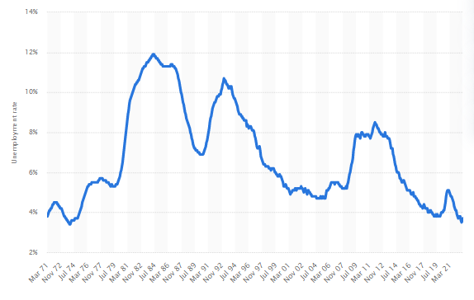
Figure 2: The unemployment rate between 1971 to 2021 in the UK
(Source: Statista.com, 2023)
Another data of statists shows a graph of the unemployment rate in the period between 1971 to 2022 in the UK. The graph shows that a 3.8% unemployment rate was present in March 1971 in the UK and this rate was 5.1% in March 2016, 3.8% in March 2019 and 5% in February 2021 (Statista.com, 2023). The unemployment rate got decreased to 3.7% unemployment rate was present in October 2022 in the UK and this shows less value than the 1971 unemployment rate in this country.

2.0 The emerging changes in Human Resourcing Strategies in the post-Covid, post-Brexit external environment

2.1 Emerging new strategies of HRM after the pandemic
After the pandemic situation, there was a huge change in various sectors, as they needed huge growth because they suffered from covid-19 that leads to a downfall in various sectors. The demand for labours increased and many companies increased the hiring rate for the development of the organisation. As opined by Moradlou et al. (2020), at the time of Covid-19 the chances of dissatisfaction rates have sustainably increased which can be created a negative effect on the labour marketing sectors in the UK. In this vital timing, the multiple ranges of problems related to hybrid structures, international expansion, and workers experienced based on precedence, automation, and analytics for gaining seats have been enhancing the rates of difficulties. The effective strategy has also created growth and increased the ultimate ranges of efficiency by chafing the cultures of performance management attributes. In contradiction, the chances of effective strategies related to recruitment procedures have been also made a positive workflow by effectively diversifying the right talents. The above-depicted issues have also sustainably increased by discovering the workforce ability and creation of effective ranges of flexibility have been also creating collaborations and notified on the collaborative workplace ability at the timing of Brexit. However, Azizi et al. (2021), have argued that the issues related to prioritised workers' experienced and flexibility of working adjustments have also up-skilled the workforce and creation of effective ranges of recruitment policy by taking the help of "Artificial Intelligence (AI)". The adaptations of effective ranges of strategies related to developments of transparency have created a negative effect by the continuous developments rates of transparency and making an effective range of talent acquisitions plans. In the year 2022, the rates of unemployment have been transformed by nearly 75.5% and that has been lower than the 0.3% of the previous quarter and increased the ultimate ranges of employment ability by reducing the rates of issues (Ons.gov.uk, 2022). Therefore, the chances of employment rates have also transformed by nearly 0.3% and that has been making beneficial side by filling up the vacancies and removing the issue regarding staff recognition plans.
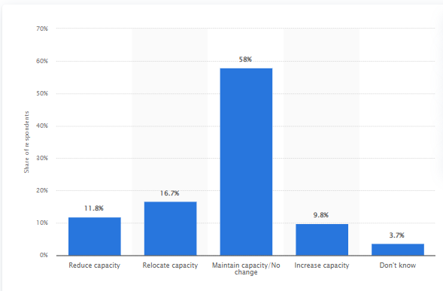
Figure 3: Changes in human resources capacity or company's productions in the UK within Brexit
(Source: Statista.com, 2016)
The above-depicted graph has to make a precise concept regarding the developments of production capacity of the organisational structures at the timing of Brexits within three years (Statista.com, 2016). The graph has also been represented that the rates of reduction in capacity have been transformed by nearly 11.8% and the relocation capacity has also been transmitted by 16.7% have analysed the ultimate ranges of production capacity's modules. In this regard, the maintenance of capacity has been sustainably increased that is 58% and the chances of developments of continuous growth in capacity rates have also transformed by nearly 9.8% (Statista.com, 2016). As a result, the chances of a continuous development activity have created a beneficial side that has changed the cultures of work forcing abilities and developing the cultures of human resources attributes by emerging the natures. However, Caliendo (2022), has argued that the "Re skilling and Upskilling" activities have supported the learning process and supported the carriers by improving the cultures of prominent by developing the cultures of HR trends. Thus, in the situation of Covid-19, the rates of upgrading technological advancements have increased the rates of the labour markets capital and improved the cultures of the company's well-being in a sustainable manner. As a result, the above-depicted trends have been also focusing on the multiple kinds of strategic attributes related to "Collaboration, Positive work-life behaviours, Coaching mindsets and Effective communications" increased the ultimate rates of flexibility and indicated the results of the performances modules.

2.2 Post-Brexit impact on job vacancies in Uk
In contradiction, Gigauri (2020), has stated that the multiple ranges of changing attributes related to "Hiring and Recruitment", "Workers Engagement", "Dynamics of HR", "Evaluations and Performance Management", and "Developments and Training" programmes have been making a wider range of changing attributes that have improving the cultures of business objectives. Thus, the rates of motivational infrastructures have also helped to create a wider range of developments of increased rates of knowledge as well as understanding skills.
As per the view of McCann et al. (2021), the continuous rates of improvements related to "Literature and Engagement Skills", "Intellectual and Cognitive Skills", "Life Professional Practice and Transferable Skills" and "Understanding and knowledge skills" have also collected reliable information and formulated ideas by diminishing the ultimate ranges of issues that have enhanced in the situations of Covid-19. For instance, the strategies related to "Forecast HR requirements" have also created a beneficial side by improving the cultures of talent acquisitions and evaluating the effective ranges of strategies by making planning structures. With the continuous development rates of "Human Resources Management (HRM)" sectors, the chances of workplace ability have been effectively improved by creating flexibility and positioning the worker's wellness and improving the cultures of ecosystems. In this regard, the chances of competitive advantages have been also provided with training and development activities the chances of skills effectiveness and boosted confidence rates. The strategies related to "Evaluate and Review" have also been treated as other strategies modules that have been making planning structures by collecting valuable information among the workers and developing the cultures of long-term determinations by evolving the workforce ability. However, Trondal et al. (2022) have argued that the rates of improvement have also been effectively conducted by upgraded technological advancements and leveraged AI and making empathy by improving the cultures of soft skills. The rates of determination and development of IT infrastructures have been sustainably developed by creating a positive effect on the safety and security departments and changing the cultures of designs and implementations by making uncertainty and adaptations of effective strategies.
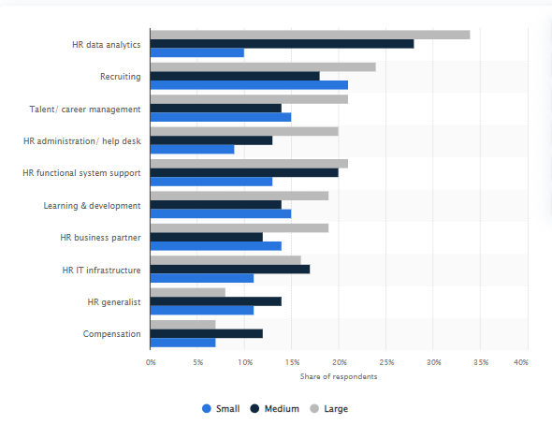
Figure 4: Shares of organisations globally based on developments in human resources In Covid-19 situations
(Source: Statista.com, 2022)
The above-depicted graph has been representing that in the situation of Covid-19 the rates of "HR data analytics" have increased the rates of human resources headcount by recruiting workers in the different kinds of sectors that is Large-24%, Small-21% and Medium-entrepreneurs 21% in the year 2019 (Statista.com, 2022). In addition, "Carrier or Talent Management" has been improving the cultures of HRM sectors by making segmentations of the multiple kinds of attributes related to Large-21%, Small-15% and Medium-14% effectively and improving the cultures of HRM sectors (Statista.com, 2022).

2.3 External issues affecting the labour market after post-Brexit
Swot analysis
Strength | Weakness
- Home market  - Fertile land  - Good technical skills  - Close to consumers  - world-class breeding | - Tight regulation  - High-cost land  - Much political influences  - High market awareness  - Lack of investment  - lack of cooperation
Opportunity | Threat
- Cooperation with horizontal and vertical integration  - Good understanding of values and marketing  - Investing in technical | - Variation in currency  - Exports of technical skills  - Cheaper oversea labour and land  - Various diseases
Analysis
The strength of the labour market includes techniques skills and various aspects that have a good impact on labour in the UK market. Weakness includes various weak points that harm the labour of the UK. opportunities include various chances that help in building the effectiveness of the UK market. The threat includes the difficulties faced by the nation that helps in the development of a nation in environmental aspects.
Analytics of the multiple kinds of attributes related to "Recruitment, HR administration, HR business partner, Compensation, HR generalists, IT infrastructures, Learning and developments" have been sustainably improved by the continuous rates of improvements rates in capacity, performance management and efficiency modules. The wider ranges of fluctuations have also been overviewed in the cases of developments of the recruitment process of the respective organisations related to "Small Medium Entrepreneurs (SME)". As opined by Dirani et al. (2020), the rates of attracting people in the respective organisations have been getting successful to increase the rates of resource planning by assessing the resources planning structures related to "Accessing of current HR capacity" have been considered one of them. Therefore, the chances of future growing cultures have also made beneficial outcomes that have accelerated the digital transformations, led the business activities by influencing the workforce cultures and affected HR management.

3.0 PESTLE analysis
PESTLE | Factors | Impact
Political | - The political stability value of the UK is 0.54 in 2021 (Theglobaleconomy.com, 2022).  - The corruption perception index score is 78 in 2021 (Statista.com, 2022).  - Exports developed by £10.4 billion in 2022 which is an 11.5% increment and imports developed by £37.7 billion which is 30.2% more than the rate of 2018 (Ons.gov.uk, 2022).  - The total trade value of the UK is £25.6 billion in 2022 which got an increment of £0.2 billion (Ons.gov.uk, 2022). | Positive
Economic | - The GDP growth rate of the UK is 7.4% in 2021 and provides an indirect impact on the nation's economy (Datacommons.org, 2022).  - The Bank interest rate is 3.5% in the UK (Bankofengland.co.uk, 2022).  - The stock market index point of the UK is 7268.25 points in 2022 (Tradingeconomics.com, 2022). | Negative
Social | - The population growth rate is 0.4% in the UK in 2021 (Datacommons.org, 2022).  - Per capita income is 33510 GBP in 2019 (Statista.com, 2022).  - Over 80% of the total population considers e-commerce business in the country (Statista.com, 2022). | Positive
Technology | - The test automation rate is 5.68% in 2022 (Itjobswatch.co.uk, 2022).  - Expenditure in R&D was 15.5 billion Euros in 2020 (Ons.gov.uk, 2022). | Positive
Legal | - Employment Rights Act 1996  - Heath and Safety Act 1974  - Equity Act 2010 (Resource.download.wjec.co.uk, 2023).  - Labour Relation and trade union | Positive
Environment | - Climatic condition is suitable for developing human health and increasing employment conditions.  - Ethical sourcing has increased the price of goods (Cipd.co.uk, 2023).  - CSR has built effective support for sustainable development. | Positive
Analysis
It is an external environmental aspect that helps in analysing the labour market in the nation. This helps in building an effective awareness about the nation in various aspects that include Political, Economical, Social, Technological, Legal and Environmental. These factors have an impact on the employment of the labours and provide support for the economical condition of the nation by casting a future shadow for labours. The political aspects give an evaluation of governmental decisions in terms of stability or corruption that provides an effect on employment. Economical aspects give a clear idea of economic development and that has a clear concept for employment as the economic condition depends on employment and national development. The social aspect gives a clear idea of the population and provides an estimate of employment and inflation. Legal aspects give legislation set by the government for employees' benefits. Technology and environment give a concept of the development of a nation technically and economic development by the type of environment faced by the citizens.

4.0 Theories and tools
The theories for the labour market are neoclassical, radical economic and institutional theories. The tool that has a huge influence on finding jobs and knowing the rate of employment in the nation is the online job-searching website. These are the process that helps give the concept of employment rate in a nation.

Conclusion
The above-depicted analysis has created a precise concept by developing the cultures of "Human Resources Management (HRM)" strategies and the effective ranges of challenges have been effectively discussed. The identification of effective challenges and adaptations of effective ranges of strategies can be increased the rates of performance modules, efficiency and capacity rates that can also be improving the cultures of economic stability by effectively generating future growing cultures. The analysis has also been based on the current state of the labour market that has located in the UK and evaluations of market perspectives by providing reliable information the discussions have been also effectively held on. After that, the key findings have also been briefly elaborated on and entire discussions have been also effectively going on by making a contradiction of the two kinds of perspectives related to Covid-19 and Brexits.

References
Journals
Azizi, M.R., Atlasi, R., Ziapour, A., Abbas, J. and Naemi, R., 2021. Innovative human resource management strategies during the COVID-19 pandemic: A systematic narrative review approach. Heliyon, 7(6), p.e07233. https://doi.org/10.1016/j.heliyon.2021.e07233
Bell, D.N. and Blanchflower, D.G., 2020. US and UK labour markets before and during the Covid-19 crash. National Institute Economic Review, 252, pp.R52-R69. https://dspace.stir.ac.uk/bitstream/1893/31481/1/final%20NIESR%20April%2017th%20covid-19%20bell%20blanchflower%202-3.pdf
Berry, C. and McDaniel, S., 2022. Post-crisis precarity: Understanding attitudes to work and industrial relations among young people in the UK. Economic and Industrial Democracy, 43(1), pp.322-343. https://journals.sagepub.com/doi/pdf/10.1177/0143831X19894380
Börsch-Supan, A., Hanemann, F., Beach, B., Halimi, D., Harding, S., van der Waal, M., Watanabe, D. and Staudinger, U.M., 2021. Older adults’ integration in the labour market: A global view. Ageing & Society, 41(4), pp.917-935. https://researchmap.jp/daisukewatanabe/published_papers/15553358/attachment_file.pdf
Caliendo, G., 2022. Vaccine Nationalism or ‘Brexit Dividend’? Strategies of Legitimation in the EU-UK Post-Brexit Debate on COVID-19 Vaccination Campaigns. Societies, 12(2), p.37. https://doi.org/10.3390/soc12020037
Dirani, K.M., Abadi, M., Alizadeh, A., Barhate, B., Garza, R.C., Gunasekara, N., Ibrahim, G. and Majzun, Z., 2020. Leadership competencies and the essential role of human resource development in times of crisis: a response to Covid-19 pandemic. Human Resource Development International, 23(4), pp.380-394. https://doi.org/10.1080/13678868.2020.1780078
Fana, M., Torrejón Pérez, S. and Fernández-Macías, E., 2020. Employment impact of Covid-19 crisis: from short-term effects to long terms prospects. Journal of Industrial and Business Economics, 47(3), pp.391-410. https://link.springer.com/article/10.1007/s40812-020-00168-5
Gigauri, I., 2020. Effects of Covid-19 on Human Resource Management from the Perspective of Digitalization and Work-life-balance. International Journal of Innovative Technologies in Economy, (4 (31)). https://doi.org/10.31435/rsglobal_ijite/30092020/7148
McCann, P., Ortega-Argilés, R., Sevinc, D. and Cepeda-Zorrilla, M., 2021. Rebalancing UK regional and industrial policy post-Brexit and post-Covid-19: lessons learned and priorities for the future. Regional Studies, pp.1-13. https://doi.org/10.1080/00343404.2021.1922663
Moradlou, H., Fratocchi, L., Skipworth, H. and Ghadge, A., 2020. Post-Brexit back-shoring strategies: what UK manufacturing companies could learn from the past?. Production Planning & Control, pp.1-18. https://doi.org/10.1080/09537287.2020.1863500
Trondal, J., Gänzle, S. and Leruth, B., 2022. Differentiation in the European Union in Post-Brexit and-Pandemic Times: Macro-Level Developments with Meso-Level Consequences. Journal of Common Market Studies. 10.1111/jcms.13404
Watermeyer, R., Crick, T., Knight, C. and Goodall, J., 2021. COVID-19 and digital disruption in UK universities: Afflictions and affordances of emergency online migration. Higher Education, 81(3), pp.623-641. https://link.springer.com/article/10.1007/s10734-020-00561-y
Websites
Cipd.co.uk, 2022. Workforce trends: the impact of Brexit - CIPD Available at: https://www.cipd.co.uk/knowledge/brexit-hub/workforce-trends#gref [Accessed on: 31/12/2022]
Cipd.co.uk, 2023. PESTLE Analysis | Factsheets - CIPD Available at: https://www.cipd.co.uk/Images/PESTLE-example-for-retail-industry-2021_tcm18-27108.pdf [Accessed on 02/01/2023]
Commonslibrary.parliament.uk, 2023. UK Labour Market Statistics - House of Commons Library Available at: https://commonslibrary.parliament.uk/research-briefings/cbp-9366/ [Accessed on: 31/12/2022]
Ons.gov.uk (2022). Labour market overview, UK: October 2022. Available from: https://www.ons.gov.uk/employmentandlabourmarket/peopleinwork/employmentandemployeetypes/bulletins/uklabourmarket/october2022#:~:text=The%20UK%20employment%20rate%20for,while%20self%2Demployed%20workers%20increased/ Accessed on 02/01/2023
Ons.gov.uk, 2023. Labour market overview, UK: November 2022 Available at: https://www.ons.gov.uk/employmentandlabourmarket/peopleinwork/employmentandemployeetypes/bulletins/uklabourmarket/november2022#:~:text=2.,December%202019%20to%20February%202020). [Accessed on: 31/12/2022]
Resource.download.wjec.co.uk, 2023. UNIT 4: LEGAL FACTORS - WJEC Available at: https://resource.download.wjec.co.uk/vtc/2020-21/el20-21_4-22/WJEC-Eduqas/business-a_level-legal-factors.pdf [Accessed on 02/01/2023]
Statista.com (2016). How would your company's production and/or human resources capacity change in the UK within three years of a Brexit?. Available from: https://www.statista.com/statistics/517925/predicted-change-to-companys-uk-production-human-resources-post-brexit/ Accessed on 02/01/2023
Statista.com (2022). Share of organizations worldwide who expect to increase their human resources headcount: in 2019, by role and organization size. Available from: https://www.statista.com/statistics/1040411/expected-hr-staffing-changes-worldwide/ Accessed on 02/01/2023
Statista.com, 2023. United Kingdom Unemployment Rate - December 2022 Data Available at: https://www.statista.com/statistics/279898/unemployment-rate-in-the-united-kingdom-uk/ [Accessed on: 31/12/2022]

