

RESULT

ASSIGNMENT DETAILS AND FEEDBACK

SOUTH WEST WALES CENTRE OF TEACHER EDUCATION

Sections marked with * should be completed by module lead
Student name: | JACOB BLACKMORE | Student number: | 1500684
Programme: | BA Primary Education with QTS
Module: * | Enterprising and Creative Teaching and Learning | Module Level (4, 5, 6): | 6
Module code: * | ECAD6004/C | Contribution to Overall  Module Assessment (%): * | 50%
Module Lead:* | Mr T. Cox
Start date:* | 3/10/17 | Assignment No (x of x):* | 1 of 1
Submission deadline:* | 15/12/17 | Return date of provisional marks & written feedback:* | 26/1/18
Assignment Title:* | Critically evaluate your creativity and enterprise dispositions in terms of the Entrecomp frame work and how you might develop these to the next level and demonstrate progression.

Referencing: | In the main body of your submission you must give credit to authors on whose research your work is based. Append to your submission a reference list that indicates the books, articles, etc. that you have read or quoted in order to complete this assignment (e.g. for books: surname of author and initials, year of publication, title of book, edition, publisher: place of publication).
Submission: | All assignments must be submitted to Turnitin unless otherwise instructed by the Lecturer.  Note: the Turnitin version is the primary submission and acts as a receipt for the student. Late submission of the electronic version of the assignment will result in a late penalty. Penalties for late submission: Up to one week late, maximum 40%. Over one week late will be recorded as a non-submission. Late submission penalties may be lifted only with the approval of the Extenuating Circumstances Panel. | Date: | 15/12/17

Module lead to tick to indicate if a hard copy version of the assignment must be submitted.* | YES
 | NO | X

marking criteria and Student FEEDBACK

This section details the assessment criteria. The extent to which these are demonstrated by you determines your mark. The marks available for each criterion are shown. Lecturers will use the space provided to comment on the achievement of the task(s), including those areas in which you have performed well and areas that would benefit from development/improvement.

Common Assessment Criteria Applied | Marks available | Marks  awarded
1. Subject Knowledge and Understanding (which includes using research-informed literature and knowledge and understanding of the subject)  Extent of research and/or own reading, selection of credible sources, application of appropriate referencing conventions. Extent of knowledge and understanding of concepts and underlying principles associated with the discipline. | 30
2. Intellectual Skills (Analysis)  Analysis, evaluation and synthesis; logic, argument and judgement; analytical reflection; organisation of ideas and evidence | 30
3. Pedagogic and Professional Applications (Practical Application and Deployment)  Deployment of pedagogic methods, materials, tools and techniques; application of concepts; formulation of innovative and creative solutions to solve problems. Attributes in professional practice: individual and collaborative working | 30
4. Key Transferable Skills  Deployment of appropriate media; presentation and organisation. | 10

Assignment Mark (Assessment marks are subject to ratification at the Exam Board. These comments and marks are to give feedback on module work and are for guidance only until they are confirmed. ) | Late Submission Penalties (tick if appropriate) |  | %
 | Up to 1 week late | 40% Max | %
 | Over 1 week late | 0% | %
ASSESSMENT AND MARKING CRITERIA FOR ECAD5001/C ASSIGNMENT
Level 5 | Assessment Criteria Descriptors for BA Primary Education with QTS  This format emphasizes the holistic nature of judgements to be made by markers. Criteria weighting is adjusted for each module.
 | 0-39 (F) | 40-49 (P) | 50-59 (P) | 60-69 (P) | 70-79 (P) | 80-100 (P)
 | Poor / Weak F | Satisfactory 3rd | Good 2:2 | Very good 2:1 | Excellent 1st
Assessment Criteria | Poor, superficial, unsystematic, incomplete and/or inaccurate | Satisfactory understanding of main issues demonstrated | Good understanding demonstrated with some analysis | Very good understanding of basic principles and relevant evidence, with a coherent and logical argument | Thoughtful answer informed by wider reading, showing clarity of thought and personal insight | Outstanding answer, well written, highly structured and informed, showing striking personal insight and originality
Module Learning Outcomes matched to: | 0-11 | 12-14 | 15-17 | 18-20 | 21-23 | 24-30
Subject Knowledge and Understanding  (Conceptual)  (Reading) | Basic misunderstanding, misconceptions, misinterpretations and/or superficial knowledge in places | Outline knowledge of few key issues with evidence of understanding and application | Defined knowledge of some key issues and wider implications | Wider knowledge of most key issues, concepts and arguments | Clear understanding of the key issues under discussion with logical discussion | Excellent knowledge of key issues, concepts and arguments clearly discussed
Subject Knowledge and Understanding  (Conceptual)  (Reading) | Some inappropriate literature/material with limited reading range and lack of accuracy | Satisfactory range of reading drawn from the recommended list and other sources | Good range of reading drawn from the recommended list and other sources | Very good range of relevant literature from a variety of sources beyond recommended list | Evidence of well-considered thinking from a wide reading base using a variety of sources | Clear evidence of independent thinking informed by an excellent range of reading from a variety of sources
 | 0-11 | 12-14 | 15-17 | 18-20 | 21-23 | 24-30
Intellectual skills  (argument)  (presentation of findings/analysis)  (critical /reflective evaluation) | Argument is weak, little attempt to present differing viewpoints.  Generally too descriptive | The argument is beginning to be balanced with a growing awareness of other viewpoints | A balanced argument is presented while attempting to justify other viewpoints | A balanced argument is presented showing an understanding of different viewpoints and the reasoning behind them | A thoughtful argument is presented with appropriate consideration of viewpoints | A well- structured critical argument is presented with insightful consideration of viewpoints
 | Findings presented within incomplete descriptive framework and few or inaccurate conclusions are drawn | Findings are beginning to be presented in a developing framework with some analysis and reasonable conclusions | Findings are presented in a framework with some analysis and interpretation of data to form reasonable conclusions | Findings are presented in a framework with some analysis, interpretation and evaluation of data to form reasonable conclusions | Findings presented with some analysis and justified conclusions | Findings presented in a critical and analytical framework. Thoughtful conclusions, firmly based upon the evidence presented
 | Lack of evidence of evaluation and/or critical reflection | Evaluation and/or reflection are present but lacks depth | Good engagement with evaluation and reflection | Very good evidence of beginning to evaluate and critically reflect | Evidence of thoughtful critical engagement with evaluation and reflection | Effective and more in-depth critical engagement with evaluation and reflection
 | 0-11 | 12-14 | 15-17 | 18-20 | 21-23 | 24-30
Pedagogic and Professional applications  (linking theory to practice)  (professional reflection)  (ethical conduct where appropriate) | Superficial or lack of understanding of pedagogic and professional context(s) | Relates principles and concepts to underlying theoretical frameworks and approaches with respect to the pedagogic and professional context(s) | Identifies principles/ concepts underlying theoretical frameworks and begins to identify their strengths and weaknesses with respect to the pedagogic and professional context(s) | Evidence of the use of relevant research or developments to inform actions with respect to the pedagogic and professional context(s) | Clear evidence of integration of theory and practice with respect to the pedagogic and professional context(s) | Effective integration of theory and practice with respect to the pedagogic and professional context(s)
 | Little or no evidence of reflection | Reflection is evident | Evidence of good reflection | Beginning to critically reflect | Critical reflection is evident | Effective and in-depth logical and critical reflection is evident
 | Little or no awareness of ethical issues | Awareness of ethical issues | Awareness of ethical issues and able to discuss these in relation to personal beliefs and values | Ethical issues have been discussed showing an awareness of personal responsibility and professional codes of conduct | Ethical issues have been clearly discussed in the context of personal responsibility and professional codes of conduct | Ethical issues have been effectively addressed especially in the context of personal responsibility and professional codes of conduct
 | 0-3 | 4 | 5 | 6 | 7 | 8-10
Key/Transferable Skills  (Referencing techniques) | Weak presentation of written work | Satisfactory presentation of written work | Good presentation of written work | Very good presentation of written work | Effective presentation of written work | Outstanding presentation of written work
Key/Transferable Skills  (Referencing techniques) | A number of basic errors in spelling, punctuation or grammar | Some errors in spelling, punctuation or grammar | Few errors in spelling, punctuation or grammar | Very few errors in written language | Minor errors in written language | No errors in written language
Key/Transferable Skills  (Referencing techniques) | Weak structure with unclear writing style in parts | Satisfactory structure with a mostly coherent writing style | Good structure with a coherent writing style | Very good structure which supports the reader | Effective structure which supports the reader | Highly coherent and mature writing style which fully engages the reader
Key/Transferable Skills  (Referencing techniques) | Little or no use of protocols and conventions of Harvard referencing | Satisfactory use of Harvard referencing protocols and conventions | Good use of Harvard referencing protocols and conventions | Harvard system mainly used accurately, with some secondary sources | Harvard system used accurately including secondary sources | Harvard system used accurately, consistently and effectively with all sources

Student Self Evaluation Form

This section repeats in brief the common assessment criteria detailed on previous pages. The extent to which these are demonstrated by you determines your mark. Using these criteria, tick the box that best indicates the level of achievement you feel you have achieved with regard to each of them.
Common Assessment Criteria Applied | Level of Achievement
Common Assessment Criteria Applied | REFER |  | 3rd | 2:2 | 2:1 | 1st | 1st
 | OUTRIGHT FAIL | UNSATISFACTORY | SATISFACTORY | GOOD | VERY GOOD | EXCELLENT | EXCEPTIONAL
1. Subject Knowledge and Understanding (which includes using research-informed literature and knowledge and understanding of the subject) | 0-29% | 30-39% | 40-49% | 50-59% | 60-69% | 70-79% | 80-100%
 |  |  |  |  |  | ✓
2. Intellectual Skills (Analysis) | 0-29% | 30-39% | 40-49% | 50-59% | 60-69% | 70-79% | 80-100%
2. Intellectual Skills (Analysis) |  |  |  |  | ✓
3. Pedagogic and Professional Applications  (Practical Application and Deployment) | 0-29% | 30-39% | 40-49% | 50-59% | 60-69% | 70-79% | 80-100%
 |  |  |  |  | ✓
4. Key Transferable Skills | 0-29% | 30-39% | 40-49% | 50-59% | 60-69% | 70-79% | 80-100%
4. Key Transferable Skills |  |  |  |  |  | ✓
PLEASE COMMENT ON AREAS IN WHICH YOU FEEL THAT YOU HAVE PERFORMED WELL | PLEASE COMMENT ON AREAS you feel that you need TO DEVELOP
. Good use of wider reading for assignment, helping to develop knowledge and understanding of enterprise, creativity and EntreComp Framework.  . Applied wider research to personal practice, to inform steps for progression. | . More in-depth analysis of sources could improve writing further
Student’s Name | JACOB BLACKMORE | Date | 15/12/17
Student’s Signature | J.Blackmore

Critically evaluate your creativity and enterprise dispositions in terms of the EntreComp Framework and how you might develop these to the next level and demonstrate progression.

Introduction
Within this assignment, the author aims to explore definitions for creativity, dispositions and enterprise, providing a summary of the benefits and challenges of using creativity and enterprise dispositions for a teacher. Additionally, the author intends to display their knowledge and understanding of the EntreComp Framework and demonstrate how this can be of use when undertaking professional practice as a classroom practitioner. Furthermore, a critical self-evaluation will be carried out by the author, with current performance of creativity and enterprise dispositions in teaching being identified. Selected competences of the EntreComp Framework, in conjunction with wider research, will be used to inform the self-evaluation and outline recommendations for the development and progression personal performance in the discussed areas.

What is Creativity?
Creativity has a number of definitions, with research suggesting that it can have different meanings for various individuals; although, set individuals often share a similar foundation as to what creativity is to them.

N.A.C.C.C.E. (1999: 30) define creativity as ‘imaginative activity fashioned so as to produce outcomes that are both original and of value’. Within their definition, N.A.C.C.C.E (1999) highlights the close relationship between creativity and being imaginative and original. Thorne (2007: 17) also relates creativity to these concepts expressing creativity as being ‘the original thought, the spark, the ignition, the original design concepts or the blueprint’.

It is also implied by researchers that creativity has definitive purposes and outcomes, and does not just occur for no apparent reason (N.A.C.C.C.E, 1999; Thorne, 2007; Desailly, 2012). Desailly (2012) says that ‘a creative act happens when someone wants to try something or make something happen’. This relates back to the definition of creativity outlined by N.A.C.C.C.E (1999: 30) with creative processes requiring ‘value’ in order to be effective. Furthermore, Bacigalupo et al. (2016) describe part of creativity as the ability to ‘develop several ideas and opportunities to create value, including better solutions to existing and new challenges’.

Attributable to being informed from wider research, I believe creativity is something that can be of great power and can be applied to a wide variety of contexts in everyday life, such as within education. The creative process can be seen to encompass an initial imaginative and innovative thought, that is then developed and applied in order to solve existing or new problems. For effective use of creativity, this must be done for a particular purpose, or to reach a desired outcome, that is of value to the individual.

What are Enterprise Dispositions?
Enterprise can be defined as ‘the application of creative ideas and innovations to practical situations’ (QAA, 2012). From this definition, a close relationship with enterprise and creativity can be recognised. Enterprise introduces a practical situation that creative thoughts and processes can be applied to. Additionally, QAA (2012) state that enterprise is a generic concept that can be applied across an extensive variety of contexts, that should not be confused with entrepreneurship; this is where enterprise is applied to the concept of growing an organisation or business.

The term ‘disposition’ is defined as ‘a person’s inherent qualities of mind and character’ (Oxford University Press, 2017). Thus, when we discuss the term ‘enterprise dispositions’ we are referring to an individual’s inherent qualities in relation to their ability to apply their creativity to practical situations (QAA, 2012; Oxford University Press, 2017).

Challenges and Benefits of using Creativity and Enterprise Dispositions for Classroom Practice
A class teacher may wish to utilise their own strengths with regards to personal creativity and enterprise dispositions, as a tool for effective practice within the primary school. However, when attempting to apply these to their planning and classroom practice, a practitioner may encounter various challenges. From personal experience of working as a student teacher, at times I have found it difficult to teach more innovatively as with creative methods, teaching and learning can become increasingly unconventional. An element of pressure is placed on students to follow a more conventional style of teaching within their lessons, with there almost being a ‘checklist’ of aspects to include during lesson observations. Desailly (2012) reiterates this point explaining that parents and other school-based professionals, such as senior management, may not understand the thought processes behind more creative and alternative teaching and learning. Furthermore, teachers are presented with the challenge of generating their own ideas at a short notice. Although differing from conventional structure, Desailly (2012) suggests that teachers are responsible for scaffolding these more creative teaching ideas, to ensure learners’ skills and confidence are developed gradually. Other challenges of incorporating creativity and enterprise within practice include: time management of extended tasks, ensuring all content of lessons is covered in enough depth and ensuring the assessment of a child’s creativity and enterprise dispositions is effective (Desailly, 2012).

Nevertheless, if such challenges are overcome there can be a number of benefits, from which the teacher and their learners can acquire the rewards. One benefit of creative teaching is that it can enhance the levels of motivation for teachers and their pupils (Fisher and Williams, 2004). Fisher and Williams (2004) explain that when creative teaching takes place, the teacher develops a passion to assist their learners to succeed and reach an overarching end goal. Likewise, Desailly (2012) states that learners will store more knowledge and understanding in their long-term memory stores, if the teacher adopts a more creative method of teaching. This is due to teaching and learning becoming more fun and interactive (Desailly, 2012). In conjunction with enterprise learning, creative methods also allow learners to apply their knowledge and understanding to real-life contexts and situations (Desailly, 2012). An additional benefit for teachers, when incorporating their creativity and enterprise dispositions into their practice, is that they will be working towards the achieving aims for the development of the national curriculum in Wales. Donaldson (2015) and Welsh Government (2017) state that education in Wales should support learners in becoming ‘ambitious, capable learners, ready to learn throughout their lives’ and ‘enterprising, creative contributors, ready to play a full part in life and work’; these are goals that teachers can achieve if they implement creativity and enterprise within their classroom. Further benefits of applying creativity and enterprise to teaching and learning include: developing a pupil’s self-efficacy and self-esteem, varying learning styles are catered for, learners can demonstrate their ability differently and this different approach to teaching is also more fulfilling for teachers (Gardner, 2006; Desailly, 2012).

The EntreComp Framework
The EntreComp Framework, or The Entrepreneurship Competence Framework, is a tool that can be used by teachers in order to improve areas of their own and their learners’ enterprise dispositions (Bacigalupo et al., 2016). The framework is composed of the three competence areas of, ideas and opportunities, resources and into action; within which a list of fifteen competences are also defined (Bacigalupo et al., 2016). Within the document, Bacigalupo et al. (2016) also outline learning outcomes and proficiency levels, which teachers can use to assess their own ability of each competence and that of their learners. I believe that the EntreComp Framework can provide a clear and structured path for development of enterprise dispositions for teachers and their learners, if utilised effectively.

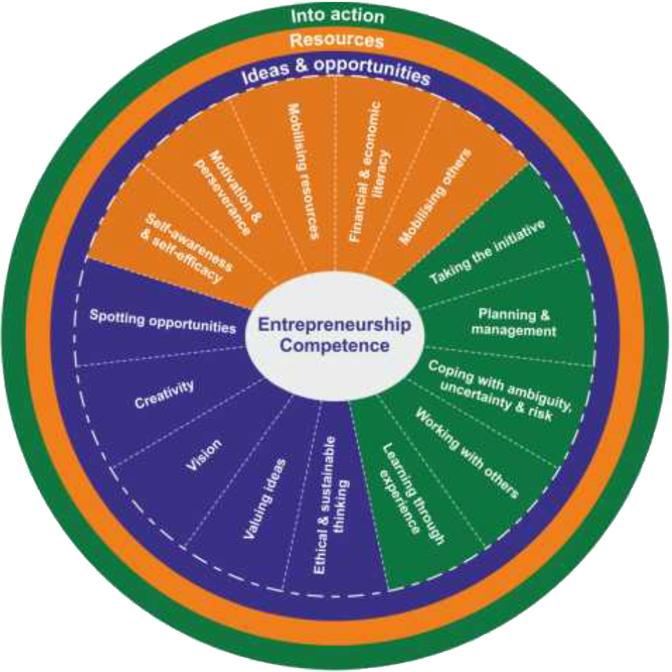
Figure 1: Competence areas and competences of the EntreComp Framework.

Bacigalupo et al. (2016: 14) state that learning related to competences of the EntreComp Framework can ‘develop increasing autonomy and responsibility in acting upon ideas and opportunities to create value’. The idea of developing pupils’ autonomy and responsibility is closely related to the idea of heutagogical learning; a shift from traditional pedagogy, that is pupil centred where the individual directs their own learning. Penaluna and Penaluna (2015) explain that heutagogy can develop a learner’s capability to become self-reliant, spotting opportunities and solving problems for themselves within their learning. By using the EntreComp framework to develop heutagogical learning, teachers can provide their learners with these capabilities. The EntreComp Framework also provides teachers and learners with the opportunity to ‘create value’ which relates back to the component of value within creativity, that has previously been discussed (N.A.C.C.C.E, 1999).

It must be noted that a possible limitation to the EntreComp Framework is that is ‘has not yet been adapted to, or tested in real settings’ (Bacigalupo et al., 2016: 9). Though, in my opinion, if used effectively the EntreComp Framework could be a highly beneficial tool for teachers to use within their practice.

Self-Evaluation of Creativity and Enterprise Dispositions
Within this self-evaluation of my levels of creativity and enterprise dispositions as a teacher, I will focus on the three competences of: 1.2 creativity, 2.2 motivation and perseverance and 3.2 planning and management from the EntreComp Framework. I will assess my current performance and outline suggestions for development in these competences. Reference will be made to professional teaching experiences, with evidence being provided in the appendices.

1.2 Creativity
In relation to the EntreComp Framework, creativity can be seen as the ability to develop creative and purposeful ideas (Bacigalupo et al., 2016).

As a classroom practitioner, I would assess myself as being at an intermediate level described in the EntreComp Framework for creativity (see Appendix 1). I believe this due to the fact that I am experimental with my skills and competences, often looking for new solutions to challenges I face (Bacigalupo et al., 2016). This is often the case when I am trying to develop my teaching methodology, by using new and different techniques and approaches. Within one of my ARC lesson reflections (see Appendix 2), I display my ability to teach in an alternative, more creative way. By applying the mathematical concept of fractions to a problem-solving activity, I was able to motivate and engage my pupils, who showed excitement and enthusiasm during the lesson. Furthermore, throughout my practice I believe that I also show a good ability to generate ideas for the manufacturing of resources; often differentiating created resources for pupils of varying ability (see Appendix 3).

Whilst evaluating my creativity as a teacher, as well as identifying my personal strengths, I have also recognised a number of areas that need to be improved in order for progression in this competence to occur. On reflection of my practice, I personally believe that I need to ensure I provide my learners with more innovative lessons and methods of teaching, in order to secure the benefits of creativity previously discussed. I will attempt to do this by deviating away from more conventional methods of teaching, when I feel it will be beneficial. This could be done by providing learners enthusing opportunities to develop their own enterprise dispositions, challenging learners with real life contexts where they must endeavour to reach a desired outcome or end goal. Moreover, I could design real life contexts to develop a more heutagogical approach to learning, that will help to develop more independent, ambitious and capable learners (Penaluna and Penaluna, 2015; Donaldson, 2015).

2.2 Motivation and Perseverance
Bacigalupo et al. (2016) outline motivation and perseverance as having the ability to stay focused and not give up in times of adversity.

I would assess my levels of motivation and perseverance as being at the higher end of the intermediate level, edging towards the advanced level outlined in the EntreComp Framework (see Appendix 4). Within my practice as a teacher, I often set myself challenging goals in order to stimulate myself to do the best I can for my personal development and for my learners. Brown (2000) states that motivation affects the amount of time people are willing to devote to achieve something. I feel that I am highly motivated and driven and can devote time and effort to persevere and overcome simple adverse circumstances within the classroom. This can be seen within my ARC reflections from teaching time to a year 4 class (see Appendix 5). At times a large proportion of the class really struggled to grasp the concept of time, which can be tricky for learners of their age. However, I did not give up on my learners as I persevered and adapted my teaching to help them develop their understanding of time, which was incredibly rewarding on a personal level.

There are areas of my motivation and perseverance that I believe require development and improvement, in order for me to progress to the more advanced level of this competence. Inspiring my learners to stay motivated and encourage them to persevere to achieve what they want to, is something that I feel I have not yet achieved in my teaching. Schunk et al. (2013) suggest that improved motivation will in fact improve pupils overall learning and performance. In future, I will try to drive and influence my pupils by relating their learning to a personal area of interest for them in order to enable them to develop their initiative by undertaking active enquiry (Hayes, 2010). Further development of this could also be to use elements enterprise education to develop learners’ dispositions.

3.2 Planning and Management
Bacigalupo et al. (2016) describe planning and management as the processes of prioritising, organising and following up.

From assessing my current levels of performance in planning and management, I would place myself at the lower end of the intermediate level on the boundary with the foundation level of the EntreComp Framework (see Appendix 6). Areas of strength that I have shown in this competence is the ability to be flexible, by adapting to and managing unexpected changes or circumstances. Additionally, I have also shown an ability set short term goals that I can act upon. Evidence of these strengths can be seen with my tracking and lesson planning (see Appendix 7). Using my pupil tracking, I was able to identify learners who required extra support within fractions and implemented this extra support within my lesson plan for the following session. This allowed me to effectively manage the pupils’ learning, helping them move from a red, to a green level of understanding.

Throughout my practice however, I have shown an element of poor time management on occasions which can be seen within my ARC lesson reflections (see Appendix 8). At times during my teaching, I have been unaware of how much time is available to me within my lessons. Giving the children too long of a period on tasks has led to occasions where I have not been able to summarise their learning effectively, as there has not been enough time available to deliver a solid plenary. In order to progress and advance my planning and management to the next level, I will need to develop my ability to manage my lesson time effectively. To do this, I will strive to define the priorities that I feel should be present in my lessons, such as an effective plenary, monitoring the progress of each priority (Bacigalupo et al., 2016). The use of a set timer for each part of my lesson will help me manage my lesson efficiently, allowing me to overcome the challenge of time management of creative and enterprise extended tasks (Desailly, 2012).

Conclusion
From conducting this assignment, I have established that creativity and enterprise share many similar traits, with enterprise education providing practical situations for creative processes to be applied to. As a classroom practitioner, it is important to have a good knowledge and understanding of the benefits of incorporating creativity and enterprise into teaching, whilst also being aware of its challenges and limitations.

The EntreComp Framework can be used as a tool by teachers, to aid them in implementing enterprise and creative learning within their practice. The framework provides scaffolding for the development of their own personal enterprise dispositions, as well as those of their learners (Bacigalupo et al, 2016).

Personally, I feel that I show good level of a majority of the competences within the EntreComp Framework. Yet, I also recognise that there is room for improvement, as there is always across all areas of my professional development as a teacher. Furthermore, I recognise that there is a greater need for me to develop my enterprise dispositions in the coming years, in order to provide learners with opportunities to become creative and enterprising individuals of the future (Donaldson, 2015; Welsh Government, 2017).

Word count: 2,697.

Appendices
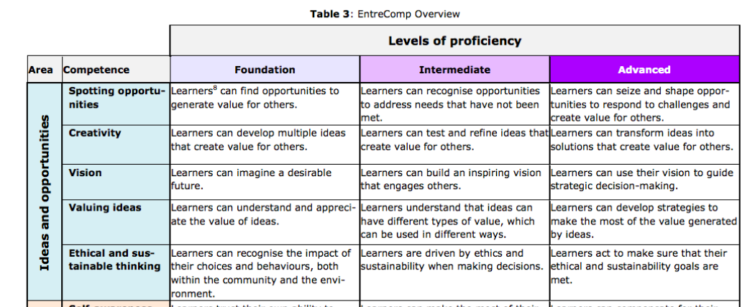
Appendix 1: Creativity – Levels of proficiency within the EntreComp Framework.
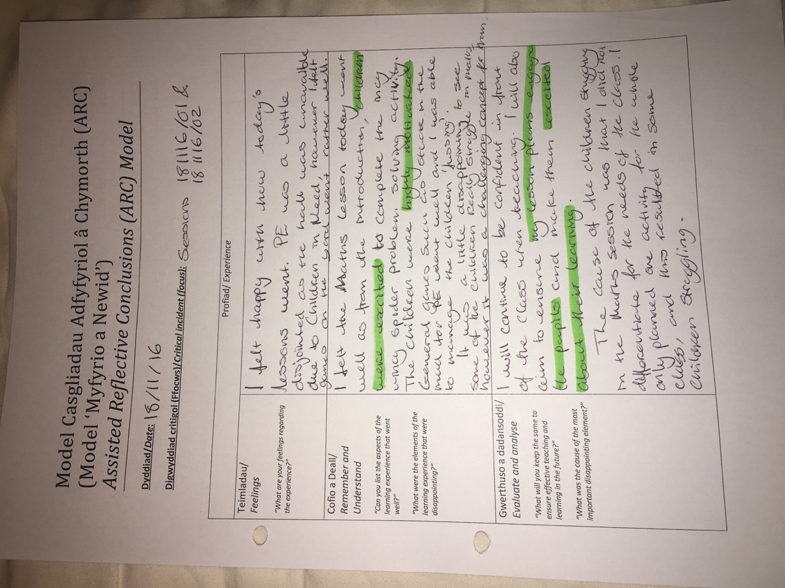
Appendix 2: ARC lesson reflection – Alternative creative approach to maths topic of fractions with year 4 pupils.
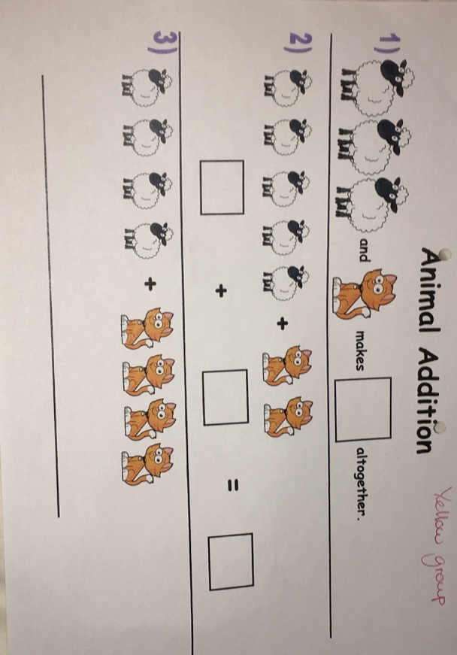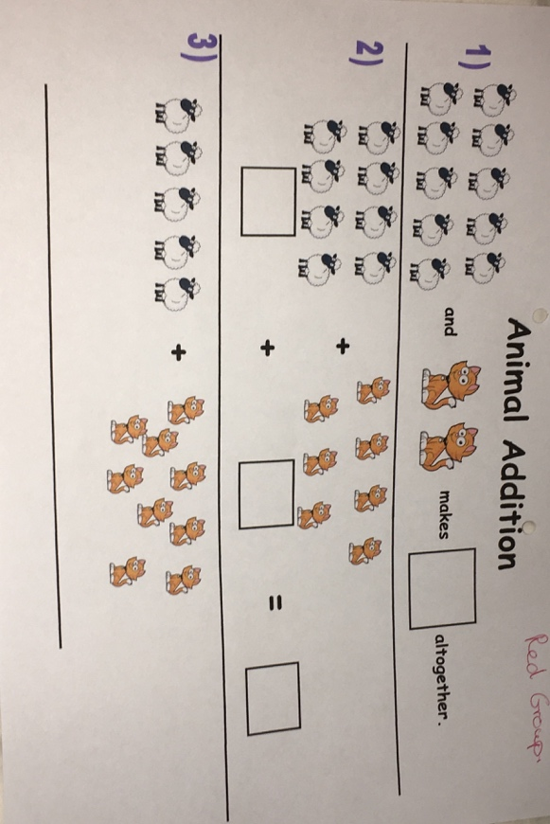
Appendix 3: Created and differentiated resources for maths topic of addition with year 1 pupils.

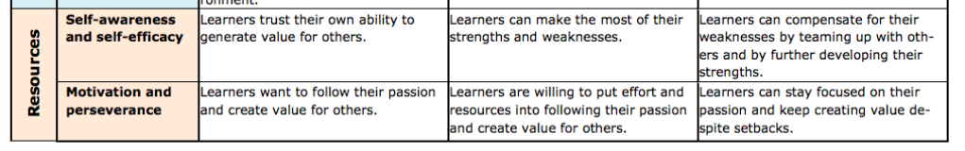
Appendix 4: Motivation and Perseverance – Levels of proficiency within the EntreComp Framework.
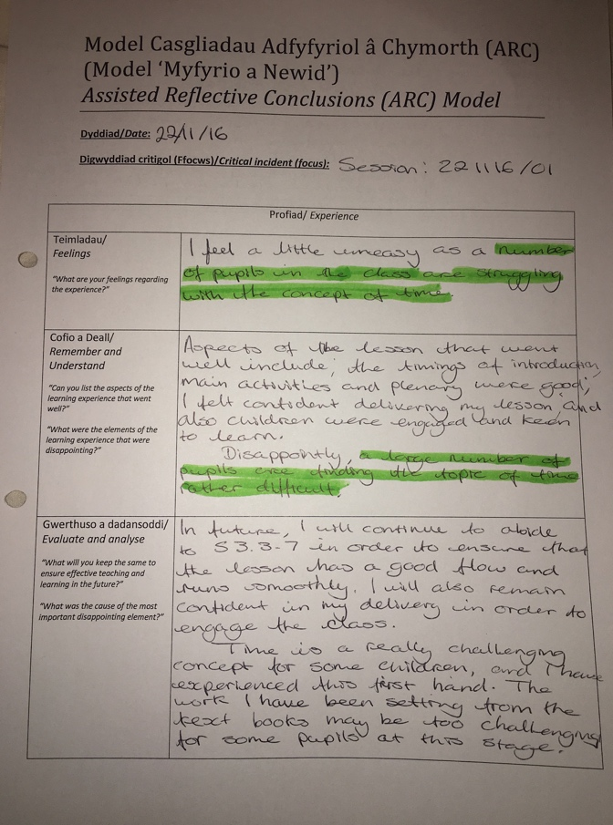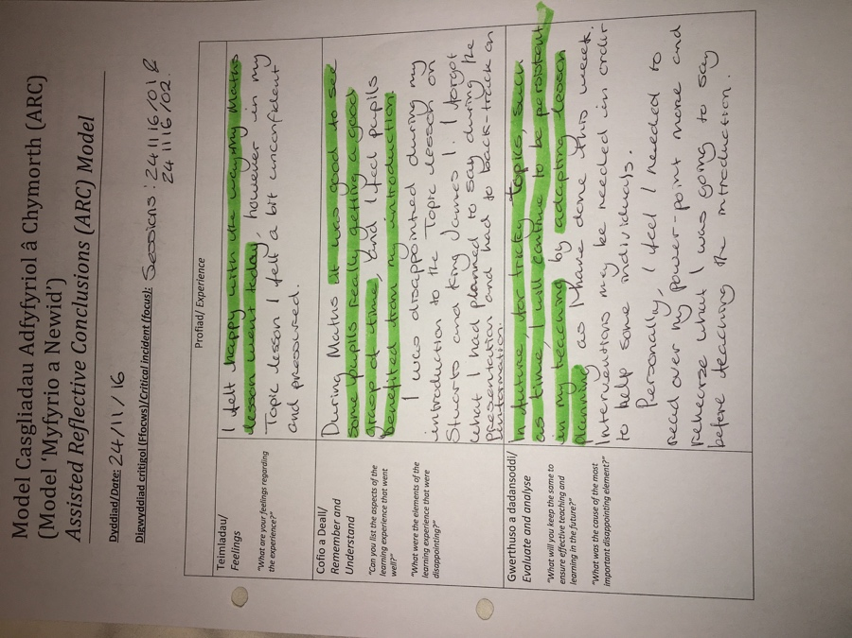
Appendix 5: ARC lesson reflections – High levels of motivation allowed me to persevere with my teaching of time to year 4 pupils. Didn’t give up on my learners, helped them to grasp a tricky concept.

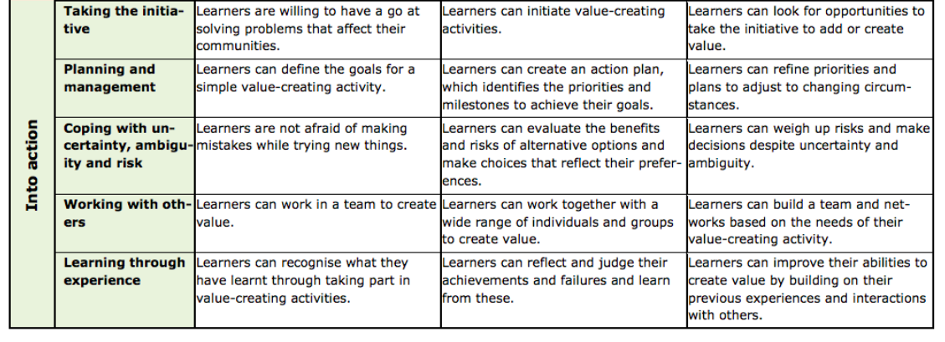
Appendix 6: Planning and Managment – Levels of proficiency within the EntreComp Framework.
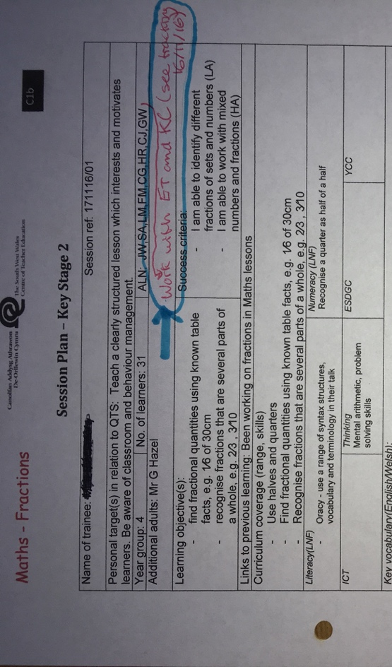
Appendix 7: Pupil tracking system – identified learners who need extra support with fractions. Lesson plan – plan intervention with these pupils in next session. Managed pupils’ learning helping them to achieve green level of understanding in next session.

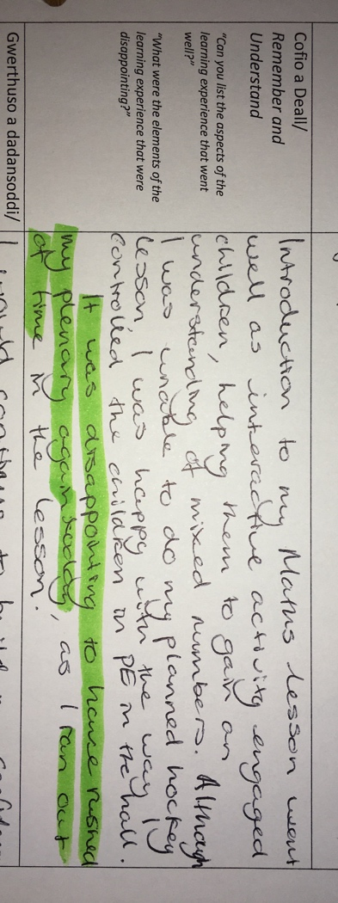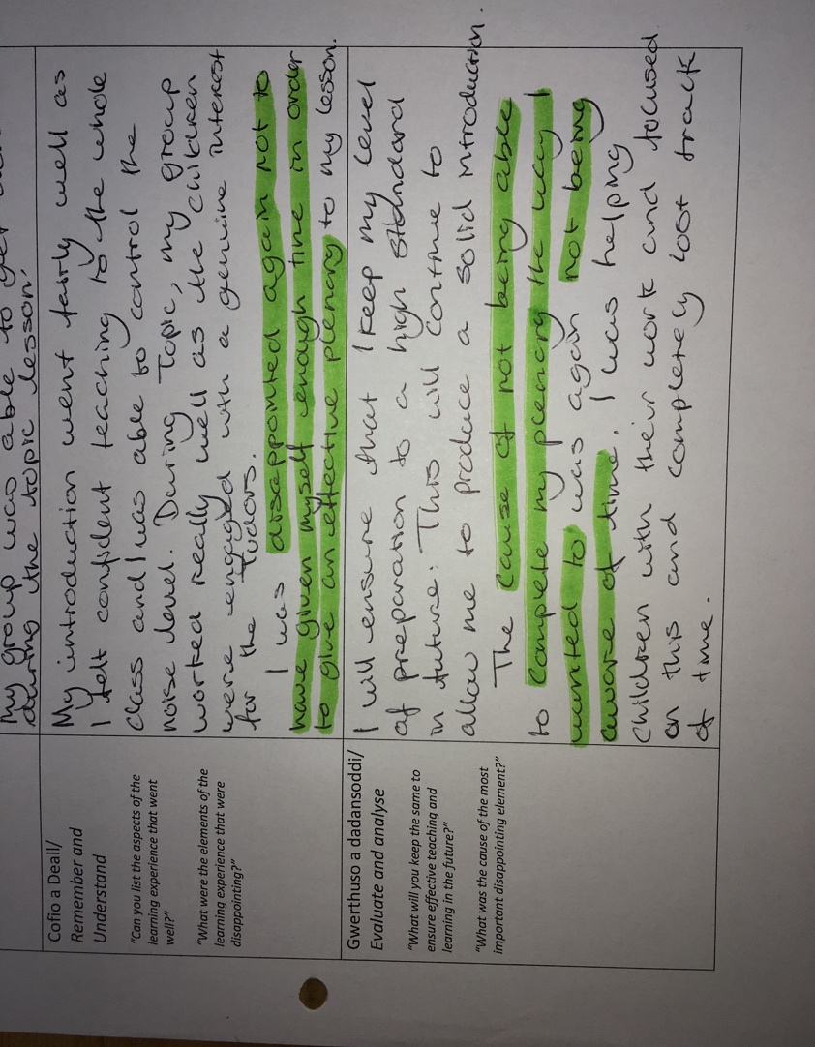
Appendix 8: ARC reflections – poor time management leading to plenaries being rushed and not effective.

Reference List
- Bacigalupo, M., Kampylis, P., Punie, Y. and Van den Brande, G. (2016) EntreComp: The Entrepreneurship Competence Framework. Luxembourg: Publication Office of the European Union.
- Brown, H. D. (2000) Principles of Language Learning and Teaching. (4th ed) New York: Addison Wesley Longman.
- Desailly (2012) Creativity in the Primary Classroom. London: SAGE.
- Donaldson, G. (2015) ‘Successful Futures’ Independent Review of Curriculum and Assessment Arrangements in Wales. Cardiff: Welsh Assembly Government (WAG).
- Fisher, R. and Williams, M. (2004) Unlocking Creativity: Teaching Across the Curriculum. Oxon: David Fulton Publishers.
- Gardner, H. (2006) Changing Minds: The Art and Science of Changing Our Own and Other People’s Minds, Boston: Harvard Business School.
- Hayes, D. (2010) ‘The seductive charms of a cross-curricular approach’, Education 3-13, 38, 4, November, pp.381-387.
- N.A.C.C.C.E. (1999) All our futures: creativity, culture and education, London: DfEE.
- Oxford University Press (2017) ‘Oxford Dictionaries’ Available at: https://en.oxforddictionaries.com/definition/disposition [Accessed: 11th December 2017].
- Penaluna, A. and Penaluna, K. (2015) ‘Entrepreneurial Education in Practice: Part 2 – Building Motivations and Competencies’, Entrepreneurship360 Thematic Paper, pp.14-15.
- QAA (2012) ‘Enterprise and entrepreneurship education: Guidance for UK higher education providers’ Available at: http://www.qaa.ac.uk/en/Publications/Documents/enterprise-entrepreneurship-guidance.pdf [Accessed 11th December 2017].
- Schunk, D., Meece, J. and Pintrich, P. (2013) Motivation in Education: Theory, research and applications. (4th ed) Boston: Pearson College Div.
- Thorne, K. (2007) Essential Creativity in the Classroom. Abingdon: Routledge.
- Welsh Government (2017) Education in Wales: Our national mission. Cardiff: Welsh Assembly Government (WAG).

