UNIVERSITY OF WALES TRINITY SAINT DAVID (LONDON CAMPUS)

MODULE CODE: LCMB7007
MODULE TITLE: Creativity Innovation and Intellectual Property

ASSESSMENT TYPE – Assessment 1

ASSISGNMENT TITLE: Electric Cars – are they an innovation opportunity or a major threat to big business?

MODULE TUTOR: Mr Richard William Small

STUDENT NAME: Margaret Kyakunda

STUDENT NUMBER: 1712816

Table of Contents
- Introduction 2
- History to date of motor industry 3
- Table .1 Evolution of the electric car 4
- Industry analysis 5
- Table .2 Global Electric Sales 5
- Market Analysis 6
- Table 3. Share growth in passenger electric car 7
- Fiver forces Analysis of Electric car 7
- Buyer Power 7
- Supplier bargaining power 7
- New Entrants---------------------------------------------------------------------------------------------7
- Threat to substitutes----------------------------------------------------------------------------------.7
- Degree of Rivalry ---------------------------------------------------------------------------------------7
- Leading companies-------------------------------------------------------------------------------------8
- Impacting factors in the global vehicle market--------------------------------------------------8
- Technological advancements 8
- Proactive Government initiatives 8
- Increase in demand -------------------------------------------------------------------------- --------9
- Rules and regulations on emissions ----------------------------------------------------------------9
- High manufacturing cost------------------------------------------------------------------------------9
- Innovation cycle 10
- Conclusion 11
- Reference------------------------------------------------------------------------------------------------12

INTRODUCTION
The era of the combustion engine that’s has dominated the transport industry and helped provide flexible movement for people and goods is being shaken by the rapid growth of Electric Vehicle (EV) technology in the transport sector. United Kingdom has seen an increase of EVs on the road from 4000 in 2013 to 160,000 as of June 2018. Even though we have seen growth EVs are still at an early stage the big players in the industry are setting the scene. insights series, implications of the transition to Electric vehicles (2018), Ofgem.
“An electric car is an alternative fuel automobile that uses electric motors and motor controllers for propulsion, in place of more common propulsion methods such as the internal combustion engine (ICE). Electricity can be used as a transportation fuel to power battery electric vehicles (EVs)”
Electric Vehicle Definition, (2018), News Electric Vehicles Driving the future green, http://electricvehiclesnews.com
By 2020 to 2030 majority of vehicle on the roads on a global scale will be battery powered. (Bloomberg New Energy Finance (BNEF) reports, “…further estimates in the USA there will be over 1mill sales, 10 times of 2017s 104,000 total and China will top 3 million… due to environmental regulations by governments on air quality, consumer demand and drop of prices making batteries affordable…. and all this started with Robert Andersons 1832 electric carriage, by Gertz, (2019), https://www.bloomberg.com/news/photo-essays
“Innovation on the other hand can be said to be the first use of an invention.” Bainbridge. D.I (2012). p.g.433. The patents ACT 1977 contains no definition for invention as it was a daunting area and felt in future development of law in tune with technological development.
Innovation is something new and difficult for most organisations as the external environment is volatile, as it keeps changing, it always drifts away from where as an organisation want to be from an escalating rate of change. Innovation is uncertain end this means the current situation is to produce electric cars by 2030 as the government has issued bans on petrol and diesel cars and companies like the Volkswagen has reduced some of the production of its diesels fleet.

History to date of the motor industry
Early 1900s, saw the electric car technology innovation in the transport industry. It was the future and electric vehicles accounted for a third of all vehicles on the road. It ended abruptly due to mass production of gas engines. Its here again and its uncertain of what the future will be.
As to whether electric car is an innovation opportunity, this electric technology has been around for decades and has been revived by the environmental, technological concerns and government regulations putting a ban on diesel and petrol engines production by 2030. This an opportunity for car manufactures to revive the electric cars and make them profitable. According to the Head of Goldman Sachs, Michael Ronen on the revolution in the car industry “cars and car manufactures are changing their business in several ways … we’re on the verge of a huge disruption that creates tremendous opportunities’ for folks around the world.” Ronen. M, (2017), Auto 2.0, www.goldmansachs.com.
Battery -powered cars have come a long way from the first electric carriages. As in car manufacturing the idea of innovation is slow paced. The background from Horses –cars shows that the industry took its time to regarding was Disk brakes, alloy wheels, seat belts and fuel ignition.it was not unit good at electrics until the personal computer that they started looking at electrics.

Evolution of electric car
1800s -1832 | first electric carriage created -Robert Anderson (British Inventor)
1900-1910 | in the US are electric cars make 1/3 of all vehicles.
1914 | 100 miles cheap and practical electric cars project by Henry Ford abandoned.  Ferdinand Porsche creates first hybrid
1920s -1960s | decline in electric cars due to high demand for Ford’s mass-produced Model T plus other gas cars on the market.
1930 | Few battery powered cars
1954 | new use emerges lektro introduces commercial electric golf cars
1959 | National Union Electric Corp modifies 100 renalul Dauphines to run on batteries.
1970-80 | 1971-1972 NASA electric lunar roving vehicle
1990 | Emissions rules -auto companies focus on alternative fuel vehicles.  1997 GM Introduces the EVI hybrids go on sale -Toyota Prius. Honda and Nissan Powered by lithium batteries
2000 | GM destroys the EVIs when lease expired
2003 | Elon Musk invests 7.6 million and becomes chairman of the board 2004
2008 | Tesla Launches Roadster sports first production to use Lithium -ion cells
2010 | Nissan leaf goes on sale world bestselling car
2010- present | Tesla adds more models
Glimpse to the future | uncertain
Gertz (2019), Years-before-tesla-the-evolution-of-electric-vehicles, www.bloomberg.com/news/photo-essays

INDUTRIAL ANALYSIS
All car manufactures by 2040 will have electric car production in the market or face extinction as by that time 50% of the cars will be powered by batteries, as forecasted by Gertz (2019) www.bloomberg.com/news/photo-essays, Battery -powered cars have come a long way from the first electric carriages, since 1950 many things that happened here should have appeared in 1930s. it has taken the industry 50 year to get here as no competence in the industry brought on by weak innovation strategy. Most small care are similar due to platform sharing brought on by wrong strategies regarding platforms. e.g. Maserati and other cars use of type 4 platform.
What’s happening now in the car industry is the ban for production of petrol and diesel will take effect in 2040 but for diesel engines the ban sooner by 2030, Volkswagen was caught cheating on emissions, was not telling the truth about the diesel engines and this ended up affecting the whole industry because of plausible deniability from Volkswagen regarding pollution from its diesel engines cars.
To many its not an innovation opportunity as they are not prepared and relying on China but its doubted that China will be ready to provide as its also coming up with its own electric cars for its own big population. The motor businesses relying on china to provide might find themselves out of the game.
The electric car yes, it’s a game changer no choice to car manufactures as they to change their business models. For Established players in the car manufacturing it’s all over for them as electric cars are here to stay as their new entrants in the market. May be in future is going to be a Samsung, iPhone or Dyson car to mention a few. These non-producing cars might be selling us the future what shape no one knows may be box or any other shape. Dyson is moving its manufacturing plant to Singapore to prepare its electric car production.

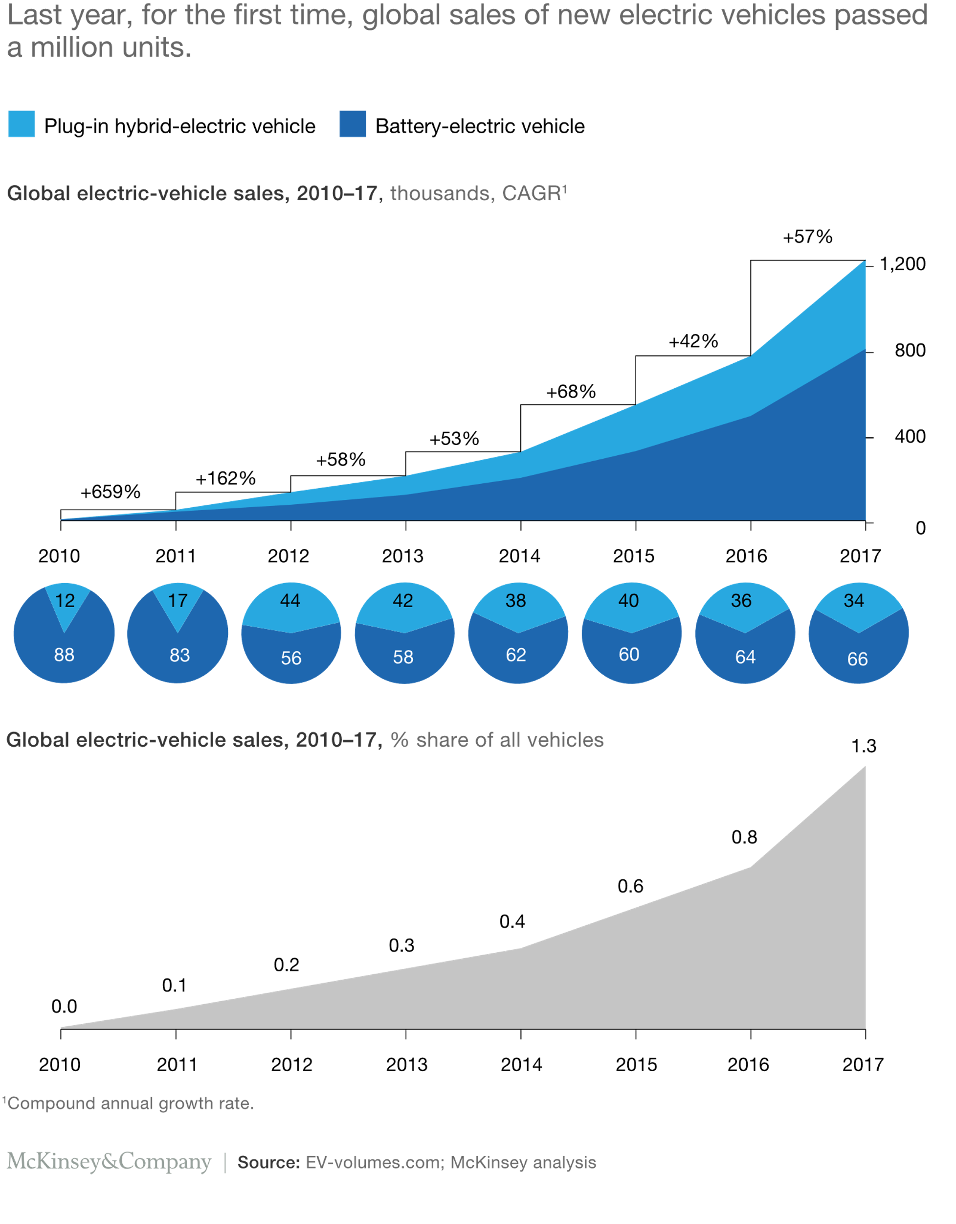

Market Analysis
Recent years has seen a growth in the market for hybrid and electric cars. The forecast is showing a double increase by 2040. The country to market first will be in lead position and to achieve this to have a proper efficient infrastructure to meet the increased demand of the vehicles on road and to meet the target in combating CO2 emissions. Global Hybrid & Electric Cars’ (2017) Hybrid & Electric Cars Industry Profile: Global, pp. 1–41.
A niche market has been created for the electric vehicles and its growth has been due to incentives from both the government and car manufactures. For example, cash incentives towards a new hybrid and zero tax for the year. With continued support and innovation, we are seeing more hybrids on the roads. Mason. N, Head of Retail Research https://store.mintel.com/uk-hybrid-and-electric-cars-market-report.
Major players dominating the global market in the electric vehicle market are from Japan, USA, German to mention a few these countries are engaged in the manufacture of electric vehicles releasing hybrids, plug-in hybrids or pure battery electric vehicles “variants. www.persistencemarketresearch.com/market-research
Share of growth in passenger electric vehicle sales, selected regions

Source: Bloomberg NEF
Note: Data are for China, Europe, Japan and North America. Figure for 2018 is for 12 months through June.

.

Five Forces Analysis
Buyer power
Due to the price tag on the vehicles manufactures must invest a lot in the brand in order to retain customers. Electric cars now are very costly and available for people with high income
Suppliers bargaining power
Raw material prices have been fluctuating in the past. The seriousness of electric production saw prices for cobalt increase and expected to reach time high in the future. The long-term supply chain for raw materials is something electric car manufactures must look at.
There is a long wait for the product to reach the customer, to shorten the delivery times the operating costs and get competitive advantage, customer service should be improved while supplier increase turnover and decrease margins.
New entrants-
To succeed as a new business in the market is a bit tough due to existing well-known brands. In the motor industry your competing with big names as brand is everything. The landscape in the electric car manufacturing is open to new big names which have no business in automobiles and encouraged by the rapid growth in the market.
“Dyson, a leader in vacuum cleaners and hand dryers, has announced that it will be releasing its very own EV by 2020 and is investing $2.7 billion in the research and development process. This highlights that having relevant experience and knowledge in the technological field could be beneficial, thus encouraging new entrants.” ‘Europe-Hybrid& Electric Cars’ (2018) Hybrid & Electric Cars Industry Profile: Europe. P. N.
Threat to substitutes
The Petrol car is still a major player in the automobile industry and the threat by electric cars is very low. Major threat to big business by the electric cars may be in ten years’ as forecasts show that by 2040 the sales of electric cars will be 50%
Degree of rivalry
Due to high production cost and lack of innovation in the auto industry many manufactures have not yet considered entering the market. The big players have dominated the electric market by releasing few electric cars in the market,
Nevertheless, the recent change of strategy of Toyota to upgrade its new model to the plug-in niche market is expected to alter the structure of competition, intensifying rivalry with other large players present in this market such as BMW, General Motors, Mitsubishi and Honda. Likewise, another notable player, Volkswagen has the same competition ability with Volkswagen and Audi brand.

Leading companies
Volkswagen AG, Ford, Tesla, BM W Group, Nissan, Motor Corporation, Toyota, General Motors Tesla, BMW Group, Nissan Motor Corporation, Daimler AG, Energica Motor Company S.P.A., BYD Company Motors, Zero Motorcycles, Renault Motors, Audi AG, Citroën, and Mahindra & Mahindra Ltd. who are in the driving seat which is very costly project in looking at the existing opportunities to create something different and capture value by searching for the triggers to innovation through incrementalistic and radical change eyes and deliver the electric car.

IMPACTING FACTORS IN THE GLOBAL VEHICLE MARKET
Technological advancements
Lithium-ion batteries are better, and China has claimed they have the technology “By 2021, capacity will exist to build batteries for more than 10 million cars running on 60 kilowatt-hour packs, according to data of Bloomberg NEF… supply will come from places like China, Thailand, Germany and Poland that rely on non-renewable sources like coal for electricity https://www.bloomberg.com/news
Energy density -is a hurdle for electric car in case you ran out of battery how far is the battery charge going to take you compare to a jerry can on fuel with can take you 20 miles than a recharged battery which will take out 1 mile. The question her is how much distance you can travel with your battery> if it’s for short distances fine but long haul it’s a bit of risk.

Advances in technology and the increasing cost of lithium -ion batteries are allowing the industry to begin replacing diesel -fuelled equipment from drill to quieter and more efficient and less polluting electric powered alternatives. Companies like Tesla its emphasis on its technology on battery is not working as after 5 years it must be changed.
Proactive Government initiatives
Technological advancements in electric vehicles and proactive government initiatives are expected to create opportunities for the growth of the stakeholders of the electric vehicle market. Various companies have also tried to expand their business by opening various manufacturing facilities in the developing countries, such as India, South Africa, to develop electric vehicles for commercial purposes.
To be competitive lessons should be taken from Schumacher and others by
Leasing IP and lease others IP- (Henry Chesbrough 2003 lecture notes) and do the following
“…partnerships, joint venture and collaborations among firms allow to identify cost reduction opportunities and ways to increase revenues, through sharing process, activities, resources and competences (Kajuter and Kulmala, 2005; Anderson and Dekker, 2009). For example, sharing product design activities could be a way to reduce research and development costs for each firm involved in this cooperation”.) …”;. Giannetti, R., Risso, L.& Cinquini, L., 2016. Managing costs by business model: issues emerging from the case of E-Car. Measuring Business Excellence, 20(4), pp. 28-45. e.g. Tesla can have an alliance with Boeing.
Volkswagen and Ford can also forge an alliance – “. talks expected to centre on how Ford would licence VW’s electric car technology ...” Financial times, Ford and Volkswagen to forge deeper alliance January 9,2019. www.ft.com/electriccars
Corporate leadership it’s too slow as many depend on their leaders to drive change. In the UK there, few teams working together. Team working should be introduced and small teams can lead on innovation or create ideas and need to balance vision and management also revision of governance structure and strategic leadership.
Increase in demand for fuel efficient, High -performance and low emission
Once the infrastructure is in place, prices fall, and mass production then more will be purchased. It’s expected that the industry will experience a rapid transition. As it was for the Airbus A380 a decade ago which was supposed to offer a way airlines transport passenger in great volumes and take market share from Boeing Co.’s 747 and 777. The plan did not work that way even with its biggest customer airline Emirates has reached impasse. By giving this example am of the view that the electric car introduction on the scene is not an end to the oil industry even if they have predicted that by 2040, but let’s not forget that this is an immediate reality for developed countries who will be able to purchase these electric cars with the support of the governments for instance the ban of diesel engines by 2030 and stop production petrol cars. “… a big market in developing countries which will continue to purchase fossil fuelled cars. Flicking &Trivedi. A, (2018)-Bloomberg, Future Transport Eludes the Seers, by 04/11/2018.
Stringent government rules and regulations towards vehicle emissions
Even though its government regulation to stop production the electric car market is still not ready as electric cars are still very expensive.
Green strategy introduction in business is vital a move away from the carbon culture. Most European governments, North America and emerging economies are taking measure to decrease the dependence on fossil fuel and encourage alternatives to conventional fuel sources.
The new emission targets set by the EU will be so difficult to meet for example Volkswagen largest maker of cars” …its 300billion Euros, effort to roll out electric vehicles will not be met ...”. Financial times.com, VW electric car plans not enough to hit EU emissions rules. December 2018.
Rules and regulation for instance new technology can be supressed by rules. Example Lotus racing car used water injection system in its car but due to rules its was stopped in the 1970s. in the car industry suppliers work with car – petroleum industry racing is sponsored by oil business
High Manufacturing cost
“The role of external networks in organizations and the integration of suppliers in product development are important ways of managing product life-cycle costs (Davila and Wouters, 2007, p. 834) …”; Giannetti, R., Risso, L.& Cinquini, L., 2016. Managing costs by business model: issues emerging from the case of E-Car. Measuring Business Excellence, 20(4), pp. 28-45.
Innovation cycle:
Stage 1: 2018 – Industry Fluid much uncertainty and flexibility
Stage 2: is imminent but the Automobile industry not there yet; even though Tesla is trying its best it might lose out in the future as changes are uncertain.
Stage 3: Hopefully integrated into production and as by the forecasts and assumptions in 10-15 years we can see 50% of electric cars on the road.

CONCLUSION
Innovation is a moving target as the car industry did not know where the car will end up even as of today we don’t know how the car of the future if going to look like. Whether is going to be an ugly box or something beautiful we leave this in the hands of the creative team in the organisations.
Car manufactures must manage innovation in a way that it must be reconfigured differently as electric engines have been around. Improvement in technology and software infrastructure. Organisations must become learning organisations and be able to handle change

REFERENCES
- Future insights series, implications of the transition to Electric vehicles (2018), Available at: https://www.ofgem.gov.uk/ofgem-publications/136142. Accessed on 27th November 2018.
- Electric Vehicle Definition, (2018), News Electric Vehicles Driving the future green ; Available at; http://electricvehiclesnews.com/Definition/description.htm, Accessed on 28 November 2018
- David Bainbridge (author), (2012) Intellectual Property D.I.p.g.433. 9th Edition
- Ronen. M, (2017), Auto 2.0, 06 JAN 2017, Available at: https://www.goldmansachs.com/insights/pages/auto-2.0.html, Accessed on: 24 November 2018
- Gertz (2019), years-before-tesla-the-evolution-of-electric-vehicles 11.00 GMT, (Available at),https://www.bloomberg.com/news/photo-essays
- Accessed on (5TH January 2019 )
- Gertz (2019), years-before-tesla-the-evolution-of-electric-vehicles 11.00 GMT, (Available at),https://www.bloomberg.com/news/photo-essays
- Accessed on (5TH January 2019
- Gertz (2019), years-before-tesla-the-evolution-of-electric-vehicles 11.00 GMT, (Available at),https://www.bloomberg.com/news/photo-essays
- Accessed on (5TH January 2019
- Gertz (2019), years-before-tesla-the-evolution-of-electric-vehicles 11.00 GMT, (Available at),https://www.bloomberg.com/news/photo-essays
- Accessed on (5TH January 2019
- Global Hybrid & Electric Cars’ (2017) Hybrid & Electric Cars Industry Profile: Global, pp. 1–41. Available at: https://ezproxy.uwtsd.ac.uk/login?url=https://search.ebscohost.com/login.aspx?direct=true&db=bth&AN=124099800&site=ehost-live (Accessed: 11 January 2019).
- https://www.persistencemarketresearch.com/market-research/electric-vehicles-market.asp. 02nd December 2018
- Mason. H, Head of Retail Research https://store.mintel.com/uk-hybrid-and-electric-cars-market-report 02nd December 2018
- https://www.persistencemarketresearch.com/market-research/electric-vehicles-market.asp 02nd December 2018
- Source: Bloomberg, NEF Note: Data are for China, Europe, Japan and North America. Figure for 2018 is for 12 months through June.
- Bloomberg) Future Transport Eludes the Seers, by David, Flicking and Ajani Trivedi 04/11/2018
- the-dirt-on-clean-electric-cars, https://www.bloomberg.com/news/articles/2018-10-16/ Accessed on 02nd December 2018
- Financial times.com, VW electric car plans not enough to hit EU emissions rules. December 2018.
- GIANNETTI, R., RISSO, L. and CINQUINI, L., 2016. Managing costs by business model: issues emerging from the case of E-Car. Measuring Business Excellence, 20(4), pp. 28-45.
- Volkswagen to forge deeper alliance January 9,2019. www.ft.com/electriccars
- Money Talk, April 28, 16 are electric cars a threat to the oil industry? https://www.moneytalkgo.com/video/the-electric-car-markets-impact-on-oil/

