Academic report

What is the most effective way to motivate staff?

Student Name: Elvis Liviu Nassiri Basti
Student Number: 2112789
Lecturer Name: Mr Nazmul Hassan
BMSW 4001
Academic and Employability Skills

Table of Contents
Introduction 1
Motivation 1
Financial Motivation in the workplace 2
Recognition and awards 3
Additional holidays 5
Good working conditions 5
Conclusion 6
Reference: 6

Introduction

Many studies were been done on motivation topics. In the twentieth century, many theories about the concept of motivation come out like Maslow's hierarchy of needs, Herzberg's two-factor theory, Vroom's expectancy theory and many others which were focused on employee motivation.

Different definitions of motivation come out, for instance, Herzberg defined employee motivation as the desire to perform a specific work activity. It is agreed that employee motivation is different from extrinsic and intrinsic motivation.
According to Staw, Herzberg's two-factor theory was the first attempt to make a distinction between intrinsic and extrinsic motivation but changed later in time (Obiekwe, N., 2016.)

Previous studies on the relationship between job performance and employee motivation were not able to establish a high statistical relationship. However, after further research, it has been concluded that both are related. This report aims to comprehensively analyse the relationship between job performance and employee motivation.

The diversity of employees in the workplace makes it harder for managers to deal with the best way to take the best out of employees. Is difficult to clear understand the motivation of each individual to perform well can make it difficult for them to make the best decisions. This report will analyse many factors which can affect employee motivation and aim to provide managers with valuable information on how to improve employee performance.

Motivation

Concept of motivation (Peters, R.S., 2015). Motivation is the employee's wish to reach a goal which directs people to the job required. Nobody will do anything without a reason, we are eating because we are motivated by hunger, we are drinking because we are thirsty, we steeping because we are tired, and we are doing all this because we are motivated by something. Unmotivated employees are more likely to waste their time and effort at work, and even leave the organization. On the other hand, those who are motivated are more likely to work hard and produce high-quality work
Motivation is a process or external factor that causes an individual to desire to pursue a certain goal and can be various factors internal or external processes (Islam, N., 1999)

Pay Motivation

They are many ways where how business can motivate their employees and the most common way is financial motivation.
Remuneration is the money which an employee receives for the working hours in a business which normally depends on the position is having in the business, the higher the more money he earns. When we talk about motivation remuneration can be very effective because money is one of the key reasons many people are working (Leete, L., 2000).

The most common is wages where employees are paid at time-based rates. Factories have the piece rate method, with this method employees are motivated because they are paid for the number of products they produce, their employees tend to work more effetely because the money they will receive is higher and will increase productivity for the business. In addition to time rates and piece rates, some businesses offer overtime pay. Overtime is when a business offers employees extra working hours on top of the standard ones and the employee get paid better rates. During busy periods, companies are offering overtime for employees, so they will start working more efficiently to be chosen if any competition.

Salaries are a fixed amount of pay, that employees receive for their work on monthly bases or every four weeks. Salaries are split into an equal guaranteed amount of pay which gives safety and comfort in their roles. Very often when employees meet or exceed targets companies are rising their yearly salaries. In time many theories come out regarding motivation, one of these is two factors of Herzberg's motivation theory by Alshmemri et al. (2017).

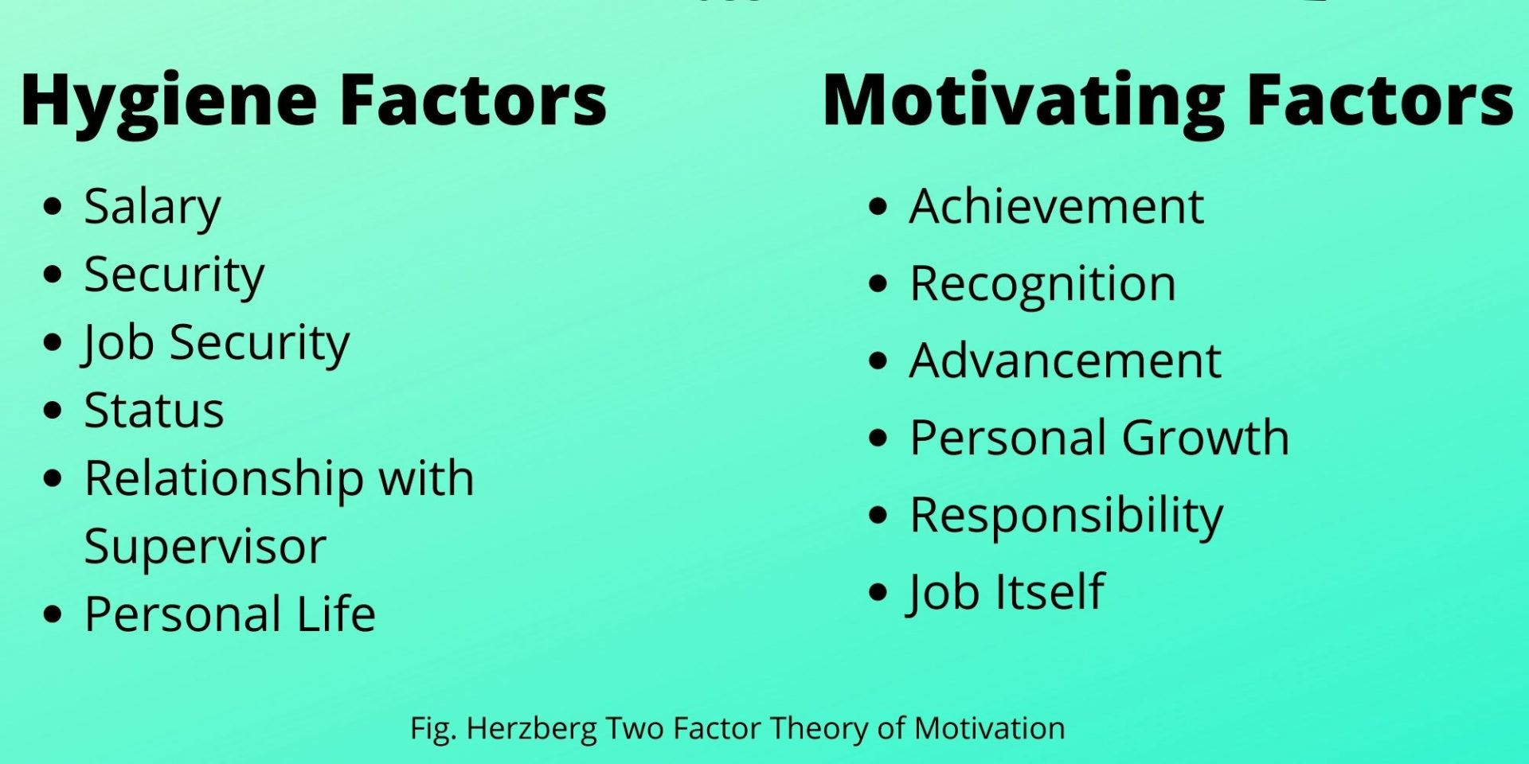

According to Herzberg's two-factor theory, maintenance factors and dissatisfiers are external factors that can affect employees' performance. Maintaining a minimum level of satisfaction is the most important factor that employees need to consider when it comes to improving their performance. Herzberg stated that managers should focus on maintenance factors and hygiene factors to improve employees' performance.
The concept of Herzberg's two-factor theory states that various factors can motivate people, such as job content factors, satisfiers, and motivators. These factors are related to the job itself and can cause high levels of satisfaction and motivation.

Recognition and awards

These factors are related to individual experience and the relationship with the work environment, recognition by others, responsibility for one's work, advancement, and personal fulfilment. Individual motivation is strictly related to the fulfilment of these factors. Management, to obtain from the employees a constant and good quality effort, as well as outstanding performances, must, first of all, remove the factors that produce dissatisfaction, by creating a favourable organizational environment, which also includes appropriate relationships with colleagues, and managers and other people involved. Only after that, the manager can hope for an increase in effort and of course performance, by intervening with motivating factors, to inspire the desire for self-realization at the same time those that managers should ensure a satisfied staff.

The capacity for self-realization is directly affected by the pleasantness of the activity and the responsibilities held. The greater the responsibility, the more it increases and the satisfaction offered by advancement in the hierarchy. The motivators are based on personal development and self-fulfilment. The motivation of employees can be strengthened by increasing their level of responsibility and enriching their activity. Also known as substantial theories, the theory of A. Maslo and F. Hehrzberg had special practical consequences (Gawel, J.E., 1996). They allowed the structuring of remuneration policies and provided a basis for a new approach, such as participative management.

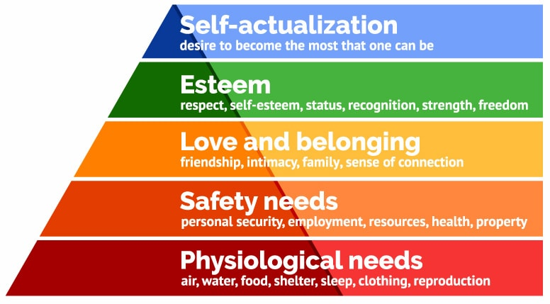

According to Maslow's theory, individuals should first meet their lower-level deficit needs before they can start addressing their higher-level growth needs. However, growth needs will continue to grow once people are engaged in addressing them. Once people have been able to sufficiently satisfy these needs, they can start reaching their highest level of self-actualization.
Despite having the necessary skills and abilities to move up the hierarchy, people tend to fail at reaching their higher self-actualization goals when they don't meet their lower-level needs. This is because life experiences such as divorce and job loss can cause individuals to fluctuate between levels
Physiological needs, the human body can function optimally if its physiological needs are satisfied. According to Maslow's Hierarchy of Needs, the most important need is to meet the physiological needs of the body.

Safety needs, the need for safety and security becomes more prominent, people want to feel secure and have control over their lives. These can be fulfilled by society and family.

Love and belonging, this is an emotional need that people have for belongingness. It involves being able to belong to a group or social network.

Esteem According to Maslow, esteem needs are, those for oneself and those for others. He noted that the need for reputation is most important for adolescents and children.

Self-actualization needs the level of ambition that is considered to be the highest in Maslow's Hierarchy and is referred to as the desire to achieve everything that one can do to become the best version of themselves.

Additional holidays

Many companies pay higher salaries than market levels, they also recognize that it is not enough to just pay them above market levels to motivate and encourage employees. In addition, giving a cash bonus or raising pay may not be beneficial immediately. Employees can also be motivated by various non-financial factors, can be hard to choose the best rewards for them due to their subjective nature. However, consulting staff members about their favourite rewards can be a good way to start.
Another strategy is to provide employees with a choice of rewards, similar to flexible benefits. employees should also be given rewards which can be in various forms such as providing them with additional insurance coverage, holding team events, and allowing them to take part in sporting events or concerts, flexible working hours can additionally help keep employees motivated.
Some of the organizations will allow employees to take more types of leave holidays, paid or unpaid. Thus, employees will have holidays for family reasons, they will be able to be absent from work in cases of force majeure, and fathers will have more days of paternity leave. Main changes that are part of a European Directive, (EU) 2019/1158 of the European Parliament and of the Council of June 20, 2019, regarding the balance between the professional and private life of parents and caregivers (Chieregato, E., 2020).
Organizations aim that parents and any category of employees who care for relatives or other people with whom they live, to regulate flexible working formulas and holidays for family reasons. Thus, employees who have the role of caregivers of relatives with serious medical problems will be able to benefit from a paid leave of 5 working days per year, which also regulates the right to be absent from the workplace in cases of force majeure, family emergency, illness or accident. Rewarding holidays are offered to motivated staff during stressful times at work.

Good working conditions
According to Vroom (1964), job satisfaction is a vital component of employee motivation and development (Aziri, B., 2011). It is about the feelings that employees have about their role at the company. The working environment is composed of two broad dimensions, work and context. Work refers to the various characteristics of the job that are related to the tasks that are performed. These include the type of tasks that are carried out, the control that is given over the activities related to the job, and the intrinsic value of the task.
Studies have shown that the intrinsic aspect of job satisfaction is related to the work environment. This suggests that the positive effects of the work environment on a worker’s performance can be attributed to various factors. Good working conditions can also boost the motivation of employees. On the other hand, a poor working environment can make them afraid for their well-being.
Having a positive atmosphere can help boost the productivity of the employees. Very important is for employees to feel safe and comfortable in the workplace. This day is very common for the organisation to come up with new or updated working methods and also new tools and equipment are playing an important role in employee motivation. Good conditions are not only about bringing up-to-date technologies, a clean workplace and a good supportive team are also important.
Difficult working conditions can be external factors like climate and smoke, meteorological conditions, humidity, dust, temperature and other harmful factors. Subjective factors include gender and age of the worker, unfavourable posture during work, etc. Factors related to the organization of production such as duration of the work shift, work schedule, time, excessive strain and many more (Aseanty, D., 2016).

Conclusion

To succeed in maintaining employee motivation, organizations need authentic and dedicated leaders, true leaders, who understand the value of a coherent motivation strategy, support, and the organizational culture through concrete interventions, to create and apply motivational action. This day’s employees seem to be more motivated on flexible working hours but the most importation seems to be financial rewards.
Day by day needs tent to make our life very busy and so many times people's mind is preoccupated with unexpected problems. Having continued stress because not having enough money to pay rent, children’s schools or utility bills can seriously damage employees' work quality. For these financial rewards are the best way to keep them motivated to do their best to gain it.
The key to going to work is to earn money and as long as the employee sees his relationship with the company as an important one, the activity he performs brings with it personal fulfilment. In this way, the result of the motivation approach will have a decisive impact on personal motivation.

Reference:

Alshmemri, M., Shahwan-Akl, L. and Maude, P., 2017. Herzberg’s two-factor theory. Life Science Journal, 14(5), pp.12-16.

Atlanta, D., 2016. Impact of working ability, motivation and working condition to employee's performance; Case in private universities in west Jakarta. OIDA International Journal of Sustainable Development, 9(04), pp.35-42.

Aziri, B., 2011. Job satisfaction: A literature review. Management research & practice, 3(4).

Chieregato, E., 2020. A Work-Life Balance for All? Assessing the Inclusiveness of EU Directive 2019/1158. International Journal of Comparative Labour Law and Industrial Relations, 36(1).

Gawel, J.E., 1996. Herzberg's theory of motivation and Maslow's hierarchy of needs. Practical Assessment, Research, and Evaluation, 5(1), p.11.

Islam, N., 1999. A Few Aspects of Motivation: An overview of concepts, Theories and Techniques. Khulna University Studies, June, 1(1), pp.103-108.

Leete, L., 2000. Wage equity and employee motivation in non-profit and for-profit organizations. Journal of Economic Behavior & Organization, 43(4), pp.423-446.

Peters, R.S., 2015. The concept of motivation. Routledge.
Obiekwe, N., 2016. Employee motivation and performance.

