

University of Wales Trinity Saint David
School of Engineering

BSc AUTOMOTIVE ENGINEERING

Anti-Lock Braking Systems

Gareth England

1702839

Emissions Control & Diagnosis
M5X02202

Contents
Introduction 3
Research. 4
On-board diagnostics. 5
Wheel speed sensors. 6
Fault diagnostics. 9
Methodology. 10
Wave form results. 11
Safe working practices. 17
Diagnostic procedure chart. 17
Teves / Bosch comparison. 18
Systems strengths and weaknesses. 18
Conclusion. 18
Latest on-board diagnostics: EOBD 19
References. 20

Introduction
This report will consist of an assessment and analyzation of two main anti-lock braking systems or ABS. the first system is the Teves Mk IV ABS and the second system is the Bosch 2EH ABS.
The task at hand is to complete a fault diagnosis procedure on the Teves system to find a fault that’s caused the ABS light to permanently illuminate. The diagnosis will be carried out as part of a team and the results will then be assessed individually. The Bosch system will also be tested on as a comparator to the Teves system, so that the functionality, practicality and prevalence can be compared.
The diagnosis testing will be carried out on the systems which will be fitted to dedicated test rigs that allow the ABS systems to run simulated to mimic real road use. The rigs utilize a brake actuator and the original equipment manufacturer (OEM ) Electronic control unit (ECU).

Research.
General ABS
An Anti-lock braking systems basic functions can be broken down in to three steps, pressure build up, pressure hold and pressure release.
The main objective of ABS and the crucial reason it’s a requirement to be fitted to vehicles is because it allows the vehicles wheels to stay free from locking up which allows the vehicle to be steered under braking conditions, mostly resulting in shorter stopping distances but not always. Some conditions such as gravel and snow increase the braking distances because abs works by releasing the brakes when certain wheels are locked up, but in these conditions locking the wheels would create a wedge in front of the wheels making braking more efficient.
ABS systems are constructed using digital technology and solenoids.
ABS is not active constantly, ABS will only intervene when it senses wheels locking. Under normal driving conditions the ABS is deactivated and normally actuated braking is used. The ABS system also gets deactivated if a fault is present and will revert to normal braking.
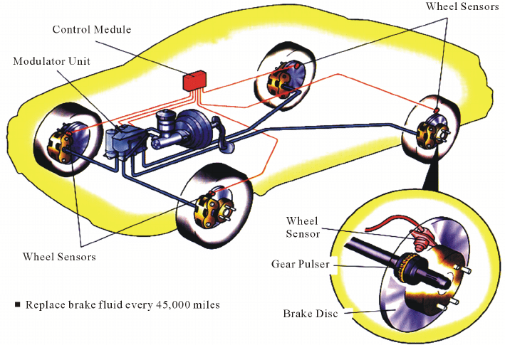
Utilizing the following components:
electronic control unit
accumulator
motor
return pump
solenoid valves
master cylinder
speed sensors
Techpedia (2019)
pulse rings

ABS acts in three stages. The first stage is pressure build up, this stage is normal braking, applying pressure to the brake pedal and increasing the pressure to the brakes at the road wheels.
Stage two is pressure hold, the ABS system will hold the pressure at a steady rate to effectively slow down the vehicle. It will apply and hold the pressure to a point just before the wheels lock.
Stage three activates ABS intervention and it is classed as pressure release, this occurs when one wheel is moving at a slower speed to the others or locking up. It can also occur at heavy braking such as in an emergency.
ABS systems can run through this cycle 15 times a second.
ABS can be felt by feedback through the brake pedal as the ABS pulses.
Apec Braking (2016)

On-board diagnostics.
OBD is an abbreviation of On-Board Diagnostics and refers to the automotive electronic system that provides vehicle self-diagnosis and reporting capabilities for repair technicians to access subsystem information for the purpose of performance monitoring and repair.

OBD (On-Board Diagnostics) is the standard protocol used across most light-duty vehicles to retrieve vehicle diagnostic information. Information is generated by the engine control unit (ECU or also called engine control module) within a vehicle. It’s like the vehicle’s brain or computer.
1988 — Standardization of on-board diagnostics came in the late 1980s after the 1988 SAE recommendation that called for a standard connector and set of diagnostics.

1991 — The state of California required all vehicles to have some form of basic On Board Diagnostics. This is referred to as OBD I.

1994 — Three years later, California mandated that all vehicles sold in the state starting in 1996 must have OBD as recommended by SAE — now referred to as OBD II. This stems from the desire to perform across the board emissions testing. OBD II included a series of standardized diagnostic trouble codes (DTCs), some examples being

1996 — OBD-II becomes mandatory for all cars manufactured or sold in the United States.

OBD Around the World
2001 — EOBD (European version of OBD) becomes mandatory for all gasoline vehicles in the European Union (EU).

2003 — EOBD becomes mandatory for all diesel vehicles in the EU.

2008 — Starting in 2008, all vehicles in the US are required to implement OBD-II through a Controller Area Network as specified by ISO 15765-4.

Wheel speed sensors.
Sensors are used to monitor and record the wheel speed of the vehicle. This is crucial to the system to maintain functionality. Knowing the speed of the wheel is how ABS knows when and how to intervene.

Teves MK IV ABS uses variable reluctance sensors (passive or inductive sensor).
The Bosch 2EH ABS system also uses variable reluctance sensors (passive or inductive sensor).

Types.
There are two types of sensors found on today's vehicles, the passive and the active.
passive
a passive sensor works without any additional power supply.
Passive sensors produce an alternating current (AC). The AC current has to be tuned into a digital signal before it is recognisable by the ECU.
Passive sensors are comprised of a thin wire coil wound around a magnetic core and a permanent magnet. The magnetic core inside the coil is connected to the magnet and the magnetic field extends to the tone ring. The rotational movement of the tone ring and the associated alternation of teeth and gaps effects a change in the magnetic flux through the pulse wheel and the coil. The changing magnetic field induces an alternating voltage in the coil that can be measured. The frequencies and amplitudes of the alternating voltage are related to the wheel speed. The sensor creates an AC signal that changes frequency as the wheel changes speed. The ABS control unit converts the AC signal to a digital signal for interpretation.
Active
Active sensors work by adding an additional power supply.
Active sensors produce a digital signal that doesn’t need to be interpreted by the ECU.
Active sensors use a hall effect wave form.
The active sensor is a proximity sensor with integrated electronics that is supplied with a defined voltage from the ABS control unit. A multipole ring can be used as an impulse wheel while at the same time being integrated in a sealing ring of a wheel bearing. Inserted in this sealing ring are magnets with alternating pole directions. The magneto-resistive resistors integrated in the electronic circuit of the sensor detect an alternating magnetic field when the multipole ring rotates. This sinusoidal signal is converted by the electronics in the sensor into a digital signal. It is then transferred to the control unit as a current signal using the pulse-width modulation method.

Apec Braking (2016)
Hella (2009)
FreeASEStudyGuides (2019)

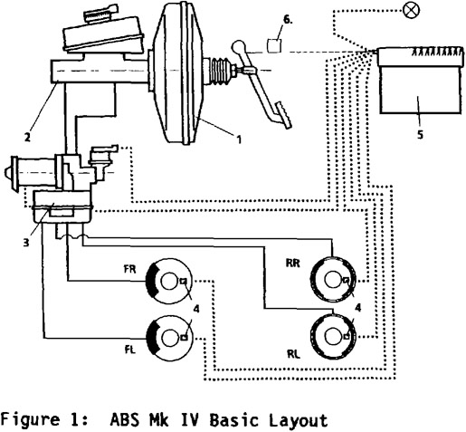
BASIC SYSTEM LAYOUT
The main hydraulic components of the system are a brake actuation unit, consisting of a vacuum booster (1) and an ABS tandem master cylinder (2), and a separate hydraulic control unit (3). The main electrical components are the wheel speed sensors (4) for each wheel and the electronic controller (5). Furthermore, there is a device (6) shown to monitor the brake pedal position.

The MK IV system is a 3-channel ABS system which permits individual control of the front wheels and joint select-low control of the rear wheels. This feature gives optimal vehicle stability, steerability and deceleration behaviour. It also uses the open circuit concept which has been proven successfully in the MK II system. This concept has the potential for an upgrade to a brake-intervention Traction Control System (TCS) with a minimum of additional hydraulic components.
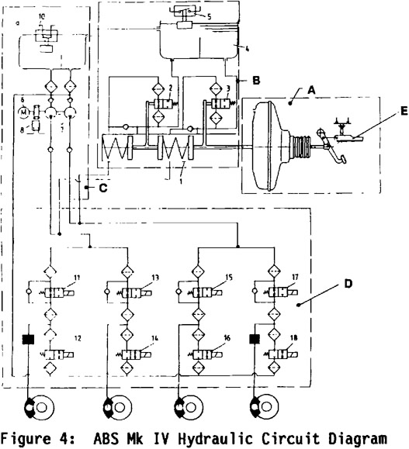
There are three hydraulic connection lines between the brake actuation unit and the hydraulic control unit. Two high-pressure lines supply the fluid from both master cylinder chambers to the inlet valves (11 to 15). These are standard brake tubes. One low-pressure line connects the master cylinder reservoir (4) with an additional small reservoir at the pump unit. This line is subjected only to ambient pressure except for pressure-filling at the vehicle assembly plant and is designed as a low-pressure hose.

The valve block contains 4 pairs of inlet/outlet solenoid valves to accommodate for a diagonally split base brake system. The joint control of both rear wheels in the select-low mode therefore has to be achieved with software methods by adequately exciting both rear axle valve pairs. With a front/rear split brake system only one inlet/outlet valve pair for both rear wheels would be required.

The return flow from the outlet solenoid valves (12 to 18) is routed directly inside the hydraulic control unit back to the suction side of the pump. Therefore, the reservoirs act only as a buffer storage to compensate for the momentary discrepancy between pump displacement volume and outlet valve return flow volume.

The pump is driven by an electric motor which is actuated by the electronic controller and a motor relay during ABS braking. By its internal design it is a dual circuit piston pump with valve control.

There is however no back-up to the electric motor itself and in the fluid supply to the pump. Any failure of the pump to turn on demand or any case of lack of fluid at the pump suction side would therefore seriously affect both hydraulic circuits during ABS braking. This situation has to be covered by the safety concept of the system.

The pump unit speed is monitored by the electric controller with a speed sensor (8). Therefore, the software can detect any condition in which the motor does not turn on demand, either during an ABS stop or during system test cycles which are performed when the vehicle passes through a low speed threshold.

The availability of brake fluid on the pump suction side is monitored by the electronic controller software using a fluid level indicator (10) at the pump buffer reservoir (9). If the electronic controller detects a failure condition of the pump or lack of fluid at the suction side, the ABS system is deactivated. The driver is warned in this case by the ABS warning lamp.
SAE Technical Paper 900208

Fault diagnostics.
On board diagnostics.
The Bosch 2EH ABS system used OBD 1.
The Teves system uses OBD 2.
The basic way to diagnose any fault can be expressed in a basic list:
- Verify the fault
- Collect further information
- Evaluate the evidence
- Carry out further tests in a logical sequence
- Rectify the problem
- Check all systems
In relation to the ABS system the process would follow something like;
Step one, question the customer find out if the ABS light is illuminated and under what conditions it came on.
Step two. check the light is illuminated, take the car on a test drive to see if the ABS is faulty or deactivated.
Step three, plug in a diagnostic code reader and narrow the search to a specific region of the vehicle.
Step four, carry out an inspection using tools such as a multimeter or oscilloscope.
Step five, replace wheel speed sensor or reluctor ring etc.
Step six, wipe the codes and retest and road test again to ensure correct functionality.
Denton, T., 2006.

Methodology.
Part of a team tasked to investigate a fault on an ABS system where the light is permanently illuminated.
- Confirm vehicle has fault.
- In a usual industry position, you would road test the vehicle but as these tests were carried out on a test rig, this was not possible.
- Retrieve relative and useful vehicle data.
- In a usual industry position, you would use Autodata or maybe a Haynes manual etc. to find out pin locations and wiring diagrams plus other relative information.
- Test fuses.
- Make sure the fuses are correct using data. Then remove the fuses and check for continuity both visually and with a multimeter.
- Test pin connections.
- Using a multimeter and an oscilloscope probe the back of each pin connection and check the data against the pin and wiring data provided (make sure a good connection is made and no wires get damaged).
- Test wheel speed sensors
- Visually inspect the wiring and mechanical assemblies
- Check the supply voltages and signals using a multimeter and oscilloscope
- Compare and evaluate signals from individual wheel speed sensors
- Voltmeter (check the voltage supply)
- Using an ohmmeter check the internal resistance (the internal resistance cannot be measured on active sensors)

- Using an oscilloscope check the signal depiction (evaluation of signal curve)
- Evaluate parameters

- Test solenoids
- Sometimes a stuck or defective solenoid or pump will set a code. A solenoid has a resistance between 2 and 8 ohms. On some units, it is impossible to access the individual solenoids. Testing the unit with a scan tool with bidirectional control might be the best way to confirm the condition of the control unit.
- Test brake servo
- Test 1 Pump the brake pedal with the engine off until it becomes stiff
and doesn’t travel.
- Test 2 Press the pedal with some pressure, start the engine and the
pedal should travel as the vacuum should increase.
- Test 3 Disconnect the vacuum pipe. Connect to gauge to check for
vacuum with engine running (min of 0.5 bar negative pressure). If there’s
low or no vacuum, check the pipe, connections and pump (if it’s a diesel
vehicle) and replace as required.

Denton, T., 2006.
Babcox Media (2020)
Pagid (NA)

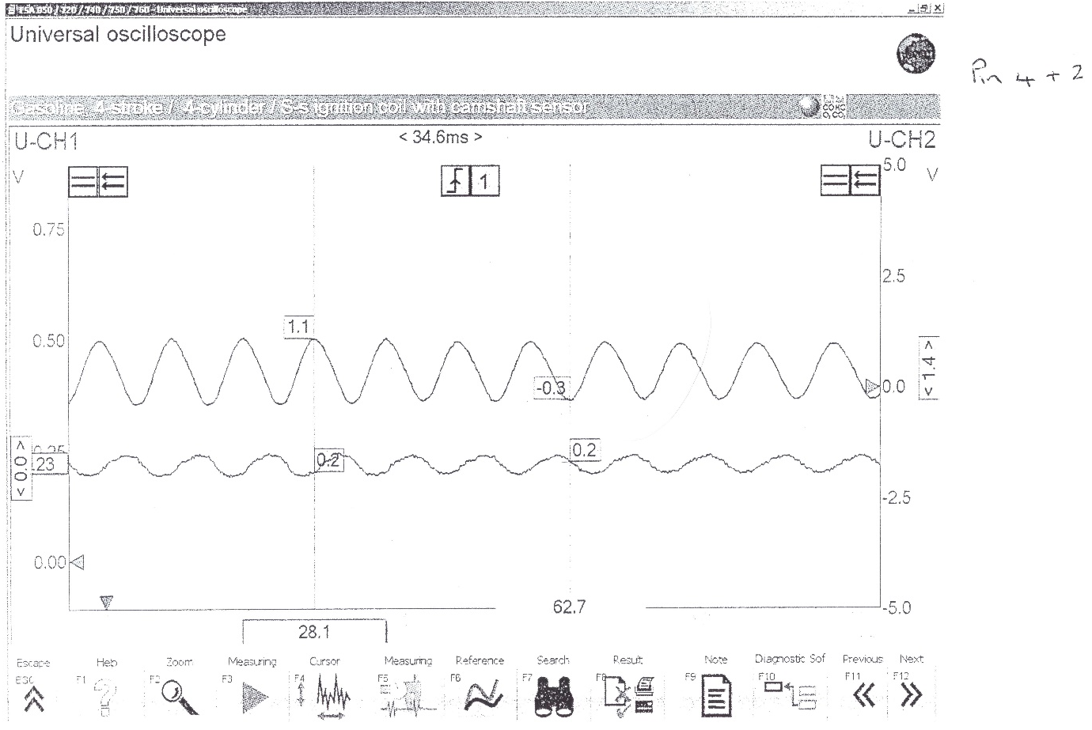
Wave form results.
Figure 1
Figure 1 above refers to pins 4 and pins 2. Pin 4 is the near side rear wss wheel speed sensor signal and pin two is the its ground. Pin 2 the ground is the shallow oscillating scope pattern and the larger oscillating pattern is the wss signal. the wave form is sinusoidal because the sensor is an inductive type sensor.The signal is between 0.5volts and 1.2volts which is well within normal operating voltage.

Figure 2

Pin nine in figure 2 is the brake light switch feed. Upon activating the ABS you can see there is a large current draw this is because of the ABS intervention and the current then returns to normal and levels out as the ABS disengages.

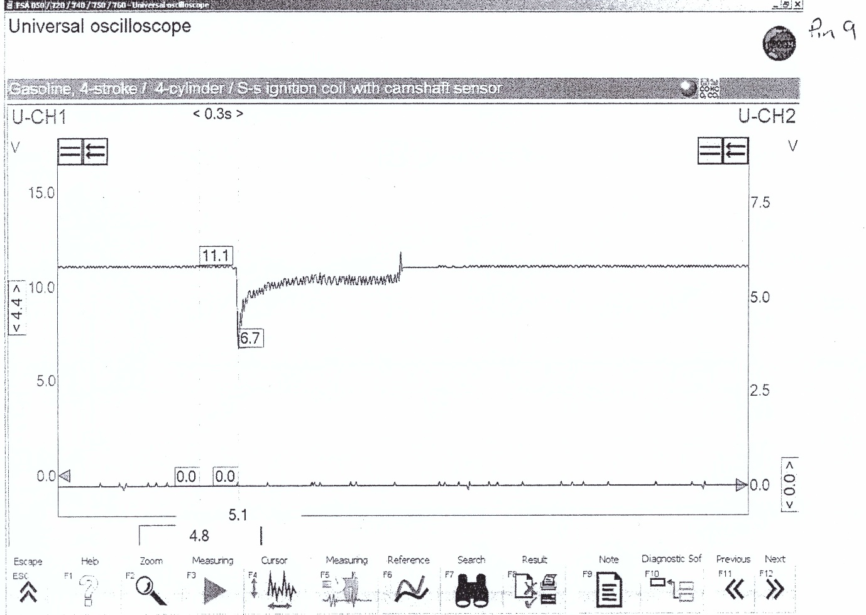
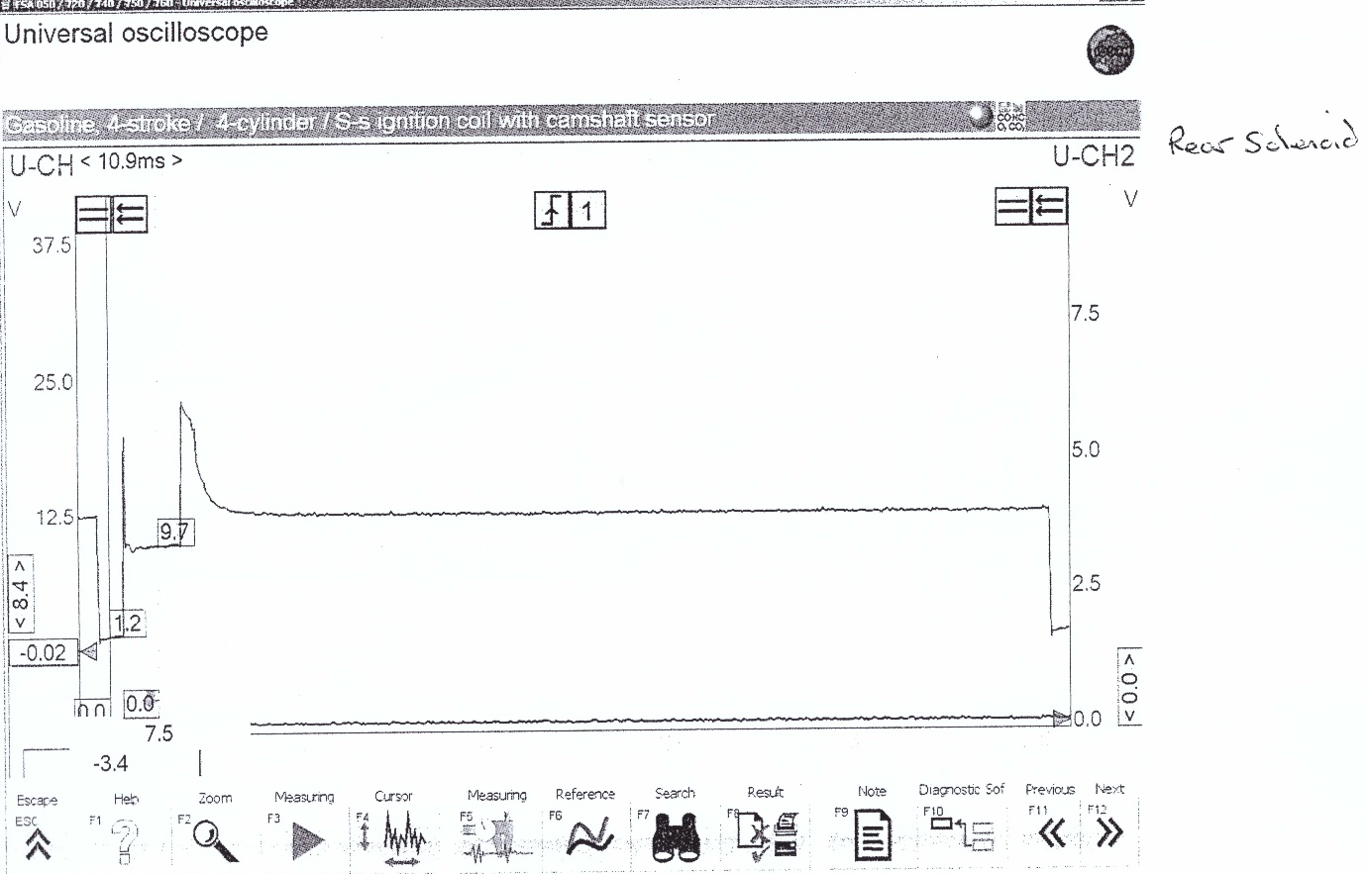
Figure 3

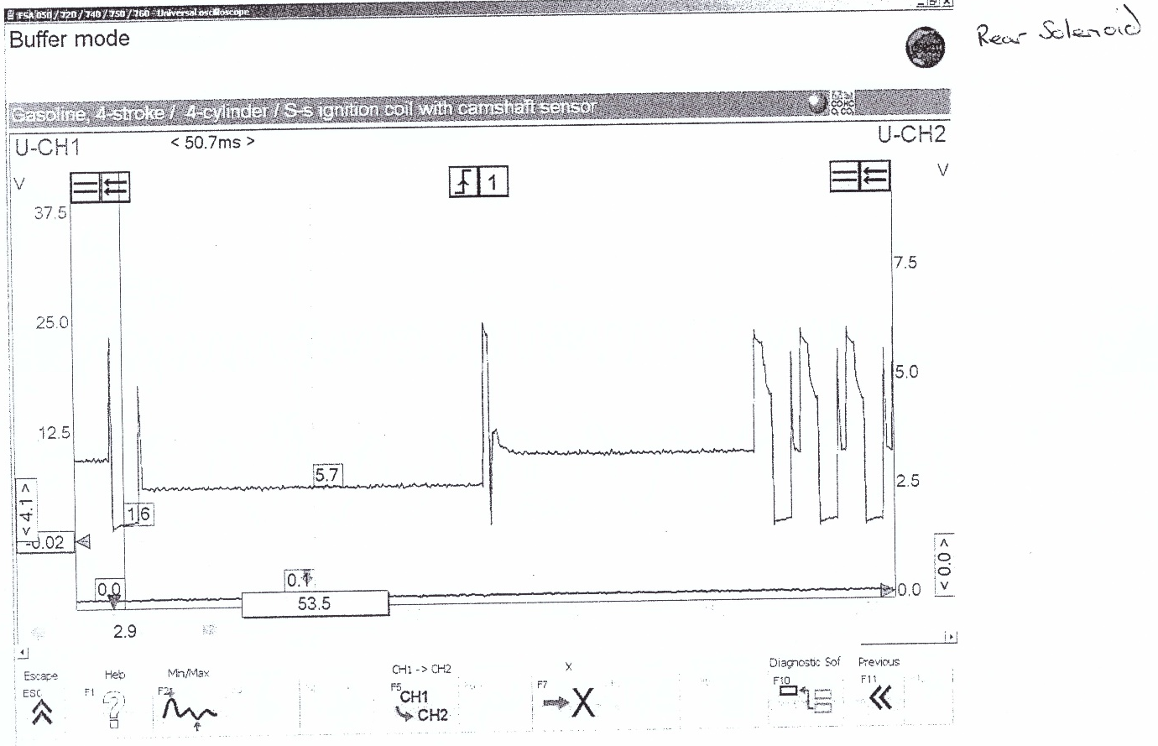
Figure 4
Above in figures 3 and 4 you can see the solenoids during ABS intervention. As the ABS activates there is a massive current draw, this is the solenoids pulsing as you can see the voltage then increases this is due to the back EMF (electromagnetic force).
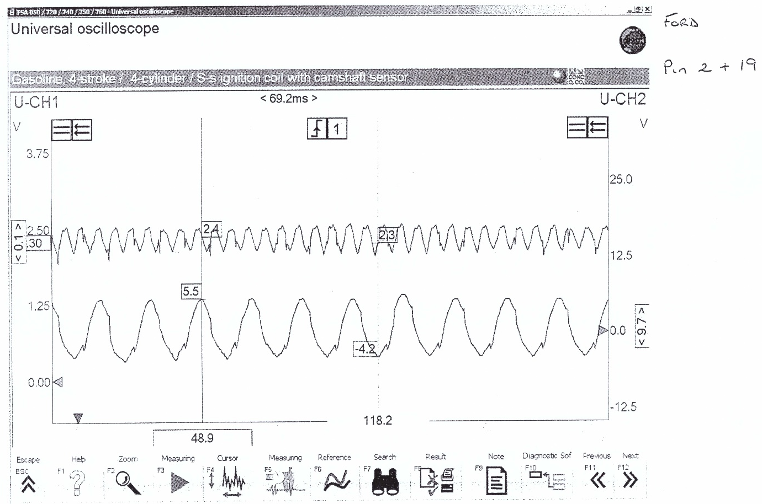
Figure 5
Figure 5 above is the wheel speed for the Teves system. As you can see its very similar to the Bosch system but the voltage range is a lot higher spiking at 5.5volts but this is still in working range. There are also small spikes in the voltage this could be due to a cracked reluctor ring tooth or debris in the ring.

Table 1
Table 1 above is for the Teves MK4 ABS system.
Table 2 below is for the Bosch 2EH ABS system



Table 2

Safe working practices.
The hydraulic modulator is capable of self-pressurizing and generates pressures over 200 bar any time the ignition is switched ON. Relieve the system pressure before testing or repairing the hydraulic system. Improper repair or test procedures can cause serious or fatal injury.

Diagnostic procedure chart.

Teves / Bosch comparison.
The Teves system is a simpler and more compatible design making it the better system, the Bosch system is a more intricate and efficient design but lacks in it capabilities in allowing itself to be used in other features such as traction control. The Bosch system is also more costly due to the intricate parts and sealed unit.

Systems strengths and weaknesses.
Teves strengths.
- The ABS Mark IV is designed as an open system. If the brake pressure has to be reduced during ABS control, the brake fluid released by the relevant ABS valve flows directly back into the reservoir. The brake fluid is also pumped once again from this reservoir so that the brake pedal does not creep down to the floor board during a prolonged controlled braking procedure (by draining off the brake fluid during pressure reduction).
- The Teves system has a brake booster.
- 4 wheel speed sensors and pulse wheels
- All components are in active at rest.
- Multi stage pedal position switch.
- Still prevalent today.
- Can add traction control.

Teves weaknesses.
Sensors are common faults.
Bosch strengths

Bosch weaknesses
- When carrying out electrical welding operations, the wiring harness plug must be removed from the electronic control unit.
- During painting operations, the electronic control unit may be exposed to a maximum temperature of 95°c for a short time and for a longer term - approximately 2 hours, to a maximum of 85°c.
- After working on the braking system, it must be bled and a pressure Inspection carried out.
- Never unplug the wiring harness multiplug from the electronic control unit or plug it in while the ignition Is switched on.
- Not very common and has many successors.

Conclusion.
From sheer research I can say that the Teves system is the better system. Its derived from its predecessors so the technology is that of tried and tested. Its simplicity allows for a cheap and easy mass production also allowing parts to be cheaper for the consumer. The Teves also has supreme qualities such as the ability for traction control to be added, this is perfect for an ever growing market where traction control is so prevalent.

Latest on-board diagnostics: EOBD
Like the US variant OBD II, the European On-Board Diagnosis (EOBD) features a standardised diagnosis interface, as well as storage and indication of faults relevant to exhaust emissions. EOBD has been adapted to comply with European exhaust emission standards.
Goals of EOBD:
- continuous monitoring of components relevant to exhaust emissions in vehicles
- immediate detection of faults that can lead to an increase in emissions
- indication of faults relevant to exhaust emissions to the driver
- continuously low exhaust emissions in daily vehicle operation
On October 13 1998, the European Union passed an EU directive stipulating the introduction of the European On-Board Diagnosis (EOBD) for all member countries. This directive was incorporated into national law in the Federal Republic of Germany. New diesel-powered passenger car models will only be eligible for homologation with effect from January 01, 2003 if they are equipped with an EOBD system. Production diesel-powered passenger cars are required to be equipped with an EOBD system with effect from 2004.The deadline with regard to new petrol-driven models was January 01, 2000.
The EOBD checks components, subsystems and electrical components which are relevant to exhaust emissions and, in case of malfunction or failure, can cause defined emission limits to be exceeded. EOBD is a "lifetime" function. It is required to last for the entire life cycle of a vehicle. The duration of a vehicle life cycle is defined in the EU3 European exhaust emission standard. At this time, EOBD is required to ensure compliance with EOBD exhaust emission limits over a mileage of at least 80,000 km. When EU4 comes into force in 2005, EOBD must function properly over a mileage of 100,000 km.
Volkswagon AG (2003)

References.

Apec Braking (2016) ABS Sensors.
Available at: https://www.apecbraking.co.uk/Resources/TechniciansGuides/ABS-Sensors.aspx
(accessed: 16th December 2019)

Techpedia (2019) abs anti-lock braking system.
Available at: https://worldtechpedia.com/abs-anti-lock-braking-system/
(accessed: 16th December 2019)

FreeASEStudyGuides (2019) Wheel speed sensors.
Available at: https://www.freeasestudyguides.com/wheel-speed-sensors-types-of.html
(accessed: 16th December 2019)

Kolbe, A., Neitzel, B., Ocvirk, N., and Seiermann, M., "Teves MK IV Anti-Lock and Traction Control System," SAE Technical Paper 900208, 1990, https://doi.org/10.4271/900208.

Denton, T., 2006. Advanced automotive fault diagnosis 2nd ed., Amsterdam ; New York: Elsevier BH.

Babcox Media (2020) ABS Solenoid Diagnosis: What is going on inside the HCU?
Available at: https://www.tirereview.com/abs-solenoid-diagnosis-going-inside-hcu/
(accessed: 20th December 2019)

Pagid (NA) Brake Servo – Test procedure.
Available at: https://pagid.com/wp-content/uploads/2017/06/Servo-test-procedure.pdf
(accessed: 20th December 2019)

Volkswagon AG (2003) Self-study programme 315, Service Training, Design and function, European On-Board Diagnosis, for Diesel Engines.
(accessed: 20th December 2019)

Robert Bosch GmbH, 2002, Electronic Automotive Handbook 1. Edition

Hella KGaA Hueck & Co., Wheel speed sensors in motor vehicles Function, diagnosis, troubleshooting, Lippstadt 9Z2 999 127-942 TT/06.09/0.4 Printed in Germany

Geotab (published Aug 19, 2017. Updated May 25, 2018) What is OBD II? History of On-Board Diagnostics.
Available at: https://www.geotab.com/blog/obd-ii/
(accessed: 28th December 2019)

