Michael Davies (2224231)
2224231@student.uwtsd.ac.uk
Abstract
A contented document showing information relevant to the Personal Development Plan.
Learning in the digital era
Personal Development Plan

Contents

Personal Development Plan

Written Summary

Presentation

Automatic Referencing Tool

Personal Development Plan Creation and Review

Personal Development Plan
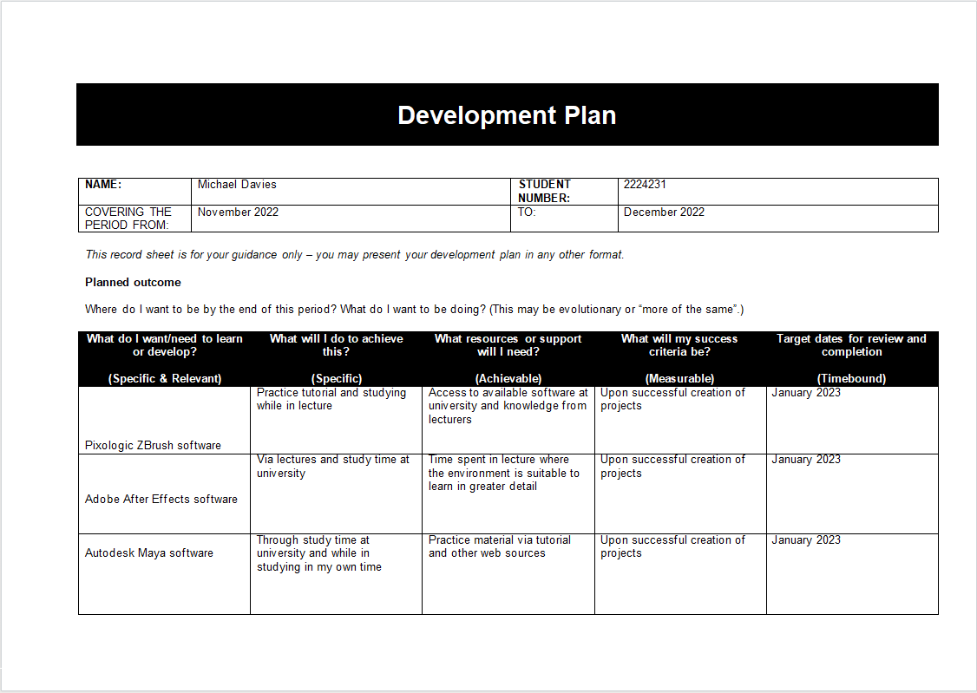
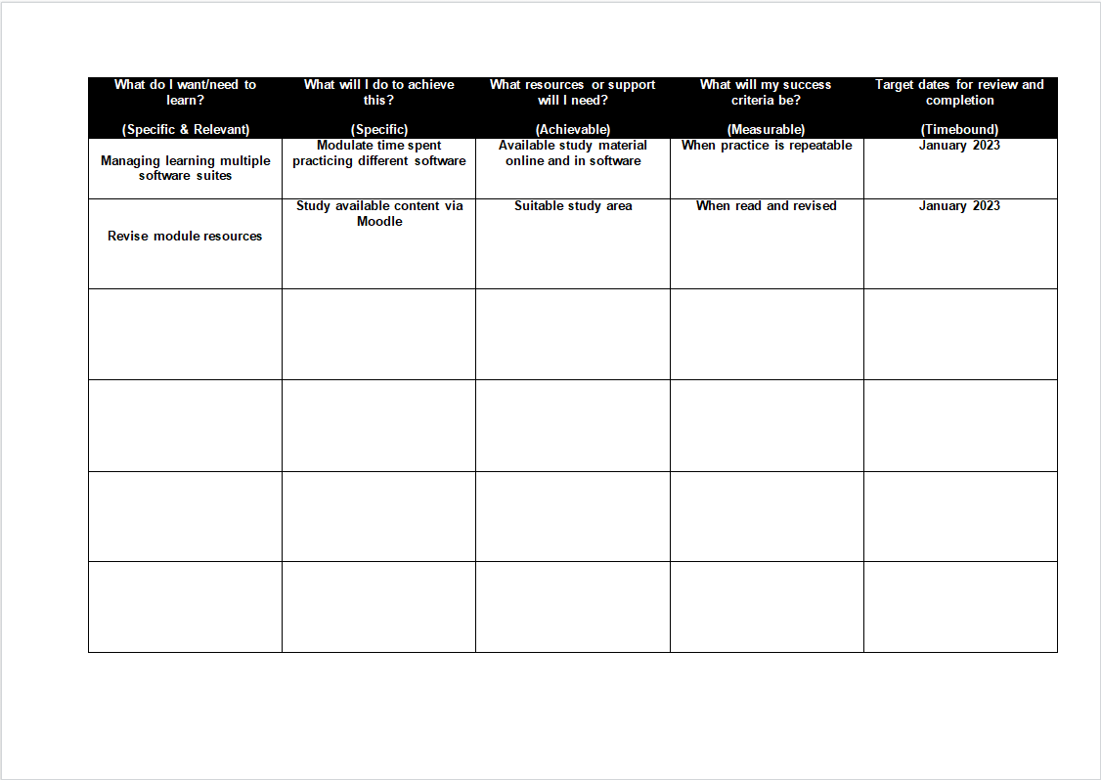
PDP Link:
https://uowtsd-my.sharepoint.com/:w:/g/personal/2224231_student_uwtsd_ac_uk/EeiA41l7hNtFgOcXZFCjGCoBZo-SO99K4oM6xQQYgP8YSQ?e=rI4Yaa

Written Summary
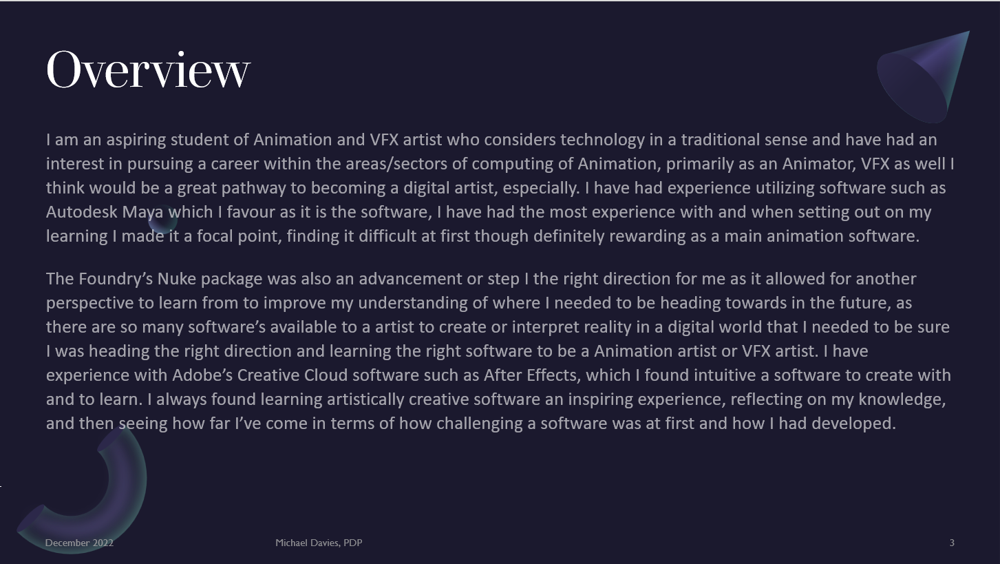
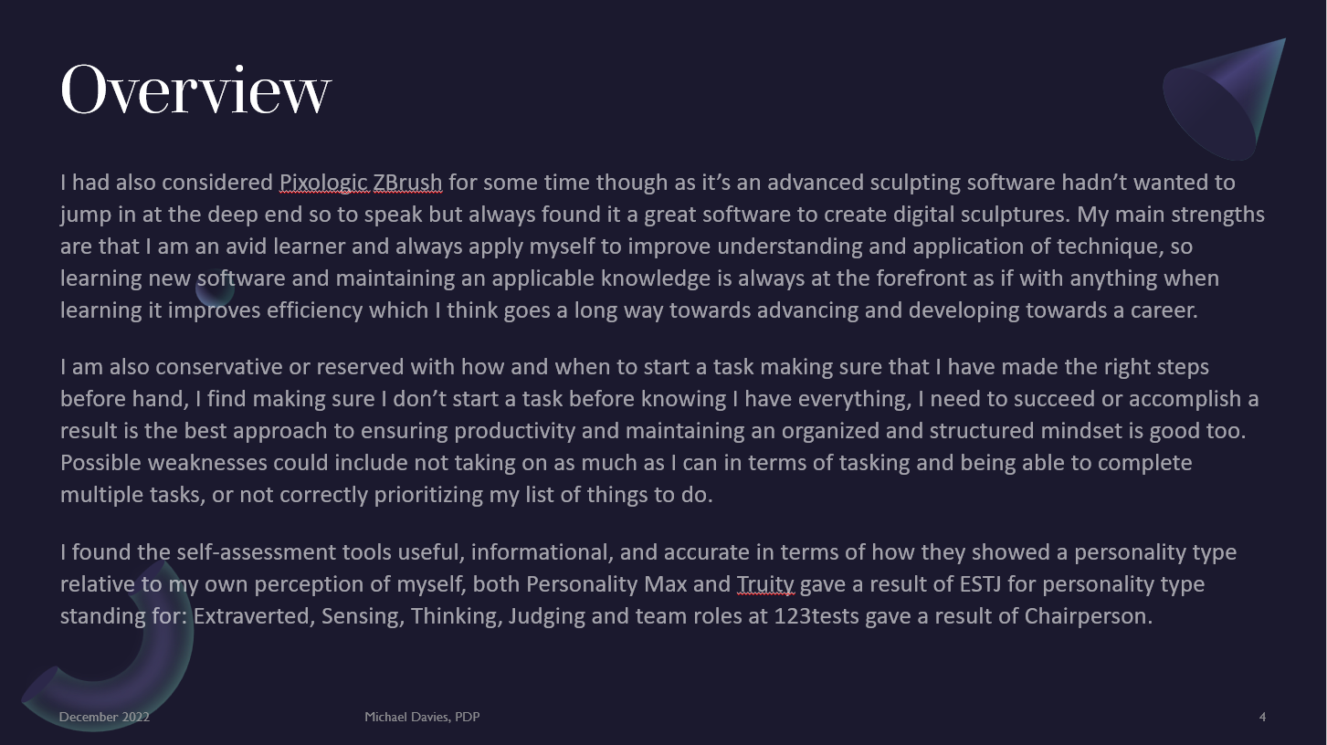
A written summary of my thoughts on personal development planning.

Presentation

Presentation Link:
https://uowtsd-my.sharepoint.com/:p:/g/personal/2224231_student_uwtsd_ac_uk/EbaX3Bst3YJNt30On0Vm_4ABmWZaDPmiWOkXkBNPivgMgQ?e=FXo8jw

Automatic Referencing Tool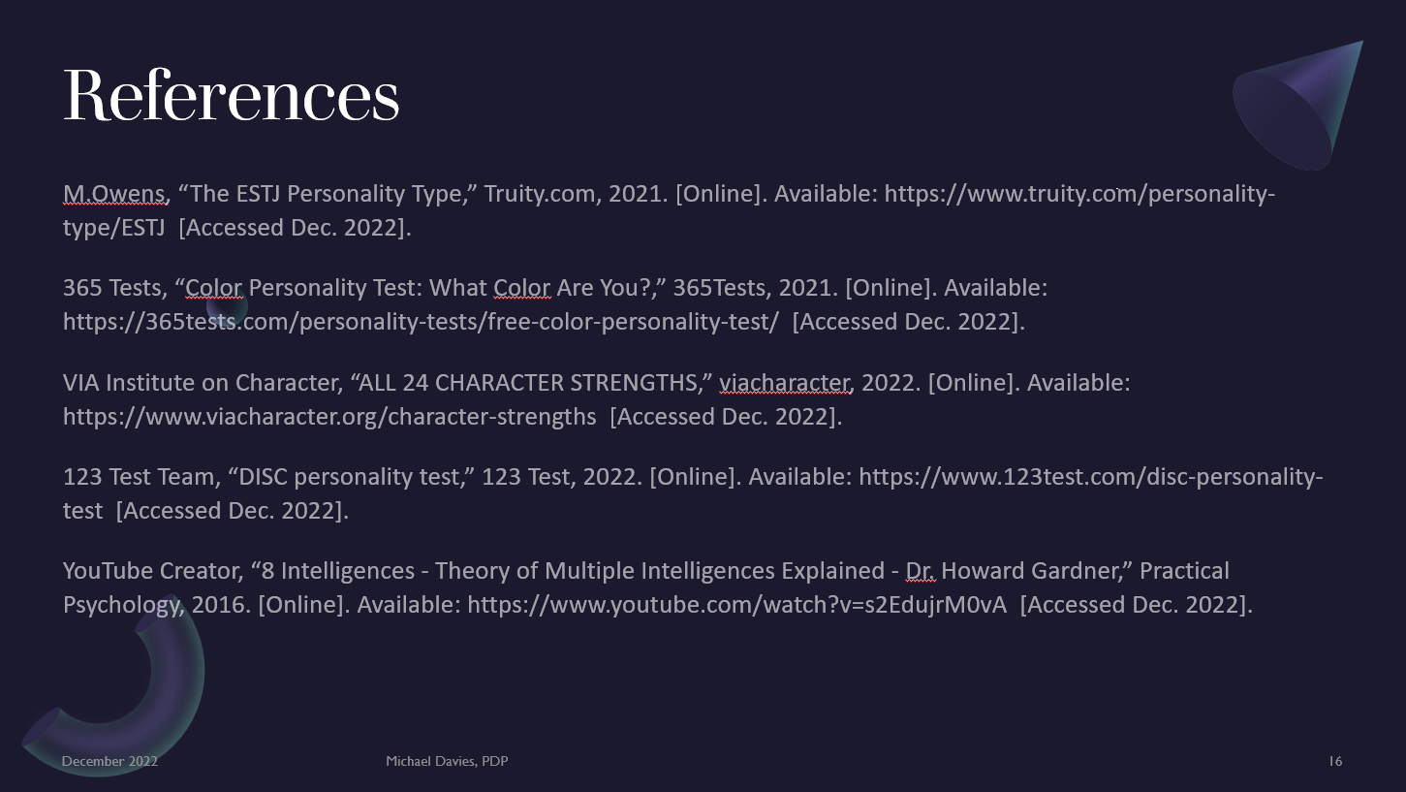
I had chosen to use available resources via Moodle supplied via lecture.

Personal Development Plan Creation and Review

Link:
https://uowtsd-my.sharepoint.com/:v:/g/personal/2224231_student_uwtsd_ac_uk/EfnOfRdTvW9BhD-S4-SL2xwBAknsTkBlqKTHD10VWBJVPgg?e=zLiybz

