Name | Student Number | Date | Lecturer’s Name | Your score
Nicoleta Robu | 2440060 | 27 June | Ellie | To be filled by the marker  ___/40
You will have 75 minutes to complete this assessment. It is divided into three sections: note-taking, paraphrasing and writing a paragraph.
---------------------------------------------------------------------------------------------------------------------
1. Take diagrammatic notes from the passage below using the space provided:

As a student you've got a lot on your plate - academic work, social life, work commitments, career plans, relationships and finances - sometimes stress can get in the way of this juggling act. When you recognise that you have become overwhelmed with stress, adopt a few strategies to help you manage your triggers more effectively. Those strategies could include exercising; you simply need to get your heart racing, for example by going for a brisk walk or a bike ride. Another suggestion is to try mindfulness, a relaxation technique originating in Buddhism. It is used by clinicians to improve patients' physical and mental health as it can significantly lower stress levels. Thirdly, why not speak to your friends and family - they know you best and care about you the most. What's more, studies suggest that socialising with a friend just once a week can reduce your stress levels and improve your mood as much as therapy or counselling. Simple time management techniques can also help you to feel more relaxed and focused. Try creating a written schedule, breaking your tasks down into manageable chunks, planning accordingly and allocating yourself time every day to relax or socialise. Finally, an obvious but often overlooked solution: get enough sleep, as no one functions at 100% when they're tired.
Adapted from: https://www.prospects.ac.uk/applying-for-university/university-life/5-ways-to-manage-student-stress

Space for your notes (max 12 marks):
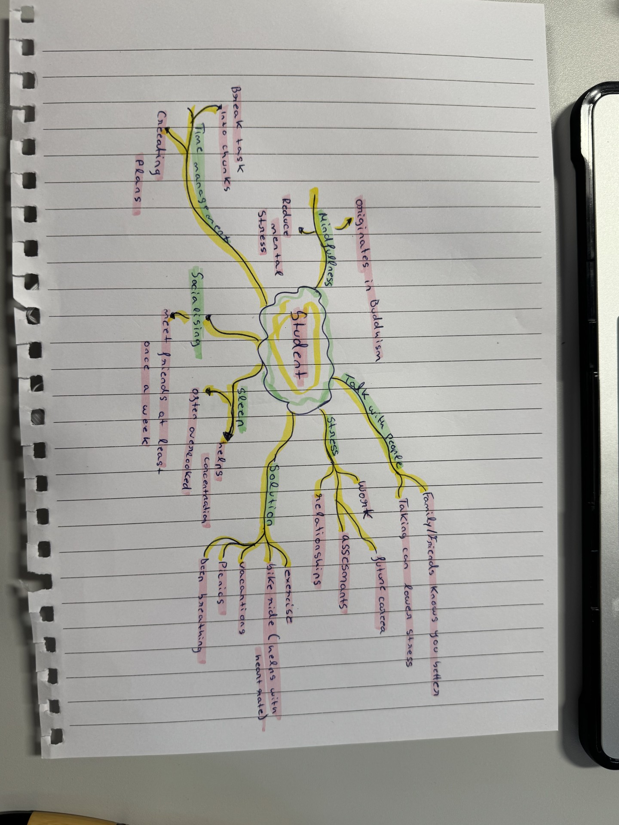

2. Paraphrase the following sentences (max 3 marks for each, max 12 marks in total):

a) Good time management techniques can help you feel more relaxed and focused.
Effective time management strategies can reduce stress and improve concentration.

b) Speaking to your friends and family can significantly lower stress levels.
Connecting with your loved ones can substantially decrease stress.

c) University life offers numerous opportunities for personal growth and development.
Highest education provides many chances for personal advancement.

d) Attending lectures regularly is crucial for understanding course material.

Regular lecture attendance is essential for grasping the subjects matter.

3. Write a well-structured paragraph (8 sentences) on the following topic:

Strategies for managing a student budget and reducing costs while at university.

Your paragraph must be written in full sentences (no bullet points) and in an academic style.

(max 16 marks in total)

Managing a student budget and reducing costs while at university requires a multifaceted approach. Firstly, eating a detailed budget is essential, outlining income sources and all the anticipated expenses. Secondly, tracking spending meticulously helps identify areas where costs can be minimized. Thirdly, exploring affordable accommodation options, such as shared housing or university residences can significantly reduce living expenses. Fourthly, utilizing free resources available on campus like libraries and computer labs, minimizes the need for costly alternatives. Fifthly, cooking meals at home instead of eating out frequently saves a considerable amount of money. Sixthly, taking advantage of student discounts on transportation, entertainment, and other services is a smart strategy. Seventhly, seeking part-time employment can supplement income and ease financial burdens and finally prioritizing needs over wants and making informed financial decisions contributes to effective budget management and cost reduction throughout the academic journey.

