Module: Marketing Management

MARKETING MANAGEMENT - ASSIGNMENT
Daniela Cotenescu, student number 1815754
5th of September 2019

The aim of this report is to present, how Jaguar Land Rover, through innovative marketing strategies, raise the awareness of the brand and in the same time managing and evaluating the current journey through a variety of communication channels, to ensure current and future stakeholders.
The research made by (Kumar et al., 2017) advices “ the company main focus should be on customer requirement and quality” and for this, it is important to pay attention to the customer experience that is “ the internal and subjective response customer has from the company” (Schwager et. al.,2007).
(Kumar et al., 2017) study brought to light the “benefits of branding along with customer perception” (Figure 1) as well as the importance of a good branding strategy implementation that “will generate turnover than expected”.

Figure 1: Brand Benefits
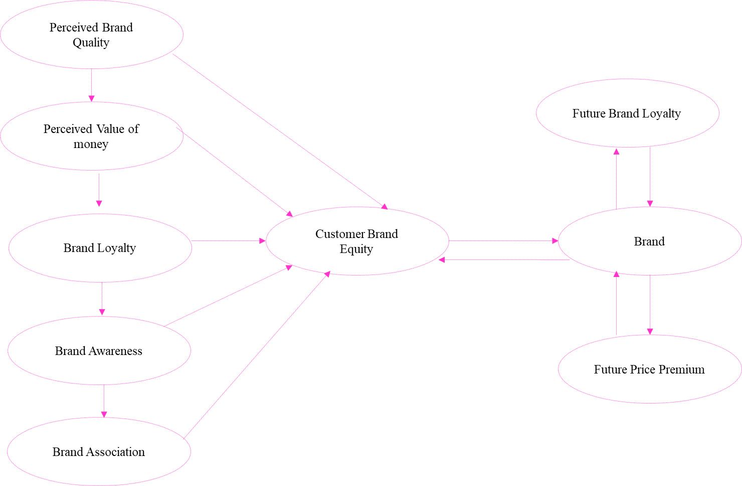
Source: (Kumar et al., 2017)

(Schwager et. al.,2007) considers a brand of success “shapes customer`s experiences” by concluding the values of every feature that offers. (Homburg, et al.,2017) defines customer experience management as a “higher-order resource of cultural mindsets” that is going to determine the strategic directions for customer experiences development, goals achievements and “long term customer loyalty”.

(Schwager et. al.,2007) helps us to make the important difference between Customer Relationship Management (CRM), that “tracks customer action after the fact” and Customer Experience Management (CEM), that “captures the immediate response from the customer” and in Tab. 1 is presented the comparison between these two.
Tab. 1 CRM vs. CRM
Source: (Schwager et. al.,2007)
It is also important to track customer experience periodically, to be persistent because this is going to give us the opportunity to know and understand our customer. (Schwager et. al.,2007).
(Lemon, et al., 2016) defines customer engagement as “attempts to distinguish customer attitudes and behaviours that go beyond purchase” and “ (Bitner et al. 2008) “ develop the so-called service blueprint methodology” that considers the customer is focused on “service innovation and service improvement.”
During its journey, the customers encounters multiple touch points, that may become adaptive helping them to develop their own journey, and beside of that the customer faces multiple channels that, are considered “choice behaviour” (Lemon, et al.,2016). An important element of customer journey analytics is the mapping and there is necessary to “go beyond the blueprint methodology” (Lemon, et al.,2016).
(Ron Ashkenas, 2010) considers simplicity as “key driver of business success” and a very efficient customer relationships are “the lifeblood of any commercial enterprise” concludes (Chief Marketing Council, 2008).
(Fandel, H., 2019 ) bring into attention the future success, in automotive industry, is to define a “ customer -centric behavioural framework”, increase “employee engagement”, permanent focus on quality, and to “ identify and digitize relevant touch points “ on customer journey.
(Bodine et al., 2012) considers among those six disciplines of customer experience: “the strategy, customer understanding and culture” by having an important impact over organization future customer experience management. The strategy related to customer experience presents the elements that future customer experience is going to have. It is very important the strategy and the brand to be on the same page with the vision.
About customer understanding provides information about who the customer are, how is perceived by them the interaction with the company, they needs and wants as well as their expectations from the product/ service.
The culture is very important in customer journey and in customer satisfaction as well as in company revenue. The culture of the organization puts together the employees to be focus on the customer delight and to be aware that their actions are very important.
(Intelligence Briefing, 2016) in their survey of more than 7,000 marketers rise a very important point over the touchpoints as “ the most confidence learning path involves touchpoints that are outside a brand`s direct control” and for this customer engagement is very important and 94% considered the “ optimising creative flow “ will deliver an outstanding customer experience.
Often the companies are focus on touch points and measurements, the reality has shown companies that had 90% customer satisfaction on the touch points measurements, and they were loosing customers very fast. The investigations shown in the end, they were missing the customer journey, what happen between the touch points, and they had not been on the customer`s shoes. By doing the customer end-to-end journey map and understand how to measure customer feedback and pay attention to what the customer says, for sure the customer satisfaction and loyalty will come up and the customer retention will not be any more a miss and the company revenue will increase. This is a win-win journey for the customer and the organisation.

“Experience people love, for life”
Jaguar Land Rover
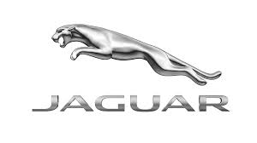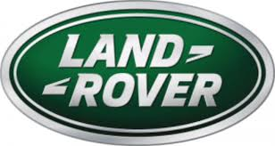

Jaguar Land Rover, a company of two iconic premium brands Jaguar and Land Rover. As been able to understand the company analysis, it is important to know the heritage of these two powerful brands that made history over time.
Jaguar Brand Heritage
In 1922 was created the company that was going to produce the Jaguar brand, and in 1948 made its debut as sport car on British market. In 1961 Jaguar E-Type was considered as one of the most produced cars in the world.
The Jaguar Brand, presented in Figure 2, is focus on three vehicle segments: sports, luxury and Lifestyle.
Figure 2: The Jaguar Brand Model
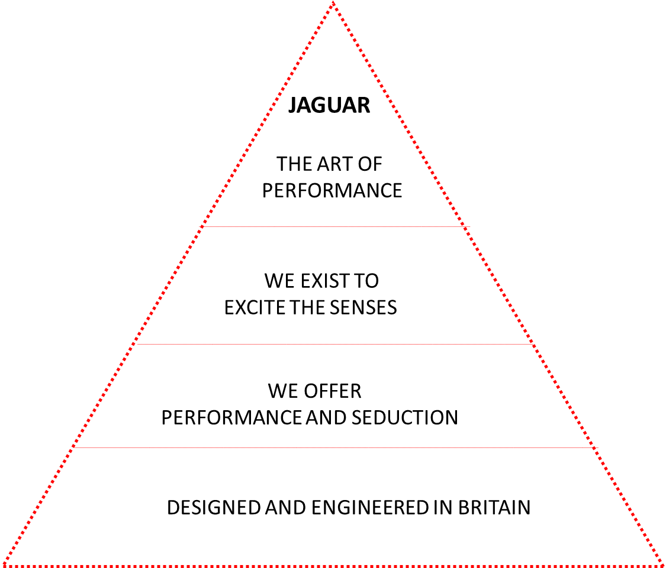
Source: Jaguar Land Rover Financial Statement 2014/2015, pp.24
The Jaguar brand vision from 2014 to be the world performance brand, becomes reality in 2019 when Jaguar I-Pace had been declared “2019 World Car of the Year”, “2019 World Car Design of the Year” and “ 2019 World Green Car” at New York International Auto Show.
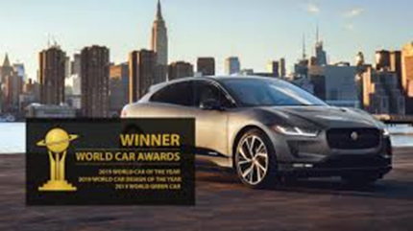
Land Rover Heritage
The Land Rover brand began the production in 1948, in the United Kingdom. The classic Range Rover was introduced on the market, in 1970 as luxury brand.
In 2008 Tata Motors acquired Jaguar Land Rover for £1.1bn. The patience of Ratan Tata, the chairman of Tata and the British professionalism determine in 2010 the company sales revenue (£13.5bn) to be more with 37% than previous fiscal year. Tata Motors annual profits are more then £1.1bn, that cost Jaguar and Land Rover brands purchasing in 2008. When they decided to buy, they know the Brand Potential, both brands had global awareness, strong heritage and beside of this it was the management that “has been used to steward the brand” (Ritson, 2012).
Jaguar Land Rover is a British company with a German Chief Executive Officer and owned by an Indian company and this wonderful teamwork makes Jaguar Land Rover unique and powerful on the automotive market.
The Land Rover Brand, presented in Figure 3, is similar with adventure an incorporate the “go anywhere” spirit and the attitude “can do”, determining people to follow and achieve their goals and ambitions. (JLR, Financial Statement, 2014/2015).
Figure 3: Land Rover Brand

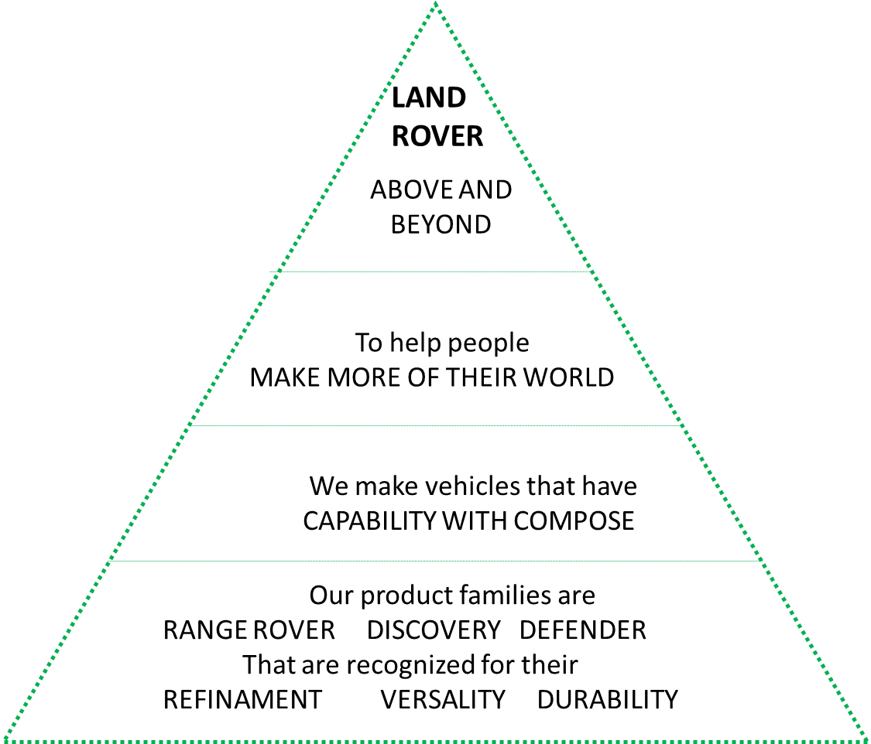
Source: Jaguar Land Rover Financial Statement 2014/2015, pp.24
The Land Rover brand focuses on three vehicle segments that corresponding to three vehicle families: luxury segment and there is the globally recognized Range Rover, leisure segment where Discovery is known for versatility and dual-purpose segment where Defender express durability.

Jaguar Land Rover Brand Strategy
Brand strategy is defined by “Brand distinction and synergies” as presented on Tab.2.
Tab.2. Jaguar Land Rover Brand Strategy
Jaguar Land Rover Brand Strategy
Brand Distinction | Synergies
Design | Research & Development
Product attributes | Architecture
Positioning | Manufacturing
Communications | Logistics
 | Network
Source: Jaguar Land Rover Investor Day, 2019, pp.44
The Jaguar Land Rover brand strategy is “the spine” of the development for each brand strategy. Each brand strategy has the role to open new markets and new business opportunities, in 2019/2020 as presented on Tab.3
Tab.3. Jaguar Land Rover Brands Strategies
Jaguar Land Rover Brands Structure and Strategy
 | Jaguar Brand | Land Rover Brand
2019/2020  Strategy | Brand Re-focus on powertrain expansion with focus on new opportunities of creating value | Systematic brand building and powertrain expansion and the main focus is over the new opportunities that are going to create value
2020 Focus | Beauty, luxury, excitement, innovation | Design and capability
Segments | The Brand focuses on three vehicle segments: Luxury, Lifestyle and Sports | The brand is focus on Luxury, Leisure and Dual-Purpose vehicle segments
Source: JLR Financial Statement 2014/2015, pp.24 and JLR Investor Day, 2019, pp.42-43

The mixture between both brands strategies and the focus on Customer First, Jaguar Land Rover culture, are present on each area of the company, as presented on Tab. 4.
Tab.4. How Brands supports Jaguar Land Rover strategy
How Brands supports Jaguar Land Rover strategy
 | Design support | Technology support | Manufacturing support
Customer first | The distinctive design makes our vehicles unique in the premium sector and is loved by customers around the world. | New technology enables greater connectivity and enhanced experiences for Jaguar Land Rover | Jaguar Land Rover "integrated Production System" puts customers at the forefront of everything company does.
Source: Jaguar Land Rover Financial Statement 2014/2015
Clear brand strategies and “Customer First” culture unites the whole company to act as one and in this way, Jaguar Land Rover employees, from all over the world, know they can “win the hearts and minds of our customer”.
Jaguar Land Rover Customer Journey
Jaguar Land Rover`s customer is in the early beginning of their processes, during the process and at the end of the process, and here we are talking not about sales processes, it is about manufacturing, design, marketing, sales, logistic, purchasing, new products development and research. Their customer end-to-end journey is never ending because they are a part of the company and the centre of their heart and without them the company would not be where is it today.
With this in mind, on Jaguar Land Rover case we are not talking about only touchpoints where the measurement is taken place, here the measurement is taken place during the customer journey and as could be seen on Figure 4,and at the centre of the journey is the customer data, the data analysing system, the permanent feedback analysis and constant connection with the inside of the organisation and this determine smooths and continuous “end to end customer experience”.

Figure 4. Touchpoint and Customer journey on Jaguar Land Rover

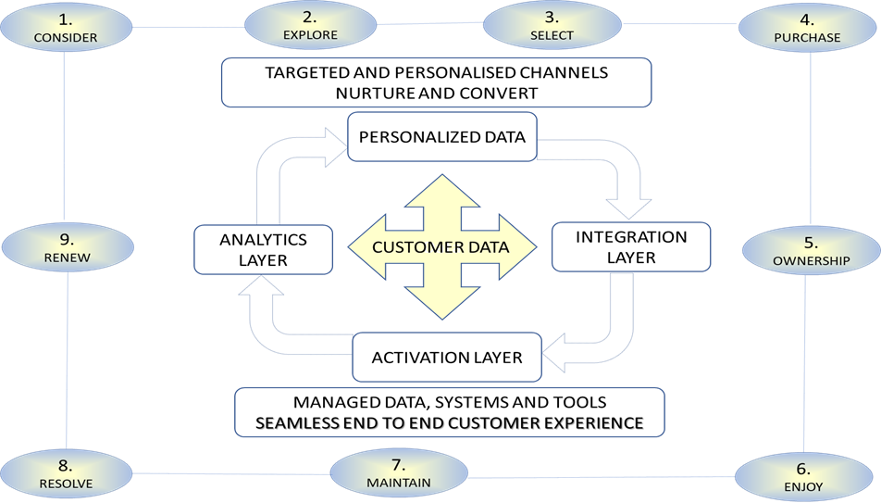
Source: Jaguar Land Rover Investor Day, 2019, pp.47

Jaguar Land Rover is focus to provide to their customer the “ experience people love, for life” and it is perfectly aware that, the key of success and sustainability, it is to be permanently focus on end to end customer journey and not only work for the customer but also co-create with the customer.
By known the customer needs and not only, by been in real contact with the customer and see how the vehicles have impact over their lives, makes Jaguar Land Rover team to be grounded, to know deeply and recognize the customer on each stage of their processes.
In this case, indeed we can talk about customer end to end journey, a journey without end and with a great reward, customer satisfaction. Customer involvement presented on Tab. 5 and the recognised British excellence for details, determines Jaguar Land Rover brand to receive 232 awards in 2018/2019.
Tab.5. Customer involvement
Customer involvement from the beginnings of the process
Jaguar Land Rover team communicated to their customers through Customer Advisory Boards and private online communities
Customer feedbacks are collected from their retailers in 143 markets.
Weekly bases customers feedbacks are collected and analysed.
The analysis results are transferred to the designers, product engineers and managers for decisional process and improvements
The team visit the customers at home/ work and learn about who they are, how they live, and the role Jaguar Land Rover vehicles have in their lives.
(JLR Financial Statement 2018/2019, pp. 26)

Customer contribution determines many the technical improvements, and the final impact beside of the customer delight, the Jaguar brand added another award on 2019, as presented on Table 6.

Table 6. Technical improvements based on customers feedback
We have listened to, and acted on, customer feedback to improve features and quality
63,000 new car owners voted Jaguar as Brand with Best Features
Jaguar is 2019 Winner on Auto Trader New Car Awards
Jaguar customer feedback:" drives well and automatic gearbox is superb. The option to change model is brilliant. Very comfortable."
Positive praise for the quality and features transformation in our new vehicles
Source: JLR Investor Day, 2019, pp.89

Often the focus on the touchpoints determine, the companies to reduce their presence on customer journey. Jaguar Land Rover “Customer First” Initiatives, Table 4., has the role to presents how the customer, is supported, step by step on after sales journey, between the touch points Maintain and Resolve from Figure 3. It is very important for the customers to know they can rely on the Jaguar Land Rover team`s support, each moment on their journey, so they are not alone in this quest and indeed with Jaguar Land Rover they are not alone as presented on Tab.7.

Table 7. Customer First Initiatives
Customer First Initiatives
Video capture | During the service process, the parts are recorded, and the details are sent by email to the customer
Video capture | In this way is showing transparency and building trust
Video capture | Another important thing: customers can decide and approve any work to be done remotely
Pathfinder | Pathfinder new diagnostic technology helps the technical team to find and correct faster the problems and in this way the customer will spend less time without their loved vehicle.
Encore Service | Customers are helped to know their new car features, how to use them. They may have a follow-up session with the qualified staff, in order to accustom with the new features and enjoy driving in the future.
Rapid Drop-off | When customers bring their car in for service or repair, the Jaguar Land Rover team can take them back to work, home or wherever they are needed
(JLR, Financial Statement 2016/17, pp.30)

Jaguar Land Rover culture defines “Customer First sits at the heart of everything we do” and this determine, their customers to be the “starting point” of the business strategies, marketing and branding strategies, company process, business model.
Customer First is mainly about how Jaguar Land Rover is working with and for the customers to deliver “the best quality customer experience” (JLR Financial Statement 2016/2017, pp.17) and beside of creating a strong customer loyalty, their revenue figures permanently grown in the last five years.
The Chief Marketing Officer mentioned “Customer First is the key priority for the entire brand marketing” ((JLR Financial Statement 2014/15, pp.27). The culture of Customer First exists in the whole company processes and each of 43,224 world-wide employees to know their contribution is important for the customer journey.
Jaguar Land Rover adapted Customer First as “business behaviour” and for this, they developed the following principles: “transparent, personalised, make me special, dependable and easy to do business with”. (JLR Financial Statement 2018/2019, pp26).
Jaguar Land Rover culture “Customer First” is reflected also, by the clean technologies that care coming to cover the “modern customer needs” for environment protection, health and wellbeing. Tab. 8 presents the changes made by the company in this direction.
Tab.8 Environment friendly
Health and wellbeing are the key focus for our future technologies
Sustainable interiors | Health and wellbeing
53 recycled plastic bottles in Kvadrat seats | Remove >98% impurities with Cabin Air Ionisation
30% natural wood fibres in Eucalyptus seat fabric | Motion sickness modelling to prevent recurrence
Source: JLR Investor Day, 2019, pp.96

Customer needs and expectations are changing, the business environment is changing, the automotive industry is facing with the environmentally friendly car requests. The car makers are forced by the win of change and the customers preferences, to develop new technologies, to produce hybrid, plug-in and electrical cars. Jaguar Land Rover is perfectly aware about the challenges, they are facing, and they are presented on Tab.9.
Tab. 9. External Challenges
External Challenges
Macro Risks | USA market despite of strong SUV demand, there the incentives are high (35%)
Macro Risks | British market the major risk is Brexit due to huge uncertainty Deal/No Deal, rising incentives (27%)
Macro Risks | EU market - the access on this market will be very much affected by the Brexit
Macro Risks | China market - lower consumer confidence, price deterioration
Macro Risks | Australia is expected to soften
Macro Risks | South Korea slow
Industry | Automotive industry volume trends to slow down
Environmental Challenges
ACES: Unprecedented pace of change | Autonomous, Connected, Electric, Shared
Source: JLR Investor Day, 2019, pp 35-36

Jaguar Land Rover future strategy, called the New Blueprint for Success is “Simpler, clearer and more focused” as presented on Fig.5.
Fig. 5: New Jaguar Land Rover strategy
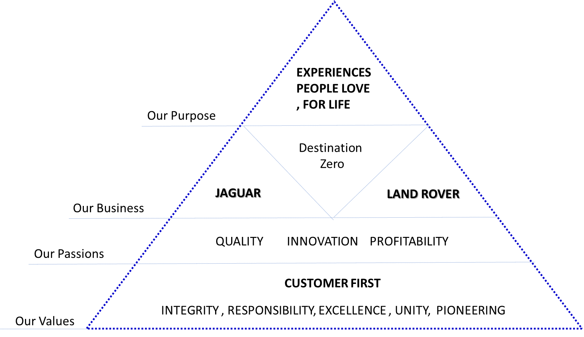
Source: Jaguar Land Rover Investor Day, 2019, pp. 22

Ralf Speth, the Chief Executive Officer of the Jaguar Land Rover said, “We are taking concerted action to reduce complexity and to transform our business through cost and cash flow improvements.” (Jaguar Land Rover Investor Day, 2019). The simplicity strategy is going to be implement in the company at world-wide level starting the fourth quarter of 2019 fiscal year.
The Chief Finance Office has mentioned the “cost and cash flow improvements” can be achieved only by increasing customer service, developing a rapid diagnosis and issue resolution, focus to offer customer centric product and features, rise customer marketing efficiency and maximise customer value. (Jaguar Land Rover Investor Day, 2019)
The environmental challenges direct Jaguar Land Rover`s, responsible business, to zero emissions, zero congestion, zero accidents and this is comprehended in the new vision is Destination zero
By having the customer in mind, as focal point, the company is going to respond to challenges presented on Tab.9 by creating value through customer excitement as Fig.6 presents.

Fig. 6. Responding to challenges
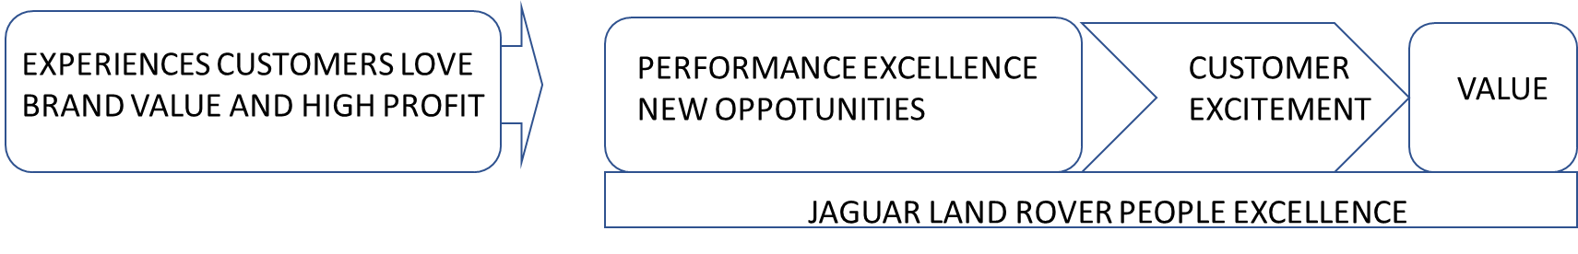
Source: Jaguar Land Rover Investor Day 2019, pp.41

Culture transformation is going to “fix customer clock” by adding more flexibility and faster responsiveness as Fig. 7 presents. This will be another “asset” to customer excitement”.
Fig.7 Improve the customer experience

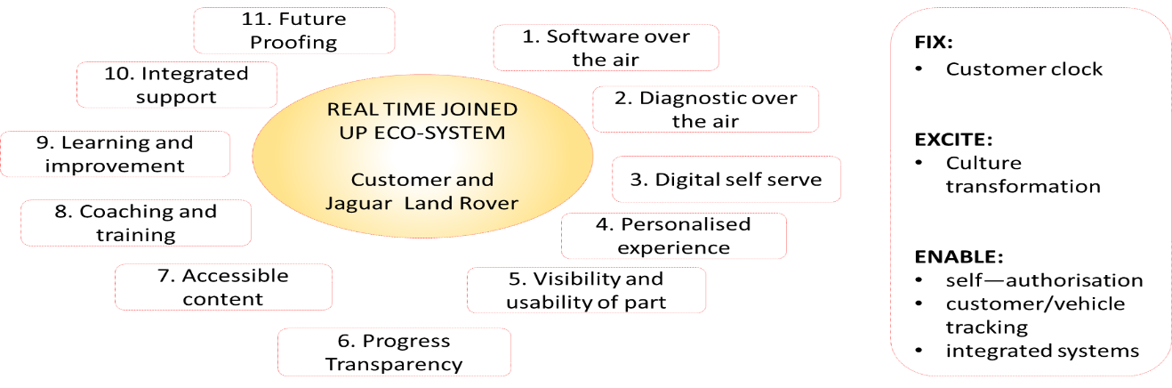
Source: Jaguar Land Rover Investor Day, 2019, pp.79
Innovation will have a huge impact on customer excitement and for Jaguar Land Rover this is not a problem, because the “Innovation is in our DNA” (JLR Financial statement 2016/2017). Through the new developed technologies “Cloud Car” and “Connected Car Diagnostics, the company is able to use “in real time”, the data from the vehicles and anticipate the customer needs. “It means our customers – just like us can stay ahead of the game” (JRL Financial Statement 2016/2017, pp.17)
All the changes, mentioned on Tab.9, have impact over the Customer journey and the organization developed the “future integrated digital journey” as presented on Fig. 8., to be continue the customer journey without breaks.

Figure 8. Future integrated digital journey
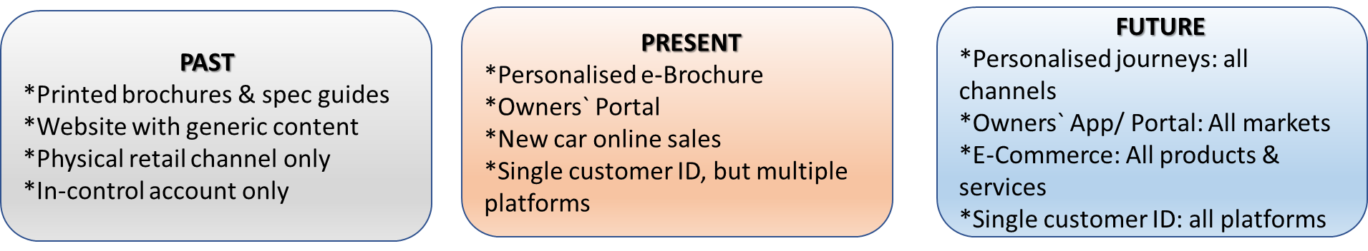
Source: Jaguar Land Rover Investor Day, 2019, pp.48

In 2019 China market, Jaguar Land Rover registered the recorded loss of 3.2 £bn, and one of the directions where the company faces one of the key challenges, is the Brand. There it was “insufficient investment in brand development and support relative in competition” and the corrective actions are brand development and efficiency improvement by working with external partners, in order to analyse the data base and determine, in real time, the next move. (JLR Investor Day, 2019, pp.57).
As conclusion, Jaguar Land Rover customer end-to-end journey is the heart of the business, creating in this way an outstanding customer experience which increase customer loyalty and determine a permanent ascendant revenue trend.
Jaguar Land Rover efforts to produce environmentally friendly cars, focus to develop the technology for electrical cars, permanent focus on customer excitement, made the company to be loved and appreciated all over the world by the employees, suppliers, customers and competitors.
Together with the customer, Jaguar Land Rover`s 43,224 employees, from all over the world, deliver the “Experience that people love, for life”.

Reference List

Baxendale, S., Macdonald, E., Wilson, H., (2015). The impact of Different Touchpoints on Brand Consideration. Journal of Retailing 91 (2,2015), 235-253.
Annual report 2018, JLR. (2019). Reports and Financial Downloads/ JLR Corporate Website. [online] Jaguarlandrover.com. Available at https://jaguarlandrover.com/2016/reports-and-financial -downloads [Accessed 1 Sept.2019].
Annual report 2016, JLR. (2019). Reports and Financial Downloads/ JLR Corporate Website. [online] Jaguarlandrover.com. Available at https://jaguarlandrover.com/2016/reports-and-financial -downloads [Accessed 1 Sept.2019].
Annual report 2015, JLR. (2019). Reports and Financial Downloads/ JLR Corporate Website. [online] Jaguarlandrover.com. Available at https://jaguarlandrover.com/2016/reports-and-financial -downloads [Accessed 1 Sept.2019].
Ashkenas, R. (2010). Simply effective: how to cut through complexity in your organization and get the things done. 1st ed. Harvard Business School.
Bodine, et al., (2012). Outside the power of putting customers at the centre of your business. New York: Houghton Mifflin Harcourt Publishing.
Calderon, H., Cervera, A., Molla, A., (1997). Brand Assessment: a key element of marketing strategy. Journal od Product and Brand Management, ISSN: 1061-0421
Chief Marketing Council (2008). Business Gain from you retain. [online]Cmocouncil.org. Available at: https://www.cmocouncil.org/thought-leadership/reports/business-gain-from-how-you-retain [Accessed 1 Sept.2019].
Gerhart, et al., (2019). Market Intelligence Dissemination Practices. Journal of Marketing, 83(3),pp.72-90.
Fandel, H. (2019). Driving the automotive customer experience toward the age of mobility. [online] Mckinsey & Company. Available at: https://www.mckinsey.com/industries/automotive-and-assembly/our-insights/driving-the-automotive-customer-experience-toward-the-age-of-mobility [Accessed 3 Sept. 2019].
Intelligence Briefing (2016). Quarterly Digital Intelligence Briefing: 2016 Digital Trends.[online] Econsultancy. Available at: https://econsultancy.com/reports/quarterly-digital-intelligence-briefing-2016-digital-trends/ [Accessed 1 Sept 2019].

Lemon, K.N., Verhoef, P., (2016 ). Understanding Customer Experience Throughout the Customer Journey, Journal of Marketing, 80(6)
Homburg, C., Jozic, D., Kuehnl C., (2017). Customer experience management: toward implementing an evolving marketing concept. Journal of the Academy of Marketing Science, 45(3), 377-401
Kumar, P., Rekhi, S., (2017). The impact of Brand equity on Business and customer perception. International Research Journal of Management and Commerce, ISSN: (2348-9766)
(Jaguar Land Rover Investors report, 2019).[online] Tatamotors.com. Available at: https://tatamotors.com/wp-content/uploads/2019/06/06043410/jlr-investor-day-2019.pdf [Accessed 1 Sept 2019].
Park, C.W., Macinnis. J., Priester, J.,(2010). Brand attachment and brand attitude strength: conceptual and empirical differentiation of two critical brand equity drivers. Journal of Marketing, 74(6)
Ritson, M. (2012). Mark Ritson: Subtle key to Jaguar Land Rover success-Marketing week.[online] Marketing Week. Available at: https://www.marketingweek.com/subtle-key-to-jaguar-land-rover-success/ [Accessed 2 Sept 2019].
Schwager, A., Meyer, C., (2007). Understanding customer experience. Harvard Business Review
Wolny, J., Charoensuksai, N., (2014). Mapping customer journeys in multichannel decision-making. Journal of Direct, Data and Digital Marketing Practice, 15(4), 317-326.

