proffesional career development
2016140 - Jade Godsall

Contents
Introduction – 2
Findings 2
Johari window 2
Studies undertaken. 3
Learning styles. 4
Myers Briggs 4
The big 5 4
Vark 4
Employability skills 5
Gap Analysis 5
Personal Development Plan 6
Conclusion 6
References 7
Appendices 8
Swot analysis 11

Introduction –
In this report I will be expanding in detail on various learning styles that I have learnt in my lectures and throughout my research. The learning styles that will be discussed are Myers Briggs, The big 5 and the Vark. As the report continues the discussions will be about Smart, swat and gap analysis, personal development plan and a Johari window. I will be discussing in more detail about what I want my goal to be and how I plan on developing my skills to enable me to create the best future for myself.
I will also be discussing about a gap analysis which will show what I am doing currently and what my goal for the future is, and how I plan on improving myself, my skills and my attitude to enable me to reach my dream job soon.

Findings

Johari window
When undertaking the Johari window, I established personal attributes. When speaking with family it was brought to my attention that I did not know things about myself which other seen. My family and friends made me aware that I need work on some of my flaws, some of these are that I can be to forgiving and get emotional. They have indicated that I am also gullible which could potentially affect me later in my career.
The factors that are known by others and myself is that I am a passionate person about my work and family. I get stressed when I am under pressure or if I have tasks that I need to complete within a deadline.
A few factors that my family and friends are not aware of with myself is that I get angry easily. I find it hard to control my temper when I am emotional. I hide a lot from my family and friends as I like to keep my problems to myself rather than cause a scene. A lot of my family are not aware that I do suffer with my mental health which I am trying to focus my mind set onto positive things to become more detached to the illness.
When the discussion about what others thought on me, I become overwhelmed to hear that they thought I was a strong person. I like to go through life not placing my problems on other people.
(Gaw, 1976)

Studies undertaken.
During previous years I have undertaken a hairdressing course to complete 3 NVQ qualifications, which was over a period of 3 years to ensure that I can develop a future working in the hairdressing industry.
Currently I am undertaking skills for the workplace in higher education Cert HE courses in St trinity Swansea university which will take 3 years of studies to achieve a degree. In the past 8 weeks since I have been studying the course, I have learnt about different learning styles. I have learnt about smart, swat and pdp and a gap analysis. While undertaking the Vark, Myers briggs and the big 5 It has been brought to my attention what type of learner and what techniques work best for myself.
While carrying out a variety of tests online, I have learnt that the best way I learn it by reading and writing. I as a person find it difficult to focus if I cannot see it or write it. I have discovered how to set out a smart and swot analysis.
Learning and creating my Swot analysis, it helped me set my goals to where id like to be in the future. By creating a swot table, it puts things into prospective. Understanding your strengths and weaknesses is important to ensure that you develop to the best to your ability. When its clear for you to see your weakness, you can then turn them into an opportunity to develop better skills.
When identifying the opportunities, it is critical that you take notice of what could potentially stop you in your journey. It helps put your goals into prospective, while giving you a clear vision to what you need to achieve.
During my recent studies I have also learnt how to create a smart analysis.
My goal in life is to be able to gain enough clients in the hairdressing industry and gain enough experience working with different people to enable me reaching my future goal which would be to eventually become an owner to a salon and have employees working for me to ensure that my business would reach the best that it could.
For me to reach my goal I need to continue to work at a salon to enable that I gain enough experience that I would feel confident start my own business. While doing this my goal is to continue with my studies at University to gain a degree which would give me the best starting point to know what and where I need to be next.
For me to pass the courses at University I will need to complete many assignments and meet the deadlines that are given. I need to have a pass of 40 percent or more for each assignment. Being realistically i know my goal will be reached if I stay dedicated, and motivated.

Learning styles.

Since studying at University I have learnt about Myers briggs personality, the big 5 and Vark. I took tests online which helped me see how my personality scores and how well I learn as a person.

Myers Briggs
While undertaking the Myers Briggs test, I found out a lot about myself which I was not that sure on before. My learning style scored ESFP, which stands for extraverted, sensing, feeling and perceiving.
(Sims and Sims, 1995)
I learnt that I am better doing practical than I would be written. My personality shows that I am outgoing and enjoy being adventurous, especially in new opportunities. I like things to be realistic, but also let myself give chances for open ideas.
I can be a talkative person and love speaking my mind. Working in a fast-paced environment works well with my personality as I enjoy being more practical so busier the better.
I value everyone’s opinions and ideas. Id like to think of myself as a warm-hearted person, who has empathy for another person’s decisions and ideas. I am a spontaneous person, love having surprises. My personality can come across to other people as over whelming as I do like to see the best in people.

The big 5
Since taking the big 5 personality test online i discovered I have a mixture of personality traits. I am an outgoing person and have a lot of energy which makes me have a high extraversion. I am a warm person who always considers how other feel. I like to become helpful as and when needed.
When undertaking the test, I also scored a high percentage to being open to experiences. This is something I strongly agree with. I enjoy using my imagination, while being open to new ideas from the opinion of others. When I set a goal for myself, I like to reach it no matter what gets in my way.

Vark
When undertaking the Vark questionnaire it indicated that I have a variety of different learning objectives. The highest I scored was being a better learner when reading and writing, while the lowest was aural.
I agree with the results I received slightly, but on the other hand I do disagree as I believe that I am a better learner when I am undertaking tasks that are physical. I engage and learn better when undertaking a practical rather than anything written.
Receiving the score for the visual I agree with this as I find it hard to concentrate when listening to someone else speaking, I feel like it does not register.
The average score that I received was the aural, I agree and disagree with the results as I don’t necessarily believe I should of received the balanced score for this, as when I listen I find it hard to engage and my mind goes off subject, but If I take notes as a person is speaking to myself then I do find it easier to engage as id be able to go back over my notes in my own time to recap on whats been said. (VARK Learning Style Questionnaire, 2021)

Employability skills

While undertaking different assignments I have learnt that Employability skills are an important to have in order to accomplish in the industry today. There will be many positions and professions that come and go for most people so I need to ensure that I stay focused and push myself to enable me to become the best I can.
I need to ensure that I stand out from the crowd, to ensure that I get the best role I can to help me in the best direction on becoming where I want to be in my future.
To achieve this, I need to work on my resilience skills for me to stay calm when in stressful situations and be able to indicate to myself that I am stable enough to continue with the dream job that I have always wanted to enable it is achievable to the best that I can be.
I would also hope to develop much better time keeping, as recently I feel as I have fallen behind on a lot of my assignments, so that is something I would like to become better at for my future. Developing my digital competency skills is something that I would also like to improve on as I do struggle with technology. Having digital skills will benefit me if I have my own company as it will help increase my business reputation.
. (Chaita, 2016)

Gap Analysis
While creating my gap analysis it helped me see a clearer to how I will achieve my goals for the future. I am currently working as a hairdresser. My aim now it to gain enough clients and experience to develop my reputation to ensure that I can succeed in the hairdressing industry.
While working at the hair salon I am also studying for a degree in business certHE. This course will be completed after 3 years.
In order to achieve my aims it is important that I carry out all my assignments and get a pass of 40 percent on each module. I then will have the proud moment of receiving my cap and gown.
,

Personal Development Plan

Conclusion
Since learning about different learning styles, I have become more knowledgeable to learning about what a smart and swot plan Is. It has helped me set plans in place to see how I can develop my goals for the future.
While also learning about the personal develop plan and a gap analysis it showed me how to write a plan to see what I need to do and how I can make it possible. It has given me a clear mind set on how I want things to continue for my future.
My conclusion on the learning styles that I have learnt about and taken the tests online, it shown me that I am a positive person who wants to achieve the best that I can. It helped me understand what learning techniques I am best at. I have become more aware of what employability skills I need to improve on to ensure I get where id like to be.
I am very happy I have become more aware about how my family and friends perceive me, it helped me realise what my weaknesses and strengths are as a person.
Since I have been studying, I am please with how much I am developing. It is giving me hope that if I keep trying as hard as I am then eventually with enough dedication and hard work, I one day will reach my dream job of becoming a business owner, I will have something to show for and be able to be proud of.
(Rosser, 2021)

References

VARK - A Guide to Learning Styles. 2020. VARK Learning Style Questionnaire. [online] Available at: <https://vark-learn.com/the-vark-questionnaire/?p=results> [Accessed 26 November 2020].

Test, M., 2020. 100% Free Personality Test - Discover Yourself. [online] My Personality Test. Available at: <https://my-personality-test.com/results/6201244054311645567/personality-type-indicator> [Accessed 26 November 2020].
Rosser, J., 2021. What is a Personal Development Plan and How to Use It? | Success Stream. [online] Success Stream. Available at: <https://www.success-stream.co.uk/what-is-a-personal-development-plan-and-how-to-use-it/> [Accessed 26 February 2021].
Gaw, B., 1976. The Johari window and a partnership: An approach to teaching interpersonal communication skills. Communication Education, 25(3), pp.252-255.
VARK - A Guide to Learning Styles. 2021. VARK Learning Style Questionnaire. [online] Available at: <https://vark-learn.com/the-vark-questionnaire/> [Accessed 26 February 2021].

Chaita, M., 2016. Developing Graduate Employability Skills. Boca Raton: Universal Publishers.

Sims, R. and Sims, S., 1995. The importance of learning styles. Westport, Conn.: Greenwood.

Appendices

Appendix A
Myers Briggs
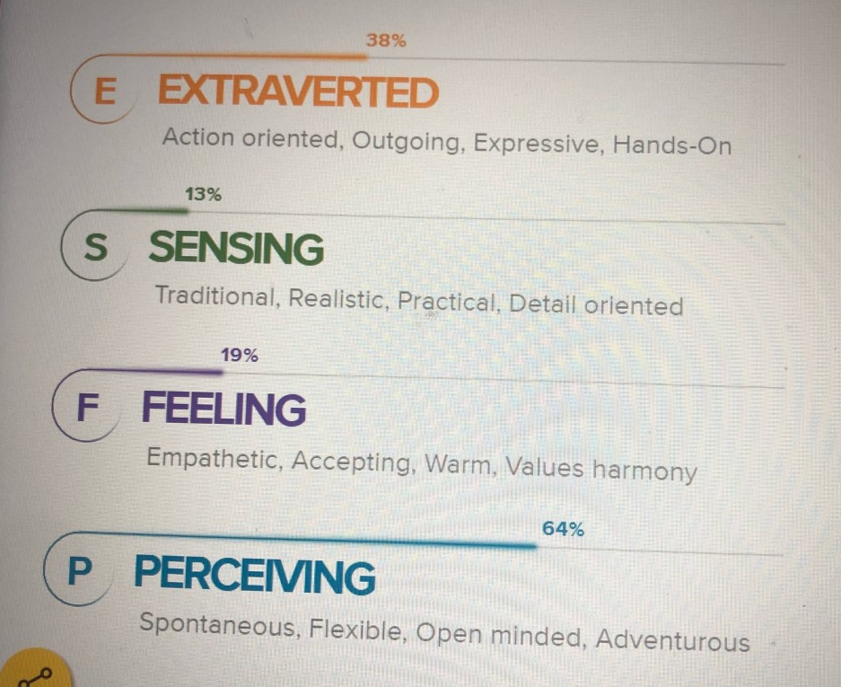
(Test M, 2020).

Appendix B
Big five personality test.
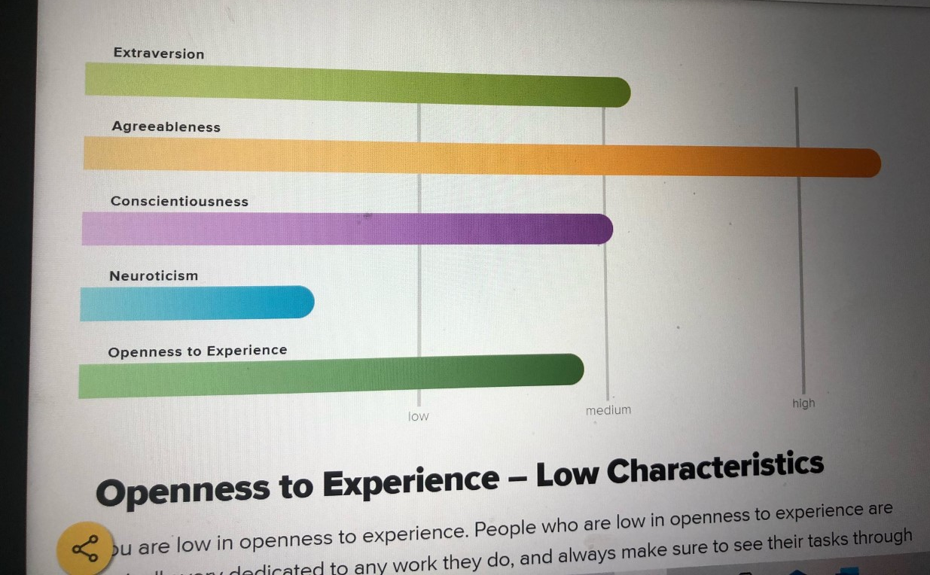
(Test, 2020).

Appendix C
VARK
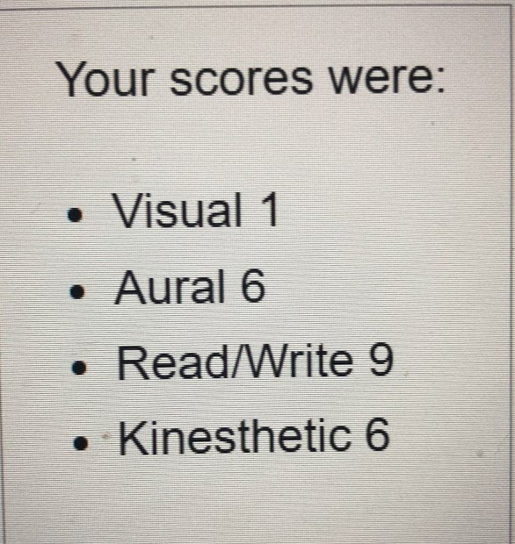
(VARK Learning Style Questionnaire, 2020).

Appendix D
VARK TWO
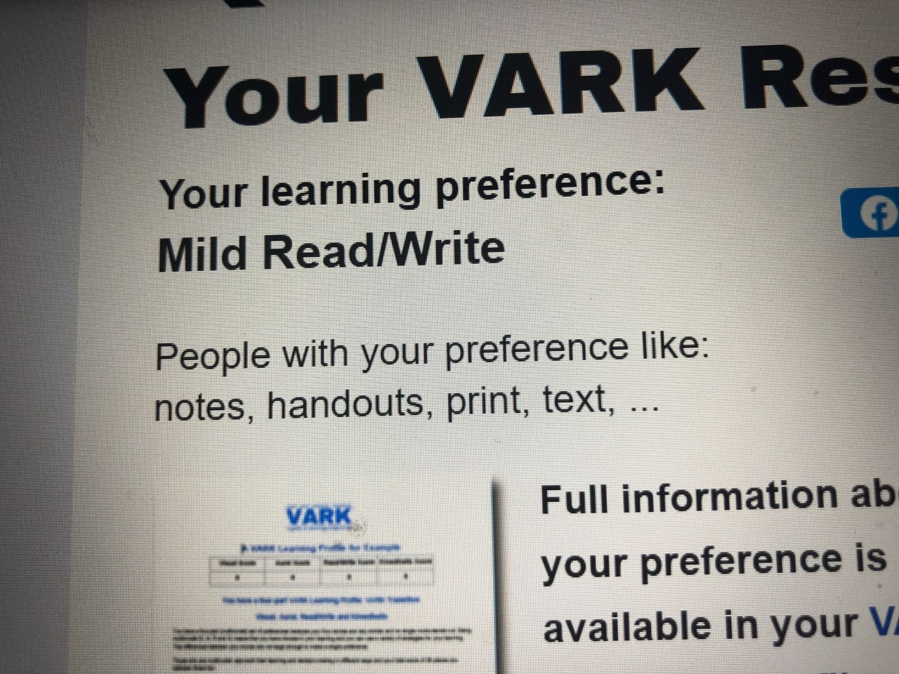
(VARK Learning Style Questionnaire, 2020).

Appendix E

Swot analysis

Strengths | Weaknesses | Opportunities | Threats
- 3 years NVQ hairdressing qualifications  - Years of hairdressing experience  - Good at communication  - Brilliant at practical | - Struggle with meeting deadlines  - Not very good at technology  - Get stressed very easy  - Do not ask for help if needed | - To qualify in a sert he at university  - Develop better skills  - A chance to become a salon owner | - Failing my assignments  - Having personal issues  - Not gaining the experience I need

Smart – appendix E
Specific | The goal I have set myself for the future is to open my own hairdressing salon.
Measurable |  | Experience  Qualifications
Achievable | Attending university completing sert HE.
Realistic | If I work hard toward completing the course
Timebound | It will be achievable if I complete the 3 year course.

Johari Window
Appendix F

 | Known by self | Not known by self
Known by others | - Passionate about work  - Get stressed  - Family orientated  - Loyal | - To forgiving  - Gullible  - Cannot stay focused  - Emotional
Not known by other | - I can get angry and frustrated  - I get emotional  - I cut myself off from people  - I suffer with mental health | - People think I am strong  - I am very emotional while on my own  - Overthink everything

What I am doing now | My goal in life | Actions needed | How will I know I have succeeded | Rewards and achievements
Studying ser he at university | To become a salon owner | To complete my 3 year course. | When I get a pass on all of my assignments | Receiving a gap and gown
Working at a salon | To gain enough clients for my future business | Gain a variety of experiences | When I open my own salon | By owning my own business

Gap analysis
Where I am currently |  | What I need to get to where I want to be
I am currently working at a salon |  | I plan to develop my skills and gain clients
I am studying for a degree | Need to complete all of my assignments with a pass
Want to open my own business | Graduate at the end of 3 years
Appendix H – Personal development plan
Appendix G -

