
Name: Kathlyn Kanu
Module Title: Organisational Culture
Module Code: LCLM5005
Lecturer’s Name: Amir Homanyounfand
Assessment Title: Individual Report

4.2026
TABLE OF CONTENTS

Introduction …………………………………………………………………………………………… 1.
Organisational Culture of Teco Plc UK ………………………………………………………… 2.
Tesco’s cultural influence on its Organisational structure and Decision-making
Processes ……………………………………………………………………………………………….3.
Using Schein’s Model to identify and discuss Tesco’s prevailing Organisational
Culture …………………………………………………………………………………………………. 4.
Tesco’s Organisational Culture and Its Adaptability to the External Environment
Influences…………………………………………………………………………………………..…..5.
Organisational Culture and the effective functioning of Tesco…………………………..6.
The impact of Tesco’s Culture on its overall performance and evidence-based
proposed improvement ……………………………………………………………………………..7.
Conclusion….……………………………………………………………………………………………8.
Reference…………………………………………………………………………………………………9.

INTRODUCTION
Tesco Plc is a multinational retailer specialising in groceries and general merchandise. It was founded in 1919 when Jack Cohen, after resigning from the Royal Flying Corps at the end of World War I, used his demobilisation payment to buy and resell surplus groceries from a stall in the East End. In 1924, the company launched its first own-brand product, Tesco Tea, which Jack believed would offer unmatched value.
Tesco is rapidly expanding across the UK, with its headquarters now based at Kestrel Way, Welwyn Garden City (Marketline, 2026). Jack firmly believed that affordable food should be accessible to everyone, a philosophy reflected in Tesco’s slogan, “Every little helps”. Today, Tesco is the largest supermarket chain in the United Kingdom, boasting over 4,000 stores and more than 330,000 staff members (Tesco's Annual Report, 2026).
2. ORGANISATIONAL CULTURE OF TESCO.
The concept of organisational culture refers to the shared perceptions of work practices within an organisation that differ from those of other organisations; success or failure is mainly attributed to this, reflected in employees' values, norms, and deeply held beliefs, and visible in corporate practices, statements, symbols, and artefacts. Organisational culture influences employee behaviour and impacts firm performance (Penny, 2022, pp. 5-22).
Tesco’s organisational culture is centred on customers, community, and teamwork. This culture benefits creativity, innovation, team spirit, and the company’s reputation, greatly influencing its structure and decision-making, in line with Mat's (2013) idea that culture is vital for action, acting as a foundation for performance.
The core values of Tesco’s culture can be divided into four, specifically
- Customer-focused
- Community-oriented
- Sustainability
- Teamwork, diversity and inclusivity.

- Customer-focused: Tesco prioritises excelling at the fundamentals and leading in areas that truly matter to customers, such as value for money, product quality, and exceptional customer service (Tesco Report, 2025). Attention is given to product quality from the very beginning of the supply chain—covering farmers, growers, manufacturing, packaging, and in-store presentation. The strong emphasis on product quality across its range has enhanced the company's perception of quality, reflected in a 153 bps increase in the brand polarity score. Tesco ensures customers receive the best product at the best price, whether they are shopping for a small or large item. The value customers receive matches the produce; they continue to invest in lowering prices this year through Aldi Price Match, Low Everyday Prices, and Clubcard Prices.

- Community is one of the strongest elements of Tesco's culture, endearing customers to the brand. Alongside serving consumers, Tesco’s community grant, supported by the Family blue token available in every Tesco store, provides valuable funding for local projects across the UK. Over £120m has been invested in local projects across 70,000 communities through the Strong Start and Give Back initiatives. Kennedy and Snell (2023) stated that, Tesco has maintained a long-standing relationship with Trusell Trust since 2012, featuring dedicated food drives and year-round food collection point and during Covid-19, donation of over £75 million worth of food between Trussell Trust and FareShare in 2020 and 2021, and has maintained a long-standing relationship with the Trussell Trust since 2012, featuring dedicated food drives and year-round food collection points.

- Sustainability: As the UK’s leading food retailer, Tesco is committed to building a resilient, sustainable system that nourishes people, supports its customers, and protects the planet for future generations (Tesco Report, 2025). To safeguard the environment, the organisation aims to switch entirely to an electric home delivery fleet by 2028 and has established six frameworks that reduce its climate footprint across the entire value chain, lessen packaging and food waste, and encourage natural conservation through sustainable farming initiatives.
The six-part sustainability framework called “ Our Planet Plan” comprises
  - Improve on products
  - Decarbonise transport
  - Reduce store emissions
  - Support sustainable consumption
  - Eliminate waste
  - Protect Nature.

- Teamwork, diversity, and inclusivity: Human Resources management is essential for achieving sustainable competitive advantage in the business environment (Navajas-Romero et al., 2022, e0271134). Tesco embraces the diverse backgrounds and identities of its colleagues, celebrating and empowering them through its “Everyone’s welcome” strategy. Tesco’s Black African Plan and Diverse Talents are other examples of this approach. This ensures Tesco genuinely reflects the community it serves while fostering an environment where colleagues can always be themselves.

3. TESCO’S CULTURAL INFLUENCE ON ITS ORGANISATIONAL STRUCTURE AND DECISION-MAKING.

- CULTURAL INFLUENCE ON ORGANISATIONAL STRUCTURE.
Tesco’s customers and colleagues are at the very centre of everything they do, thereby shaping the leadership structure the organisation has adopted. The structure is hierarchical, product-based, and decentralised, reflecting its cultural focus on empowerment and responsiveness. The top level includes the Ten Board Directors, headed by the Group Chief Executive Officer, Ken Murphy, the intermediate level comprises four committees overseeing strategy, governance, and sustainability (see figure 2), and at the base-line level, employees are divided into specific regions overseen by a regional manager at the top, store managers, and three other managers below them, see figure 3.

TOP LEADERSHIP STRUCTURE
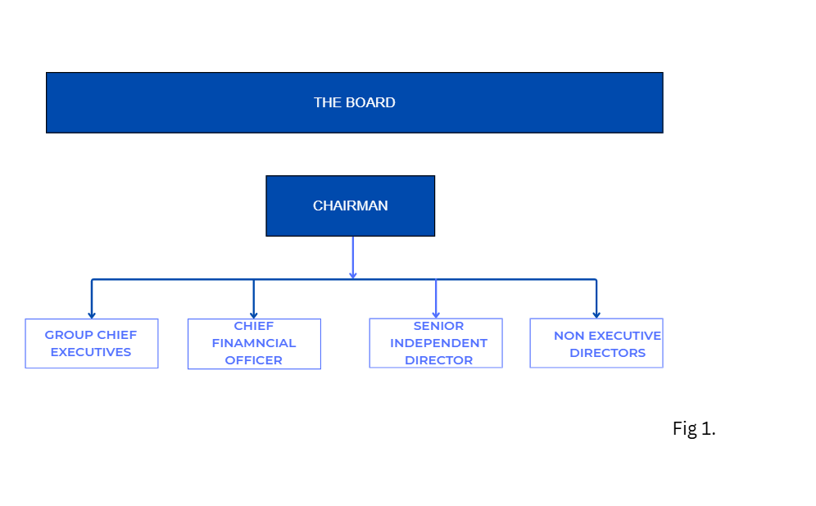
THE BOARD OF DIRECTORS.
The Board collectively bears responsibility for setting the Group's overall strategy and ensuring the creation of long-term value. They operate within an effective control framework and ensure that stakeholders' interests are properly considered. The board has implemented a schedule for matters reserved for its attention, outlining issues regarded as significant to the group due to their strategic, financial, or reputational importance or impact.
Roles of the Board of Directors
Some important issues reserved for Board review are:
- Define and oversee the group's purpose, strategy, values and culture.
- Establish the long-term plan and budget.
- Monitor commitments to net-zero emissions.
- Supervise risk management and internal controls
- Supervises the implementation of the governance framework.
- Monitor financial reporting, control, and disclosure.

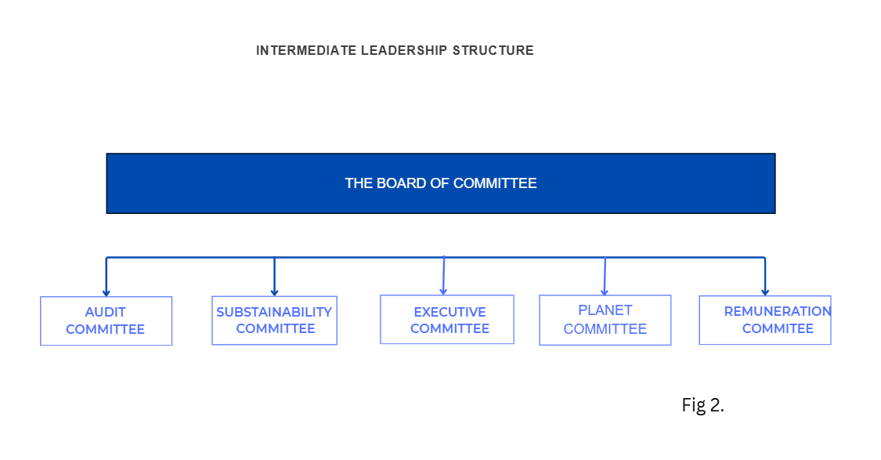

THE BOARD OF COMMITTEE
Sustainability is essential to Tesco's long-term value and societal benefit. It remains central to its strategy of providing value to customers through quality, price, variety, and experience. The Board of the Committee is responsible for delivering the Net-Zero commitments and sustainability efforts, with ongoing updates as shown in Figure 2 above.

THE EXECUTIVE COMMITTEE
This committee was established by the Group Chief Executive, who delegates its authority. It includes the Executive Director and several senior executives, whose responsibilities involve formulating and implementing the group's strategic plans and managing daily operations on behalf of the Chief Executive Officer. The main purpose of the committee is to support the group chief executive officer in fulfilling their role and to oversee the group's day-to-day operations.

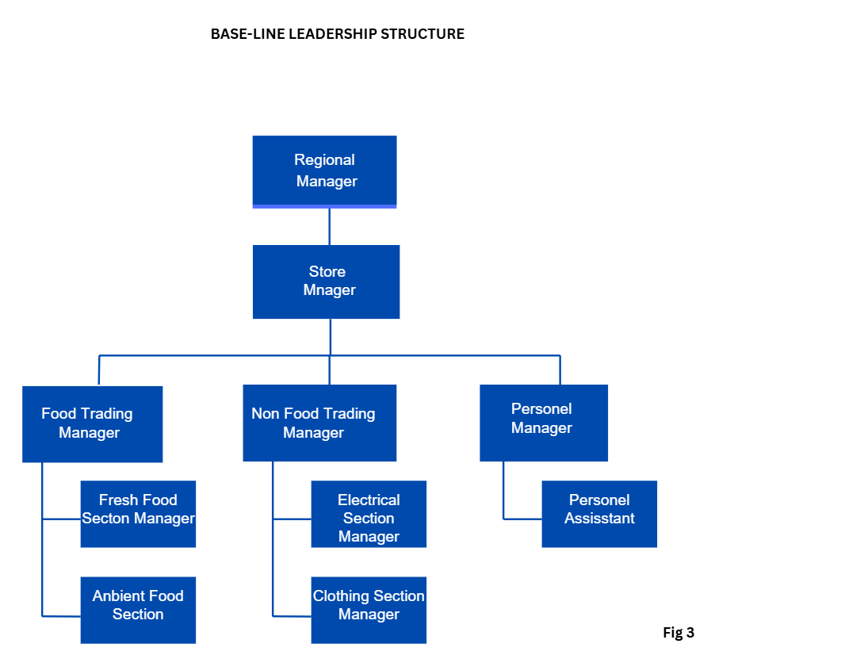

- CULTURAL INFLUENCE ON DECISION-MAKING PROCESS.

- Decentralised decision-making:
Tesco employs a leadership style that combines elements of transformational and democratic approaches due to its culture. The Board of Directors (see Figure 1) encourages participation and innovation while maintaining strategic oversight. The culture of engagement supports decentralised decision-making, where regional and store managers, as shown in Figure 3, have the autonomy to respond to market conditions and make decisions while remaining aligned with corporate objectives.
- Customer-oriented:
Tesco prioritises its culture of ‘serving customers a little better every day’, focusing on delivering value, convenience, and quality, as reflected in its slogan “Every Little Helps”. By understanding their customers, they can anticipate and respond to their needs and expectations. Decisions are often reviewed and revised based on customer responses, promotions, surveys, and Clubcard data. Aldi Price Match.
- Data-driven, rational decision-making:
To avoid a “power culture” where control is concentrated among senior leadership, they focus on facts, data, and performance metrics to support more objective decisions and reduce bias caused by hierarchy. The company reported revenues of GBP69,916 million for the fiscal year ending February 2025 (FY202), an increase of 2.5% compared to the previous year (FY2024) (MarketLine, 2026).

4. TESCO’S ORGANISATIONAL CULTURE USING SCHEIN’S THREE LEVEL MODEL
Organisational culture (OC) encompasses core values and acts as a foundation for developing norms (Paais and Pattiruhu, 2020). Schein offers a perspective on OC based on three layers of culture, ranging from the most surface to the deepest: artefacts, espoused values, and fundamental underlying values (Mullin, 2019).
- ACTEFACTS ( Visible level).
These are the visible and observable aspects of culture within an organisation. At Tesco, customer satisfaction is prioritised above everything else. The visible level includes store layout design for convenience, self-checkout systems, employees’ uniforms, and the use of technology such as online platforms.
The visible element demonstrates Tesco’s focus on customer convenience, efficiency, and accessibility. For instance, a self-checkout system reduces wait times and improves the customer experience.

- ENPOUSE VALUES ( Stated Beliefs).
An organisation’s culture includes its mission statement, principles, strategy, slogans, and other operational beliefs. Tesco promotes values such as prioritising its customers, delivering value for money, and sustainability. “Every little help,” “Servicing our customers, community, and planet a little better every day,” and “Everyone is Welcome” are some of the organisation's values.
These values influence decision-making as Tesco emphasises competitive pricing, like Aldi's Price Match and product availability. For example, offering a wide range of products at different price points demonstrates its commitment to value.
- BASIC UNDERLYING ASSUMPTION ( Deep Belief).
These are often unseen and not easily recognised in everyday interactions among organisational members; even without detailed knowledge, one can become familiar with them. Tesco has two core assumptions: that customer satisfaction leads to long-term success, and that data and performance metrics should inform decisions rather than relying solely on hierarchy.
This explains why Tesco uses customer data (e.g., loyalty schemes) and sales analysis to guide its decisions. These assumptions foster a culture that is data-driven and customer-focused, strengthening its competitive position in the market.
5. TESCO’S CULTURE AND ITS ADAPTABILITY TO EXTERNAL ENVIRONMENTAL INFLUENCE.
Tesco has cultivated a strong, customer-oriented, data-driven, and adaptable culture that it uses to respond to external changes, such as economic conditions, competition, and sustainability pressures.
- Responding to Economic influences
One major environmental factor affecting Tesco is the economic environment, particularly inflation and the cost-of-living crisis. Tesco’s culture emphasises customer value, enabling it to respond effectively to this pressure. For instance, Tesco expands its range of low-cost own-brand products and employs competitive pricing strategies such as Aldi's price match. This demonstrates a culture that prioritises customer affordability; consequently, Tesco can maintain customer loyalty even when consumers reduce their spending.
However, this approach might reduce profit margins, highlighting that while culture aids adaptation, it can also lead to financial strain.
- Data-driven response to the market trends
Tesco highly values facts, data, and performance metrics, enabling it to respond swiftly to shifting market trends.
By analysing customer data from loyalty programmes and sales patterns, Tesco can adjust stock levels, introduce targeted promotions, and more accurately forecast demand. This improves efficiency and guarantees that Tesco meets customer needs more effectively than competitors.
Therefore, its data-driven culture provides a significant competitive advantage. However, excessive dependence on data could impede innovation if decision-makers focus too heavily on past trends rather than future opportunities.
- Responding to Environmental and Ethical Pressures
Environmental concerns and sustainability expectations are vital external factors for any organisation. Tesco’s culture encompasses a commitment to corporate responsibility and sustainability, which enables it to respond effectively to these pressures.
The organisation has launched an initiative to cut carbon emissions, reduce food waste, and enhance sustainable sourcing. This aligns with both government directives and evolving consumer expectations. Grocers like Tesco face pressure to lower waste, energy consumption, and emissions while maintaining sustainable sourcing (TESCO, 2023).
As a result, Tesco improves its brand image and long-term competitiveness. However, these initiatives might raise operational costs, potentially causing a conflict between sustainability and profitability.
6. TESCO’S CULTURE AS AN ENABLER TO ITS EFFECTIVE FUNCTIONING.
Tesco's organisational culture is crucial for the company's efficient operation. The emphasis on customer satisfaction, data-driven performance, and diversity and inclusion consistently helps ensure smooth management.
One of the key ways Tesco’s culture supports efficient operations is through its focus on customer service. The idea behind its slogan “Every little helps” is to encourage employees to prioritise customer satisfaction in their daily tasks. As a result, staff are more likely to provide good service, keep shelves stocked, and ensure stores are easy to navigate. This enhances the overall customer experience and helps Tesco to maintain loyalty and sales.

Tesco's data-driven culture also boosts its effectiveness. The company collects extensive data through systems like loyalty schemes and sales-tracking tools. This enables managers to make well-informed decisions about stock levels, pricing, and promotions, as decisions are based on evidence rather than guesswork. Tesco can operate more efficiently and reduce waste.
Another important aspect of its organisational culture is its relatively decentralised structure, which reflects its culture of flexibility. Store managers have the authority to make decisions based on local demand, enabling each store to respond swiftly to customers' needs. This boosts efficiency and helps ensure that businesses remain responsive across different locations.
Furthermore, Tesco's culture promotes clear performance targets and accountability. Employees are assigned measurable goals, which help maintain high standards and productivity. This results-oriented approach ensures that all parts of the organisation work towards shared objectives.
Werner and Iradukunda (2025) speculated that DEI is not only about demographic representation or formal policies. It also involves how people are treated, how included they feel, and whether they believe they belong, which is another core value in Tesco’s culture. The organisation strives to foster a work environment where colleagues from diverse backgrounds are valued, treated fairly, and included. “Everyone is welcome” is a common phrase among colleagues when referring to employees. This has a direct impact on the company's overall performance.
One important benefit of diversity is that it introduces a wide range of perspectives and ideas into the business. Tesco operates in different communities, so having a diverse workforce helps employees better understand customer needs. For instance, staff from different backgrounds can assist Tesco in tailoring its products and services to suit local preferences. This enhances customer satisfaction and can result in higher sales.
“Our colleagues are at the heart of everything we do; they are key to ensuring we serve our customers, community and planet a little better” is another memorable phrase at Tesco, which expresses its dedication to the well-being of its colleagues. (Tesco, 2024).
Inclusion is a crucial part of Tesco’s culture, significantly improving business performance. The organisation encourages a culture where colleagues feel comfortable sharing ideas and being themselves. This can result in better decision-making as more perspectives are considered, fostering teamwork and collaboration, which are vital for daily operations in stores and distribution centres.
However, strong performance and cost control might pressure employees, potentially impacting motivation in the long term. Also, prioritising low prices for customers can decrease profit margins, which may limit investment in other areas.
Justifiably, Tesco’s organisational culture plays a vital role in its effective operation. Its emphasis on customer satisfaction, data utilisation, DEI, and operational flexibility enables the business to run seamlessly and adapt to changing environments. Despite some disadvantages, this culture remains a key factor in Tesco’s continued success in a highly competitive market.
7. IMPACT OF TESCO’S ORGANISATION CULTURE ON ITS OVERALL PERFORMANCE AND SOME EVIDENCE-BASED PROPOSITIONS FOR IMPROVEMENT.
The OC of Tesco greatly impacts the organisation’s FY2025 performance, offering both advantages and disadvantages.
A key strength of Tesco’s culture is its exceptional customer satisfaction; most decisions are focused on the customer, from product enhancements to value, quality, and convenience.
Another positive OC is a strong sustainability and DEI strategy that supports its workforce and boosts resilience to environmental and economic shifts.
However, in its effort to satisfy customers, maintaining low prices and efficiency can decrease this year’s profit margin due to cost inflation caused by the ongoing war.

TESCO’S PRICE RECOMMENDATION.
A major aspect of Tesco’s culture that requires immediate change or adjustment to prevent bankruptcy is the excessive focus on satisfying customers at the expense of other operational concerns.

Recommendation | Implementation | Benefit | Limitation
Balance pricing strategy | Combine low-cost products with premium ranges | Increase revenue from different customer segments | May confuse the brand if not clearly positioned
Dynamic/Data-driven pricing | Adjust price based on demand, real-time and customer behaviour | Improve efficiency and reduce waste | The customer may see pricing as unfair
Loyalty-based pricing  ( Clubcard) | Offer personalised discounts and rewards | Build customer loyalty and repeat purchase | Reduce profit margins due to discounts
Focus on price perception | Keep the key items very cheap to attract customers | Improve Tesco’s value image | Store managers may reduce short-term profits
Psychological pricing | Use price like£0.99 and bundle deals. | Increase sales volume and attractiveness | Limit long-term impact on brand

8. CONCLUSION OF TESCO’S ORGANISATIONAL CULTURE.

In conclusion, the organisational culture adopted by my chosen organisation (Tesco) plays a crucial role in shaping its overall performance and success. Its strong focus on customers, combined with a data-driven, performance-oriented approach, allows Tesco to operate efficiently and respond to external changes. This culture supports key strengths, including customer loyalty, effective decision-making, and operational flexibility. However, it can also create challenges, such as pressure on employees and a reduction in profit margins due to consistently low prices.
Overall, Tesco's culture is a significant competitive advantage, but its long-term success will rely on how effectively it balances customer focus with employee well-being, innovation, and profitability.

Reference:
- MarketLine. (2026). Marketline@globaldata company. Available at: https://advantage-marketline-com.uwtsd.idm.oclc.org/Company/Summary/tesco_plc (Accessed: 01.04.2026)
- Williams, P. (2022). 'Chapter 2: Organisational culture: definitions, distinctions and functions', in C.L. Cooper (ed.) Handbook of Research Methods for Organisational Culture. Cheltenham: Edward Elgar Publishing, pp. 5–22. Available
at: https://doi.org/10.4337/9781788976268.00008 (Accessed: 01 April 2026).
- Kennedy, K. and Snell, C. (2023) ‘Relationships between supermarkets and food charities in reducing food insecurity: lessons learned’. Voluntary Sector Review, 16(2), pp. 332-341. Available at: Relationships between supermarkets and food charities in reducing food insecurity: lessons learned in: Voluntary Sector Review Volume 16 Issue 2 (2025)(Accessed: 01 April 2026).
- Deepa, D. and Arulmozhi, B. (2025)’ A Study on Sustainability and Waste Reduction Initiatives by Super Market’, IPE Journal of Management, 15(2), pp. 200-203. Available at: (PDF) A STUDY ON SUSTAINABILITY AND WASTE REDUCTION INITIATIVES BY SUPER MARKETS ( Accessed: 01 April 2026).
- Navajas-Romero V., Ceular-Villamandos N., Pérez-Priego M.A. and Caridad-López del Río, L. (2022) ‘Sustainable human resource management the mediating role of work engagement and teamwork performance’, PLoS ONE, 17(8) e0271134. Available at: Sustainable human resource management the mediating role between work engagement and teamwork performance | PLOS One( Accessed: 01 April 2026)
- Alvesson, M. (2013). Understanding organisational culture. 2nd edn. London: SAGE.
- Tesco Plc, (2025). Tesco PLC Annual Report and Financial Statements. Available at: Tesco Annual Report 2025 (Accessed: 02 April 2026).
Canva (2026), Canvaprojectdesign.com. Available at: Beige Simple Organisational Structure Chart Graph - Graph( Accessed: 03.04.2026).
- Mullin, L. and Christy, G. ( 2019). Management and Organisational Behaviour in the Workplace. (20th edn). Pearson Education Limited.
- Paais, M., & Pattiruhu, J. R. (2020). Effect of motivation, leadership, and organisational culture on satisfaction and employee performance. The Journal of Asian Finance, Economics and Business, 7(8), 577–588. Available at: https://doi.org/10.13106/jafeb.2020.vol7.no8.577 (Accessed: 05 April).
- Werner, F. and Iradukunda, Q. (2025) Diversity, Equity and Inclusion in Practice: A qualitative study exploring how implementation of DEI policy in an organisation shapes employee engagement. Bachelor's thesis. Linnaeus University. Available at: Thesis PM3 (Accessed: 09 April 2026).

• Author/editor
• Publication year (in round brackets)
• Title (in italics)
• Edition (if not the first)
• Publisher
Eg, Smith, E. (2016). How to improve your research project. 2nd edn. Kiln Press.
In-text citation: (Author’s surname, year of publication, page number)
Eg. (Smith, 2016, p. 5)

