Food & Beverage Operations
BMIH4002
Student name: Iulia Petronela Ferent
Student ID: 2225255
Lecturer: Ffion Cumberpatch
Wordcount: 407



Part 1: Restaurant Concept
The restaurant concept of the business idea will be the fine-dining concept. It will be open fine dining and Asian Cuisine that create dishes of exquisite sophistication with a hint of Asian touch. The restaurant will use the best products from the Lake District. The restaurant will provide a sophisticated and elegant ambience with a focus on details in its environment, décor, and table setting. The restaurant will give importance to exceptional service, hiring trained employees who have enough information about the menu and deliver personalized focus to their customers (Kanyan et al. 2016). However, fine dining restaurants provide a selection of gourmet dishes developed by expert chefs in terms of menus. These chefs are proficient at using high-quality ingredients and new culinary methods. The fine dining restaurant mainly promises a good customer experience because the food dishes are catered to the clients in huge quantities (Amelia and Garg, 2016)
Target audience of a business mention to the particular group of customers most probable to want the service or product offered by a company (Van Den Berg and Wein, 2018).. The target audience for the restaurant will be families and people who need vegan options. The restaurant will be the best choice for special occasions, such as birthday celebrations and anniversaries. Asian communities will be a target market for the stated restaurant because this restaurant serves authentic Asian dishes that attract people from Asian backgrounds who are looking for a taste of their home cuisine. These venues appeal to individuals seeking a casual dining experience or a quick bite with family or friends (Aguilera, 2018).
The reason behind the selection for this restaurant is that it is classified by multi-course meals that may involve palate cleansers, amuse-bouche, vegan choices, and the development of courses like salads, soups, and desserts. Moreover, wine pairing is also common, with extensive wine lists containing both international and local selections (Castillo et al. 2016). The main reason behind this restaurant includes the popularity of Asian cuisine in the UK, with a broad range of culinary traditions from several Asian nations addressed all throughout the country. The ambience of the restaurant will be casual and relaxed, and the dishes are made for sharing with influences of Asia (Narzary et al. 2021). The menu of a restaurant include comfort food as families in large business or groups on a trip need a taste that brings a sense of comfort and familiarity to a nation.

Part 2: Menu Design

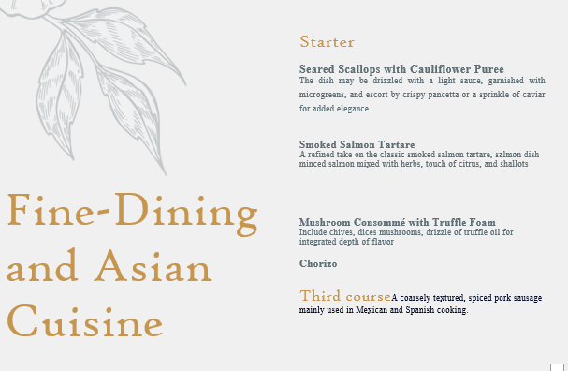
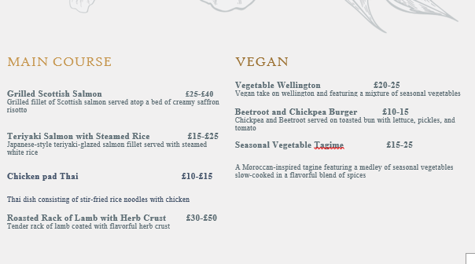
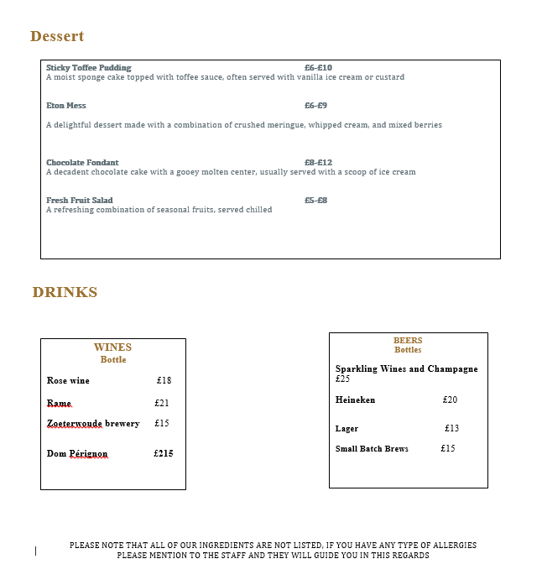

References
Amelia, M. and Garg, A., 2016. The first impression in a fine-dining restaurant. A study of C Restaurant in Tampere, Finland. European Journal of Tourism, Hospitality, and Recreation, 7(2), pp.100-111.
Aguilera, J.M., 2018. Relating food engineering to cooking and gastronomy. Comprehensive reviews in food science and food safety, 17(4), pp.1021-1039.
Castillo, J.S., Villanueva, E.C. and García‐Cortijo, M.C., 2016. The international wine trade and its new export dynamics (1988–2012): A gravity model approach. Agribusiness, 32(4), pp.466-481.
Fanny Trollopes, 2023. Carte Menu. Available at https://fannytrollopes.co.uk/menus/a-la-carte-menu/. [Accessed on 2nd May 203]
Fig & Thistle. Available at https://figandthistle.co.uk/menus.php. [Accessed on 2nd May 203]
Kanyan, A., Ngana, L. and Voon, B.H., 2016. Improving the service operations of fast-food restaurants. Procedia-Social and Behavioral Sciences, 224, pp.190-198.
Karrysdeli, 2023. Available at https://karrysdeli.com/. [Accessed on 2nd May 203]
Narzary, Y., Das, S., Goyal, A.K., Lam, S.S., Sarma, H. and Sharma, D., 2021. Fermented fish products in South and Southeast Asian cuisine: indigenous technology processes, nutrient composition, and cultural significance. Journal of Ethnic Foods, 8, pp.1-19.
van den Berg, G. and Wein, T., 2018. Three Crucial Questions about Target Audience Analysis. Retrived from https://studylib. net/doc/8326180/three-crucial-questions-about-target-audience-analysis.
Tampopo, 2023. Available at https://tampopo.co.uk/menus/the-best-asian-food-in-manchester/. [Accessed on 2nd May 203]

