Name:_Emyr Jones

Student Number: 1701036
__________________________________________________________

WORKSHEET 2 – TESTING (Tiles)

- Original code:

import math

Tile_Width = 20
Tile_Length = 20
Tile_size = Tile_Length * Tile_Width

flag = 0
while flag == 0:
try:
Wall_length = float(input("Please enter the length of your wall: "))
except ValueError :
print("Not a valid number, try again: ")
else:
flag = 1
if Wall_length <= 0:
print("not a valid number, try again: ")
else:
flag = 1

flag = 0
while flag == 0:
try:
Wall_width = float(input("Please enter the width of your wall: "))
except ValueError :
print("Not a valid number, try again: ")
else:
flag = 1
if Wall_width <= 0:
print("not a valid number, try again")
else:
flag = 1

Wall_Tiled_Width = math.ceil(Wall_width / Tile_Width)

Wall_Tilled_length = math.ceil(Wall_length / Tile_Length)

N_tiles = (Wall_Tiled_Width) * (Wall_Tilled_length)

print("you will need ", N_tiles, " tiles for your wall")

- Code Testing

For each test below (i – vii), run your code and enter the values provided. Present a screenshot of the of what happened when the programme ran. Did the programme behave correctly or did it do something unexpected, and if so, why?

Input:

- Enter dimensions of wall: Width 40 Length 45
- Enter dimensions of wall: Width 100000 Length 200000
- Enter dimensions of wall: Width -16 Length -20

Logic:
- Enter dimensions of wall: Width 80 Length 80. The result should be 16 tiles
- Enter dimension of wall: Width 40 Length 45. The result should be 6 tiles
- Enter dimensions of wall: Width 85 Length 90. The result should be 25 tiles.
- Enter dimensions of wall: Width 15 Length 15. The result should be 1 tile.

Note: If you decided to include logic within your program to allow a tile to be cut such that 2 pieces can be used from the same tile where possible (therefore reducing the total number of tiles required), your results may differ from the above. In this case, explain your logic as part of your answer. If you did not, consider adding this logic to your final code.

Fill in a box for each test above. You should present 7 separate boxes, 1 for each test. (Note: the first box is provided as a template)

Test i:
Input i. - Enter dimensions: Width 40 Length 45

Screenshot(s) of output:
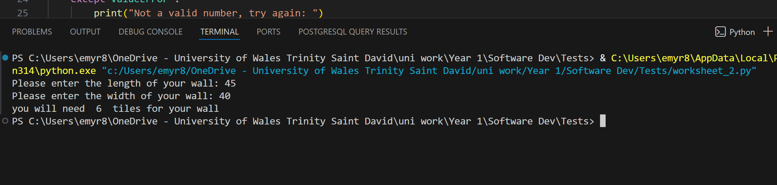
Result: Did the programme behave as expected ie syntactically and logically correct?
YES
If YES, comment on what happened
No issues with any inputs, code works as expected

Continue the rest of the tests below. (Copy and paste a box for each one)

Test:

ii. Enter dimensions of wall: Width 100000 Length 200000

Screenshot(s) of output:
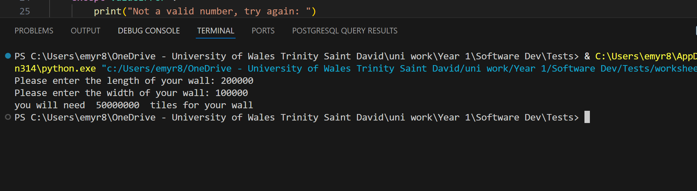
Result: Did the programme behave as expected ie syntactically and logically correct?
NO
If NO, what went wrong?
The code doesn’t validate to make sure the inputs entered are too big as a wall this size would be unrealistic.

Test:
- Enter dimensions of wall: Width -16 Length -20

Screenshot(s) of output:
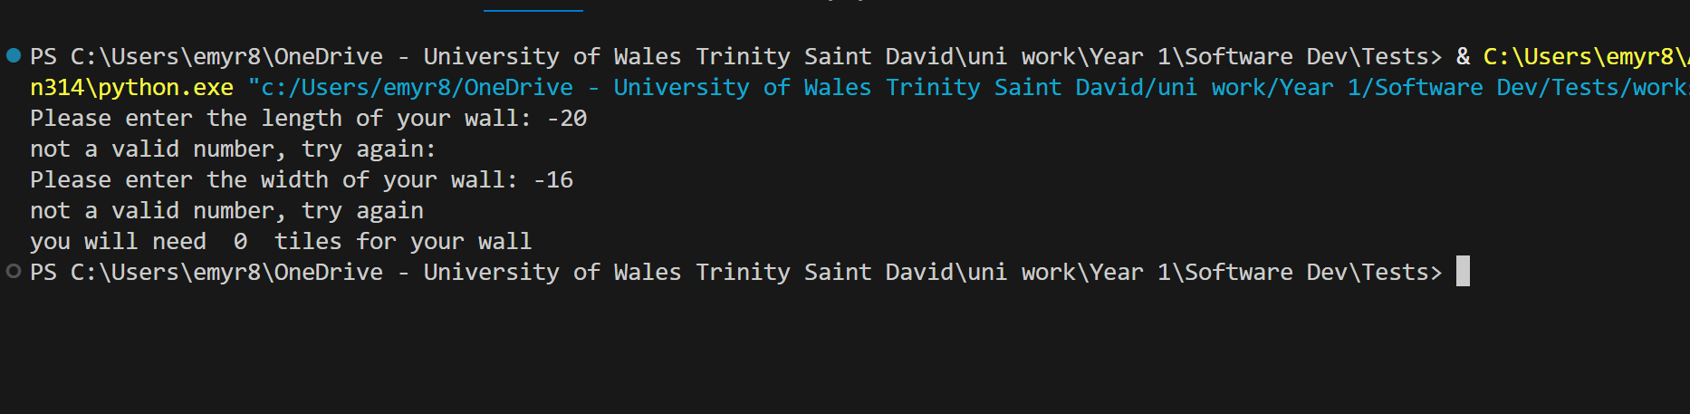
Result: Did the programme behave as expected ie syntactically and logically correct?
NO
If NO, what went wrong?
Although the program does understand that entering -16 and -20 is not valid it does not give the user a chance to input the correct dimensions.

Test:

- Enter dimensions of wall: Width 80 Length 80. The result should be 16 tiles

Screenshot(s) of output:
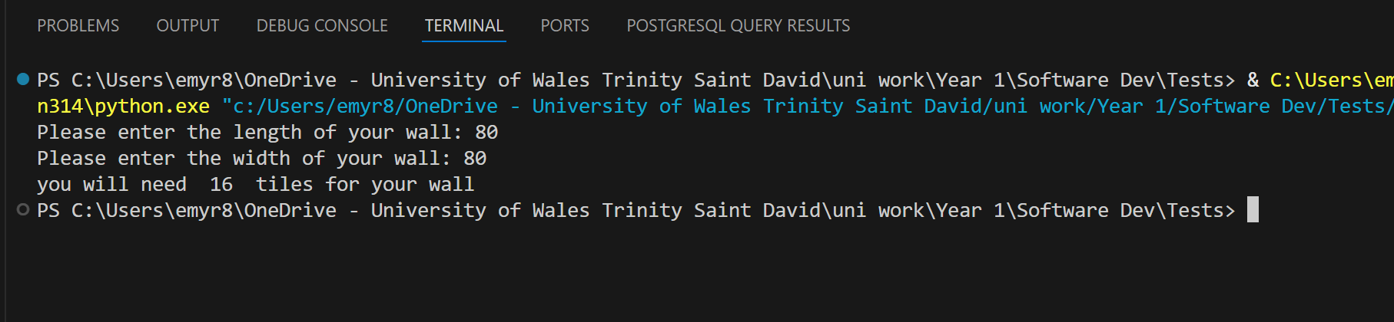
Result: Did the programme behave as expected ie syntactically and logically correct?
YES
If YES, comment on what happened
The code correctly tells the user how many tiles the user needs for the wall.

Test:
- Enter dimension of wall: Width 40 Length 45. The result should be 6 tiles

Screenshot(s) of output:
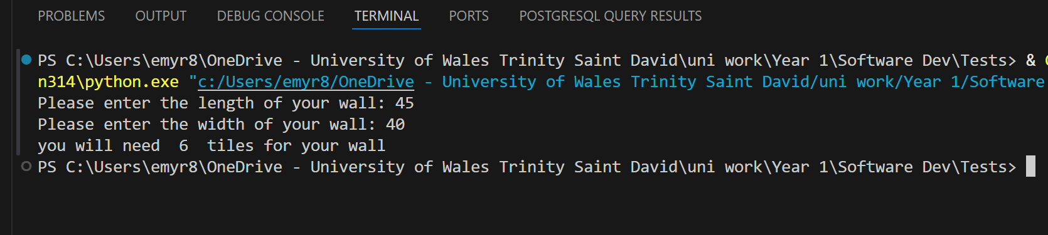
Result: Did the programme behave as expected ie syntactically and logically correct?
YES
If YES, comment on what happened
The code correctly tells the user how many tiles the user needs for the wall.

Test:
- Enter dimensions of wall: Width 85 Length 90. The result should be 25 tiles.

Screenshot(s) of output:
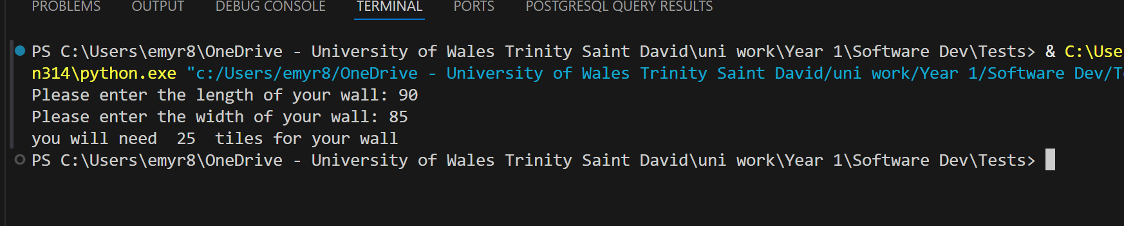
Result: Did the programme behave as expected ie syntactically and logically correct?
YES
If YES, comment on what happened
The code correctly tells the user how many tiles the user needs for the wall.

Test:
- Enter dimensions of wall: Width 15 Length 15. The result should be 1 tile.

Screenshot(s) of output:
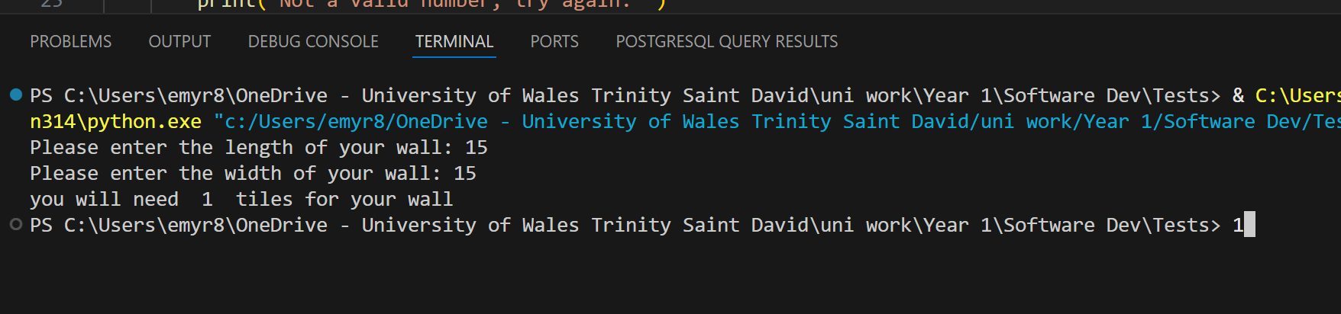
Result: Did the programme behave as expected ie syntactically and logically correct?
YES
If YES, comment on what happened
The code correctly tells the user how many tiles the user needs for the wall.

- Consider the results of the above tests and revisit your code in order to solve any problems discovered at the testing phase. (Note: you may not be able to solve all of them, but solve as many as you can.)

Paste your revised code here:

import math

Tile_Width = 20
Tile_Length = 20
Tile_size = Tile_Length * Tile_Width

flag = 0
while flag == 0:
try:
Wall_length = float(input("Please enter the length of your wall: "))
if Wall_length <= 0 or Wall_length > 1000:
print("Not a valid number (must be between 0 and 1000), try again.")
else:
flag = 1
except ValueError:
print("Not a valid number, try again.")

flag = 0
while flag == 0:
try:
Wall_width = float(input("Please enter the width of your wall: "))
if Wall_width <= 0 or Wall_width > 1000:
print("Not a valid number (must be between 0 and 1000), try again.")
else:
flag = 1
except ValueError:
print("Not a valid number, try again.")

Wall_Tiled_Width = math.ceil(Wall_width / Tile_Width)
Wall_Tilled_length = math.ceil(Wall_length / Tile_Length)

N_tiles = Wall_Tiled_Width * Wall_Tilled_length

print("You will need", N_tiles, "tiles for your wall")

