Student name: Geanina Alina Cotonban
Student ID: 1917121
Lecturer Name: Husam Alharahsheh
Module name: International Business Communications
LCBBL001
ASSIGNMENT 1

Table of Contents
Introduction 3
Introduction to the selected developing country 3
Application of theories of intercultural communication 6
Critical evaluation of cultural sensitivity 9
Different communication barriers 10
Communication strategies and other relevant recommendations to enable the company to succeed in the Indian market 11
Conclusion 13
Reference list 14

Introduction
The respective report is based on international business and communication. When a business wants to or intends to expand their business in a foreign country then it is known as international business. In this context, communication is an important factor as it helps the company in maintaining the intricate business dealing. There also needs intercultural communication training to avoid the cultural barriers and build awareness among the companies employees. For this purpose, the chosen company is Brainlabs which is a small business organisation in the UK. The company is operating under the marketing and PR sector and is powered by data and automation. The chosen country where Brainlabs wants to expand its market is India. In relation to this, the company needs to discuss the topic of international business and communication. The structure will be followed by an introduction to the selected developing country and will apply some relatable theories of international and intercultural communication. Next, it will focus on the critical evaluation of cultural sensitivity and will discuss different communication barriers that can be experienced by the company. At last, the report will be concluded by suggesting some appropriate strategies for effective communication.

Introduction to the selected developing country
The selected country is India where Brainlabs intended to expand its business. In the form of an international business, the respective company is going to operate in the Indian market. India is investing a good amount to drive international business more efficiently. The huge customer market, growing economy and abundant skills and market of India is the factor encouraging the foreign companies to operate their business in this country (Aneez et al., 2019). The scope of the international market in India is in the following sectors; telecommunication, digital marketing, information technology and electronics hardware.
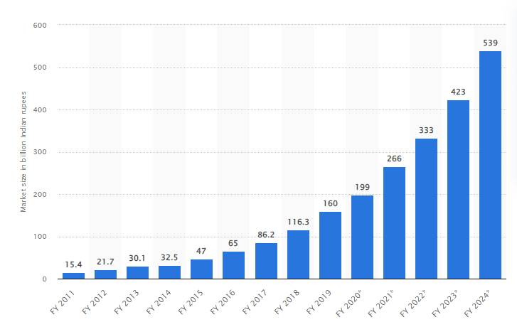
Figure 1: Market size of the digital advertising sector in India
(Source: statista, 2022)
From the above-demonstrated graph, it can be noted that from the year 2020 there is a drastic growth in the digital marketing sector of India (statista, 2022). So, it can be stated that India is a suitable international market for Brainlabs to grow its profit margin. However, after the pandemic, the economical condition of India has become unstable but the digital marketing sector has benefited from the terms and conditions of the Covid-19 protocol. Due to the lockdown, the companies and even the educational institution has shifted their marketing through the online medium which results in a growing digital industry. On the other hand, the present demographic factor-like population is another factor influencing foreign companies to start their business in India.
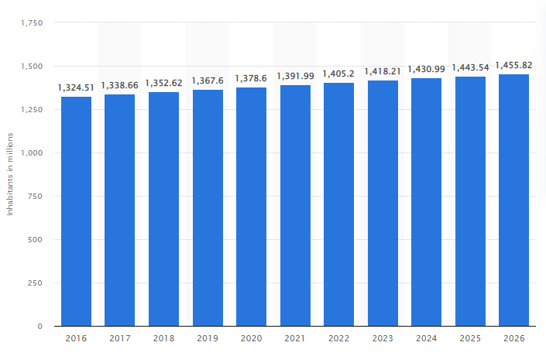
Figure 2: Population in India
(Source: statista, 2022)
The figure shows that India has a growing population from the year 2016 and it is expected that it will be almost 1,455.82 within 2026 (statista, 2022). Therefore it can be stated that India is an appropriate developing international country for business in terms of gaining a huge customer base.
For instance, the technological advancement of India is another advantage for the concerned company. India ranked 46 among all the countries in the “global innovation index (ibef, 2022). In addition, the robust demand, attractive opportunities, policy support and rising policy activity are the supporting factors for Brainlabs in terms of their international business.

Application of theories of intercultural communication
- Hofstede’s Model Of Cultural Dimensions
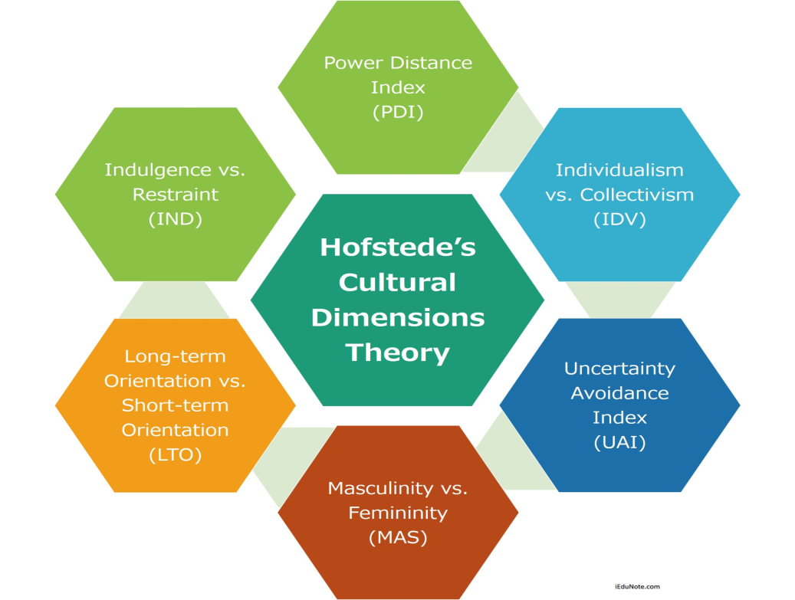
Figure 3: Hofstede’s Model of Cultural Dimensions
(Source: Kaasa, 2021)
Hofstede's model is developed by Geert Hofstede to understand the differences between different cultures across the countries as well as to identify the ways that businesses should usually do across different cultural countries for effective communication. Here to understand the culture of India Brainlabs needs to apply this model. Here the UK and India’s culture will be compared through implementing Hofstede’s Model of Cultural Dimensions. According to this model there are six categories to define culture, these are;

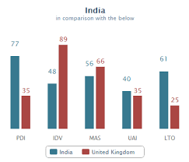
Figure 4: Hofstede’s Model Of Cultural Dimensions of UK and India
(Source: Sonawane, 2021)
Power distance index: UK scored 35 in power distance index while India scored 77 in the power distance dimension which is indicating an appreciation for the hierarchy in Indian society and organisations. In the UK, the dependence on the power holder is low while dependent on the power holder in India and acceptance of unequal rights between the higher and lower power holder, paternalistic leadership style and loyalty of the employees are the factors that highlight the Indian attitude in terms of power distance dimension.
Individualism vs collectivism: In individualism, India has scored 48 which means India has both the collective and individualism culture. Whereas in the UK it is 89 which means the country focused on individualism rather than collective culture. On the collective side, the population of India likes to belong within a larger social framework and within this culture, the individuals are expected to act accordingly with others (Saarikallio et al., 2021). Uncertainty avoidance index: The UK has scored 35 in this index while India's score for uncertainty index is 40 which means the population have a medium to low preference to avoid uncertainty. Therefore both the UK and Indian culture accepts imperfection and it is a country where the tolerance level for unexpected behaviour or things are high. However, the UK is relatively low in this context (Sonawane, 2021). It is the most empowering factor of the country that provides power to the businesses and population (Shin et al., 2020). Therefore, companies like Brainlabs will get flexibility if they can do anything wrong in their business activities.
Masculinity vs femininity: For this index, India's score is 56 and it is considered that it is a masculine society. On the other hand, the UK scored 66 in this index which means the society is relatively improved in terms of facilitating only the masculine society. In both terms of visual display of power and success India is a masculine society where the power is in the hand of men (Sivakumar and Manimekalai, 2021). However, as a developing country, India is now providing the same opportunities to the females also and it will add more value to the country and will help in bringing more foreign business in the country.
Short-term vs long-term orientation: A medium score of 61 in this index indicates a dominant aspect of Indian culture can not be identified. On the contrary, the UK has scored 25 in this particular cultural index. Therefore Uk is a short-term oriented society where the population mainly focuses on quick results in the future. The concept of the Indian population being satisfied with less amount is a hindering factor for the culture that they are focussed on short-term goals over the long-term (Saarikallio et al., 2021)..
Indulgence vs restrain: India has a low score of 26 for the concerned dimension. It means India has a culture of restraint. Therefore the India population has a tendency to criticise others.
- Trompenaars Cultural Dimensions
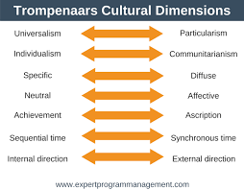
Figure 5: Trompenaars Cultural Dimensions
(Source: Pirlog, 2021)
According to Trompenaars, the individualist culture is associated with the concept of the western world while the communication culture is associated with the non-western nations. Cultures can change rapidly and often change more quickly than organisations can realise. The seven dimensions of this theory are:
Universalism vs particularism: India is considered a strong particularistic society.
Sequential vs Synchronous time: the structure of Indian culture is synchronous time and allows us to do different things at the same time.
Individualism vs communitarianism: India has a communitarian culture with a high influence on family values; they believe in a collective society (Pirlog, 2021)
Neutral vs emotional: Indian people are open-minded about their feelings and happiness and like share their friends and families, which indicates India has an emotional cultural index over a neutral attitude.
Achievement vs ascriptions: Indians value the ascriptions as they have an influence on the caste system.
Internal direction vs external direction: there is an external directional culture among the Indians and shows accommodating behaviours to the situation (Pirlog, 2021)
Specific vs diffuse: India has diffuse culture over the specific culture.

Critical evaluation of cultural sensitivity
In simple words, India is the land of diversity as there can be observed, different cultural people. The major religions of India are Hinduism and Islam and also Buddhism, Christianity, Janis all are lived in India. From the above-demonstrated analysis, it can be known that there is cultural sensitivity among the Indian culture and due to the sensitive issues the businesses are also bonded within some policies and laws (Kawaguchi-Suzuki et al., 2019). Before doing business in India it is important to consider some specific factors like respecting equity, understanding the language of business, building long term relationships with different cultural customers and making the right first impression. As India is a multilingual country with different cultures, businesses are rooted in establishing long-term relationships. There is a specifically hierarchical relationship between the higher authorities and lower authorised business stakeholders in India (Kawaguchi-Suzuki et al., 2019). For example, during a meeting time, the most senior person should be greeted by others as per the Indian culture and business ethics. Some more Indian culture in the context of business is that during exchanging the business card the individuals should always receive the business card through their right hand.
For instance, English is the most used language for business purposes and many locals are used to this language however the national language of India is Hindi. As it was previously demonstrated that Indian people think emotionally and their tolerance level is high they tend to base business decisions on trust and good feelings (Kawaguchi-Suzuki et al., 2019). The Indian people will give full effort to build a commercial relationship with Brainlabs. Therefore, after observing the cultural sensitivity it can be stated that Brainlabs will get many advantages if they expand their business in an international developing country like India.

Different communication barriers
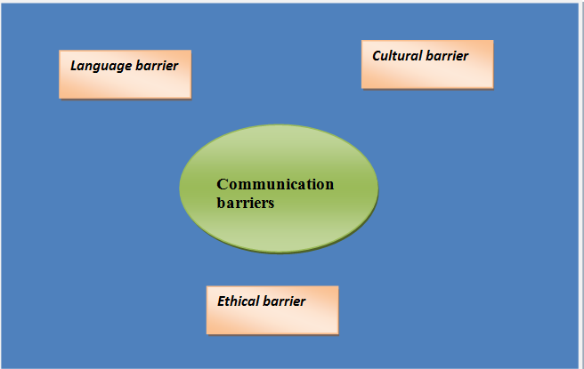
Figure 6: Different communication barriers
(Source: Created by learner)

Language barrier: Language is a big issue in the context of international business and communication. The majority of Indians know Hindi but in English, many of them find it hard to speak (Sharma and Dewangan, 2018). So, it can be a major barrier for Brainlabs when they come to do business in this country. India is a multilingual country where numerous cultural people live and they speak in different languages. In terms of gaining strong communication with the commercial sector of India may the concerned UK company will have some potential issues. As their targeted customers will be Indians, they need employees who are able to understand Indian languages as well as build strong relationships with their potential customers. In this context, it can be stated that due to a language barrier the company can face many issues while they will come to the concerned country for an international business purpose.
Cultural barrier: As it was previously discussed that India is a country with different cultural people it is obvious that Brainlabs will have to face communication barriers with the customers as they have to deal with all cultural people. On the other hand, different cultures mean different norms, rituals and different preferences (Sharma and Dewangan, 2018). Considering all these factors Brainlabs have to come to this country for their business purposes. Maybe for fulfilling the requirements of different people the company has to invest more as well as need a more efficient workforce which has experience or insight knowledge about the Indian market and customers.
Ethical barrier: Every country has its own ethics and laws that should be abided by all to maintain the culture and tradition. Although the country already is in commercial relationships with many international countries, the business ethics between UK and India may create communication barriers for Brainlabs. Some of the ethical issues in international business are outsourcing, workplace diversity, child labour, equal opportunity, political issues, human rights, corruption, bribery and so on. Infrastructure is another ethical issue of the Indian market (Sharma and Dewangan, 2018). All these factors may lead to unexpected negative consequences of unethical activities that can impact the business of Brainlabs negatively.

Communication strategies and other relevant recommendations to enable the company to succeed in the Indian market
First of all, Brainlabs need to make an effective team for their international business in India and then considering the cultural sensitivity and communication barriers they are required to provide a program or training where they will train them and will enhance their potential so that they can successfully run their business in the Indian market. Some communication strategies by which they can remove the barriers are;
Proper training about ethical risks: By providing proper training to the staff of Brainlabs who will manage their business in the Indian market, the company can mitigate the issues. Through the training, the company can make the workforce efficient in identifying, mitigating and transforming ethical risks and improving their organisational competencies as well as developing the identity of Brainlabs in the Indian market.
Promoting the importance of cultural diversity: In order to create awareness about cultural sensitivity the companies like Brainlabs need to promote the importance of cultural diversity among their employees to whom they are going to hand over the activities of the business for the Indian market. On the other hand, the company needs to know the preferences of their potential customers to whom they want to sell their service or products (Khelifa et al., 2021). For this purpose, they can provide employee diversity training in their workplace.
Lead an open discussion about the norms and shared values: the team created for the international business purpose should know the norms and shared values of the Indian culture as well as their company. It will help the team to understand the preferences of different cultures as well as the organisational objectives of Brainlabs as to why they are going to operate in the Indian market. The main objective of the company is to gain a huge customer base and to achieve a targeted profit margin so that they can build a strong relationship with India in terms of international business.
Trying to learn to communicate in the local language: Knowing the language and understanding and respecting the linguistic values of the target market can significantly help in communicating fluently with the customers. A great way to implement that is by hiring a proper interpreter to help in the communication. An interpreter will help the company in learning the local language as well as prevent any sort of miscommunication (Khelifa et al., 2021). Thus the company should first start by searching and hiring an efficient interpreter in the local area. Another method of learning the language is by using technical methods such as Google Translate. Learning the language properly will show the efforts the company has put in order to gain the respect of the people which in turn will help the company reach many more heights in the upcoming days.

Conclusion
From the above discussion, it can be stated that international business and communication is not an easy process and the companies need to practice more before going to an international market. The chosen company Brainlabs wants to grow their business in India as an international market but to do so they found that there are many obstacles in international communication. The above-stated theories of intercultural communication show that India is a multilingual and multicultural country and it is somehow their advantages or on the other hand are the barriers to communication in the business context. So, there are some recommendations to mitigate those barriers and to help the company in their international business and communication.

Reference list
Aneez, Z., T Neyazi, A., Kalogeropoulos, A. and Nielsen, R.K., 2019. India digital news report.
ibef.org 2022. Science and Technology Development in India[online] Available at: <https://www.ibef.org/industry/science-and-technology.aspx#:~:text=India%20now%20ranks%2046%20among,till%20they%20become%20commercial%20ventures> [Accessed on: 12th March, 2022]
Kaasa, A., 2021. Merging hofstede, schwartz, and inglehart into a single system. Journal of cross-cultural psychology, 52(4), pp.339-353.
Kawaguchi-Suzuki, M., Hogue, M.D., Khanfar, N.M., Lahoz, M.R., Law, M.G., Parekh, J., Zairina, E., Hong, J., Robles, Y.R. and Van Thang, V., 2019. Cultural sensitivity and global pharmacy engagement in Asia: India, Indonesia, Malaysia, Philippines, and Vietnam. American journal of pharmaceutical education, 83(4).
Khelifa, R., Amano, T. and Nuñez, M.A., 2021. A solution for breaking the language barrier. Trends in ecology & evolution.
Mamatha, S.V. and Geetanjali, P., 2020. Founder Leaders and Organization Culture: A Comparative Study on Indian and American Founder Leaders Based on Schein’s Model of Organizational Culture. IIM Kozhikode Society & Management Review, 9(1), pp.23-33.
Pîrlog, A., 2021. Intercultural profile of managers in the republic of Moldova in the context of the trompenaars and hampden-turner theory of cultural dimensions. Economie şi Sociologie, (2), pp.70-84.

Pirlog, A., 2021. National Cultural Profile in the Republic of Moldova According Hofstede and Trompenaars-Hampden-Turner Models. Revista de Management Comparat International, 22(4), pp.450-457.
Pirlog, A., 2021. National Cultural Profile in the Republic of Moldova According Hofstede and Trompenaars-Hampden-Turner Models. Revista de Management Comparat International, 22(4), pp.450-457.
Saarikallio, S., Alluri, V., Maksimainen, J. and Toiviainen, P., 2021. Emotions of music listening in Finland and in india: comparison of an individualistic and a collectivistic culture. Psychology of Music, 49(4), pp.989-1005.
Sharma, A. and Dewangan, R.L., 2018. Indian socio-cultural conception of wisdom: Does it follow universal understanding?. Journal of Psychology and Behavioral Science, 6(1), pp.5-19.
Shin, L.J., Armenta, C.N., Kamble, S.V., Chang, S.L., Wu, H.Y. and Lyubomirsky, S., 2020. Gratitude in collectivist and individualist cultures. The Journal of Positive Psychology, 15(5), pp.598-604.
Sivakumar, I. and Manimekalai, K., 2021. Masculinity and Challenges for Women in Indian Culture. Journal of International Women's Studies, 22(5), pp.427-436.
Sonawane, U., 2021. The Impact of Customers' Expectations on the Cross-cultural Marketing in the Hotel Hospitality Industry: A Comparative Study of the UK and India (Doctoral dissertation, Cardiff Metropolitan University).
statista.com. 2022. India: Estimated total population from 2016 to 2026 [online] Available at: <https://www.statista.com/statistics/263766/total-population-of-india/> [Accessed on: 12th March, 2022]
statista.com. 2022. The market size of the digital advertising industry across India from the financial year 2011 to 2020, with estimates until 2024. [online] Available at: <https://www.statista.com/statistics/795262/india-market-size-of-digital-advertising-industry/> [Accessed on: 12th March, 2022]

