

Student Name: Sahab Uddin
Student ID: 2416538

Programme: Master of Business Administration
Module & Code: International Business Concepts (LCMB7034)

Company Name: Unilever
Country: Operation in India

Word: 4963

Lecturer: Chung Lai Johnny Wan
Submission Deadline: 21/11/2025

Table of Contents
1. Introduction 1
2. Benefits and Challenges of Unilever Operations in India 2
2.1 Unilever as Multinational Corporation (MNC) 2
2.2 Nature of Unilever’s Global Operations 2
2.3 Entry Modes of Unilever Operations in India 4
2.4 Benefits of Unilever Operations in India 5
2.5 Challenges of Unilever Operations in India 5
3. Impact of OLI Factors on Market Entry Mode 6
3.1 Ownership Advantages 6
3.2 Location Advantages (Home vs. Emerging Economy) 7
3.3 Internalisation Advantages 8
3.4 OLI Framework Applied to Unilever and India 9
4. Cultural Differences and Their Impact 10
4.1 Introduction 10
4.2 Cultural Framework: Hofstede’s Dimensions 11
4.3 Impact on Market Entry Strategy 13
4.4 Impact on Organisational Culture and Management Practices 13
4.5 Impact on Marketing and Consumer Behaviour 14
4.6 Impact on Potential for Success 15
5. Recommendations for Adjustments in Standard Operating Procedures (SOPs) 16
5.1 Introduction 16
5.2 SOP Adjustment 1: Localisation and Decentralisation of decision-making 16
5.3 SOP Adjustment 2: Cultural Integration in Human Resource Management 17
5.4 SOP Adjustment 3: Sustainability-Driven Supply Chain Adaptation 19
6. Conclusion 20
7. References 21

1. Introduction
This report will analyse the Unilever PLC as a major multinational company. It is a global corporation that has business in over 190 countries (Unilever, 2024). It offers a product lineup comprising of food, beauty, personal care and household goods (Euromonitor, 2022). More than fifty percent of the total revenue of Unilever is generated in emerging markets like India and Indonesia (Statista, 2023).
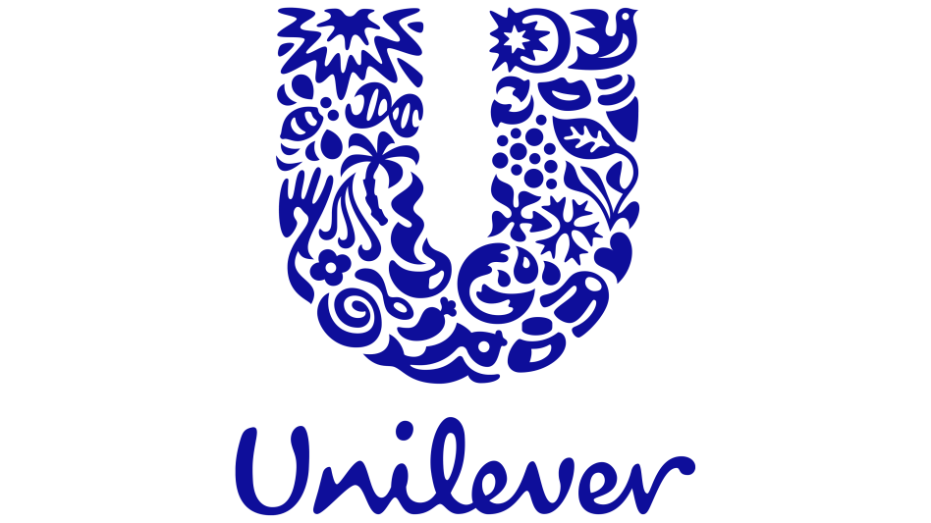
Source: (Unilever, 2024)
This report is written to provide an analysis of global operations of Unilever and assess advantages and disadvantages of the global expansion. It uses the OLI framework to evaluate the market entry strategies and the operations of Unilever in the emerging economies. Cultural differences between the United Kingdom and India are also discussed to comprehend about their effects on the success of business. Lastly, suggestions are made to optimise Unilever Standard Operating Procedures and maintain the expansion in foreign markets (Unilever, 2024).

2. Benefits and Challenges of Unilever Operations in India

2.1 Unilever as Multinational Corporation (MNC)
A multinational corporation (MNC) is a business entity that conducts and regulates business operations in a country or more than one country with a central headquarters (Deloitte, 2021). These companies put capital investment directly in overseas business and have a unified management structure to provide worldwide effectiveness and local reactiveness (Johnson et al., 2020).
Why Unilever Qualifies as an MNC?
Unilever can be considered an MNC due to the fact that it possesses and regulates subsidiaries, manufacturing plants, and supply chains in more than 190 countries (Unilever, 2024). It has two headquarters in London and Rotterdam, which handle activities worldwide, and subsidiaries such as Hindustan Unilever Limited in India operate locally (Unilever, 2023). This transnational nature of the company enables it to achieve global standardisation and locally adapt to the market. This hybrid organisation allows international knowledge sharing, effectiveness, and innovation (KPMG, 2024).

2.2 Nature of Unilever’s Global Operations
Unilever is operating in all major areas such as Europe, Asia, Africa, and Latin America (Unilever, 2024). It has a global distribution and production network and its products reach out to more than 3.4 billion consumers on a daily basis. More than 55 percent of its turnover is based on emerging markets India, Brazil, and Indonesia (Statista, 2023).
Unilever spends a lot of money to develop new innovations and ensure sustainability through research and development (Euromonitor, 2022). The UK, Netherlands, India and China have global research and development centres that concentrate on the development of products that fit the local climates, local incomes and local culture requirements. As an example, its India R&D centre customises formulations to suit local skin characteristics and water conditions.
The sourcing policy of Unilever is based on ethical sourcing and local supplier relationships. The company has more than 60,000 suppliers which operate globally and supports sustainable agriculture by its Partner to Win programme (Unilever, 2024). In India, it procures palm oil, tea, and dairy products on a local basis and this assists the smallholder farmers and lowers transportation expenses.
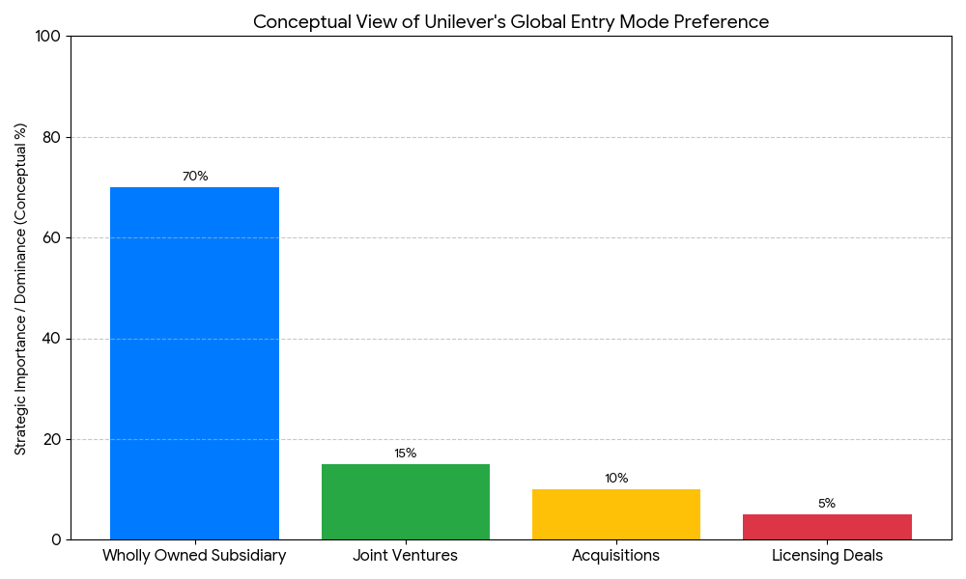
Source: Unilever, 2024
The chart gives a conceptual illustration of the strategic preference of the various modes of global market entry by Unilever. As it clearly shows, it dramatically favors the Wholly Owned Subsidiary model (which is conceptually represented as the domination of 70 percent), with the help of which Unilever retains the maximum control over the quality of products, brand image, and strategy in the international operations. Subsidiary model is supported by Joint Ventures (15%), Acquisitions (10%), which are usually used to negotiate markets having regulatory restrictions, intense domestic competition, or local knowledge. Such visual mixture proves the flexible but control-focused character of the diverse international strategy of Unilever and its global risk management.
Unilever has over 300 manufacturing plants spread over the world, utilising the concept of regional manufacture to maximise logistics and responsiveness (Unilever, 2023). In India, both domestic and export markets are supplied by factories in different states like Maharashtra and Tamil Nadu. Local manufacturing would allow quicker delivery, creation of employment, and coordination to the government programmes such as Make in India (World Bank, 2024)
In emerging economies, distribution efficiency is the key to the success of Unilever. The firm also has a multi-level logistics network that incorporates major distributors and minor rural stores (Deloitte, 2021). In India, the Unilever project, Shakti, gives rural entrepreneurs the courage to sell the products to the remote villages to enhance the last-mile delivery and product brand loyalty.
Unilever aligns its marketing campaign with the local culture and consumer preference. Some of the brands such as Lifebuoy, Surf Excel use hygiene and sustainability social messages in India. The brand consistency of the globe is ensured by common corporate values and unified digital marketing solutions (KPMG, 2024).
Unilever funds its business with an equal combination of equity, reinvested earnings and world capital markets. With centralised treasury management, there is control of risks and financial efficiency (Unilever, 2024). The investments are also channelled strategically to the emerging markets which have high growth rates and are experiencing increased incomes that create greater demand of consumer goods.

2.3 Entry Modes of Unilever Operations in India
Unilever has various market-entry strategies, such as wholly owned dreams, joint ventures, acquisitions, and licencing deals (Euromonitor, 2022). The choice of these modes depends on the potential in the market, the law as well as the competition.
Unilever came to India by acquiring Lever Brothers India Ltd later on as Hindustan Unilever Limited, which is still a majority-owned subsidiary (Unilever, 2023). It first penetrated China in joint ventures to exchange local experience. It has been acquiring local brands and distribution networks in Africa and Latin America.
Unilever predominates its international operations with the model of a wholly owned subsidiary as they provide control of the quality of the product, brands image, and strategy (Unilever, 2024). This should be supplemented by joint ventures and acquisitions in markets that have regulatory barriers or have strong local competitors. This is a versatile blend of modes of entry that empowers Unilever in the face of global expansion and risk management.

2.4 Benefits of Unilever Operations in India
The contribution of up-and-coming economies like India to the stability of the total revenues is also immense (Statista, 2023). The economies of scale in Unilever are the result of centralised production planning, global purchase, and common R&D (Deloitte, 2021). Economies of scopes come about due to exploiting the marketing, logistic and distribution channels in a variety of product lines.
Internationalisation facilitates the availability of local raw materials and skilled labour at Unilever. In India, they work with agricultural farmers to increase the supply of resources, and with universities to develop talents (Unilever, 2023).
The international business contributes to the brand equity and reputation of Unilever. Sustainable and social responsibility are some of the corporate values that are maintained consistently to strengthen consumer confidence in the markets (KPMG, 2024). The effectiveness of cross-market knowledge transfer is seen in the success of such global brands as Dove and Lifebuoy.

2.5 Challenges of Unilever Operations in India
Unilever has cultural issues in coping with global strategies and local norms. Performance may be influenced by the differences in consumer behaviour and workplace culture (Hofstede Insights, 2023). Laws Regulatory differences such as product safety and advertising legislation need continuous adjustment.
The coordination is difficult due to running large networks of suppliers and logistics. Supply chains can be interfered with by natural disasters, geopolitical tensions, or pandemics and increase costs (Deloitte, 2021). Sustainability and transparency only complicate the situation even more.
The currency fluctuations affect the profits and profit margins of Unilever in the world. The consumer purchasing power can be influenced by economic volatility in emerging markets (Statista, 2023). Hedging is one of the methods that the firm applies to reduce such financial risks.
Sustainability is also an opportunity and a challenge to Unilever. The company needs to minimise plastic waste, carbon emissions, and sourcing unethically (Unilever, 2024). Programmes such as the Sustainable Living plan mitigate these problems although their application in various jurisdictions is also a challenge.
Summary
The global activities of Unilever show how a multinational company can achieve a global efficiency and local responsiveness. The success across the globe is pegged on its diversified value chain, flexible modes of entry, and robust sustainability agenda. Nevertheless, to deal with cultural diversity, regulatory disparities, and operational complexity, one will need to work continuously on innovation and ethical leadership.

3. Impact of OLI Factors on Market Entry Mode
The OLI framework, which was invented by John Dunning, results in the reasons and ways in which multinational enterprises (MNEs) undertake international production in three dimensions namely, Ownership, Location, and Internalisation advantages. Using this framework can explain why Unilever decided to venture in and conduct business in the Indian market.

3.1 Ownership Advantages
Ownership benefits are firm-specific assets like technology, brand reputation, management skills, and innovation, which make a firm have competitive strength in the global markets (Johnson et al., 2020). The benefits of Unilever ownership lie in the fact that it has powerful global brand portfolio, huge R&D process and management system.
Unilever has a wide range of products, such as Dove, Lifebuoy, and Surf Excel; these are household products that lead to brand trust and customer loyalty on a global scale (Unilever, 2024). Such brand equity is one of the major intangible assets that enhance its competitive advantage in the emerging markets such as India. Furthermore, Unilever has highly developed marketing and consumer research systems that enable the company to know and react to various consumer preferences in an effective manner (Euromonitor, 2022).
The other type of ownership advantage is its technological and organisational expertise. Unilever spends a lot of money on digital transformation and improvement of supply chains to achieve greater efficiency in operations (KPMG, 2024). Its UK and Indian R&D centres are centred on sustainable product innovation which has strengthened its image of a responsible and innovative corporation. It also has an established corporate culture of sustainability and social responsibility, which enhances its legitimacy in the new markets where ethical consumption is on the rise (Unilever, 2023).
All these ownership benefits make Unilever to have control over quality, consistency through subsidiaries, and management of brand image in complicated markets such as India.

3.2 Location Advantages (Home vs. Emerging Economy)
The location advantages are the reason why a company will invest in a particular foreign state instead of just manufacturing in the home country (Dunning, 1993). In the case of Unilever, India has strong location benefits based on its high population of consumers, economic development and good institutional environment.
The Indian population is already over 1.4 billion, which gives the country an enormous consumer goods market (Statista, 2023). The rapid urbanisation, escalating disposable income and the increasing middle income population have provided a long-term need of personal care and household products. The government is also interested in industrialisation and the Make in India programmes, which offer incentives to foreign investments in the form of tax incentives and better infrastructure (Deloitte, 2021).
Cost efficiency and availability of labour are other important location advantages. India has a young and educated labour force at relatively lower labour costs when compared to the developed markets. This renders India desirable in terms of manufacturing and research and development processes. The HUL is a subsidiary of Unilever in India that enjoys the advantage of local supply networks that lower transportation and production expenses (Unilever, 2024).
The location advantage of India is also increased by cultural aspects. The varied inclinations among the consumers promote product innovation and localisation. To illustrate, HUL designs products which meet Indian requirements like Fair and Lovely (now Lifebuoy soaps) and Fair and Lovely soaps to suit local climatic and water conditions.

3.3 Internalisation Advantages
The internalisation advantages describe why companies strengthen their foreign subsidiaries as opposed to licencing or outsourcing the companies to other independent companies (Dunning, 1993). In the case of Unilever, internalisation is more effective in guaranteeing higher control of its brand image, intellectual property, and production standards.
Unilever is able to avoid the issue of opportunist behaviour of its partners by holding majority stakes in Hindustan Unilever Limited (Unilever, 2023). It keeps its strategic decisions, marketing policies as well as distribution structures under control and its brand remains intact. Internalisation enables the firm to experience the entire value of the proprietary technology, marketing expertise, and management systems without being leaked to the rivalry (Johnson et al., 2020).
Shared learning is also an advantage to Unilever in its network of the world. Internalisation enhances information sharing between subsidiaries enabling innovations in India to drive global strategy. As an example, the distribution model of Unilever, called Shakti, which was created in rural India has been copied to other developing markets such as Bangladesh and Nigeria (Deloitte, 2021).
Also, internalisation fosters other functional coordination such as supply chain, marketing and research and development. Such a fit allows Unilever to realise the economies of scale, but customise its strategy to the local consumer behaviour. In this way, complete control via a subsidiary offers strategic control and operational effectiveness.

3.4 OLI Framework Applied to Unilever and India
The integration of ownership and location and internalisation benefits can be seen in the market entry and continued operations at Unilever in India. The ownership of the global brands, marketing experience and innovation that was sustainably oriented enabled the company to develop a good competitive positioning in India (Unilever, 2024). Its choice of location was based on the size of the market in India, costs and the increased consumer demand. In the meantime, internalisation with wholly owned subsidiary of Hindustan Unilever Limited guaranteed the quality of its brands and consistency of operations.
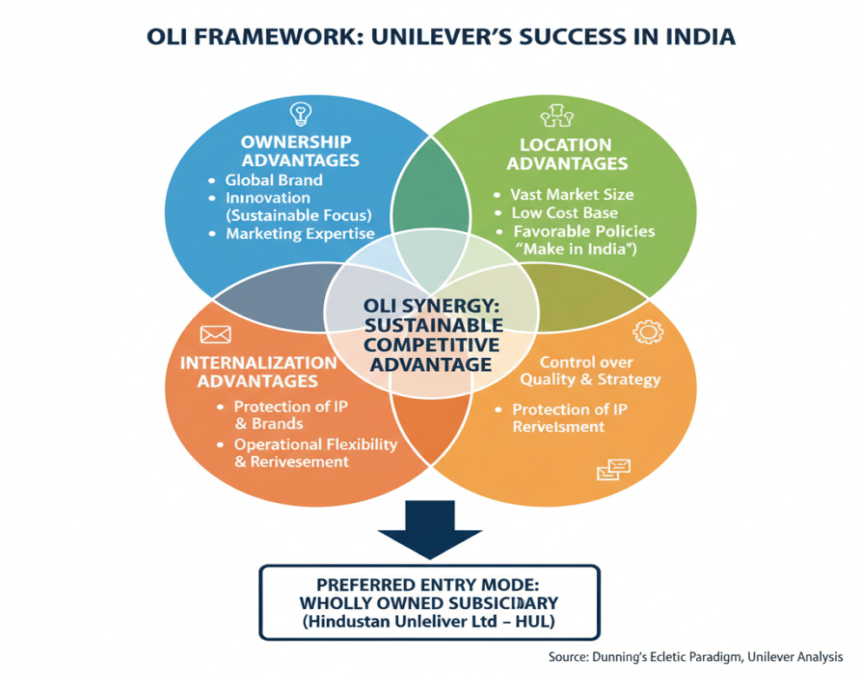
Source: Unilever, 2024
This combination of OLI factors favors a monopoly mode of entry of wholly owned subsidiary as opposed to licensing or franchising. This ownership gives the ability to be innovative, fit the culture of the area, and be able to adjust the products effectively. Indicatively, to accommodate the local purchasing behavior, Unilever adopted smaller pack sizes and low pricing strategies in India. Subsidiary model also facilitates ability of reinvestment of profits in the Indian economy, and in line with the national development priorities.
In general, the OLI framework is useful in describing the successful integration of Unilever in the Indian consumer goods market. Its proprietary capabilities, advantages of local markets, and direct control of its operations have synergy that gives sustainable competitive advantage. Nonetheless, the continued success is pegged on how Unilever will be able to keep changing with the ever-changing socio-economic and regulatory landscape in India.
Summary
The example of Unilever expansion into India can be explained through the strategy of the OLI paradigm. The benefits of ownership like brand strength and research and development capability enable the firm to compete at the international level. The benefits of location in India include high consumer base, low costs and favorable policies, which prepare a good ground on investment.

4. Cultural Differences and Their Impact

4.1 Introduction
The strategies of multinational corporations working across the borders are highly influenced by cultural factors. In the case of Unilever, managing and comprehending cultural differences between the home country, which is the United Kingdom, and new markets like India, is a key to success of the company in an international context. Culture shapes how consumers make their choices, how managers operate and how they communicate, which has an impact on the entry modes and performance of the operations (Hofstede Insights, 2023).

4.2 Cultural Framework: Hofstede’s Dimensions
According to Hofstede, six cultural dimensions, including power distance, individualism, masculinity, uncertainty avoidance, long-term orientation, and indulgence, can be used to identify differences in behavioural and managerial differences among nations (Hofstede, 2023). Using UK and India as the comparative countries based on these dimensions can serve as a good understanding of the international strategy of Unilever.
Dimension | United Kingdom Score | India Score | Key Implication for Unilever
Power Distance | 35 | 77 | Indian workplaces accept hierarchy; Unilever must use structured authority and clear reporting lines.
Individualism vs Collectivism | 89 | 48 | India’s collectivism requires community-focused marketing; UK values individual expression.
Masculinity vs Femininity | 66 | 56 | Both value achievement; Unilever should highlight success and social recognition in advertising.
Uncertainty Avoidance | 35 | 40 | Both tolerate ambiguity; flexibility supports product innovation and experimentation.
Long-Term Orientation | 51 | 61 | India favours long-term growth; Unilever invests patiently in rural market development.
Indulgence vs Restraint | 69 | 26 | UK consumers seek enjoyment; Indian consumers emphasise savings.
(Source: Hofstede Insights, 2023)
This comparison shows that India has higher power distance and lower indulgence than the UK, signalling the need for Unilever to maintain structured leadership and affordability-driven marketing. In contrast, similar uncertainty-avoidance levels allow the company to innovate freely in both markets.
Cultural comparison
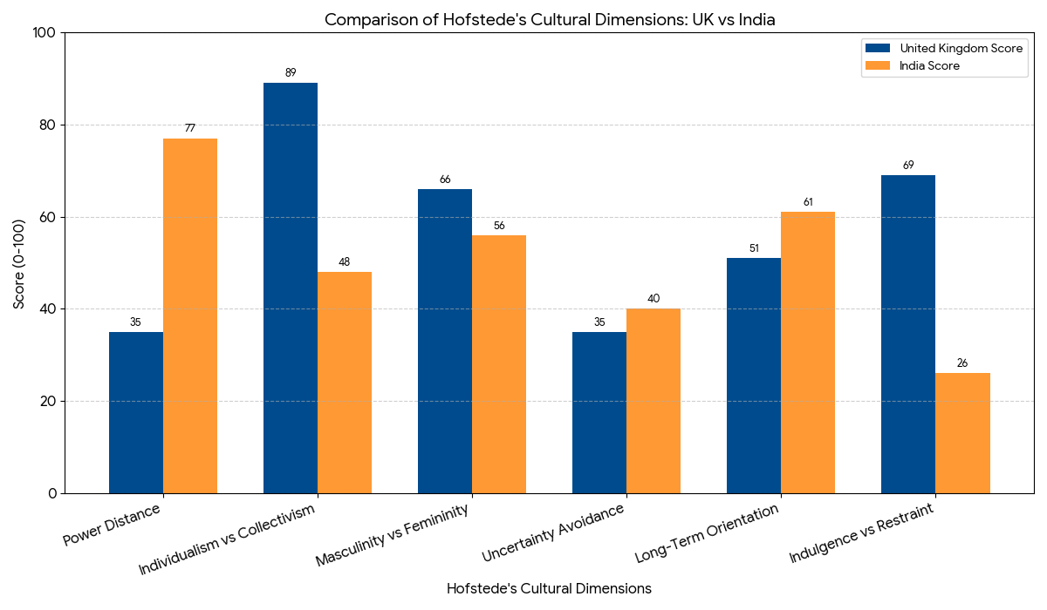
Source: Hofstede Insights, 2023
The graph is the high cultural disparity between the UK and India along the six dimensions of Hofstede which is important to the international strategy of Unilever. The chart shows that Power Distance (77 vs. 35) and Collectivist (48 vs. 89) is much higher in India, requiring structuring, hierarchical manager style and community centered marketing. Moreover, the UK is very Indulgent (69 vs. 26 on India), this means that Unilever needs to emphasize on enjoyment in the UK but on practicality and savings among the Indian consumers. On the other hand, the associated low Uncertainty Avoidance scores (35 and 40) in the two countries allow Unilever to be flexible and free to innovate in both markets.

4.3 Impact on Market Entry Strategy
In India, cultural differences are also very influential concerns in the selection of entry mode and localisation strategy used by Unilever. Having a collectivist and hierarchical culture, Unilever implemented a subsidiary model under Hindustan Unilever Limited that allows being very close to local managers and policymakers (Unilever, 2023). This form of ownership enables cultural adjustment and responsiveness and not strictness that would otherwise have been the case with direct control at the UK headquarters.
The company also applied the localised management technique whereby Indian executives who understand the cultural norms and market behaviors were engaged. It will increase the trust of the stakeholders and increase the legitimacy of the firm in the local environment (Deloitte, 2021). More than that, the marketing campaigns by Unilever in India have the local celebrities and storeys that appeal to the Indian values, including family, hygiene, and aspiration.
The cultural adaptation is also implemented in the product strategy of Unilever. The company changes formulations to fit the local requirements like water hardness or weather conditions and provides smaller packaging options to meet the requirements of consumers with lower incomes (KPMG, 2024). This is an appreciation of the collective buying behavior of the Indians and cultural focus on savings.
Therefore, the cultural difference between the UK and India influenced the choice of Unilever to internalise its operations into a local subsidiary and flexible and localised market strategies that are sensitive to the Indian social norms.

4.4 Impact on Organisational Culture and Management Practices
The British corporate culture of Unilever focuses on innovation, interpersonal communication, and individual performance (Unilever, 2024). Nevertheless, the employment of employees in India must be sensitive to the hierarchical demands and group identified motivation. Leadership in India is also linked to power and paternalism, so UK managers would choose participative leadership styles (Hofstede Insights, 2023).
In order to fill the gaps, Unilever is fostering a hybrid culture that is a combination of global corporate values and local cultures. The company provides cross cultural training and leadership training programmes to employees and managers. This will guarantee proper communication and minimise the misconceptions between the UK and Indian teams (Deloitte, 2021).
The engagement strategies of the employees are also customised. As an example, HUL rewards group performance and offers non-discriminatory benefits in accordance with the Indian social values. The practices enhance employee retention and commitment to the organisation. In addition, the area of diversity and inclusion is presented differently: the UK branch is more concerned with gender equality and inclusion of LGBTQ+, whereas HUL is less concerned with gender inequality, more focused on women empowerment and community development, which is more oriented to local socio-cultural priorities (Unilever, 2023).

4.5 Impact on Marketing and Consumer Behaviour
The consumer marketing strategy of Unilever is also affected by cultural differences, as there are differences between the UK and India. In UK, advertising focuses on individuality, self-care and convenience, which are messages that are close to high individualism consumers. Indicatively, the campaigns in the UK by dove show self-confidence and personal empowerment.
Conversely, in Indian campaigns emotional and family-oriented storytelling is employed. The advertisements used by Lifebuoy in India emphasis the idea of hygiene being the responsibility of the family and not a personal obligation. In the same way, the campaign by Surf Excel, Daag Acche Hain (Dirt is Good), links cleanliness to moral and emotional virtues and appeals to the collective and community values (Euromonitor, 2022).
There are also dissimilarities in pricing tactics. The British consumers are more attracted towards high quality and environmentally-friendly products whereas the Indian consumers are more attracted towards goods with low prices as they have less disposable income. Unilever will respond by downsizing their products such as sachets, smaller packages to make the products affordable to low-income earners in rural and urban areas.
In general, the localisation of the marketing of Unilever is also based on the thorough knowledge of the culture, which ensures long-term success in the Indian heterogeneous market.

4.6 Impact on Potential for Success
One of the reasons why the company of Unilever has remained successful in India has been cultural intelligence. Its local strategy in managing and marketing as well as product development makes it highly brand loyal and socially acceptable (KPMG, 2024). The sensitivity of the company to the cultural values, social stratifications, and consumer desires allows the company to fit in the ever-changing Indian market.
Besides, the capability of Unilever to combine global sustainability objectives with regional cultural stores promotes its image. The hygiene, empowerment and community welfare campaigns reflect the Indian cultural and ethical systems. Such initiatives do not only enhance the brand reputation, but also meet the objectives of national development.
Nevertheless, there are still cultural challenges in India as a country. The regional differences in the language, religion, and consumer behavior demand continuous adaptation and decentralisation of the decision-making. It is essential to keep cultural coherence when there is diversity of such magnitude and this requires strong leadership and inclusion practices in organisational practices.
Nevertheless, the issues have not impeded the success of Unilever because the company is the most reliable brand of FMCG in India due to its strategic localisation and cultural flexibility (Statista, 2023). Its effective performance proves that the ability to properly address cultural differences may help to turn the possible threats into the long-term competitive advantages.
The international strategy of Unilever is largely affected by cultural differences between the UK and India. Hierarchy, collectivist values and price sensitive consumer behaviour have led to successful market entry and success within the company. Unilever is able to match its global competencies with local demands through localised management, localised marketing, which is culturally sensitive and through a wholly owned subsidiary. Overall, Unilever’s case illustrates how cultural intelligence enhances global competitiveness and ensures resilience in emerging markets.

5. Recommendations for Adjustments in Standard Operating Procedures (SOPs)

5.1 Introduction
The success of Unilever in India is a testament of its capacity to fit the global standards to the local situations. Nevertheless, results of the OLI and cultural analyses show that in some aspects, the Standard Operating Procedures (SOPs) of Unilever can be improved to better align with the Indian socio-economic and cultural context. In this part, three significant changes in SOP are suggested that will support the performance of Unilever in India:
1. Localisation and decentralisation of decision-making,
2. Cultural integration in human resource management, and
3. Sustainability-driven supply chain adaptation.
All the recommendations refer to the issues of ownership, location and internalisation (OLI factors) and cultural differences between the UK and India outlined according to Hofstede.

5.2 SOP Adjustment 1: Localisation and Decentralisation of decision-making
The global approach of Unilever is based on efficiency and brand consistency, but as the analysis in Section 3 indicated, it should be more localised in order to take the advantage of the Indian market.
The high power distance and collectivism culture characteristic of India (Hofstede Insights, 2023) imply that a balance must exist between global control and good local autonomy in decision-making. The corporate policies may be taken in London and Rotterdam but the operational decisions, especially on product designing, pricing, and marketing must have their source in Hindustan Unilever Limited (HUL).
Implementation Recommendations:
- Give local leadership increased budgetary and strategic powers to address the needs of consumers in the region in a timely manner.
- Create the regional hubs of innovation in India (e.g., South, North, East, and West regions) to enable the tailored strategies, depending on the local cultural, linguistic, and climatic circumstances (KPMG, 2024).
- Amplify cross-functional cooperation amongst HUL and the global R&D centres of Unilever to combine the international know-how with the local market knowledge.
Rationale:
According to this modification, it will benefit location by capitalising on local knowledge and talent of India (Deloitte, 2021). It also improves internalisation benefits in that, in-house teams can make informed decisions using their own cultures without the need to incorporate external partners. Decentralisation allows Unilever to be more innovative, and competitive positioning.
Expected Outcome:
A more agile and culturally responsive management structure that increases brand relevance, operational efficiency, and local stakeholder trust.

5.3 SOP Adjustment 2: Cultural Integration in Human Resource Management
There exist strong cultural differences between the UK and India, especially in terms of power distance, collectivism, and long-term orientation. These directly influence communication in the workplace, leadership demands, and employee motivation.
Unilever ought to incorporate cultural intelligence in its HR practices and training processes to enhance the organisational performance and cross cultural harmony.
Implementation Recommendations:
- Conduct cross-cultural leadership training to both UK and Indian managers to develop the understanding of each other, work styles, communication norms, and motivating factors (Deloitte, 2021).
- In order to explore Chinese cultural competency in the global training system of Unilever, the cultural competency module could be developed based on the dynamics of the Indian workplace, social hierarchies, and business etiquette in the local market (Hofstede, 2011).
- Enhance local leadership pipelines through encouraging Indian managers up to senior positions across the globe to maintain a representation and continuity of culture (Unilever, 2024).
- Intensify the use of collectivist reward systems like team based rewards and community recognition programmer in accordance with the Indian culture (KPMG, 2024).

Rationale:
The introduction of cultural awareness in HR SOPs is consistent with the benefit of ownership, as it does not compromise the brand and organisational culture of Unilever but increases the local engagement. Furthermore, diversity helps to minimise turnover, increase productivity, and enhance innovation by culturally sensitive HR practices.
Expected Outcome:
An integrated corporate culture that allows diversity, enhances employee satisfaction, and strengthens Unilever as a culturally flexible and inclusive workplace.

5.4 SOP Adjustment 3: Sustainability-Driven Supply Chain Adaptation
The sustainability strategy by Unilever is a worldwide standard, but the SOPs of its supply chain may be tailored to suit the environment and social-economic environment in India. The country is experiencing issues of unpredictable infrastructure, regional disparity, and environmental degradation and therefore localised sustainability practices are necessary in India.
Implementation Recommendations:
- Grow the collaboration with local small suppliers and farmers to stimulate the inclusive development and moral sourcing (Unilever, 2023).
- Use renewable energy, green logistics in India in production and distribution systems (KPMG, 2024).
- Implement circular economy measures, like plastic collection systems and refillable pack designs designed specifically to fit the Indian customers.
- Adopt real-time sustainability tracking on the digital platforms to monitor carbon emissions, water consumption, and waste along the value-chain (Deloitte, 2021).
Rationale:
Such adaptation complies with location advantages; it is responsive to the sustainability and local resource requirements. It is also favourable to internalisation, whereby direct control of the supply chain is useful in making sure that ethical and environmental standards are upheld.
Furthermore, the Indian consumers are becoming more inclined toward socially responsible brands, so sustainability is something that Indian consumers can closely relate to (Statista, 2023). Processes of aligning sustainability SOPs and local values are improved in terms of corporate reputation and long-term profitability.
Expected Outcome:
A sustainable, open and environment friendly supply chain that reinforces the market leadership and social licence of Unilever to operate in India. The OLI and cultural analyses make it clear that Unilever’s competitive edge in India depends on flexible, culturally aware management. These adjustments not only strengthen Unilever’s ownership and internalisation advantages but also make the most of India’s location-based strengths.

6. Conclusion
This report examined Unilever’s international business operations, focusing on its growth and strategy in India as a major emerging economy. It confirmed that Unilever is a true multinational corporation, diverse value chain, and strong organisational capabilities. The company’s international success is grounded in the effective coordination of research, production, marketing, and financial management across different regions. Using the OLI framework, the report showed how Unilever’s ownership advantages its global brand, and knowledge-sharing systems combined with India’s strengths through Hindustan Unilever Limited. Full ownership allowed the company to retain control, maintain product quality, and align global standards with local needs.
The cultural comparison between the UK and India highlighted key differences in hierarchy, collectivism, and consumer attitudes. Unilever’s ability to recognise differences through leadership style, communication, and product strategy has been central to its success in India. Unilever’s journey shows that global success comes from balancing efficiency with empathy combining global consistency with local understanding. Unilever’s continued focus on cultural awareness and sustainability will drive long-term global growth. This approach reinforces its vision of making sustainable living accessible to everyone.

7. References
- Deloitte (2021) Global Powers of Consumer Products 2021. Deloitte Touche Tohmatsu Limited. Available at: https://www.deloitte.com (Accessed: 11 November 2025).
- Euromonitor (2022) Unilever PLC Company Profile. Euromonitor International. Available at: https://www.euromonitor.com (Accessed: 11 November 2025).
- Hofstede Insights (2023) Country Comparison: United Kingdom and India. Available at: https://www.hofstede-insights.com (Accessed: 11 November 2025).
- Hofstede, G. (2011) Dimensionalizing Cultures: The Hofstede Model in Context. Online Readings in Psychology and Culture, 2(1), pp. 1–26.
- Johnson, G., Scholes, K. and Whittington, R. (2020) Exploring Strategy. 12th edn. Harlow: Pearson Education.
- KPMG (2024) Global Retail Trends 2024. KPMG International. Available at: https://home.kpmg (Accessed: 11 November 2025).
- Statista (2023) India Consumer Market Outlook 2023. Available at: https://www.statista.com (Accessed: 11 November 2025).
- Statista (2023) India’s Most Trusted FMCG Brands 2023. Available at: https://www.statista.com (Accessed: 11 November 2025).
- Statista (2023) Unilever’s Revenue Share from Emerging Markets 2023. Available at: https://www.statista.com (Accessed: 11 November 2025).
- Unilever (2023) Annual Report and Accounts 2023. London: Unilever PLC. Available at: https://www.unilever.com (Accessed: 11 November 2025).
- Unilever (2024) Annual Report and Accounts 2024. London: Unilever PLC. Available at: https://www.unilever.com (Accessed: 11 November 2025).
- Porter, M.E. (2021) Value Chain and Competitive Advantage in Global Industries. Harvard Business Review, 99(3), pp. 45–60.
- PwC (2023) Global Consumer Insights Pulse Survey 2023. PricewaterhouseCoopers. Available at: https://www.pwc.com (Accessed: 11 November 2025).
- World Bank (2024) India Economic Update 2024. Washington, DC: World Bank Group.
- UNCTAD (2023) World Investment Report 2023: Investing in Sustainable Energy for All. Geneva: United Nations.
- Mintel (2022) Unilever: Global Strategy Overview. Mintel Group Ltd. Available at: https://www.mintel.com (Accessed: 11 November 2025).
- The Economist (2023) Why Unilever’s Emerging Market Strategy Still Works. The Economist, 8 September.
- Grant, R.M. (2021) Contemporary Strategy Analysis. 11th edn. Hoboken: Wiley-Blackwell.
- Johnson, G., Scholes, K. and Whittington, R. (2020) Exploring Corporate Strategy. 12th edn. Harlow: Pearson Education.

