

Coping with Change: Exploring the Lived Experience of Moving to a New University Campus

ABSTARCT
EMS students were given an in-depth interview in relation to their recent move to a new university campus. A qualitative, interview method was used to examine the thoughts and experiences when moving. Three undergraduate students participated in a 10 to 15-minute interview process, individually. The challenges and themes identified by the participants included adjustment, expectations, and belonging. Participants were able to share their own experiences and coping strategies used to help them adjust to the new environment. The overall hypothesis made, was supported.

INTRODUCTION

The aim of this study is to discover how many participants feel positively or negatively, when changing university campuses. There were many articles found in relation to, coping with changes. The first article found; “coping mechanisms of parents of children recently diagnosed with autism in Taiwan: a qualitative study” (Lin et al., 2008). This study discovered how people with autistic children, their way of coping with problems and emotional coping strategies. A qualitative, interview method was used to examine the types of coping strategies. The results shown that many parents with autistic children often use similar coping strategies; e.g. “adjusting to self-change, developing treatments for the autistic child and seeking support” (Lin et al., 2008). Another article found is called; “Understanding the coping strategies of international students: A qualitative approach” (Khawaja & Stallman, 2011), was established to understand the challenges that international students faced, and how coping strategies can help with the change. A qualitative methodological approach was used to discover the challenges and coping strategies created by students, within the study. The thematic analysis shown that, even though the students had challenging aspect within the university (e.g. social isolation; language barriers; psychological distress), they were able to develop coping mechanisms to support the changes; technology, learning Australia’s culture, managing social isolation – pushing themselves to join social groups etc. These coping strategies can be developed and used by all students struggling with change. The final article I found was created by Birkeland & Natvig (2009), “Coping with ageing and failing health: A qualitative study among elderly living alone”. The aim of this study was to gain more of an understanding of how elderly people cope; unhealthy and living alone. Many elderly individuals were interviewed through a qualitative approach. The findings showed that, even though the elderly struggle physically in everyday activities, they were able to adapt and carry out routines that do not need physical strength. One of the main coping strategies was to adapt to the new situations, but also have the necessary health professionals to be more active in problem-solving and help to encourage the elderly to adapt to the changes in life. The hypothesis created for this particular study was, that all students would first have difficulty understanding the university changes, however after moving to the new campus they began to feel more at ease and was able to adapt to the new environment. Each of these articles explained above seem to agree with parts of the hypothesis, that all participants will adapt to the changes and coping strategies made throughout the studies thematic analysis.

METHOD

PARTICIPANTS:

A total of 3 participants were used in a structed, in-depth interview (thematic analysis). Two of these were female, and one was a male. The age range for the qualitative study was between 18 and 23 (M = 21.33, SD = 1.70). The participants were all students, whom recently were in the old campus, and all moved together in the second year, to the new campus.

DESIGN:

The participants involved were invited to attend interviews separately, in the hourly session provided. The duration of each of the following conversations was around 10-15 minutes. Each session was audio recorded and then later transcribed and analysed, through IPA (Interpretative Phenomenological Analysis). The structured interview was conducted in a laboratory setting where we were sat opposite one another and started the transcript before turning to audio recording on, to help the participant feel more comfortable and if they had any questions off recording, they could ask when they have enhanced the relaxed environment.

MATERIALS:

The participants were assessed, including five structured open-ended questions. These questions were spoken through an in-depth interview. Firstly, the participants were asked to comment on the “information they were provided about the move to the new campus” (APPENDIX C), adjustment issues due to being unable to see the new campus and having a mismatched expectation on the new facility. Following this, the next question involved how they “initially felt about the move” (APPENDIX C), and how they have felt since they have been at the new campus. Issues like; changing their personal opinion on the uni from the first question, and how they have begun to settle (positively or negatively). Final question involved “how well they settled into the new campus” (APPENDIX C); if answered positively or negatively, other follow-up questions were added to explain the influences of how they have settles into the university campus.

PROCEDURE:

Each participant was first provided with a consent form, describing what they study is about and what the purpose of the study is (APPENDIX A). Then participants were asked to complete to consent form and were informed that the whole study was voluntary, and they could discontinue at any time. The confidentiality and anonymous circumstance were also explained – “so for example if you say your friends name I will just replace those with a different name when writing up this interview” (APPENDIX C). When assessing the answers created by the participants, the researcher would encourage the participants slightly, to examine more on their answers – prompting the less vocal participants to express their opinions on the university move. At the end of the session, each participant was given a debrief sheet to read through and if they had any issues, or would like to discontinue the information provided, could either say now or email the researcher (APPENIDX B).

RESULTS

The process of identifying commonly reoccurring themes was facilitated, using an Interpretative Phenomenological Analysis (IPA). The text was coded through a process of scrolling through each piece of text and colour coding relevant comments, to discover any emerging themes.
SUB-QUESTIONS | THEMES | SUB-THEMES
2. Can you tell me how you initially felt about the move? | 1. Initial thoughts/ adjustment | a. Information provided – “weren’t given much information at all”  b. Positive or Negative – “It has impacted me positively”
3. Can you tell me how you felt since you have been at the new campus? | 1. Expectations  2. Belonging | a. Met or unmet expectations – “they’ve really enhanced it”  b. Lecturers and students – learning environment – “my counselling lecturer…very helpful”

Adjustment: Participants were asked to discuss their feelings on the initial move to the new campus (APPENDIX C). Each participant would agree on feeling positive about the move; “I was quite nervous”, “I was excited”, “I had mixed feelings” (APPENDIX D, E & F). These participants explained excitement for the new move and was able to discuss the reasons why. Even though they had to adjust to the new environment, each participant was “excited” to work and become apart of the new university campus. As these students were studying their first year at the old campus, they were able to compare the two universities and would comment that they were better off at the new facility; “Obviously it’s a new building we never been there, it was going to be different to the old Townhill campus” (APPENDIX D). Even though not a lot of information was provided, as most participants said, they were still able to adjust.

Expectations: Once participants commented on how they initially felt about the move, they would be told to comment on how they have felt since moving to the new university. Their expectations on the new university were seen to have been met; “I feel like it has impacted me positively…there’s always places where you can sit or go on the computer and stuff like that” (APPENDIX E). Each participant was able to explain how the move has met their expectations, and was able to comment on the new and positive changes that has impacted them, throughout the time settling in. Participant 2 discussed that the new campus; “made it a positively learning environment…feel like they’ve really enhanced it” (APPENDIX E).

Belonging: The participants describe their move to the new campus as; better, more fun. They all express the words like “exciting”; “quite happy”; “positively”; “mixed feelings” (APPENDIX D, E & F). These words all relate back to the theme, as each participant is discovering the new environment; “it’s easy enough for me and my classmates to do and socialise as well as do work so it’s a good environment” (APPENDIX F). The participants are starting to feel like a community when in university and feel more comfortable in the new environment.

DISCUSSION

The outcome of this study was to discover how many participants feel positively or negatively, when changing university campuses. The hypothesis made, suggests that all students would first begin to feel difficulty when changing university campuses, however after moving, they began to feel more at ease and were able to adjust to the new facility. Overall, the hypothesis was supported by all the articles explained in the introduction and was supported through this study completed here; that all students moving to a new campus will create coping strategies and will begin to adjust to the new environment. The studies examined previously, supported the hypothesis, making the whole study more reliable.

Concluding this whole experiment, there are a few limitations that have been recognised which could impact these final results. The studied validity is very low, as only three participants took part in the interviewing process. Sadly, this can impact the studies final result due to only examining a few participants’ responses. Another limitation, in relation to low validity is, only second year students were evaluated. Therefore, they only spent one academic year at the old campus and may have a different point of view, compared to those who have spent more than one year. The final limitation found was that, there was not much of an age and sex differentiation: only one male, and the age gap was 19 to 23. This can lower the reliability, as there was not much differentiation when it came to examine the students within the university. Having more males, and more older participants could have an impact on the overall themes and results.

Reference List:

Birkeland, A., Natvig, G. K. (2009). Coping with ageing and failing health: A qualitative study among elderly living alone. International Journal of Nursing Practice, 15(4). 257-264.

Goodman, J. P. (2013). A Qualitative Study to Examine the Relationships of First-Year Student Residents and Their Resident Peer Assistants at a Four-Year Private University. Retrieved from http://digitalcommons.unl.edu/cgi/viewcontent.cgi?article=1143&context=cehsedaddiss
Gibbs, G. [Graham R Gibbs]. (2015, February 21). The analysis of narratives [Video File]. Retrieved from https://www.youtube.com/watch?v=ZJbnPKJmrpY
G

Khawaja, N.G., Stallman, H. M. (2011). Understanding the Coping Strategies of International Students : A Qualitative Approach. Australian Journal of Guidance and Counselling, 21(2). 203-224.

Lin, C. R., Tsai, Y. F., Chang, H. L. (2008). Coping mechanisms of parents of children recently diagnosed with autism in Taiwan: a qualitative study. Journal of Clinical Nursing, 17(20). 2733-2741.

Appendices:

A)

School of Psychology
Townhill Campus
Swansea

Study Consent Form

I understand that this research study is being carried out by a 2nd year Psychology Student for the purpose of a module assessment, and that taking part in this study will explored the lived experience of moving to a new university campus; coping with change.
This task will take approximately 15 minutes to complete.
I understand that participation in this study is entirely voluntary and I am free to withdraw participation at any time without giving a reason. I am aware that if I have concerns about the study I can discuss these concerns with the researcher or academic supervisor at any time during or after the study.
I understand that the information provided by me will be held confidentially, with a code assigned in place of my name. These data will be stored indefinitely in accordance with the Data Protection Act.
I also understand that at the end of the study I will be provided with a debrief form and the opportunity to discuss any issues with the researchers.

I, ___________________________________(NAME) consent to participate in the study conducted by students. School of Psychology, University of Wales Trinity Saint David, Swansea under the supervision of Stacey Coleman.

Participant Signature:________________________________________________
Date:___________________
Name and signature of researcher taking consent
___________________________________________________________________

B)
School of Psychology
Townhill Campus
Swansea

Study Debrief Sheet
Coping with Change: Exploring the Lived Experience of Moving to a New University Campus

Thank you for taking part in this study.

The aim of this study was to explore the lived experience of moving to a new university campus: coping with change.

If you wish to withdraw your data from the study you must tell the researcher now. After this point, all of your data will remain confidential/anonymous and we will not trace it back to you.

If taking part in this study has raised any questions please speak to the researcher Alisha Wady on 1700769@student.uwtsd.ac.uk or contact the academic supervisor Stacey Coleman on Stacey.coleman@uwtsd.ac.uk.

Thank you once again for taking time to participate in this study.

Alisha Wady

BA Counselling Studies and Psychology

University of Wales Trinity Saint David, Swansea

C)
MOVE OF CAMPUS QUESTIONS:
Hello [PARTICIPANT], I’m Alisha. Thank you for taking the time to be here today and for agreeing to take part in this interview. Before we start, I am aware you have already returned your consent and read the information sheet, but I will begin by giving you a brief overview of what we are here to discuss today. Before that, can I please just check that you are happy for this interview to be recorded? And if you are, just to confirm that everything that is discussed by us today will only be listened to by me for the purposes of transcription and once this interview has been transcribed, the recording will be deleted. Is that ok? Can I begin recording?
So, the purpose of this interview today is to explore the perceived benefits of moving university campuses. As you are aware, the data collected from this interview will be used by transcribed and analysed by me for the purposes of one of my second-year degree assessments. Any information that you provide today will be kept strictly confidential and the audio recording will only be listened to by myself. If you do wish to discuss anything that is not relevant to the specific questions being asked today please do not hesitate to ask me once I have turned the audio recorder off. Is that ok?
Great. Finally, I’d just like to let you know that your name will be replaced with a pseudonym when this interview is transcribed, and any identifiable context will be removed. I’d also like to remind you that if you want to pause or stop the interview at any time because you feel uncomfortable please just let me know.
[Switch on tape recorder]
Do you have any questions before we begin?
Great. I’d also like to reiterate that anything that you mention today that could be traced back to identify you will be replaced with some unidentifiable context - so for example if you say your friends name I will just replace those with a different name when writing up this interview. Is that ok?

- Can you tell me what information you were provided about the move to the new campus?
- Can you tell me how you initially felt about the move?
- Can you tell me how you felt since you have been at the new campus?
- Overall, can you tell me how well you feel you have settled into the new campus?
- If answered positively can you explain to me how the move has helped you to settle in?
- If answered negatively can explain to me how the move has influenced you?
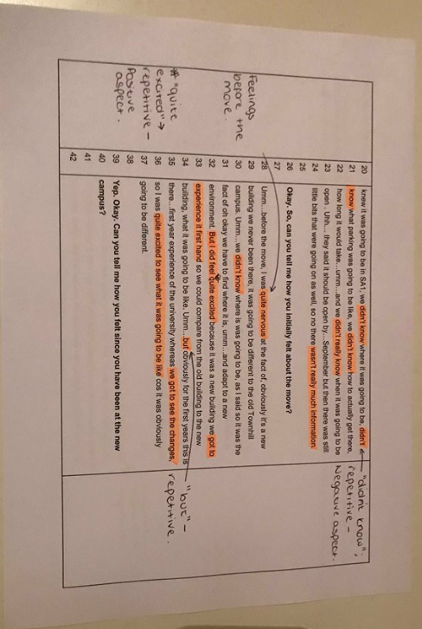
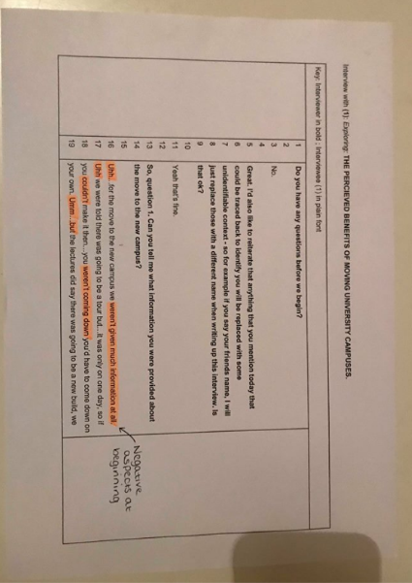
D)

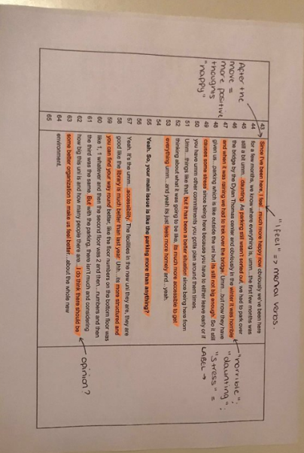
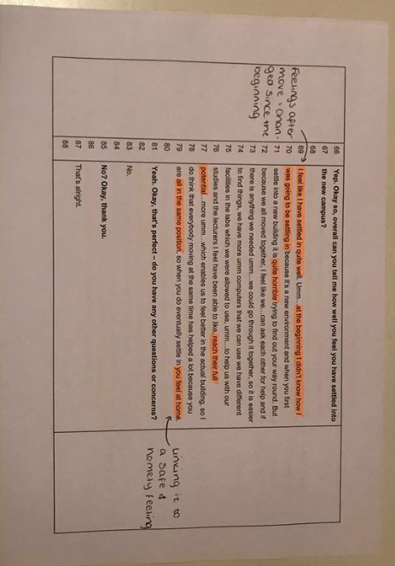

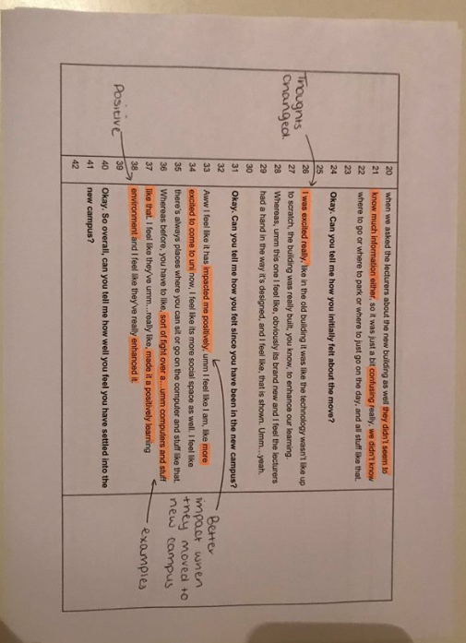
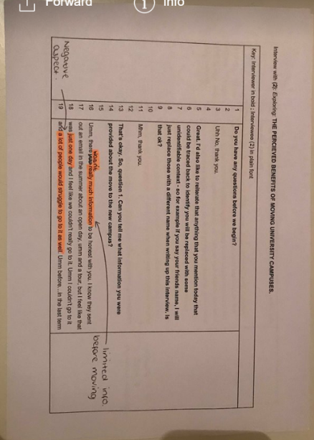
E)

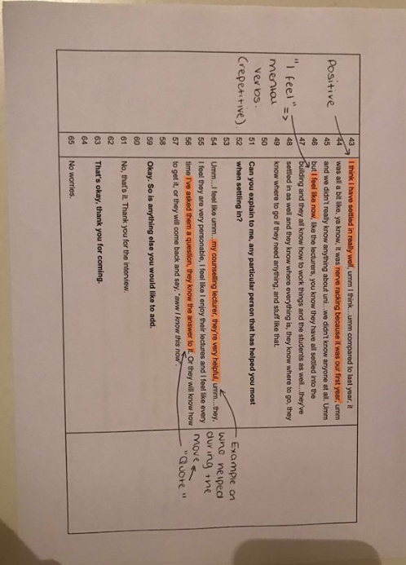

F)

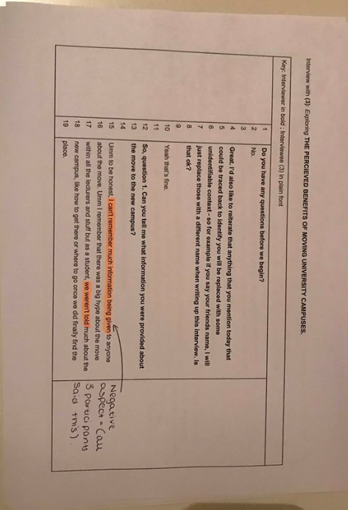
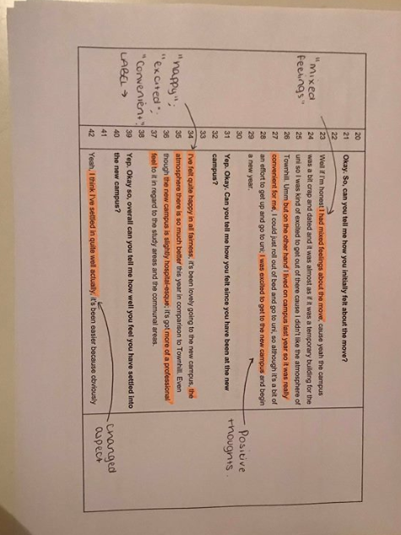
F)



