

BMIH5007 Financial Management for the Hotel Industry
Sustainable Business Revenue Generation Plan
Assignment 2
Student Name: Syeda Aklima Khatun
Student ID: 2112458
Lecturer Name: Dale Clarke

Table of Contents
Introduction 2
Argument consideration for the housekeeping department of Marriott International 3
Difference between traditional budgeting and zero-based budgeting 3
The decision
Process and Implementation of Zero-based Budget 5
When to Use a Zero-Based Budget 6
Budgeting Control for sustainability 7
Sustainable business revenue generation plan with zero-based budgeting for Marriott International 8
Conclusion 9
References 10

Introduction
The study highlights the merits of the Zero-based Budgeting methodology for businesses. Our analysis uncovered the benefits of ZBB over more conventional budgeting methods, and it showed why these advantages matter to a business's bottom line. Here, we contrast Zero-Based Budgeting with more conventional approaches to financial planning. The department needs to have a solid understanding of both zero-based budgeting and traditional budgeting to develop a plan for the sustainable development of corporate revenue. Methods for incorporating ZBB into an organization's budgeting were also analyzed. The following is an illustration of the differences between the two styles of budgeting and emphasizes the necessity of zero-based budgeting for long-term initiatives aimed at creating profits.

Argument consideration for the housekeeping department of Marriott International
The hotel's housekeeping department is in charge of all accounting and budgeting tasks. This is why the division must appreciate the significance of zero-based budgeting. To develop a long-term strategy for bringing in money for the hotel, the department in charge of budgeting needs to be familiar with both traditional budgeting and zero-based budgeting (Walsh, 2015). The point of this discussion is to differentiate between linear budgeting and zero-based budgeting. The following demonstrates the dissimilarities between the two types of budgeting and the significance of zero-based budgeting for long-term profit development strategies.

Difference between traditional budgeting and zero-based budgeting
Traditional budgeting
When utilizing previous years' data, traditional budgeting is a straightforward process to carry out. It is possible to implement it throughout an organization in its various departments. On the other hand, zero-based budgeting is a sophisticated strategy that is only applicable to profit centres. People can't use it for any other type of organization. Because it takes into consideration the expenditures from the previous year, traditional planning does not result in cost savings in the same way as zero-based budgeting does. Nevertheless, because there is no starting point in a budget that is zero-based, there is no requirement to set aside any monies to get things moving (Nikbakht and Groppelli, 2018). By developing budgets that account for all of their anticipated revenues and expenditures, organizations can obtain valuable insight into their long-term financial prospects. A procedure of budgeting should be implemented in enterprises to monitor how the available money is spent so that expenses may be kept under control. One can plan their finances by using the conventional methods of budgeting. While developing a conventional budget, it is standard practice to base the projection for the current year on the actual expenditures incurred in the previous year. On the other hand, the traditional approach of budgeting, often known as zero-based budgeting, doesn't make any assumptions other than the fact that budgeting in and of itself is a zero-sum game (Brealey, Myers and Marcus, 2019).

Zero-based budgeting
The practice of beginning the budgeting process with nothing more than a sheet of blank paper is referred to as "zero-based budgeting," and is described by that name. In contrast to a conventional budget, which is formed based on previous budgets, a zero-based budget is constructed without using any precedent budgets as a point of reference. According to this strategy, before being factored into the final budget, each expense must first be rationalized (Kapoor et al., 2020). While using a budgeting method called zero-based budgeting, reducing wasteful spending is the first focus. Participation from the team is necessary to construct a budget that has a baseline that is based on zero. In the following, we will examine the similarities and differences between the characteristics of traditional budgeting and zero-based budgeting.
- When putting together a budget, it is common practice to start by looking at the financial situation from the previous year. When a budget, on the other hand, is made from scratch, everything in it must be reevaluated, and the process must start over (Brealey, 2023).
- Traditional approaches to budgeting give considerable weight to expenditures from the previous year. On the other hand, when it comes to the management of monetary resources, the purpose of employing a budgeting method that is based on zero is to continually rethink how things are done.
- Traditional budgeting, which has its roots in cost accounting, tends to place a greater emphasis on numerical considerations than other methods of budgeting. The necessity of decision-making, on the other hand, is highlighted when using the zero-based budgeting method (Ross et al., 2022).
- While using a typical method of budgeting, it is not necessary to include an explanation for each expense and line item. Every dollar that is spent is required to have a justification in a budget that is based on zero, often known as a zero-based budget.
- When a budget is created, the decision on how much will be spent on each product is often made by higher management. In contrast, when using a zero-based budget, those responsible for making decisions are the ones who ultimately determine whether or not to allow a particular sum of money toward a particular item (Ross, Westerfield and Jordan, 2021).
- The zero-based budgeting strategy is more efficient than the traditional budgeting approach because of the openness and flexibility it offers.
- The typical approaches to budgeting take a lot of time and are difficult to understand. Instead, a straightforward method known as zero-based budgeting is utilized (Myers, 2022).

The decision of the Housekeeping team and outsourcing housekeeping
Zero-based budgeting is the method that works best for the housekeeping department. It's simple for the cleaning staff to stick to the budget, and outsourcing housekeeping is a sound financial choice both in terms of the skillset of the staff and the overall cost of each strategy. As a comparison, both the in-house housekeeping staff and the outsourcing housekeeping prefer zero-based budgeting, and both types of budgeting are acceptable to the cleaning services outsourcing hotel. They both agree that zero-based budgeting is the best method for creating long-term financial stability at Marriott International (Topsacalian et al., 2015).

Process and Implementation of Zero-based Budget
Every single proposed line item in the budget must be accompanied by a justification from the appropriate authority who will be making the decision. Initiating the decision package process is critical at this time for firms. Every combination of options is one of a kind. The hotel's values can be seen in these decision bundles (Griffin, 2017). ZBB's next step is to rate the available decision bundles. A cost-benefit analysis was used to compile this list. Using the aforementioned data, a pyramid ranking approach is used to allocate funds to get the best possible results for all parties involved (Hellriegel, 2017). Here's a quick rundown of how zero-based budgeting generally functions:
Setting a hotel goal: The hotel should lay out its plans for the upcoming fiscal year before they get underway. The hotel should begin by defining its mission and making sure that its ultimate goal is measurable (Samson, Donnet and Daft, 2018). This is true regardless of whether the hotel's primary objective is cost reduction, profit maximization, or both.
Actions that will bring about the desired result: In this stage of zero-based budgeting, the hotel identifies the activities that must be performed to achieve the hotel's predetermined goals. To achieve its goals, the hotel must investigate the most effective methods of distributor outreach (Trevor, 2018).
Examine the factors that affect prices: The next step is for the hotel to estimate how much it will cost to reach its objectives. The costs currently associated with operating and maintaining the hotel must be accounted for (Heizer, Griffin and Render, 2014).
By the use of zero-based budgeting, the hotel can ensure that its resources are being used effectively. The only way for the hotel to know for sure if its objectives have been fulfilled is to evaluate the actual results against those projected. The cycle will restart with the next budget session (Montana and Charnov, 2015).

When to Use a Zero-Based Budget
When it comes to keeping tabs on costs, several businesses have found that zero-based budgeting helps the most. Due to its more detailed and rigorous nature than conventional budgeting methods, ZBB requires a longer period of implementation. Useful for businesses that want to save expenditures by at least 10% (Theimer, 2014). To the brave hotel, zero-based planning might be a huge benefit. A hotel-wide commitment to cost-cutting is essential for the successful adoption of a zero-based budget. Zero-based budgeting has long-term benefits for businesses that are willing to put in the work.
A zero-based budget may help organizations of all sizes and types save money in the long run. Numerous hotel leaders have remarked that ZBB is not limited to companies that can't grow. Incorporating zero-based budgeting into their hotel's financial planning could be a game-changer for their hotel's success. The method does this by redirecting previously wasted funds toward more productive endeavours (Hotel Management and B, 2019). Zero-based budgeting can aid growing businesses in the short term, especially those that are very modest in size. It can also be used by businesses that have already implemented some forms of cost reduction but are looking to go even further (Chakravarti, 2018).

Budgeting Control for sustainability
For any system to thrive in the long run, fair distribution of public funds is essential. In the last few decades, governments all over the world have accepted the Paris Agreement on Climate Change and the Sustainable Development Goals (SDGs), both of which are intended to improve national policy responses to sustainable development (Jackson, 2018). By advocating for more transparency, public input, and dispassionate analysis, the Organization for Economic Co-operation and Development (OECD) wants to assist countries in establishing innovative ways to budget planning and preparation. The Paris Collaboration on Green Budgeting has established robust partnerships with nations to assist those governments in better coordinating their budgets with their environmental and climate change goals (O’fallon and Rutherford, 2019).
Governments at all levels and the general public could benefit from green budgeting if it leads to a greater awareness of the impact of their spending habits on the planet. When decisions on how to raise income and distribute resources are made taking into account the long-term effects of policies on future generations and the long-term sustainability of resources, it is possible to arrive at more informed conclusions (Ferrell, Hirt and Ferrell, 2019). Information on the ecological effects of financial choices is likely either unavailable or underutilized.
It is necessary to incorporate environmental concerns into all policy areas of the budget, including the environment and climate, transportation, health, and money, to align incentives and develop a coherent approach to policy-making that is supported by financial decisions. These areas include the environment and climate, transportation, health, and money. The majority of the budget allocations in OECD countries go to the ministry responsible for climate change adaptation. Canada, Finland, and Ireland are just a few of the countries that have fully incorporated money for climate change into their national budgets (Stonehill, 2020). A more rigorous approach to achieving sustainability might be developed through the use of performance indicators linked to a government's budget.

Sustainable business revenue generation plan with zero-based budgeting for Marriott International
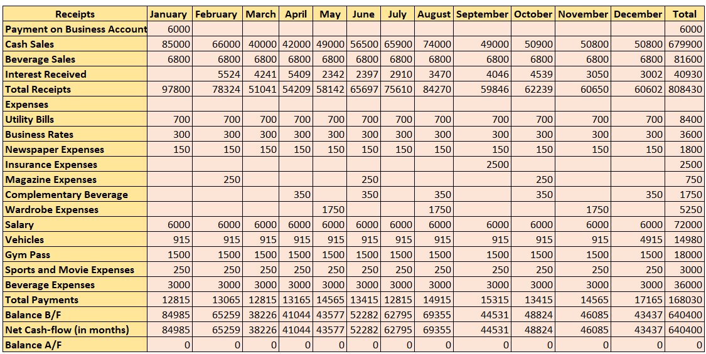

Conclusion
In conclusion, it has been discovered that the ZBB method of budgeting allows for greater leeway in terms of flexibility than the Conventional Budgeting method. In conclusion, the housekeeping department of a hotel needs to have a solid understanding of zero-based budgeting because it is responsible for financial budgeting (Hoggett et al., 2018). If Marriott International adopts and implements the Zero-based Budgeting methodology, it will have the opportunity to improve its overall organizational performance in terms of finances, controls, and sustainability. This improvement will be possible because of the hotel's ability to capitalize on the opportunity.

References
‌Brealey, R.A. (2023). Principles of corporate finance. New York, NY: McGraw Hill LLC.
‌Brealey, R.A., Myers, S.C. and Marcus, A.J. (2019). Fundamentals of corporate finance. New York, NY McGraw-Hill Education.
‌Chakravarti, B.K. (2018). Hotel management. New Delhi: A.P.H. Pub. Corp.
‌Ferrell, O.C., Hirt, G.A. and Ferrell, L. (2019). Business. New York, NY: McGraw-Hill Education.
‌Griffin, R.W. (2017). Management. Boston, Ma: Cengage Learning.
‌Heizer, J.H., Griffin, P. and Render, B. (2014). Operations management. Toronto: Pearson Education Canada.
‌Hellriegel, D. (2017). Management. Cape Town; Oxford: Oxford University Press.
‌Hotel Management and B, F. (2019). Practical Hotel Management. With notes and comments on Hotel Law. [By F.B. Bourne-Newton.]. London: Newton & Eskell.
‌Jackson, E. (2018). Hotel management. New York, Ny: Larsen & Keller.
‌Kapoor, J.R., Dlabay, L.R., Hughes, R.J. and Hart, M.M. (2020). Personal finance. New York, NY: McGraw-Hill Education.
‌Montana, P.J. and Charnov, B.H. (2015). Management. Hauppauge, NY: Barron’s Educational Series, Inc.
‌Myers, R. (2022). Ise Fundamentals of Corporate Finance. S.L.: McGraw-Hill Education.
Nikbakht, E. and Groppelli, A.A. (2018). Finance. Hauppauge, New York: Barron’s Educational Series, Inc.
‌O’fallon, M.J. and Rutherford, D.G. (2019). Hotel management and operations. Hoboken, N.J.: Wiley.
‌Ross, S.A., Westerfield, R. and Jordan, B.D. (2021). Fundamentals of corporate finance. New York: McGraw Hill LLC.
‌Ross, S.A., Westerfield, R., Jaffe, J.F., Roberts, G.S. and Hamdi Driss (2022). Corporate finance. Toronto: McGraw-Hill Ryerson Limited.
‌Samson, D., Donnet, T. and Daft, R.L. (2018). Management. 6th ed. South Melbourne, Victoria, Australia: Cengage.
‌Stonehill, D.K. (2020). Multinational business finance, global edition.
‌Theimer, K. (2014). Management. Lanham, Maryland: Rowman & Littlefield.
‌Topsacalian, P., TeuliéJ., Jean-Pierre Helfer and Orsoni, J. (2015). Finance. Paris: Vuibert, Impr., Cop.
‌Trevor, J. (2018). Management. Milton, Qld.: John Wiley & Sons Australia.
Walsh, J. (2015). Hotel. New York Bloomsbury Academic.

