Hello students – welcome to our exploration of the world of change. Given recent events, we will not be short of material to explore!
Teaching begins formally on Wednesday 14 April – please see the module handbook on moodle for the weekly delivery plan, and also check your allocated tutorial group.
This session is designed to help you prepare for the module and you should undertake all the tasks as specified.
If you are working individually, please summarise your outcomes in your personal reflective log – a section on the moodle page. If you are working on a task with others, agree a summary and post to each individual log.
Task 1: Attitudes to Change Quiz INDIVIDUAL TASK
This short questionnaire is designed to get you thinking about your personal attitude to change and reflecting on your experience of change in your personal and professional lives.
Please work through it carefully and once completed, follow the scoring instructions at the end (no peeking until you’re finished please!).
Once completed, please make an entry into your personal reflective log summarising your results and whether you feel it is a fair reflection of your overall approach to change.
A reminder that logs are individual and private and can only be viewed by course tutors.

Task 2: Getting to know you……
Please make a personal log entry answering the following questions about you and your thoughts about change at this preliminary stage. We’ll discuss a selection of the answers in the first class so please ensure you do this before teaching begins. Please explain…..
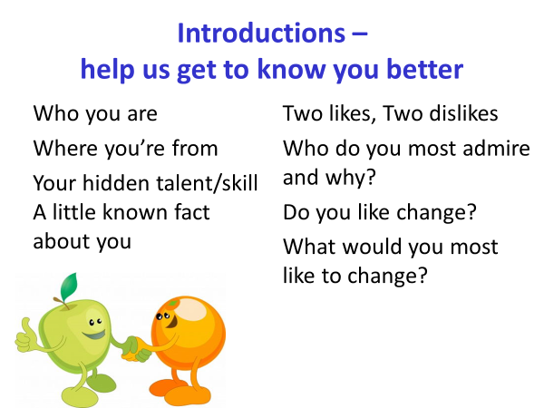
Task 3: Your personal experience of change
Reflect and consider something that has caused change in your life, and answer the following questions in brief. Ideally relate this to a work situation, but you can refer to a personal event if this helps you to focus on the task better.

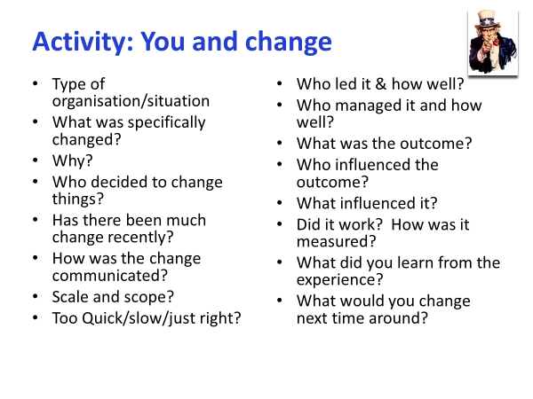
Task 4: Change is everywhere…..
As MBA students, you are expected to be up to date with current events as they affect the world of business and commerce. This exercise allows you to focus on a contemporary change issue being faced by an organization in the real world today. Please take some time to research it appropriately using resources such as quality newspapers (available via the UWTSD online library database ‘NewsBank’), websites (but take care here for impartiality), or broadcast media generally.
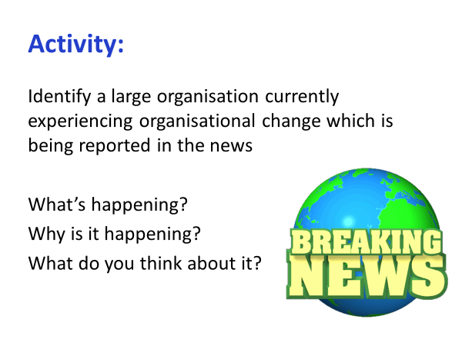
Summarise your thoughts as a reflective log entry please.
Task 4: What would you like to change and why? GROUP TASK – 2/3 STUDENTS (YOU CHOOSE YOUR PARTNERS)
We will be exploring the topic of change from a variety of perspectives in this module, but it is likely that at the outset you already have issues and opinions regarding the topic and things you would like to change. This initial activity is designed to get you thinking about the subject in terms of delivering a practical outcome from a change project.

Develop a project proposal designed to accomplish a meaningful, worthwhile change. It must create a change in a process, system, or structure within the community, a business or non-profit organisation, government institution, or the university.

The change project must meet two criteria:
- It must show promise of being a worthwhile learning experience, and
- It must have some social value.
Your group is encouraged to select a project that you personally value and a goal for which you have a genuine concern that goes beyond a simple need to pass the module successfully. Scale is important and it must be deliverable within a reasonable time period.

Produce a one page summary on which is stated:
- A concise statement of the change project is and why it is important
- A brief plan of what you think has to be done to achieve the change
- A statement of how you will measure whether the change has been accomplished.
- Details of who was in your group

Post this to your personal reflective log before the next class.

Task 5: Perspectives on Change
TED talks allow us to gain insights into the views of a variety of speakers with a range of perspectives on this complex topic of change. Here are some short films (around 15m each) which should be quite thought provoking before we begin to explore in more detail. One deals with personal change, the other organizational change. If you want to comment on them, again please do so via your personal learning log on moodle.

Stell Bida https://youtu.be/_TqbC4E2f9E
McKinsey consulting and change https://youtu.be/k69i_yAhEcQ
The Sharing Economy – economic insights https://youtu.be/DNBY8yNXGoA
Tourism, hospitality & disruption by the sharing economy https://youtu.be/7AbYT7b0XWQ
Please ensure that you have posted your answers via the learning log before the module begins on Wednesday 14 April at 10am – 1pm. The first session will be delivered live via Microsoft Teams.
PLEASE READ THE MODULE HANDBOOK AND ASSIGNMENT BRIEF BEFORE THE NEXT CLASS. PRODUCE A SHORTLIST OF THREE POSSIBLE ORGANISATIONS FOR YOUR CASE STUDY.

