Javascript/JQuery enabled website – Dysgu iaith y ddraig
Steven Tanner Moore
University of Wales Trinity St David, Swansea, Wales
1801309@student.uwtsd.ac.uk
Web and Mobile Technologies
ACCA5031
Date of Submission: 03/12/2021

Contents
Introduction 2
JavaScript / jQuery 2
A. JavaScript Quiz – JS/jsQuiz.js 2
1) Javascript quiz part 2 - JS/jsQuizP2.js 6
II. jQuery – Darkmode toggle – JS/switch.js 9
III. Javascript – Seasonal Themes – JS/themes.js 11
1) Christmas theme: 11
2) Spooktober theme: 11
3) Saint David’s Day theme: 12
B. Other JavaScript components 14
1) Scroll Animations – JS/scroll.js / JS/scroll2.js 14
2) Bootstrap / Javascript contact form. 15
3) Navigation bar and Accordion 16
I. Conclusion 17
II. Bibliography 17

Introduction
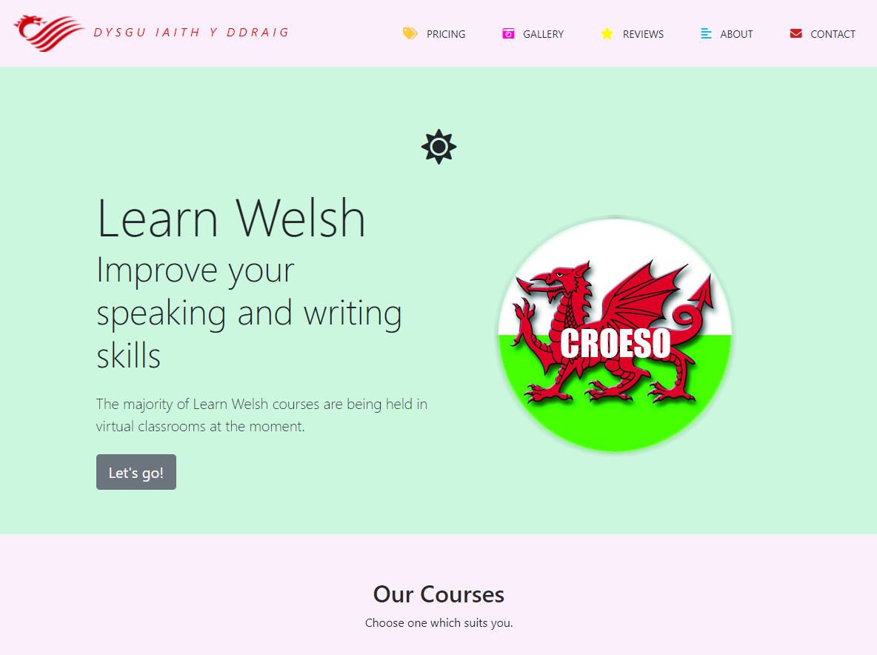
This report details the creation of a JavaScript / jQuery enabled website, named “Dysgu iaith y ddraig” or “Iath y ddraig” meaning ‘learn the dragon language’. A Welsh learning site which aims to host a Welsh learning course. The site includes three main JavaScript / jQuery components and three other smaller components contained within the site. This report also includes a discussion of how the author may extend the site in the future and how they may take a different approach when doing so. The website also uses the Bootstrap 5 framework which is mainly used for styling page content.

JavaScript / jQuery

JavaScript Quiz – JS/jsQuiz.js
The first JavaScript component is a timed quiz, which also includes a second multiple choice section. A screenshot of the general layout of the quiz is below:
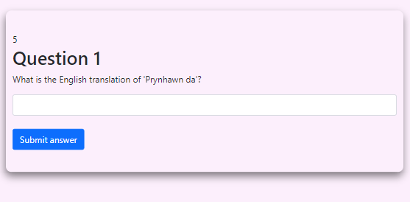
As shown above the quiz is presented to the user in one box which updates every time the “submit answer” button is clicked. The box also contains a timer and question number. The quiz additionally provides right / wrong feedback by turning the font colour to green/red after each question. This is demonstrated on the next page.
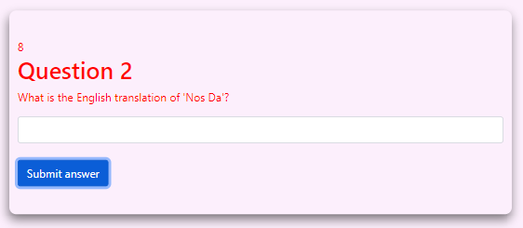
Incorrect answer demo:

Correct answer demo:
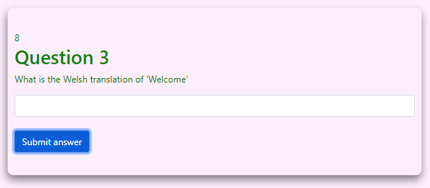

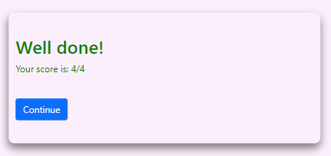
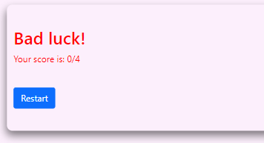
Once the user completes the quiz they are presented with their score and a continue button if they answered at least one question correctly, or a restart button if they didn’t answer any of the questions correctly. This is achieved using jQuery.
The quiz is presented in a single box because it allows the user to concentrate on one question at a time. It also suites the timed function which wasn’t implemented until much later in development.
The JavaScript for the quiz is displayed on the next page(s).

var counter = 10 ; // countdown variable

const questions = [ //A 2D array used to store two values per entry (the question followed by "," and the answer)
["What is the English translation of 'Prynhawn da'?", "good afternoon"],
["What is the English translation of 'Nos Da'?", "good night"],
["What is the Welsh translation of 'Welcome'", "croeso"],
["What is the English translation of 'Bore da'?", "good morning"]
]
var questionNo = 1; //used to store current question number.
var score = 0; //used to store the users score.

window.onload = hideQuiz()

function hideQuiz() //just hides the quiz until the user click the start button.
{
document.getElementById("pricing").style.display = "none";
document.getElementById("button2").style.display = "none";
document.getElementById("button3").style.display = "none";
}

function setup() //loads the questions / answer from the 2d array.
{

document.getElementById("pricing").style.display = "block"; //makes the quiz visible.

if (questions.length != 0) {
document.getElementById("question").innerHTML = questions[0][0]; //display question if the quiz is not finished.
document.getElementById("questionNo").innerHTML = "Question " + questionNo; //display question number.
} else if (score == 0) //at end of questions
{
document.getElementById("questionNo").innerHTML = "Bad luck!"; //output bad luck if 0 questions answered correctly.
document.getElementById("text-field").remove(); //removes the text field so the user cant type.
document.getElementById("button").remove(); //removes submit button.
document.getElementById("count").remove(); //removes countdown.
document.getElementById("button2").style.display = "block"; //displays restart button
document.getElementById("question").innerHTML = "Your score is: " + score + "/4"; //displays user's score.
$(".box").css("color","red");
} else //same as above just more positive :)
{
document.getElementById("questionNo").innerHTML = "Well done!";
document.getElementById("text-field").remove();
document.getElementById("button").remove();
document.getElementById("count").remove();
document.getElementById("button3").style.display = "block"; //displays continue button, goes to part two (multiple choice)
document.getElementById("question").innerHTML = "Your score is: " + score + "/4";
$(".box").css("color","green"); (JQ).
}

}

function check() //used to check user input against the 2d array.
{
if (document.getElementById("text-field").value.toLowerCase() == questions[0][1]) { //changes any input text to lower case
score++; //if user input is = to questions array adds one to score.
$(".box").css("color","green"); //changes text to green when answer is correct.

}else{
$(".box").css("color","red"); //changes text to red when answer is correct (JQ).
}
document.getElementById("text-field").value = ""; //resets the input text box.
}

function clickButton() //submit button, ^ functions
{

check() //check answer and ++array
questions.shift();
questionNo++;
setup(); //run setup function
counter = 10 //reset counter to 10.
id = document.getElementById("count"); //set the counter html to 10.
id.innerHTML = 10;

}

//clock
function countDown() {

setInterval(function () { //creating an interval, runs the function everytime the clock ticks.

counter--; //-1 from counter var
if (counter >= 0) { //if counter more than or = to 0 change html to what ever is stored in the counter var.
id = document.getElementById("count");
id.innerHTML = counter;
}
else { //else (if 0) reset the counter and run the clickButton function which cycles to the next question.
id.innerHTML = 10;
clickButton();
counter = 10;
}
}, 1000); // setting the interval to 1 second in ms.

}

The timer works by calling the “clickButton()” function every time it reaches 0. The clickButton() function is usually called whenever the user clicks the “submit answer” button themselves.

Javascript quiz part 2 - JS/jsQuizP2.js
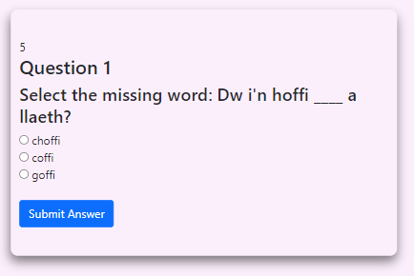
The quiz does have a part 2. The main difference being that part two includes multiple choice questions via radio buttons. In terms of code, it uses a multidimensional array instead of a 2D array as it needs to store multiple answers. Part 2 of the quiz has all the same features as part 1 (feedback, timer etc) The general layout is shown below.
Code is displayed below and on the next page(s):
var counter = 10; // countdown var

document.getElementById("pricing").style.display = "none"; //Hide quiz.
function setup() {
document.getElementById("pricing").style.display = "block"; //makes the quiz visible.

}
//declaring variables
var questionNumber = 0,
test, test_status, question, choice, choices, choiceA, choiceB, choiceC, correct = 0;
//Multidimensional Array - https://youtu.be/Cta5s1QBD8E
var questions = [
["Select the missing word: Dw i'n hoffi ____ a llaeth?", "choffi", "coffi", "goffi", "B"],
["What is sheep in Welsh?", "Yfed", "menig", "dafad", "C"],
["What is gloves in Welsh?", "menig", "eliffant", "llygoden", "A"],
["What is to drink in Welsh?", "menyn", "gweithio", "yfed", "C"]
];
//function which saves me typing.
function _(x) {
return document.getElementById(x);
}

function showQuestion() {
test = _("test");
if (questionNumber >= questions.length) { //check if user has finished
test.innerHTML = "<h2>You got " + correct + " of " + questions.length + " questions correct</h2>" + "<a class='nav-link' href='index.html'>Home</a>";;
_("test_status").innerHTML = "Test Completed" //if they have output their score and homepage link.
document.getElementById("count").remove(); //removing counter
questionNumber = 0; //reset
correct = 0;
return false;
}
_("test_status").innerHTML = "Question " + (questionNumber + 1); //output question number
//getting question / answer from array
question = questions[questionNumber][0];
choiceA = questions[questionNumber][1];
choiceB = questions[questionNumber][2];
choiceC = questions[questionNumber][3];
test.innerHTML = "<h3>" + question + "</h3>";
//using += to append. Displays the radio button and applies A, B or C value.
test.innerHTML += "<input type='radio' name='choices' value='A'> " + choiceA + "<br>";
test.innerHTML += "<input type='radio' name='choices' value='B'> " + choiceB + "<br>";
test.innerHTML += "<input type='radio' name='choices' value='C'> " + choiceC + "<br><br>";
//display submit button
test.innerHTML += "<button class='btn btn-primary' onclick='checkAnswer()'>Submit Answer</button>";
}

function checkAnswer() {
choices = document.getElementsByName("choices"); //choice var = users choices
for (var i = 0; i < choices.length; i++) { //for loop which checks which choice the user checked
if (choices[i].checked) {
choice = choices[i].value;
}
}
if (choice == questions[questionNumber][4]) {
correct++; //if correct add one to score and change font colour to green
$(".box").css("color", "green");
} else {
$(".box").css("color", "red"); //else change to red
}
questionNumber++; //add one to question number
showQuestion(); //call showQuestion function to advance the quiz
counter = 10 //reset counter
id = document.getElementById("count");
id.innerHTML = 10; //reset html
}
window.addEventListener("load", showQuestion, false); //shows quiz once user clicks start button

//clock - same method as part 1
function countDown() {

setInterval(function () {

counter--;
if (counter >= 0) {
id = document.getElementById("count");
id.innerHTML = counter;
} else {
id.innerHTML = 10;
checkAnswer()
counter = 10;
}
}, 1000);

}

jQuery – Darkmode toggle – JS/switch.js
The second major component of the website is a dark mode toggle. The purpose of this component is to allow the user to toggle between dark / light mode – changes the website body to black and font colour to white. This component also uses local storage – a form of cookie which stores the user’s preference. This is used to make the user’s choice persistent across different pages so that they don’t have to click the toggle every time a new page is loaded. The dark mode toggle is demonstrated below. To use the feature the user clicks the sun icon which plays a small animation and switches to a moon icon.

Light Mode:


Dark Mode:
This component uses jQuery which is displayed on the next page(s). The code also contains an unfinished smooth scroll bar the author was working on.
$(pageready)
var $win = $(window); //gets viewport information.
var $scrollbar = $('.scroll_icon'); //var for scroll icon, (only visible on large displays)
var $dice = $('.list-item') //var for scroll icon, (only visible on large displays)
let darkMode = localStorage.getItem('darkMode'); //declaring local storage (similar to a cookie however it is stored local: https://youtu.be/wodWDIdV9BY)

function pageready() //loads anonymous function when page loads
{
//side "smooth" scroll bar buttons. only visible on wide screens.
$win.on('scroll', function () {
var top = $win.scrollTop() / 6; //Gets how many pixels the user has scrolled from the top of the page and stores in top var. divide by 6 to slow down the animation.
$scrollbar.css('transform', 'rotate(' + top + 'deg)'); //Uses the value from "top" variable to rotate dark mode icon when the user scrolls.

});

$(".theme_icon").on('click', function () { //adds a .onclick event to the sun / moon icon, function which includes the toggles.
$(".theme_icon").toggleClass("flip"); //toggles the class "flip" which calls the CSS.
$(".theme_icon").toggleClass("fa-sun"); //switches between sun / moon icons
$(".theme_icon").toggleClass("fa-moon");

//gets current value of data-theme attribute applied to the html tag.
let current_theme = $("html").attr("data-theme");
if (current_theme == "dark") { //checks what the data value of "data-theme"
$("html").attr("data-theme", "light"); //if dark change to light
localStorage.setItem('darkMode','light') //if user changes to light mode store "light" in local storage
}

else { //else change to dark
$("html").attr("data-theme", "dark");
localStorage.setItem('darkMode','dark') //if user changes to dark mode store "dark" in local storage
}
});

window.onload = function()
{

$("html").attr("data-theme", localStorage.getItem('darkMode')); //on page load set html data attribute to whatever string is stored in local storage. Not very well optimised for the contact page.

}
}

This component relies heavily on the CSS file which can be found in the root folder. The local storage aspect works by getting the current value stored in the <html> data attribute which is either ‘light’ or ‘dark’, depending on which it will then change the website to either light or dark mode. The user can change the value stored in local storage by clicking the sun / moon icon. The value stored in local storage is then passed to the html file. One issue with using local storage involves poor optimisation on the “contact” page which causes a delay in the theme being applied.

Javascript – Seasonal Themes – JS/themes.js
The third major component is seasonal theming. Meaning the theme of the website will automatically change depending on the current date. For example, when its December the website theme changes to a more Christmassy theme. Currently the site has three themes which are shown below.

Christmas theme:

This theme includes animated snow, which falls and fades from the top of the screen. This could potentially reduce accessibility as it can obscure text. This could be fixed by implementing a button which toggles the snow on / off. This theme is only applied whilst the current month is December. These themes are only applied to the home page.

Spooktober theme:
This theme is only applied during October. It does not include any extra animations.
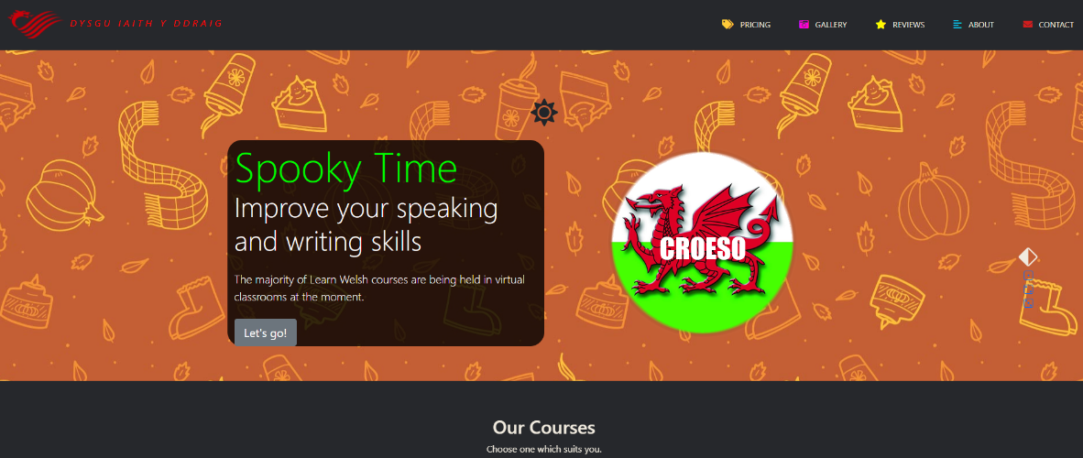

Saint David’s Day theme:
The code for this theme is slightly different from the last as it must consider the current month and day as the theme is only applied on the 1st of march.
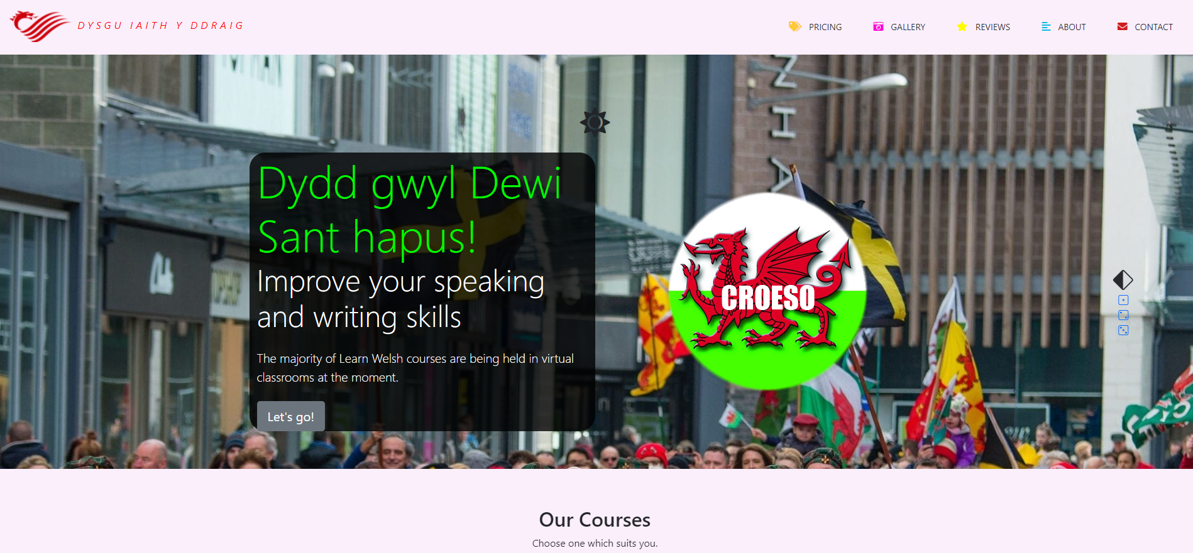
The code for all three themes is below:
const d = new Date(); //getting the current date and storing it in d var.
d.getMonth(); //get month and add one as it starts from 0 by default
var m = d.getMonth() + 1; //built-in function
var day = d.getDate(); //get current date and store it in day var.

if (m == 12) //if month is Dec run code. Change to current month to view effect.
{

document.getElementById("CText").innerHTML = "Happy Holidays"; //change intro text
document.getElementById("intro").style.backgroundImage = "url('images/Wintertheme.jpg')"; //change background colour
$('#Textback').css('background-color', 'rgba(0, 0, 0, 0.8)'); //adding a background to intro text (JQ).
document.getElementById("CText").style.color = "lime"; //change text colour
document.getElementById("CText1").style.color = "white";
document.getElementById("CText2").style.color = "white";
setInterval(createSnowFlake, 50); //interval for calling CreateSnowFlake function is 50ms

} else if (m == 10) { //if oct run code
document.getElementById("CText").innerHTML = "Spooky Time"; //change intro text
document.getElementById("intro").style.backgroundImage = "url('images/Spookytheme.jpg')"; //change background colour
document.getElementById("snowflake").style.display = "none"; //do nothing and hide snowflake if month != 12 or Dec
$('#Textback').css('background-color', 'rgba(0, 0, 0, 0.8)'); //adding a background to intro text (JQ).
document.getElementById("CText").style.color = "lime"; //change text colour
document.getElementById("CText1").style.color = "white";
document.getElementById("CText2").style.color = "white";
} else if (m == 3 & day == 1) { //if saint david's day run code
document.getElementById("CText").innerHTML = "Dydd gwyl Dewi Sant hapus!"; //change intro text
document.getElementById("intro").style.backgroundImage = "url('images/dewi.jpg')"; //change background color
document.getElementById("snowflake").style.display = "none"; //do nothing and hide snowflake if month != 12 or Dec
$('#Textback').css('background-color', 'rgba(0, 0, 0, 0.8)'); //adding a background to intro text (JQ).
document.getElementById("CText").style.color = "lime"; //change text colour
document.getElementById("CText1").style.color = "white";
document.getElementById("CText2").style.color = "white";
} else {
document.getElementById("snowflake").style.display = "none"; //do nothing and hide snowflake if month != 12 or Dec
}

function createSnowFlake() {
const snow_flake = document.createElement('i'); //creates an element
snow_flake.classList.add('fas'); //adding snowflake from fav icons
snow_flake.classList.add('fa-snowflake');
snow_flake.style.left = Math.random() * window.innerWidth + 'px'; //using random math to randomly drop snow flakes along the width of the screen.
snow_flake.style.animationDuration = Math.random() * 3 + 2 + 's'; // between 2 - 5 seconds
snow_flake.style.opacity = Math.random(); //using random math to determine snowflake opacity and size
snow_flake.style.fontSize = Math.random() * 10 + 10 + 'px';

document.body.appendChild(snow_flake); //add snow flake to body.

setTimeout(() => { //removing snowflakes after 5 seconds / also fades out using CSS.
snow_flake.remove();
}, 5000)
}

Other JavaScript components
This section is for all the other JavaScript components implemented into the site. This includes two scroll animations, form validation and some basic jQuery/UI. The scroll animations simply transform and fade-in the page content.

Scroll Animations – JS/scroll.js / JS/scroll2.js
The JavaScript scroll animations simply hide page content until the user has scrolled onto them. This is demonstrated below. The author has implemented two separate methods of enabling these scroll animations, the 2nd method arose when the author was trying to allow the first to affect multiple elements.
Keyframe 1 Keyframe 3

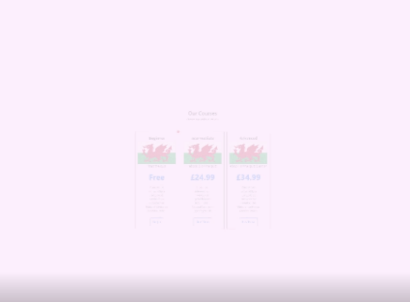

Keyframe 2 Keyframe 4




Code for scroll 1:
window.addEventListener('scroll', () => //registering scroll events

{
let content = document.querySelector('.scrollAnim') //anything with the .scrollAnim tag in HTML is effected.

let contentPostition = content.getBoundingClientRect().top; //gets the size of the element and its position relative to the viewport, stores in the content position var.
let screenPosition = window.innerHeight //gets the interior height of the window and stores it in the screenPosition var.
if (contentPostition < screenPosition) { //if the content is less the screen postion grabs the 'active' CSS, animating the div.
content.classList.add('active')
}

});
Code for scroll 2:
function scrollAppear()
//slightly different method to the first scroll. Could not figure out how to apply one scroll to multiple divs. For loop?
{
var introText = document.querySelector('.scrollStart');
var introPosition = introText.getBoundingClientRect().top;
var screenPosition = window.innerHeight;
if (introPosition < screenPosition) {
introText.classList.add('scrollEnd')
}
}
window.addEventListener('scroll', scrollAppear)

Bootstrap / Javascript contact form.
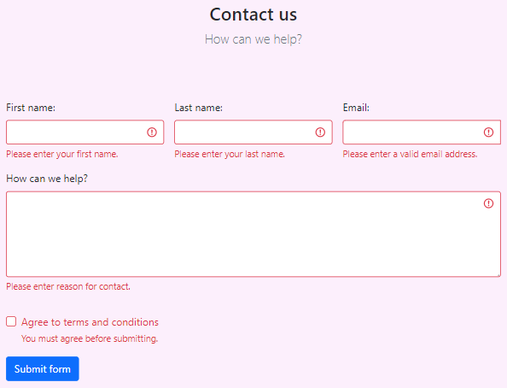
The contact form on the contact page uses Bootstrap 5’s framework for styling and JavaScript for input validation. The negative & positive feedback is demonstrated below:

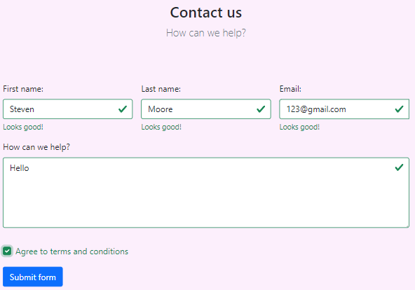

Code for form validation: Line 231 in contact.html
<script>
//JavaScript for disabling form submissions if there are invalid fields
(function () {
'use strict'

// Fetch all the forms to apply custom Bootstrap validation styles to
var forms = document.querySelectorAll('.needs-validation')

// Loop over them and prevent submission
Array.prototype.slice.call(forms)
.forEach(function (form) {
form.addEventListener('submit', function (event) {
if (!form.checkValidity()) {
event.preventDefault()
event.stopPropagation()
}

form.classList.add('was-validated')
}, false)
})
})()
</script>

Navigation bar and Accordion
The navbar uses the jQuery framework. The author originally implemented a Bootstrap version however changed it to what is shown below. This navbar was adapted from a YouTube tutorial: https://youtu.be/NXJ1wLsllwg
The accordion is a customised version of the default jQuery version. The navbar and accordion are also compatible with the dark mode toggle script.
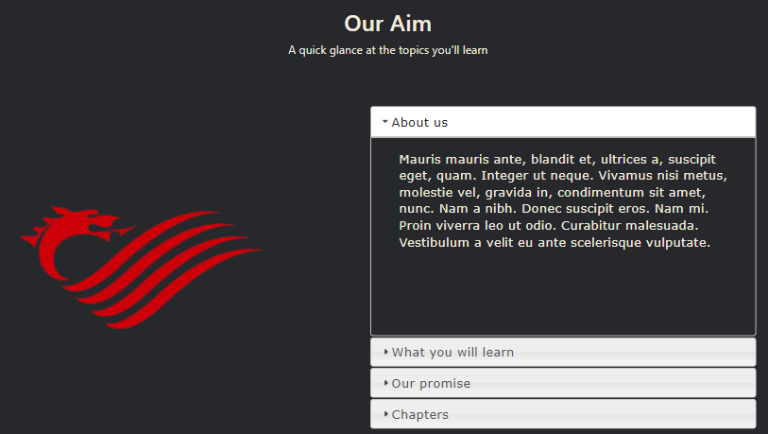
JavaScript for accordion and navbar (collapse):
//accordion
$( function() {
$( "#accordion" ).accordion({
"collapsible":true
});

} );
//navbar collapse
$(".menu-toggle-btn").click(function(){
$(this).toggleClass("fa-times");
$(".navigation-menu").toggleClass("active");
});

Conclusion
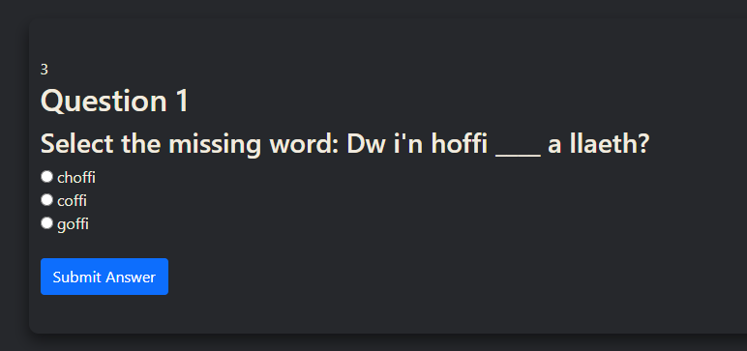
There are a few things in the site which would benefit from changing such as the smooth scroll which was unfinished. However, there is a major bug with the Christmas theme which is applied throughout December. The bug only occurs on smaller screens and involves the snowflake elements which are dropped along the width of the screen. For some reason the screen begins to extend past its intended width more and more the longer the page is open, making the page quite difficult to navigate. For this reason, the Christmas theme has been disabled. The bug may be in the random math section of code of the themes.js file, or potentially something in the CSS file.
The author would also like to change the radio buttons (used in part two of the quiz) to normal buttons which would not only look better but also make the quiz easier to use on mobile, as the current radio buttons are quite small and difficult to use. Potential new design:
C
B
A

One other minor change would be implementing a different scroll animation method which could be applied to multiple elements at once. As the current implementation of scroll animations can only be applied to a single element, which is why the author has two scroll.js files. Issue described here: - https://greensock.com/mistakes/

Bibliography
[1]A. Khoury, Multidimensional Array JavaScript Programming Tutorial. 2014 [Online]. Available: https://youtu.be/Cta5s1QBD8E. [Accessed: 03- Dec- 2021]

[2]K. Powell, Dark Mode JavaScript toggle using localStorage. 2019 [Online]. Available: https://youtu.be/wodWDIdV9BY. [Accessed: 03- Dec- 2021]

"Bootstrap 5 Tutorial", W3schools.com, 2021. [Online]. Available: https://www.w3schools.com/bootstrap5/. [Accessed: 03- Dec- 2021]

"JavaScript Tutorial", W3schools.com, 2021. [Online]. Available: https://www.w3schools.com/js/. [Accessed: 03- Dec- 2021]

"jQuery Tutorial", W3schools.com, 2021. [Online]. Available: https://www.w3schools.com/jquERy/default.asp. [Accessed: 03- Dec- 2021]

