University of Wales Trinity Saint David
How to Improve the application process at Med Team Primary Care Services

Table of Contents
1.0 Project Justification 2
1.1 Aims and Objectives 2
1.2 Rational 3
2.0 Business Case and Project Approach 3
3.0 Research Methodology 6
Secondary Research 6
Primary Research 6
4.0 Project Management Team Structure 7
5.0 Project Plan 8
5.0 References 9

Project Justification

This project is going to look into at the recruitment company Med Team Primary Care Services (Med Team), and consult on how they can improve their application process for their candidates and how this will save time for the recruiter. Med Team is a recruitment company that supply's medical staffing to a variety of work places throughout the UK.

Aims and Objectives

The aim of the project is to look into the current processes that are taking place at Med Team, and see how that can be changed or adapted to benefit both the candidates and the recruiter. This should hopefully allow the recruiter to save time in order them to focus on the placements of the candidates and build a better relationship with both them and the clients they are serving. After a brief looking at the company, it can be seen that a considerable amount of a candidates time is spent chasing and uploading documents to make sure a candidate is compliant for work, they need to find a faster process which can free up more time for the recruiter to look for work, and also take some of the stress away from the process.
The objective will be to decrease the time of a recruiter making a candidate compliant for work by 2 days and make it the job of the candidate to ensure they are compliant for work, not just the recruiter. Once this project proposal has been completed, the new systems put in place should take space over a year to implement them.

Rational
This project is necessary as currently a lot of a recruiter’s time and stress is being put on due to making candidates compliant and therefore safe to work. It also means that the company has had to employ several people to keep on top of the increasing work load. As a small company the extra workers although necessary for the day to day running of the business, are adding a higher strain on the financial situation. By improving the current systems that are in place, this could hopefully help speed up the processes and therefore less man power will be needed.
It currently takes approximately a week to make each new candidate compliant, and therefore this is also affecting how quick they can get staff into current vacancies. This is not suggesting that members of they need to lay off members of staff at this moment, as it will take all members of staff to work together so get the new system up and running, so that the whole business is working the same way. However, it could mean that once everything is up and running, they could lose the unnecessary staff.

Business Case and Project Approach

Med Team Primary Care previously known as Belvia Medical Services is a recruitment company based in Swansea that supply medical staffing throughout the UK. They supply the following:
- Dentistry
- Forensic Medical Examiners
- General Practitioners
- Nurses
- Prison Doctors/Nurses
They have been running since 2008, however the local owner Wendy Bartlett has had over 15 years’ experience in the medical service field (Med Team, 2016). There are currently 13 members of staff working at the company.
Below an organisational structure can be seen.
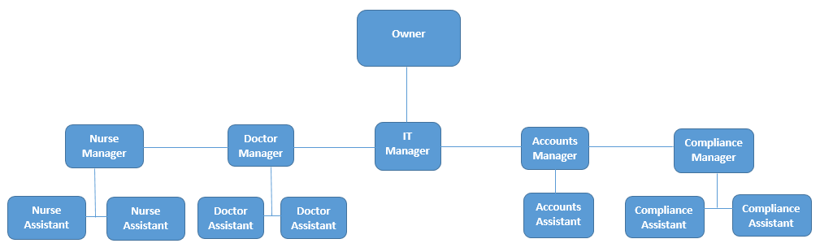
Figure 1
(Source: Med Team Primary Care Services, adapted by Hollingworth 2017)
Kotters change management theory can be used to look at the types of issues that can arise when introducing a change into an organisation (Kotter, 1995). It will also look at what can be done to avoid the issues. The 8 steps of Kotters change theory can be seen below:
Figure 2
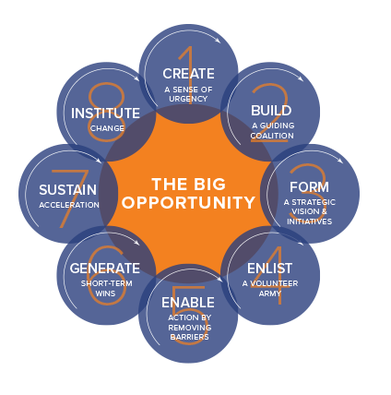
(Sourced: Online - Kotter International, 2017)
From Kotter (1995), one can look further into each of these steps to see how they will affect organisational change.
- Create –Showing the staff that there is a need for change.
- Build - “Encouraging the group to work together as a team”
- Form - Creating a vision and then developing an approach for achieving the vision.
- Enlist – Finding people willing to volunteer to take part in the changes
- Enable - Empowering all the employees to take on the change
- Generate - Planning short term improvements and rewarding employees.
- Sustain - Implement the changes to the system and help employees change to meet the new demands.
- Institute - “Developing the means to ensure leadership development and succession”
This model can be looked at in comparison to this project in order to see any issues that could potentially rise, and how to avoid them. Possible problems that could occur in the case of Med Team are getting the employees involved and willing to change.

Research Methodology

To ensure that the correct data is used in order to provide an accurate view of the organisation, and what aspects need to be looked at and improved, primary research will need to be conducted as well as secondary research. Research can be defined as “a process by which researchers extend their knowledge and possibly that of the whole community” (Sharp, Peters and Howard, 2002). It is important that up to date research is carried out for this project, so only the most reliable information is used.

Secondary Research

Secondary research, is referred to as "re-analysis of data for the purpose of answering the original research question with better statistical techniques, or answering new questions with old data" Glass (1976). The secondary research carried out will be gathering information off their current website, what functions it has and how they are used. It will also look at other agencies websites to see how they compare and what types of systems online they have in place. Finally it will use internet sources to look at any relevant literature/theories that can be used in the report.

Primary Research

Primary research is where information is gathered straight from the source, it can also be known as field research. “Primary research does not actually exist until and unless it is generated through the research process as part of the consultancy of dissertation or project” (Crowther and Lancaster 2012). The first part of primary research that will need to be conducted is an interview with the owner of the business to find out what functions she thinks can be improved, how they will affect the day to day running of the business and the members of staff. The questions will also include how she think this would affect the members of staff and whether she thinks this would motivate or demotivate the employees. Then, questionnaires will be conducted with a few members of staff to gather their opinions on if the changes will affect them, and if so if they would find it a positive or negative change, along with any ideas that they may have to gather the views and opinions.

4.0 Project Management Team Structure

A consultant is “an independent advisor who adds value by helping managers to identify and achieve beneficial change appropriate to their situation” (Newton, 2010). Newton (2010) goes further onto state that a good consultant is one who is a people person and must be happy to interact with others.
The reason why this consultant – xxx - would be the best consultant for this job is that she is a natural extrovert, which according to Wickham and Wilcock (2012) is someone who is outgoing, energetic and someone with the tendency to seek stimulation in the company of others. Another research why it would be appropriate for xxx to take on the role of a consultant at Med Team, is due to the fact she has previously worked at the company and therefore has had a personal experience of how it is run and the current systems that are in place. This gives her a natural interest in this field and also have a greater knowledge than someone else.
Due to the fact that is company is also run by a close family member to the consultant, ensures that it will serve a purpose and hopefully allow them to improve and look into using this project as a way to take the company forward. It will also allow Sarah to gain the access and information that will be needed in order to complete the research needed for the project taking place.
An ethics form will be needed in order to ensure that any primary research carried out is done ethically. Please find this attached to the back of this project initiation document (PID).

5.0 Project Plan

This project is hoping to consult the company on how they can change their systems in order to improve the company’s application and compliance process. It will start on the 8th March, the first two weeks will include any primary and secondary research that needs to be completed, and the final project will be written up and completed by May 1st.
The first research that will take place is the secondary research. This will ensure that more background information on the company, and any available literature gathered can be used to direct the primary research. Therefore, it is necessary to do some brief secondary research straight away in order to carry out the primary research. The first part of primary research that will be done is creating a questionnaire and distribute it to the recruiters, and also come up with provisional questions for the interview with the business owner. This will need to be done in the first couple of days of the project plan, in order to sure that the questionnaires are returned within the 2 week time slot, this will ensure that there are no delays with the project. From this the results can then be drawn and the most relevant answers can be noted to use within the report.
The report will contain a SWOT analysis of the company along with a PESTLE analysis. From these, it should then show the need for the change and where this project can help benefit the company.
The project will look at any relevant theory that can be looked at to help improve the current state of the organisation. Then, a summary will be concluded from the main findings, and then results and recommendations will be drawn. Finally the project will then be presented to Med Team to see if they will accept the proposed changes.

5.0 References

Crowther, D. and Lancaster, G., 2012. Research methods. Routledge.

Glass, G.V., 1976. Primary, Secondary, and Meta-Analysis of Research 1. Educational researcher, 5(10), pp.3-8

Kotter, J.R., 1995. Leading change-Why transformation efforts fail. Harvard business review, 85(1), pp.96-+.

Kotter Internatioanl. 8 Step Process.
Available at: https://www.kotterinternational.com/8-steps-process-for-leading-change/
[Accessed on 01/03/2017]

Med Team Primary Care Services. About Us.
Available at: http://www.medteam.co.uk/Websites/medteampcs.nsf/0/80AF24202842960980256FEB002FC9AD?OpenDocument
[Accessed on 21/02/2016]

Newton, R. (2010) The Management consultant: Mastering the art of consultancy. Harlow, England: Financial Times/Prentice Hall.

Sharp, J.A., Peters, J. and Howard, K. (2002) The Management of a student research project. 3rd edn. Aldershot, England: Ashgate Publishing

Wickham, L. and Wilcock, J. (2012) Management consulting: Delivering an effective project. 4th edn. New York, NY: Financial Times Prentice Hall.

