THE decline of

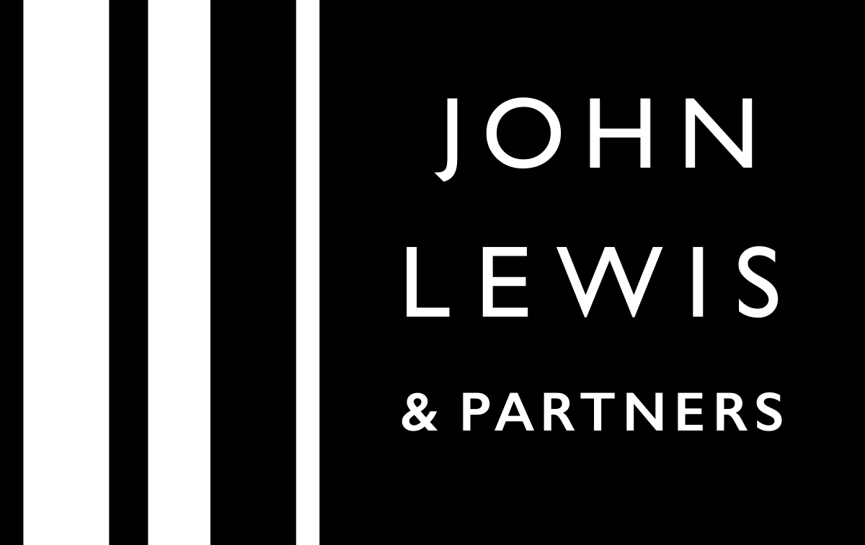

Usha nandhini krishna raj
29/10/2021
Student NO: 2022598

CONTENTS
- Introduction

- Nature of the problem: Decline in Sales
- Loss of sales in 2021
- Dull sales performance compared to previous year
- Loss and uncertainty in trade

- Scope
- Insecure employees
- Devastated Management
- Distresses Stake holders & Suppliers
- Dissatisfied Consumers
- Impact
- Covid 19 & the government policies
- Shift to Online shopping & Shop Closures
- Economic fluctuations and Price cuts
- Cancellation of international expansion plans
- Abandoned Christmas sale

- SWOT Analysis
- Appendices of SWOT analysis
- Description - Strengths, Weaknesses, Opportunities & Threats involved in JLP business

- PESTLE Analysis
- Appendices of PESTLE analysis
- Description – Political, Economical, Social, Technological, Legal & Environmental.

- Conclusion

- References

Introduction

John Lewis & Partners is a brand of high-end department stores and they have concessions located in the Republic of Ireland and Australia. Spedan Lewis, son of John Lewis, created it in 1929.
They are famously known as ‘Retail Giant’ and have been focusing on differentiation and innovation on three key areas – unique products, personal service and expanding into new services. The recent times have been very unfortunate to the organization, bringing in various difficulties like
- Inconsistent profitability,
- Cessation of international trade,
- Store shut downs,
- Cancellation of huge plans and so on.
The main problem that sums up all these issues into one, is the decline in sales. Let us discuss its nature, scope and impact in detail;

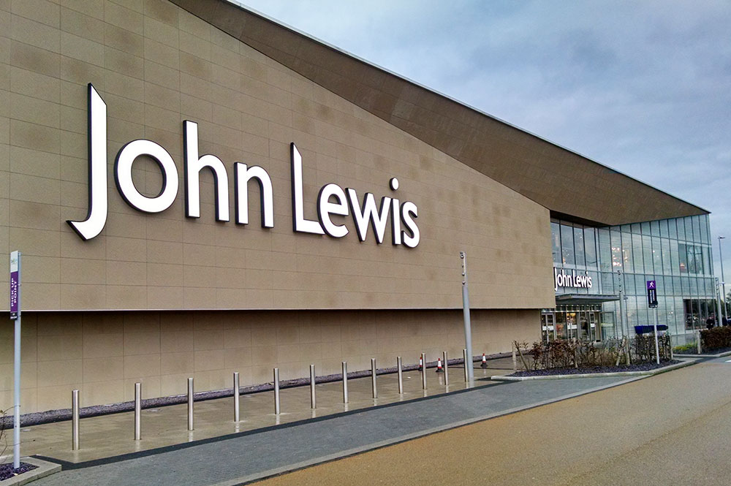

Decline in Sales

Nature of the problem
Sales play a vital role in any Company / Organization. One of the most important problem faced by The John Lewis Partnership is their decline in sales. Unfortunately the sales pitch in John Lewis has become ineffective. Every single business have their win-loss analysis for their sales operation. Similarly John Lewis have their own analysis for their sales process. Let us now discuss the views of reputed authors regarding the decline in sales with the John Lewis Partnership.


Author Hammett (2020), in her article states that the John Lewis Partnership (JLP) is making themselves prepared for a terrible situation, which is the decline in sales of around 35% for the year 2021.Hammett also says the John Lewis Partnership had forecasted a huge loss in sales and to add more shock they had generated £122.6m with their sales which was a lower-than-expected profit in their annual report [1].
The Author mentions that the 23% decline in sales implies that they are at another difficult period of trade this year. This clearly shows the impact of their dull performance on the overall business. She states, the recent report shows John Lewis sales have decreased by 17%, compared to previous years since mid of March and have decreased by 7% compared to previous year since 26 January.
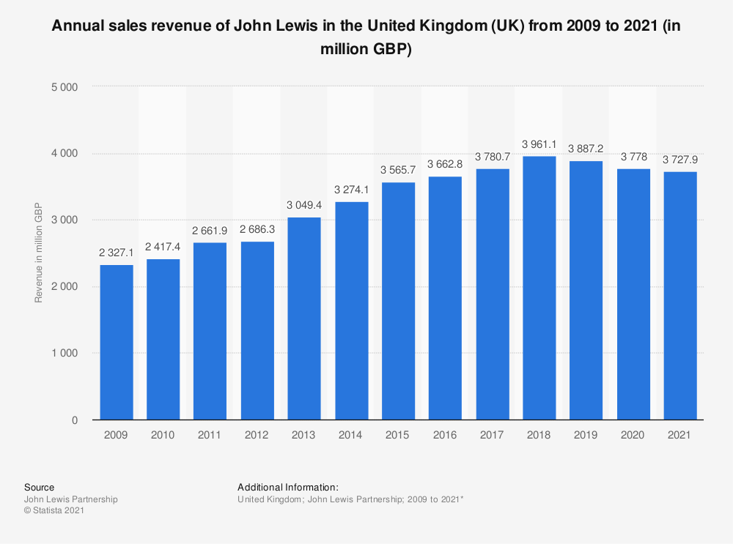
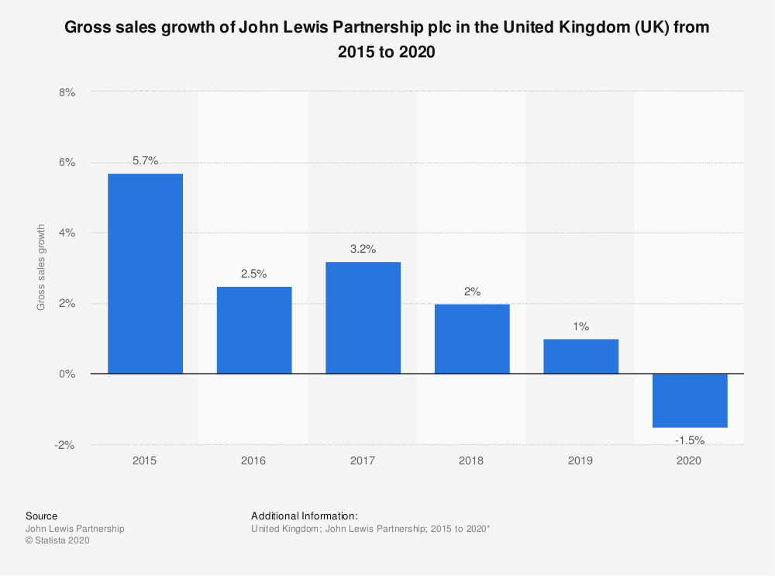

Picture: a. Annual sales revenue of John Lewis in UK from 2009 – 2021
b. Gross sales growth of JLP in UK from 2015 - 2020

‘The Independent’ Journalist Saker-Clark [2021], in one of his article states that the retail group of JLP remarked there will be a significant uncertainty in the trade, while it still manages to deal with supply chain problems and insufficient labour. The opinion of the retail team in JLP visibly shows their lack of confidence with their trade process, overwhelmed with the fear on supply chain problem and insufficient labour [2].

Scope

Although JLP has been a pioneer in retail industry, due to various causes and unfortunate global situations it had to undergo drastic changes in various parts of its business and also various sectors of people have been affected. There are plenty of factors contributing to this decline and been influenced by the decline. Let us discuss this in detail;
Insecure Employees
During the unprecedented time of Covid 19, JLP have taken numerous hard decisions on its employees that has affected them dreadfully.


‘The Guardian’ Journalist Butler (2021) reports that about 300 people have left the organization in the first half of this year and further the JLP team is in discussion regarding announcing 2500 job cuts which results from their planned store closures and changes in management. This has pushed the employees in grief and hunt for new jobs [3].
Author Elias Jahshan (2021) states that last year JLP had cancelled staff bonus that has never occurred since 1953. This has made the employees lose hope on JLP with regards to career progression or any kind of growth inside the organization. He has also mentioned that JLP Spokesman said the Organization tries its best to redeploy its employees into different departments and redundancies would be considered as the last choice [4].
Devastated Management
Author James Davey (2021) states that the JLP plans to remove 1000 management jobs at its Waitrose stores and JL departmental stores to do cost cutting. He also says JLP plans to simplify management structures and this would lead to a major redundancy with 34 John Lewis stores and 331 Waitrose supermarkets in total [5].
Distressed Stake holders & Suppliers



Author Elias Jahshan (2021) states that the Partners and Stake holders consider the cost involved in restructuring the organization and redundancy is also a reason for the loss in revenue and this has made them shift their selling pattern to Online Sales which has led to store-closures and changes in management [6].
Numerous Suppliers lost their business with JLP as a result of their decline in sales. Suppliers that are already suffering labour shortage due to Brexit are a bigger victim, after losing the trade with JLP. John Lewis is not ready to have the same amount of suppliers after closing down 8 shops at various locations.
Dissatisfied & Disappointed Consumers



Consumers that had built their sense of dressing, interior-exterior decoration etc. with John Lewis’ products, had to hunt for another Retailer that had the same sense and taste with their products. Consumers that have been a regular-buyer at JLP lost their trust due to their shop-closures, negative-fame and cancelled plans. The Elderly customers of JLP that that did not have online knowledge or those that were not good with online shopping were not unhappy with the products delivered to them.

Impact

The Decline in sales in JLP has created a wide range of impact among various categories of people such as employees, consumers, management, shareholders etc. They were affected in various grounds which is categorized in a PESTLE analysis below. However, let us discuss these impacts in detail here, with the ideas of journals, reporters and authors.
Covid-19 & The Government Policies
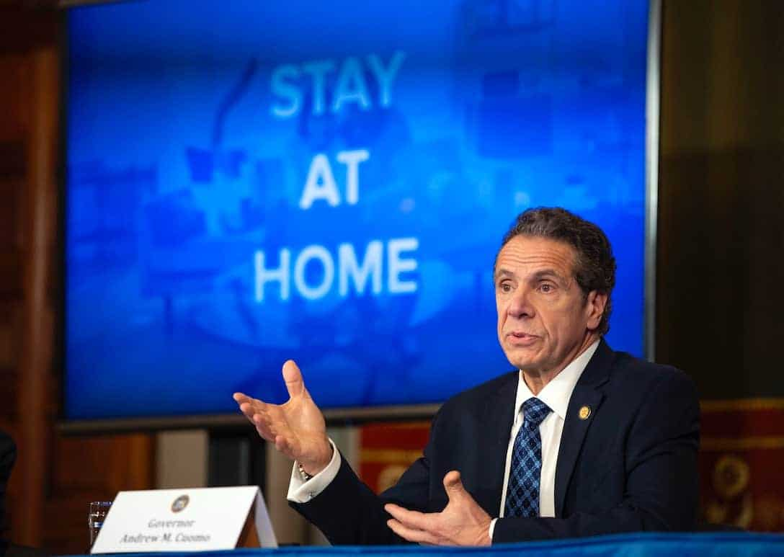

The most predominant factor that impacted the growth of JLP was Covid-19. The remarkable one among the policies is the Government’s ‘Stay at home’ policy which is said to the origin of the decline.
The Government made various amendments to the law structure during this pandemic and imposed vigorous trading policies that JLP found difficult to sink with their strategies of business operations. They had to adjust financially to a greater extent in order to prevent loss to their revenue. Despite of the efforts, the company suffered a major loss and had to pay very less wages to the employees.
Journal Strauss (2021) reported in Financial times that JLP was added in the list of employers “named and shamed” for paying employees below the legal minimum and this has brought embarrassment to the retailer amidst the customers [7].
Shift to Online shopping and Shop-closures
Journal Joanna Partridge reports on The Guardian that, on the other side, the ‘shopping-loving’ crowd stayed at home, obeying the lockdown rules and shifted to online – shopping culture. As a result of this John Lewis permanently closed 8 of its 50 stores with a potential risk of 1300 job losses [8].

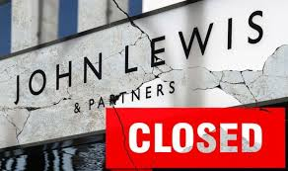

During the lockdown, there was a plenty of job-losses across UK in various industries like Retail, Hospitality, Real-Estate, Construction etc. So the Government introduced the Furlough scheme to help the businesses however the people were not paid in full and still plenty of them suffered job losses. Financial Times journal Eley says that, about 14,000 employees of John Lewis were furloughed under the UK government ‘s job retention scheme and several thousand employees were transferred to Waitrose [9].
Economic fluctuations and Price cuts
Once the lockdown came to an end, government imposed a rise in taxes & prices. There was a severe economic fluctuation across the country which greatly impacted the life-style of consumers. People were not keen on top brands, instead chose to buy conventional clothes as most of them did work from home.
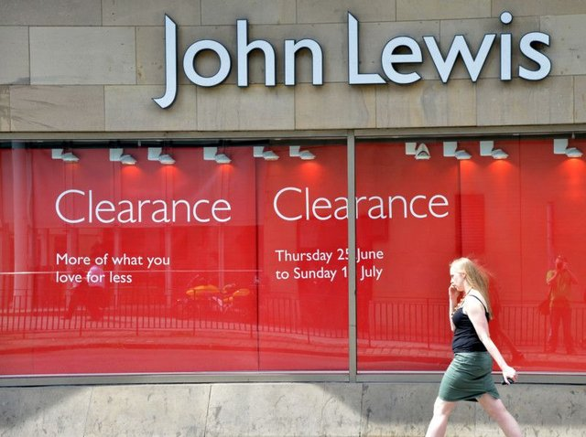

BBC Reporter Plummer (2018) reports that JLP Chairman, Mayfield told the main reason for the decline in profit is all about margin and they had to cut prices to match with those of competitors. She also blamed an increase in the cost of buying goods overseas due to the higher import prices [10].
Cancellation of international expansion plans

Author Rigby ( 2020) says, John Lewis has ended its plan of international expansion as they are now only focusing on serving local UK customers. He also says the company no longer accepts orders for over-seas delivery as JLP believes it is too expensive especially in the current situation [11].
Abandoned Christmas Sale


Christmas celebrations were very simple, celebrated within the families with no guests. As known by all, JLP is popular for branded office clothes and products related to Christmas celebration. The Lockdown closed the offices and made office-goers to work from home .This lead them to causing stop buying office clothes and also refrained from buying presents for Christmas or Christmas related products; there was no Christmas parties or gatherings.

SWOT Analysis

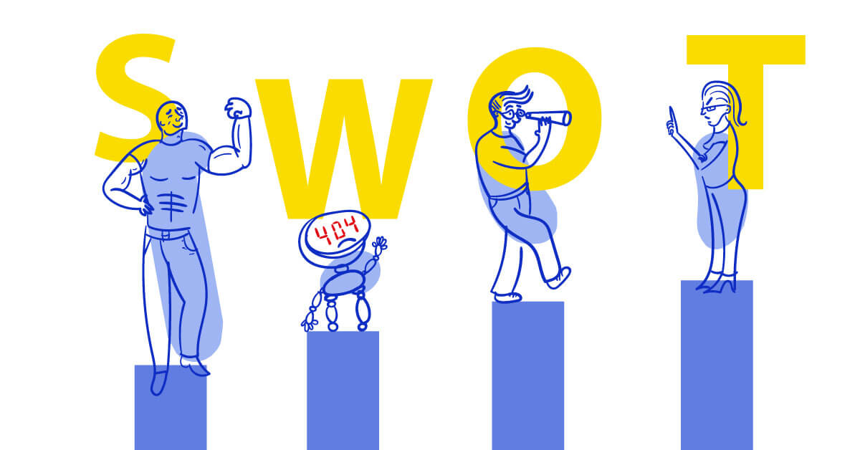

STRENGTHS | WEAKNESSES
Possessing top brands | Inconsistent Profitability
Numerous business sectors | Lack of International presence
Innovation & Creativity
OPPURTUNITIES | THREATS
Increasing demand for Private Labels | Stringent laws and regulations
Scope to enter new markets | Vigorous Competitors

Strengths
The remarkable reason for JLP’s possession of top brands is its overall global presence and its reputation everywhere across the world. The major brand value of JLP lie along the lines of performance, innovation & growth. John Lewis have their hands of various sectors such as home furnishings, decors, outfits and they offer services like personal styling, opticians, beauty services, property holding operations, insurance, car finance and management services as their challenge is to continually provide customers with greater choice of the products to improve their lifestyle. JLP has always focused on innovation and creativity as its key strategy which has increased their product portfolio and customer engagement for the company.

Weaknesses
Profits were unreachable and adding to this, they had to cut prices to match with those of competitors. JLP cancelled their plan of international expansion to focus on local customers.
Opportunities
The Rise in demand for private labels in JL is because they know their customers better, so they can flexibly design their own products with lower costs involved. Reporter Davey (2021) says John Lewis enters the investment market as a new venture to generate more revenue outside of retail [12].
Threats
JLP found difficult to follow the vigorous government regulations. JLP struggled with prices higher than competitors. Though the Organization sold top branded products, they promised to match the price of the product with any of its high street competitors to attract the customers.

PESTLE Analysis
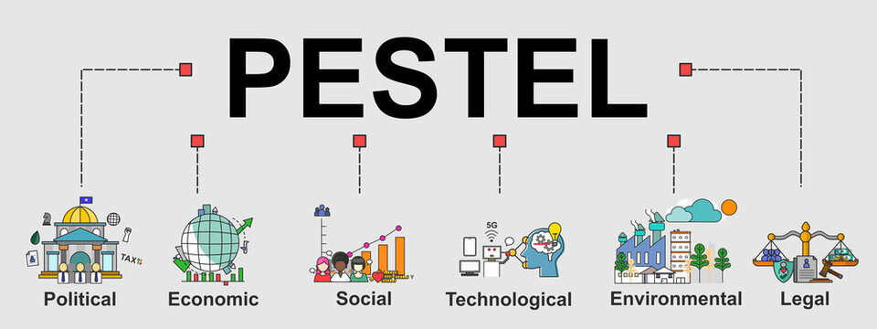

Elements | Factors | Impact
Political | Vigorous trade policies imposed by Government. | JLP found difficult to sink their strategies of business operations with Government policies.
Political | Lockdown & pandemic. | Redundancy, Scrapping staff-bonus, Deployment.
Political | Government’s Furlough scheme | Employees were disappointment for not being paid in full to manage their monthly bills.
Economical | Rising inflation, taxes, duties and recession | Shift in consumer spending.
Economical | Rising inflation, taxes, duties and recession | Shop closures.
Economical | Government’s Furlough scheme
Economical | Government’s Furlough scheme | Stops international expansion.
Social | Life style of Consumers change | JLP top branded products sold with high discounts to match with the prices of competitors.
Social | Online shopping | JLP spends on Online business and digitalization of business operations using Web – Commerce platforms.
Technological | Digital transformation | JLP digitalizes business operations using Web-commerce platform with a motive to make the business agile.
Technological | Tech innovations | IT of JLP brings in new technology to support & approve deployment electronically.
Environmental | Lacks on rating for sustainability & eco-friendly products | JLP pays no attention in elimination hazardous chemicals.
Environmental | Lacks on rating for sustainability & eco-friendly products | No evidence in minimizing textile wastes.
Environmental | Lacks on rating for sustainability & eco-friendly products | No evidence in minimizing textile wastes.
Legal | Unlawful practices | Paid employees less than legal minimum.

Political
The Varying trade policies with regards to import and export regulations imposed by the government impacts JLP’s business and its operations. Especially when the company suffered heavy loss due to the pandemic, it had an immense struggle to make their strategies of business operations sink with the vigorous government trade policies.
Economical
Economic fluctuations have driven consumers to spend less. The rise in taxes & prices and the recession due to Covid 19 has changed the spending habits of consumers.
Social
Life style of consumers have changed drastically following the lock down due to redundancy, deployment, being paid 80% on government’s furlough scheme etc. People have also switched to online shopping where they can compare prices and choose the retailer and their products according to their budget with variety of options.

Technological
John Lewis has transformed digitally with new innovations within their IT and business operations. Author Shein (2021) says JLP is aiming to become more agile, to be able to test and learn, especially with deployment. They are looking to automate the changes created for every deployment, making service-management agile [13].
Environmental
Good on you, the trusted source of sustainability ratings for fashion says, JLP’s environment rating is ‘not good enough’. It says, though JLP uses few eco-friendly materials, yet there is no evidence that it has taken fair action to cut down hazardous chemicals. Good on you also says there is no evidence it minimizes textile wastes & has no animal welfare policy [14].
Legal
Legal factors play an important role in the retail luxury industry. Therefore, it is the Organization’s duty to frame their company rules carefully to protect their employees from any unlawful practices. However, government added JLP in the list of employers “named and shamed” for paying employees below the legal minimum, bringing embarrassment to the Organization.

Conclusion

From the findings above, I conclude saying that, though John Lewis was a Retail giant, those factors mentioned above created a huge impact on its brand and business. Therefore, it is high time for John Lewis to
- focus on the welfare of employees,
- rebuild relationship with loyal customers,
- promote good environmental practices
- frame new business strategies coordinating with government policies
and this in turn will naturally uplift their brand, leading to growth of the business.

Referencing:
1.Hammett, E. (2020) ‘John Lewis prepares for 35% hit to sales this year’, Marketing week – 21(Pg 30)
2.Saker-Clark, H. (2021) ‘John Lewis Partnership narrows losses despite £54m hit from redundancies’, Independence.
3.Butler, S. (2021) ’John Lewis cuts losses to £29m but warns of Christmas uncertainty’, The Guardian.
4.Jahshan, E. (2021) ‘John Lewis prepares for 36% hit to sales this year’, Retail Gazette – Retail News.
5.Davey, J. (2021) ‘John Lewis Partnership to cut 1,000 management jobs’, Reuters - ‘Edited by James, W. and Clarke, D.
6. Jahshan, E. (2021) ‘John Lewis prepares for 35% hit to sales this year’, Retail Gazette Retail News.
7. Strauss, D. (2021) ‘John Lewis on ‘named and shamed’ list for breaching minimum wage’, Financial times.
8. Patridge, J. (2020 ) ‘John Lewis prepares to drop ‘never knowingly undersold’ pledge’, The Guardian.
9. Eley, J. (2020) ‘John Lewis Furloughs14000 staffs as corona virus hits sales’, Financial Times.
10.Plummer, R. (2018) ‘Is ‘Never knowingly undersold’ killing John Lewis?’, BBC. September 13.
11. Rigby, C. (2020) ‘John Lewis ends its strategy of international expansion – will stop delivering online orders abroad from next week’, Internet Retailing. Dec 1.
12. Davey, J. (2021) ’British Retailer John Lewis enters wealth management market’, Reuters. Aug 19.
13. Shein, E. (2021) ‘How John Lewis & Partners accelerated its Digital transformation’ Tech Beacon. May 13.
14. ‘John Lewis not taking adequate steps to ensure payment of a living wage for its workers’, Good on you - Journal - https://directory.goodonyou.eco/brand/john-lewis.

