

Public Perception of Police Pursuits

Joshua Jackson, Student Number – 2222457

BSC(Hons) Professional Policing Practice

June 2025

Word Count: 8585

Acknowledgements:

Balancing a full-time role as a police officer whilst undertaking a university degree has been both challenging and transformative. The first three years of my career in policing have significantly shaped my outlook, developed my resilience, and provided a unique perspective that has enriched this research into public perception of police pursuits. This dual journey has tested my limits but has also reinforced the importance of perseverance and support.

I am incredibly grateful to those who have supported and encouraged me throughout this journey.

Firstly, to my parents – Mum and Dad – Thank you for your unwavering support, encouragement, and belief in me. Your guidance and love have been vital throughout every stage of this process.

To Leah – Thank you for your constant patience, understanding, and motivation. Your support has been a source of strength and comfort during the most demanding time of this journey. This final year would’ve been far harder without you by my side.

I would also like to thank my dissertation supervisor for their guidance and constructive feedback throughout the year, which helped shape the direction of this research.

This dissertation is not only a culmination of my academic efforts but also a testament to the incredible people who have stood beside me throughout. I am truly grateful.

Declaration

This work has not previously been accepted in substance for any degree and is not being concurrently submitted in candidature for any degree.
Signed: Joshua Jackson
Date: 22/11/2024

STATEMENT 1
This dissertation is being submitted in partial fulfilment of the requirements for the degree of BA.
Signed: Joshua Jackson
Date: 26/06/2025

STATEMENT 2
This dissertation is the result of my own independent work/investigation, except where otherwise stated.
Other sources are acknowledged by footnotes giving explicit references. A bibliography is appended.
Signed: Joshua Jackson
Date: 26/06/2025

STATEMENT 3
I hereby give consent for my dissertation, if accepted, to be available for photocopying and for interlibrary loan, and for the title and summary to be made available to outside organisations.
Signed: Joshua Jackson
Date: 26/06/2025

STATEMENT 4
I hereby give consent for my dissertation, if accepted, to be available on the university’s IT system to those who have consent to use the system.
Signed: Joshua Jackson
Date: 26/06/2025

Abstract

This dissertation investigates public perceptions of police pursuits within the United Kingdom, with a focus on the demographic, social and media-based influences that shape public opinion. As police pursuits remain a highly visible and contentious aspect of modern policing, understanding how the public interprets their use is vital to maintaining legitimacy, accountability, and community trust. A mixed-methods approach was adopted, incorporating both quantitative and qualitative data collected via an online survey. Findings suggest that perceptions vary significantly by age, ethnicity, and exposure to media, with younger respondents generally more supportive of pursuits, while older individuals and those from minority backgrounds expressed greater concern over safety and fairness. Media coverage, particularly when focused on high-profile incidents or negative outcomes, was found to strongly influence strategies. The study concludes that while pursuits are viewed as necessary in serious cases, concerns over proportionality, transparency, and public risk persist. Recommendations include improving public communication, revising pursuit guidelines, and enhancing engagement with underrepresented communities. These findings contribute to ongoing discussions about ethical policing and highlight the need for a balanced approach that prioritises both public safety and public trust.

Abbreviations

College of Policing – CoP

Roads Policing Specialist Operations – RPSO

Force Control Room - FCR

Senior Leadership Team - SLT

Independent Office for Police Conduct – IOPC

Tactical Pursuit and Containment – TPAC

Initial Pursuit Phase - IPP

Table of Contents

Chapter One - Introduction 8
1.1 Background 8
1.2 Aims and objectives 8
1.3 Rationale 9
1.4 Structure 10
1.5 Conclusion 10

Chapter Two – Literature Review 11
2.1 Introduction 11
2.2 Police Pursuits: Definitions and Practices 11
2.3 Public perception of police practices 12
2.4 Risks and Consequences of Police Pursuits 13
2.6 Demographics and Perceptions 14
2.7 Research Gaps and Future Directions 15
2.8 Conclusion 15

Chapter Three – Research Methodology 16
3.1 Introduction 16
3.2 Research Strategy 16
3.3 Data Collection 16
3.4 Data Analysis 17
3.5 Limitations and Potential Problems 17
3.7 Ethical Considerations 18
3.8 Summary of Chapter 18

Chapter Four - Analysis of Results 19
4.1 Introduction 19
4.2 Overview of Survey Design and Methodology 19
4.3 Quantitative Data Analysis 19
4.3.1 Age and Risk Perception 20
4.3.2 Ethnicity and Trust in Police 21
4.3.3 Media Influence on Public Perception 21
4.4 Qualitative Data Analysis 23
4.4.1 Concerns About Public Safety 23

Chapter Five – Findings and Conclusions 26
5.1 Summary of key findings 26
5.2 Conclusions 26
5.2.1 Age and Risk Perception 26
5.2.2 Ethnicity and Public Trust 27
5.2.3 Media Influence and Framing Effects 27
5.2.4 Public Safety and Police Accountability 27
5.3 Recommendations 28
5.3.1 Clarify and Publicise Pursuit Policy Guidelines 28
5.3.2 Implement Independent Review Mechanisms 28
5.3.3 Improve Media Strategy and Public Messaging 28
5.3.4 Strengthen Community Outreach in Minority Areas 28
5.3.5 Mandatory De-escalation and Cultural Awareness Training 28
5.3.6 Enhance Future Research with Targeted Sampling 28
5.4 Limitations of the study 29
5.5 Final Reflections 29

Bibliography 30

Appendices 36
Appendix A: Online Survey Results 36
Appendix B: Ethics Form 45
Appendix C: Research Proposal Form 56

Chapter One - Introduction

1.1 Background

Police pursuits have historically served as a key tool in police forces worldwide, enabling officers to respond swiftly to criminal activity and apprehend fleeing suspects. However, their use remains controversial, particularly when public safety is compromised or fatalities occur. Although pursuits may be warranted in cases involving serious offences, concerns about proportionality, necessity, and public awareness of pursuit protocols have grown considerably, (HMICFRS, 2022).

In the UK, the issue is further complicated by the policing model built on public consent. Trust is central to the model, and any use of high-risk tactics – especially when poorly communicated or perceived as excessive – can erode community confidence, (Bowling, Reiner, and Sheptycki, 2019). High-profile incidents involving fatal outcomes have intensified public scrutiny, raising challenging questions about accountability and the quality of police communication during critical incidents.

The Ely incident in South Wales exemplifies this tension. Initial police denials of pursuit involvement were later contradicted by CCTV footage, leading to widespread public unrest and diminished trust. Such events highlight the essential need for procedural transparency, real-time risk assessment, and accurate communication.

These concerns are reflective of a wider national trend. Trust in UK policing has declined, particularly among communities historically subjected to disproportionate enforcement, (Murray, 2013). Police pursuits, therefore, are not only operational decisions but also tests of legitimacy that directly affect public perceptions of fairness and institutional integrity.

Understanding how the public views these tactics is essential – not only for policy development but also for reinforcing the foundations of democratic policing. This dissertation explores public perception of police pursuits, how these perceptions are shaped, and the broader implications for legitimacy, operational practice, and public safety.

1.2 Aims and objectives

The primary aim of this research is to investigate public perceptions of police pursuits within the UK, with particular attention to the factors that shape both positive and negative viewpoints. This study seeks to provide a nuanced understanding of how the public evaluates the legitimacy and justification of pursuits, ultimately offering insights that can inform national policing practices.

Objectives:
- To identify and analyse the key factors that contribute to negative public perceptions of police pursuits.
- To explore the influences that lead to positive public perceptions and support for police pursuit practices.
- To examine public opinions on what constitutes a justified police pursuit, and how these views compare with existing operational policies.
- To offer evidence-based insights that can support UK police forces in understanding and responding to public attitudes towards police pursuits.

By addressing these objectives, the study aims to contribute to more transparent, accountable and publicly informed approaches to pursuit-related decision making across UK policing.

1.3 Rationale

Operational Legitimacy and Risk

Pursuits are among the most visible applications of police power, often unfolding in public spaces and under media scrutiny. Their potential to cause harm to suspects, officers or bystanders places them under constant evaluation. This research investigates whether current practices align with current expectations regarding risk and legitimacy, (Waddington, 2007).

Media Influence

Media coverage often focuses on dramatic or tragic outcomes, particularly where pursuits involve young people or vulnerable individuals. These narratives can influence public perception, sometimes without sufficient context (Chermak and Weiss, 2005). Understanding this dynamic is crucial for refining communication strategies and maintaining public confidence.

Community Trust and Representation

Trust carries significantly across communities. Research shows that individuals from minority ethnic backgrounds are more likely to report negative experiences with police and perceive enforcement as excessive (Sharp and Atherton, 2007). This study includes diverse public voices to assess whether pursuit practices are viewed as fair across demographic lines.

Addressing a Research Gap

While clear policy frameworks govern police pursuits, limited research explores how the public perceives these policies. By analysing public views and comparing them with operational guidance, this dissertation contributes to filling a policy-relevant gap and informs future approaches to risk, transparency and engagement.

Practitioner-Researcher Perspective

As a serving police officer, this research offers practical insights that enrich the academic inquiry. This dual perspective bridges theory and practice, offering grounded reflections on how legitimacy and accountability play out in real-world policing scenarios.

1.4 Structure

This dissertation follows a logical structure:

Chapter One – Introduction

Introduces the research context, aims, rationale and structure.

Chapter Two – Literature Review

Review’s key themes including public trust, pursuit protocols, media influence, and demographic variation.

Chapter Three – Methodology

Details the mixed-methods approach, survey design, data analysis, and ethical considerations.

Chapter Four – Analysis of Results

Presents findings organised by themes and demographic trends, integrating both quantitative and qualitative data.

Chapter Five – Findings and Conclusions

Summarises the research outcomes, discusses implications for policy and practice, and offers recommendations for future work.

1.5 Conclusion

This chapter has set the foundation for examining police pursuits through the lens of public perception, operational legitimacy, and institutional accountability. Pursuits are more than tactical responses – they are moments where public trust is tested and often reshaped. By exploring how these interventions are viewed, especially across different communities and media contexts, this study contributes to ongoing efforts to improve legitimacy, refine operational guidance, and enhance police-community relations.

The following chapters expand on these themes through a detailed review of literature, original data collection and critical analysis.

Chapter Two – Literature Review

2.1 Introduction

Police forces across the nation have been utilising the tactic of police pursuits since policing began, the use of this tactic inherits public scrutiny upon police forces and the officers who are involved in using such tactics. The use of police pursuits balances how police forces are tackling, preventing and catching dangerous criminals whilst potentially jeopardising public safety, making it critical that this tactic is used correctly, minimising the risk towards the public.

Police forces across the UK have a duty to understand public perceptions of them using tactics such as pursuits, especially British police forces working off the ‘Policing by Consent’ model, (Torrible, 2022). This article stresses how police forces will suffer without the trust of the public and, how their attitudes and reactions to the public’s concern directly affects this. This literature review focusses on the key themes in policing causing a rise in police pursuits, the direct risks of pursuits, media portrayals and how this damages trust within policing and the demographic influences on how police forces react to tackling crime.

This chapter critically examines how public perception of police pursuits is constructed and influenced. It interrogates definitions and procedures from official sources, evaluates media and demographic influences through a theoretical lens, and identifies notable research gaps that limit our understanding of legitimacy and risk in pursuit practices.

2.2 Police Pursuits: Definitions and Practices

The College of Policing (2024) outlines that a pursuit begins when a driver fails to stop after police signals, prompting officers to follow whilst actively assessing associated risks, suggesting that if a driver of a vehicle makes no indication or shows any intention of stopping after being told to by police emergency equipment (blue lights/sirens). Or if the police driver continues behind the subject vehicle after attempting to make a compliant stop with the subject vehicle failing to comply.

Across the UK, different police forces have their own policies and procedures around the authorisation of police pursuits as well as who and when they can be used. Some forces will allow response officers to engage in a pursuit after they have completed the required training. Whereas other forces will not allow ordinary response officers to engage in a pursuit and will only allow dedicated/specially trained traffic officers, more commonly known as Roads Policing Specialist Operations (RPSO) officers to engage in such a tactic, as highlighted by the National Police Chiefs Council (2009). However, the training requirement for engaging in pursuits is the same, nationwide, being that any officer engaging in the initial pursuit phase (IPP) must have successfully completed the “Initial phases pursuit course”, West Yorkshire Police, (2024). This course will provide the essential training to effectively risk assess the pursuit and relay all this information back to the force control room (FCR), seeking advice for authorisation to continue from the senior leadership team (SLT) reviewing the pursuit.

For a pursuit to begin, a police officer must have witnessed a crime taking place or have intelligence upon the vehicle/individual driving that vehicle that they have committed a crime. However, the type of crime which has been committed will determine if it is severe enough to authorise a pursuit, potentially endangering the lives of the public. The College of Policing (2024) stresses the steps which should be taken to prevent a pursuit from occurring avoiding unnecessary risk to anyone directly or indirectly involved.
While pre-emptive tactics are promoted to avoid high-risk pursuits, their effectiveness in practice remains a subject of concern, Officers are advised to consider alternatives such as maintaining distance, requesting support units, or using tactical measures like stingers and TPAC (Tactical Pursuit and Containment) strategies. However, these options are not always feasible, especially in rapidly evolving situations where time is limited. The College of Policing (2024) highlights various factors that should influence the decision to initiate a pursuit – such as time of day, pedestrian density, and whether the suspect is known to pose a risk of violence. Despite these guidelines, inconsistencies remain in how policies are applied across forces. It is unclear whether these procedures consistently prevent harm or simply transfer risk to different stages of police engagement. While national training standards exist, further statistical evidence would help determine where the current approach effectively reduces pursuit-related incidents or merely standardises response procedures. A more in-depth evaluation of outcomes across regions is needed to assess both the strengths and limitations of existing policies (College of Policing, 2024).

2.3 Public perception of police practices

The public’s perception on police pursuits is directly impacted on the perception of police in their day-to-day job, (MacDonald, and Alpert, 1998). Research by Owen-Evans and Law (2024) and Bradford and Myhill (2015) has shown that police who have more of an active presence within their communities and engage with members of the public regularly have a positive impact on how the communities engage and respond to being policed. (Owen-Evans and Law (2024)’s study showed that the overall trust in UK policing has declined, outlining that in October 2024, 52% of adults asked, stated they did not have trust in UK police, as opposed to 39% in October 2019. It is found that the general public’s attitude towards police practices is primarily negative.

The decline in trust in UK police forces has formed out of a “series of high-profile cases of gross misconduct and illegal behaviour by police officers” (Taylor, 2023). Taylor (2023) explains the seemingly never-ending stories and media coverage about police officers committing heinous crimes. More recent examples include the Sarah Everard kidnap and murder (Bhattacharyya, 2021) closely followed by the Chris Kaba story, (Curran, 2022). Both stories take an alternate perspective, whereby Sarah Everard was kidnapped and murdered by an off-duty police officer, abusing his position, whereas Chris Kaba has been fatally wounded after a police incident involving firearms officers. Both incidents have significantly damaged public trust and confidence in police officers, ultimately undermining overall faith in policing, (Choi, Yim and Hicks, 2020). Drury et al., (2020) describes the police as the “common enemy,” suggesting that negative media coverage of police incidents directly correlates with increased public unease towards police enforcement (Telesco, 2020).

Incidents like the Sarah Everard case have had a profound impact on public confidence in policing, drawing attention to issues of accountability and institutional trust, (Bhattacharyya, 2021), as well as the fatal shooting of Chris Kaba, (Curran, 2022). Whilst media coverage can intensify public reactions, it is the severity of these incidents that primarily drives mistrust. Choi, Yim, and Hicks (2020) note that such events damage community-police relations, whilst Drury, et al., (2020) suggests that repeated negative portrayals contribute to framing police as a “common enemy”. Thus, both the incidents themselves and the way they are reported play roles in shaping public perception.

The South Wales Police pursuit in May 2023, which led to the deaths of two young males on an electric bike, underscores the wider implications of how police communication impacts public trust, (IOPC 2024; BBC, 2023). Initially, South Wales Police denied any pursuit had occurred, but later acknowledged officers had been following the individuals and released CCTV evidence to that effect, (South Wales Police, 2023). This reversal contributed to public unrest, including rioting, and raised concerns about transparency and accountability (Harrison, 2023). In response, updated policies now restrict pursuits involving motorcyclists not wearing helmets, (Clark, 2024). This incident reflects a broader issue: when police communication is inconsistent, especially following critical incidents, it can erode public confidence and raise questions about the legitimacy of police practices.

2.4 Risks and Consequences of Police Pursuits

Police pursuits inevitably come with a high risk to everyone involved, and more so not involved. Suspects are willing to go to great lengths to evade capture and are willing to take high risks whilst on a public highway. This is existential to the crime/level of care they have towards other road users and pedestrians. IOPC (2019) highlights the most severe outcome of a police pursuit, showcasing that per annum, according to the IOPC data (2019), police pursuits result in approximately 30 deaths annually across England and Wales, reflecting the inherent dangers of such operations, demonstrated by the below graph, (IOPC, 2017).
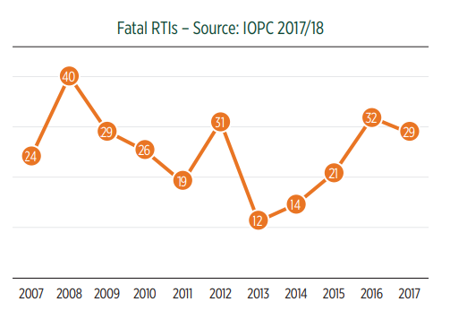

Fatalities

The College of Policing (2024) emphasises that officers must continuously assess the level of risk during a pursuit to ensure it remains proportionate and justified. This includes evaluating factors such as road conditions, time of day, and the suspects behaviour. Officers are also trained to recognise the onset of ‘red mist’ – a state of heightened emotion or tunnel vision that may impair judgement. A failure to identify this can lead to poor decision-making and unnecessary escalation, potentially endangering the public, the suspect, and the officers involved, (College of Policing, 2024).

The consequences of a police pursuit ending with a fatality will result with an automatic referral to the IOPC (IOPC, 2023). Alongside this will be the detrimental impact on loved ones losing a family member, subsequently affecting the relationship with the police and their local communities. A recent event whereby a police pursuit led to a referral to the IOPC was recorded in 2021 (IOPC, 2023), whereby a speeding vehicle was pursued by police, and shortly after ended in a collision, resulting in four attending hospitals with significant injuries and one losing their life. The collision occurred during the initial stages of the pursuit, meaning it hadn’t yet been reviewed by the senior leadership team (SLT) to authorise the pursuit to continue (IOPC, 2023). This incident underscores the broader issue that even well-intentioned police pursuits can escalate rapidly, reinforcing the critical need for clear policies, sound judgement, and continual risk assessment to protect public safety and maintain trust in policing.

2.5 Media and Public Opinion

How the media surrounding pursuits is presented and which platforms have published these stories will attract the attention of different demographic personalities. Televised and printed news outlets tend to attract an elder audience, (Bergstrom, 2020). Bergstrom, (2020) states that elder communities seek to receive their news through “traditional media outlets”. Whereas social media platforms will attract a more youthful audience, (Loh, Sun, and Weninger, 2023). The reaction the media will result in, is solely dependent on how it is presented to the audience viewing the content. OFCOM (2024) have recently published their findings of research showcasing the different age groups and what their news is consumed through, explaining that 82% of young adults will get their news through social media platforms whereas 85% of adults over 55 will consume their news through televised platforms, live broadcasted news. Therefore, Police forces having a successful social media platform, will dramatically increase their connection with the younger age group, due to them being more likely to interact with their content through social media.

Police are often in the limelight when it comes to media attention which inevitably reflects on how police forces are perceived by members of the public nationwide. Research by Society of Editors (2024) found that 67.5% of published stories are either neutral or positive as opposed to the remaining 32.5% being negative. Although this suggests that the media portrays a positive perception of the police, Gower (2023) found that people are more likely to remember the negative media stories.
This is commonly referred to as “negativity bias” implying subconsciously, humans tend to overlook the positives and find the negatives, (Vaish, et al., 2008). Taking negativity bias into consideration, forces need to deem rebuilding the relationships between the police forces and communities as a priority within their role.

Although it is known that police pursuits are a core part of apprehending criminals, it has been identified the public’s outlook on police pursuits is heavily dependent on the level of crime which has been committed. MacDonald and Alpert (1998) suggest that the public are supportive of police pursuits if the level of crime committed reflects the risks which will continue to be taken during a pursuit. MacDonald and Alpert’s (1998) report concludes that the public are more receptive to the use of police pursuits if the nature of the crime is high, however they’re less receptive when the dangers a pursuit poses is presented to them, especially for a lower-level crime. This implies that officers pursuing a vehicle that fails to stop for them, is not proportionate enough to justify a pursuit of that vehicle, however if a known offender is failing to stop, and is wanted for serious offences, the public are more likely to approve of the use of a police pursuit.

2.6 Demographics and Perceptions

Payne, Hitchens, and Chambers, (2017) highlight that many younger people from ethnic minority backgrounds report lower levels of trust in the police, shaped by a combination of lived experience, perceived misuse of police powers, and broader social narratives. While negative media coverage plays a role in reinforcing these perceptions, it is not the sole factor. Instead, these attitudes often reflect a more complex reality – one shaped by ongoing issues of inequality, historic tensions, and personal or community-based interactions with police forces. Highlighting the importance of viewing public trust as a multifaceted and deeply rooted issue.
Briggs (2018) implies that news articles involving police and individuals from a demographic background typically receive more media coverage and interaction with the public, this has become apparent since the Steven Lawence enquiry and has been something which police forces face to this current day, often being referred to as “institutionally racist” (Stone, 2013). Of recent times, the death of Chris Kaba that has caused massive upset throughout communities from ethnic backgrounds, disrupting trust between these communities and police, (Liddle, 2024).

Media agencies have been said to carefully choose a headline in a way which is going to get the most attention for their news report (Briggs, 2018). This research investigates the process of news media agencies and how they report upon police pursuits, showcasing the disproportion of pursuits which are chosen to be reported on that have resulted in injury or fatality, as opposed to reporting on successful pursuits whereby the offender has been successfully apprehended, without anyone being injured. Inevitably, affecting the perceptions of the public on pursuits.

2.7 Research Gaps and Future Directions

This literature review researches into the public perception of police pursuits, including the impact that the media can have on the opinions of the public. It is evident that there is limited research into what the public believes to be a justifiable offence for a police pursuit to take place. This research project aims to identify some of the gaps in research, focusing on how these offences can be identified during the “initial pursuit phase” and understanding how to appropriately manage the risks to anyone involved or not involved in a pursuit. The hope is that this research project will compare, analyse and contrast the different opinions to conclude the public’s perception of police pursuits.

2.8 Conclusion

The literature review of public’s perception of police pursuits has identified that they are majorly influenced by the risks involved of any pursuit, how the media portrays stories involving police pursuits and the demographic factors impacting the confidence and trust within police. There appears to be a mounting collection of studies advocating for a reform within British policing and the use of police pursuits. This literature review has identified important gaps within the literature which this study aims to fill.

Chapter Three – Research Methodology

3.1 Introduction

This chapter outlines the methodology employed to investigate public perceptions of police pursuits. Featuring a research strategy, data collection, data analysis/limitations, potential challenges, and ethical considerations. The objective is to apply a structured approach that supports credible and transparent findings. As identified in the literature review, there remains limited research into what the public considers a justified reason for police officers to initiate a pursuit. This research methodology addresses that gap by capturing a range views from participants, offering an evidence-based understanding of public attitudes.

3.2 Research Strategy

This research inherits a mixed-methods strategy, combining both quantitative and qualitative data to explore how the public perceives police pursuits. The sensitivity and complexity of the topic – shaped by personal experience, media representation, and wider societal influences (Briggs, 2018) – necessitate a multi-dimensional approach.

A structured online survey will serve as the primary data collection tool (Keough and Tanabe, 2011). Quantitative questions will produce measurable data for comparison across different demographic groups. Open-ended, qualitative questions will allow participants to express their individual opinions in more detail, (Tang, 2020). The survey will be anonymous to encourage candid responses and will be distributed to individuals from a range of demographic backgrounds.

To support validity and inclusivity, a random sampling technique will be used, (Emerson, 2015). This strategy aims to minimise bias and ensure a balanced representation. Stratified sampling will also be applied, where responses from different demographics are analysed separately, helping to identify any patterns or inconsistencies (Stratton, 2024). Selected responses will be analysed within demographic categories to facilitate comparison. The overall strategy is designed to produce meaningful data that reflects a variety of viewpoints, without overgeneralising, (Stratton, 2024).

It is important to acknowledge that while efforts have been made to reduce bias, no method can guarantee purely objective or universal truths. This study seeks to add insight and depth to an under-researched area, rather than aims to offer definitive conclusions.

3.3 Data Collection

The data will be collected through an online survey, as this method is accessible, efficient, and has been shown to increase response rates due to reduced social pressure, (Wight, 2005). Participants may be more willing to provide accurate and honest responses when anonymity is assured, (Webroprol, 2024). The survey will include both quantitative (close-ended) and qualitative (open-ended) questions, offering a balanced method for gathering data suitable for both statistical and thematic analysis.

As outlined by Verhoef and Casebeer (1997), using both types of questions allows researchers to explore both breadth and depth in participant responses. The quantitative section will include questions where participants rate or select answers using scales or multiple-choice options. These responses will be translated into charts to visually represent the data trends, as suggested by Unwin (2020), making this information more accessible to readers.

The qualitative section, positioned at the end of the survey, includes open-ended questions designed to allow for more nuanced opinions. This section aims to uncover the reasoning behind participants’ views, offering a richer insight into public perceptions, (Renjith et al., 2021). The survey will be prefaced with clear information about anonymity, voluntary participation, and data handling procedures.

Participant recruitment will take place via multiple channels to maximise reach and diversity. These will include email invitations, social media posts, and collaboration with local community groups. Targeted outreach will help engage people from various age groups, geographic locations, and socio-economic backgrounds. While social media offers convenience and reach, it is acknowledged that it may skew participation towards older demographics, as such, additional measures will be taken to share the survey in non-digital settings to better represent the wider public.

3.4 Data Analysis

Data analysis refers to the process of examining and interpreting the data to answer the research question, (Fauzi and Pradipta, 2018). Quantitative data will be presented in charts to aid visual interpretation, with comparisons made across demographic variables. This descriptive statistical approach will allow the identification of patterns, such as differences in responses based on age, gender or other characteristics. Outliers will also be considered to understand any anomalies or unexpected views.

Qualitative responses will be analysed using a thematic analysis approach. This method allows for the identification or recurring themes and opinion expressed across the data set, (Naeem et al., 2023). These themes will help demonstrate how different groups understand and relate to the issue of police pursuits. The analysis will highlight commonalities and divergences, aiding to contextualise the quantitative results and adding depth to the findings.

It is important to note that the aim of this study is to present descriptive insights rather than complex statistical inference. The data will be used to explore trends and themes rather than establish casual relationships or generalisations about the entire population.

3.5 Limitations and Potential Problems

This research method presents certain limitations. Relying on an online survey may introduce sampling bias, as not all individuals have equal access to digital platforms. This could result in underrepresentation of older adults or those with limited internet access, (Pokhriyal, Valentino, and Vosoughi, 2023).

To mitigate this, the survey will be circulated via multiple platforms – including email, social media, and community-based outreach to engage a broader demographic. Nonetheless, full representation cannot be guaranteed, and this limitation will be acknowledged in the analysis of results.

Another limitation lies in the self-selecting nature of survey participants. Those with strong opinions or relevant experiences may be more likely to participate, which could influence the balance of perspectives presented. While this research seeks to present a range of views, the findings will not claim to capture a definitive “public opinion”. Instead, they will offer a snapshot of views from a diverse participant group, helping to inform future research and debate.

3.7 Ethical Considerations

Ethical approval is an essential part of this research to ensure participants are protected throughout the study. The survey will be anonymous, with no personal identifiers collected, maintaining participant confidentiality. Informed consent will be obtained before participants begin the survey, clearly outlining the purpose of the research and their right to withdraw at any point without giving a reason. All data collected will be securely stored in line with GDPR requirements, and only the researcher will have access to this information. Given the potentially sensitive nature of police pursuits, care will be taken to reduce any risk of harm or discomfort to participants by ensuring the questions remain respectful and non-intrusive.

3.8 Summary of Chapter

This chapter has outlined the methodological framework for examining public perceptions of police pursuits. A mixed-methods approach using an online survey will generate both statistical and thematic data. A descriptive analysis will allow for the identification of trends across demographic groups, while qualitative responses will offer further insight into individual perspectives. While limitations regarding sampling and representation are acknowledged, the methodology has been designed to enhance validity and reduce bias. Ethical procedures are in place to ensure the security and wellbeing of all participants. The next chapter will present the findings gathered through this strategy.

Chapter Four - Analysis of Results

4.1 Introduction

This chapter presents the analysis of data collected from a survey examining public perceptions of police pursuits. A total of 25 participants responded to the survey, providing insights into how various factors – including demographic characteristics, media representation, and individual beliefs – shape opinions on police policies and practices. Drawing on both quantitative and qualitative data, the analysis interprets the survey findings in alignment with the methodology outlined in Chapter Three and the Literature Review outlined in Chapter Two. The aim is to develop a comprehensive and nuanced understanding of public attitudes towards police pursuits and to identify the key influences behind these perspectives.

4.2 Overview of Survey Design and Methodology

The survey produced for this study employed a mixed-method approach, incorporating both closed-ended and open-ended questions (Creswell, 2009). Closed-ended questions utilise a Likert-scale with the intention of capturing the respondents’ level of agreement and disagreement surrounding statements on police pursuits (Croasmun and Ostrom, 2011). The qualitative data received were then supplemented with open-ended questions, allowing respondents to provide written responses on their views of ethical implications and the overall effectiveness of police pursuits.

Targeting a diverse range of demographic characterises including varying age groups, ethnic backgrounds and socio-economic statuses ensured that the respondents answers incorporated the real views of the general public, with the goal of exploring how these factors influenced different attitudes towards police pursuits and how these perceptions are shaped by media portrayals and prior knowledge of police actions. The responses are analysed by using statistical methods (Mishra et al., 2019) for closed ended questions and thematic coding (Xu and Zammit, 2020) for open-ended questions providing both breadth and depth to the analysis.

4.3 Quantitative Data Analysis

The quantitative data provided by the survey responses revealed several important trends and correlations, highlighting the diverse range of public perceptions. Respondents were asked to rate their agreement with statements regarding the acceptability of police pursuits in various scenarios, including distinctions between minor and serious offences. The results indicated differing levels of support based on demographic variables. For instance, younger participants generally expressed more support for police pursuits, even in cases involving minor offences, whereas older respondents tended to be more cautious. Differences in opinion were also observed based on ethnicity and media exposure, suggesting these factors significantly influence individual perspectives on police pursuit policies.

4.3.1 Age and Risk Perception

One of the most notable findings in the responses from the various age groups is that 44% of respondents were between the ages of 18 and 24, with the next most popular age group being 25 to 34 accounting for 36% of respondents. 62% of younger respondents (those aged between 18 and 34) agreed that police pursuits should be permitted, regardless of the severity of the offence. This remains consistent with the findings from the literature review outlined in chapter two which suggested younger people regularly display a higher sense of trust in police forces and have a higher tolerance for risk (Timukaite, and Buil-Gil, 2025). Remaining in line with the social trust theory, younger individuals are mostly more trusting with authorities, and may not perceive the risks associated with high-speed chases as severely as the older generation (Doyle, 2024).

Figure 1: Age of Participants
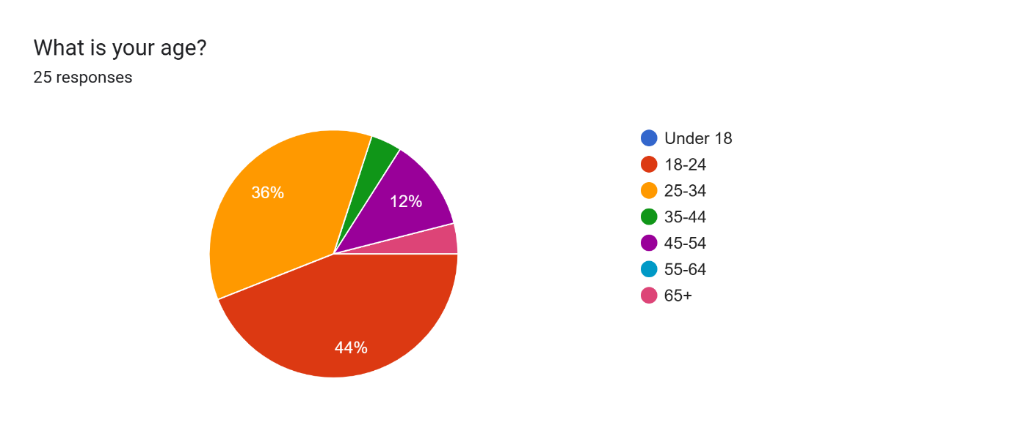
Figure 2: Necessity of Police Pursuits
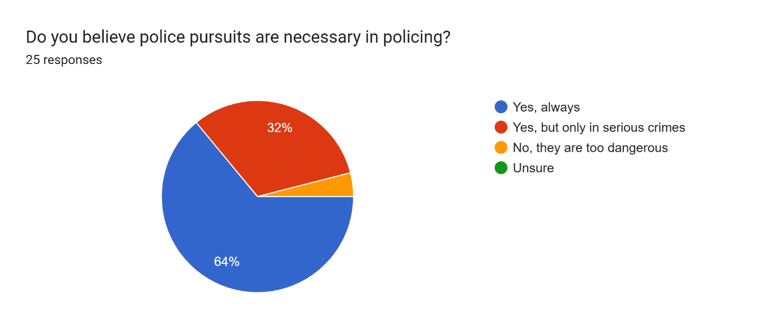

On the other hand, elder respondents (those over 45) were more circumspect in their answers, 68% of them agreed that police pursuits should only be used for major offences. This remains consistent with a study completed by Kappes, Greve, and Hellmers (2013) who discovered that older people are more likely to be risk adverse and worry about how police pursuits may affect their safety. Older participants frequently expressed concerns about potential accidents during pursuits and the safety of innocent bystanders.

4.3.2 Ethnicity and Trust in Police

The survey revealed a lack in responses from ethnic backgrounds, consisting of 25 respondents. With 5 stating they’re from communities of colour, whilst the remaining 20 respondents identified as white.

Figure 3: Ethnicity
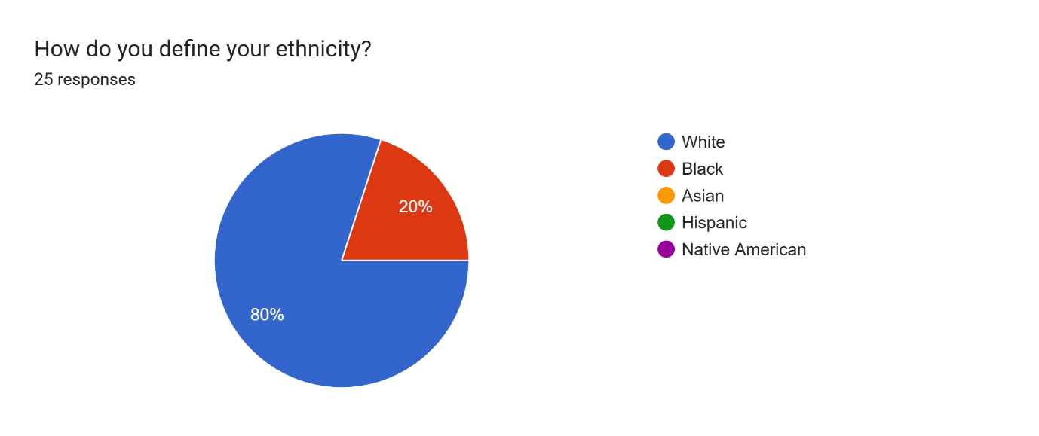

With only 20% identifying as black the statistical comparisons are limited, restricting the ability to draw a firm conclusion and should be interpreted cautiously. However, the initial patterns received, suggest that trust in the police varies by ethnicity, particularly around high-risk incidents such as pursuits. With most white respondents reporting they have trust in the police during pursuits, black respondents expressed lower levels of trust and the concerns they have revolving around pursuits. This disparity is consistent with Wheelock, Stroshine, and O’Hear’s (2019) research, which focussed on communities of colour tend to have lower levels of trust in the police.

Although the sample of ethnic backgrounds is small throughout the survey, the responses suggest that issues of trust are racialised, meriting a deeper investigation. The lack of ethnic diversity within this survey indicates the limitations in the reach, highlighting a potential bias in representation from the respondents, masking the extent of distrust from ethnic minorities.

4.3.3 Media Influence on Public Perception

Media exposure is a key factor on influencing opinions on police pursuits, as previously discussed in Section 2.5 of the Literature Review. The data collected from respondents within this survey has highlighted that 76% of people are exposed to media reports about crime and policing weekly. Respondents within this survey, who have reported being regularly exposed to media portrayals have generally been supportive of police utilising the powers of pursuits, however, have expressed deeper concerns to the safety of those involved, particularly the general public with 72% of respondents expressing their concerns of putting members of the public at un-necessary risk.

Figure 4: Watching or Reading News Related to Crime and Policing
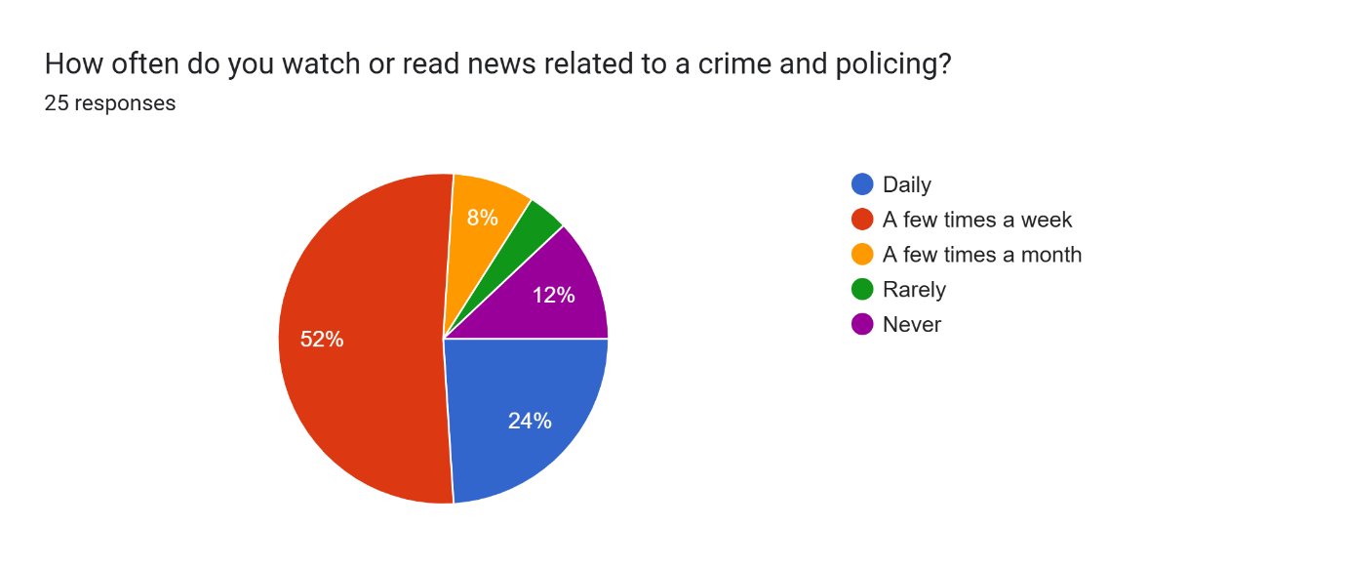
Figure 5: Concerns Regarding Pursuits
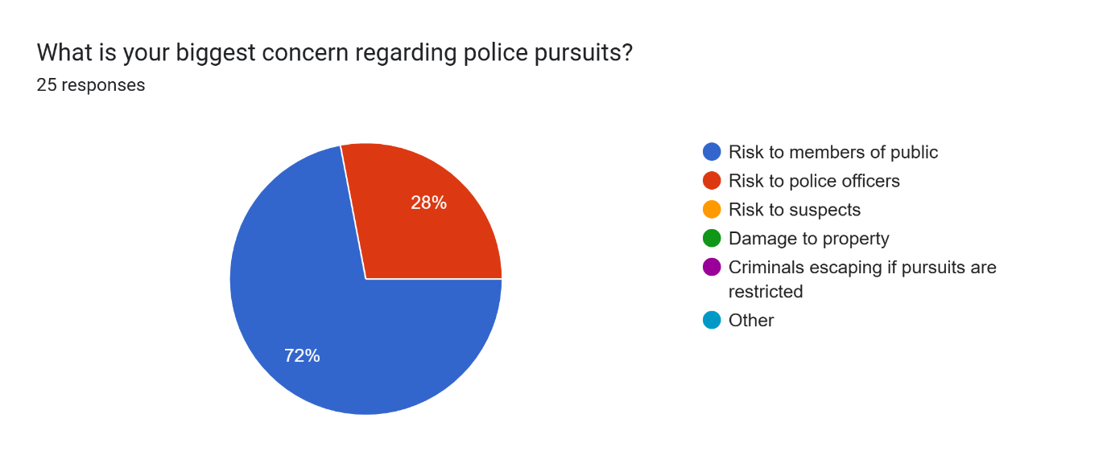
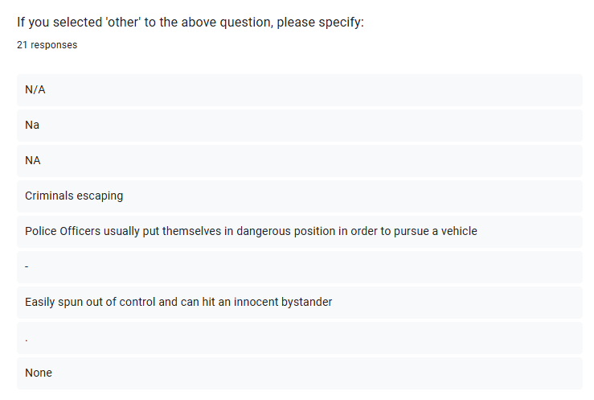

According to Vaish et al., (2008) the Negativity Bias Theory contends that negative media representations typically have a greater influence on public opinion than positive ones. The findings of this survey are consistent with this theory. The publics opinion of police pursuits’ efficacy and morality is probably greater influenced by how the media portrays them, especially when it comes to their possible risks and unfavourable outcomes.

4.4 Qualitative Data Analysis

The open-ended responses from participants highlighted further insights into the views of the public. Showcasing several recurring themes related to ethical implications, public safety concerns and the role of police accountability.

4.4.1 Concerns About Public Safety

A major concern raised by respondents was the safety implications associated with police pursuits. Many respondents emphasised that pursuits should be limited to situations whereby there is a clear and immediate threat to public safety. Figure 6 focusses on the biggest risks and disadvantages to police pursuits, with several participants highlighting their concerns over the safety of everyone involved, either directly or indirectly. With several participants expressing their concerns over injury or death, “The risk it poses on everyone involved”.

Figure 6: Risks/Disadvantages of Police Pursuits

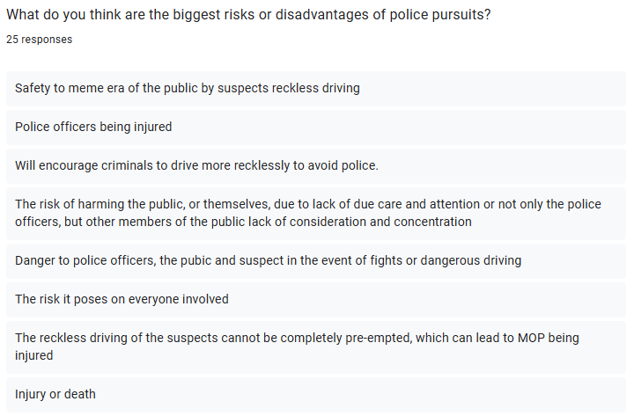
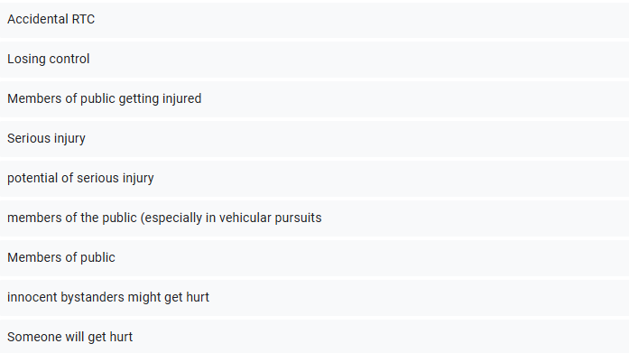
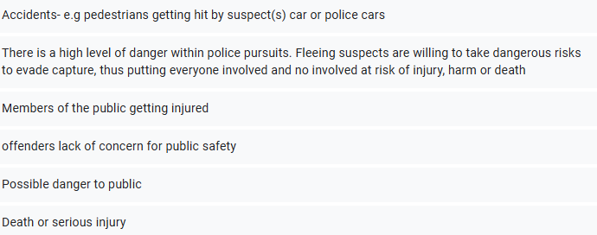

Figure 7 refers to participants suggesting alternative methods for police pursuits, which have been suggested all need to be considered, leaving a pursuit as the last remaining option. With several participants highlighting a lack of police on the ground, potentially deterring criminals from wanting to flee from police. These findings are consistent with the Public Safety Theory, which posits the primary responsibility of police is to protect the public, expressing how pursuits often lead to unintended harm to innocent bystanders, (Goulka, Pozo and Beletsky, 2021)

Figure 7: Better Alternative to Police Pursuits
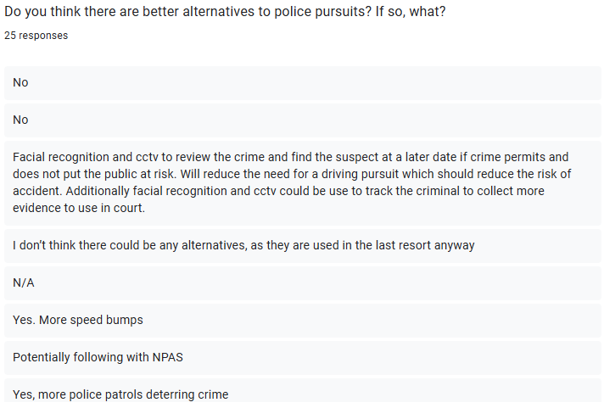
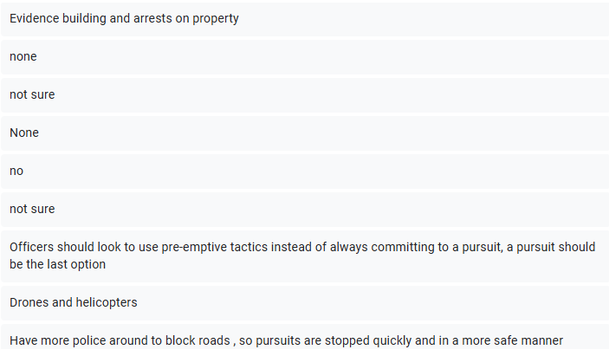

4.5 Conclusion

This analysis of the survey data collected exaggerates the multifaceted nature of public perception on police pursuits. Demographic factors as well as the influence of media portrayals, directly shaping of the perception of police pursuits. The findings suggest the requirement for greater transparency and accountability requiring a more nuanced approach. Practising public safety and addressing concerns of racial profiling. These insights contribute to the wider discussion of police policies and procedures, creating recommendations for future policy considerations.

Chapter Five – Findings and Conclusions

5.1 Summary of key findings

The purpose of this dissertation was to explore the public’s perception of police pursuits throughout the United Kingdom, aiming to develop on key themes identified within the literature review, outlined in Chapter Two and corroborated through the mixed-method survey-based methodology in Chapter Three. Utilising analysis of both quantitative and qualitative data, the research confirmed that public perception is shaped by a range of demographic variables, such as age, ethnicity, media portrayals and police conduct, while broader concerns surrounding safety and accountability emerged. These results resonated with patterns observed in the literature, including the works of MacDonald and Alpert (1998), Payne et al. (2017) and the College of Policing (2024), which mutually underline the sensitivity of police powers in public consciousness.

The methodology was designed to identify both statistical and in-depth personal beliefs allowed for a rugged analysis going beyond superficial generalisations. Highlighted within Chapter Three, combining quantitative Liker-scale items with open-ended questions allowed for the identification of demographic trends as well as exploring the layered perceptions in respondent’s own words. By utilising this approach, the literature gap was addressed, noted in section 2.7, particularly the lack of public insight into what is considered a ‘justifiable’ use of pursuit and how these opinions vary across communities.

5.2 Conclusions

The conclusion drawn from the completed study, reinforced the themes that emerged from the literature as well as adding empirical depth. From this, four major conclusions have been identified, age and risk perception (5.2.1), ethnicity and public trust (5.2.2), media influence and framing effects (5.2.3), and public safety and police accountability (5.2.4) all deepened with both theory and data.

5.2.1 Age and Risk Perception

This study highlights how age significantly impacts how different people perceive risk in relation to police pursuits, remaining in line with research conducted by Rolison et al. (2014) and the College of Policing (2024). Younger respondents (ages 18-29) were generally more favourable of police pursuits, even for minor infractions. According to the qualitative data highlighted in Chapter Four, 62% of younger adults agreed that any failure to stop, calls for immediate police action. Comparatively, 68% of older participants suggested that pursuits should only be used for violent or high-risk crimes.

The findings noted above align with the risk aversion theory and the concept of generational policing expectations, both referenced within the literature chapter, (2.4 and 2.6). the collected data validates MacDonald and Alpert’s (1998) observation that older individuals tend to perceive greater risk, particularly in situations where public safety may be compromised. This suggests police communication strategies must be detailed to different age demographics, a point highlighted within the research methodology outlined in Chapter Three, where the sample was intentionally varied in age to surface these contrasts.

5.2.2 Ethnicity and Public Trust

Complementing the results of Section 2.6, which includes the writings of Stone (2013) and Payne et al. (2017), the longstanding distrust between police forces and ethnic minority communities were echoed within the survey findings. Ethnic minority respondents, though underrepresented, voiced their reservations towards police pursuits, regularly expressing fears of racial profiling and excessive use of force. This remains centred with the broader concerns demonstrated through cases such as Chris Kaba’s, detailed in the literature review.

While Chapter Three recognised that distributing the survey online might lead to the underrepresentation of certain communities, the analysis of the qualitative responses uncovered widespread feelings of distrust (Section 4.4.2), underscoring the need for culturally competent policing. These results support earlier studies, reinforcing calls for targeted community engagement strategies and anti-bias training. Additionally, it highlights the importance of future research targeting more inclusive sampling, as identified in the limitations section of Chapter Three.

5.2.3 Media Influence and Framing Effects

A significant finding from both the literature review (Section 2.5) and the data analysis (Section 4.3.3) is the notable influence media has on public perceptions of police pursuits. The literature identifies the media as a framing tool (Briggs, 2018) expressing the tendency to prioritise dramatic and negative narratives, also known by Vaish et al. (2018) as “Negativity Bias”. Corroborated throughout the present study, where individuals who have said they are regularly exposed to news stories involving fatal or injurious pursuits, were more likely to oppose the tactic altogether.

The choice to include open-ended questions in the methodology proved to be a crucial decision. Participant responses revealed that participants’ opinions were more strongly shaped by media narratives than by direct personal encounters, with several individuals noting that specific news stories had shifted their views. Aligning with Bergstrom’s (2020) observation that both the format and platform of news significantly influenced beliefs, particularly among younger users on social media. These findings highlight the need for proactive police communication strategies that offer balanced, factual accounts of pursuit incidents (5.3.4), reinforcing a call made by Society of Editors (2024) in the literature review.

5.2.4 Public Safety and Police Accountability

The advocacy for accountability was a recurring theme throughout both the literature review and the survey data. Chapter Two emphasised how pursuit-related fatalities, such as those cited by the IOPC (2019 and 2023) have intensified public scrutiny and minimised confidence in police decision making. The survey results obtained, and thematic coding confirmed that the public is not inherently opposed to pursuits, but, demands clear justifications, real-time risk assessment and post-incident transparency.

Chapter Four consistently emphasised how respondents rated “public safety” as a top concern, with many questioning the purpose of pursuits initiated over minor offences. Closely aligning with the principles of proportionality outlined by the College of Policing (2024) and MacDonald and Alpert’s (1998) emphasis on perceived justification. The study substantiates these findings by providing contemporary data on how these concerns manifest across different communities.

5.3 Recommendations

In response to the findings from the research project and building upon themes explored in Chapter Two and Four, the following recommendations are proposed.

5.3.1 Clarify and Publicise Pursuit Policy Guidelines

Emphasised in the literature review, (Chapter 2.7), police forces should aim to make pursuit policies more accessible and understandable to the public. Establishing transparent pursuit criteria and ensuring public access to post-incident evaluations are attainable. Enhancing legitimacy, trust and fostering confidence within police forces.

5.3.2 Implement Independent Review Mechanisms

Drawing from the IOPC recommendations and echoed by the respondents, post-pursuit reviews should be overseen by independent civilian panels to ensure objectivity and increase public trust.

5.3.3 Improve Media Strategy and Public Messaging

As media framing heavily influences perception, (Briggs, 2018 and Loh et al. 2023), police forces should strategically release footage and statements about successful, proportionate pursuits to balance the negative bias that dominates current narratives.

5.3.4 Strengthen Community Outreach in Minority Areas

Consistent with Payne et al. (2017), community engagement in ethnically diverse areas should be increased. Police forces should prioritise transparent communication, community dialogue, and context-sensitive policy implementation.

5.3.5 Mandatory De-escalation and Cultural Awareness Training

As suggested in the survey results and remaining in-line with the findings of Lingle, Calaway and Mathis (2024), pursuit-trained officers should receive annual refresher training in de-escalation techniques and cultural competence, reducing the need for high-risk tactics.

5.3.6 Enhance Future Research with Targeted Sampling

Future studies should prioritise reaching underrepresented groups through targeted sampling and community-based methods. Improving the inclusivity and reliability of data collected, as discussed in Section 3.5.

5.4 Limitations of the study

As highlighted within the methodology chapter, this study was limited by numerous factors. Most notably, ethnic minority groups underrepresented due to the reliance within online survey distribution. This led to uneven participant representation, potentially limiting the broader applicability of certain findings – particularly around race and trust.

Additionally, while the survey was well-structured to gather demographic and opinion-based data, it lacked triangulation from police officers themselves, including the perspectives of frontline officers. Face to face interviews or a separate survey could have added valuable comparative dimension, offering insight into how the public expectations align or diverge from operational realities.

Finally, while this study focussed on the UK context, the issue of police pursuits is globalised. Cross-national comparative studies may further illuminate best practices and policy models, particularly when comparing countries with varying legal systems, accountability frameworks and public trust levels.

5.5 Final Reflections

This research project has provided a comprehensive exploration into how the British public views police pursuits, illuminating the factors that foster support, fuel opposition and deepen mistrust. While not fundamentally contentious, police pursuits attract criticism when lacking transparency, clear justification or oversight.

This study reinforces the insights of previous scholars but also addresses gaps in the literature – specifically, the need for data on public opinions about when and how pursuits should be used. The methodological choices allowed for a meaningful exploration of these perspectives, and the findings present actionable insights for both policy and practice.

As both police officer and researcher, this study has highlighted the value for public engagement, not only for effective policing but for the preservation of ‘policing by consent’. In an era where institutional trust is fragile, particularly considering recent misconduct scandals and tragic pursuit-related incidents, police forces must continually reflect on their use of force, communication, and public accountability.

Looking ahead, policing must be rooted in community values and guided by responsiveness and proportionality. Pursuits should remain a viable option, but, only when weighed against the greater good, supported by training, oversight, and above all, the trust of the communities being served.

Bibliography

Alford, D. & Battle, J. (2024) The police and the media, repairing the relationship. Available at: https://www.societyofeditors.org/wp-content/uploads/2024/06/POLICE-AND-THE-MEDIA-REPAIRING-THE-RELATIONSHIP-REPORT.pdf (Accessed: 09 January 2025).

BBC (2023) Cardiff riots: Police refer themselves to watchdog after crash deaths. Available at: Cardiff riots: Police refer themselves to watchdog after crash deaths - BBC News. (Accessed: 22 January 2025).

Bergstrom, A. (2020) ‘Exploring digital divides in older adults’ news consumption’, Nordicom review, 41(2), pp. 163–177. Available at: https://doi.org/10.2478/nor-2020-0021. (Accessed: 16 June 2025).

Bhattacharyya, R. (2021) ‘Sarah Everard Nirbhaya: Comparisions and Commonalities’, Space and culture, India, 8(4). Available at: https://doi.org/10.20896/saci.v8i4.1175. (Accessed: 16 June 2025).

Bowling, B., Reiner, R. and Sheptycki, J.W.E. (2019) The politics of the police / Benjamin Bowling, Robert Reiner, James Sheptycki. 5th edn . Oxford: Oxford University Press.

Bradford, B. and Myhill, A. (2015) ‘Triggers of change to public confidence in the police and criminal justice system: Findings from the Crime Survey for England and Wales panel experiment’. Criminology and Criminal Justice, 15(1), pp. 23 to 43. Available at: https://doi.org/10.1177/1748895814521825 (Accessed: 16 June 2025).

Briggs, S.J. (2018) ‘The selection of police pursuits of fleeing motorists for coverage in newspapers’, Journal of crime & justice, 41(3), pp. 310–321. Available at: https://doi.org/10.1080/0735648X.2017.1373691. (Accessed: 16 June 2025).

Chermak, S. and Weiss, A. (2005) ‘Maintaining legitimacy using external communication strategies: An analysis of police-media relations’, Journal of criminal justice, 33(5), pp. 501–512. Available at: https://doi.org/10.1016/j.jcrimjus.2005.06.001. (Accessed: 09 June 2025).
Choi, J., Yim, H. and Hicks, R.D. (2020) ‘Direct and indirect effects of crime-related media consumption on public confidence in the police’, International journal of police science & management, 22(1), pp. 38–49. Available at: https://doi.org/10.1177/1461355719880572. (Accessed: 16 June 2025).

Clark, N. (2024) Police officers will not chase helmet-less e-scooter riders, chief constable warns. Available at: https://www.maidenhead-advertiser.co.uk/news/maidenhead/193879/police-officers-will-not-chase-helmet-less-e-scooter-riders-chief-constable-warns.html (Accessed: 09 January 2025).

College of Policing (2024) Police Pursuits. Available at: https://www.college.police.uk/app/roads-policing/police-pursuits (Accessed: 08 January 2025).

College of Policing (2022) Media Relations. Available at: https://www.college.police.uk/app/engagement-and-communication/media-relations (Accessed: 09 January 2025).

Creswell, J.W. (2009) ‘Editorial: Mapping the Field of Mixed Methods Research’, Journal of mixed methods research, 3(2), pp. 95–108. Available at: https://doi.org/10.1177/1558689808330883 (Accessed: 28 April 2025).

Croasmun, J.T. and Ostrom, L. (2011) ‘Using Likert-Type Scales in the Social Sciences’, Journal of adult education, 40(1), pp. 19-22. Available at: https://eric.ed.gov/?id=EJ961998 (Accessed: 28 April 2025).

Curran, M. (2022) ‘The death of Chris Kaba: A timeline, Socialist lawyer.’ Pluto Journals, pp. 16–19. Available at: https://doi.org/10.13169/socialistlawyer.91.0016. (Accessed: 16 June 2025).

Doyle, J. (2024) ‘Fragile Trust, Stable Mistrust: A Theory of the Formation and Sustainability of Social Trust’, Social psychology quarterly, 87(4), pp. 333–356. Available at: https://doi.org/10.1177/01902725231204848 (Accessed: 28 April 2025).

Drury, J., Scott, C., Ball, R., Reicher, S., Neville, F., Bell, L., Briddlestone, M., Choudhury, S., Lovell, M. and Ryan, C. (2020) ‘A social identity model of riot diffusion: From injustice to empowerment in the 2011 London riots’, European journal of social psychology, 50(3), pp. 646–661. Available at: https://doi.org/10.1002/ejsp.2650. (Accessed: 16 June 2025).

Emerson, R.W. (2015) ‘Convenience Sampling, Random Sampling, and Snowball Sampling: How Does Sampling Affect the Validity of Research?’, Journal of visual impairment & blindness, 109(2), pp. 164–168. Available at: https://doi.org/10.1177/0145482X1510900215. (Accessed: 14 February 2025).

Fauzi, A. and Pradipta, I. (2018) ‘Research methods and data analysis techniques in education articles published by Indonesian biology educational journals’, JPBI (Jurnal Pendidikan Biologi Indonesia), 4(2). Available at: https://doi.org/10.22219/jpbi.v4i2.5889. (Accessed: 14 February 2025).

Gower, L. (2023) Why we remember negatives more acutely. Available at: https://www.lucidity.org.uk/negativity-bias-why-we-remember-negatives-more-acutely/ (Accessed: 09 January 2025).

Goulka, J., Pozo, B. and Beletsky, L. (2021) ‘From public safety to public health: Re-envisioning the goals and methods of policing’, Journal of community safety & well-being, 6(1). Available at: https://doi.org/10.35502/jcswb.184 (Accessed: 28 April 2025).

Harrison, M. (2023) ‘The multiple faces of police identity in Wales: A case study in public order policing’, Policing : a journal of policy and practice, 17. Available at: https://doi.org/10.1093/police/paad066. (Accessed: 16 June 2025).

HMICFRS, 2022. Police pursuit: A review of national guidance and practice. Her Majesty’s Inspectorate of Constabulary and Fire & Rescue Services. Available at: https://www.justiceinspectorates.gov.uk/hmicfrs/publications/police-pursuit-review-of-guidance-and-practice/. (Accessed: 09 June 2025).

IOPC (2024) IOPC investigation into South Wales Police actions prior to the deaths of two boys in Ely near to conclusion. Available at: https://www.policeconduct.gov.uk/news/iopc-investigation-south-wales-police-actions-prior-deaths-two-boys-ely-near-conclusion (Accessed: 22 January 2025).

IOPC (2023) Investigation into police pursuit and subsequent road traffic incident – Metrpolitan Police Service, March 2021. Available at: https://www.policeconduct.gov.uk/our-work/learning/investigation-police-pursuit-and-subsequent-road-traffic-incident-metropolitan (Accessed: 09 January 2025).

IOPC (2023) What we do. Available at: https://www.policeconduct.gov.uk/about-us/what-we-do (Accessed: 22 January 2025).

IOPC (2023), Road traffic collision shortly after police pursuit – Metropolitan Police Service, March 2021. Available at: https://www.policeconduct.gov.uk/our-work/learning/road-traffic-collision-shortly-after-police-pursuit-metropolitan-police-service. (Accessed: 22 January 2025).

IOPC (2019) RISK INSIGHT – POLICE PURSUITS. Available at: https://volanteglobal.com/wp-content/uploads/2020/11/Edison-Motor-Police-Pursuits-July-2019-Final.pdf (Accessed: 09 January 2025).

IOPC (2017) RISK INSIGHT – POLICE PURSUITS. Available at: https://volanteglobal.com/wp-content/uploads/2020/11/Edison-Motor-Police-Pursuits-July-2019-Final.pdf (Accessed: 09 January 2025).

Kappes, C., Greve, W. and Hellmers, S. (2013) ‘Fear of crime in old age: precautious behaviour and its relation to situational fear’, European Journal of Ageing, 10(2), pp. 111–125. Available at: https://doi.org/10.1007/s10433-012-0255-3 (Accessed: 28 April 2025).

Keough, V.A. and Tanabe, P. (2011) ‘Survey Research: An Effective Design for Conducting Nursing Research’, Journal of Nursing Regulation, 1(4), pp. 37–44. Available at: https://doi.org/10.1016/S2155-8256(15)30315-X. (Accessed: 14 February 2025).

Liddle, R. (2024) The lessons of the Chris Kaba case, The Spectator (London. 1828). London: The Spectator Ltd. (UK). Available at: https://www.spectator.co.uk/article/the-lessons-of-the-chris-kaba-case/ (Accessed: 16 June 2025).

Lingle, N., Calaway, T. and Mathis, M. (2024) CULTURAL COMPETENCE: A CRITICAL SKILL FOR TODAY’S POLICE OFFICERS, Diverse issues in higher education. Fairfax: Cox, Matthews & Associates, pp. 38–39. Available at: https://www.diverseeducation.com/opinion/article/15679130/cultural-competence-a-critical-skill-for-todays-police-officers (Accessed: 20 May 2025).

Loh, C.E., Sun, B. and Weninger, C. (2023) ‘“Because I have my phone with me all the time”: The role of device access in developing Singapore adolescents’ critical news literacy’, Journal of adolescent & adult literacy, 66(5), pp. 319–329. Available at: https://doi.org/10.1002/jaal.1281. (Accessed: 16 June 2025).

MacDonald, J.M. and Alpert, G.P. (1998) ‘Public attitudes toward police pursuit driving’, Journal of criminal justice, 26(3), pp. 185–194. Available at: https://doi.org/10.1016/S0047-2352(97)00080-9. (Accessed: 16 June 2025).

Mishra, P., Pandey, C., Chandra, M., Singh, U., Keshri, A. and Sabaretnam, M. (2019) ‘Selection of appropriate statistical methods for data analysis’, Annals of cardiac anaesthesia, 22(3), pp. 297–301. Available at: https://doi.org/10.4103/aca.ACA_248_18 (Accessed: 28 April 2025).

Murray, A. (2013) ‘Jackson, J., Bradford, B., Stanko, B. and Hohl, K. Just Authority? Trust in the Police in England and Wales’, Policing : a journal of policy and practice, 7(2), pp. 233–235. Available at: https://doi.org/10.1093/police/pas058. (Accessed: 09 June 2025).

National Police Chiefs Council (2009) Management of Police Pursuits. Available at: Microsoft Word - Managenment of police pursuits - Final _2__2009_website. (Accessed: 08 January 2025).

Naeem, M., Ozuem, W., Howell, K. and Ranfagni, S. (2023) ‘A Step-by-Step Process of Thematic Analysis to Develop a Conceptual Model in Qualitative Research’, International Journal of Qualitative Methods, 22. Available at: https://doi.org/10.1177/16094069231205789. (Accessed: 14 February 2025).

OFCOM (2024) News consumption in the UK: 2024. Available at: https://www.ofcom.org.uk/siteassets/resources/documents/research-and-data/tv-radio-and-on-demand-research/tv-research/news/news-consumption-2024/news-consumption-in-the-uk-2024-report.pdf?v=379621. (Accessed: 09 January 2025).

Payne, Y.A., Hitchens, B.K. and Chambers, D.L. (2017) ‘“Why I Can’t Stand Out in Front of My House?”: Street-Identified Black Youth and Young Adult’s Negative Encounters With Police’, Sociological Forum, 32(4), pp. 874–895. Available at: https://doi.org/10.1111/socf.12380. (Accessed: 16 June 2025).

Pokhriyal, N., Valentino, B.A. and Vosoughi, S. (2023) ‘Quantifying participation biases on social media’, EPJ data science, 12(1), pp. 26–20. Available at: https://doi.org/10.1140/epjds/s13688-023-00405-6. (Accessed: 14 February 2025).

Owen-Evans, R. and Law, N. (2024) Public trust and confidence in the police. Available at: https://post.parliament.uk/public-trust-and-confidence-in-the-police/. (Accessed: 08 January 2025).

Renjith, V., Yesodharan, R., Noronha, J., Ladd, E. and George, A. (2021) ‘Qualitative methods in health care research’, International journal of preventive medicine, 12(1), pp. 20–20. Available at: https://doi.org/10.4103/ijpvm.IJPVM_321_19. (Accessed: 14 February 2025).

Rolison, J.J., Moutari, S., Hewson, P. and Hellier, E. (2014) ‘Overestimated Crash Risks of Young and Elderly Drivers’, American journal of preventive medicine, 46(1), pp. 58–64. Available at: https://doi.org/10.1016/j.amepre.2013.08.014. (Accessed: 30 May 2025).

Sharp, D. and Atherton, S. (2007) ‘To serve and protect? The experiences of policing in the community of young people from black and other ethnic minority groups.’ British Journal of Criminology, 47(5), pp.746–763. Available at: https://doi.org/10.1093/bjc/azm024. (Accessed: 06 June 2025).
Society of Editors (2024) ‘Police and the media: repairing the relationship.’ Society of Editors. Available at: https://www.societyofeditors.org/wp-content/uploads/2024/06/POLICE-AND-THE-MEDIA-REPAIRING-THE-RELATIONSHIP-REPORT.pdf (Accessed: 30 May 2025).

South Wales Police (2023) Ely disorder: Investigative update. Available at: https://www.south-wales.police.uk/news/south-wales/news/2023/mai-may/ely-disorder-investigative-update/ (Accessed: 09 January 2025).

Stone, R. (2013) Hidden stories of the Stephen Lawrence inquiry : personal reflections. Bristol: Policy Press. Available at: https://doi.org/10.46692/9781447308492. (Accessed: 16 June 2025).

Stratton, S.J. (2024) ‘Purposeful Sampling: Advantages and Pitfalls’, Prehospital and disaster medicine, 39(2), pp. 121–122. Available at: https://doi.org/10.1017/S1049023X24000281. (Accessed: 14 February 2025).

Tang, J.M.L. (2020) ‘A qualitative study and thematic analysis concerning the applicability and efficacy of service design processes applied to healthcare service innovation’, University of Wales Trinity Saint David, pp. 1-280. Available at: https://repository.uwtsd.ac.uk/id/eprint/1281/1/Tang%2C%20Jeffrey%20%282020%29%2C%20A%20qualitative%20study%20and%20thematic%20analysis%20concerning%20the%20applicability%20and%20efficacy%20of%20service%20design%20processes%20applied%20to%20healthcare%20service%20innovation.pdf (Accessed: 14 February 2025).

Telesco, G.A. (2020) ‘Race, riots, and the police’, Police practice & research. Abingdon: Routledge, pp. 96–98. Available at: https://doi.org/10.1080/15614263.2017.1351666. (Accessed: 16 June 2025).

Timukaite, A. and Buil-Gil, D. (2025) ‘Trust in the police and crime reporting: Reassessing assumptions in the context of violent crime in England and Wales’, International review of victimology, 31(2), pp. 265–284. Available at: https://doi.org/10.1177/02697580241296569 (Accessed: 28 April 2025).

Torrible, C. (2022) ‘Trust in the police and policing by consent in turbulent times’, Safer communities, 21(3), pp. 171–183. Available at: https://doi.org/10.1108/SC-08-2021-0036. (Accessed: 08 January 2025).

Unwin, A. (2020) ‘Why is Data Visualization Important? What is Important in Data Visualization?’, Harvard data science review [Preprint]. Available at: https://doi.org/10.1162/99608f92.8ae4d525. (Accessed: 14 February 2024).

Vaish, A., Grossman, T. and Woodward, A. (2008) ‘Not All Emotions Are Created Equal: The Negativity Bias in Social-Emotional Development’, Psychological bulletin, 134(3), pp. 383–403. Available at: https://doi.org/10.1037/0033-2909.134.3.383. (Accessed: 16 June 2025).

Verhoef, M.J. and Casebeer, A.L. (1997) ‘Broadening Horizons: Integrating Quantitative and Qualitative Research’, Canadian journal of infectious diseases, 8(2), pp. 65–66. Available at: https://doi.org/10.1155/1997/349145. (Accessed: 14 February 2025).

Waddington, P.A.J., 2007. Policing Citizens: Authority and Rights. London: Routledge. Available at: https://librarysearch.uwtsd.ac.uk/permalink/44WHELF_UWTSD/11c0l68/alma9924008102421. (Accessed: 09 June 2025).
Webroprol (2024) What is a good response rate for a survey?. Available at: https://webropol.co.uk/what-is-a-good-response-rate-for-a-survey/#:~:text=According%20to%20research%2C%20the%20average,are%20sent%20to%20many%20people. (Accessed: 10 February 2025).

West Yorkshire Police (2024) Driving and Use of Police Vehicles - Force Policy. Available at: https://www.westyorkshire.police.uk/about-us/policies-and-procedures/policies/operational-policing/driving-and-use-of-police-vehicles#:~:text=Police%20officers%20with%20a%20Standard,an%20Initial%20Phase%20Pursuit%20authority. (Accessed: 08 January 2025).

Wheelock, D., Stroshine, M.S. and O’Hear, M. (2019) ‘Disentangling the Relationship Between Race and Attitudes Toward the Police: Police Contact, Perceptions of Safety, and Procedural Justice’, Crime and delinquency, 65(7), pp. 941–968. Available at: https://doi.org/10.1177/0011128718811928 (Accessed: 28 April 2025).

Wright, K.B. (2005) ‘Researching Internet‐Based Populations: Advantages and Disadvantages of Online Survey Research, Online Questionnaire Authoring Software Packages, and Web Survey Services’, Journal of computer-mediated communication, 10(3) Available at: https://doi.org/10.1111/j.1083-6101.2005.tb00259.x. (Accessed: 14 February 2025).

Xu, W. and Zammit, K. (2020) ‘Applying Thematic Analysis to Education: A Hybrid Approach to Interpreting Data in Practitioner Research’, International journal of qualitative methods, 19. Available at: https://doi.org/10.1177/1609406920918810 (Accessed: 28 April 2025).

Appendices

Appendix A: Online Survey Results
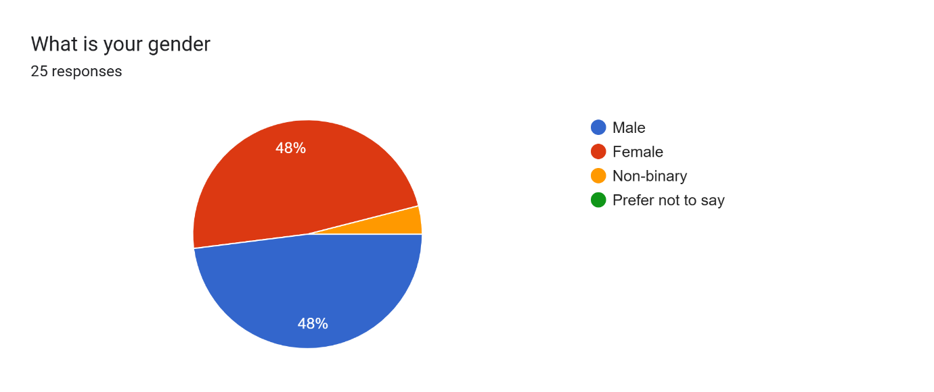
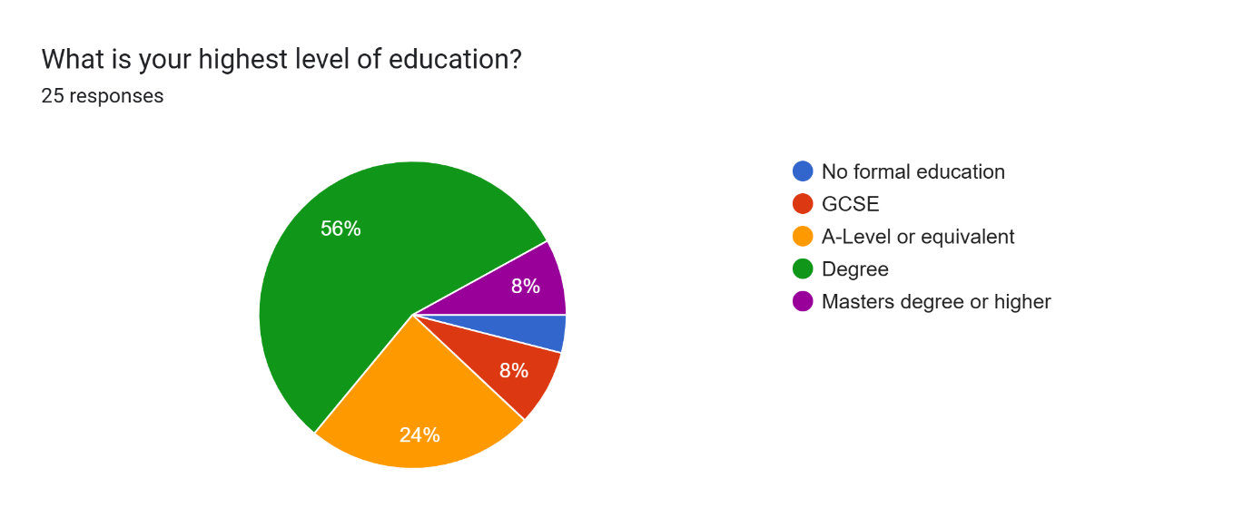
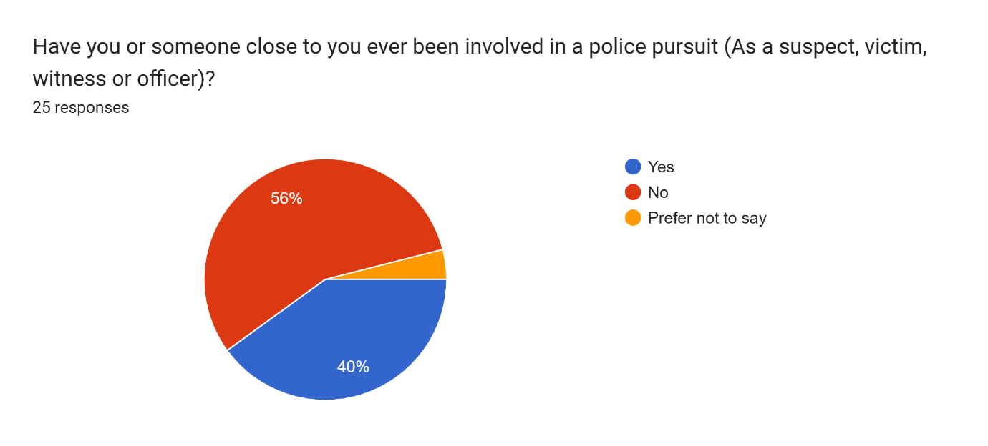

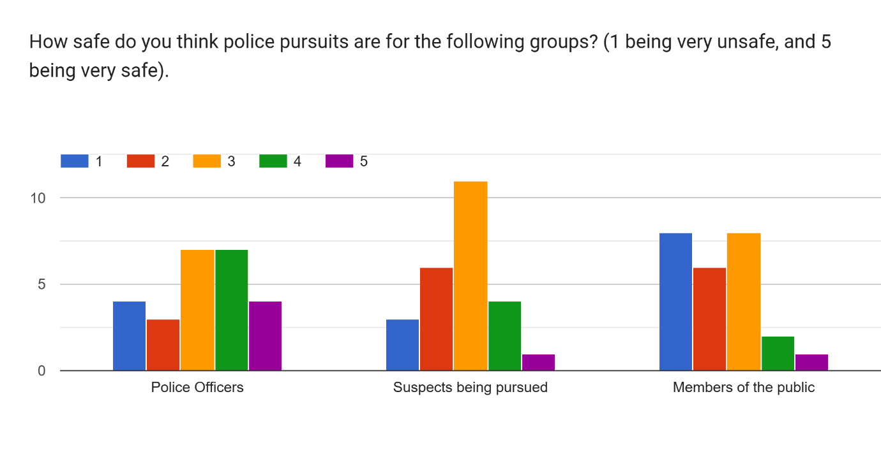
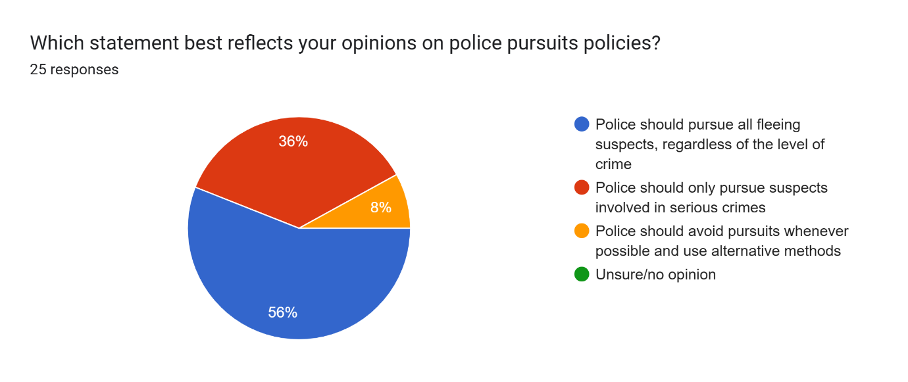
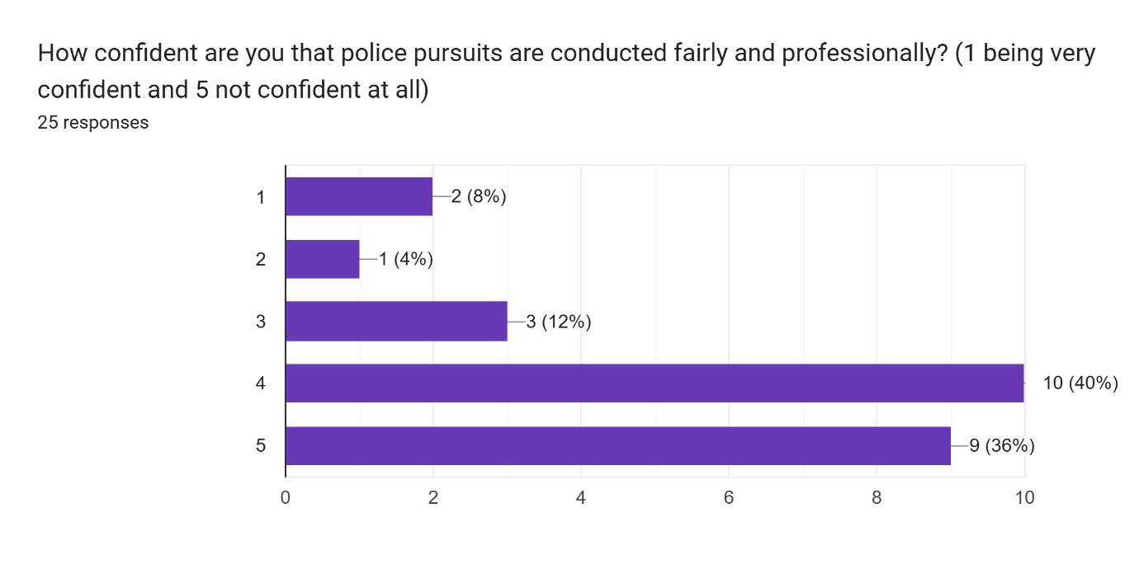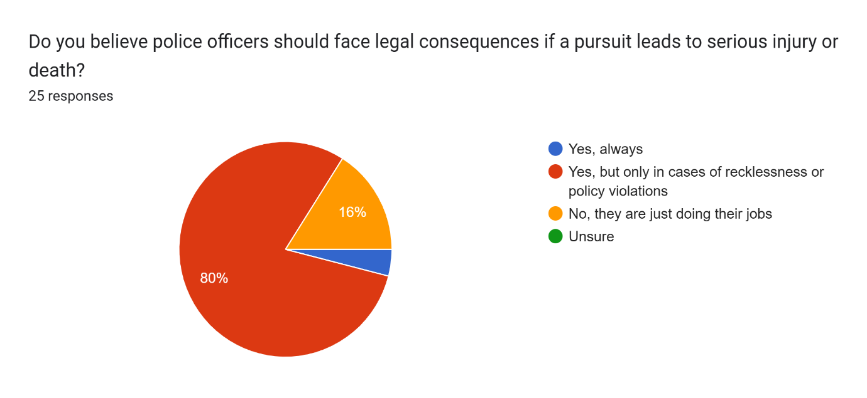
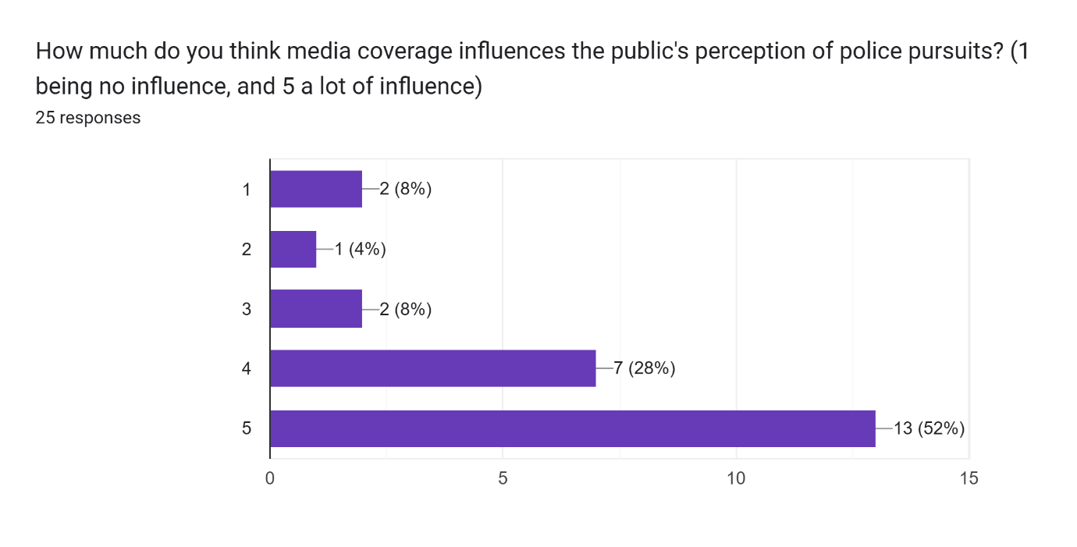
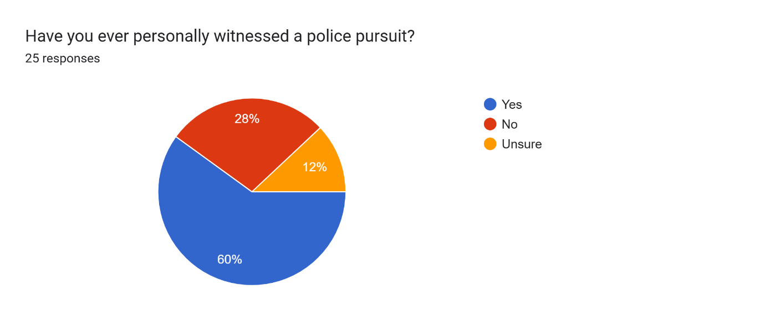
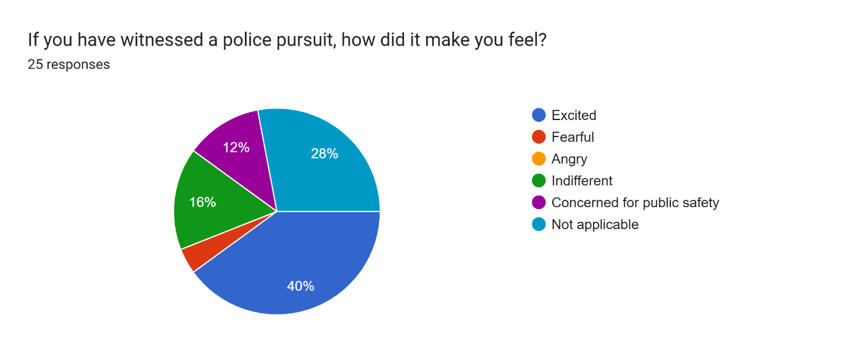

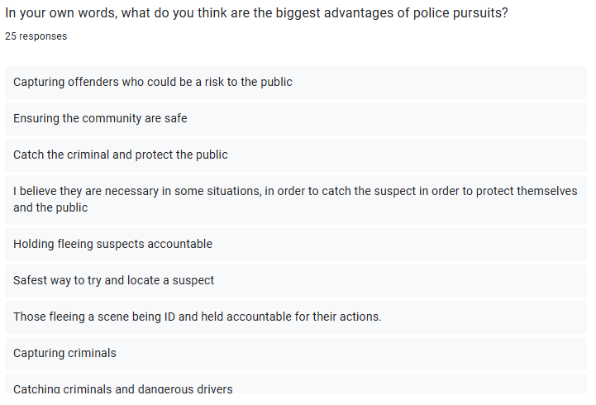
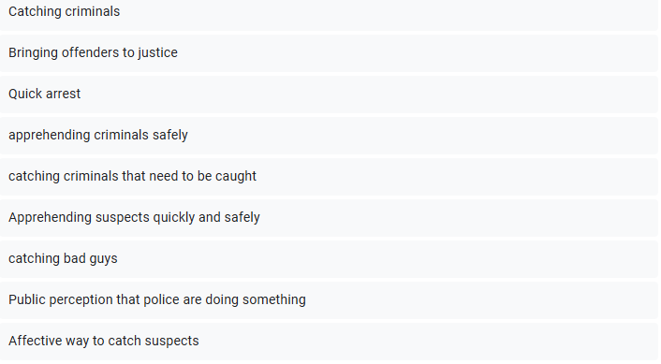
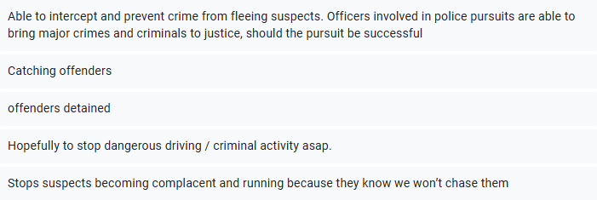

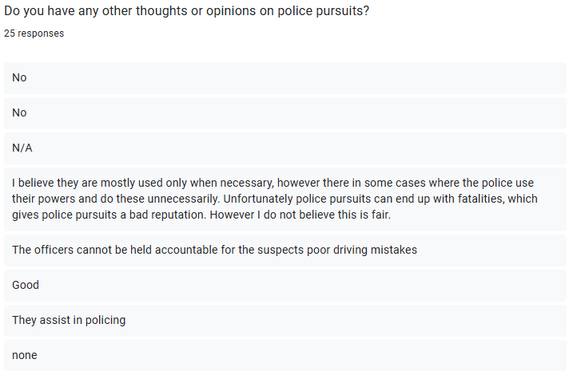
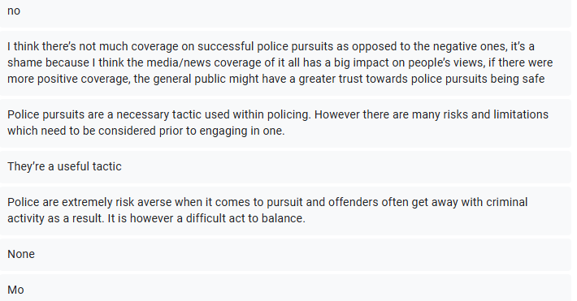

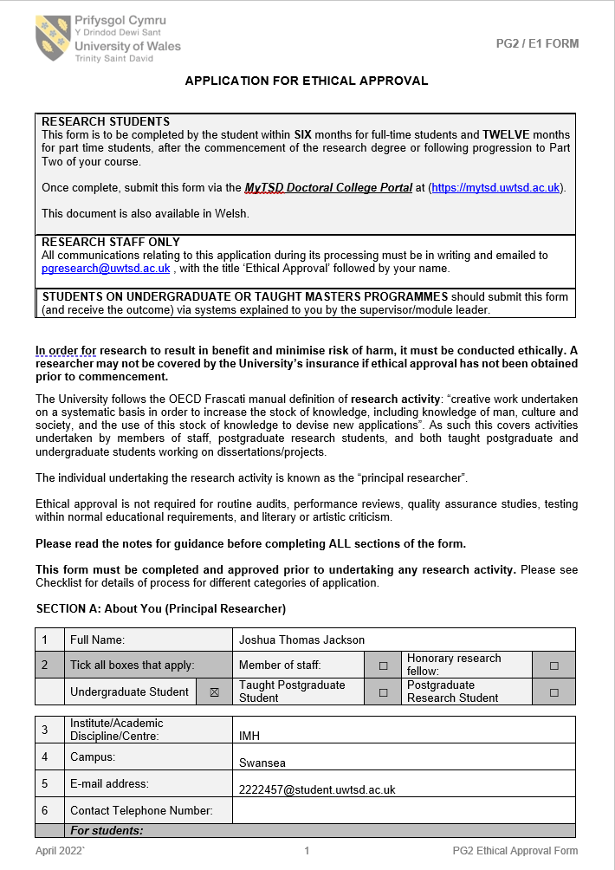
Appendix B: Ethics Form

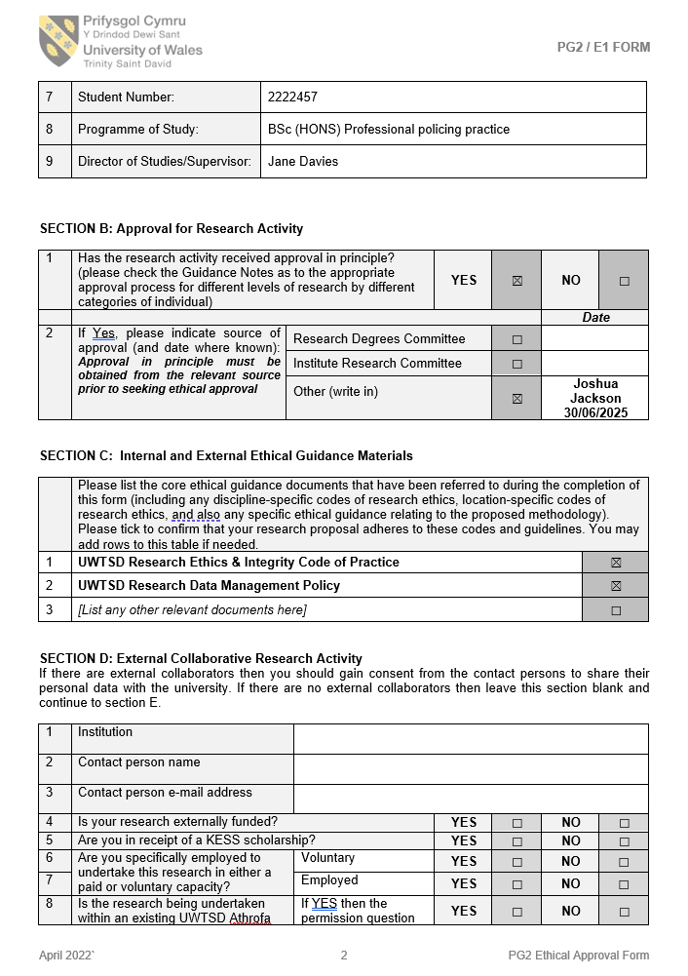

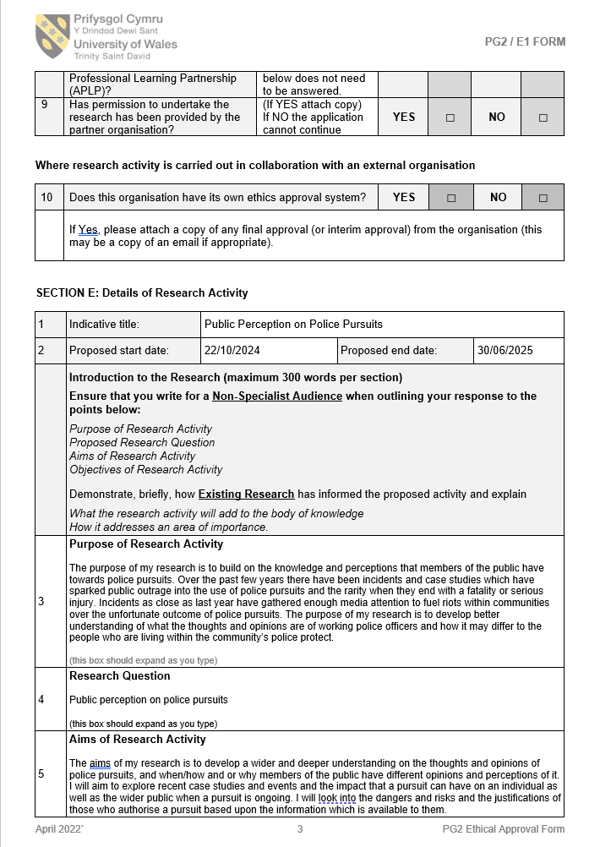

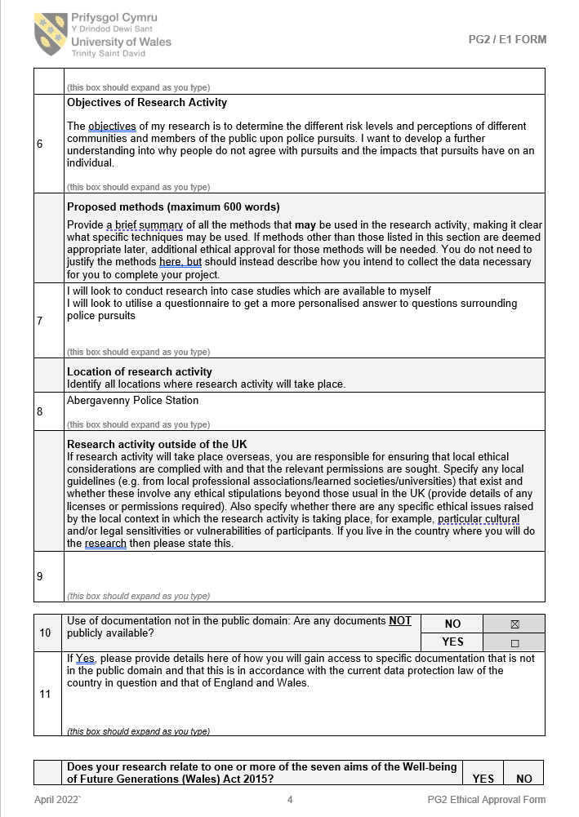

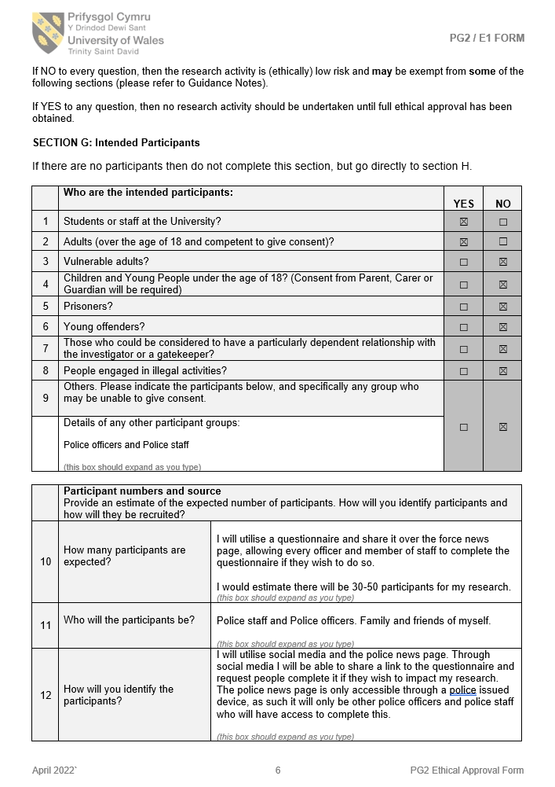
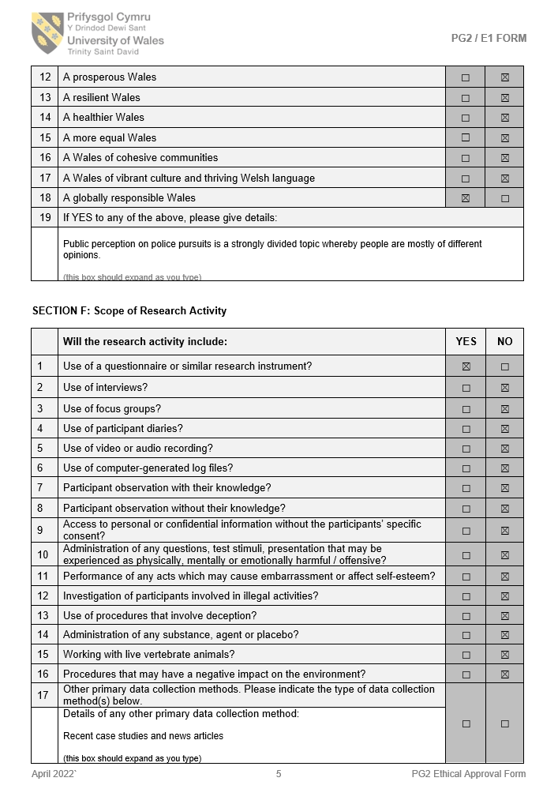

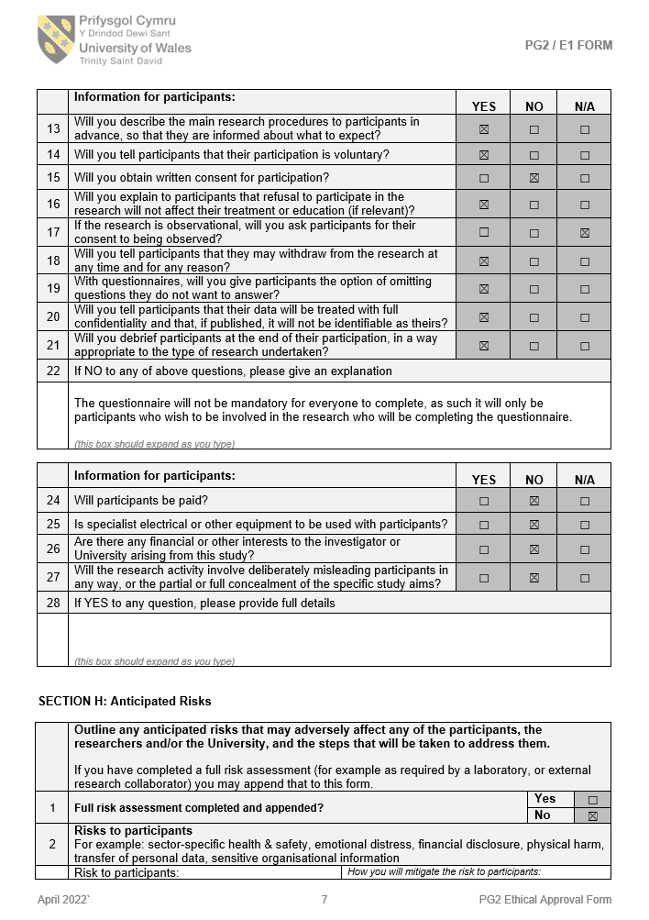

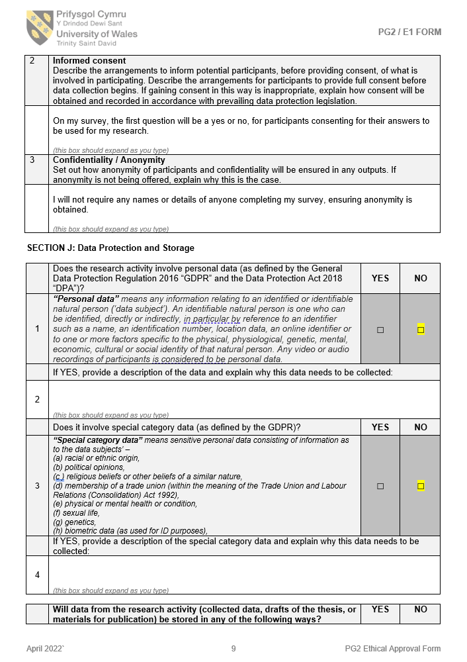

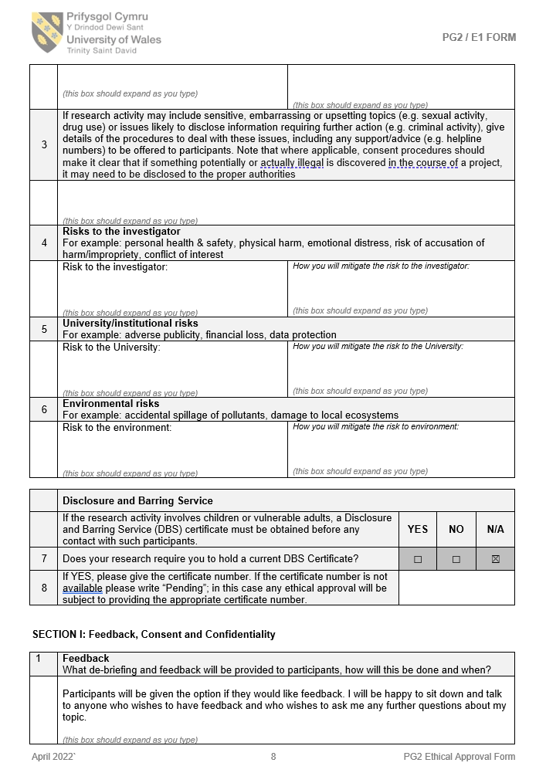

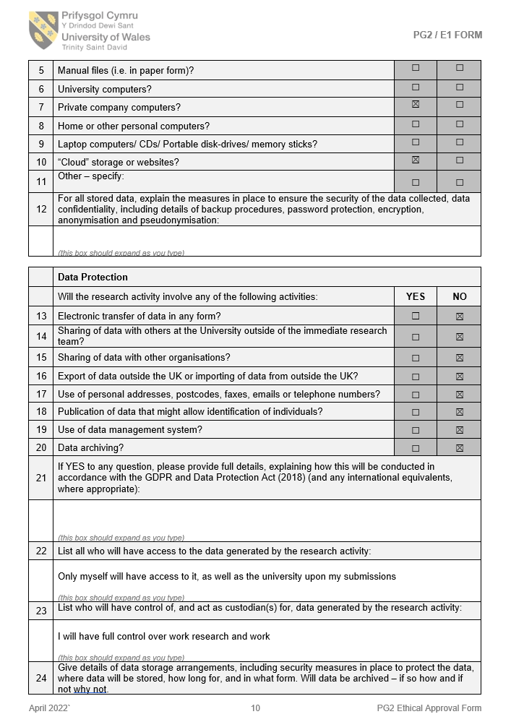

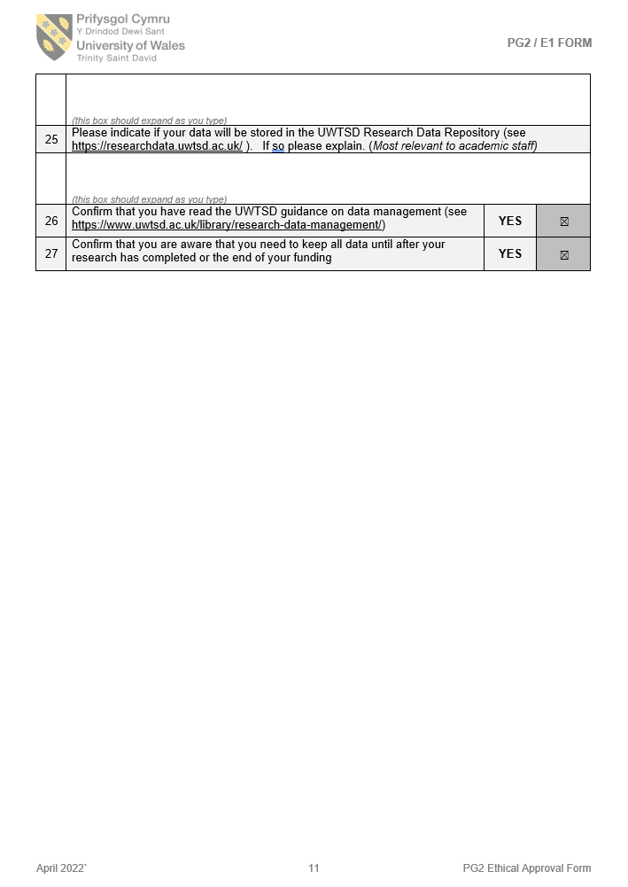
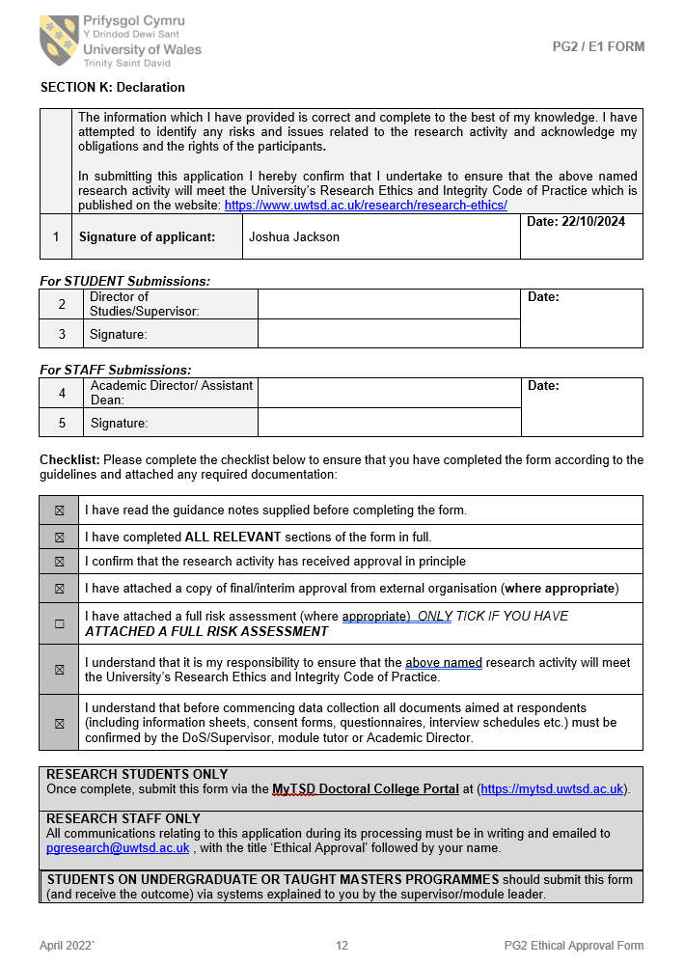

Appendix C: Research Proposal Form



UNDERGRADUATE DISSERTATION
RESEARCH PROPOSAL FORM

Please complete the following research proposal and submit it to Turnitin.

Which project option are you taking? Please tick:

8,000 word project:
OR
4,000 word project and presentation:

Please remove the red writing for your final submission.

NAME:  Joshua Jackson | STUDENT ID No.: 2222457
DRAFT RESEARCH TITLE QUESTION: What is the Public’s Perception of Police Pursuits?
INTRODUCTION:

Why this topic?

I have chosen to complete my dissertation on this topic as there are evidently underlying issues surrounding the police power of police pursuits, I am aiming to conduct research to establish the concerns surrounding the topic and to determine how police forces can build relationships and trust within communities to safely utilise this power.

On the 22nd May 2023 a police pursuit sparked controversy nationwide after two young males lost their lives after failing to stop for the police, BBC (2024). The purpose of me completing my dissertation on this topic is to further understand the thoughts of the public towards Police pursuits, and why people have such strong feelings towards them, occasionally ending in a major incident.

Throughout my initial research, I have read how some forces allow response officers to use this power whereas other only allow specially trained roads policing officers to use it, Home office (2018).

I have further read how the two main reasons police pursue vehicles is due to an individuals fleeing from the scene of a criminal offence/failing to stop after committing an offence, or the use of a motor vehicle to crash by a way of suicide, Christie, N. (2020), I’m aiming to bridge the gap between what is thought to be known and the actual views and opinion from the public to this police power.
SUMMARY OF RESEARCH OBJECTIVES:

- To identify factors which have a negative impact on public perception of police pursuits
- To identify factors which have a positive impact on police pursuits
- To identify what justifies a police pursuit
- To provide an insight to police forces nationwide as to how the public view police pursuits
I am aiming to establish this information by creating a questionnaire which will be accessible to the public to answer, this will be anonymous, and I will be aiming to ask questions which will give people an opportunity to answer how they truly feel.

LITERATURE REVIEW:

As it lies, and from my pre reading, I have learnt that there is limited research and analysis on this topic, leaving so many questions un-answered. I am aiming to bridge the gap between members of the public and police officers to understand how people are really feeling. My research will assist in understanding both perspectives and compare them against each other to have an in depth understanding.

The college of policing and IOPC reports have played a major part in understanding currently where the research lays. In March 2021, the Metropolitan Police Service have been involved in a pursuit of a Vauxhall Astra, prior to having authorisation to pursue the fleeing vehicle, the Astra has crashed leaving the five occupants of the vehicle requiring immediate first aid, and later one of the occupants, has unfortunately lost their life, IOPC (2023).

The issue with the research as it currently stands, is that there are limited resources to fully understand the different views and opinions surrounding this topic. Throughout my dissertation, I will look to complete my own research to assist in getting as much information collated as possible to fully support all views of this police power.

I will look to be using case studies, publicised reports of police pursuits as well as organisational plans and a questionnaire I will make to understand views and opinions of the public.

I will aim to compare publicised research against the questionnaire I will create to compare both and how they differ.

SUMMARY OF RESEARCH –SURVEY METHOD:

My research will undertake reviewing resources which are already available to me, through reviewing already published articles surrounding the topic. This will be a foundation to where the research surrounding my chosen topic currently stands.

I will then look to produce my own survey with a mixture of questions which will allow me to get the views and opinions of as many different people as I can, from both members of the public as well as police officers. This will give me an in-depth understanding as to how people are really feeling. I will ensure my survey protects the identities of those completing it, by making it anonymous, I believe people will be able to answer the survey honestly to ensure the opinions are accurate and not adjusted to fit a certain stereotype.

This is the best way to get a transparent understanding as to how people actually feel about this police power.
SUMMARY OF SAMPLING FRAMEWORK:

I will be making a questionnaire which will incorporate as many questions as possible to gauge the real opinions of what different members of the public think. I will first start by posting the questionnaire I make to different social media platforms. This will reach different target audiences to properly understand what different people, of different backgrounds genuinely think. It will be anonymous, giving people completing it security in knowing their actual opinions won’t be put against them. This is best for my research as it is a topic which I believe people will either be for or against. As such anonymity is imperative in getting an accurate result from my survey.

To ensure I get comparison for my research, I will also utilise police officer’s perceptions through completing my survey, this will assist in making sure I can evaluate both perspectives and compare how members of the public actually feel and how it differs to police officers.

ETHICAL ISSUES:

The topic I have chosen has scope to cause upset to people who may have been affected by police pursuits, therefore I need to ensure my research is conducted in as fair of a way as possible, keeping anonymity between everyone involved in my research and truly understanding different opinions is essential to keeping my dissertation ethical.

TIME SCALE:

I will conduct thorough research into already publicised articles which are widely available to anyone, I will be completing this over the course of my dissertation.

For my survey, the time scale of my research will be completed over a few weeks, I understand everyone has their own commitments and it will be down to myself to work around the schedules of people which are involved in my research.

The survey will allow people to complete in their own time without having a time pressure on it.
REFERENCE LIST:

BBC (2024) How the deaths of two best friends sparked a riot. Available at: Ely riot 2023: What happened in Cardiff? - BBC News (Accessed: 18/11/2024).

Christie, N. (2020) ‘Managing the safety of police pursuits: A mixed method case study of the Metropolitan Police Service, London’, Safety science, 129, pp. 104848-. Available at: https://doi.org/10.1016/j.ssci.2020.104848.

Home office (2018) The law, guidance and training governing police pursuits: current position and Proposals for change. Available at: police pursuits (Accessed: 18/11/2024).

IOPC (2023) Investigation into police pursuit and subsequent road traffic incident – Metropolitan Police Service, March 2021. Available at: Investigation into police pursuit and subsequent road traffic incident - Metropolitan Police Service, March 2021 | Independent Office for Police Conduct (IOPC) (Accessed: 18/11/2024).

