
Master of Business Administration
Module Code and title: LCMB7034 International Business Concepts
Assignment title: International Business Concepts
Title: Emerging Market
Lecturer: Dr. Jean Wang

Student Name: MD Ashikur Rahman
Student ID: 2421727
Words: 5481
Date: 15.12.2025

Table of Contents
1. Introduction 3
2. Benefits and Challenges of International Operations 4
a. Why PUMA can be designated an MNC/TNC 4
b. Nature of PUMA’s Global Operations across the value chain 5
c. Entry modes used by PUMA in International Markets and Dominant Mode 8
d. Key benefits obtained from international operations 10
e. Challenges of International operations 11
3. OLI factors and their impact on PUMA’s market entry mode in India 12
Ownership Advantages 12
Location advantages 13
Internalisation advantages 13
4. Critical Evaluation of Cultural Differences 15
5. Major SOP Adjustments required for PUMA to ensure success in the emerging country 20
SOP Adjustment 1: Localised Decision-making and Hierarchy Alignment 20
SOP Adjustment 2: Flexible Compliance, Supplier Management and Quality Assurance Systems 21
SOP Adjustment 3: Localised Marketing, Product Portfolio and Consumer Engagement Protocols 22
6. Conclusion 25
References 26

Introduction
This report provides a global business consultancy study of PUMA SE, one of the foremost German multi-national companies in the sports sector. It assesses how PUMA conducts its business and grows globally, and what strategic considerations promote its global success. These factors should be understood because multinational companies are expected to operate in different market environments, cultural distinctions and competitive forces that may adversely influence performance.
The report is structured on the basis of the current success retention of PUMA in the two main markets of Germany and the United States, and the two emerging markets of India and Vietnam. It explores the advantages and risks of foreign business, assesses entry tactics using the OLI model, analyses cultural differences, and makes some critical recommendations to facilitate forthcoming growth.

Benefits and Challenges of International Operations

Why PUMA can be designated an MNC/TNC
PUMA is a multinational/transnational corporation (MNC/TNC) since it has its headquarters in Herzogenaurach, Germany, although it has subsidiaries and partners in over 120 countries (Apparel Resources, 2019). At the end of 2024, PUMA had approximately 101 direct or indirect subsidiaries (Carp, 2025). Central planning is conducted at the head office, where the main processes, such as brand positioning, major R&D, global supply-chain management and financial governance, are harmonised. At the same time, PUMA provides regional hubs, such as Americas, Asia-Pacific, and EMEA, with marketing, distribution, and retail freedom adapted to local conditions (Deloitte, 2023). This combination of the centralised global strategy and local responsiveness depicts a classic transnational approach.

Figure 1: PUMA
The global character of PUMA is reflected in its staff, as it has around 19,600 employees distributed all over the world (Euromonitor, 2023). It has distribution centres, staff in Europe, Asia/Pacific, the Americas and other locations which support distribution, marketing, sourcing, R&D and administration functions. With a global talent strategy, the top management team consists of Germany, the United States, France, the United Kingdom, and other Asian countries (IBISWorld, 2023).
The company is structurally and operationally global because it sources materials and product development, and supply chains span across regions of various continents (Kelly, 2025). Its production focus in Vietnam, China, Bangladesh, and Cambodia has a solid sales and brand presence in Germany, the United States, the UK and Japan, with fast-growing operations in emerging markets in India and Vietnam (Innes, 2024). PUMA obviously qualifies as an MNC/TNC, as it is an enterprise with borders, multiple chains of value creation, numerous countries of action, and a wide distribution of resources on the global level.

Nature of PUMA’s Global Operations across the value chain
The global operations of PUMA include the complete chain of values, including product design and R&D up to sourcing, manufacturing, logistics, distribution, sales, and financing (Kelly, 2025). To be competitive, the company integrates on the global front and localises to fit various regions.
R&D and Product Development
PUMA keeps its main R&D in Germany, where designers, material scientists and engineers produce high-performance shoes, sportswear, and accessories. This is an international product innovation that has a uniform brand name and contributes to technological growth (MarketLine, 2019). Meanwhile, PUMA utilises the global talent that gathers international designers and experts and combines global tendencies with local sensitivities (Morgan, 2025).
Sourcing and Manufacturing
PUMA has been greatly dependent on sourcing and producing in Asia. In 2023, the company reported that it sourced 95% of its total volume in Asia, and that it bought 158 independent suppliers in 29 countries (Puma, 2023). The large manufacturing centres are Vietnam, China, Bangladesh, and Cambodia, among other Asian countries (Statista, 2024) which enables the brand to enjoy the benefits of reduced labour costs, relevant manufacturing, and economies of scale (Rowland, 2019).
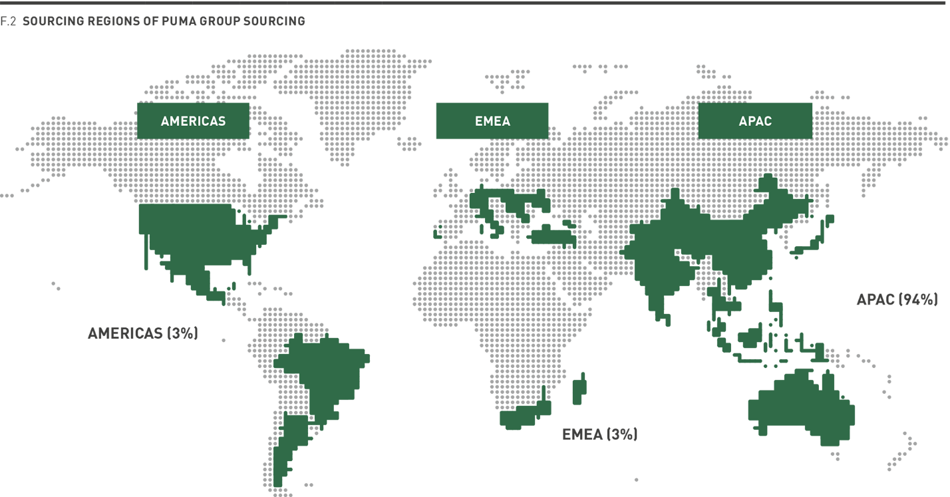
Figure 2: Sourcing Regions of PUMA Group (PUMA, 2024)
PUMA maintains social standards through consistent partner factory inspections and through a programme called Fair Wage Assessment. In 2024, the brand assessed factories in Bangladesh, Vietnam, China, Indonesia and the Philippines, among others, to check compliance with living wages (The World Bank, 2025). PUMA initiated wage remediation programmes where necessary (WorldFootwear, 2025). Sourcing and manufacturing facilities are distributed throughout the world, but controlled through a one supply-chain management mechanism.
Logistics, Distribution and Global Integration
The international management of PUMA is based in some regional centres. The company enumerates four main hubs in Somerville, Massachusetts (USA), Hong Kong, and Ho Chi Minh City, Vietnam (Puma, 2024). This network facilitates logistics, distribution and regional management across continents. Distribution is managed via a combination of world-trade, company-generated retail outlets, direct-to-consumer internet platforms and subsidiary lines. With this multi-channel model, PUMA worked with over 120 countries in 2024 (Wu, 2025).
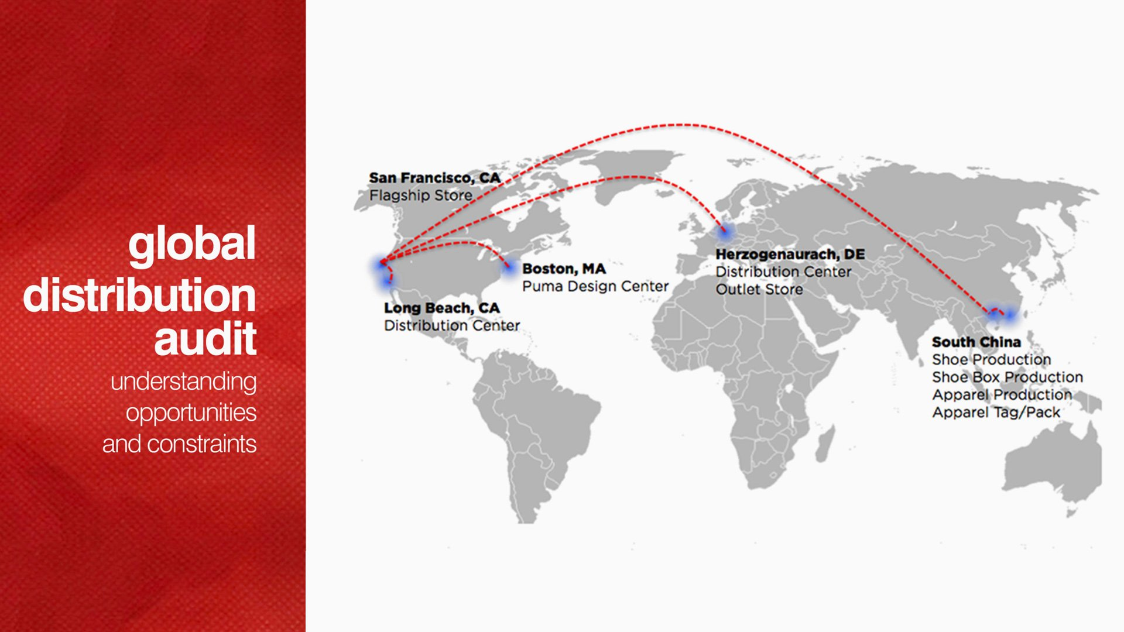
Figure 3: Global distribution network of PUMA (Fuse Project, 2025)
Sales and Marketing
In terms of sales and marketing, PUMA is highly globalised and centrally based in Herzogenaurach, Germany, with execution being locally tailored to meet the local consumer preferences (Ceylan, 2024). The firm maintains a consistent global brand communication, including Neymar Jr. or Rihanna, and thus has a dependable brand image in the diverse markets (Isensee, 2024). At the same time, local marketing teams in India and Vietnam adjust promotions based on cricket players or youth street trends to appeal to the specific cultural appeal. The e-commerce, flagship stores, wholesale partners, and digital marketplaces are integrated into a global omnichannel model that facilitates sales (Pan et al., 2023). This combination of core strategic control and localisation strengthens the competitiveness of PUMA in heterogeneous marketplaces.
Financing, Global Governance and Corporate Responsibility
PUMA is publicly traded on the Frankfurt Stock Exchange and funds itself using international financial markets. Its governance encompasses consolidated financial reporting, global auditing and compliance systems, which are monitored within Germany with the support of regional financial offices (Andal et al., 2020).
PUMA is a sustainability-focused brand. In 2024, as part of its Vision 2030 initiative, numerous products have started to have improved materials like certified cotton and recycled polyester (Puma, 2025). The company has also made a commitment to transparency in human rights and living wages compliance across its supply chain.
Competition and strategic positioning
PUMA operates on a global scale with major competitors such as Nike and Adidas. Its global operations provide it with a competitive advantage as cost-effective production, speedy product cycles, and extensive market coverage are critical in keeping up with these giants (Niskanen, 2019). The global supply chain and regional responsiveness enable PUMA to respond to local demand more quickly than domestic competitors acting only on the domestic level.
Germany is the head office for the company responsible for overall Research and Development, and European supply chain and control for the company. The United States operates as a large retail and wholesale area, with great sales, as part of the Americas regional operation (Jaworek and Karaszewski, 2020). India is an emerging market expansion, distribution via subsidiaries and franchise operations, and marketing modified to sports that are localised, like the cricket game. Vietnam is a major manufacturing hub, and one of the PUMA central regional offices is located in Ho Ching City, one of the main manufacturing volumes, part of the global supply chain (Xu, 2023). These operations combined demonstrate how PUMA has harmonised its operations globally and yet remains flexible at regional levels-typical of a transnational corporation.

Entry modes used by PUMA in International Markets and Dominant Mode
PUMA has embraced an entry mode mix depending on the relevance of the market, the regulation and the cost (Mudambi and Puck, 2016). The most common modes are wholly-owned subsidiaries (FDI), franchising, and retail partnerships.
Wholly Owned Subsidiaries (FDI): PUMA has subsidiaries in its major markets such as Germany, the United States, the United Kingdom, France, India and China and offers them absolute power in branding, retail, as well as pricing and marketing. PUMA has wholly owned or majority owned subsidiaries in about 40 to 50 countries (Collinson et al., 2020). The company operates in Germany via its wholly-owned headquarters and local subsidiaries with a baseline foreign direct investment construct that offers full control of design, production coordination, and European retailing (Puma, 2025). Furthermore, PUMA has developed a wholly-owned subsidiary in India with the assumption to fully own its retail operations and e-commerce distribution to react quickly to the local market conditions and to be able to control its supply chain and branding (Kelly, 2025). In the US, PUMA uses a majority-owned subsidiary business model by owning its retail stores and distribution channels to have direct influence on brand position and logistics (Acosta, 2024).
Franchising and Retail Partnerships: PUMA ventures into African countries, such as Nigeria and Kenya, the United Arab Emirates and Saudi Arabia from the Middle East, and Southeast Asia markets, such as Indonesia and the Philippines, mostly through franchising and retail partnerships with minimal capital investment and local retailers’ knowledge and experiences (WorldFootwear, 2025). Over 60 countries depend primarily on franchised stores of PUMA (Daniels et al., 2022).
Strategic alliances and licensing: PUMA has licensed its manufacturing and distribution in chosen markets, where it perceives its target audience to include accessories, fragrances and team merchandise (Hill, 2023). For example, PUMA has licensed the distribution of its accessories and team wear with partner companies, including Alshaya group in the Middle East, and licensed distributors in Latin American markets, ensuring that the company’s customers can easily access their products without the need to run every retail outlet in the market (Lechner et al., 2020).
Dominant Entry Mode
The entry mode of the company is a mix of wholly owned subsidiaries in major markets and franchising and distributorship in minor markets. Franchising and distributorships, particularly in Asia, Africa, Latin America, and Eastern Europe, are the prevalent ones globally (Isensee, 2024). This method will enable PUMA to expand instead of spending as much capital and reduce the risk of expansion to an international frontier, but retain a similar brand image.

Key benefits obtained from international operations
The value chain provides several strategic and financial benefits to PUMA in terms of global expansion.
Revenue Diversification and Growth
With its businesses in more than 120 countries, PUMA protects itself against declines in the performance of a particular market (Andal et al., 2020). The United States and Germany maintain high-end demand, Indian maintains good growth due to the presence of youth in the population and increasing middle earners, and Vietnam, in terms of retail sales and low-cost production (Niskanen, 2019). The geographic diversification ensures that PUMA sustains strong sales in the face of regional changes.
Cost efficiency through global production
The cost of production in emerging economies such as Vietnam and Bangladesh is reduced, and helps PUMA to remain price-competitive. Vietnam has provided skilled labour and advanced footwear technology, whereas Bangladesh has provided low-cost production with respect to apparel and enhanced compliance (Jaworek and Karaszewski, 2020). Such economic gains release finances towards research and development and international branding.
Access to global talent and innovation
Creativity and innovation are provided by a global workforce. Asian, European and North American designers and engineers collaborate in designing shoes and apparel which are attractive worldwide (Xu, 2023). Though Germany is still an important innovation hub, talents worldwide come to the country, offering new cultural values that can be used in product designs and marketing.
Market expansion and brand recognition
PUMA enjoys international business operations as the foundation of building its brand name, supported by the sponsorship of leading football clubs, Olympic teams, and global celebrities. PUMA collaborates with NBA sportspeople in the U.S., which promotes its lines in basketball (Mudambi and Puck, 2016). In India, cricket or Bollywood endorsements bring cultural understanding.
Economies of Scale and Global Supply Chain Synergies
Scaling up also enables PUMA to achieve good supplier terms, invest in sustainability, optimise logistics, and reduce the per-unit costs (Lechner et al., 2020). The distribution network that traverses Germany, Vietnam, China and India provides rapid delivery and inventory optimisation.

Challenges of International operations
International business operations give rise to many challenges for PUMA. Coordinating sourcing and distribution is major challenge for PUMA. The success of the company depends greatly on efficient coordination of sourcing and distribution (Puma, 2023). Besides, ensuring sustainable operations and legal compliance of suppliers in developing countries like India, Bangladesh, Vietnam is a critical challenge. Legal misdeeds by suppliers can hamper the brand image as well as bring consequences (Jaworek and Karaszewski, 2020). Moreover, there are risks of exchange rate fluctuations and supply chain disruptions that can hamper profitability of the company.

OLI factors and their impact on PUMA’s market entry mode in India
The OLI framework provides a clear perspective of why PUMA ventures into India by some means and how ownership advantages, country advantages and control requirements contribute to such ventures (Bartlett and Ghoshal, 2017).

Ownership Advantages
Ownership advantages are firm-specific resources, tangible or intangible, accelerating the ability of PUMA to defeat its domestic competitors in international markets. These strengths guide its mode of entry to India (Sheth et al., 2020).
To begin with, PUMA has a differentiated global brand image. Being one of the largest sportswear companies globally with a multibillion-dollar valuation, the brand provides instant credibility in immature markets and allows high-end pricing (Acosta, 2024). Second, the design and manufacturing expertise of PUMA is decades of German innovation and other development centres. Its product brand incorporates performance technology, eco-friendly materials, and celebrity partnerships and provides a clear differentiation (Bhutoria, 2024). Third, the portfolio of PUMA is diversified worldwide, allowing the company to react swiftly to the local trends. In India, it is centred around merchandise in regard to cricket (Bruin, 2017). This flexibility is a strategic owned power that promotes investment by direct ownership instead of licencing.
Limitations: Nonetheless, PUMA has its share of ownership vulnerability. It has fewer technological patents than Nike and Adidas as well as its investment in research and development is low (Confino, 2011). This implies that PUMA cannot afford to stick to the merits of performance technology but should focus on speed, cost-effectiveness, and design relevance, which is particularly considered essential in low-end emerging markets.
Impact on entry mode in India:
With these robust but ambivalent ownership features, PUMA favours holding wholly owned or majority subsidiaries in India. These enable it to introduce its brand, design capacity, and product strategy in totality without compromising brand equity by licensing (Bruin, 2016).

Location advantages
Location advantages are country-specific factors that cause a certain foreign market to be appealing to investment (Cote, 2020).
India’s location advantages
India offers one of the biggest emerging markets of consumers in the world, and the sports-wear industry has double-digit growth (De Bruin, 2020). The young demographic, increasing middle-income, and a robust digital economy will make the environment conducive to foreign brands.
The 100% FDI limit on single-brand retail by automatic route provides PUMA with complete ownership in India, allowing it to open direct-owned outlets without the need to form joint ventures (Indian Retailer Bureau, 2025). Moreover, India also provides cost-efficient labour, which promotes the operations of huge retail outlets and warehouse chains.
Limitations: Nonetheless, some of the challenges facing India are high price sensitivity, regional market diversity and logistical inefficiencies in some states. Although there have been enhancements within the context of GST, there is operational complexity (Farooqui, 2024).
Impact on entry mode in India:
These forces necessitate strong branding and pricing control by PUMA suggesting entry via wholly owned subsidiary business ventures supplemented by franchise in minor cities. WOS would provide full control over branding and pricing (Hill, 2023).

Internalisation advantages
Internalisation benefits will involve the ability of PUMA to derive more value by undertaking operations within the company instead of licensing or outsourcing the same activity to local collaborators (Scharpf, 2024). In the case of a global brand like PUMA, internalisation presents the key to guaranteed uniformity in the quality of products, branding, and customer experience in different markets.
The coordination of global design, marketing campaigns, as well as releasing products has to play a major role in the operations of PUMA. Investing in India should be characterised by internalisation operations, which will ensure the preservation of its global brand name and quality of products (Wild and Wild, 2023). Internalisation helps carry out similar store formats, similar pricing approaches, and effective integration of omnichannel (Shastri, 2021).
India offers internalisation in the supply chain. Since India is a big manufacturing centre of sportswear, internalisation would allow PUMA to cut the lead times, keep in pace with sourcing and production partners, as well as improve its cost effectiveness (Smith, 2024). Internalisation also strengthens PUMA's command of the labour market, ethical sourcing and sustainability activities, which are becoming of great significance to consumers worldwide.
Limitations: However, internalisation does not go without limitations. It requires large capital investments, advanced leadership skills, and long-term dedication. In India and Vietnam, there is further complexity in real-estate spending, regulation compliance and talent management (Wale, 2025).
Impact on entry mode in India:
India has the advantages of internalisation into the supply-chain activities. Being a major sportswear manufacturing centre, concentrating operations in India allows PUMA to trim lead times, align sourcing with production partners and achieve cost efficiency (Vu, 2025). Thus, PUMA combines internalisation with selective franchising to speed up retail growth in situations that would have been resource-intensive to fully own.

Critical Evaluation of Cultural Differences
Based on the six cultural dimensions developed by Hofstede, this section explores how cultural differences between Germany, the country of origin of PUMA, and India, the chosen emerging market, affect its market-entry mode and its chance of success.
Hofstede framework operationalises the culture of countries in terms of six dimensions (Wang, 2024). The corresponding Germany versus India scores on each dimension are interpreted and explained in terms of their explicit implications to the entry strategy, operational behaviour, the market entry policy, and the human-resources practice of PUMA in India (Wale, 2025).
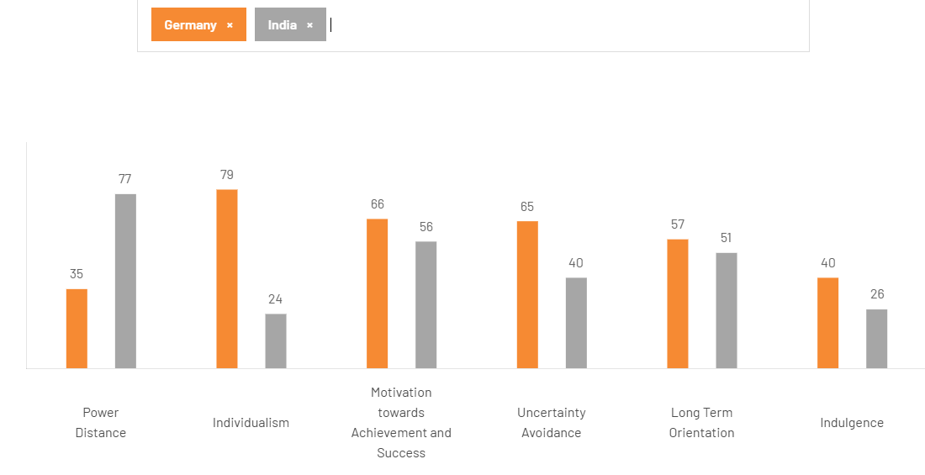
Figure 01: Hofstede’s Cultural dimensions differences for Germany and India (Wale, 2025)
Power Distance
Power Distance summarises the degree to which a society tolerates unequal power distribution and hierarchical authority (Vu, 2025). The low score of Germany (35) means that it is inclined towards egalitarian order, flat hierarchy and direct communication, but the high score of India (77) means that it tolerates hierarchical relations, respect to rank and respect to seniority (Smith, 2024). The horizontal and consensus-driven culture of the German headquarters of PUMA might come into conflict with the Indian requirements of a clear hierarchy of authority and senior decision-makers.
Impact on market entry and potential for success in India:
Based on this, in market entry, PUMA must employ a hybrid model of management in India whereby local senior managers have conspicuous power and the final right of decision-making without compromising German governance standards of reporting and controls (Shastri, 2021). Specifically in terms of negotiations and forming partnerships, PUMA will be obligated to exhibit decency to elderly partners and follow protocols. Internally, the firm must shape up an organisational setup that not only allocates experienced country heads initially, but also creates very clear lines of authority to the local Indian teams and aligns communication styles in order to gain trust and legitimacy in interacting with the local elites (Scharpf, 2024).
Individualism vs Collectivism
Individualism is a measure that determines how actors interpret themselves as independent or included in group networks (Nagar, 2024). The score of 79 in Germany shows that Germany has an individualistic culture that values individual performance and independence, and India has a low score (24) that reflects a strong collectivist culture, where family, societal, and group identity are the main concerns (McMillan, 2024).
Impact on market entry and potential for success in India:
As a result, the product positioning, the retail experience and HR policies of PUMA should be adjusted accordingly. The marketing messages about the particular performance, personal style, which are a major part of the German culture, should be supported in India with messages based on the group identity, family usage, team sports, and community events (PUMA, 2024). At the retail level, promotion of family bundles and team packs, like local school clubs and community activation, will be more effective. In terms of HR, reward systems must strike a balance between individual incentives, such as Sales commissions, and team-based rewards and opportunities that recognise group harmony (Group, 2024).
Masculinity/ Achievement
The masculinity dimension reflects the social reward of success, competition and the material triumph (Farooqui, 2024). The scores in both countries are in the higher range, with Germany being a little more masculine at 66.
Impact on market entry and potential for success in India:
The Puma worldwide positioning on the motto of performance, Forever Faster, fits the preference of both cultures towards achievement (De Bruin, 2020). In India, PUMA can tap into the competitive positioning, which includes athlete endorsements, performance-based product lines, and product sponsorship of sports leagues, to tap into aspiration and status motives (Cote, 2020). But since India is more sensitive to price and social image than performance, claims should be coupled with value messaging and locally relevant success stories, such as community sports upliftment programmes.
Uncertainty Avoidance
The concept of uncertainty avoidance in the Hofstede cultural dimensions scales out how a society does not do well with ambiguity or does not prefer structured regulations (Confino, 2011). Germany has a score of 65, which indicates a strong tendency towards the formal process, contractual agreements, and risk mitigation plans. On the other hand, the score of 40 for India shows a relative flexibility and tolerant attitude to ambiguity (Bruin, 2016).
Impact on market entry and potential for success in India:
The German head office will tend to focus on overall contractualisation, stricter supplier audits and formal compliance controls. Conversely, Indian business partners usually conduct a flexible, relationship-powered negotiation and might expect flexible deals (Bhutoria, 2024). In this regard, PUMA should implement a hybrid form of governance that combines strictness in global compliance, like in forms of labour standards, sustainability and quality control, with locally negotiated variations, such as pricing, delivery schedules and marketing implementation (Acosta, 2024). This two-fold approach will likely make the organisation more responsive to changes in the market, without compromising global standards.
Long-term Orientation
Long-term orientation is the focus on long-term planning and persistence in comparison with short-term performance and loyalty to tradition (Sheth et al., 2020). The fact that the scoring in both countries is mid to high implies a moderately long-term bias. This moderate-long-term orientation implies that PUMA needs to be guided by strategies that give it immediate market sensitivity coupled with long-term commitment to brand equity and relationship capital (Bruin, 2017).
Impact on market entry and potential for success in India:
India and Germany focus on long-term planning to a moderate degree, so that PUMA can justify long-term investments in India, such as retail chains, advertising campaigns, and supply chains (Bartlett and Ghoshal, 2017). PUMA must explain such long-term growth provisions to the Indian regulators and partners, with emphasis on local manufacturing, workforce training schemes, and the nurturing of mutually beneficial relations to create local goodwill. At the same time, the company needs to be operationally agile to exploit short-term seasonal changes, which are part of the Indian retail dynamics (Lechner et al., 2020).
Indulgence
The indulgence dimension reflects the degree to which societies allow indulgence and leisure (Mudambi and Puck, 2016). A low score is a sign of restraint. A moderate-low score of 40 in Germany and a low score of 26 in India suggests that both cultures share a restrained tendency, with India being even more conservative in respect to indulgent consumption (Wale, 2025).
Impact on market entry and potential for success in India:
Advertising campaigns that are hedonic or obviously luxurious will likely fare poorly in India compared to more value-focused advertising (Xu, 2023). PUMA must thus position some product lines on the basis of practical benefits, product durability, or family usefulness, and use aspirational messages sparingly when promoting products relating to festivals, sporting successes, or milestone successes (Jaworek and Karaszewski, 2020).
Overall, cultural differences between India and Germany create both barriers and entry opportunities. PUMA has a strong global brand, focus on performance, and supply-chain business, which are well matched with growth potential in India; however, long-term success depends on contextual adaptation (Niskanen, 2019). These are enabling the local leadership to redesign marketing approaches to appeal to the values of collectivism, aligning formal German control with relationship-based Indian business approaches. By making culturally sensitive adaptations, such as through local approvals, multichannel growth, and/or appointing local leaders, PUMA increases its chances of lasting success in India (Andal et al., 2020). On the contrary, the lack of adaptation can result in lower levels of adoption, brand mismatch, and operational tension.

Major SOP Adjustments required for PUMA to ensure success in the emerging country
Advertising campaigns that are hedonic or obviously luxurious will likely fare poorly in India compared to more value-focused advertising (Isensee, 2024). PUMA must thus position some product lines on the basis of practical benefits, product durability, or family usefulness, and use aspirational messages sparingly when promoting products relating to festivals, sporting successes, or milestone successes.

SOP Adjustment 1: Localised Decision-making and Hierarchy Alignment
One of the key Standard Operating Procedures (SOP) changes to be used in introducing PUMA to India is localisation of managerial decision-making, which will require more distinct hierarchical levels and power (Pan et al., 2023). This is necessitated by the cultural difference between Germany, which is high (77), compared to the low Power Distance (35) in India. German organisational culture is generally characterised by flat structures, participative decisions and consensus processes (Ceylan, 2024). Indian stakeholders, on the other hand, such as employees, suppliers, landlords, or government officials, expect dictatorial leadership, quick top-down decisions, and recognitory high-level intervention. As a result, the current SOPs developed by PUMA to be decentralised, empowered, and based on collaborative decision-making will also have to be reformulated to fit a more hierarchical, directive, and relationship-oriented leadership paradigm (Mohamed, 2018).
Through the Ownership element of the OLI model, PUMA enjoys high global governance systems, a clear reporting ladder, and strict quality controls. However, when the German headquarters imposes strict channels of decision-making that require clearances in Europe, then there are threats to setbacks to the operations of the company, lost retail opportunities, and lagging in adapting to changing market trends in the fast-moving consumer environment in India (Wu, 2025). As an example, in India, the athleisure market has grown more than 18-20% per year from 2021-2024 proactively due to the rapid changes in the youth market, cricket products, and festivals sections sales (WorldFootwear, 2025).
In order to exploit such opportunities, PUMA India needs to be endowed with the power to quickly revise pricing, authorise marketing partnerships, introduce city-centric product choices, or alter retail format designs (Hill, 2023). In this regard, SOPs must empower the Country Manager and the regional managers to autonomously make decisions within given financial parameters (The World Bank, 2025).
In addition to intra-organisational decision-making, external hierarchies also have outcomes. The negotiations with mall owners, distributors, e-commerce partners like Myntra, and local sports associations will require the attendance of senior executives in the meetings. Consequently, SOPs must require the high-level staff to address relationship-driven negotiations, as it is within the collectivist culture of business in India, where connections are formed on the basis of trust, and not through contractual agreements (Rowland, 2019). This further enhances the internalisation advantage of PUMA that guarantees high-quality local partnerships without excessive use of intermediaries.

SOP Adjustment 2: Flexible Compliance, Supplier Management and Quality Assurance Systems
A second key SOP reform that PUMA will have to embrace relates to localised supply chain management, whereby Germany is more precise in uncertainty avoidance (65), and India has lower uncertainty avoidance (40), where the business is flexible and situational. According to the OLI framework, critical internalisation benefits at PUMA would include the ability to ensure strict quality control, sustainability and operational consistency in the global markets (Puma, 2025). These requirements, however, need to be modified, without watering down, to suit the intricate supplier ecosystem in India.
Cost-effective labour, increasing manufacturing potential, expanding logistics capacity, and supportive industrial policies are some of the locational advantages that have been previously recognised in India (Morgan, 2025). However, the Indian supply chain often faces fluctuating schedules, bottlenecks at infrastructure, and occasional multiple types of regulations across state lines. SOPs that are designed in the highly predictable and standardised European environment cannot be applied without adjustment.
In this regard, Puma will have to amend its SOPs to reflect a dual-layered compliance framework (Puma, 2024). The initial tier creates tough international standards, including the material tests, approved proxies, labour rights, and zero-tolerance safety standards, so that the bottom line in the supply chain remains consistent throughout. The second layer provides the flexibility in documentation format, the cycle of delivery, onboarding a vendor, and the state-level regulatory processes (Nagar, 2024).
Considering the vibrant regulatory landscape in India, specifically regarding sustainability reporting, e-commerce tax (GST), and labour codes, the SOPs of PUMA must incorporate a formalised local regulatory intelligence system (MarketLine, 2019). This system would mandate monthly reporting of any legal change by Indian teams, making headquarters anticipate and act before they even have operational effects, hence minimising compliance risk.
Lastly, logistics protocols need to be amended by the SOP. India has advanced its delivery infrastructure considerably; the logistics market has reached USD320-330 billion in 2024, and the problems of last-mile delays and interstate transport dissimilarity are still present (Statista, 2024). The new SOPs should then require buffer scheduling, regional warehousing and demand forecasting supported by AI that is consistent with Indian e-commerce cycles (Kelly, 2025). This maintains quality standards and expectations for the timely delivery of PUMA.

SOP Adjustment 3: Localised Marketing, Product Portfolio and Consumer Engagement Protocols
The third critical SOP reforms are associated with marketing, consumer engagement, and product-portfolio adjustment. The cultural environment of India, characterised by high power distance, low indulgence, and a swiftly developing middle-class foundation, necessitates SOPs that consider the local sensitivities and market forces (Innes, 2024). The individualistic culture of Germany, with power distance 35, indulgence 40, is not directly applicable to India.
The decision-making process of consumers in India is influenced by family, community identity, festivals, and celebrities. In 2024, the sportswear market had a value of over USD 2.7 -3.0 billion, with young buyers being driven by the sub-populations of cricket, pop culture, and social-media influencers (Indian Retailer Bureau, 2025). The international marketing SOPs of PUMA, namely, individual performance, minimalist Germanism, and unconstrained imagery, should be extended to encompass regionally specific campaigns and products (IBISWorld, 2023).
An updated SOP must require PUMA India to carry out quarterly regional consumer-insight research, based on language areas of North India, Tamil Nadu, Karnataka and West Bengal. This makes the campaigns flexible to various cultural tastes, themes of festivals, colours, and promotional stimuli (Euromonitor, 2023).
Besides, SOPs should institutionalise influencer-based marketing, which is essential in a collectivist society such as India. Cricket stars, Bollywood actors, or regional stars endorsing any product have a lot more value compared to Germany (Deloitte, 2023). PUMA India has already excelled in popular-figure partnerships, yet the SOPs must organise the standards to choose the influencers, track the ROI, and handle reputational risk.
Festive-season planning is another SOP change that should be made. In contrast to Germany, the retail calendar in India is highly motivated by festivals like Diwali, Durga Puja, Eid, and regional new years that heavily impact consumption (Carp, 2025). SOPs should involve a season-based festival product and promotion calendar, so that PUMA can roll out culturally relevant campaigns and inventory strategies six months in advance. This is essential due to the fact that festival seasons may add 20-30% annual retail sales in India, and thus they form an indispensable part of operational planning (Apparel Resources, 2019).
Lastly, the digital-engagement SOPs should also reflect the fast-paced mobile-first shopping in India. Mobile e-commerce was necessary as there are 750+ million smartphone users in India by 2024 (Innes, 2024). The SOPs are to require mobile-optimised marketing, connection with Indian payment systems, such as UPI, Paytm, PhonePe, and cooperation with popular online-commerce services (Hill, 2023). This is also congruent with the high growth potential, as the location advantage of India encourages PUMA to internalise digital capabilities as opposed to using only external partners.

Conclusion
Finally, this report indicates that successful international expansion is propelled by robust globalisation, strategic resource leverage and market alignment. It ascertains that PUMA is indeed a true multinational since its value chain is managed globally; the market is non-specific; decision-making is centralised but relevant. Germany, India, Vietnam, and other prominent markets are examples of operations that combine research, sourcing, production, marketing, and financing to ensure that the company remains competitive. The discussion of OLI factors and cultural dimensions indicates the necessity to coordinate the ownership advantages, location profit, and internalisation gains with the cultural characteristics of emerging economies. Consequently, the suggested modifications to SOP that include localised decision making, flexible supply chain and culture-based marketing are necessary for long-term success.

References
Acosta, Z. (2024). Globalisation Benefits and Challenges: Expand Your Business. [online] Eos Global Expansion. Available at: https://eosglobalexpansion.com/globalisation-benefits-and-challenges/ [Accessed 7 Dec. 2025].
Andal, D. V., Suganya, D. S., and Vennilaa Shree, D. S. (2020). Financial performance analysis of PUMA. International Journal of Management (IJM), 10(6), 2019.
Apparel Resources (2019). Puma to expand its operations with 20 new stores in India | Retail News India. [online] Apparel Resources. Available at: https://apparelresources.com/business-news/retail/puma-expand-operations-20-new-stores-india/ [Accessed 7 Dec. 2025].
Bartlett, C. A., and Ghoshal, S. (2017). Managing across borders: new strategic requirements. In International Business (pp. 295-305). Routledge.
Bhutoria, M. (2024). Gloroots. [online] Gloroots.com. Available at: https://www.gloroots.com/blog/benefits-and-challenges-of-international-expansion [Accessed 7 Dec. 2025].
Bruin, L. de (2016). Eclectic Paradigm/OLI Paradigm EXPLAINED with EXAMPLES | B2U. [online] B2U - Business-to-you.com. Available at: https://www.business-to-you.com/choosing-the-right-entry-mode-strategy/ [Accessed 7 Dec. 2025].
Bruin, L. de (2017). Hofstede’s Cultural Dimensions EXPLAINED with EXAMPLES | B2U. [online] B2U - Business-to-you.com. Available at: https://www.business-to-you.com/hofstedes-cultural-dimensions/.
Carp, S. (2025). Puma hopes biggest-ever marketing spend helps separate brand from rivals - SportsPro. [online] SportsPro. Available at: https://www.sportspro.com/news/puma-go-wild-campaign-marketing-spend-brand-positioning-march-2025/ [Accessed 7 Dec. 2025].
Ceylan, D. C. (2024). Equity Research of Puma: Assessing Its Performance in the Global Sportswear Market (Master's thesis, Universidade NOVA de Lisboa (Portugal)).
Collinson, S., Narula, R., and Rugman, A. M., 2020. International Business. 8 ed. Essex: Pearson Education Limited.
Confino, J. (2011). Puma world’s first major company to put a value on its environmental impact. [online] the Guardian. Available at: https://www.theguardian.com/sustainable-business/puma-value-environmental-impact-biodiversity [Accessed 7 Dec. 2025].
Cote, C. (2020). 5 common challenges of international business. [online] Harvard Business School. Available at: https://online.hbs.edu/blog/post/challenges-of-international-business [Accessed 7 Dec. 2025].
Daniels, J. D., Radebaugh, L. H., Sullivan, D. P., and Click, R. W., 2022. International Business: Environments and Operations. 17 ed. Essex: Pearson Education Limited.
De Bruin, L. (2020). International Business Strategy Explained with Examples | B2U. [online] B2U - Business-to-you.com. Available at: https://www.business-to-you.com/international-business-strategy/ [Accessed 7 Dec. 2025].
Deloitte (2023). Global Powers of Retailing 2022 | Deloitte | Consumer Business industry reports. [online] www.deloitte.com. Available at: https://www.deloitte.com/global/en/Industries/consumer/analysis/global-powers-of-retailing.html [Accessed 7 Dec. 2025].
Euromonitor (2023). Sportswear Market Reports (2023–2024). [online] Euromonitor.com. Available at: https://www.euromonitor.com/ [Accessed 7 Dec. 2025].
Farooqui, J. (2024). Indian sports market to reach USD 130 bn by 2030: Google-Deloitte report. [online] The Economic Times. Available at: https://economictimes.indiatimes.com/news/sports/indian-sports-industry-to-reach-usd-130-bn-by-2030-google-deloitte-report/articleshow/115303299.cms?from=mdr [Accessed 7 Dec. 2025].
Group, I. (2024). India Sportswear Market Size, Share, Growth and Industry Report. [online] Imarcgroup.com. Available at: https://www.imarcgroup.com/india-sportswear-market [Accessed 7 Dec. 2025].
Hill, C. W. L., 2023. International Business: Competing in the global marketplace. 14 ed. New York: McGraw-Hill.
IBISWorld (2023). Global Sporting Goods Manufacturing (2023–2024). [online] Ibisworld.com. Available at: https://www.ibisworld.com/ [Accessed 7 Dec. 2025].
Indian Retailer Bureau (2025). IndianRetailer.com. [online] Indian Retailer. Available at: https://www.indianretailer.com/news/retail-india-news-pumas-fourth-quarter-sales-and-profit-fall-short-amid-market-challenges [Accessed 7 Dec. 2025].
Innes, M. (2024). Puma launches first global brand campaign in a decade. [online] Marketing Week. Available at: https://www.marketingweek.com/puma-global-brand-campaign-decade/ [Accessed 7 Dec. 2025].
Isensee, J. C. H. I. (2024). Equity Research–Puma: Evaluating Its Performance in the Athletic Wear Industry (Master's thesis, Universidade NOVA de Lisboa (Portugal)).
Jaworek, M., and Karaszewski, W. Ł. O. D. Z. I. M. I. E. R. Z. (2020). The largest athletic apparel, accessories and footwear multinational companies: economic characteristics, internationalization. Journal of Physical Education and Sport, 20(5), 3053-3062.
Kelly, C. (2025). Inside Puma’s new brand positioning and largest global campaign to date. [online] Marketing Dive. Available at: https://www.marketingdive.com/news/inside-pumas-new-brand-positioning-and-largest-global-campaign/742757/ [Accessed 7 Dec. 2025].
Lechner, C., Lorenzoni, G., Guercini, S., and Gueguen, G. (2020). Supplier evolution in global value chains and the new brand game from an attention‐based view. Global Strategy Journal, 10(3), 520-555.
MarketLine (2019). Country & Industry Profiles. [online] Marketline.com. Available at: https://advantage.marketline.com/HomePage/Index?returnUrl=Home [Accessed 7 Dec. 2025].
McMillan, A. (2024). How PUMA is Making Supply Chain Sustainability a Priority. [online] Procurementmag.com. Available at: https://procurementmag.com/sustainability/how-puma-is-making-supply-chain-sustainability-a-priority [Accessed 7 Dec. 2025].
Mohamed, M. (2018). Challenges and benefits of industry 4.0: An overview. International Journal of Supply and Operations Management, 5(3), 256-265.
Morgan, C. (2025). Anta Sports’ Strategic Move to Acquire Puma: A Gateway to Global Expansion and Market Premium Realization. [online] Ainvest. Available at: https://www.ainvest.com/news/anta-sports-strategic-move-acquire-puma-gateway-global-expansion-market-premium-realization-2511/ [Accessed 7 Dec. 2025].
Mudambi, R., and Puck, J. (2016). A global value chain analysis of the ‘regional strategy’perspective. Journal of Management Studies, 53(6), 1076-1093.
Nagar, J. (2024). Marketing Strategies of Puma. IJFMR240219006, [online] 6(2). Available at: https://www.ijfmr.com/papers/2024/2/19006.pdf [Accessed 7 Dec. 2025].
Niskanen, H. (2019). Sustainability in the sporting goods industry: How Nike, Adidas and Puma have developed company sustainability.
Pan, Z., Wang, K., Wang, Y., and Zhao, R. (2023, June). An Analysis of Puma’s Global Marketing in the COVID-19 Era. In Proceedings of the 6th International Conference on Economic Management and Green Development (pp. 35-49). Singapore: Springer Nature Singapore.
Puma (2023). About PUMA. [online] PUMA SE. Available at: https://about.puma.com/en [Accessed 7 Dec. 2025].
Puma (2024). Financial Reports | PUMA®. [online] about.puma.com. Available at: https://about.puma.com/en/investor-relations/financial-publications [Accessed 7 Dec. 2025].
PUMA (2024). India. [online] PUMA SE. Available at: https://about.puma.com/en/taxonomy/term/81 [Accessed 7 Dec. 2025].
Puma (2025). Sustainability. [online] PUMA SE. Available at: https://about.puma.com/en/sustainability [Accessed 7 Dec. 2025].
Rowland, C. (2019). Puma’s Generic Strategy, Intensive Growth Strategies & Competitive Advantage. [online] Panmore Institute. Available at: https://panmore.com/puma-generic-strategy-competitive-advantage-intensive-growth-strategies [Accessed 7 Dec. 2025].
Scharpf, S. (2024). Gamechanger moves for sports brands on the global market. [online] ISPO.com. Available at: https://www.ispo.com/en/sports-business/gamechanger-moves-sports-brands-global-market [Accessed 7 Dec. 2025].
Shastri, A. (2021). Extensive Marketing Strategy of Puma & SWOT Analysis | IIDE. [online] IIDE. Available at: https://iide.co/case-studies/marketing-strategy-of-puma/ [Accessed 7 Dec. 2025].
Sheth, J., Uslay, C., and Sisodia, R. (2020). Global Expansion Strategies for Multinationals from Emerging Markets. In The Global Rule of Three: Competing with Conscious Strategy (pp. 195-226). Cham: Springer International Publishing.
Smith, W. (2024). Global Expansion: Key Benefits and Challenges for Businesses. [online] Multiplier. Available at: https://www.usemultiplier.com/global-expansion/pros-and-cons-of-global-expansion [Accessed 7 Dec. 2025].
Statista (2024). PUMA Global Market, India & Vietnam Data (2022–2024). [online] Statista.com. Available at: https://www.statista.com/ [Accessed 7 Dec. 2025].
The World Bank (2025). India Country Overview (2023–24). [online] Worldbank.org. Available at: https://data.worldbank.org/country/india [Accessed 7 Dec. 2025].
Vu, N.H. (2025). Vietnam’s Economic Outlook for 2025 and Key Sectors for Investors. [online] Vietnam Briefing News. Available at: https://www.vietnam-briefing.com/news/vietnams-economic-outlook-for-2025-push-for-digitalization-and-sustainability.html/ [Accessed 7 Dec. 2025].
Wale, H. (2025). Hofstede’s Cultural Dimensions Theory. [online] Corporate Finance Institute. Available at: https://corporatefinanceinstitute.com/resources/management/hofstedes-cultural-dimensions-theory/ [Accessed 7 Dec. 2025].
Wang, H. (2024). Analysis of Sport Brand Puma’s Marketing Strategies Based on 4P Theory. Highlights in Business, Economics and Management, 45, pp.834–838. doi:https://doi.org/10.54097/gjcrcw50.
Wild, J. J. and Wild, K. L., 2023. International Business: The Challenges of Globalization. 10 ed. Essex: Pearson Education Limited.
WorldFootwear (2025). Puma’s third quarter results show impact of reset strategy. [online] World Footwear. Available at: https://www.worldfootwear.com/news/pumas-third-quarter-results-show-impact-of-reset-strategy/11035.html [Accessed 7 Dec. 2025].
Wu, K. (2025). China’s Anta Sports and Li Ning exploring bid for Puma, source says. Reuters. [online] 28 Nov. Available at: https://www.reuters.com/world/china/chinas-anta-sports-exploring-bid-puma-bloomberg-news-reports-2025-11-27/ [Accessed 7 Dec. 2025].
Xu, J. (2023). Sustainable practices in the supply chain of the fashion industry: the cases of Nike, Adidas, and Puma (Doctoral dissertation, European University Institute).

