

Engine Cycle Simulation
Powertrain and Control
M5X00404

Wesley Patrick
1701708

BEng Motorcycle Engineering

7th January 2020

Contents
1.0 Introduction 4
2.0 Aim 4
3.0 Task 1 5
3.1 Pressure against Volume 5
3.2 Delta P against Crank Angle 7
3.3 Pressure against Crank Angle 8
3.4 Log Pressure against Log Volume 8
3.5 Polytropic index (n) against Crank Angle 12
3.6 The Wiebe Function 13
3.7 Temperature against Crank angle 14
3.8 Work Done against Crank Angle 15
4.0 Task 2 16
4.1 Pressure against Crank Angle 16
4.2 Delta Pressure against Crank Angle 17
4.3 Work done against Crank angle 18
4.4 Pressure against Volume 19
4.5 The Wiebe Function 20
5.0 Conclusion 21
Bibliography 22

Figure 1 Pressure against volume (Patrick, W 2019) 4
Figure 2 The ideal Otto cycle (Spakovszky, 2002) 4
Figure 3 an actual Otto cycle (Samuel, 2020) 5
Figure 4 DeltaP against C.A (Patrick, W 2019) 6
Figure 5 Pressure against C.A (Patrick, W 2019) 7
Figure 6 Log P against Log V (Patrick, W 2019) 8
Figure 7 n Value at 6000RPM (Patrick, W 2019) 8
Figure 8 n Value at 5000RPM (Patrick, W 2019) 9
Figure 9 n Value at 4000RPM (Patrick, W 2019) 9
Figure 10 n Value at 2000RPM (Patrick, W 2019) 10
Figure 11 n against C.A with volume overlaid (Patrick, W 2019) 11
Figure 12 provided and predicted MFB values (Patrick, W 2019) 12
Figure 13 Wiebe Function (MFB) graph (Patrick, W 2020) 12
Figure 14 Temperature against C.A (Patrick, W 2020) 13
Figure 15 Work Done against C.A (Patrick, W 2020) 14
Figure 16 Pressure against Crank Angle Comparative (Patrick, W 2020) 15
Figure 17 Delta Pressure against Crank Angle Comparative (Patrick, W 2020 16
Figure 18 Work Done against Crank Angle comparative (Patrick, W 2020) 17
Figure 19 Pressure against Volume Comparative (Patrick, W 2020) 18
Figure 20 Wiebe Function Comparative (Patrick, W 2020) 19

1.0 Introduction
Engine simulation has always been a crucial aspect of engine design and development. This aspect is guided mainly by increased restrictions over emissions and driven by a very competitive industry to produce a well-designed and capable engine, with increasingly complex engine control units (ECU) that can manage all possible engine operations and other electrical, thermodynamic and hydraulic subsystems. Engine cycle simulation is further important as it reduces experimentation with physical units therefore reducing design costs and time. (Borletti, 2019)

2.0 Aim
Within this report I will aim to elaborate on a Microsoft Excel engine cycle simulation for a Ford Sigma 1.6l engine by analysing data and investigate by way of graphs to further understand and explain what happens during the combustion cycle looking predominantly at; volume, pressure, combustion temperature and work done. Using the data provided to create graphs I will be able to investigate the thermodynamic properties such as; the weibe function, mass fraction burnt (MFB) and the polytropic index. In task 2 I will then further the investigation using gathered information from graphs I have produced and other sources to compare the results with the actual recorded data given to us.

3.0 Task 1

3.1 Pressure against Volume
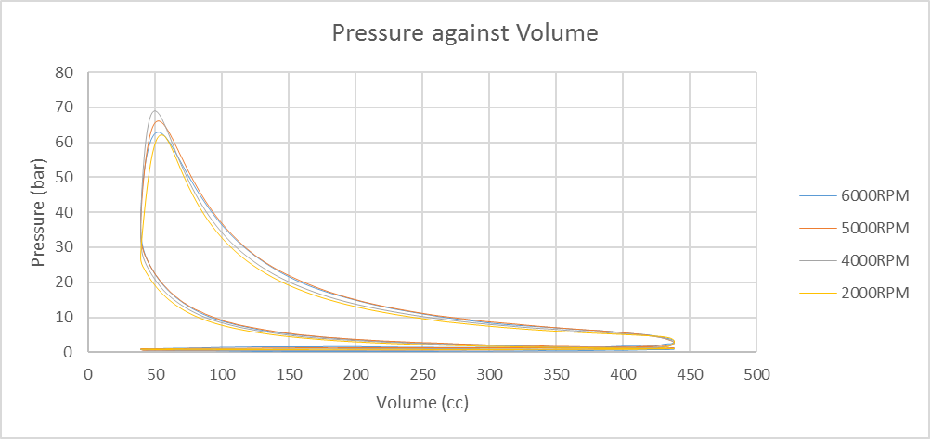
By plotting pressure (P) against volume (V) I can see how the pressure fluctuates as the volume is increased at bottom dead centre (BDC) and decreases at top dead centre (TDC). The graph below shows pressure against volume this shows the trace of the combustion cycle (otto cycle). From the understanding that when the pressure is low and the volume is high the piston is at BDC and the engine is in the induction phase of the cycle as a fuel and air mixture is drawn into the chamber, the engine is in the compression phase the pressure rises along with the piston to TDC meaning the volume decreases, the ignition phase happens when the pressure spikes but the volume stays the same momentarily before the volume increases as the piston is forced to BDC with the expansion of the fuel/air mixture. The volume and pressure decreases during the exhaust phase happens as the combustion gasses are expelled from the engine and the piston travels to TDC. (Spakovszky, 2002)
Figure 1 Pressure against volume (Patrick, W 2019)
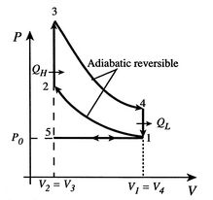

Figure 2 The ideal Otto cycle (Spakovszky, 2002)
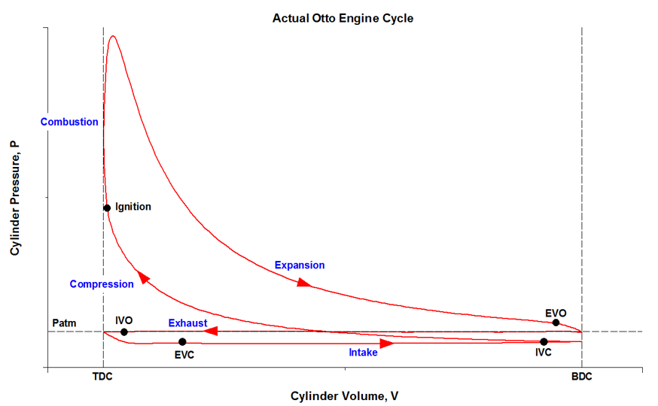
Figure 3 an actual Otto cycle (Samuel, 2020)
From figure 1 we can visualise and further understand the above statements about the combustion cycle (Otto cycle) and compare these to figure 3 which shows a sketch of an Otto cycle at no specific RPM but makes note of when the valves open and close and also when the air/fuel mixture is ignited, from looking at these two figures it is clear that they are very similar. Aspects of figure 2 are also visible in figure 1 such as the sharp rise in pressure from the point of ignition and the shape of the curve of the graph when the piston is returned to BDC. The reason 4000RPM and 5000RPM reach a higher peak pressure is because combustion is more efficient in the mid RPM range whereas when the engine is running at a higher RPM the piston is travelling at a higher velocity and doesn’t have enough time to reach a higher peak pressure.

3.2 Delta P against Crank Angle
The rate of change of pressure also called Delta pressure (ΔP), this can be worked out by taking the pressure values and using $P_{2}-P_{1}=ΔP$. By plotting delta pressure against the crank angle we can investigate how the pressure changes throughout the Otto cycle.
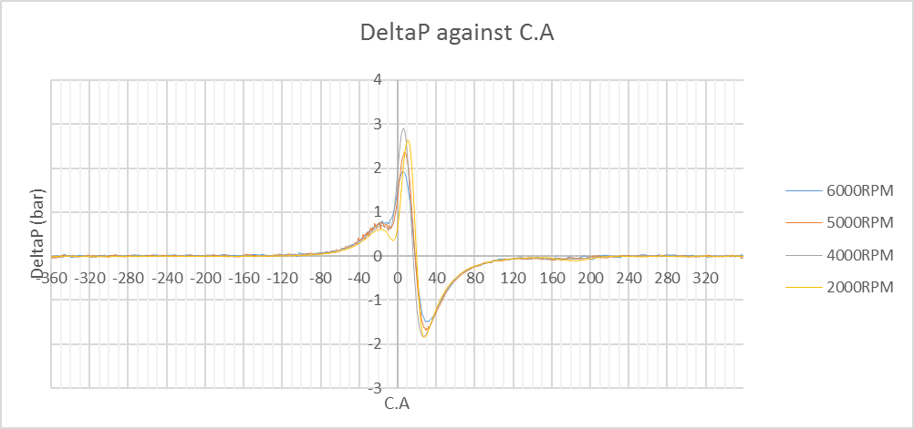
Figure 4 DeltaP against C.A (Patrick, W 2019)
Figure 4 shows delta pressure plotted against crank angle as described above. From looking at the curves we can see that all four RPM ranges start to rise at around -85 degrees steadily till it fluctuates around -10 degrees which can be inferred as the point of ignition, as the delta pressure spikes with 4000RPM almost reaching 3bar whereas 6000RPM peaks around 2bar. This point of analysis further suggests that the engine is designed to run more efficiently around the mid RPM range as the gasses are expanding at a higher velocity for a more complete combustion.

3.3 Pressure against Crank Angle
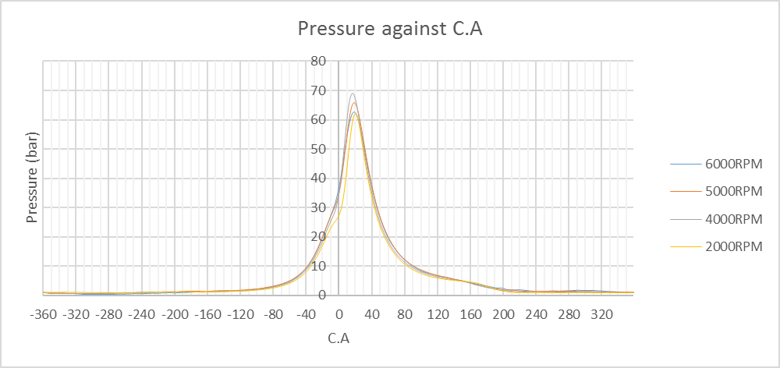
Figure 5 Pressure against C.A (Patrick, W 2019)
I have created figure 5 showing the recorded pressure values plotted against crank angle to support the statements above regarding to the point of ignition, again a small fluctuation can be seen around -10 degrees before the pressure spikes with a steeper gradient.

3.4 Log Pressure against Log Volume
By taking logs of both pressure and volume then plotting them against each other it is possible to investigate the polytropic index. The polytropic index (n) is the heat transfer within a thermodynamic system between adiabatic and isothermal.
An adiabatic process in thermodynamics happens so fast that no heat transfer is recorded into or out of the system (Q=0, n < 1.4) this means that the system would be considered perfectly insulated and all of the energy transfer recorded would be shown as work done. As there is constant heat transfer within an internal combustion engine then it is unlikely that this would be visualised. (Connor, 2019)
An isothermal process in thermodynamics happens when the heat transfer onto or out of the system (Q=1, n=1) as above it is also unlikely to see this process as the heat transfer within the engine is constantly fluctuating. (Connor, 2019)
Although it is unlikely to observe either of these processes continually, both may be observed during the full Otto cycle.
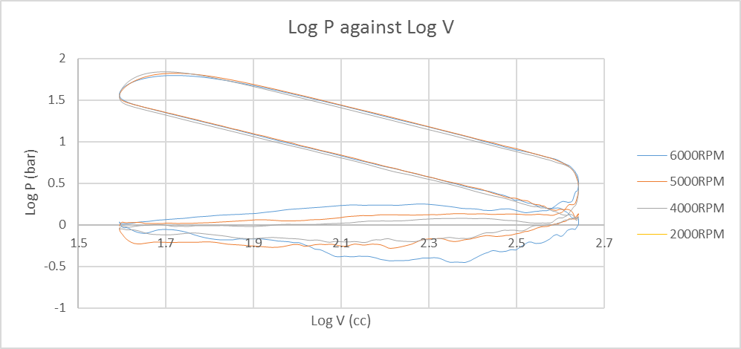
Figure 6 Log P against Log V (Patrick, W 2019)
To find the polytropic index (n) I took the straight line part of the curves in Figure 6 and applied a trendline to create a gradient (y=mx+c), where the value for “m” gives the polytropic index (n) value.
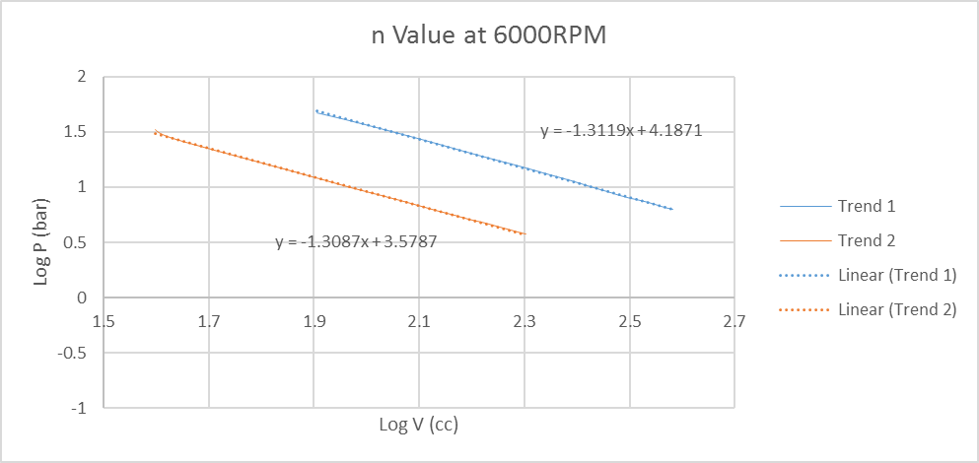
Figure 7 n Value at 6000RPM (Patrick, W 2019)

Figure 8 n Value at 5000RPM (Patrick, W 2019)

Figure 9 n Value at 4000RPM (Patrick, W 2019)

Figure 10 n Value at 2000RPM (Patrick, W 2019)
Figures 7 to 10 show the polytropic index (n) value at each RPM as titled, as shown from the gradient (m) do not exceed 1.4 (adiabatic) or descend as low as 1 (isothermal). When comparing 6000RPM to 2000RPM the compression phase (Trend 2) are very similar which is expected from investigating other graphs such as figures 1 and 5 although looking at the expansion phase (Trend 1) 6000RPM is 0.007 higher which is due to the Otto cycle being faster. When comparing 4000RPM to 5000RPM the most considerable difference is between Trend 2 at a change of 0.007, this is also expected as the curves on all the graphs that have been investigated these two RPMs have been following each other very closely.

3.5 Polytropic index (n) against Crank Angle
By plotting the polytropic index (n) against C.A it is able to investigate the fluctuations of the polytropic index (n) over the Otto cycle. To work out the values of n over the entire Otto cycle the equation $\frac{Log\left(P_{2}\right)-Log(P_{1)}}{Log\left(V_{1}\right)-Log(V_{2})}=n$.

Figure 11 n against C.A with volume overlaid (Patrick, W 2019)
By overlaying volume onto this graph it is easier to investigate at which point during the Otto cycle the fluctuations occur. As shown the major fluctuations occur at TDC and BDC, the first being at TDC when the air/ fuel mixture is drawn into the cylinder. The second fluctuation happens at BDC when the cylinder is filled with ambient air/fuel mixture, it is then compressed causing another fluctuation at TDC and by the time the piston reaches BDC there is the largest spike as this is where the most thermal energy is transferred.

3.6 The Wiebe Function
As part of the 1.6l ford sigma data we were given mass fraction burnt (MFB) values for 2%, 5%, 10%, 50% and 90%. To complete the Wiebe function curves it is important to make assumptions for the values of 0% and 100%, figure 12 below shows a table of my predicted values for these percentages. I have made these assumptions from the basis that the point of ignition is around -10 degrees and completed by around 40 degrees, but this depends on the RPM and velocity of the piston.
Figure 12 provided and predicted MFB values (Patrick, W 2019)
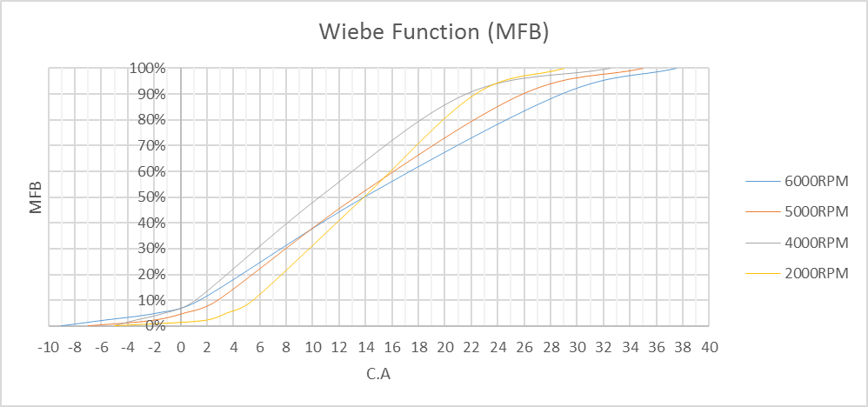
Figure 13 Wiebe Function (MFB) graph (Patrick, W 2020)
Figure 13 shows the completed Wiebe function curves including the predicted values. The graph shows each curve rising from around -10 degrees in a characteristic S-shaped curve up to around the 33 degree point. The 0% MFB indicates the start of combustion rising to the end point at 100%, the difference between these points is known as the duration of combustion (Yeliana, et al., 2008)

3.7 Temperature against Crank angle
Using the equation $\frac{PV}{{(m}_{f}+m_{a})286.9}+273$ the temperature for the entire Otto cycle can be calculated so that it can be plotted against crank angle to investigate the peak temperature and when this occurs. From thermodynamics it is expected that the temperature will rise as the piston cycles from BDC to TDC, this is because gasses compressed in a system will rise in temperature but will rise exponentially when ignition occurs then begin to fall as the piston cycles to BDC, before reducing again as the exhaust valve opens and the gasses are expelled from the chamber.
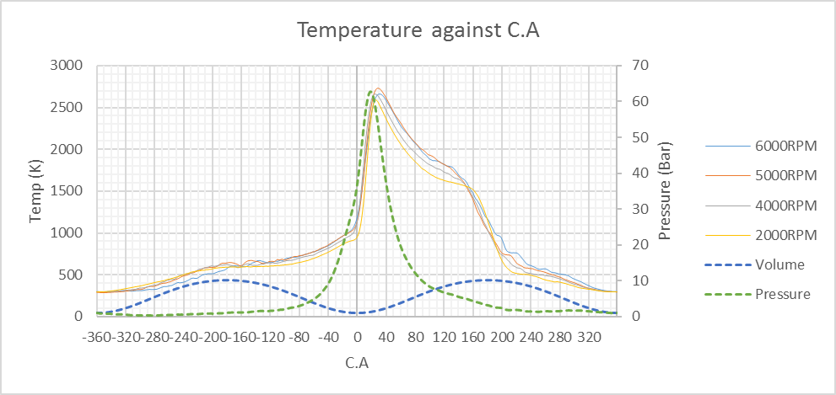
Figure 14 Temperature against C.A (Patrick, W 2020)
Figure 14 shows temperature against crank angle with volume and pressure overlaid with a secondary axis to easily investigate visually how the temperature curve fluctuates in relation to the volume of the cylinder. As stated above it can now be confirmed that the temperature starts the cycle approximately 300K (27°C) which would be an acceptable atmospheric temperature. By the time the piston reaches BDC the temperature rises similarly to the volume as expected to 600K (327°C) where small fluctuations and continues to rise at a slower rate as the pressure rises. The temperature then rises exponentially at the start of combustion approximately -10 degrees to peak pressure where the temperature reads 2600K (2327°C) at a peak value before falling to approximately 650K (377°C). the final fall in temperature comes as the exhaust gasses are expelled from the engine with a final temperature of approximately 300K (27°C). I use the word approximately as there are four different temperature values although they all correlate about the same curve.

3.8 Work Done against Crank Angle
To calculate the work done by the system the formula $dV×P$. It is important to work out the work done (j) by the system as this is also related to heat transfer and power in the engine as well as other things.
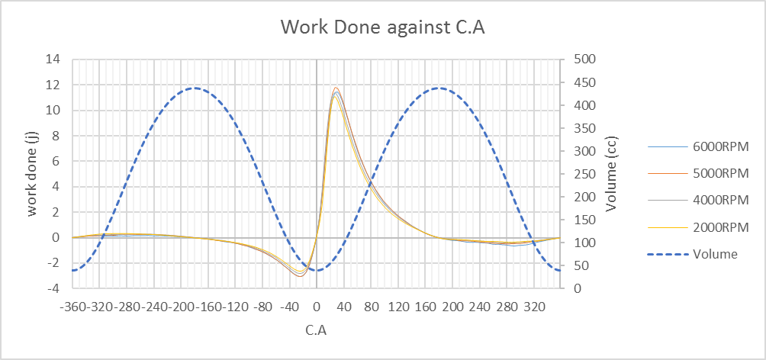
Figure 15 Work Done against C.A (Patrick, W 2020)
Figure 15 shows work done (WD) plotted against crank angle with volume overlaid for easier visualisation and investigation. Work done on the system doesn’t begin to deviate from the X-axis until approximately -160 degrees, at which point the engine is in the induction phase of the Otto cycle to a negative WD value of approximately -3J meaning an energy transfer is happening onto the system. When the WD rises exponentially from approximately 20 degrees before TDC to a peak of approximately 11.5J meaning there is an energy transfer out of the system in the form of heat and kinetic energy (OpenStax College, 2020). The work done then falls as the volume increases on the power stroke of the Otto cycle to where the WD dips slightly under the X-axis then re-joins

4.0 Task 2

4.1 Pressure against Crank Angle
To calculate pressure for the simulation the formula $P_{2}={(\left(P_{1}\left(\frac{V_{1}}{V_{2}}\right)\right)}^{n}+\frac{dQr(γ-1)}{V_{2}}){10}^{-5}$.
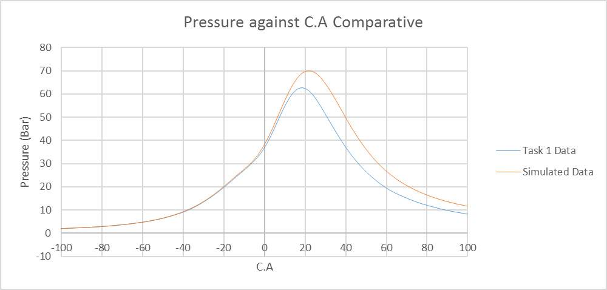
Figure 16 Pressure against Crank Angle Comparative (Patrick, W 2020)
Figure 16 shows the Task 1 data for the 6000RPM range plotted against the simulated data from the formula above. The section of the crank angle that is displayed is from -100 degrees before TDC to 100 degrees after TDC, this shows the compression and power stroke of the Otto cycle. When comparing the two curves it is clear that the simulated data follows the task 1 data up until approximately -10 degrees where it continues to climb following the task 1 data but reaches a peak pressure of 70bar which is 7bar higher than the recorded pressure. The simulated data also reaches its peak pressure 4 degrees later than the recorded data but falls following a similar curve although still higher by 3bar.

4.2 Delta Pressure against Crank Angle
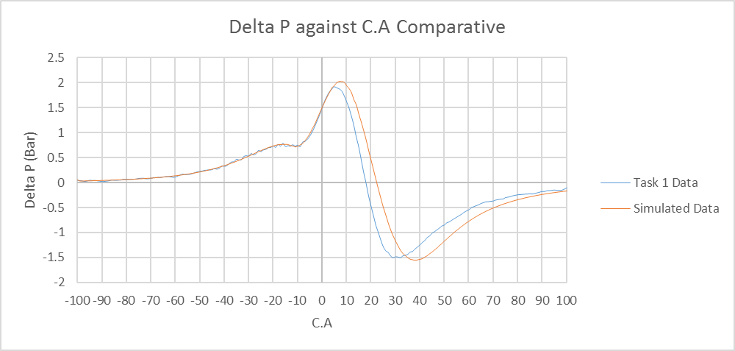
Figure 17 Delta Pressure against Crank Angle Comparative (Patrick, W 2020
Figure 17 shows the relation between the task 1 data and simulation data for delta pressure against crank angle at 6000RPM. As described in 4.1 and shown in the figure 16 the curves start off very similar but then begin to separate towards TDC. Both curves initially begin to climb at the same rate from approximately -90 degrees until approximately -17 degrees and a delta pressure value of 0.75bar the only difference being that the simulated data doesn’t have as many small fluctuations and could be considered a smooth curve throughout. The fluctuations in the task 1 data could be assumed to be a light knock caused by cylinder block vibration which would also suggest why these aren’t shown in the simulated data (Bi, et al., 2016). As the curves reach their peak delta pressure value they then fall as there is no change in pressure as the real pressure reaches its peak. As the curves pass back through the X-axis to their negative peak where the same small fluctuations can be seen in the task 1 data as before. Although both negative peaks are approximately the same at -1.5bar the task 1 data curve reaches this point at 29 degrees and the simulated data reaches this point at 37 degrees, which is more of a discrepancy than analysed in 4.1. The curves then re-join towards the 100 degree mark and reach this point in an almost identical curve segment.

4.3 Work done against Crank angle
The formula used for calculating work done that was used is $WD=dV∙P$.
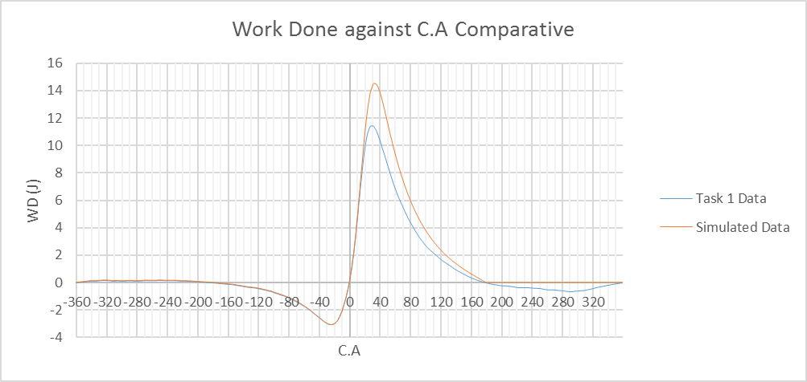
Figure 18 Work Done against Crank Angle comparative (Patrick, W 2020)
Similarly again as stated above for the figures 16 and 17 the curves for the task 1 data and the simulation data follow the same curve pattern, although in figure 18 for work done plotted against crank angle the curves separate at approximately 17 degrees. At 17 degrees after TDC as shown in figure 14 the temperature reaches its peak value which is where the most energy transfer happens. When the simulation data curve reached the X-axis it maintains at 0J of work done whereas the task 1 data curve dips below the axis to a negative peak of -0.6J which occurs throughout the exhaust phase of the Otto Cycle.

4.4 Pressure against Volume
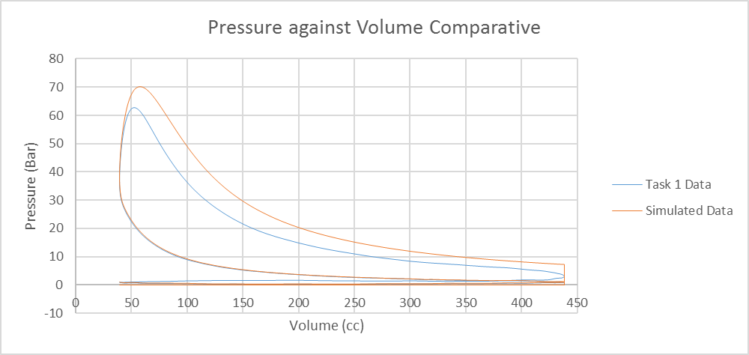
Figure 19 Pressure against Volume Comparative (Patrick, W 2020)
The volume values that were used in the simulation were the volume values from task 1 in m³ then converted in to cc via the following formula, $V_{cc}=V_{m³}∙{10}^{6}$. As described throughout the task 2 results the pressure displays a higher peak pressure displayed in figure 16 then follows an almost identical curve down to 438cc. when the simulated data reaches TDC it displays a more ideal Otto cycle displayed in figure 2 where the pressure drops instantaneously, although we know this not to be possible due to frictional or heat energy losses and the ideal Otto cycle diagram doesn’t account for gasses entering or leaving the system (NASA, 2015)

4.5 The Wiebe Function
The formula that was used to calculate mass fraction burnt (MFB) values is as follows, $MFB=1-e(-wiebe a {\left(\frac{CA-combustion start}{burn duration}\right)}^{wiebe b})$.
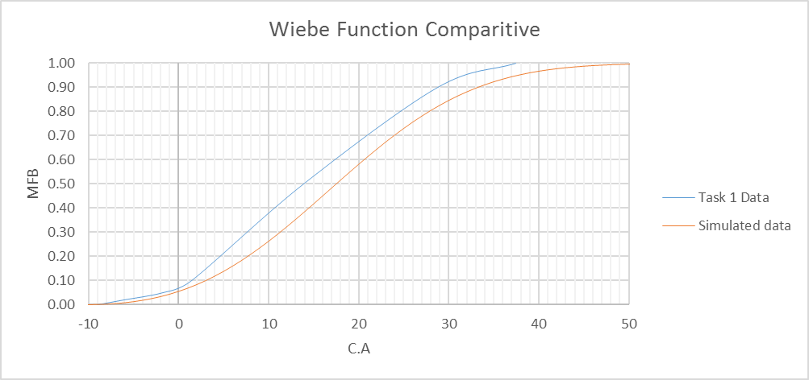
Figure 20 Wiebe Function Comparative (Patrick, W 2020)
As described in 4.1 and displayed in figure 16 the ignition happens slightly later in the simulation and as shown in figure 20 the burn duration is longer by 12 degrees than that displayed in the task 1 data curve, however it shows a smoother curve and has a more ideal S-characteristic shape.

5.0 Conclusion
In conclusion the simulation data gathered gave a realistic insight of a combustion engine, the data allowed for an investigation and analysis into the Otto cycle of the particular engine. The simulation has the ability to be adapted for use with other internal combustion engines in cars and motorcycles. The simulation displays a range of graphs showing curves with accurate characteristics in a clear understandable format.
Some limitations found within the simulation were identified as it does not factor in frictional losses of energy as stated in section 4.4. This limitation may explain the discrepancies identified with higher pressure and work done values, as some energy has the possibility to be lost through friction between the piston and the cylinder wall. The simulation also doesn’t account for cylinder block vibration and piston knock causing pressure fluctuation, identified in section 4.2.
To repeat this investigation preferably MATLAB simulation would be used for an improved display of the data and graphs. Although Microsoft Excel gave results to an acceptable degree, allowing clear analysis and interpretation.

Bibliography
Bi, F. et al., 2016. Knock Detection in Spark Ignition Engines Base on Complementary Ensemble Empirical Mode Decomposition-Hilbert Transform, Tianjin: Hindawi.
Borletti, V. A., 2019. Magnetti Marelli. [Online]
Available at: https://www.magnetimarelli.com/business_areas/powertrain/competences/virtual-engine-simulation
[Accessed 7 1 2020].
Connor, N., 2019. Thermal Engineering. [Online]
Available at: https://www.thermal-engineering.org/what-is-adiabatic-process-definition/
[Accessed 7 1 2020].
Connor, N., 2019. Thermal Engineering. [Online]
Available at: https://www.thermal-engineering.org/what-is-isothermal-process-definition/
[Accessed 7 1 2020].
NASA, 2015. Ideal Otto Cycle. [Online]
Available at: https://www.grc.nasa.gov/www/k-12/airplane/otto.html
[Accessed 13 1 2020].
OpenStax College, 2020. The First Law of Thermodynamics. [Online]
Available at: https://courses.lumenlearning.com/physics/chapter/15-1-the-first-law-of-thermodynamics/
[Accessed 12 1 2020].
Samuel, 2020. Engine Know How. [Online]
Available at: http://www.engineknowhow.com/the-engine-thermodynamic-cycles/the-actual-engine-cycles/
[Accessed 8 1 2020].
Spakovszky, Z. S., 2002. Unified: Thermodynamics and Propulsion. [Online]
Available at: https://web.mit.edu/16.unified/www/FALL/thermodynamics/notes/node26.html
[Accessed 7 1 2020].
Yeliana, et al., 2008. Wiebe Function parameter Determination MFB Calculation in a Gasoline SI Engine, Houghton: Michigan Technology University .

