University of Wales Trinity Saint David

BA (Hons) Business Management Level 4 – Group 2 Weekend

Marketing Fundamentals A1
Ferrero Rocher

Lecturer – Tusahara Balendran

Student name: Mariana Dodon

Student ID: 1917349

Background/history of Ferrero Rocher
The story of Ferrero Rocher began in 1946, when a small factory was built in Alba, which is a northern Italian town. In the year 1956, Ferrero Rocher opened its first ever international outlet in Germany and thereby, Ferrero Rocher also open-ended another factory in France in the same under rapid expansion strategy. Ferrero Rocher has been in this confectionary industry for over 70 years. After two decades, in 1966, Ferrero Rocher opened its first store in UK. Ferrero Rocher is one of the most dynamic and progressive companies in UK and Ireland. It is a family owned business and still maiming its true heritage (ferrero.co.uk, 2015). In addition to that, Ferrero Rocher has also collaborated with “English Football League Trust” for launching a sports education program within the country.
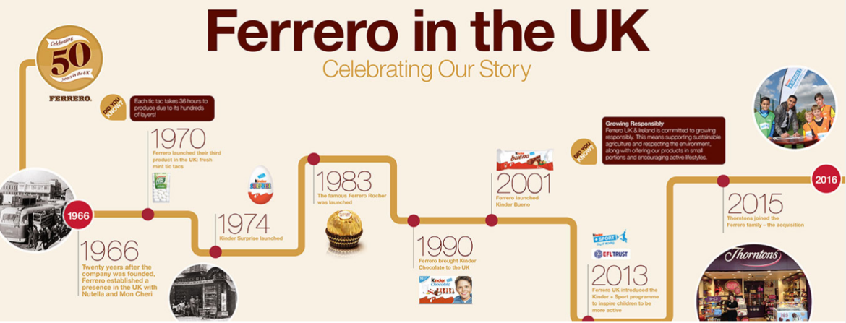
Figure 1: History of Ferrero Rocher
(Soruce: ferrero.co.uk, 2015)
Among the variety of products, Nutella has been one of the first products, which were in sales in the UK. In 1974, Kinder Surprise was introduced from the brand of Ferrero Rocher in UK; it is still one of the most famous items among children and young people (ferrero.co.uk, 2015). In terms of quality, HR aims to offer the highest quality materials for the production of the confectionaries. Ferrero Rocher is determined to bring the best quality items for the consumers. According to a mention on the official website, Ferrero Rocher claims that 95% of its products contain merely 150 kcal, which makes it more effective among the competitors (ferrero.co.uk, 2015).
Mission statement: “We aim to deliver pleasure to the life of our consumers through our high quality and premium treats.” Hence, it shows the dedication of Ferrero Rocher towards the consumer and it also helps the confectionery brand to establish itself as a responsible brand in the market.
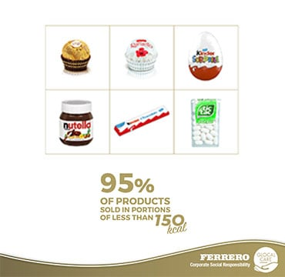
Figure 2: Ferrero Rocher quality assurance
(Source: ferrero.co.uk, 2015)

Product
Ferrero Rocher offers a range of alternatives in terms of products and offerings. All the products are a piece of art with elegant packaging especially for the products that contain chocolate and related products. Additionally, the elegant choice of wrapping and presentation makes the offering from Ferrero Rocher to be most attractive and luring for the consumers. A comprehensive list of the popular offering from Ferrero Rocher has been presented below.
NUETELLA:
Quality of the product: in terms of product quality, Nuetella comes with excellent quality. Additionally, Ferrero Rocher also offers a special focus on using sustainable sourcing for the production of Neutella (ferrero.co.uk, 2018).
Feature: Spread happiness
Benefits: Gluten free
Packaging and design: this product comes within a jar, which generally weighs at 200 gm and 400 gm (ferrero.co.uk, 2018).
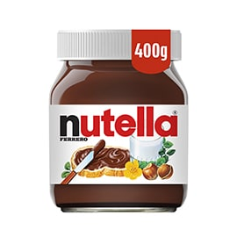
Figure 3: Nutella
(Source: ferrero.co.uk, 2018)
NEUTELLA B-Ready:
Quality of the product: Nutella B-Ready offers excellent quality in terms of taste and offers. As Ferrero Rocher focuses on quality, Nutella B-Ready comes with excellent taste (ferrero.co.uk, 2018).
Feature: Nutella B-Ready contains sprinkled Hazelnut with 81.5% Cocoa. It contains 115 kcal per 22 per gm.
Benefits: Nutella B-Ready is mid-morning food.
Packaging and design: Nutella B-Ready comes with wrapper packaging. In the case of a pack of six, the packaging is different (ferrero.co.uk 2018).
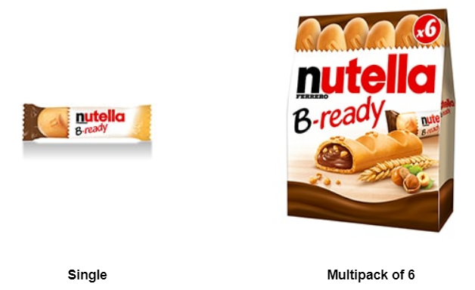
Figure 4: Nutella B-Ready
(Source: ferrero.co.uk 2018)
TIC TAC
Quality of the product: TIC TAC also manages to make up for the reputation of Ferrero Rocher in terms of quality.
Feature: Anticaking Agent, Magnesium Salts of Fatty Acids, Glazing Agent (Carnauba Wax)
Benefits: Gluten free
Packaging and design: packaging and designing of TIC TAC are elegant and comes with transparent packaging, where the colour of the packaging is done based on the flavour of TIC TAC (ferrero.co.uk, 2018).
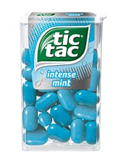
Figure 5: TIC TAC (Source: ferrero.co.uk 2018)

Price
In case of Ferrero Rocher, the pricing strategy is simple, as the company focused on value based pricing and tries to make a tally with the overall pricing of the market. This value based pricing strategy along with a focus on high quality items in the offering and portfolio has been able to offer huge potential and success for the global confectionery brand, Ferrero Rocher.
- Ferrero Rocher TIC TAC Mint containing 12 pack of Orange flavoured priced on Amazon at £36.
- NEUTELLA Hazelnut Chocolate in UK is priced at around £5.21 for a 400 gm of Jar (amazon.co.uk, 2020).
- NEUTELLA B-Ready containing 15 bars is priced at Amazon at £5.49.
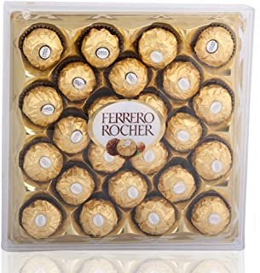
Figure 6: Ferrero Rocher T24
(Source: amazon.co.uk, 2020)
- Ferrero Rocher T24 weighs 300 gm is the price at Amazon for around £11.99 (amazon.co.uk, 2020).
- Chocolate Bouquet from Ferrero Rocher X-Large coloured in Pink is priced at £35.99 (amazon.co.uk, 2020).
- Chocolate Bouquet from Ferrero Rocher with Teddy costs in UK at around £27.99.
- A 75 gm of Ferrero Rocher Mini Cube costs in UK around £13.38.


Figure 7: Mini Cube
(Source: amazon.co.uk, 2020)

Place
As mentioned on the official website of Ferrero Rocher, the confectionary company has been the most loved one in Thornton during 2015. In the UK, the headquarters are situated in Cork, Alfreton, Derbyshire covering a huge 23-acre area (ferrero.co.uk, 2015).
The company operates its web activities from the official website, which is registered as “https://www.ferrero.co.uk/”. However, for the purpose of product selling and other sales oriented activities, Ferrero Rocher is mainly dependant on the intermediate sellers. For intactness, Amazon is one of the largest dealers of Ferrero Rocher, which sells a huge portion of the products using the ecommerce website. In case of physical outlets, Ferrero Rocher has its shop in Greenford, Loughborough, Liverpool, and Leicester. Hence, the discussion shows that Ferrero Rocher uses a combination of direct selling and third party selling channel, which has been highly supportive to offer a huge advantage in operating across the globe even without any physical presence largely.
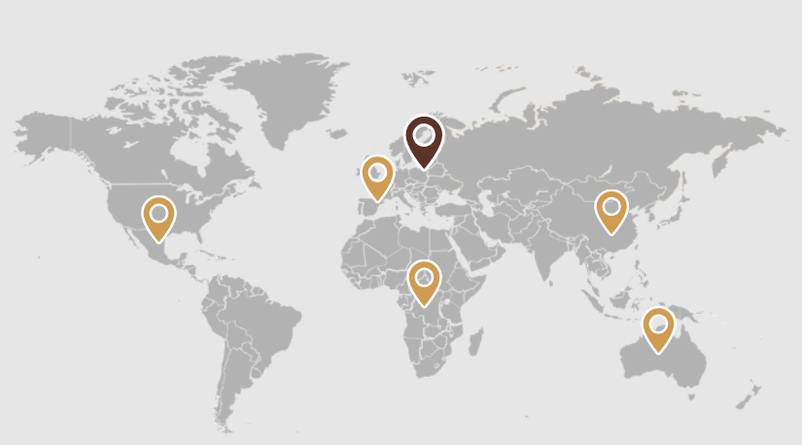
Figure 8: Ferrero Rocher Locations
(Source: ferrerocareers.com, 2018)
According to the mentions on the official website, Ferrero Rocher has its physical presence in around 55 countries. Ferrero Rocher has around 25 production plants in the 5 continents. Among the production houses of Ferrero Rocher, there are 8 factories for the production of Ferrero Hazelnut. Additionally, there are 6 plants for the agriculture company under Ferrero Rocher. However, despite the limited physical presence in only 55 countries, the products of Ferrero Rocher are sold worldwide in around 170 countries (ferrerocareers.com, 2018). The major operating regions of Ferrero Rocher include the likes of USA, UK, South Africa, Cameron and India along with the home country, Italy.

Promotion
Ferrero Rocher is mainly dependant on online promotion activities due to the large extensive coverage of social media and online mode of communication. Additionally, Ferrero Rocher focuses on responsible marketing tactics. This strategy includes the transparent use of information and the ads presented by Ferrero Rocher are applicable for people more than 16 years of age (ferrero.co.uk, 2015). The target market of Ferrero Rocher includes young people mostly. Additionally, Ferrero Rocher also produces confectioneries for the people if any age group due to its slow calorie strategy along with the use of raw material with sustainable branding has been able to offer excellent support to get the attention of target market largely.

Figure 9: Social Media Marketing
In 2019, Ferrero Rocher has won the “YouGov Ad of the Month” reward (warc.com, 2019). The entire marketing strategy of Ferrero Rocher consists of a variety of marketing channels such as Direct Selling, Social Media Marketing along with the course of direct marketing. In case of social media marketing, in collaboration with YouTube, Facebook Ferrero Rocher promotes is offers and new products to the mass market. This is one of the most prolific promotion channels for Ferrero Rocher.
In addition to that, Ferrero Rocher also utilises the in-store campaign in the physical outlets of Ferrero Rocher, where the products and related offerings are displayed using banners, placards, small cards and others. Integrated Marketing Communication is used within the premises of Ferrero Rocher in order to scale up the production and process management in coordination with other functional departments. This integrated marketing channel has been highly crucial for offering a huge prospect in managing global operations across UK.
The above section of the study has demonstrated a detailed portfolio of Ferrero Rocher, which is a world renowned brand in the confectionery business. The entire presentation has been prepared in a blog style. The identification has shown that Ferrero Rocher is an Italian brand and has its physical operations in around 55 countries, whereas the products of Ferrero Rocher are sold in around 170 countries. A detailed assessment of the pricing, promotion strategy has been communicated, which ash shown that Ferrero Rocher uses a social media marketing strategy coupled with third party marketing and brick and mortar type marketing.

References
amazon.co.uk 2020. Amazon.co.uk : ferrero rocher. [online] Available at: https://www.amazon.co.uk/s?k=ferrero+rocher&i=grocery&crid=2HZBL72XF4MO7&sprefix=Ferrero%2Cgrocery%2C305&ref=nb_sb_ss_ts-a-p_1_7 [Accessed 1 Dec. 2020].
amazon.co.uk 2020. Nutella Hazelnut Chocolate Spread, 750 g, Pack of 6: Amazon.co.uk: Grocery. [online] Available at: https://www.amazon.co.uk/Nutella-Hazelnut-Spread-Cocoa-750g/dp/B00498ZTPA [Accessed 1 Dec. 2020].
ferrero.co.uk 2015. Ferrero UK. Ferrero in UK and Ireland [online] Available at: https://www.ferrero.co.uk/Ferrero-UK#:~:text=Ferrero%20UK%20%26%20Ireland%20is%20a,as%20a%20family%2Downed%20business.&text=Ferrero%20has%20always%20had%20a,exceeding%20the%20expectations%20of%20consumers. [Accessed 1 Dec. 2020].
ferrero.co.uk 2018. Nutella B-ready. [online] Ferrero.co.uk. Available at: https://www.ferrero.co.uk/Nutella-B-ready [Accessed 1 Dec. 2020].
ferrero.co.uk 2018. NUTELLA®. [online] Ferrero.co.uk. Available at: https://www.ferrero.co.uk/Nutella [Accessed 1 Dec. 2020].
ferrero.co.uk 2018. Tic Tac. [online] Available at: https://www.ferrero.co.uk/Tic-Tac#expand-jump-4 [Accessed 1 Dec. 2020].
ferrerocareers.com 2018. About Ferrero | Global Ferrero Careers. [online] Available at: https://www.ferrerocareers.com/int/en/about-ferrero#:~:text=Today%2C%20our%20reach%20extends%20across,distributed%20in%20over%20170%20countries. [Accessed 1 Dec. 2020].
warc.com 2019. YouGov Ad of the Month – UK: Ferrero Rocher. [online] Available at: https://www.warc.com/newsandopinion/opinion/yougov-ad-of-the-month--uk-ferrero-rocher/2928 [Accessed 1 Dec. 2020].

